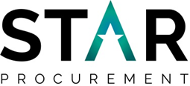
SUPPLIER ENGAGEMENT EVENT
Thursday 18th March 2021
16:00 via Zoom
STAR Procurement, in collaboration with Rochdale Council are hosting a Supplier Engagement via Zoom to discuss the future procurement of a Framework Agreement for Tree Services.
The purpose of the event is to:
- Provide the opportunity for businesses to meet with STAR and Rochdale Council who are involved in the procurement and help shape proposals
- Understand the scope of works
- Explore some of our key objectives
The event will be an opportunity to understand the market, help us develop our requirements and provide networking opportunities.
If your organisation is interested in attending this event then please register your interest by clicking on the link below. Once you are registered further details of the event including an agenda will be issued to you via e-mail
Booking Details:
https://www.eventbrite.co.uk/e/supplier-engagement-event-tickets-145206022121

