Supplier Sign up Process

Click on the link ‘Sign up’
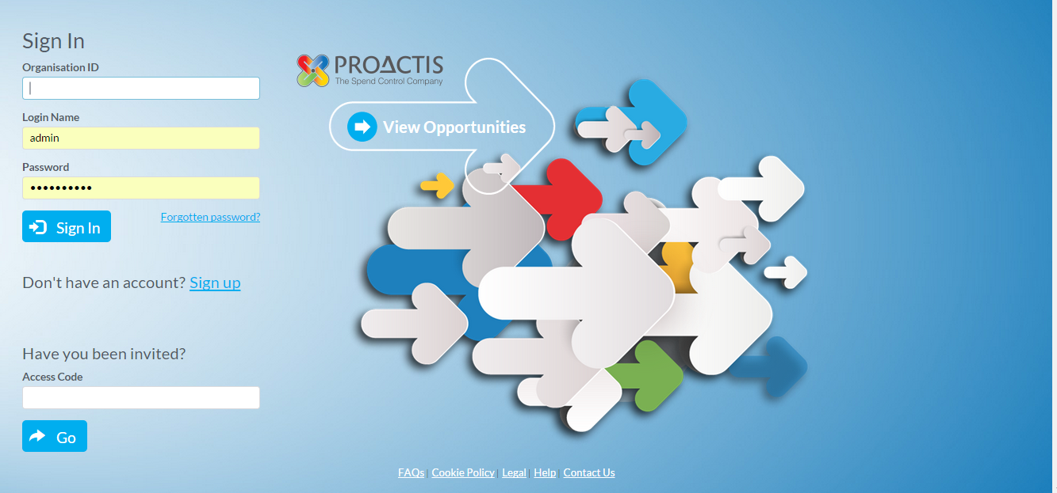

Complete basic information to register and receive account activation email
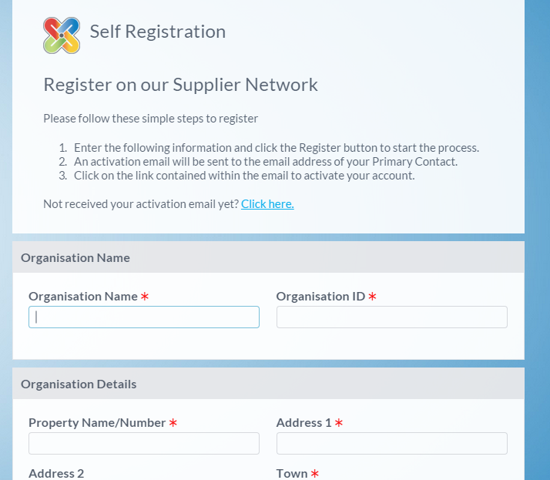
Click on the link to activate and register your account
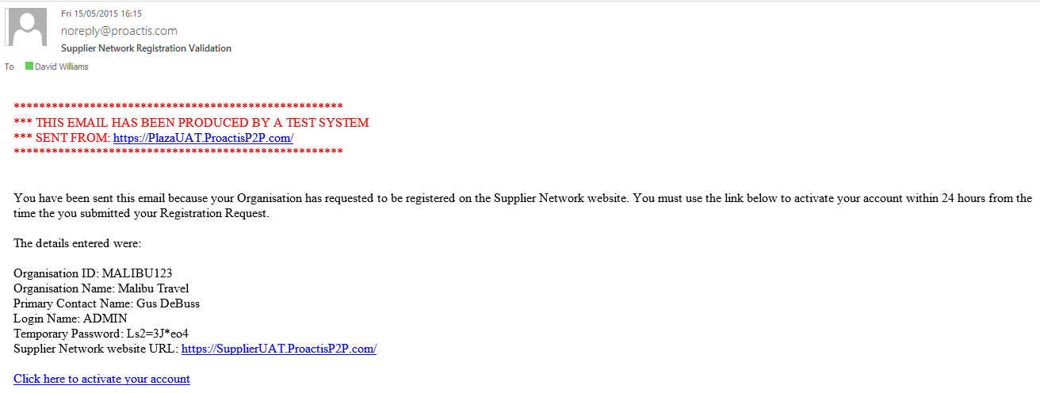

Complete Self Registration Wizard
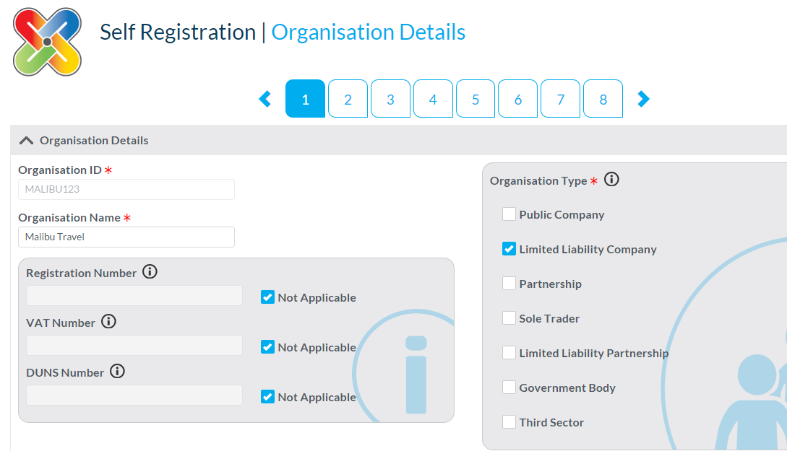
Step 4: Select appropriate CPV code using Keyword search…
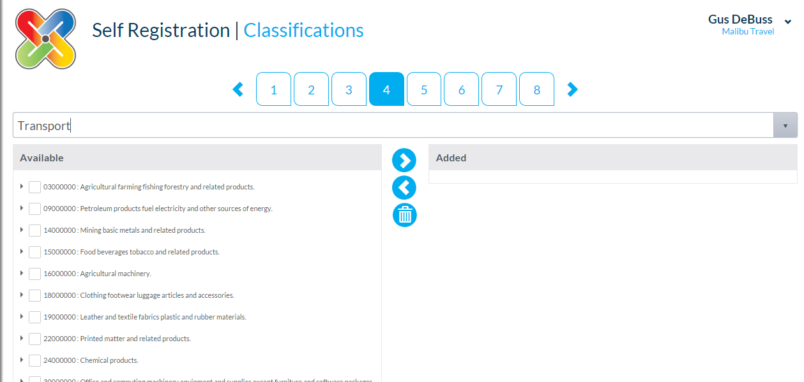

Step 5: Select Somerset CC
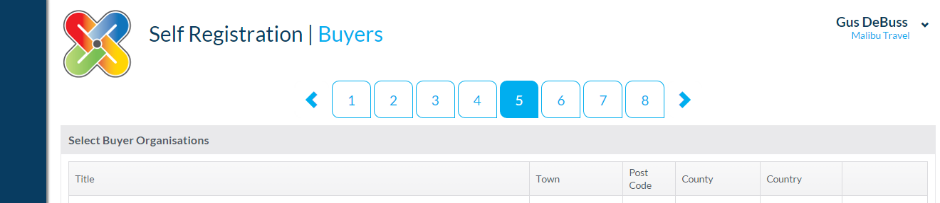

Enter personalised password and click on Complete Registration
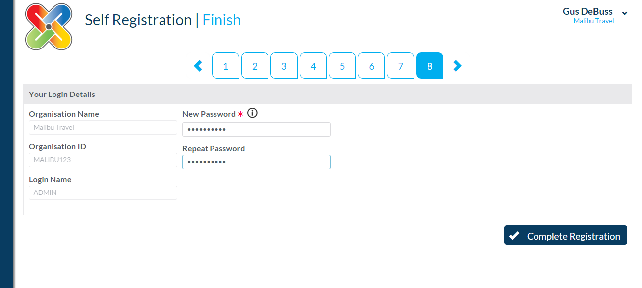

When logged in, opportunities can be access by clicking on Opportunities
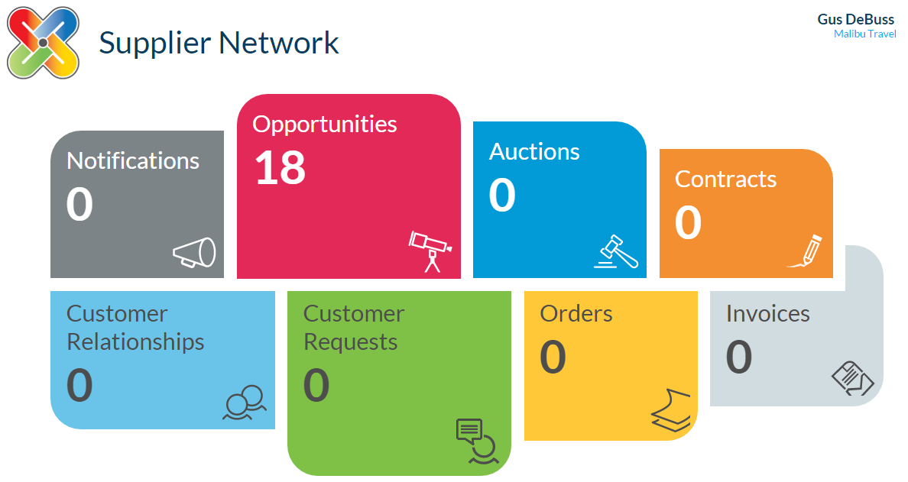

Locate relevant opportunity for SomersetCC DPS and register interest

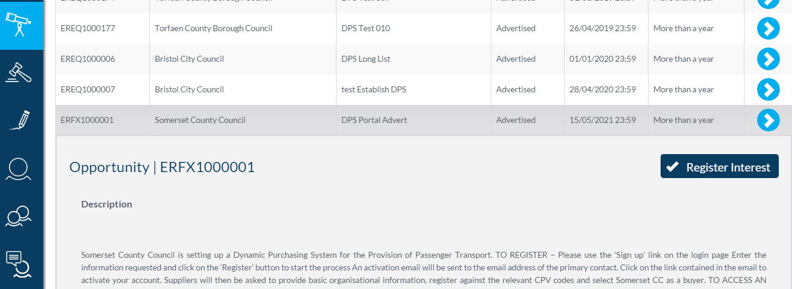
Once registered clarification questions can be asked through the New Message button
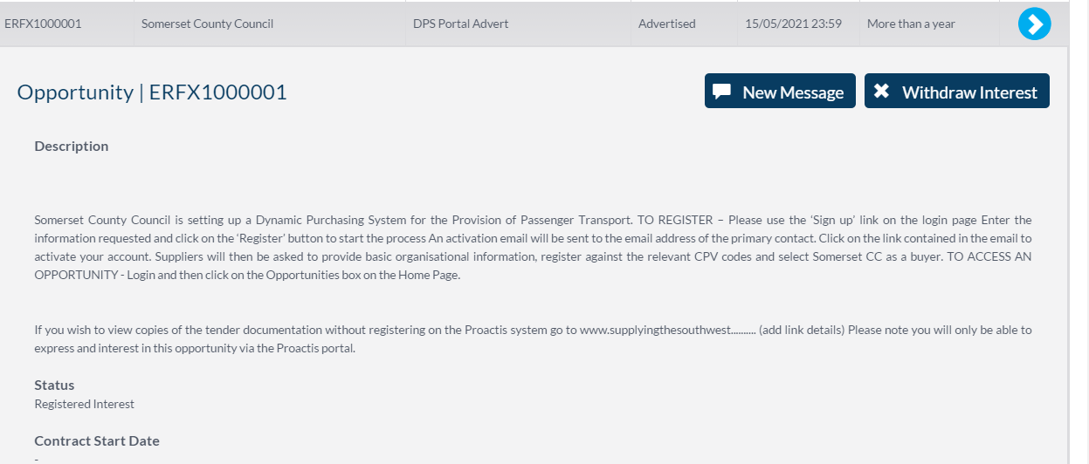

Helpful Hints and Tips
- Read all Instructions - Please ensure that you read and understand all the required instructions/actions and appropriate deadlines and any subsequent communication.
- Secure login - Please treat your Proactis portal logins securely. If you believe you have lost your password please log on to the website and click 'Forgotten Password'.
- Save regulary - For security reasons your access to the portal will 'time out' if inactive for 20 minutes if you do not click 'save changes' within this time. Failure to do so will mean you risk losing your work.
- You are able to Save your response and come back to it at any time.
- Communication / Messages: To write or read any messages use the secure messaging to communicate with the Council and to seek clarification, this will provide an audit trail for all discussions and clarifications.
Please click on the opportunity and click the ‘view messages’ button.
- Response time - Do not leave your response until the last minute or hours before the deadline. If you experience connection problems you will miss the deadline and your response may be deemed non-compliant and rejected. Always upload generic information early to avoid last minute time pressure.
- Attachment size – Size attachments should be no larger than 3MB. Please contact the Council if you need to upload a larger file.
Please note depending on the time of day and internet traffic, the submission of large electronic files may take some time. The speed at which your submission is received will also depend on the size of the file and the internet bandwidth available to you. Allow sufficient time when tendering electronically. As a general guide, a simple two page text file should take less than 30 seconds to transmit. A large file (i.e. one approaching 4MB file size) may take several minutes to transmit.
ALL of the submission must be received prior to the submission deadline.
If your transmission is part received when the deadline is reached, the submission will fail. As a general rule, if the transmission process has not completed within 10 minutes, it has been unsuccessful.
- Submitting responses - Please submit your response when completed. This will submit your response to the Council.
- Technical This site operates best using Internet Explorer (versions 8, 9 and 10), or the latest versions of Safari, Firefox and Chrome. A screen resolution of 1024 x 768 or above is recommended.
This website is not yet officially supported in Internet Explorer 11; however most issues with it are alleviated by using compatibility mode. To check to see if you have IE11 - in your browser on the top right hand side select the cog icon then select About Internet Explorer. This will show you in a pop-up the version of IE you have installed. If you are using IE11 then please follow the following steps to enable compatibility mode for this website:
If you cannot see the tools menu icon at the top right hand side then press 'ALT' on your keyboard.
Select Tools and then Compatibility View Settings.
Add "proactisplaza.com" (excluding the inverted commas) to the list. You may need to close your browser and re-open it for the changes to be accepted.
If you are experiencing technical difficulties with this site, then please ensure you are viewing the site via Internet Explorer 8, 9 or 10, or the latest versions of Safari, Firefox and Chrome.

