SOUTHEND-ON-SEA CITY COUNCIL
SERVICE SPECIFICATION FOR THE PROVISION OF A ROUGH SLEEPING RAPID ASSESSMENT HUB & OUTREACH/INREACH SERVICE
TENDER REFERENCE: DN626813
SECTION B

Introduction & background
In spring 2018 Southend-on-Sea City Council (SCC) were invited to co-produce a funding bid with Ministry of Housing, Communities and Local Government (now DLUHC (Department for Levelling Up, Housing and Communities)) from the newly launched Rough Sleeping Initiative.
Since our initial award of £425,000 for the winter of 2018/19, we have continued to be successful every year for a range of initiatives totalling investment over £2 million. Our most recent bid for the period of 2022-2025 will enable us to continue to provide:
- A team of assertive outreach/ inreach officers,
- A 12-bed rapid assessment hub providing emergency relief and wraparound support
- A full time Rough Sleeping Coordinator
- A team of Rough Sleeper Navigators, including a focus on people with restricted eligibility
- Personal budgets to increase engagement opportunities and allow individuals to access accommodation/appointments/comfort
- Additional B&B capacity for surge periods
- Specialist Housing Solutions Officers and Private Sector Solutions Officer

The above underpin the aims of the Rough Sleeping Initiative which when announced were to have an immediate impact on the reduction of rough sleeping – halving it by 2022 and eliminating it altogether by 2027.

Local context
In addition to the funded interventions listed above, there are other factors which wraparound the rough sleeper support landscape in Southend. This includes a considerable offer across the voluntary, community and faith networks including provisions of accommodation, foodbanks, soup kitchens and outreach. These organisations are well supported also by the Southend Homeless Action Network (SHAN) which is a voluntary group bringing together many of these different organisations in order to coordinate support for rough sleepers in Southend.
As a result of the funding and the strength of the multi-agency partnership in Southend, the number of rough sleepers documented in our annual count dropped from 72 in autumn 2017 to 11 in autumn 2018. Whilst there has been some fluctuation, numbers recorded at regular counts over the subsequent years have overall remained significantly lower than the 2017 figure. For example, in March 2022 the monthly snapshot count figure was 1, in April 2022 it was 5 and in May 2022 it was 10. In line with experiences in many seaside locations, we often see a slight increase in the warmer months.

Figure 1. The number of people sleeping rough on a single night in Southend-on-Sea, 2010 -2021

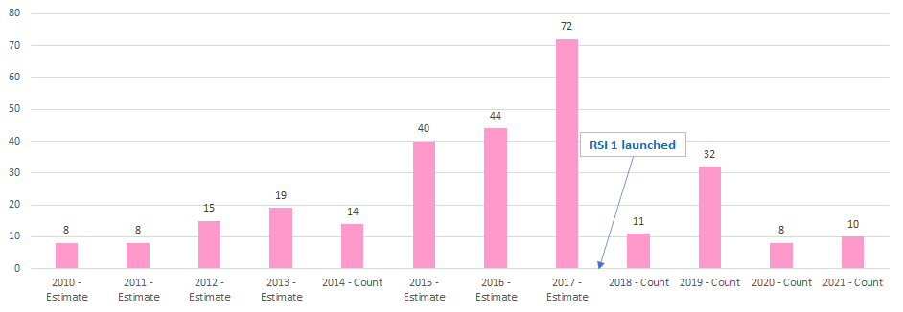

Figure 2. November 2021 count demographics
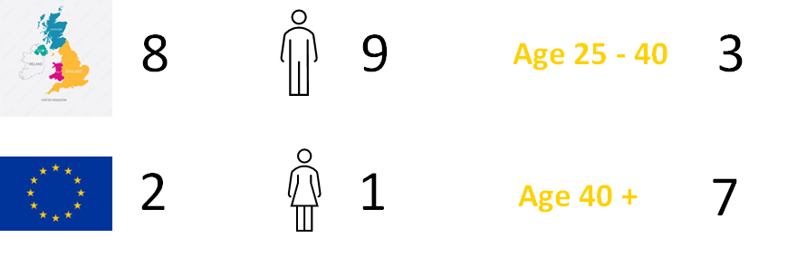

Figure 3. Streetlink referrals 2021/22
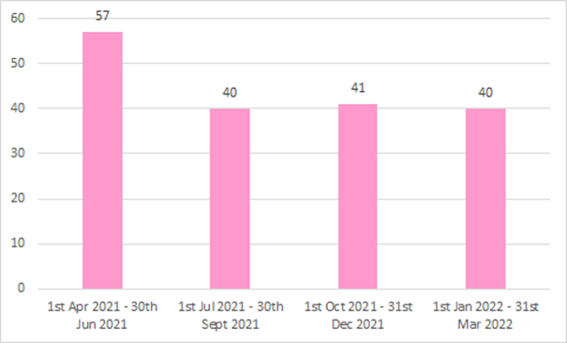

Issues shaping the procurement
The Department for Levelling Up, Communities and Housing (DLUHC) has adapted the funding model for the Rough Sleeping Initiative, moving from yearly funding rounds to a 3-year award. This means that where services could previously be awarded to named partners, we must now go out to the market where contracts would meet certain procurement thresholds. The timeline to conduct a procurement exercise has been built into the project plan for the implementation of our funding award from 2022-2025. This brings about the opportunity to build in a much more defined specification, with clear outcomes and framework for performance management to ensure that this contract delivers against the aims of the Rough Sleeping Initiative.

New service aims and outline
The provision of the Rapid Assessment Hub and Outreach/ Inreach service will be working toward the following aims:
- To reduce rough sleeping in the Borough of Southend, with a flexible and responsive approach
- To support people into accommodation through a range of prevention and relief measures
- To work in partnership across the Borough to deliver successful interventions that meet the complexities of the rough sleeping population
- To ensure those supported off the streets remain in some form of accommodation over 2022-25.

Figure 4. RSI (Rough Sleeping Initiative) emergency provision + people sleeping rough on night of Nov count (since funding started)

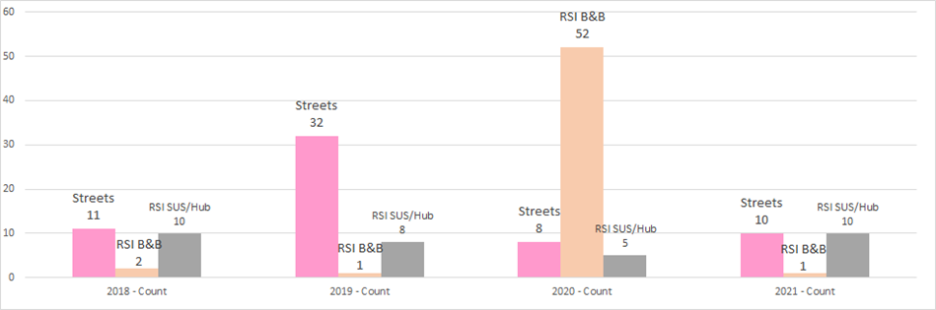
Figure 4 demonstrates the impact that being able to provide an outreach service and emergency accommodation has had since RSI funding commenced in 2018. Rough sleeper numbers would have been considerably higher at each count had these services not been available, which DLUHC recognises in its approval for this to continue to be funded over the next 3 years.

The Rapid Assessment Hub and Outreach/ Inreach service must:
- Be a Registered Provider of Social Housing, or evidence similar robust governance framework
- Already have the accommodation units available ​
- Have the requisite planning permission in place to bring bed spaces into use for the purpose of providing them to people recently off the street. ​
- Be able to provide at least 12 self-contained (no shared bathrooms) supported bedspaces​
- Be able to claim housing benefit and demonstrate how this helps to deliver the supported bedspaces
- Be able to provide wraparound support​, working with Hub residents and the wider partnership to secure move on solutions and prevent a return to the streets
- Aim to have residents move through Hub provision within 14 days (RAH best practice)
- Operate an outreach/ inreach team with adaptable service hours​ in order to best respond to any fluctuations in rough sleeping numbers

Other key features/ principles to underpin the service:
- Evidence of working in a trauma informed way/ promoting a psychologically informed environment
- Ongoing staff training and professional development, including qualifications relevant to the service
- Incorporating the voice of the service user into delivery
- Service user/ peer led initiatives
- Strong partnership working across the Southend homelessness landscape
- Attending weekly client case discussion meetings
- Attendance at bimonthly rough sleeper counts
- Multiagency support/ outreach where necessary
- Working with a range of other providers/ partners to support individuals in maintaining long term accommodation, including Southend-on-Sea City Council

Organisation, governance and running of the service
The provider must demonstrate a clear and accountable approach to the organisation, governance and running of the service. This must include demonstration of added value and flexibility and innovation to achieve service outcomes. We are looking for detail regarding:
- Being a Registered Provider or similar robust governance procedures
- Approach to staffing the 12-bed hub with focus on safety and security of guests
- Evidence that the accommodation is already in place with correct planning permission by contract start date
- Ability to make Housing Benefit claims for tenants and how this income will be utilised
- A flexible inreach/ outreach team working closely with hub staff – able to cover unsocial hours
- Responses to Streetlink referrals, and any specific referrals made by elected councillors, members of the public and the Rough Sleeper Coordinator
- Weekly/ regular client meetings prioritising support and rapid move on plans
- Collection and provision of data for quarterly KPI reporting with the contract manager
- How the requirements of data protection legislation are to be met

KPIs and contract management
KPIs for this service will be set with the provider and the Rough Sleeping Coordinator at the first implementation following awarding of the contract. KPIs will reflect the aims and requirements of the service and will be monitored by the Rough Sleeping Coordinator at regular contract management meetings.

Appendix 1 – Additional Southend background data
- Southend-on-Sea is a large coastal town and unitary authority area with borough status in south-eastern Essex, England. It lies on the north side of the Thames Estuary, 40 miles (64 km) east of central London. It has an estimated population of approximately 180,000 people.

Table 1: JSNA 2019 Demography population breakdown by electoral

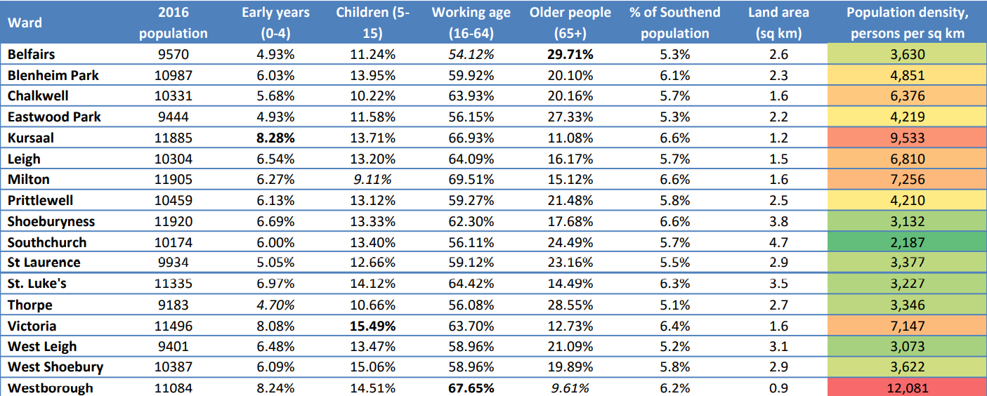

Key statistics about the borough

- In 2020, 17.1% of Southend’s residents were economically inactive. Average weekly earnings were £650 for men and £605 for women. 40% of Southend’s residents live in areas considered to be in the most deprived 30% in the country, with eight neighbourhoods falling into the 10% most deprived in the country.

- 14 of Southend’s neighbourhoods have a higher population of children living in poverty than the England average; Victoria and Kursaal wards are among the 20% most deprived wards in the country.

- Kursaal, the borough’s most deprived ward, ranks 129th most deprived neighbourhood nationally according to the 2019 Index of Multiple Deprivation.

Areas of Deprivation

- The Index of Multiple Deprivation (IMD) is a measure which is used to determine deprivation in every small area in England, relative to other areas in England. Table 4 shows the deprivation deciles, areas marked in dark red are amongst the most 10% deprived small areas in England. Many of the Council’s most disadvantaged communities are located within the Southend ‘city centre’ wards, Blenheim Park, the Shoebury area and across Southchurch and St Luke’s wards.

Table 4: Levels of deprivation within Southend

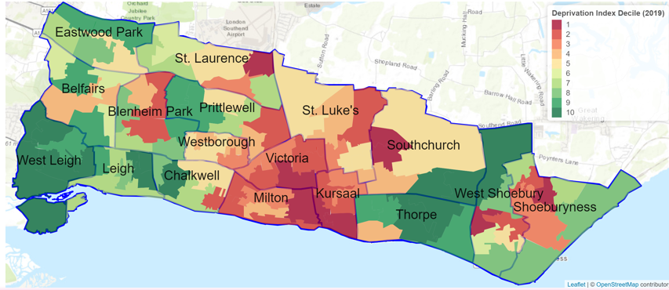

- There is a strong association between deprivation of neighbourhood and reduced life expectancy. In Southend-on-Sea, the life expectancy gap between the most deprived and least deprived wards is just over 11 years for males, and just under 10 years for females.

- In Southend-on-Sea, just under 1 in 5 children live in low-income families (households where income is less than 60% of the median income before housing costs). Around 10% of households experience fuel poverty.

Table 5: Southend deprivation indices

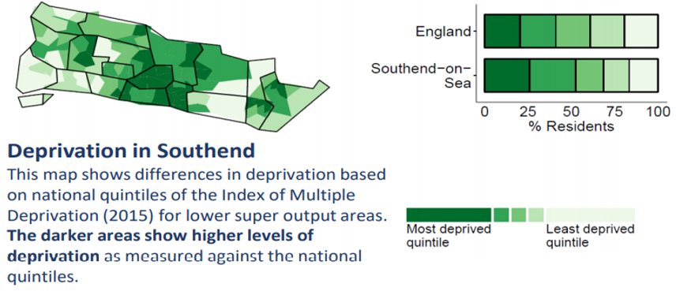

Housing (headline statistics ONS (Office for National Statistics) May 2021)

- England house prices grew by 9.7% in the year to May 2021, unchanged since April 2021. The Northwest was the fastest growing region with annual growth of 15.2% in the year to May 2021. The lowest annual growth was in London, where prices increased by 5.2% over the year to May 2021. The average price of a property in England was £271,434. The annual price change of a property in England was 9.7%. The monthly price change of a property in England was 0.4%. The index figure for England (January 2015 = 100) was 133.8.

Table 6: Average house price in Southend

Local authority | May 2021 | May 2020 | Difference
Southend-on-Sea | £310,178 | £289,790 | 7.0%

- On a non-seasonally adjusted basis, average house prices in England increased by 0.4% between April and May 2021, unchanged during the same period a year earlier (April and May 2020). On a seasonally adjusted basis, average house prices in England increased by 0.2% between April and May 2021. Across England, terraced houses showed the biggest increase out of all property types, growing by 11.2% in the year to May 2021 to £223,000. The lowest annual change was in flats and maisonettes, which increased by 5.5% in the year to May 2021 to £235,000.

Table 7: ONS Census Accommodation type by number of bedrooms and by ward

 | Total: Accommodation | 1 Bedroom | 2 Bedrooms | 3 Bedrooms | 4 or more Bedrooms
Southend-On-Sea | 74,645 | 13,060 | 22,165 | 26,748 | 12,672
Belfairs | 4,173 | 511 | 1,561 | 1,532 | 569
Blenheim Park | 4,279 | 439 | 1,059 | 2,128 | 653
Chalkwell | 4,367 | 1,125 | 1,360 | 670 | 1,212
Eastwood Park | 3,981 | 216 | 1,276 | 1,758 | 731
Kursaal | 5,085 | 1,702 | 1,782 | 1,074 | 527
Leigh | 4,608 | 896 | 1,535 | 1,438 | 739
Milton | 5,198 | 1,786 | 1,988 | 825 | 599
Prittlewell | 4,208 | 570 | 1,076 | 1,837 | 725
Shoeburyness | 4,759 | 953 | 1,346 | 1,838 | 622
Southchurch | 4,065 | 415 | 1,120 | 1,557 | 973
St Laurence | 4,205 | 481 | 1,292 | 1,948 | 484
St. Luke's | 4,645 | 600 | 1,312 | 2,398 | 335
Thorpe | 3,920 | 305 | 989 | 1,311 | 1,315
Victoria | 4,964 | 1,623 | 1,584 | 1,457 | 300
West Leigh | 3,840 | 278 | 938 | 1,436 | 1,188
West Shoebury | 3,963 | 320 | 809 | 1,716 | 1,118
Westborough | 4,385 | 840 | 1,138 | 1,825 | 582

Table 8a: 2021 Rental accommodation indicative prices (commercial comparison by letting agent July 2021)

Property Rents in Southend-on-Sea by Number of Bedrooms
No. of properties Average rent Median rent
One bedroom 58 £1,161 pcm £849 pcm
Two bedrooms 88 £1,277 pcm £1,001 pcm
Three bedrooms 26 £1,268 pcm £1,300 pcm
Four bedrooms 14 £1,710 pcm £1,598 pcm
Five bedrooms 1 £2,150 pcm £2,150 pcm

Table 8b: 2021 Rental accommodation indicative prices (commercial comparison by letting agent July 2021)

Property Rents in Southend-on-Sea by Type
No. of properties Average rent Median rent
Room 26 £480 pcm £465 pcm
Flat 145 £1,195 pcm £901 pcm
House 46 £1,469 pcm £1,499 pcm

Homelessness

- The Homelessness Reduction Act (2017) provides a clear steer on the Council’s responsibilities in addressing housing provision, prevention, and support. A lot of additional measures were brought in during the pandemic to better support this vulnerable group.

- The rate of households owed a duty of care under the Act. in Southend (11.2) is better than England (12.3) and the average for our statistical neighbours (13.4). The rate of households in temporary accommodation in Southend (2.4) is better than England (3.8) but worse than the average for our statistical neighbours (0.91).

Table 9: Southend Public Health Homelessness Data 2020/2021

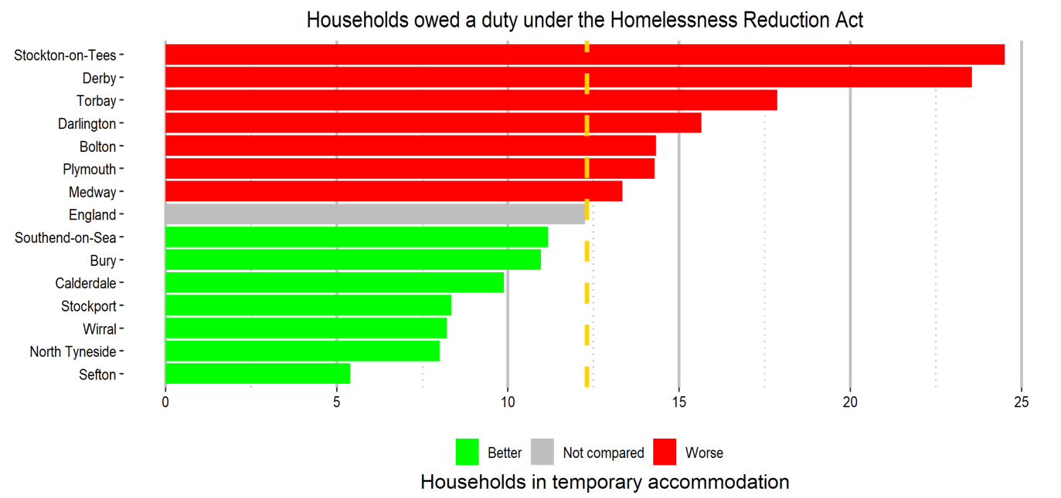

- The rate of households owed a duty of care under the Homelessness Reduction Act where the main applicant is over 55 years and over in Southend (2.89) is similar to England (2.86) but worse than the average for our statistical neighbours (2.56).

- The rate of households owed a duty of care where the main applicant is between 16 and 24 years old in Southend (2.53) is similar to England (2.58) and better than the average for our statistical neighbours (3.07).

