Contract: DN315713 – “AutoCAD LT Desktop Subscriptions with Web Support”
Warrington Borough Council (the Council) is seeking bids for the renewal of AutoCAD LT Desktop Subscriptions with Web Support, commencing 01 February 2018.
The Council will choose the winning bidder by determining the best value proposal based on price and the response to the specification. The Council is not bound to accept the lowest or any bid and the Council’s decision as to the acceptability of bids shall be final. The Council shall not be responsible for any costs in connection with the preparation of bids.
To ensure that all bidders have equal access to information regarding this RFQ, the Council will publish all of its responses to questions raised by bidders on an anonymous basis should there be a common element.
Bidders are to complete the evaluation section as their bid submission for this opportunity. Incomplete submissions will be rejected.
Completing your submission
On the right hand side of the screen you will see the” start my response” button, click on this and continue through the next fields.
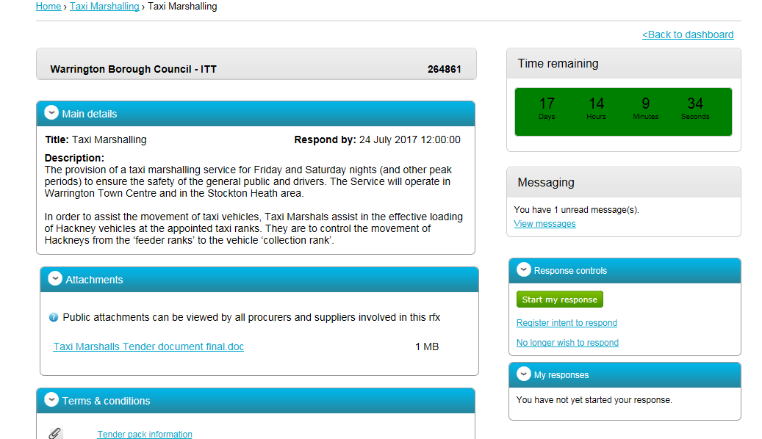

You will then see a screen with edit response highlighted, click on this, there is also a progress bar, to monitor your progress:
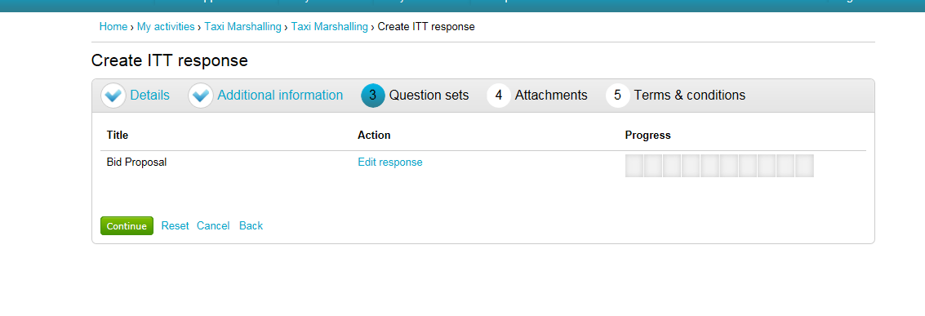
At the next screen you can start to complete the questionnaire by going into the Answer question function. Make sure you answer all questions.

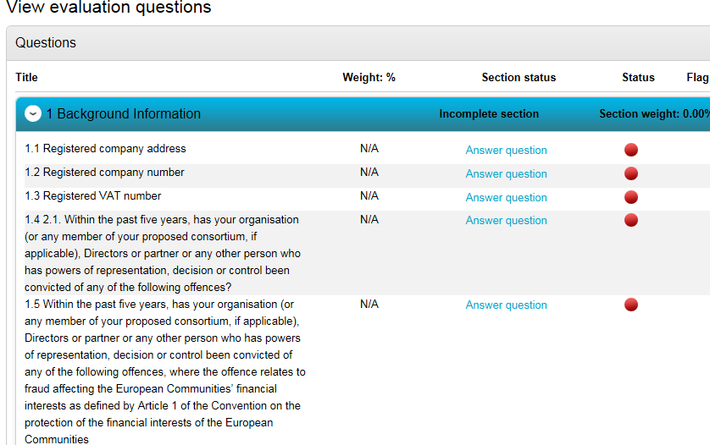

Different questions will require different forms of answer, from a simple confirmation or yes/no option through to answering in the text box or submitting an attachment
Ensure that you complete the assessment and that you submit correctly and on time. When you submit you will receive a confirmation.
You will be able to make amendments up to the closing time. Please ensure you make your submission in good time to avoid any technical difficulties.
For further assistance and support on using the Chest please visit the Supplier Help Centre: https://supplierhelp.due-north.com/

