Accessing opportunities on the NEPO Portal
A guide for organisations to locate any opportunity documentation which MUST be downloaded and fully completed to enable organisations to resubmit into the opportunity by the deadline stated.
For Help contact the Portal Helpdesk using the Help button for contact information or frequently asked questions. This applies to any Opportunity.
Website:- https://procontract.due-north.com/SupplierPreLoginHome
- Select ‘Register an interest in this opportunity’ once selected screen 2 should appear.
(if you have already registered an interest and did not access the documents immediately go straight to paragraph 4).
- Select ‘To view this DPS (or Project/Tender) event now, click ‘here’ once selected screen 3 should appear.
- Scroll to the bottom of the screen to view all documentation and download to complete.
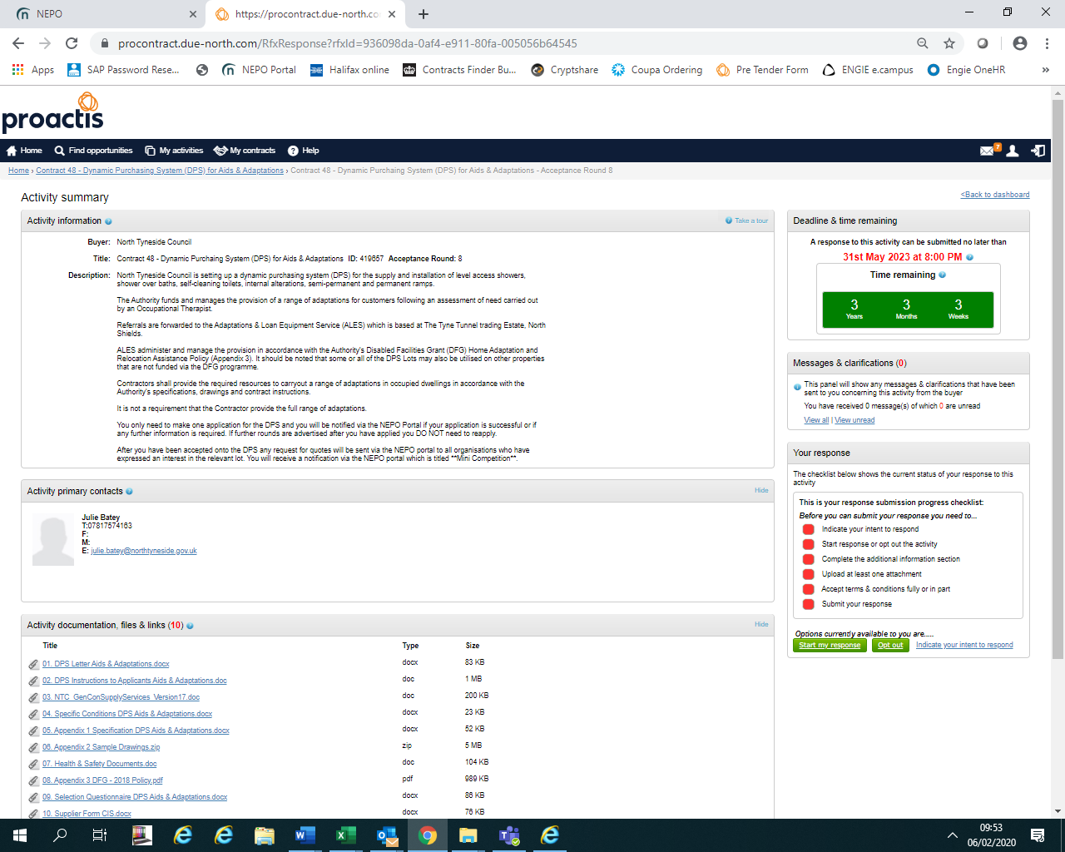
- SUPPLIERS WHOM HAVE EXPRESSED AN INTEREST ON THE NEPO PORTAL AND DID NOT VIEW THE DOCUMENTS IMMEDIATELY:-
If you logged out after registering an interest/expressing an interest and did not select the option identified in paragraph 2 above at the time. Log back into the Portal, from the home page go to the opportunity using ‘My Activities’. Follow the guidelines further below for further assistance.
‘Opting out’. Alternatively if you have changed your mind and are not interested in this, return to the Home Page or if easier log out and log back into the Portal. From the home page go to ‘My Activities’. when the next screen opens, scroll down (there maybe more than one page) until you find the opportunity you wish to either apply for or opt out and follow the instructions in the attached, ‘Opt Out’ should be visible at the point when you can see the documentation to down load. If you select ‘opt out’ and will not receive any further notifications about the opportunity you can see on your screen only, just this opportunity you are not opting out of all opportunities.

Downloading documentation is continued below.

- Screen 5a, using ‘Narrow your results’, filter to the Buyer, then select ‘Update’ and there is an option to reduce the list further either by searching using a word with the title and select ‘Go’, e.g. DPS which will reduce the list to ones only containing that word, alternatively, check page by page. Shown in screen 5b. Screen 5b shows the list of current activities once NTC and DPS had been selected, you can select the one you wish to view; anything underlined in blue is a link to another page in the Portal.
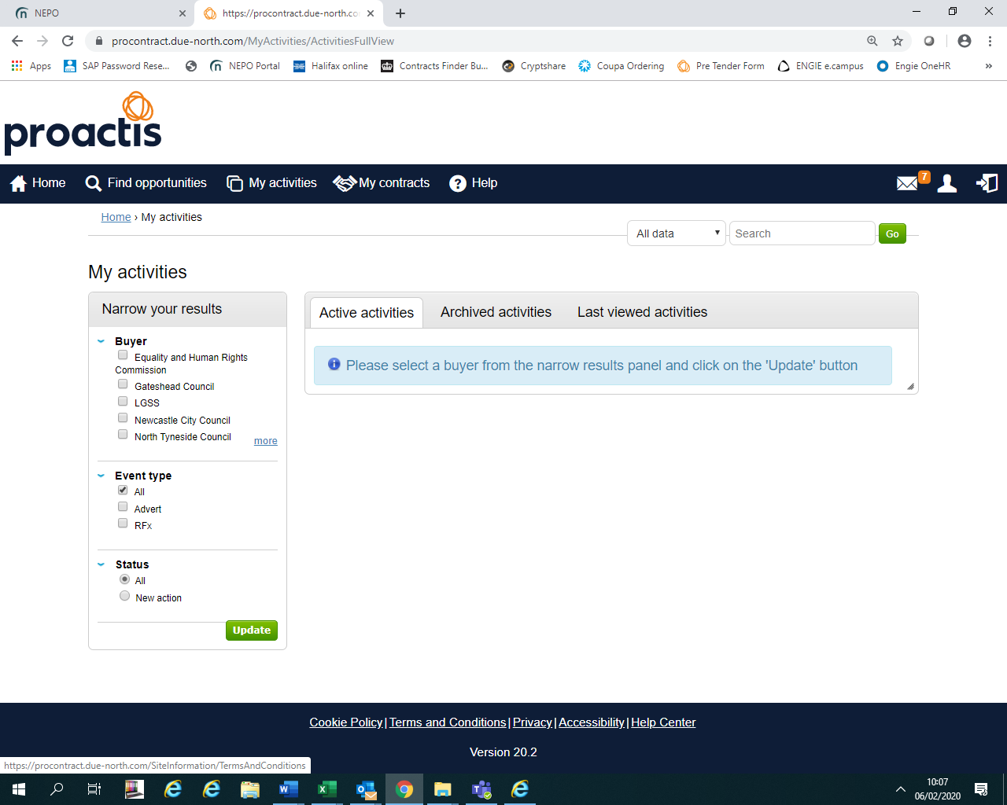
a

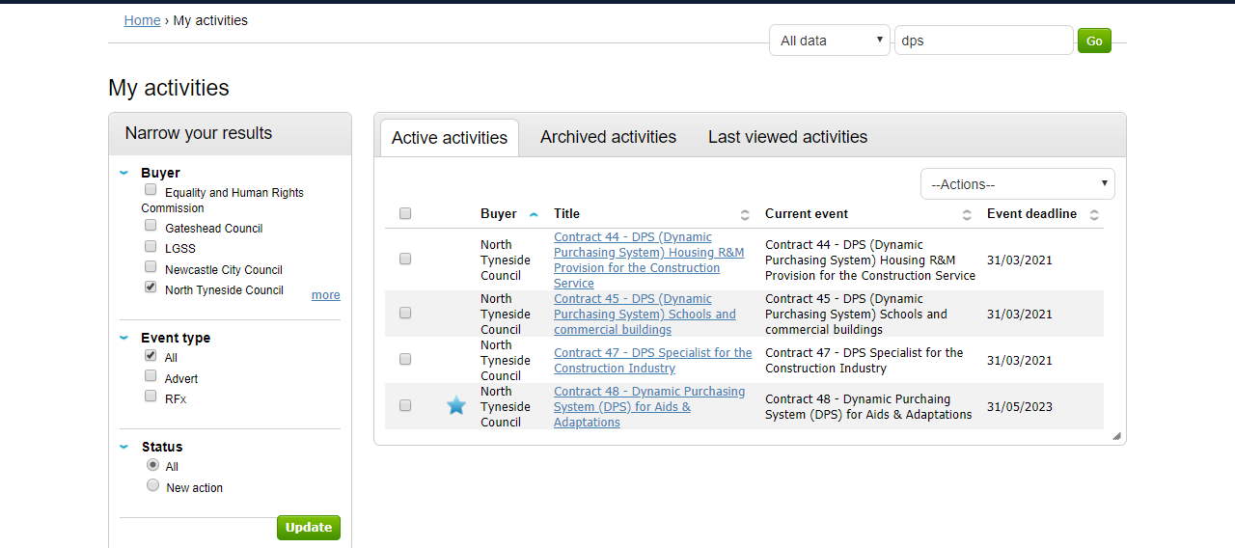
b
- Once you have selected the link to the opportunity, the following screen should open, select ‘open’.

- The opportunity should open in the next screen, showing the date for the deadline of submissions with a deadline clock, all the documents for fully completing and returning via the Portal are listed at the bottom of the screen.
NOTE – FOR DPS Frameworks:-
The sooner you apply the sooner you could be accepted and receive requests for services/works required.
Rounds are closed when the Authority receives an application, another Round opens automatically, you DO NO NEED TO RE-APPLY in another Round unless we specifically ask you to do so due to an issue with your application.

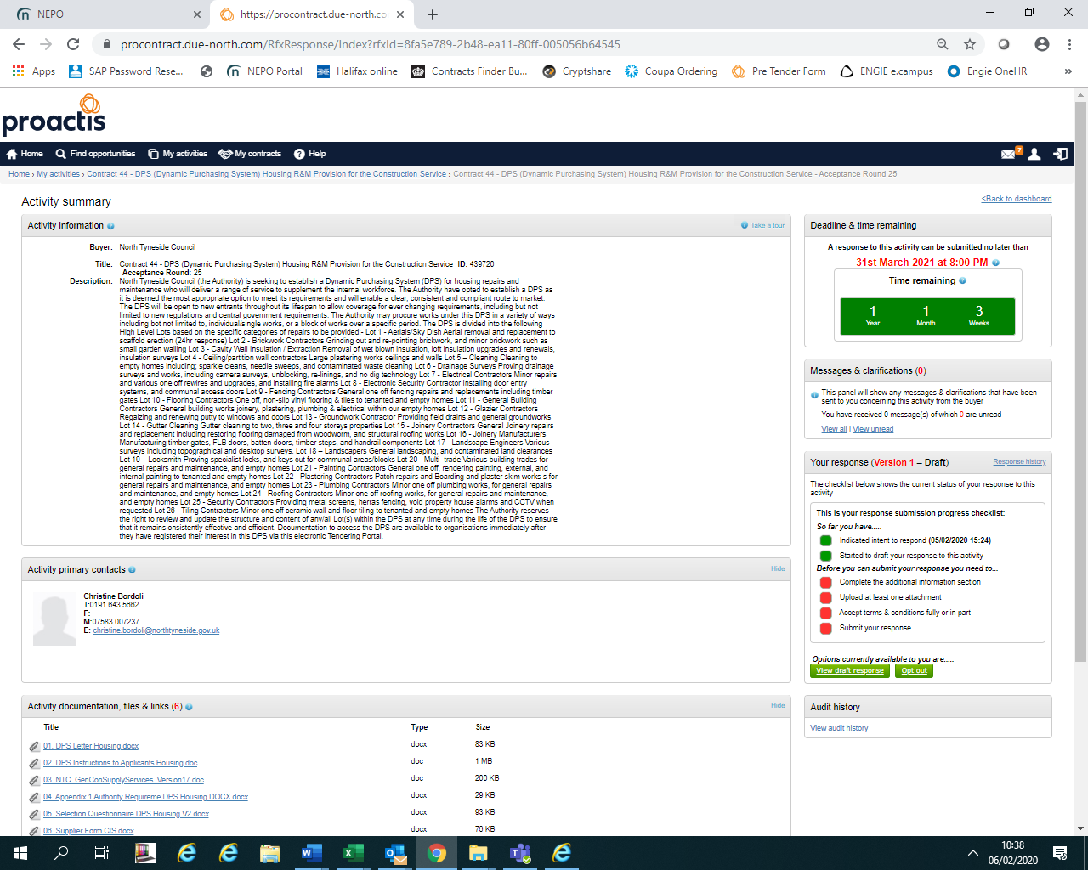

Continued for all opportunites and asking questions further below

ALL OPPORTUNITIES :-

Ensure you read ALL the documentation including the Instructions.
Ensure you upload ALL the required documents FULLY COMPLETED including any supporting documents, BEFORE THE DEADLINE to avoid missing out.

QUERIES – There is a section of the Portal which must be used If you have any queries in relation to the opportunity documents, the Specification or requirements of any opportunity, not the operation of the NEPO Portal (see further below). You can ask further information by using the messaging/clarification section which is similar to sending an email, however, there is an audit trail of all requests and responses and where necessary responses will be made public for all interested bidders to see.
A screen shot identifying where you can locate this section is below:-

MESSAGING/CLARIFICATION SECTION
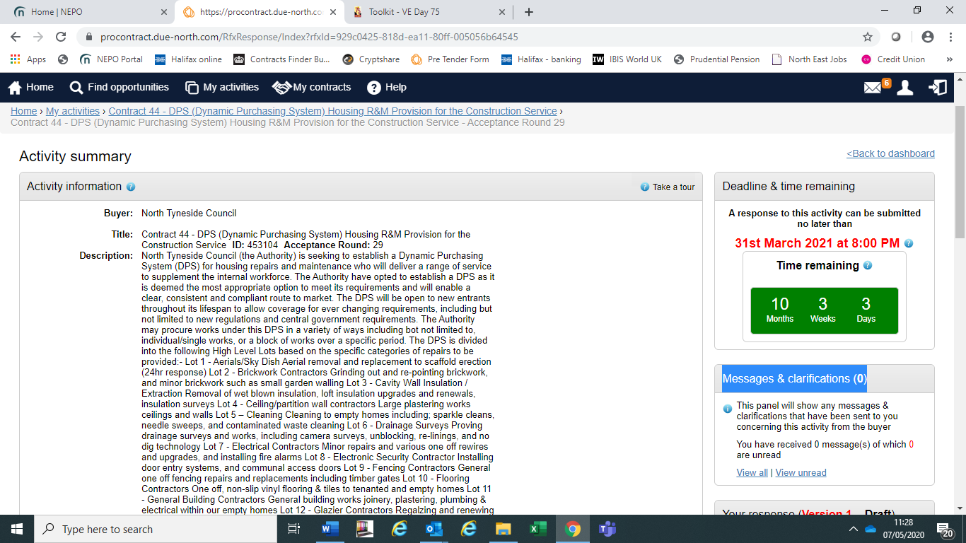

EXAMPLE ONLY

FURTHER ASSITANCE ON USING THE NEPO PORTAL SYSTEM OR ISSUES WITH THE NEPO PORTAL (Portal).
The Authority is not the operator of the NEPO Portal System, we are a user similar to your organisation and therefore we are limited to advice we can offer.
If you need assistance in relation to the Portal System, please use the HELP section, there is also contact details for the administrators of the Portal within this HELP section at the top of the screen.

