How to complete your response – (Example Project)
On the Activity Summary Page - Click on ‘Start my response’
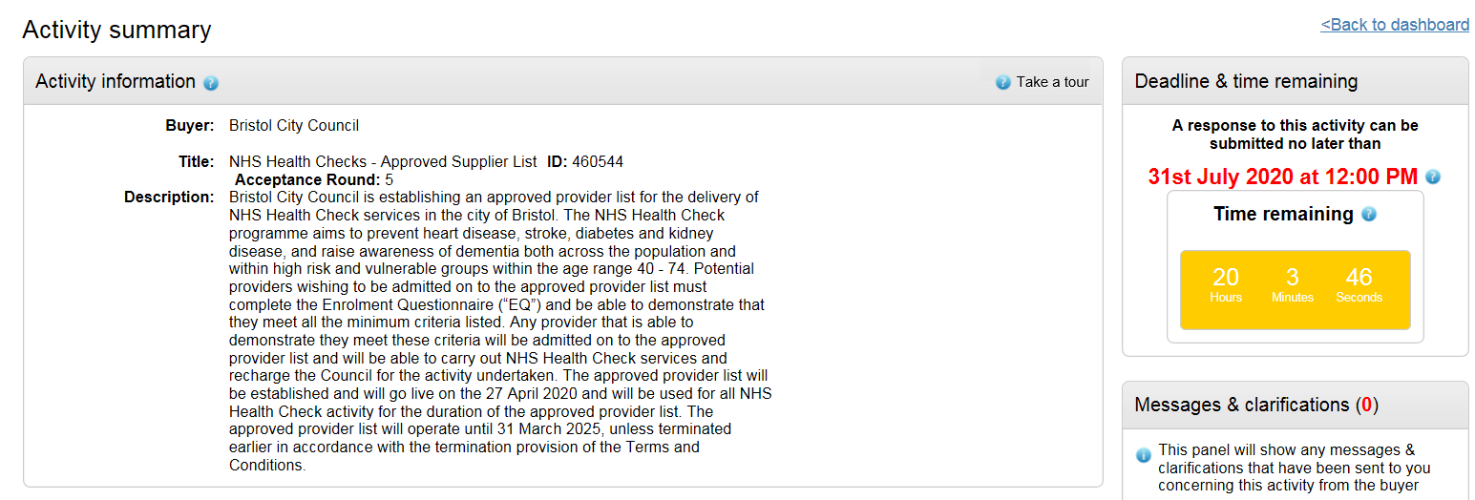
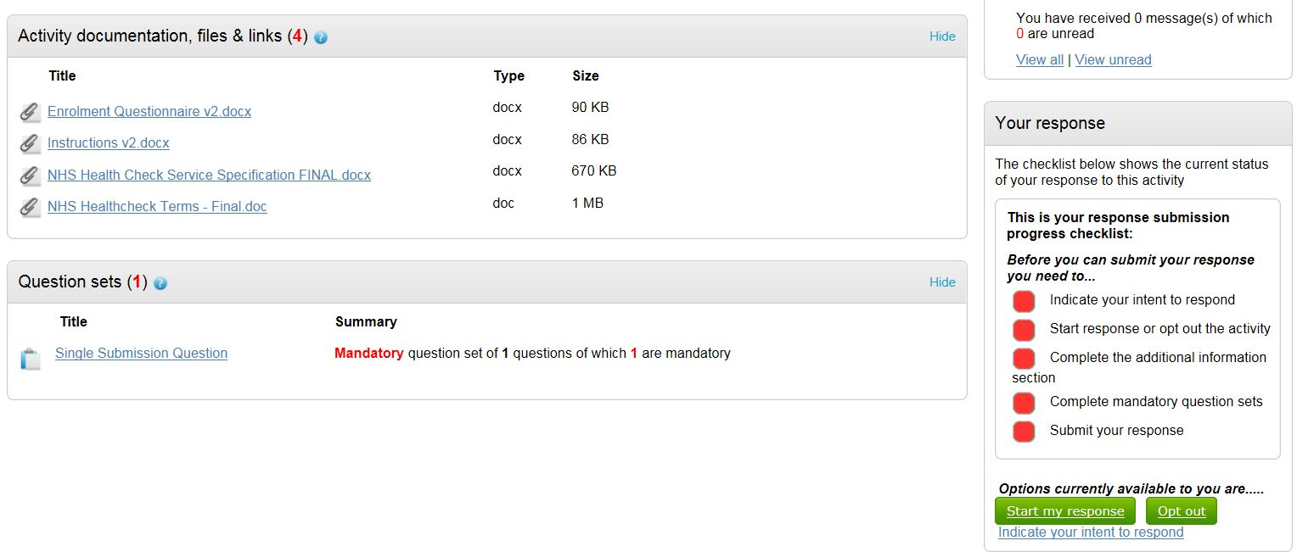
This takes you through to the page titled ‘Your response Summary’
Under Question Set, click ‘Edit’
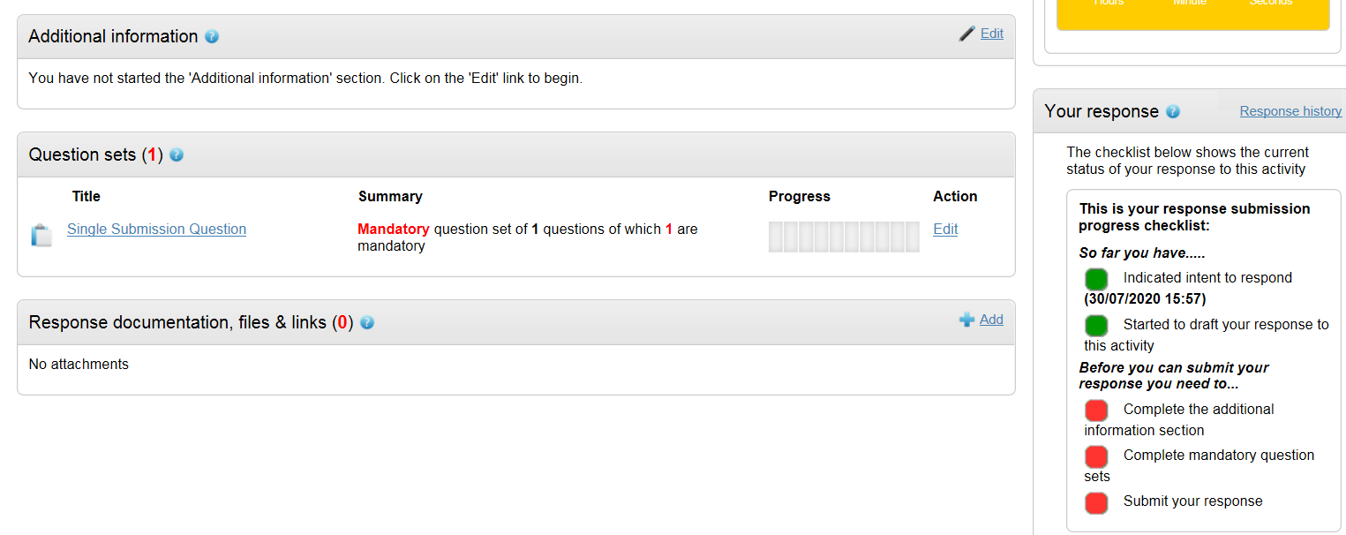

This takes you through to the page ‘View evaluation Questions’
There may be a number of sections which requires completion, click ‘Answer Question’ for each section.
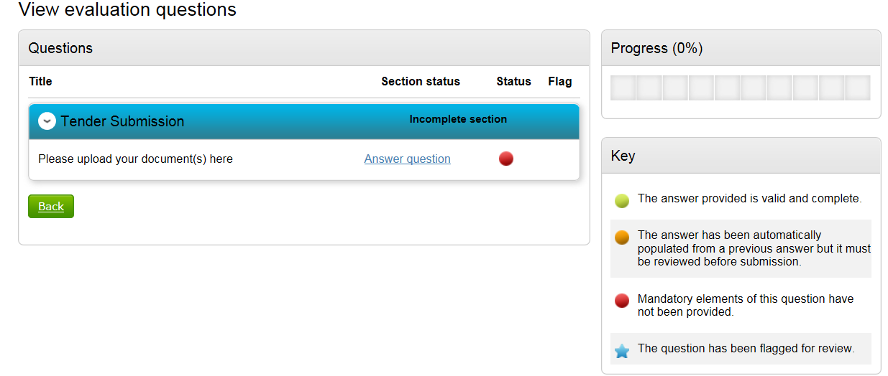
On the next page click ‘Add attachment’ and upload any supporting documents. Include any comments if required. Then click ‘save and close’.
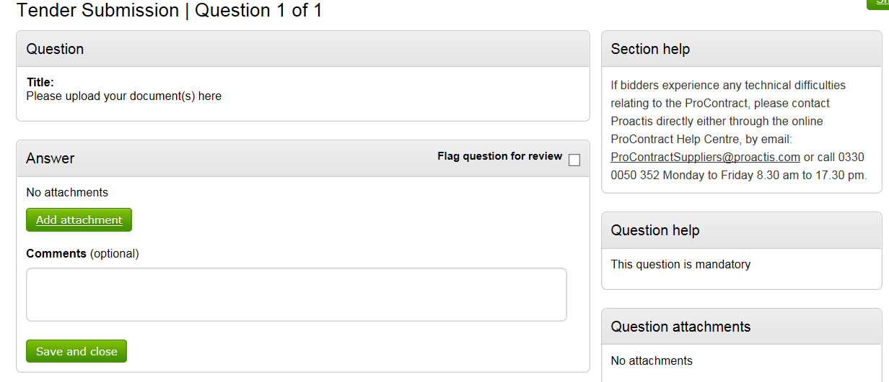
Once done, it will take you back to the ‘View evaluation questions’ page. On the right hand side the progress bar will mark how far you have progressed in completing your submission. Click the ‘back’ button.
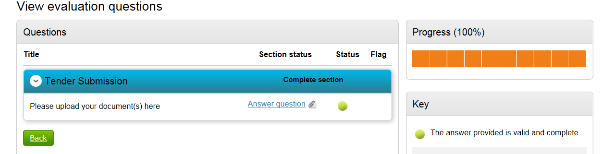

You will go back to ‘Your Response Summary’ page. On the additional information section click ‘edit’. Complete the relevant information.
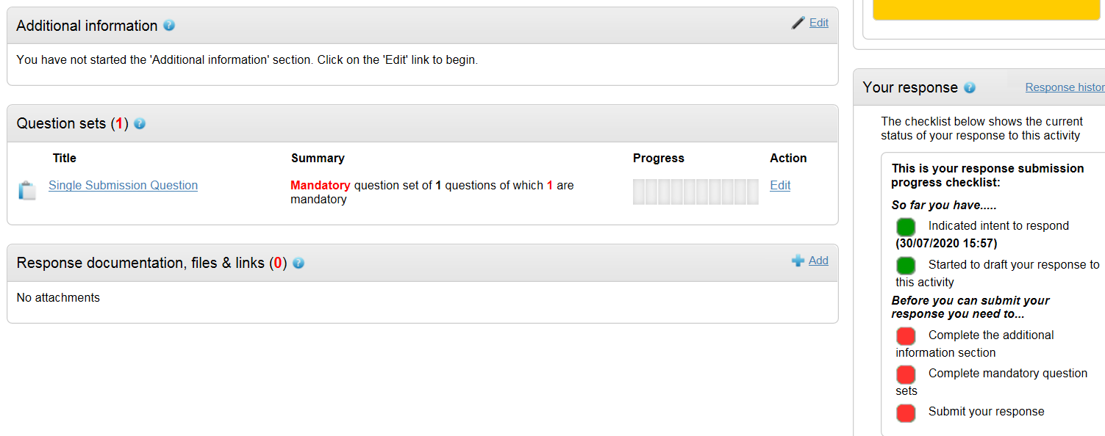
Complete the relevant information and click to say you have read and understood this section and can confirm ‘I am happy not to include any additional information’. Click ‘save’.
When all information is added you can submit the response by clicking Submit response. You will be required to reconfirm this by clicking Submit response for a second time.
