Lloyd Park Moat
Specification for Design, Supply and Install of Diffused Air System

Background
Following the drought of 2022, the water quality of the moat significantly declined:
- From 2022 onwards, there have been waterfowl deaths due to botulism.
- In 2023 there were fish deaths due to low oxygen levels.
- In 2023 there was a duckweed bloom, which has returned in 2024.
- In 2024, there is significant blanketweed again.
We have been recommended to undertake treatments (and these have gone ahead in spring 2024):
- Chalk application
- Manual duckweed removal and bacterial treatments to reduce nutrient levels.
We have also been recommended to install an aeration system.

Site Visits
- Please ensure you have undertaken a site visit, so you understand the dimensions, depth variations and local conditions associated with the moat.
- We will require a site visit with the successful supplier, prior to install.

Outcomes
- The system should be sufficient to prevent/significantly reduce the likelihood of:
  - Fish deaths due to low oxygen levels (although all the fish are unauthorised and we will not be managing the moat for fish, we still wish to manage the welfare of the fish that are present).
  - Waterfowl deaths due to avian botulism.
  - Smell from rotting bread etc.
  - Bacterial, algal, weed blooms (including duckweed and blanket weed).
- The system should also reduce the build-up of organic matter at the bottom of the moat; and prevent further build up.

System Requirements
- Will provide sufficient aeration to deliver on the above outcomes, given the depth of the moat, which in some areas is very shallow.
  - Please provide information on your diffusers, for example: are they designed for shallow water, flow rates, bubble size, what guarantees can you offer on oxygenation etc.
  - Provide the number of diffusers that you would recommend to achieve the outcomes, given the depth/volume of water.
- The system should provide upwards bubbles only, to try and prevent the disturbance & circulation of the botulism, which is likely in the anaerobic silt still.
- Minimum two pumps – one for each side of the moat, so if one fails, the other continues to function.
- To run from the existing power supply on the island if at all possible. Photos below.
- As low-cost as possible to maintain e.g. robust and long-lasting.
- Attract as little vandalism as possible e.g. minimal surface infrastructure, hidden/robust surface infrastructure.
- Replacement parts are quick, easy and as inexpensive as possible to source, over the duration of the life of the system.
- Does not get clogged with weed.
- No adverse impact on wildlife (either during install, or post-install). Wildlife includes: wildfowl, fish, terrapins, birds, foxes.
- Low noise – please provide dB levels.
- Energy efficient – please provide info.
Install Requirements
- Hook up to existing electrical supply on the island:
  - No adverse impact on supply of electrics to existing cascades.
  - No adverse impact on electrical hook ups for outdoor events.
  - Supply for aerator pumps should be on a separate switch/circuit to the cascades and outdoor event hook ups. So that each operates independently and to minimise likelihood that third party event providers will turn off the pumps in error.
- Minimal adverse impact to the island e.g. through groundworks to lay electrics or install of secure housing for pumps.
- Minimal disturbance of the silt during install, to try and prevent disturbing and circulating the botulism.
Other Requirements
- Method statement for install.
- Specification/model/brand and images of system parts.
- Images of above surface infrastructure.
- Map of install, showing location of:
  - Diffusers
  - Where tubing will be laid
  - Above-ground infrastructure
  - Where electric cabling will be laid
- Risk assessment for install.
- Warranties for parts.
- Evidence of staff qualifications (as applicable).
- Estimated time to start of install, following provision of a PO.
- Estimated build time on site.
- How you will rectify the site, following install e.g. damage to grass.
- Information on whether you will need any of the island to be closed off during works.
- Provide O&M information and basic instruction on site to the Park Manager: switches, timers, locks etc.
Track Record
- Please provide a summary of your track record for the installation of similar systems.
- Please provide a referee(s), e.g. site manager, for similar systems you have installed.
Ongoing-Maintenance
- Please indicate whether you would be able to quote to provide on-going scheduled maintenance of the system.
Electrical Supply Images
The nearest power supply is located on the western lawn of the island (location shown via red circle in map on following page).
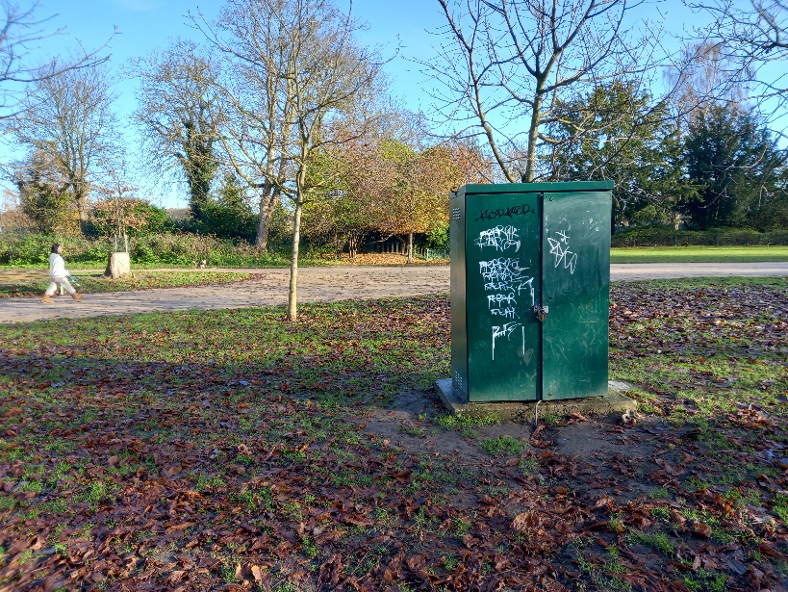
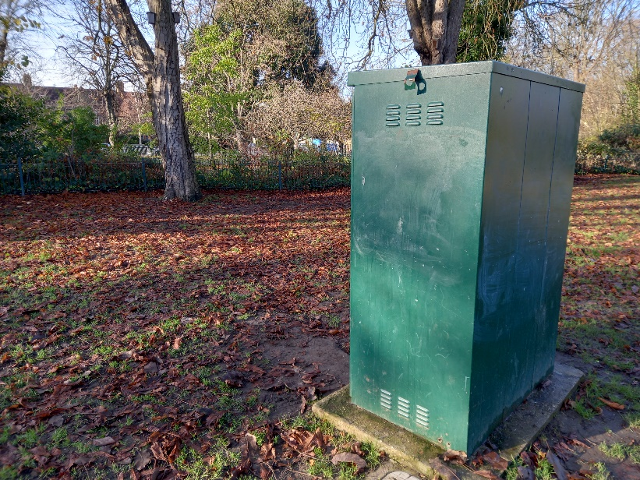
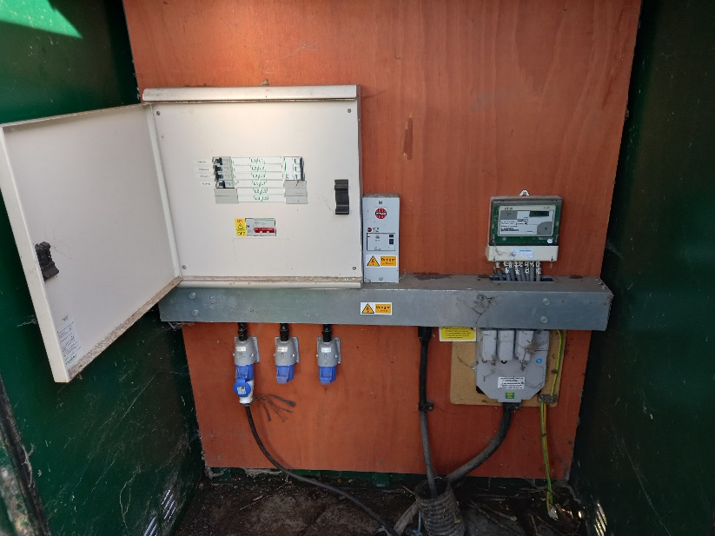
Site
Lloyd Park, Walthamstow, E17 4PP
