How to download & upload application form for Enfield Summer Uni 2021

- Go to www.londontenders.org
- Click on Suppliers Area
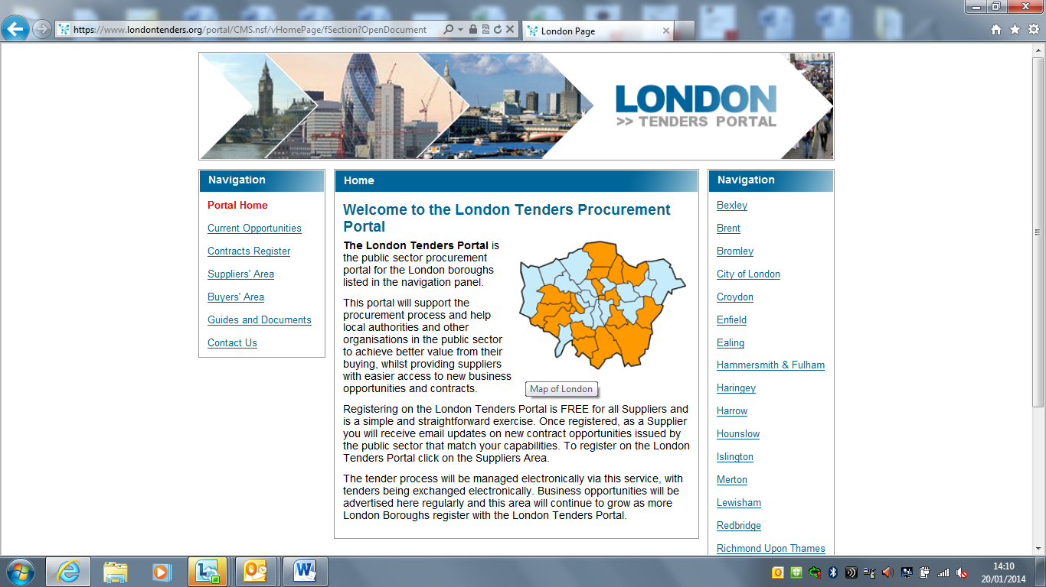
- Click on Register Free and complete the steps on the screen. Ensure you registered under the categories: Recreational, cultural and sporting services + Services provided by youth associations
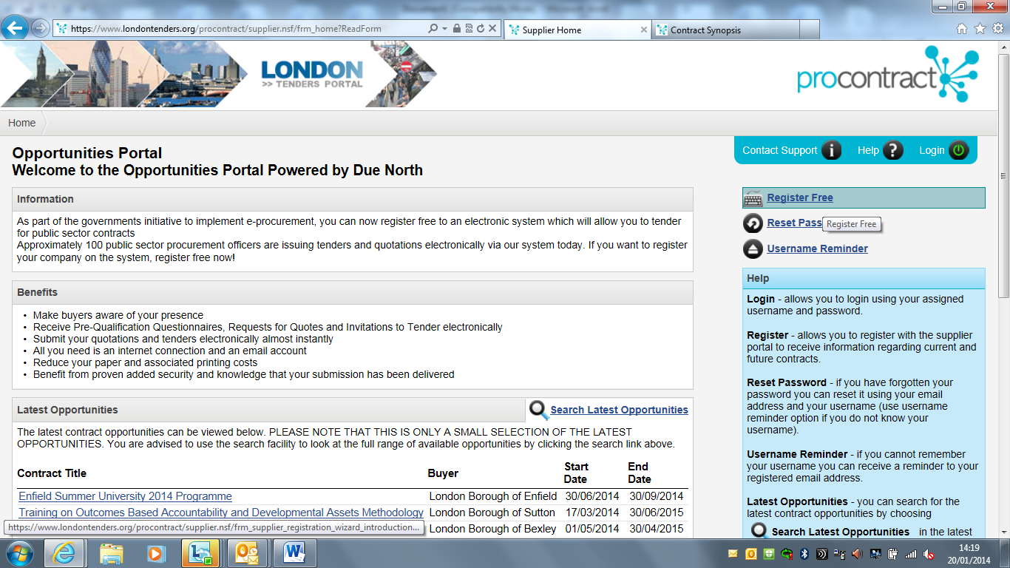

- Click onto the Enfield Summer Uni 2021opportunity
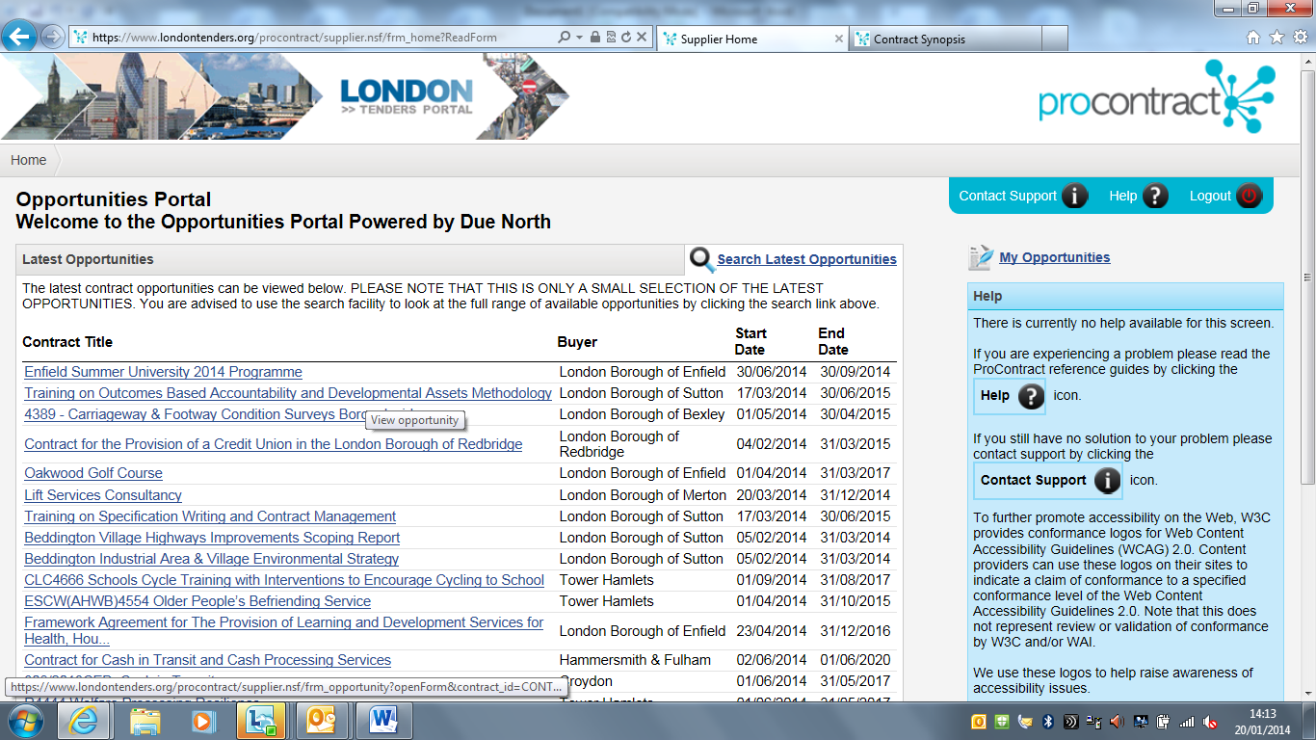
- Click Login and Register Interest at the bottom of the screen
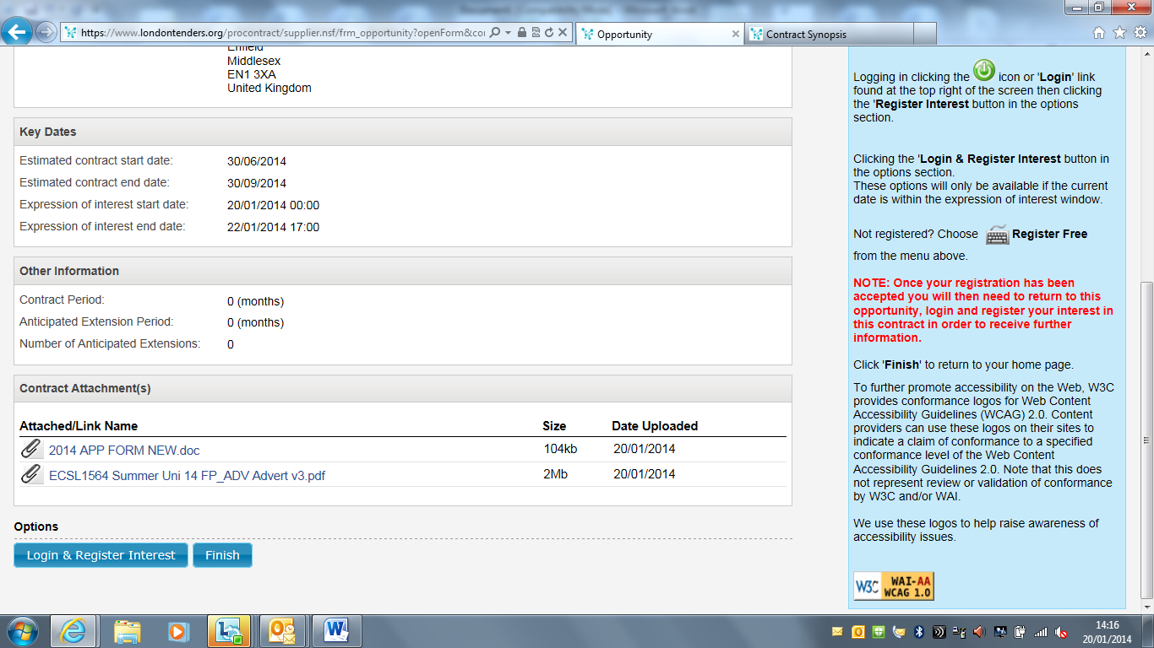
- Enter your login details
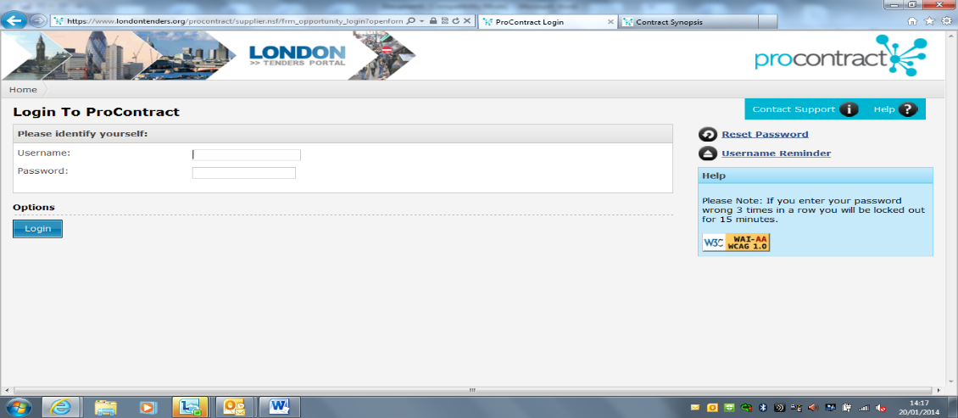
- Click Express interest
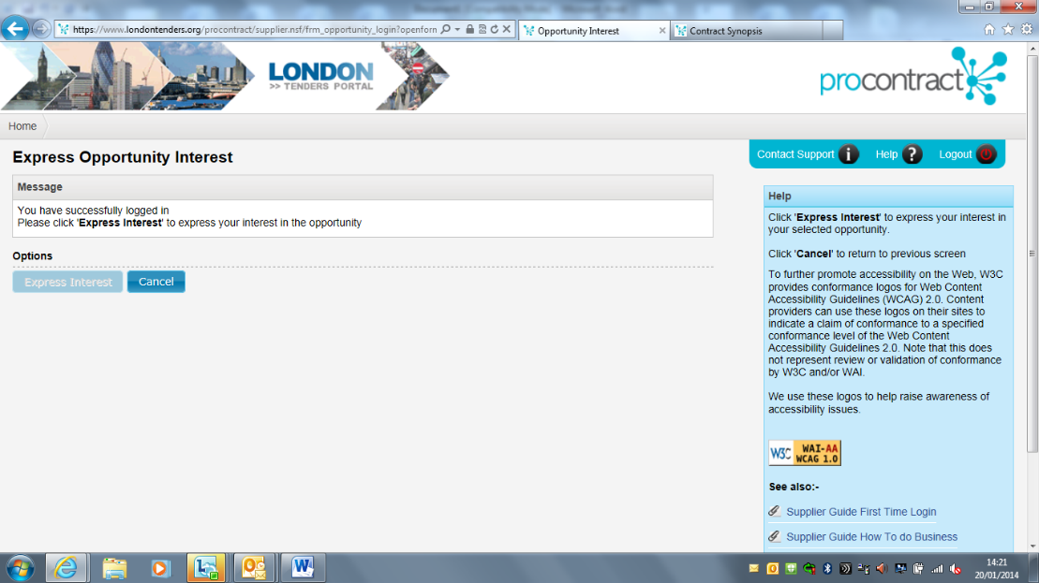
- Once you receive your confirmation email, click onto My Opportunities
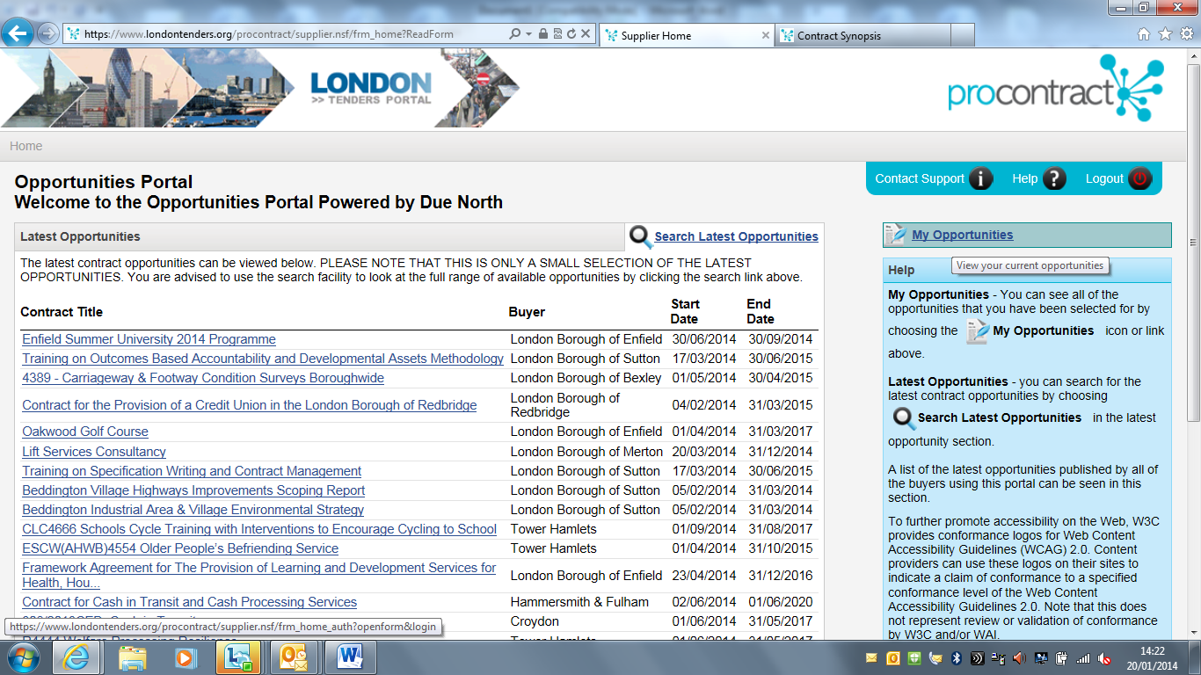
- Select London Borough of Enfield from the drop down menu and then click onto the Enfield Summer Uni link
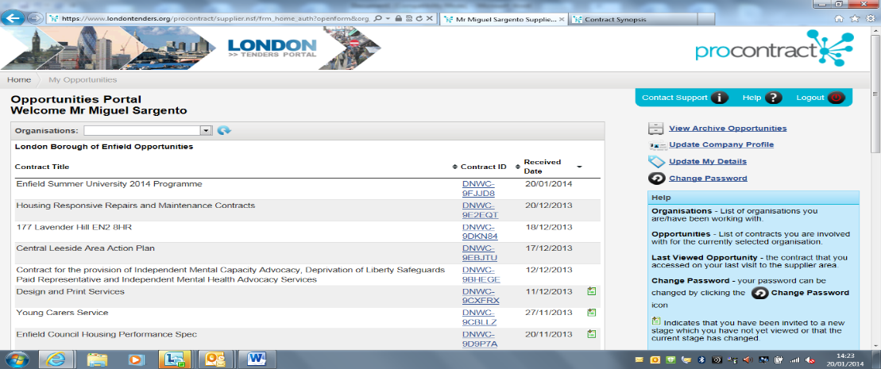
- Click View Stage detail
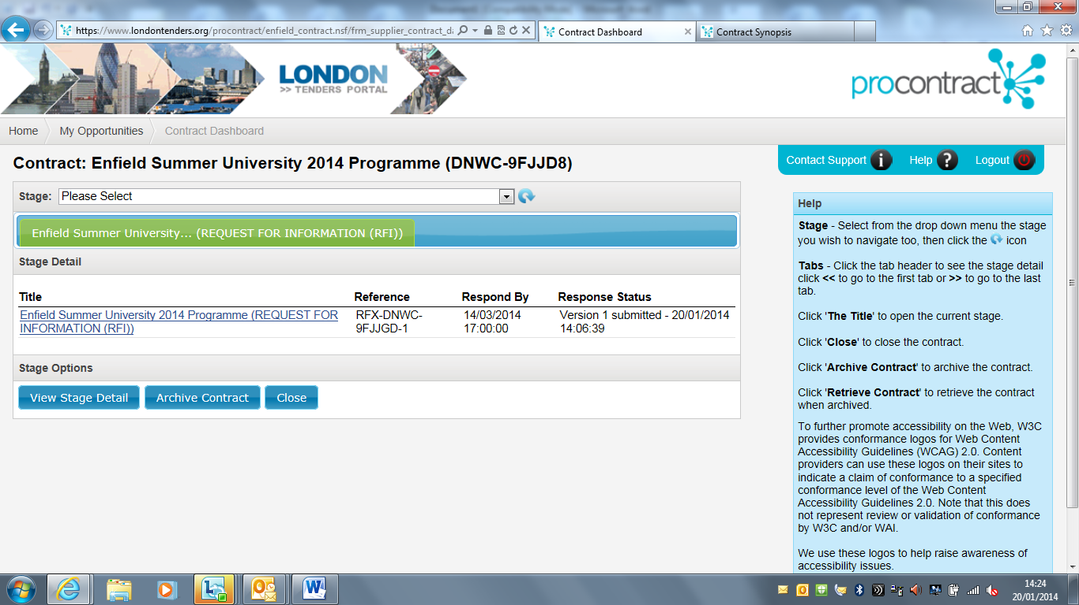
- Click view submission of application form
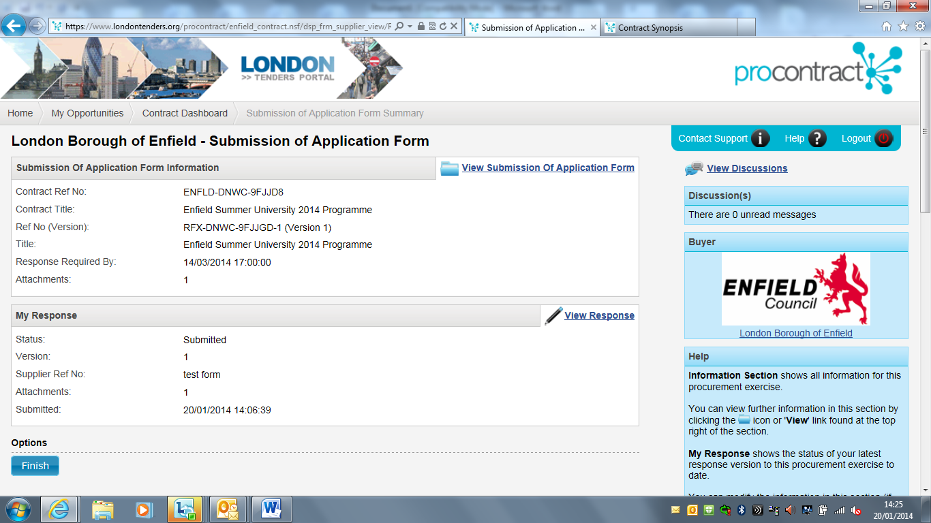
- Download and complete the Application form and click Finish
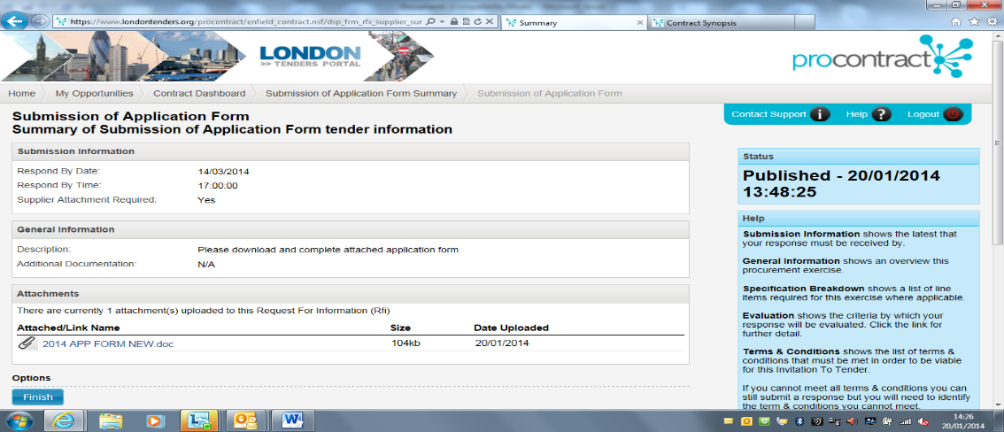
- Click Response Wizard
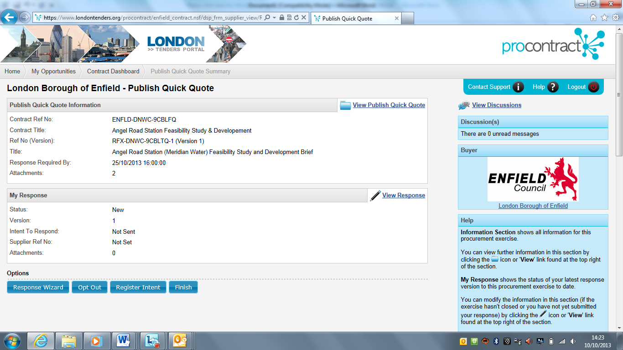
- Read intro and click next
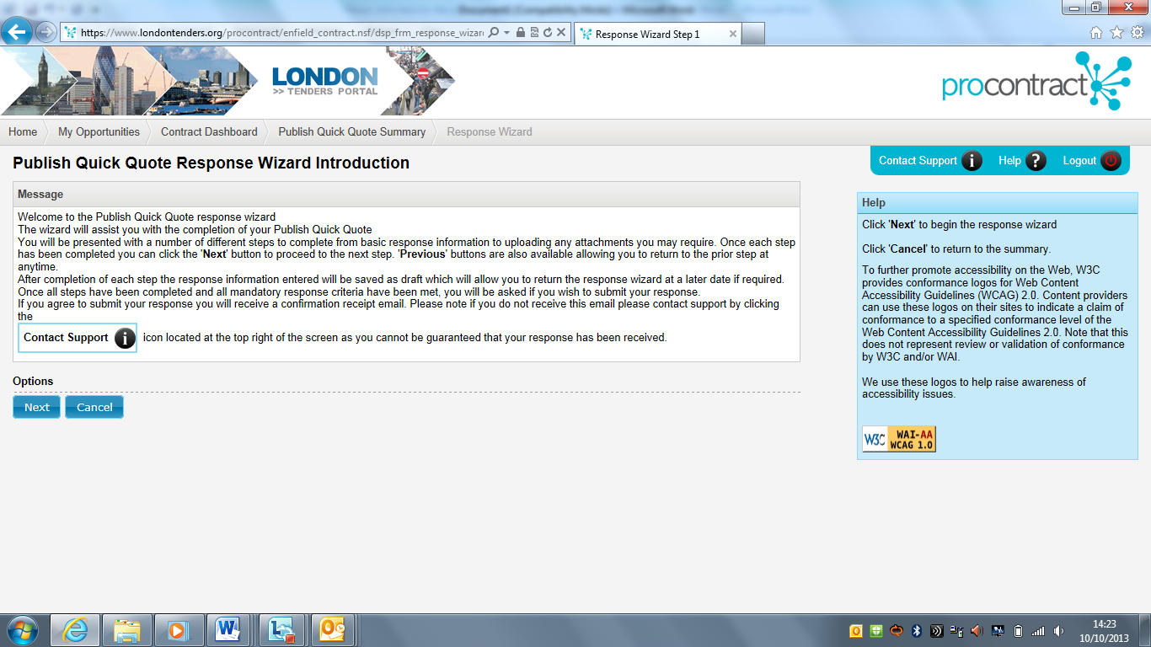
- Enter a reference number and click next
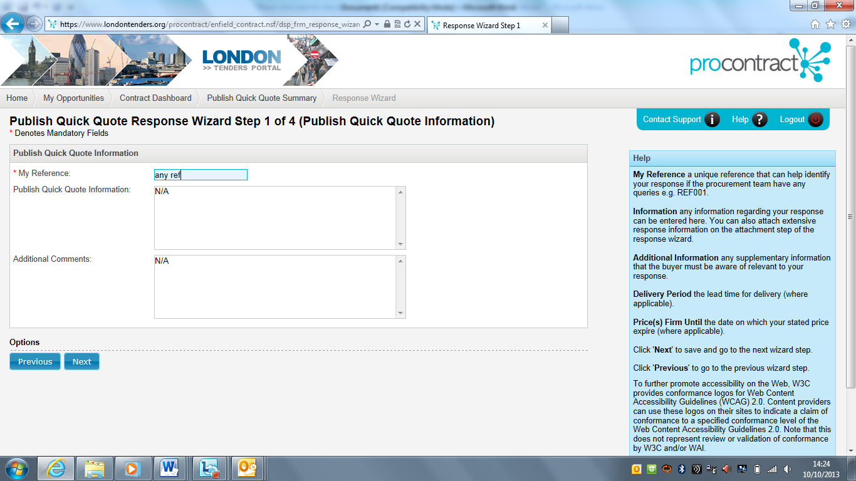
- Click onto add attachment
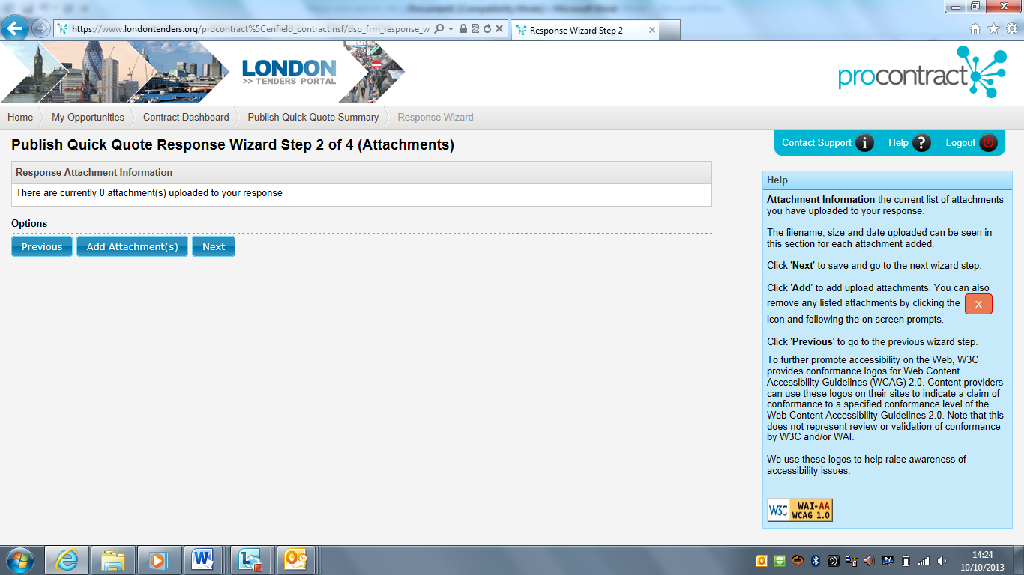
- Once you have uploaded your completed application form click next
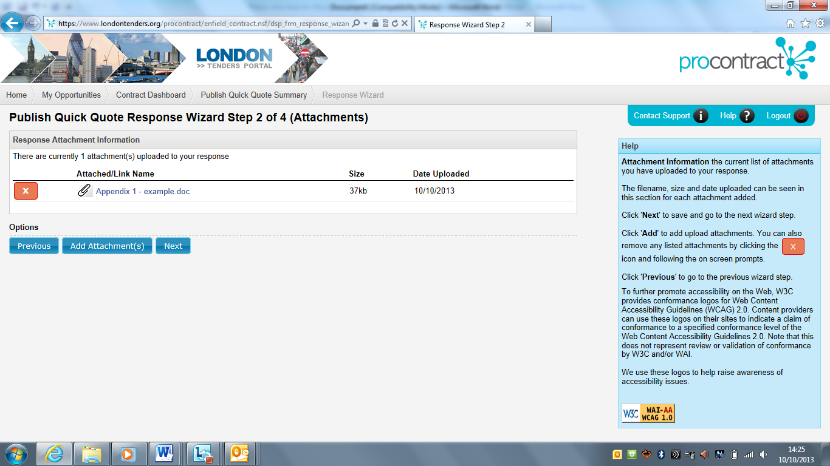
- Click submit response, you will then receive an email confirming that your form has been submitted
