LUTON COUNCIL (LBC)

REQUEST FOR EXPRESSIONS OF INTEREST
4 YEAR CONTRACT: RE BEDDING PLANTS SUPPLY, HANGING BASKET SERVICE, PLANTERS SERVICE 2022 - 2025
Luton Borough Council is seeking expressions of interest from companies that would wish to tender for the supply of seasonal bedding plants along with a range of Hanging baskets, Holestar lamp post planters, Barrier Baskets, Window Boxes and floor standing planters complete with fully functioning once a week self-watering facility.
Our scope of procurement includes:
1. Bedding plants - SUPPLY ONLY: Delivery to the Luton Parks dept at Wardown Park
2. Hanging baskets –Supply and SERVICE: pre -planted to LBC’s spec
- installed by supplier and removed in the winter
- Stored by the supplier.
- Summer and winter baskets
- Approx 75 per season per year
3. Planters and Window Boxes, Column mounted Planter
- at various locations
- Supplied and owned, Serviced and maintained by Supplier within the contract period
  - stored in the winter at the suppliers premise
  - delivered to various sites by truck with pallet truck facility
  - come pre planted with plants to LBC spec.
  - Are removed and re-supplied each season
  - And stored at the end of season.
  - Pyramids , Window box and Column mounted units
  - We do have summer and winter planter at the vale cemetery
- It is anticipated that this would be a 3 + 1 contract commencing in November 2021 to provide bedding plants and associated planters ready for Summer 2022 onwards.
- Please note each year the quantities and varieties of bedding plants and associated planters may change.
- Consideration will be given to any social value offering

We are searching for suppliers that can provide either Supply Only, or Supply and Service, however we have a preference to let the requirements as one Contract Supply and Service.
It is anticipated that the procurement work will be on the Due North E Commerce portal within the next few weeks once we have review all responses and decided upon the best procurement option.

Our Indicative consumption figures currently are:

Item | Total | Unit rate | Total Price
Begonia Non Stop Yellow 9cm Pot | 2250
Begonia on Top Sunset Shades 9cm Pot | 1280
Canna Red King Humbert 3ltr | 18
Canna variegated Tropicana (Orange Flower with Red/Orange Variegated Leaf) 3 Ltr Pot | 75
Cineraria Silver Lace (18 Cell) | 2790
Cineraria `Silver Dust` (18 Cell) | 4100
Geranium `Horizon Pink Passion Mixed` (P9) | 11,400
Verbena Santos Purple (P9) | 5300
Heliotrope Marine (18 Cell) | 4750
Marigold Marvel Orange (18 Cell) | 4950
Marigold Durango Bee (18 Cell) | 13,300
Pansy Freefall Series Mixed (18 Cell) | 1500
Salvia Seascape (18 Cell) | 1008
Salvia Victoria Blue (18 Cell) | 2790
Polyanthus Crescendo Mixed (6cm) | 17,500
Tulip Yellow (Dwarf) (Bulb) | 3750
Total |  |  | £

Item | Price
26 x Three Tier Planters (Summer) - supply & install
26 x Three Tier Planters (Summer) - maintenance
47 x Barrier Baskets (summer) - supply & install
47 x Barrier Baskets (summer) - maintenance
29 x Window Boxes (summer) - supply & install
29 x Window Boxes (summer) - maintenance
68x Hanging Baskets (summer) - supply & install
68x Hanging Baskets (summer) - maintenance
15 x Holster Planters (summer) - supply & install
15 x Holster Planters (summer) - maintenance
10 x 3 Tier Planters (winter) - supply & install
10 x 3 Tier Planters (winter) - maintenance
26 x Hanging Baskets (winter) - supply & install
26 x Hanging Baskets (winter) - maintenance
15 x Holster planters (winter) - supply & install
15 x Holster planters (winter) - maintenance
Total | £

Details of Planters are below for guidance
1 Metre Square Planter 3 Tier Black Planted
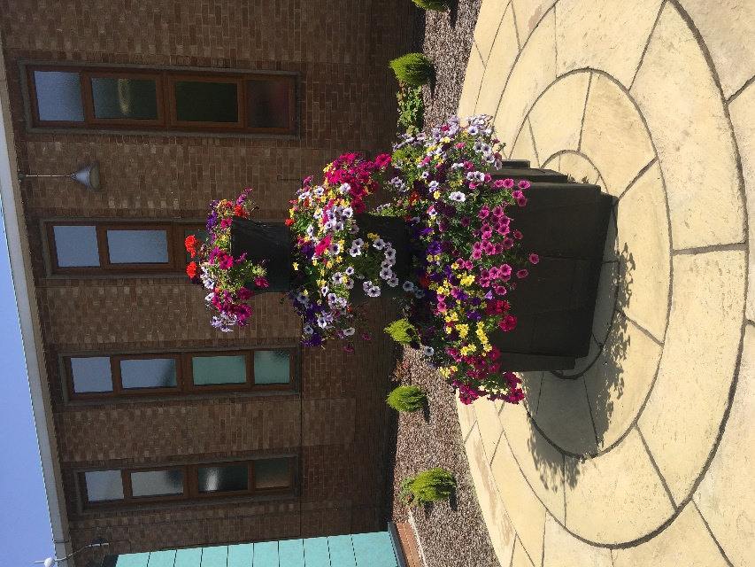

Hanging Basket 430mm Black Planted
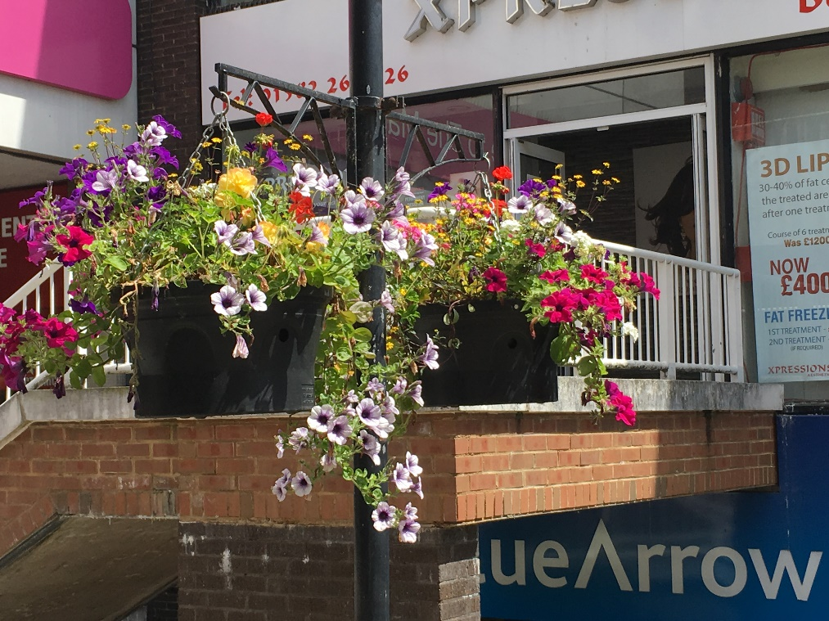

Holestar Planter 670mm Black Half planted
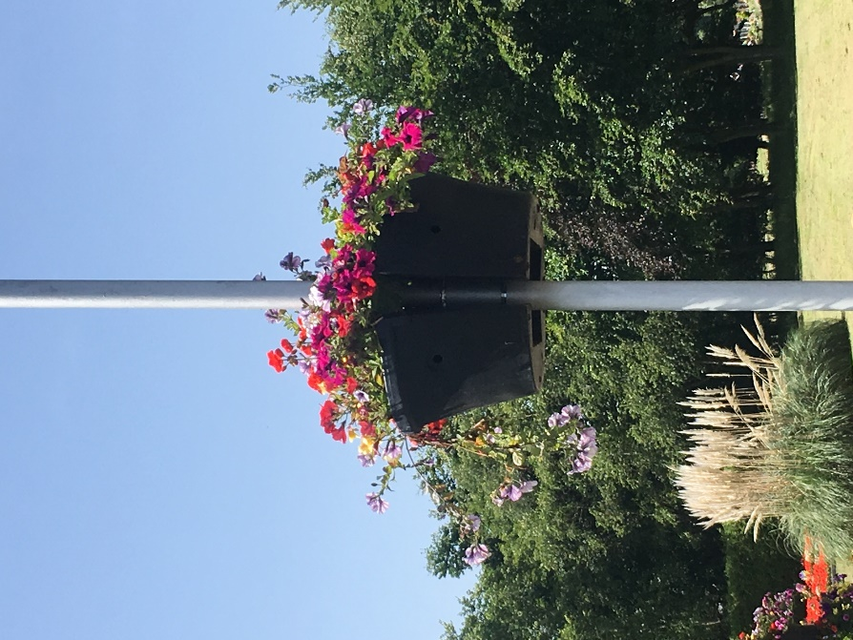

Window Box 1000mm Black Planted

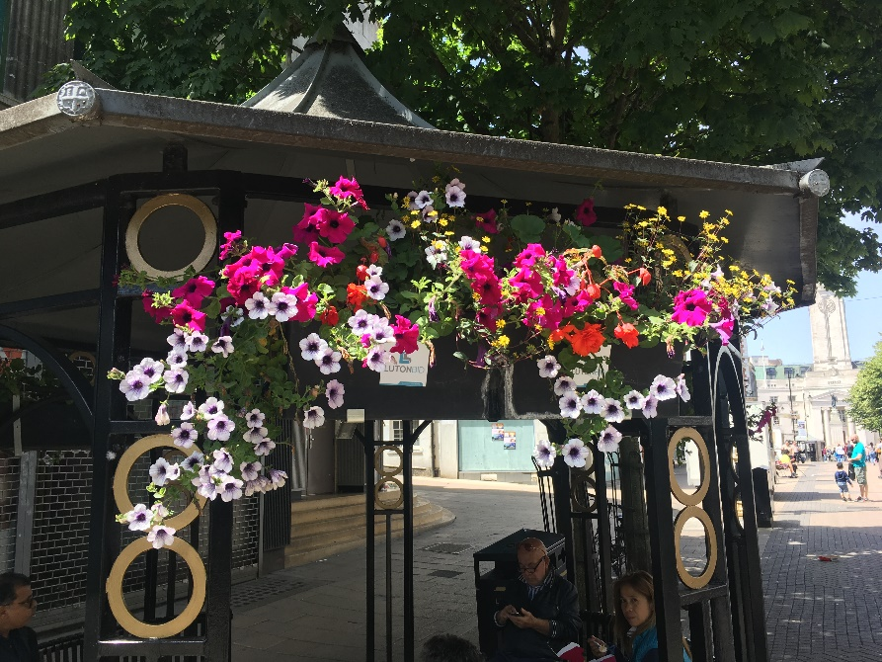

Barrier Basket 1250mm Black Contractor Planted

