Roof Survey Report/Remedial Proposals

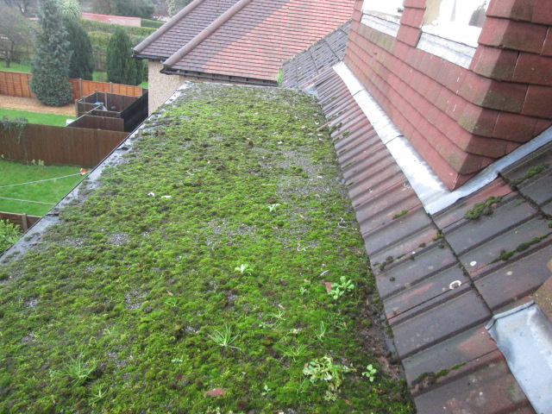

Roof Specification For:
14/15 Kenton Road – Rear Flat Roofs
(For designated areas see Roof Location Plan)

Specification Reference Number: 01-06522

Site Contract Address:
Kenton Road Care Home,
14-15 Kenton Road,
Harrow,
HA1 2BW

Date of Issue: 21/01/2016

ROOF LOCATION PLAN

Kenton Road Care Home, 14-15 Kenton Road, Harrow, HA1 2BW – Rear Flat Roofs

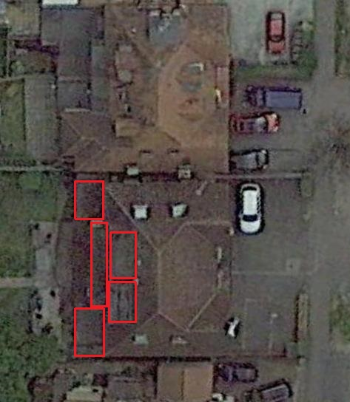
Roof 2
Roof 5
Roof 1
Roof 3
Roof 4

Key:
Red Outlines - Main Flat Roof Areas (1 – 5)

ROOF INFORMATION

Project Name: | 14-15 Kenton Road, Harrow, HA1 2BW – Rear Flat Roofs
Area (approx.) m²: | 150m² (total)
Pitch: | Not exceeding 5º
Existing Substrate/ Waterproofing Information:  Drainage:  Detail Work:  Windows/Thresholds  Plant/Equipment:  Rooflights:  Pipe Penetrations:  Survey Date: | All Roof Areas (Excluding Roof 1)  Plywood deck  3 layer BUR  Chippings  Roof 1  Plywood deck  Bitumen membrane VCL  70mm PUR insulation  3 layer BUR  Chippings  Drip edge to external gutters  Check kerbs (welted drips)/brickwork abutments (lead flashings)/pitched tiled roof abutments  N/A  N/A  N/A  N/A  07/01/16 (6ºC – poor weather conditions)
SITE VISIT

Sites visits can be arranged if required

TIMELINES

The works must be completed and invoiced by the end of March 2016

OBSERVATIONS
(To be read in conjunction with the Roof Location Plan and Photographic Record)

The existing bitumen membrane waterproofing to all the roof areas has effectively reached the end of the service life and is now breaking down at detail work, allowing water penetration.

Roofs 2 – 5 are also poorly insulated and upgrade of the thermal performance should be considered.

CONCLUSIONS/RECOMMENDATIONS

On the basis of the inspection carried out the existing waterproofing systems are failing and immediate replacement is recommended to prevent further water penetration into the building.

The IKO system or equal and approved product proposed is to prepare and overlay the existing bitumen membrane roofing with a new IKO Polimar EC/UV or equal and approved product high performance liquid coating system, including VCL and Enertherm ALU or equal and approved insulation. The insulation thickness specified for the individual roof areas will achieve an improved overall thermal performance for the roof of (U Value) of 0.18W/m²K, allowing for insulation retained within the existing build-up where applicable.

NB. The IKO system proposed uses the IKO Polimar EC/UV coating system has been specified to enable flame free application because of the pitched roof abutments. Any alternative product will need to also be a flame free application.

GUARANTEE OFFER

Tender response to the proposals contained within this document will be required to include for a 15 year guarantee covering all materials and labour when installed by an IKO or equal and approved contractor.

PHOTOGRAPHIC RECORD

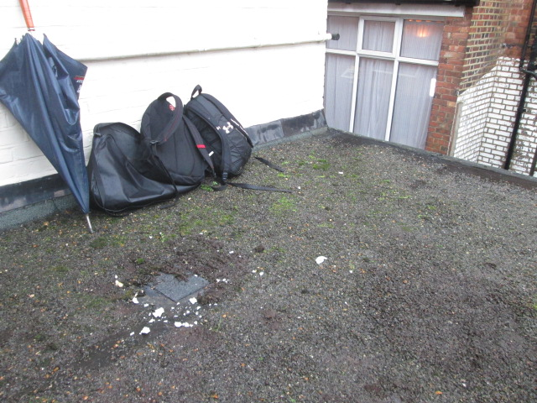 | 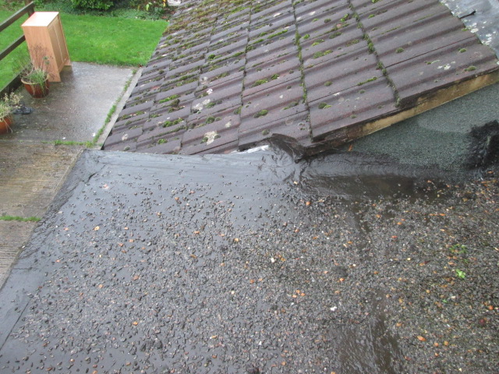
1: Roof 1 – general view showing brickwork abutment and chipping finish. | 2: Roof 1 - abutment with pitched tiled roof and liquid compound repairs having been carried out, indicating previous water penetration.

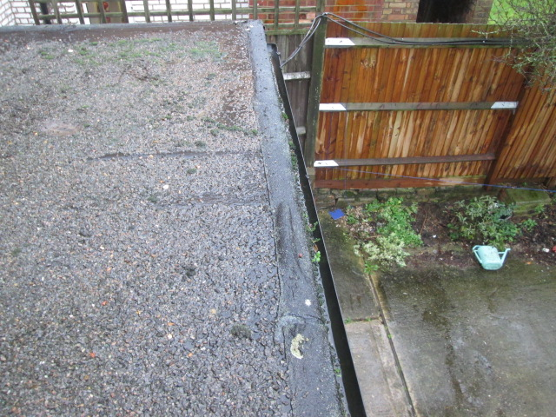 | 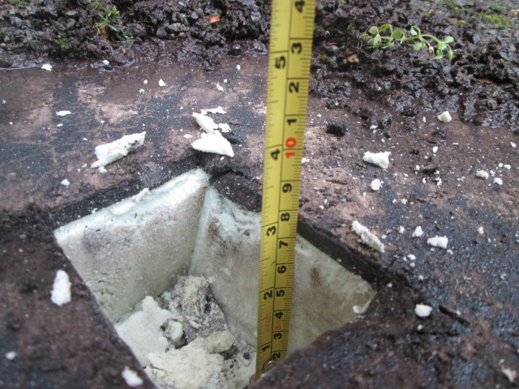
3: Roof 1 – splits and cracks in the waterproofing membrane at the drip edge. | 4: Roof 1 – core sample showing 70mm of PUR insulation in the existing build-up.

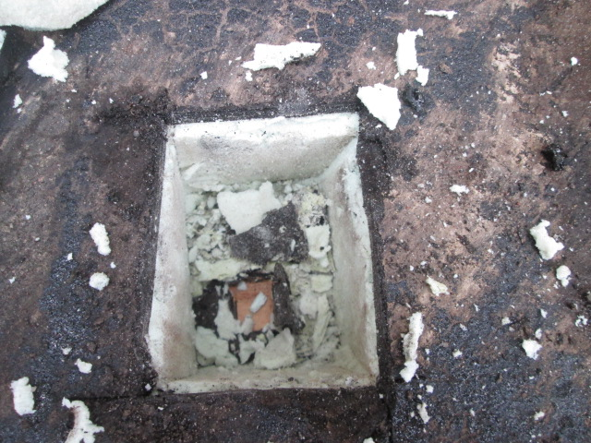 | 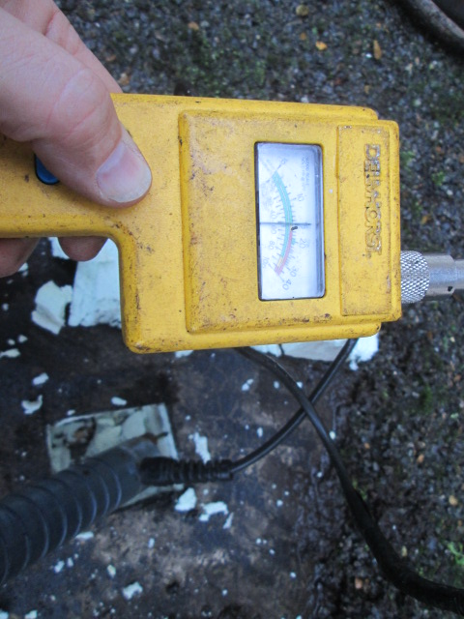
5: Roof 1 – core sample showing the plywood substrate. | 6: Roof 1 – core sample showing the PUR insulation is basically dry at this stage and suitable for overlay.

PHOTOGRAPHIC RECORD

 | 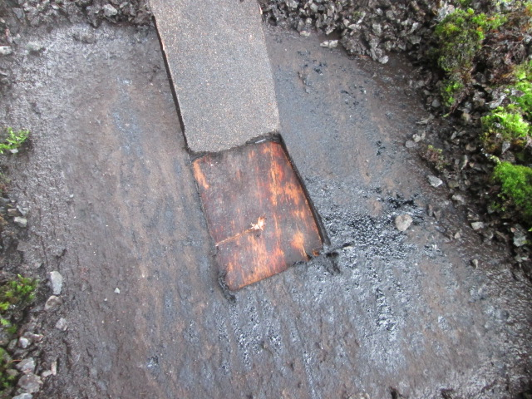
7: Roof 2 – general view, showing abutment and drip edge. | 8: Roof 2 – core sample showing the plywood substrate, with no insulation above the deck.

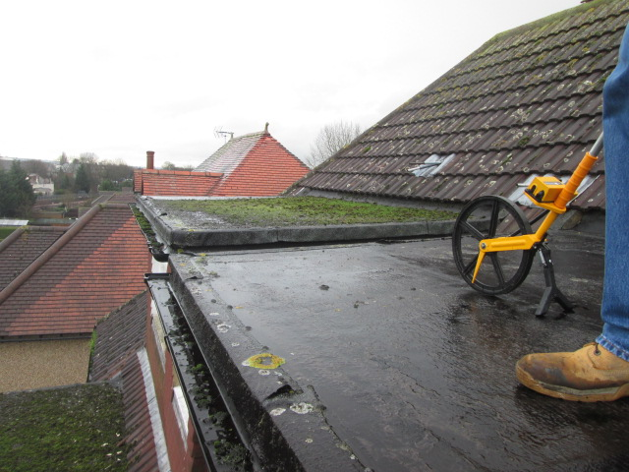 | 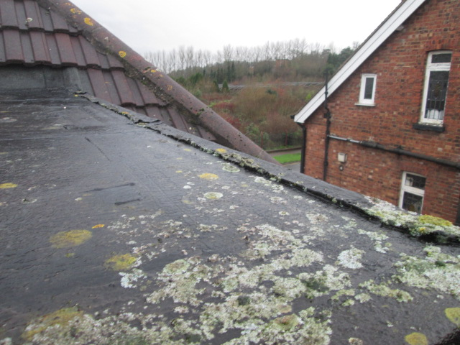
9: Roofs 3 and 4 – general view, showing abutments, drip edge and the roof generally in a poor condition. | 10: Roof 3 – drip edge detail failing.

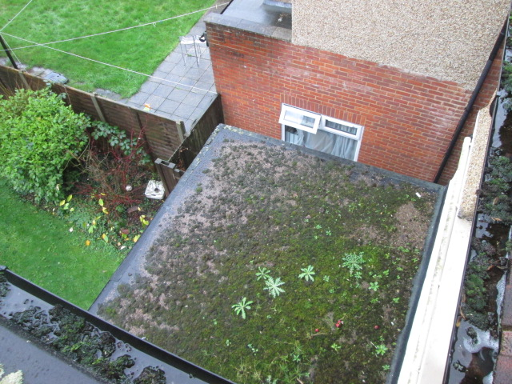 | 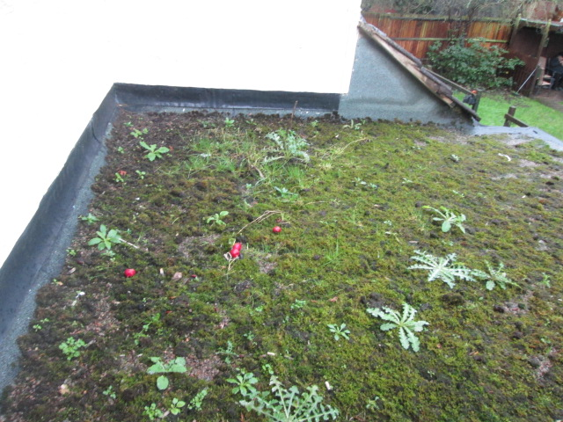
11: Roof 5 – general view. | 12: Roof 5 – showing abutments and roof in poor condition. The welted drip has completely in the corner of the roof and is allowing water penetration.

SPECIFICATION SUMMARY SHEET

14-15 Kenton Road, Harrow, HA1 2BW – Rear Flat Roofs

Enabling Works/Substrate Preparation | The works must comply with the requirements of the Health and Safety at Work Act and specific requirements as set out by the client. All risk assessments must be undertaken and recorded by the installing contractor.  Brick Abutments – Cut new chase in brickwork to allow an upstand height of at least 150mm above the new roof level, to allow for the increased thickness of insulation. Existing lead flashings to be replaced with new IKOflash lead-free flashings or equal and approved product on completion of the waterproofing.  Pitched Tiled Roof Abutments - Carefully remove tiles and valley liners from the adjoining pitched roof abutments, to allow access for waterproofing, and retain for re-use. Fix 18mm exterior grade plywood lay-board to rafters, to enable a 150mm vertical upstand height to be achieved.  Roof Preparation - Remove all surface chippings, moss, dirt and debris. Inspect and repair the existing surface, star cut and seal blisters in the existing waterproofing to receive the overlay system.  All surfaces to receive waterproofing must be clean, sound, smooth and dry.
Priming (Substrate) | Apply to prepared substrate and upstands IKOpro Systems Bonding Agent or equal and approved product (brush applied)
VCL | Install IKO Systems S-A VCL or equal and approved product (self-adhesive/hot air welded laps).
Insulation | Roof 1 - Lay 60mm IKO Enertherm ALU Insulation or equal and approved product.  Roofs 2 - 5 - Lay 120mm IKO Enertherm ALU Insulation or equal and approved product.  Insulation bonded in IKOpro PU INSULATION Adhesive or equal and approved product.  U Value 0.18W/m²K (compliant with Building Regulations Part L and allowing for insulation retained within the existing build-ups where applicable)  Contractor to install a tanalised timber batten, 100mm x 10mm less than thickness of insulation, adjacent to all gutter edges to protect the edges of the insulation and to reduce water-check. Batten to be mechanically fixed at 450mm centres to the roof substrate.  All insulation boards must be protected from moisture prior to installation by storing off the ground and covered with a tarpaulin.
Priming (Insulation) | Apply to the surface of the installed insulation IKOpro Systems Bonding Agent or equal and approved product (brush applied)
Preparation Layer | Lay IKO Polimar Preparation Layer or equal and approved product (self-adhesive/hot air welded laps)
Waterproofing System Component |  | Coverage Rate | Notes Also see notes 1 – 10
Embedment Coat: Polimar EC |  | 1.2 L/m² | Apply Polimar coatings with a brush or short pile roller.
Reinforcing Fleece: GRF Reinforcement 100/m² |  |  | Apply Reinforcing Fleece into the wet EC coat and fully saturated with the coating.
Top Coat: Polimar UV Dark Grey |  | 0.5 L/m² | Apply Top Coat only after the EC coat has cured for 24 hours minimum.

SPECIFICATION SUMMARY SHEET (CONTINUED)

14-15 Kenton Road, Harrow, HA1 2BW – Rear Flat Roofs

Notes:
1. Use Polimar Bridging Tape (MW700206) or equal and approved product at junctions between dissimilar materials.
2. Primer for brickwork and plywood at detail work to be Polimar GP Primer (coverage 0.12 L/m²) or equal and approved product
3. Primer for metal work (e.g. outlets/pipe) to be Polimar MC (2 Part) Primer (coverage 0.11 L/m²) or equal and approved product
4. System to be applied only by an Approved and Trained Installer in accordance with fixing instructions and the Technical Data/Material Safety Data Sheets provided.
5. Do not undertake in wet conditions. Suspend work in severe or continuously wet weather unless effective temporary covering is provided. Minimum working temperature must be over 5°C. Allowance should be made for additional coverage rate where the temperature is below 20°C.
6. All materials should be stored undercover and be protected from excessive changes in temperatures and humidity. Storage areas should be kept above 5°C, but application performance will be improved if the materials are stored above 10°C before use. Once opened the containers should be used within 2 -3 days.
7. Protect or mask off adjacent areas not to be treated before applying the Polimar coatings/primers.
8. All outlets and drainage pipes should be checked to ensure that they are free flowing.
9. Plant and equipment cannot be reinstalled on the roof until the waterproofing has cured for 7 days.
10. Also see detail drawings B2 / C3 / E1 / L1

Detail Work (Continued) | Pitched Tiled Roof Abutments - At the abutment with the pitched tiled roof, the waterproofing should be dressed up the lay-board provided, to give a vertical upstand height of 150mm minimum above the waterproofing and any surface finishes, and mechanically fixed at 150mm centres.
Other Works | Fascia and Gutters - Provide and install new PVC fascia and guttering at drainage points, to allow for the increased thickness of insulation, in accordance with the client specification given separately. Gutter down-pipe locations to be as directed by the Contract Administrator.  Fascia and Gutters - Re-fix tiles to adjoining roof areas previously set aside, using new fixings and all the necessary clips/cement mortar bed as directed by the manufacturer. Ensure that the existing underslating membrane is correctly re-dressed and undamaged. Any damaged tiles should be replaced with suitable/matching items and any damaged areas of underslating must be repaired or replaced, as directed by the Contract Administrator.
Guarantee | The successfully completed waterproofing system will be covered by a 15 year guarantee covering materials and labour, when installed by an Approved Installer.

GENERAL NOTES

- THE SPECIFIED OR ALTERNATIVELY AGREED AND APPROVED ROOFING SYSTEM IS ONLY TO BE LAID BY AN APPROVED ROOFING CONTRACTOR.
- Products as specified within the materials schedule or equal and approved alternatives must be used throughout and installed in accordance with manufacturers recommendations.
- Before the works commence, the roofing contractor should ensure that the surfaces to receive the new roofing system are acceptable and that the specification conforms to the requirements.
- Allowance should be made by the installing contractor for the extent of, volume and degree of difficulty in stripping and removal from site the existing waterproofing and associated build up.
- The installing contractor is to liaise with the client’s representative to establish if any hazards exist (e.g. microwave transmitters) or whether gases or noxious/flammable fumes are vented at roof level. If hazards exist, an agreed working pattern must be adopted in accordance with health and safety requirements.
- The works must comply with the requirements of the Health and Safety at Work Act and specific requirements as set out by the client. All risk assessments must be undertaken and recorded by the installing contractor.
- Any retained components from the existing structure must be sound and capable of accepting the imposed loading of the new roofing system and associated installation procedures.
- Insulation boards must be stored under cover in dry conditions, off the ground and being covered by a tarpaulin when not being used; insulation boards must not be installed if wet or damaged.
- Progress of the works is to be organised to maintain the waterproofing integrity of the roofing system and to ensure that the finished roof area(s) are adequately protected from damage by subsequent building operations. Failure to undertake this may result in additional works being necessary before any guarantee is issued.
- Where the new roofing system includes a tapered insulation or an increase in insulation thicknesses, allowance must be made for the raising of upstands, cills and DPC/cavity trays to a minimum height of 150mm above the finished roof level, as required by the code of practice. Failure to raise these details to this requirement may compromise the guarantee being offered.
- Works in severe or continuously wet weather conditions should be suspended unless an effective temporary roof is provided over the working area.
- Self-adhesive membranes should be stored above 5°C for 24 hours prior to use. It is not recommended that self-adhesive membranes be stored on the roof overnight or during hot weather conditions.
- Do not undertake the works in poor weather conditions. (Where the wind speeds are in excess of 7m/s or temperatures are below 5°C). Suspend work in severe or continuously poor weather unless an effective temporary roof is provided.
- Day-work joints in warm roof decks should be protected with a lapped and fully bonded strip of underlay felt.
- No petroleum based solvents or other chemicals harmful to bitumen should be allowed to come into contact with the roofing system.
- Protect outlets and apertures from ingress of debris and remove protection to outlets during non-operating periods. All rainwater outlets and drainage should be checked upon completion of the works to ensure that they are free flowing.
- NB. This specification makes no allowance for changes to the existing drainage. Existing falls will remain and some ponding of water may still occur in places.

