LUTON COUNCIL (LBC)

REQUEST FOR EXPRESSIONS OF INTEREST
4 YEAR CONTRACT: RE BEDDING PLANTS SUPPLY, HANGING BASKET SERVICE, PLANTERS SERVICE 2020 - 2023
Luton Borough Council is seeking expressions of interest from companies that would wish to tender for the supply of seasonal bedding plants along with a range of Hanging baskets, Holestar lamp post planters, Barrier Baskets, Window Boxes and floor standing planters complete with fully functioning once a week self-watering facility.
Our scope of procurement includes :
1. Bedding plants - SUPPLY ONLY: Delivery to the Luton Parks dept at Wardown Park
2. Hanging baskets - SERVICE : (Originally supplied by LBC) Suppliers provide pre -planted to LBC’s spec
- installed by us and removed in the winter
- Stored by the supplier.
- Summer and winter baskets
- Delivered to Wardown park
- Approx 30 per season per year
3. Planters and Window Boxes, Column mounted Planter – SERVICE:
- at various locations
- Supplied and owned , Serviced by Supplier within the contract period
- Maintained by the supplier
  - stored in the winter at the suppliers premise
  - delivered to various sites by truck with pallet truck facility
  - come pre planted with plants to LBC spec.
  - Are removed and re-supplied each season
  - And stored at the end of season.
  - Pyramids , Window box and Column mounted units
  - We do have summer and winter planter at the vale cemetery
  - Total number of each
- It is anticipated that this would be a 2 + 1 + 1 contract commencing in 2020
- Consideration will be given to any social value offering

We are searching for suppliers that can either provide either Supply Only, or Supply and Service, however we have a preference to let the requirements as one Contract Supply and Service. So please state which you can or cannot supply and we will consider all options to ensure the best value outcome for the Council and its residents
It is anticipated that the procurement work will be on the Due North e commerce portal within the next few weeks once we have review all responses and decided upon the best procurement option
The Council , Service dept, would consider entry to any existing arrangement or collaboration with other local authorities; an existing Contract or Framework within scope, terms and conditions , which permit our use providing there is benefit to do so. Or any other innovative solutions that will present best value and reduce costs to the Council.
Our Indicative consumption figures:
- Plants, Equipment and Sundries
Plants , materials and equipment | 2016 | 2017 | 2018 | 2019 | Total
Amberol Units | 207 | 50 |  | 10617 | 10874
Begonia Non Stop Yellow 9cm Pot | 70 |  |  |  | 70
Begonia on Top Sunset Shades 9cm Pot | 1280 |  |  |  | 1280
Canna Red King Humbert 3ltr |  | 918 |  |  | 918
Canna variegated Tropicana (Orange Flower with Red/Orange Variegated Leaf) 3 Ltr Pot | 918 |  |  |  | 918
Cineraria Silver Lace (18 Cell) |  | 50 |  |  | 50
Collection of Window Boxes | 1778 |  |  |  | 1778
Geranium Horizon Mixed 10.5cm |  |  |  |  | 0
Geranium Horizon Neon Rose (10.5cm) |  | 100 |  |  | 100
Geranium Horizon Scarlet 10.5cm pot | 1760 | 63 |  | 1238 | 3061
Hanging Basket Carabiners | 923 |  |  |  | 923
Hanging Baskets plants |  |  |  |  | N / A
Heliotrope Marine (18 Cell) |  |  |  | 300 | 300
Marigold Durango Bee (18 Cell) |  |  |  | 0 | 0
Marigold Marvel Orange (18 Cell) |  |  |  | 1100 | 1100
Pansy Freefall Series Mixed | 2216 |  |  |  | 2216
Polyanthus Crescendo Mixed | 1334 | 5888 | 140 | 0 | 7363
Red Field Poppy |  |  | 147 |  | 147
Salvia Seascape (18 Cell) |  | 242 |  |  | 242
Salvia Victoria Blue (18 Cell) |  | 614 |  |  | 614
Summer Hanging Baskets Colour Pallet Predominantly Red, Yellow, Orange with a touch of white. | 50 |  |  |  | 50
Tulip Red Apeldoorn Bulb | 263 |  |  |  | 263
Tulip White Prince Bulb |  | 670 | 288 |  | 958
Tulip Yellow (Dwarf) (Bulb) |  |  |  | 2835 | 2835
Window Box plants |  |  |  |  | N/A

- Our indicative consumption in provision of Service of Planters, baskets and window boxes etc
LBC ‘s Three main areas of use include The Bid, The Vale Crematorium and a External Contract (HTC)
The Bid – Summer only work, Vale – Summer and Winter, HTC – Summer & Winter

Item | Area | Qty Summer | Qty Winter | Total X 4 Years
17’’ hanging basket | Bid | 51 | 0 | 204
 | Vale | 12 | 12 | 96
 | HTC | 10 | 10 | 80
Barrier Basket | Bid | 15 | 0 | 60
 | Vale | 0 | 0 | 0
 | HTC | 0 | 0 | 0
Octagonal 3 tier | Bid | 16 | 0 | 64
 | Vale | 0 | 0 | 0
 | HTC | 0 | 0 | 0
1.25M Window basket | Bid | 29 | 0 | 116
 | Vale | 0 | 0 | 0
 | HTC | 7 | 7 | 56
1m square planter 3 tier black painted | Bid | 0 | 0 | 0
 | Vale | 10 | 10 | 80
 | HTC | 10 | 10 | 80
Holestar planter 670mm black half contract | Bid | 0 | 0 | 0
 | Vale | 15 | 15 | 120
 | HTC | 0 | 0 | 0
TOTAL |  | 175 | 64 | 956

Details of Planters are below for guidance
1 Metre Square Planter 3 Tier Black Planted
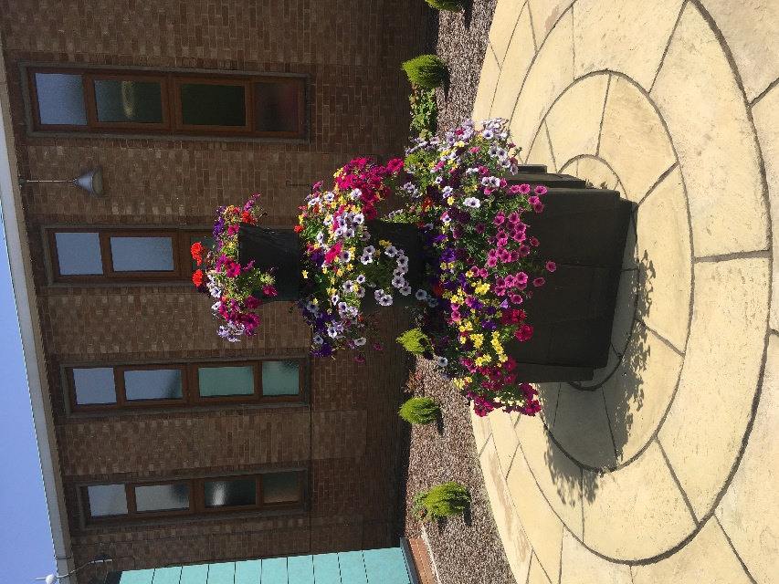

Hanging Basket 430mm Black Planted
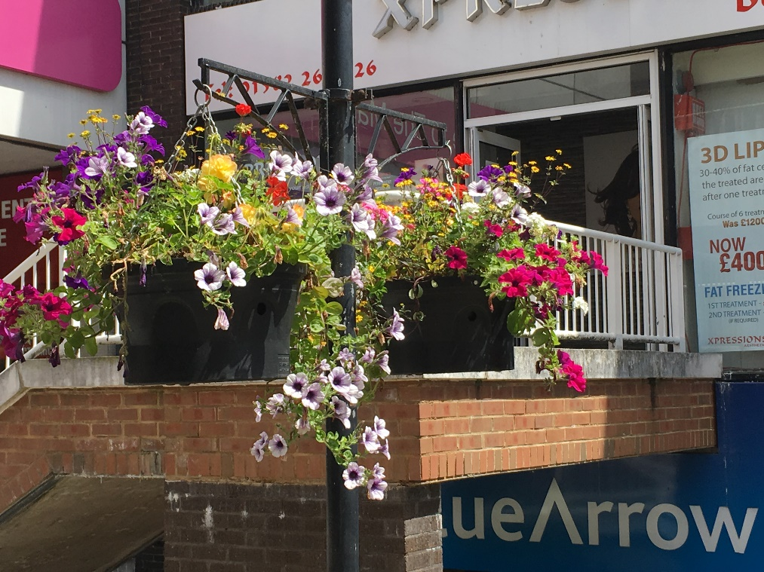
Holestar Planter 670mm Black Half planted
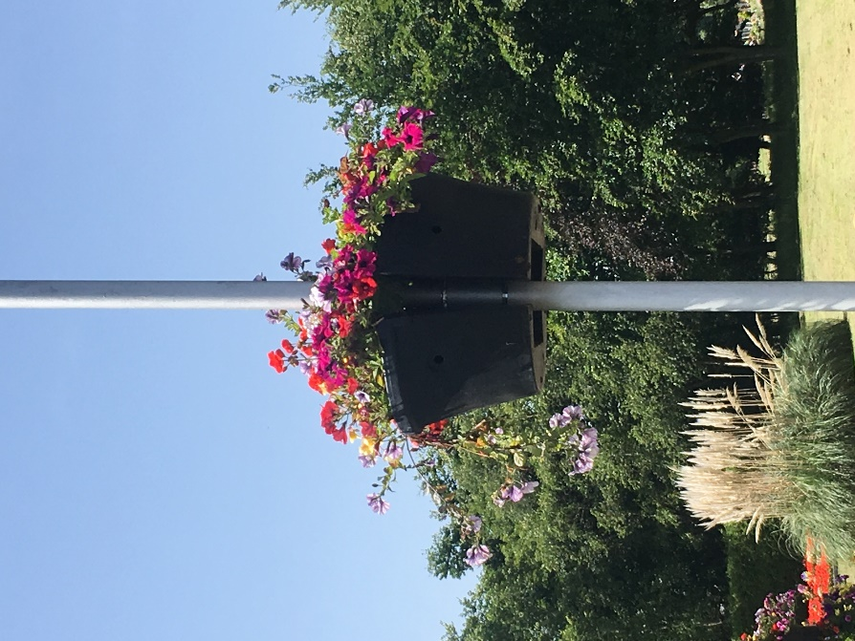

Window Box 1000mm Black Planted

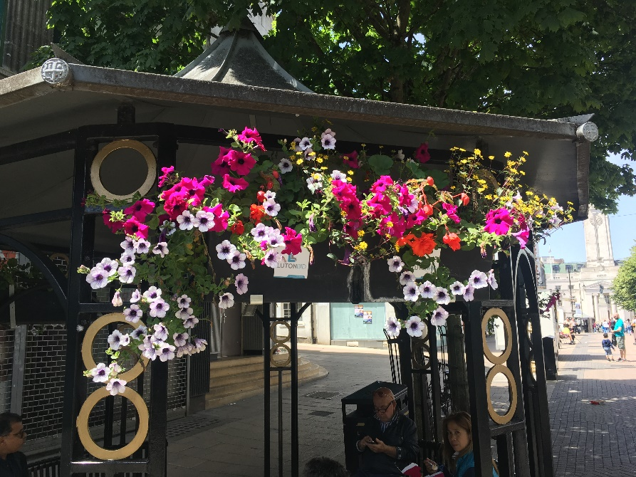

Barrier Basket 1250mm Black Contractor Planted

