Gosport Borough Local Plan 2036

INVITATION TO QUOTE

Retail and Town Centre Uses, Leisure and Tourism Study for Gosport

Project Brief

March 2019

CONTENTS

1.0 Introduction | 2
2.0 Background Information | 3
3.0 Overview and Objectives of the Study | 10
Components of the Study  4.0 A. Retail & Town Centre Uses  5.0 B. Leisure and Marine Uses  6.0 C.Tourism Accommodation & Facilities  7.0 D. Site Appraisals | 12  12  14  15  15
8.0 Project Management & GBC Input | 20
9.0 Quotation Process & Budget | 22
10.0 Delivery of the Quote | 23
11.0 Invitation to Quote Evaluation & Award Criteria | 23
12.0 Contacts | 25
Model Consultancy Agreement | Attachment

- INTRODUCTION
1.1 The Gosport Borough Local Plan 2011-2029 (“GBLP”) was adopted in October 2015. The Borough Council is currently undertaking a review of the GBLP covering the period up to 2036. The new plan will take account of changes to national planning policy, current economic conditions, the PUSH Spatial Position Statement (2016) and significant new site releases in Gosport. The original Town Centre Retail, Leisure and Office study was published in 2007 and was supported by a number of partial updates as part of the plan making process for the GBLP. That study informed the quantum of additional retail, leisure and office development set out in Policy LP3: Spatial Strategy of the “GBLP”.

1.2 As part of this local plan review, the Council would like to commission appropriately qualified and experienced consultants to undertake an assessment of the future capacity requirements for additional retail, and other town centre uses (including food and drink, community, leisure and office uses) and to identify, and where appropriate, quantify opportunities for leisure and tourism facilities within the wider Gosport Borough referred to in this document as ‘the Study’.

1.3 It will be necessary for the consultants to use guidance contained in the Government’s National Planning Policy Framework (February 2019) (NPPF) supplemented as appropriate by Planning Practice Guidance (PPG).

1.4 This Study will form an important element of the Council’s evidence base and will be used to inform the policy direction of the GBLP 2036 in terms of retail, other town centre uses, leisure and tourism. Therefore the Study will need to identify the appropriate quantity, quality, type and location of these uses. It will also identify key leisure and tourism assets and identify opportunities for potential enhancement of these assets.

- BACKGROUND INFORMATION

Sub regional context
  - Gosport is a large urban town located within the South Hampshire sub region which includes the two cities of Portsmouth and Southampton. Gosport is a partner authority in the Partnership for Urban South Hampshire (PUSH). In 2016 the PUSH published its South Hampshire Spatial Position Statement (‘the Position Statement’). The Position Statement and supporting documents are a key part of the Council’s evidence base for the preparation of the GBLP 2036. Further work is being undertaken to update this study in the light of the requirements of the latest NPPF published in July 2018 and as further amended in February 2019, other related documents.

2.2 In terms of retail, leisure, commercial and tourism provision, the Position Statement supports investment across the network of city, town and district centres throughout the sub region. Population forecasts and predicted economic growth are expected to support increased spending in retail and leisure with the potential increase in expenditure of circa £667.7million (convenience spending) and circa £3.6 billion (comparison spending) over the strategic plan period to 2036 across the sub region.

2.3 Within the PUSH sub regional town centre hierarchy, Gosport is defined as a ‘medium’ tier centre. The Study will need to have regard to Gosport’s peninsula location and its relationship to neighbouring and competing facilities in the South Hampshire Sub Region. These key destinations includes Gunwharf Quays, Portsmouth City Centre (Commercial Road), Southsea, Port Solent, Southampton City Centre, Fareham Town Centre and Whiteley.

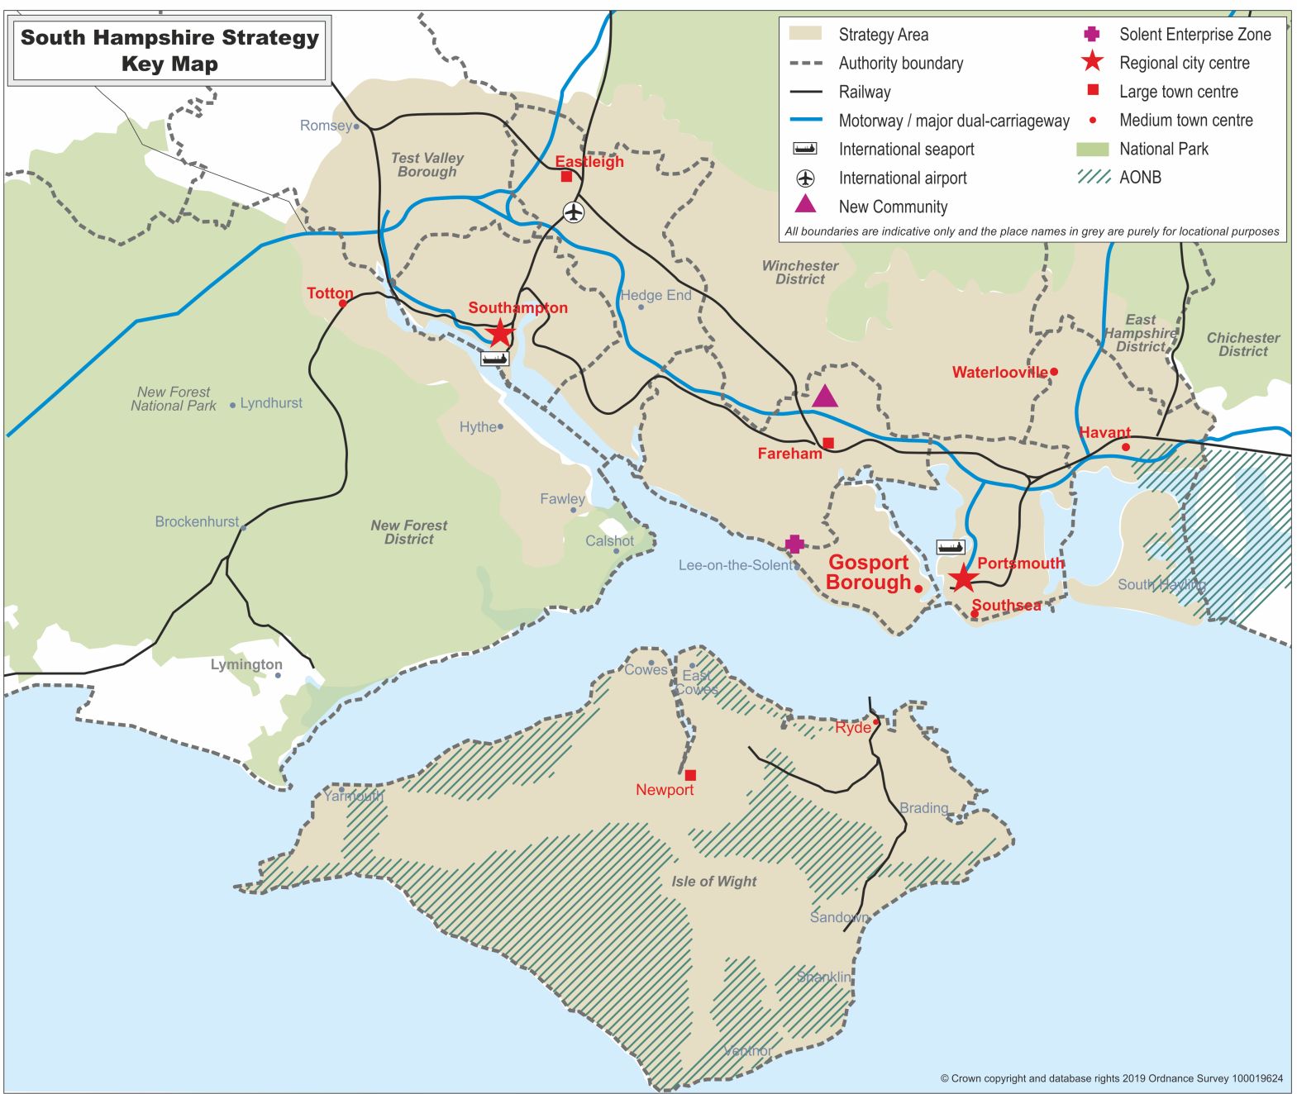
Figure 1: South Hampshire Sub Region

Local context
2.4 The Borough is located on the western side of Portsmouth Harbour opposite the city of Portsmouth. It is on a peninsula of 2,750 hectares surrounded on three sides by The Solent and Portsmouth Harbour with almost 39 kilometres of coastline. The Borough is predominantly urban in character with two key settlements of Gosport and Lee-on-the-Solent which are separated by the Alver Valley which includes the newly created Alver Valley Country Park.

Figure 2: Location of Gosport
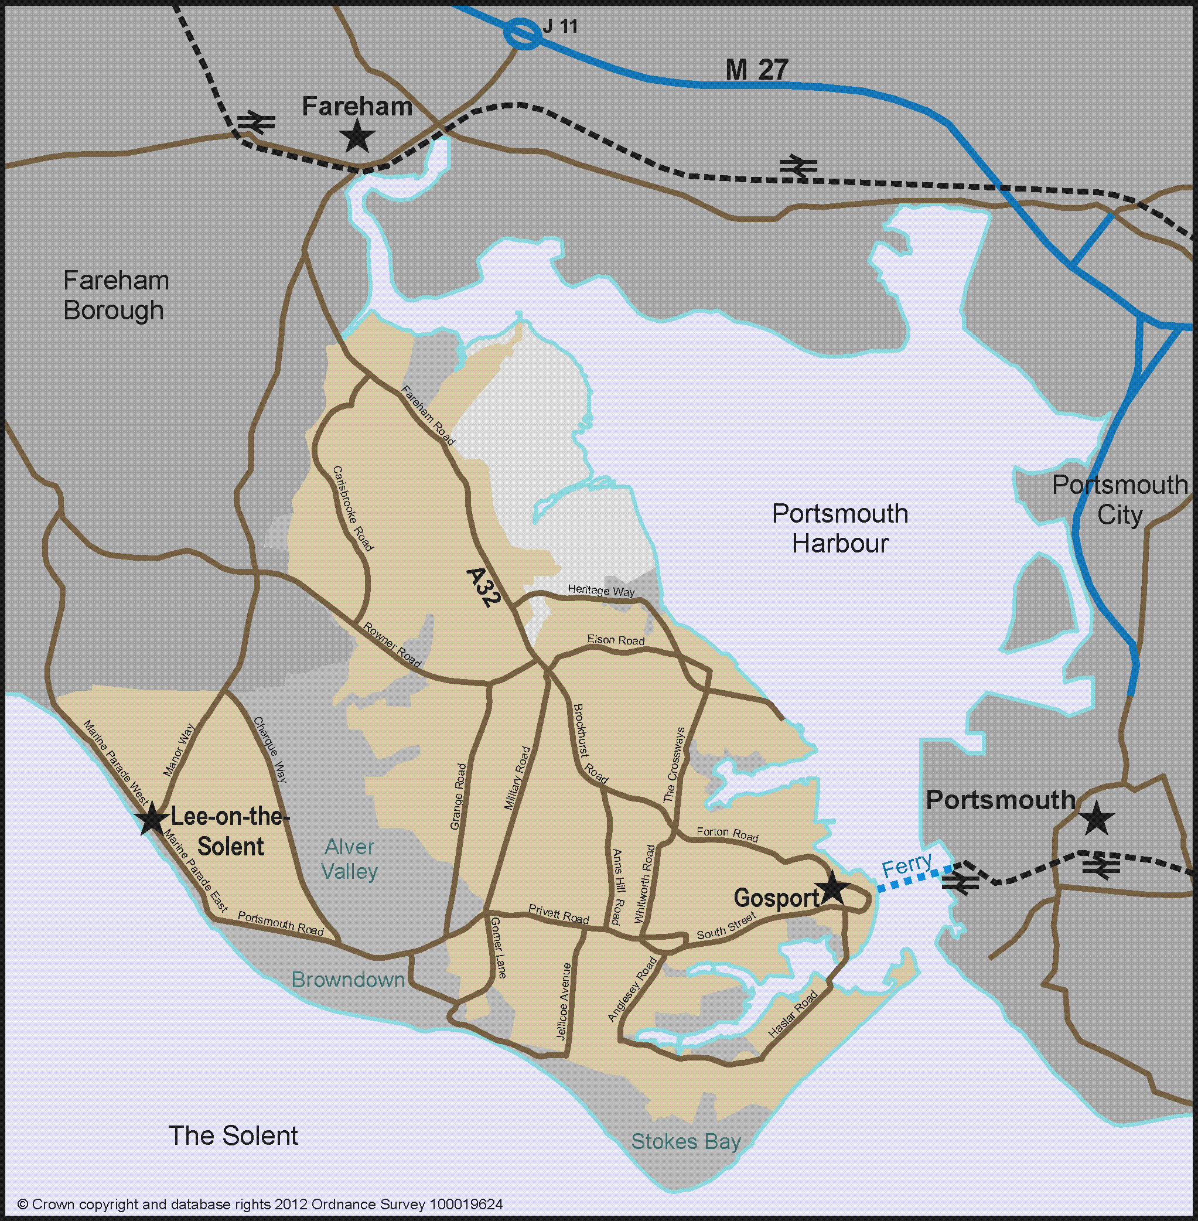

2.5 Gosport has experienced significant levels of development in recent years due primarily to the release of complex Ministry of Defence sites. The GBLP has identified other opportunities for regeneration as will the new Local Plan covering the period to 2036

Retail and Centres
2.6 The retail policies of the GBLP can be found on the Council’s website at: www.gosport.gov.uk/localplan2029

Planning policy
2.7 The Local Plan sets out the retail hierarchy of the Borough. Gosport Town Centre is the principal centre and there are a number of other centres in the retail hierarchy (Figure 3 and Table 1) providing a range of shopping and other services to support local residential areas throughout the Borough. Maintaining the commercial health of these centres is an integral part of the Council’s current planning strategy as provision of local services can add vitality to residential areas acting as community hubs providing a broad range of facilities within easy walking distances. This approach is likely to continue in the new Local Plan.
Figure 3: Location of centres
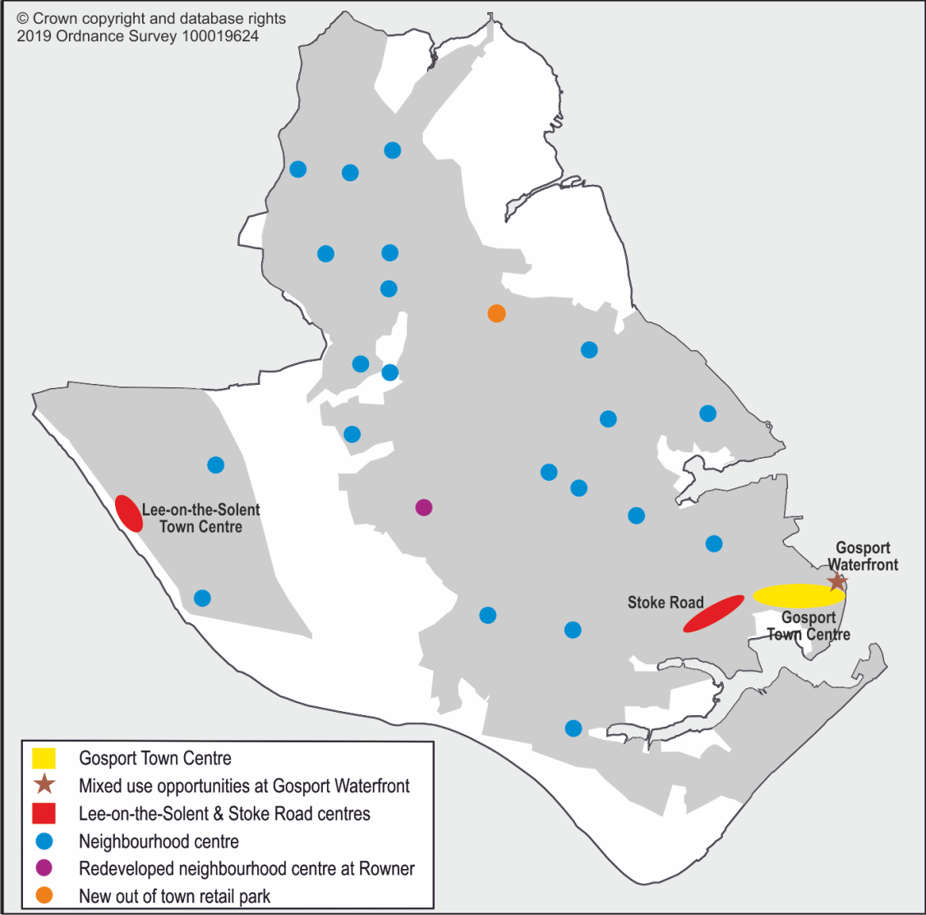

Table 1: Existing centres

Principal Centre
Gosport Town Centre
District Centres
Lee-on-the-Solent
Stoke Road
Neighbourhood Centres
Alver Village  Alverstoke Village  Antice Court, Twyford Drive  Beauchamp Avenue  Brewers Lane  Brockhurst Road  Bury Cross | Carisbrooke Road  Dartmouth Court, Priddy’s Hard  Elson Road  Forton Road/Bedford Street  Forton Road/Parham Road  Forton Road/The Crossways  Gregson Avenue  Nobes Avenue | Palmyra Road  Portsmouth Road, Lee  Queens Parade  Rowner Lane  Rowner Road  St Nicholas Avenue  Tukes Avenue

2.8 Policy LP3: Spatial Strategy of the current GBLP sets out the overarching quantum of development and the Council’s spatial planning strategy for delivery during the plan period. In terms of additional retail floorspace, the policy makes provision for 10,500 m² of net additional floorspace for the whole Borough.

  - Policy LP4 relates specifically to the Gosport Town Centre and Waterfront area. The quantum of development includes 6,500m² of retail floorspace (A1).

2.10 Policy LP27: Principal, District and Neighbourhood Centres (GBLP page 151) sets out the overarching policy for supporting the network of centres. The policy allows for a diversity of uses to be accommodated and identifies measures to enhance existing centres. Policy LP27 is supported by policy LP28: Uses within Centres (GBLP page 155). This policy sets out threshold limits appropriate to the different types of centre which help to provide for a variety of uses whilst still retaining an appropriate retail and commercial core. In addition policies LP29-LP31 relates to other detailed retail issues in the Borough.

  - In March 2018 the Council adopted the Gosport Waterfront and Town Centre SPD which is a key material consideration in the determination of planning applications. The SPD outlines in detail potential development opportunities including options for the scale and mix of future proposals on a number of different sites within the Regeneration Area including employment, additional retail and other town centre uses, residential and a range of community and leisure uses including opportunities to develop the marine leisure sector. The SPD sets out the Council’s aspirations for this part of the Borough.

2.12 Further background information can be obtained from:
- www.gosport.gov.uk/localplan2029 including the GBLP and the accompanying Retail Background Paper (Document number: LP/E1/9) and the Gosport Retail Capacity Study 2014 (Document number: LPE10/0) which can be viewed on-line in the Evidence Studies section of the Local Plan webpages.
- www.gosport.gov.uk/annual-monitoring-report including the Council’s latest Local Authority Monitoring Report (December 2018)
- Gosport Waterfront and Town Centre SPD and Background Report www.gosport.gov.uk/waterfrontspd

Retail planning proposals of note
  - In November 2017 the Council granted planning permission for a retail-led scheme at land at the junction of Fareham Road and Heritage Way (known as Brockhurst Gate). The scheme comprises of 7,215m² of mixed retail and town centre uses including a drive-thru restaurant and coffee shop (Planning application 16/00598/FULL). The retail element of the scheme is limited to a maximum of 4,707m² and of this, no more than 2,148m² can be used for the sale of comparison goods. It is expected that the implementation of Brockhurst Gate will provide a significant take-up of the remainder of the 10,500m² net additional retail floorspace. It will be necessary to understand the impact that this proposal may have on the existing network of centres particularly Gosport Town Centre and Stoke Road District Centre and as a consequence the level of future capacity and demand for retail floorspace in the new local plan period.

Leisure and Tourism
2.14 Gosport is an attractive town with scope for providing high quality leisure and tourism facilities and enjoys a Harbourside waterfront location, beaches, a high number of quality open spaces and is rich in historic maritime heritage assets.
Leisure
2.15 The Harbourside location of the Gosport Waterfront and Gosport Town Centre means there may be opportunities to increase the scope for leisure activities within the Waterfront area in order to help attract visitors and increase the footfall to the Town Centre throughout the day and develop an evening economy. There is currently a lack of leisure facilities particularly in the Gosport Waterfront and Town Centre area and this is perceived as a weakness in the area given its attractive location and close proximity to other key destinations within Portsmouth Harbour. The SPD sets out options and ideas for such uses and includes cultural and recreational facilities, bars and restaurants which will be attractive to local residents and visitors. These uses have the potential to link well with the existing marina uses and could potentially increase boat-based visitors to the Borough.

2.16 The Discovery Centre at the western end of the Town Centre accommodates library and museum services as well as exhibition and event space and forms the main cultural facility in the Town Centre. It offers a programme of events, talks, displays and educational classes throughout the year. There is also a proposal to intensify the use of the Old Grammar School on the High Street to form a key component of a cultural square. This option could include enhanced exhibition space and art facilities, café use and ‘easy-in, easy-out’ incubator type office space for start-up companies.

2.17 Recent key leisure developments include the new Gosport Leisure Park, this leisure hub located geographically within the centre of the Borough on the A32, 3.96 km northwest of Gosport Town Centre. The site also includes the privately owned Planet Ice (ice skating rink), a Premier Inn and The Sailmaker Public House. The recent creation of the Alver Valley Country Park also attracts visitors both from within and outside of the Borough and is a significant piece of sub regional green infrastructure.

Marine Leisure
2.18 Gosport has significant strengths in the recreational and small commercial marine sector. The marine leisure sector makes a significant contribution towards the tourism industry in Gosport. Gosport’s location on the Solent, its significant maritime heritage assets and close proximity to Portsmouth combine to make it a very attractive destination to visitors.

2.19 The Background Study to the Gosport Waterfront and Town Centre SPD includes information regarding the important economic contribution of the marine industry in Gosport.

Tourism
2.20 The expansion of the tourism sector offers opportunities for new investment, additional employment and increased visitor spending. There is potential to achieve economic growth by utilising the Borough’s built heritage assets and its Harbour and Solent frontage. The Council has recently been designated as a Heritage Action Zone (HAZ) by Historic England.

2.21 The Borough has a number of museums including the Submarine Museum and Explosion (both part of the Museum of the Royal Navy), a diving museum (at Stokes Bay) and the Hovercraft Museum (at Lee-on-the-Solent). The Borough has a very comprehensive Heritage Open Days programme which has developed into a 9 day programme of events. A Marine Festival is held every two years. The Borough is noted for its water sports activities particularly sailing but also has potential to attract other leisure and tourism activities. The town has three large marinas and there are opportunities for the Town Centre to retain a higher proportion of marina visitor expenditure.

2.22 The most recent visitor survey (of 400 visitors) for Gosport was carried out in 2018 and will be made available to the successful consultant together with the latest hotel accommodation studies (2013 and 2015).

2.23 The Gosport Bus Station site offers new opportunities for visitors with proposed new food and drink provision and a new tourist/visitor/heritage centre as well as leisure uses.

Key opportunity sites
2.24 In addition to the Gosport Waterfront and Town Centre Regeneration Area, there are a number of other sites within the Borough where there may be potential to accommodate leisure or tourism related facilities these are set out in Section 7 of the Brief.

3.0 OVERVIEW AND OBJECTIVES OF THE STUDY

Study Overview
3.1 The Study will need to accord with the guidance and requirements set out in the National Planning Policy Framework and Planning Practice Guidance in full.

3.2 There are four elements to the Study. The study requirements for each are set out in the sections below under:
A. Retail and Town Centre Uses including food and drink, offices, and town centre community and leisure uses;
B. Leisure Uses;
C. Tourism accommodation and facilities; and
D. Site appraisals.

Objectives

3.3 The objective of the Study is to provide evidence for the forthcoming Gosport Borough Local Plan covering the period in 2016-2036. The key requirements for each element are set out below:

Retail and Town Centre Uses
- To understand the current spending habits of residents in Gosport Borough and the local area and ascertain the proportion of expenditure retained in the Borough and how much leakage there is for different types of goods and services.
- To understand the future need and demand for A1, A2, A3, A4, A5 and other town centre uses (community, leisure, office) within Gosport Borough taking into account current retail habits and the proposed new developments in the Borough (in the context of current trends).
- To provide an up-to-date health check of Gosport’s Principal and District Centres.
- To consider the appropriateness of the Council’s current use threshold policy as included in Policy LP28 of the “GBLP”.
- To review the Council’s current approach on the threshold for requiring an impact assessment for retail and leisure development.

Leisure
- To provide an understanding of current leisure trends and what implications this has for Gosport Borough
- To understand the current spending habits of residents in Gosport Borough for a range of leisure uses
- To understand the future need and demand for leisure uses within Gosport Borough taking into account current trends and the proposed new developments in the Borough. In particular, evaluate the impact of a flexible arts/cultural performance venue on kick-starting a night time economy
- To understand the potential for an additional and improved food and drink offer in Gosport Borough as a means of developing a night time economy
- To understand the demand for leisure developments in Gosport Borough from leisure operators.
- To understand the potential that specific development sites may have to create their own specialist leisure activities.
- To understand the potential for the development of a (niche) night time economy within the town centre in order to prevent leakage to adjacent areas

Tourism uses
- To understand the scope for additional tourism accommodation in the Borough
- To identify any demand from tourism accommodation operators for additional space and type of product in Gosport Borough
- To understand the potential for additional and improved tourist/visitor attractions in Gosport Borough
- To understand the potential for both tourist accommodation and attractions to utilise proposed development sites including various historic and coastal sites which have the potential to create their own markets.

Development sites
- To understand the potential for retail, small office, leisure/visitor attractions and tourist accommodation to utilise development sites in Gosport
- To consider whether these uses are potentially viable in terms of set-up costs and customer demand.
- To understand what sources of funding and incentives are available to make such uses viable and attract significant external investment.

Key primary data requirements

Household Survey of retail and leisure habits
3.4 The assessment of quantitative need will require a new household survey to be carried out to establish current retail and leisure patterns and to assist in identifying future capacity requirements for convenience and comparison shopping (both key destination and top-up shopping) and for leisure activities to inform the forthcoming Local Plan which covers the period 2016-2036.

Health checks of the Principal and District centre
3.5 The report should include a health check of these centres using best practice indicators with a quantitative and qualitative assessment of each of the three centres.

Market demand from retail, small office, leisure and visitor attractions
3.6 Market research of retail, small office, leisure and tourism sector operators to understand potential demand in Gosport for such uses. With regard to leisure and tourism uses the Council requires the successful consultant to proactively engage with specialist operators on the potential use of specific sites for leisure uses and visitor attractions.

Survey of Marina Users spending
3.7 Gosport has an extensive marine leisure community with visitors using the marinas and moorings. A clear understanding of the spending patterns and leisure activities of this particular group of visitors will be required in order to understand the potential opportunities that may be generated by this leisure sector. Therefore interviews with representatives of the marine leisure community will be required as well as surveys of marina users with permission and assistance from marina operators. The Council will facilitate the necessary introductions.

COMPONENTS OF THE STUDY

4.0 A. RETAIL AND OTHER TOWN CENTRE USES

4.1 The Study will identify and quantify the need and demand for A1, A2, A3, A4, A5 and other town centre uses within Gosport Borough, in accordance with the NPPF and PPG. The Study will also need to take into account emerging national trends and strategies to help revitalise the High Street as identified in the Government’s Budget announcement in October 2018.

4.2 The Study must provide robust up-to-date evidence to support the development of effective planning policies and land allocations.

4.3 As part of the quotation process it will be important that the consultant sets out the approach and methodology for the householder survey and the geographical extent of the survey area which may include areas outside of the Borough. The assessment for the need for retail floorspace should be broken down into three categories: non-bulky comparison goods, bulky comparison goods and convenience goods.

4.4 The findings of the Study should address the need for any further retail, and other town centre uses including food and drink and small offices during the plan period (2016-2036). The NPPF states that strategic policies should: ‘look ahead over a minimum 15 year period from adoption’ (paragraph 22, NPPF 2019). However in terms of town centre uses local plans should cover a plan period of ‘at least 10 years’ (paragraph 85 (d), NPPF 2019). Therefore for the purposes of analysis and study recommendations this should be broken down into shorter time periods (for example 5 year periods).

4.5 The retail part of the Study will cover the following matters:

Performance of the existing centres
4.6 The Study should include a health check of the principal and district centres.

Future retail and other town centre uses (A1-D2) capacity
4.7 The Study should provide an assessment of the need and demand for further floorspace capacity requirements for retail (both convenience and comparison retail) and other town centre type uses within Gosport taking into account the current demographic profile and future population trends within the Borough. The Council also needs to understand the effects of e- shopping and other Special Forms of Trading and changing retailer requirements and how this affects future retail capacity and type of retailing provision required.

4.8 It should also identify any deficiencies in provision for retail, leisure, and other town centre uses within Gosport Town Centre, Stoke Road and Lee-on-the-Solent centres and assess the capacity of these centres to accommodate new floorspace requirements identified.

4.9 The Study will need to identify current and predicted spending patterns of local residents and identify leakage to out-of-centre locations as well as to competing centres. It will be important for the Council to understand the potential for increasing Gosport’s realistic market share options for convenience and comparison retail and reducing loss of expenditure to competing centres. It should include the quantum, if any, of any new retail floorspace taking into account aspirations to clawback residents’ expenditure to the principal and district centres.

Testing growth options and review of additional capacity projections
4.10 The draft Local Plan will test at least two different population and housing growth options. The report should consider whether there are any significant implications for the different scenarios. These will be provided to the successful consultant at the initial meeting. The Council may require further work on this aspect of the Study to be carried out at a later date as preparation of the emerging Local Plan progresses.

Managing Change – all centres
4.11 The Study should also identify if any of these centres or parts of these centres are in decline, and what changes are required including managing the diversification of uses taking into account retailing and leisure trends. This should include using the latest health check indicators identified in the PPG. Consideration on the appropriateness of the current policy thresholds is required as set out in current policy LP28 of the GBLP 2011-2029. The Study should identify opportunities to maintain and improve the viability and vitality of the Principal and District Centres. The Study should suggest how these changes could be delivered.

Out of centre retailing
4.12 The Study should also identify if there is a need for out of centre retailing in the Borough. An assessment for the need for retail floorspace should be broken down into three categories: non-bulky comparison goods, bulky comparison goods and convenience goods. The Study will also need to consider the effects of this form of retailing may have on the existing centres.

4.13 Current policy LP29 sets out the local planning policy framework for determining development proposals for retail and other town centre uses outside of identified centres. The current GBLP sets out local thresholds for carrying out an impact assessment for development proposals exceeding the following size thresholds in terms of gross external floorspace:

  - 1,000 m² for new retail development; and
  - 2,500 m² for new leisure and office development.

4.14 Whilst the threshold for new leisure and office proposals is taken from the guidance in the previous NPPF. The threshold size for new retail proposals was derived from evidence in the Gosport Retail Capacity Study 2014.

4.15 The Study should re-assess the appropriateness of the existing threshold sizes requiring a retail impact assessment and advise accordingly.

5.0 B. LEISURE AND MARINE USES

Leisure uses
5.1 Taking into account the current demographic profile and future population trends within the Borough, this part of the Study should consider the scope for accommodating a range of leisure uses including but not exclusive to:
- restaurants, pubs and clubs;
- health and fitness facilities;
- cinemas;
- other specialist leisure sectors;
- conference, theatre and cultural venues; and
- festivals and specialist market days and attractions.

5.2 The Study should provide an assessment on the leisure trends, demands and opportunities for future leisure uses in the Borough both for general mainstream leisure operators and more niche and specialist providers to locate in Gosport taking into account sites that are, or may become available during the plan period. The Council has identified a number of sites which may have potential suitability to accommodate a range of retail, commercial, leisure and tourism opportunities. A summary for each site is set out in Section 7 of this Brief.

5.3 In addition to this, the Council recognises that leisure uses, particularly those catering for a niche leisure provision can create their own market and it would be necessary for the Study to identify the scope for this potential by undertaking market research with the providers of these forms of leisure activities.

5.4 As part of the quotation process it will be important that the consultant sets out the approach and methodology used to provide the assessment on leisure demand. The consultants will be required to identify a floorspace capacity for leisure uses and to set out the demand identified. The findings of the study should address the need for further leisure uses to cover a timescale up to 2036. For the purposes of analysis this should be broken down into shorter periods (for example 5 year periods)

Marine leisure
5.5 The coastal location of the Borough means that there are significant opportunities to further develop a strong marine leisure sector. There are a number of marinas in the Borough and these facilities attract a significant number of visitors to Gosport on a regular basis. This in itself provides a key opportunity to enhance the leisure offer of the Borough and help to establish the right mix and scale of town centre uses including leisure on opportunity sites. The Gosport Waterfront and Town Centre SPD identified a number of options for marine leisure and tourism.

5.6 In addition to carrying out analysis on the spending patterns and leisure habits of residents and visitors to the Borough in general, the Council also requires the Study to provide a detailed analysis on the spending patterns and leisure activities specifically of boaters and users of the marine leisure sector in relation to firstly Gosport Town Centre (including the Gosport Waterfront and Royal Clarence Yard areas) and secondly in the context of the wider Borough, in order to understand both the leisure requirements/aspirations and the potential spend benefits to the Gosport economy arising from this key group of visitors to Gosport.

6.0 C. TOURISM ACCOMMODATION AND FACILITIES

6.1 Current trends in the domestic tourism market for ‘staycations’ and the growth in tourism expenditure in general could mean there may be further scope to grow tourism opportunities in Gosport and the Council would like the appointed consultant to explore this further (in accordance with the NPPF and PPG) and provide recommendations on the type of use and scale of development that would be viable.

6.2 The Study should provide an assessment of current tourism attraction and accommodation facilities in the Borough including its methodology of how it will do this. Consideration should be given as to whether further attractions could be accommodated at future development sites and the types of and content of such attractions

6.3 It should then consider the capacity to expand the tourism sector and what quantum, diversity and quality of development in tourism accommodation and facilities could be achievable over the plan period. The findings of the Study should address the need for further tourism accommodation and tourism related uses to cover a timescale up to 2036. For the purposes of analysis this should be broken down into shorter periods (for example 5 year periods)

6.4 The Study should provide an assessment on the tourism trends, demands and opportunities for:

- tourism accommodation (by sector); and

- tourism related uses.

6.5 In a similar way to the work relating to leisure uses the consultant will need to consider the potential for tourism attractions and tourist accommodation to utilise specific development sites in the Borough. On particular sites identified in Section 7 below there may be potential for further historic attractions relating to existing naval and maritime heritage in the vicinity. The Study should include a section on the scope for this and consider whether there is any interest from major heritage charities as well as other specialist heritage operators on whether there is appetite to include such sites in their portfolio (this could include for example, historic buildings at Royal Clarence Yard, the Gunboat Sheds, Blockhouse and Daedalus).

6.6 It will be necessary as part of the Invitation to Quote submission process for the Consultant to set out the methodological approach for identifying leisure and tourism opportunities in the Borough and the required capacity over the GBLP2036 plan period.

7.0 D. SITE APPRAISALS

7.1 The Council has identified a number of sites/potential areas which it considers may be suitable to accommodate mixed-use development including retail (where appropriate), small office, leisure, tourist accommodation and tourist attractions and facilities. The consultants will need to undertake a number of specific site appraisals. The consultants will also need to engage the relevant operators in these markets to ascertain whether there would be genuine interest for such sites in this location. The Study should provide recommendations on the potential suitability and mix of uses which could be accommodated on these sites.

7.2 The details of the sites will be discussed at the initial meeting between the Council and the successful consultant. The key sites are outlined below with a short summary. Please note this is not an exhaustive list and further sites may be considered as part of the Study arising from the research.

7.3 It will be important for the Study to outline known and anticipated viability issues and what actions could be pursued to lead to successfully developing such uses on these sites.

7.4 Appraisals should be considered for the following sites.

Fort Blockhouse
The Government announced in November 2016 the release of the Fort Blockhouse site. Policy LP6 (points (4) and (5)) in the GBLP identifies a number of potential uses at Fort Blockhouse. These opportunities could include heritage marine led development encompassing employment, training, tourism and leisure uses.

The site has significant maritime heritage assets (including the Fort itself with earlier phases of fortifications dating back to c. 1415, and the Submarine Escape Training Tank (SETT); the Gunboat Yard and other major listed buildings and features). There is the potential to create a stunning waterside walk and strengthen pedestrian links with the wider Gosport Waterfront area and Stokes Bay incorporating the England Coastal Path in this area.

It will be useful if the consultants could provide an opinion on firstly whether this site is able to host the ‘UK Maritime Innovation Hub’ (as contained in the Department of Transport’s ‘Maritime 2050: Navigating the Future’ published in January 2019) and secondly for the consultant to provide advice as to merits in bidding for this role.

There is the potential to enhance the marina and sail training facilities utilising the existing marina facilities and deep water access. Any proposals must be sensitive to the significant built heritage assets. The site is adjacent to internationally important habitats of Portsmouth Harbour Special Protection Area and Ramsar site, Solent and Dorset Coast potential Special Protection Area and the Portsmouth Harbour SSSI. Proposals would also need to be compliant with the policy LP45: Flood Risk and Coastal Erosion due to the location of the site in Flood Zone 3.

The existing Submarine Museum is a major visitor attraction which would need to be retained as part of any future proposals for the Fort Blockhouse site.

Given its stunning waterside location, there may be opportunities to support hotel and conferencing facilities, craft and arts studios and restaurant/bar facilities alongside marine employment and training opportunities.

The Council is currently awaiting information relating to the extent of the disposal and whether the disposal will be phased. A master plan will be prepared for the site.

Gunboat Sheds
This site includes Grade 1 Listed Buildings adjacent to Haslar Lake (an inlet of Portsmouth Harbour) with the potential for marine employment and leisure uses as well as the potential for a heritage attraction.
Browndown Camp
Located south of Portsmouth Road adjacent to Browndown Road and close to Stokes Bay beach. This former MoD training facility is understood to be in private ownership and is currently used by a youth group and paintballing activities. Parts of the site are located in floodzone 3 which may increase by 2115. Potential for tourism accommodation, water leisure / recreational related uses.
Alver Valley Country Park (“AVCP”)
Policy LP8 sets out the policy framework for the development of the AVCP. Recent planning permissions include car parks and play area. The Council considers there may be some limited opportunities for commercial uses which may be appropriate in a Country Park.
Gosport Leisure Park including Planet Ice Rink
This site is allocated in the GBLP under policy LP9E (1) for development including leisure uses. Planning permission was granted in July 2011 to redevelop the former Holbrook Leisure Centre. The new development has provided a new leisure centre, public house and hotel (Premier Inn) adjacent to the existing ice rink facility. The appraisal should explore what further capacity exists to enhance leisure/recreation provision in this location.
Priddy’s Hard Heritage Area
Policy LP9A of the GBLP sets out the policy framework for the site. The Priddy’s Hard Heritage Area (“PHHA”) (2.89ha) is allocated in the GBLP for a mixture of uses and The Ramparts (3.1 ha) is designated for public open space.

The PHHA accommodates the Explosion Naval Museum owned and operated by the Portsmouth Naval Base Property Trust. There are boat trips operating from the site to other Harbour attractions such as the Gosport Submarine Museum. It is considered that there is considerable scope at this site to expand the tourist leisure offer with facilities including hotel/conferencing facilities; food and beverage outlets, small offices, craft workshops, education and/or other community uses. Proposals on this site are advanced and the consultants should consider these proposals in the context of the wider study rather than provide a detailed appraisal.
Gosport Waterfront and Town Centre Sites including:
Retail, leisure, tourist accommodation and other town uses should be considered for potential sites identified in the Gosport Waterfront and Town Centre area as informed by the Gosport Waterfront and Town Centre SPD (March 2018) www.gosport.gov.uk/waterfrontspd

Sites include:
- major potential mixed uses at the Bus Station site;
- additional retail, office and other town centre uses on North Cross and South Cross Streets;
- the potential of intensifying uses at the Old Grammar School site- could include enhanced exhibition space and art facilities, café use and ‘easy-in, easy-out’ incubator type office space for start-up companies;
- the use of the units at Royal Clarence Yard for leisure, small office, community and other commercial uses; and
- Redevelopment of the Gosport Precinct site.

The potential for improving the evening economy including the possibility of a flexible performance/cinema space somewhere in the Town Centre
HMS Sultan
The MoD have recently announced the disposal of the site which is expected to become available in 2026. There may be opportunities to retain and enhance some of the leisure and recreation facilities including the theatre.

The site also includes the historic Palmerston Forts of Fort Grange and Fort Rowner. There may be opportunities to accommodate niche forms of leisure such as a spa or boutique hotel accommodation.
Fort Brockhurst
This site is owned and managed by English Heritage.

Heritage England and English Heritage Trust are about to engage on a feasibility study regarding future commercial opportunities including proposals to develop the Fort as a cultural hub. Consultants should be willing to give their views on the mix of ‘premium’ visitor/tourism attraction uses at such a ‘gateway’ site for Gosport.
Daedalus
The Daedalus site is situated within the administrative areas of Gosport and Fareham Borough Councils. The Gosport part of the site is allocated in the GBLP under policy LP5 and the Council adopted a Supplementary Planning Document in September 2011. It will be important to foster a unique identify for the site which has a number of historically important listed buildings – the Dining Room and Cookhouse, The Wardroom, Westcliffe House, and 3 Type J Seaplane Hangars and Winch Houses. The site is also part of the Daedalus Conservation Area.

Existing attractions include the Hovercraft Museum and close proximity to Lee Seafront and District Centre both of which are popular with day trippers.

8.0 PROJECT MANAGEMENT AND GBC INPUT

8.1 The contract for this work will be let and managed by Gosport Borough Council. The key contact will be:

Jayson Grygiel
Planning Policy Manager
Planning and Regeneration Services
Gosport Borough Council
Tel: 023 9254 5458
jayson.grygiel@gosport.gov.uk

Supporting Information
8.2 The consultant will be responsible for defining information needs and obtaining the necessary information to undertake the study. These will be agreed with the Council before commencement of the work. The Borough Council will provide project direction and assistance including the provision of background and site-specific information where available. Existing information includes (although this list is not exhaustive):

- PUSH Spatial Position Statement (2016) (this is currently under review);
- Gosport Borough Local Plan 2011-2029 (adopted October 2015);
- Gosport Waterfront and Town Centre SPD and associated Background Study and Site Profiles (adopted March 2018);
- Gosport Coastal Community Team Economic Plan 2016-2020 (January 2016);
- Gosport Retail Capacity Study 2014;
- Town Centres: Retail, Leisure and Office Study 2007 and subsequent updates;
- GBC Authority Monitoring Reports and general monitoring information;
- Hotel Solutions April 2013
- Hotels Futures Fareham and Gosport Hotel Market Fact File May 2015;
- Gosport Visitor Survey 2018;
- Site specific publications; and
- Relevant Council Board Reports and planning application studies.

Mapping information and OS licence
8.3 The consultants may have access to the Council’s mapping services for base map information and existing relevant digitised information subject to completing the Contractor licence for the use of Ordnance Survey Data. All information supplied will be subject to copyright protection in terms of its use.

Methodology and approach
8.4 It will be necessary in the Invitation to Quote submission to set out the methodology to be used for determining both retail capacity and the methodology for identifying future capacity for additional leisure facilities (including marine leisure) and tourism accommodation and associated facilities.

8.5 It may be preferential for the consultant to sub-contract particular elements of the project to other specialists e.g. the leisure and tourism elements. Should this be the case it will need to be clearly set out in the Invitation to Quote how this will be managed by the consultants and costs.

8.6 An Invitation to Quote should provide information relating to the cost of carrying out either a telephone or postal survey and provide details for how the Household survey will be carried out.

Outputs
8.7 Consultants will be required to submit:

- Three bound copies of the Final Report;
- An Executive Summary;
- Data and tables to be provided in Excel or in a format that can be easily updated by the Council; and
- Two electronic copies of the final report: one to be provided in Microsoft Word and one as a PDF file.

Timetable
8.8 The Council requires this report by the end of July 2019 in order to shape the options for a draft Plan to be prepared for consultation in 2019.

8.9 The consultants will need to provide a detailed work programme to meet this target date which outlines when the key tasks will be undertaken. It will also need to allow for appropriate liaison meetings with Council officers on the draft findings of the study. The consultant and Council officers will hold meetings as and when necessary but as a minimum will include the following:

- Introductory project meeting to confirm the project process, timetable and to establish information needs and sources - Mid April 2019 ;
- Progress meeting to discuss any emerging issues or clarify requirements - Mid May 2019 ;
- Meeting to discuss the findings of draft report - Mid July 2019 ; and
- It is anticipated that the Final Report will be produced by the end of July 2019 together with the handover of the relevant data.

9.0 QUOTATION PROCESS AND BUDGET

9.1 Organisations submitting a quotation are asked to submit the following information as part of their quotation submission:
- A statement of the approach and methodology of how the identified work will be carried out;
- A project timetable outlining how the approach would fit with the key dates outlined in this document;
- A breakdown of the project costs ;
- An indication of where additional work (not identified in this document) is considered essential as part of the project, including any additional costs.
The Council will also require an indication of the costs for carrying out additional analysis based on higher housing growth options. This additional work may be requested by the Council at a later date. Whilst it is understood the rates quoted for carrying out this additional analysis are based at today’s costs, it would be helpful as this would allow the Council to compare different rates.
- An outline of who would be involved in the Study, their experience, qualifications and membership of an appropriate professional body;
- Examples of similar work undertaken elsewhere, including contact names to whom the Council can refer for references;
- Confirmation of appropriate professional indemnity insurance; and
- An electronic version of the quote submission should also be submitted.

9.2 The fee for this study will be fixed and inclusive of all expenses but excluding VAT. The approximate amount available for the study is £30,000. The exact amount will be agreed with the consultant before commencement of the study. Payment through instalments following the completion of specific milestones will be considered and discussed at the Inception Meeting.

9.3 Quotes should set out the proposed fixed price for completing the work within the timescales specified including any expenses and other costs.

9.4 The successful consultant will be expected to comply with the Borough Council’s standard contract and terms and conditions and enter into a binding contract (see separate attachment accompanying this Project Brief).

9.5 The successful consultant will be required to have professional indemnity insurance with a minimum cover of £2 million to meet their liabilities under the contract.

9.6 The Council will own and have the copyright and other intellectual property rights in relation to all documents (including data) created by the consultant by virtue of this appointment.

10.0 DELVERY OF THE QUOTE

10.1 Submissions should be made in the sealed envelope, marked ‘Quotes for Gosport Retail and Town Centres Uses, Leisure and Tourism Study 2019
and received by 5.00p.m on Friday 5th April 2019. Quotes received after this date and time will not be considered.

10.2 Quotes should be addressed to:
Jayson Grygiel
Planning Policy Manager
Planning and Regeneration Services
Gosport Borough Council
Town Hall
Gosport
PO12 1EB.

11.0 INVITATION TO QUOTE EVALUATION AND AWARD CRITERIA

11.1 The Council does not undertake to accept the lowest quote and reserves the right to accept the whole or any part of any quote submitted.

11.2 Each Quote will be checked initially for compliance with all requirements set out in this brief.

11.3 Quotes will be evaluated against the award criteria set out below.

11.4 During the evaluation period, the Council reserves the right to seek clarification in writing or by means of a clarification meeting from any or all of the submitting organisations, to assist it in its consideration of their quotes.

11.5 Quotes will be evaluated to determine the most economically advantageous quote taking into consideration the following award criteria:

 | Overall criteria | Sub criteria | Weighting
Quality | Technical quality | - A full statement of methodology of how the required work will be delivered (20%).  - Evidence of the ability to meet the indicative project timetable (5%).  - Evidence of a clear understanding of the full requirements of the brief (20%) | 45%
 | Experience and Management | - Evidence of the experience of the main consultant (and any sub-consultant) of similar work undertaken elsewhere and if the satisfactory management of the commission (with references of contact details for the clients). | 20%
 | Resources  (10%) | - A resource schedule identifying the personnel who will undertake the work and their knowledge and experience  - Evidence of the timely availability of the study team | 10%
Cost | Cost (25%) | - Clear indication of the total cost of the study and a breakdown cost. | 25%
Total |  |  | 100%
Equality & Diversity | The organisation submitting the quote will need to demonstrate that they have a policy that complies with the Council’s requirements.  Failure to demonstrate this requirement will result in the quote being rejected. |  | Pass/fail
Data Protection | The organisation submitting the quote will need to demonstrate that they have a policy and procedures in place for processing personal data and meeting their statutory obligations as laid down by The Data Protection Act 1998.  Failure to demonstrate this requirement will result in the quote being rejected |  | Pass/fail
Freedom of Information and Environmental Information | The organisation submitting the quote will need to demonstrate that they will assist and co-operate with the Council in complying with its statutory obligations under The Freedom of Information Act 2000 and Environmental Information Regulations 2004.  Failure to demonstrate this requirement will result in the quote being rejected |  | Pass/fail

Scoring Models

11.6 For assessing the quality elements each sub criteria will be scored out of 20 and weighted accordingly.

Assessment of quality element | Allocated Score
Very Poor – [completely fails to demonstrate that it will meet the criteria] | 0
Poor – [some, but very limited evidence of that it will meet the criteria] | 1-5
Satisfactory – [provides evidence that it will meet the criteria sufficiently] | 6-10
Good – [shows attributes in a number of areas that are in excess of the criteria] | 11-15
Very good – [in excess of the criteria in all areas] | 16-20

11.7 For assessing the cost element the following formula will be applied:

Lowest price/bidder’s price x 25 = score

12.0 CONTACTS

12.1 The principal contacts for this study will be:

Jayson Grygiel  Manager of Planning Policy  023 9254 5458  jayson.grygiel@gosport.gov.uk | Kim Catt  Senior Planning Officer (Policy)  023 9254 5228  Kim.catt@gosport.gov.uk

PUSH includes East Hampshire District Council, Eastleigh Borough Council, Fareham Borough Council, Gosport Borough Council, Hampshire County Council, Havant Borough Council, Isle of Wight Council, New Forest District Council, Portsmouth City Council, Southampton City Council, Test Valley Borough Council and Winchester City Council.
The Borough is ranked in the Top 10 in the RSA’s Heritage Index
https://democracy.gosport.gov.uk/documents/g53/Public%20reports%20pack%2030th-Jan- 2019%2018.00%20Economic%20Development%20Board.pdf?T=10
Special Forms of Trading include all types of non-store retailing (internet, markets and mail order).
All Prices shall be stated in pounds sterling

