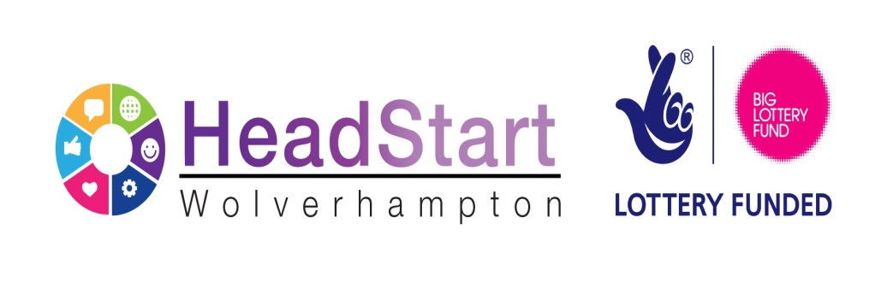

10 April 2017

Dear Partner
HEADSTART MARKET CONSULTATION EVENTS
HeadStart Place to Go,
HeadStart Work with Parents/Carers and
HeadStart News Hounds
At the Voluntary Sector meeting, on Monday 27 March 2017, providers were informed that the next HeadStart tender opportunity would be available in the spring and this letter is to invite you to a choice of two market consultation meetings either on the 21 April 2017, 9.30 – 12 noon in the Marston Room, Science Park, Wolverhampton or the 11 May 2017, 10 – 12 noon at the Marston Room too.
The market consultation meeting is to introduce the 3 “Lots” being procured, to discuss the draft service specifications and how best to tender the “Lots” required. It is intended that the contracts awarded will run for a possible 3-year period from September 2017 to the 31 August 2020. The Draft tender documents will be made available next week prior to the first meeting on the 21 April 2017.
The draft timescale for the tender process is detailed in the table below:
Stage of Tender | Date
Information Session | 21 April 2017  11 May 2017
OJEU Advert/Contract Notice | 15 May 2017
Closing date for submissions | 30 June 2017 12 noon
Evaluation period starts | 30 June 2017
Evaluation period closes | 21 July 2017
Clarification meeting (if required) | 21 July 2017
Intention to Award Contract Period (under Alcatel period) | 21 July 2017 –31 July 2017
Providers notified of outcome | 21 July 2017
Start Date of contract(s) | September 2017

These dates are given for guidance purposes only and may be subject to change
The 3 opportunities (“Lots”) are:
- Lot 1 – Place to Go - £1,000,000
- Lot 2 - Work with Parents/Carers - £500,000
- Lot 3 – HeadStart News Hounds - £100,000
The funding against each “Lot” is the total amount over three years.

If you are interested in attending the event on the 21 April 2017 please register at
https://headstartconsultation21apr.eventbrite.co.uk

If you are interested in attending the event on the 11 May 2017 please register at
https://headstartconsultation11may17.eventbrite.co.uk
I look forward to seeing you on the 21 April 2017 or the 11 May 2017.
Yours sincerely
Mai Gibbons
HeadStart Contracts Manager

