Tender Information Pack
Chell Heath Charity Shop
March 2019

Unitas (Stoke on Trent) Ltd
Planned, Mechanical & Electrical
Alton House, Cromer Road, Stoke on Trent, ST1 6AY

Property Surveying Team

Tender Information Pack
Bungalow Refurbishment Programme

Client | City of Stoke on Trent
Project Description
Number of dwellings/ units: | 1 shop unit with 2 no extensions
Build Year: | 1952 for main building – extensions at a later unknown date.
Construction Type: | Traditional cavity brickwork and flat roof over both side and rear extensions.
Property Type: | Shop
Number of Archetypes: | 1 Archetypes 213 – 11 – Main Building
Nr of storeys: | 1

Key Points
- This document outlines the work contained within the attached tender pack.
It provides a narrative and instructions to support contractors in the pricing process.
- This tender contains a refurbishment scheme, split into work streams which reflect the intended delivery of the works detailed in the proposed programme.
- Contractors are reminded that they must familiarise themselves with the site in order to fully appreciate the means of access, facilities for the storage of plant & materials etc. and, be satisfied with all site conditions, property types and layouts prior to commencement.
- Any Requests for Information must be submitted to Unitas prior to tender submission.
Quantified Schedule of Works
The pricing schedule is broken down as follows:
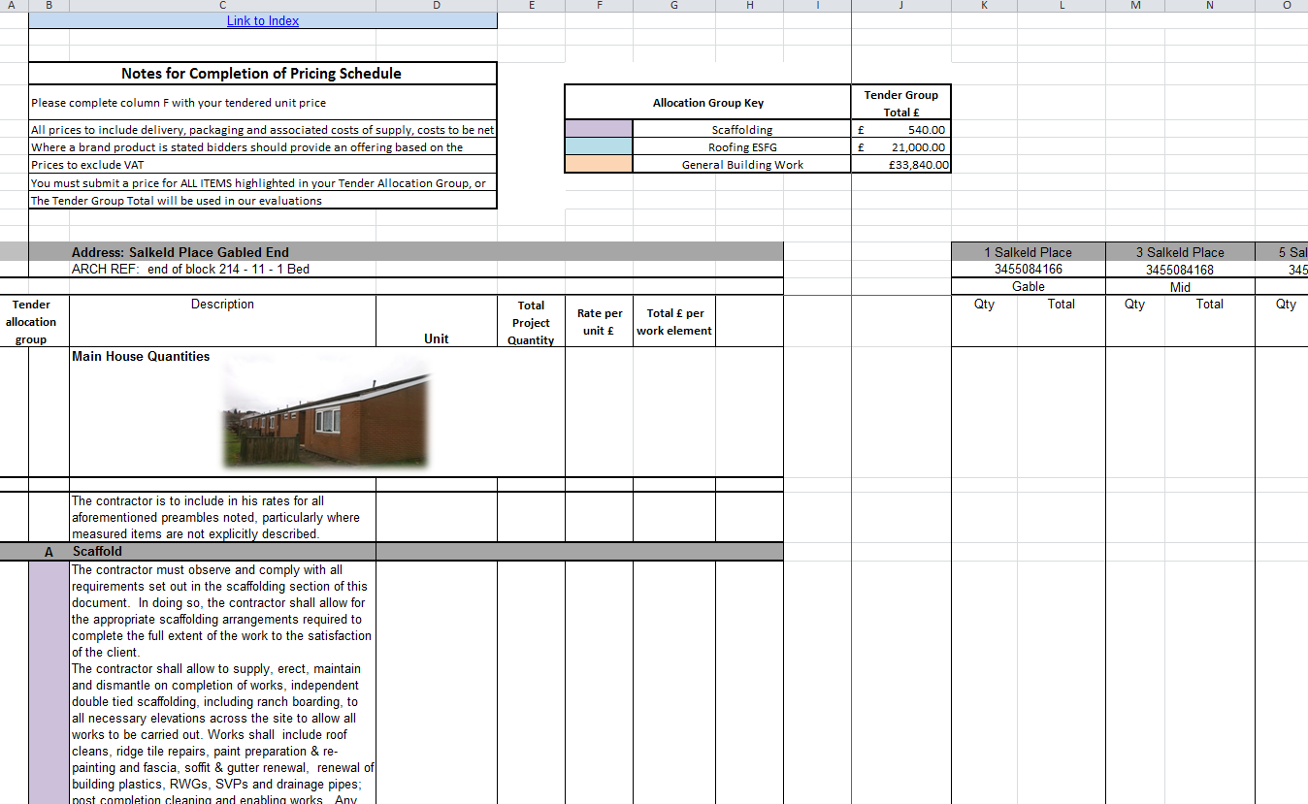
The schedule (tab 7.) Consists the main programmed works to be priced.
Each item is measured, and details cumulative quantities across the scheme.
Each works package is identified by colour code detailed as “Tender allocation group” in columns A & B, and corresponds with the key above. (See Figure 1.)
Figure 1.
Any contractor pricing a package of work must price all items within the work package to validate their submission.
Provisional Items (tab 6.) Total Project Quants (tab 7.) & Warranties (tab 8.) are also broken down into work packages and must be priced accordingly.
** Note - the only Tabs that need to be priced are - 6, 7, 8,**

The contractor will complete their tender submission by completing the “rate per unit” column (F).
On entering that rate in tab 7. The schedule will automatically populate the document at address level.

Project Overview
Chell Heath Charity shops roof works and re pointing
This project comprises refurbishment works to one extension to the rear and one to the right-hand side of the main shop (Second Chance Charity shop), Works will consist of scaffolding, careful removal / replacement of security grills, full repointing and brickwork repairs, flat roof removal/ replacement including all required insulation, parapet capping, fascia boards, rainwater goods and downspouts. These properties are traditional cavity wall brickwork, with traditional cold flat roofs.

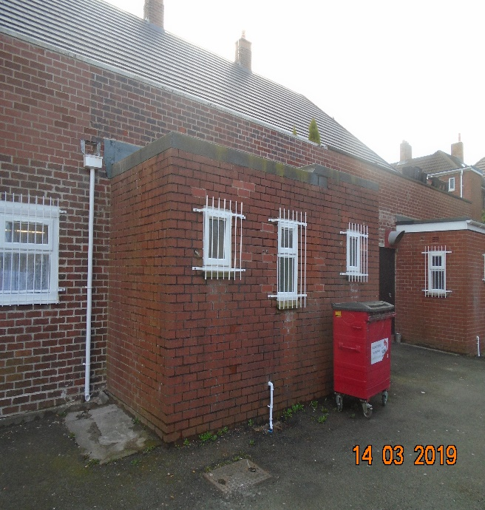
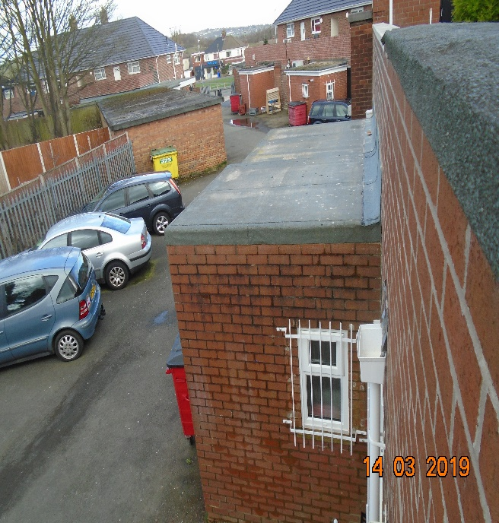

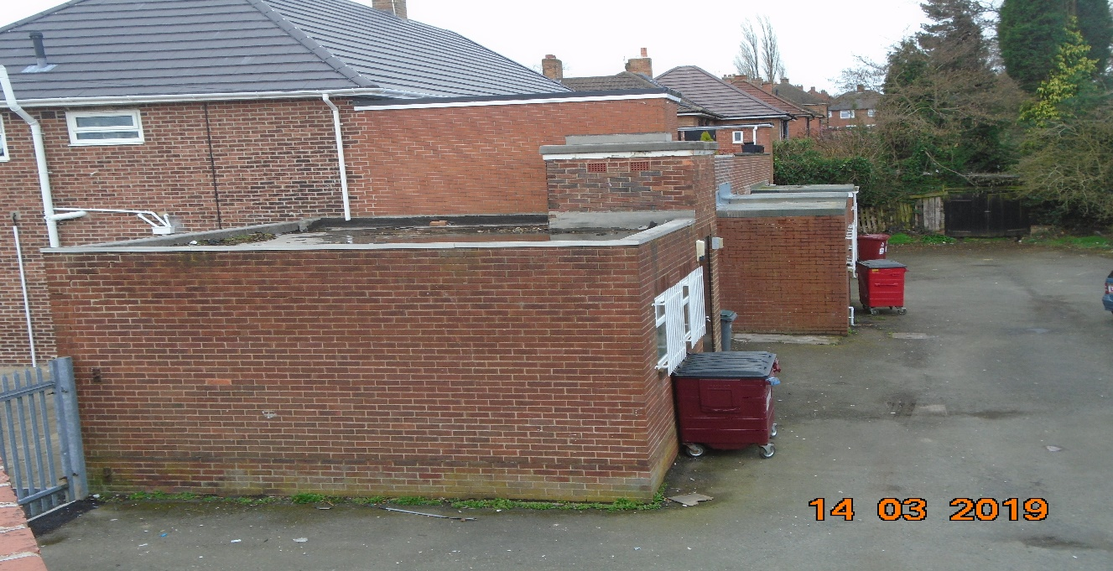

Chell Heath Shops – Plan view

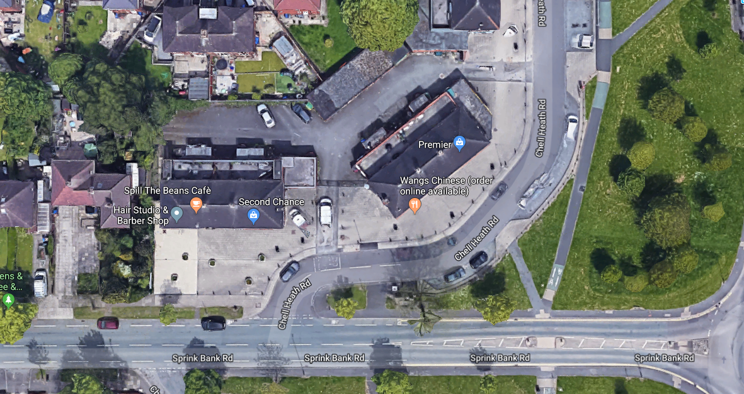

- End of Document -

