Tender for Fire Training

Tender reference number: MEH-FRA

LiveWest is a Social Housing provider, we own and manage over 38,000 homes across the South West, from Cornwall to Cheltenham & Gloucester.

At LiveWest we aim to achieve a professional and strategic approach to procurement.
We currently spend approximately £56 million a year on goods, services and works. We need to ensure our procurement activities are informed, effective, efficient and fair. Contractors need to be customer focused and offer ‘value for money’.

All companies who work for LiveWest will be required to confirm their agreement to comply with our contractor code of conduct and our Financial Crime Prevention Policy and Procedures.

If you have any further questions, please email our Procurement team at Martin.Hitchcox@LiveWest.co.uk

LiveWest wishes to create a framework agreement and appoint suitable training provider for:
- Level 3 for Inspection and testing of fire resisting door installations
- Fire door maintenance and repair of fire resisting doors
- Installation of fire resisting fire doors,
- Surveying and supervising fire doors
within the geographical regions of Cornwall, Devon, Somerset, Bath, Bristol and Cheltenham & Gloucester.

Contracts will be awarded according to the most economically advantageous tender. The scoring criteria is contained within the tender documentation.

LiveWest does not bind itself to accept the lowest or any tender and reserves the right to accept a tender either in whole or in part, each item being for this purpose treated as offered separately. LiveWest reserves the right to award the contract for works / services in South West to more than one supplier.

This Invitation to Tender package comprises the following documents (if any of these documents are missing please contact me immediately):

- This invitation to tender and Form of tender
- Specification of course requirements
- Pricing Schedule
- Contractor Code of Conduct
- Modern Day Slavery Questionnaire

Course 1. Surveying and Supervising Fire Doors

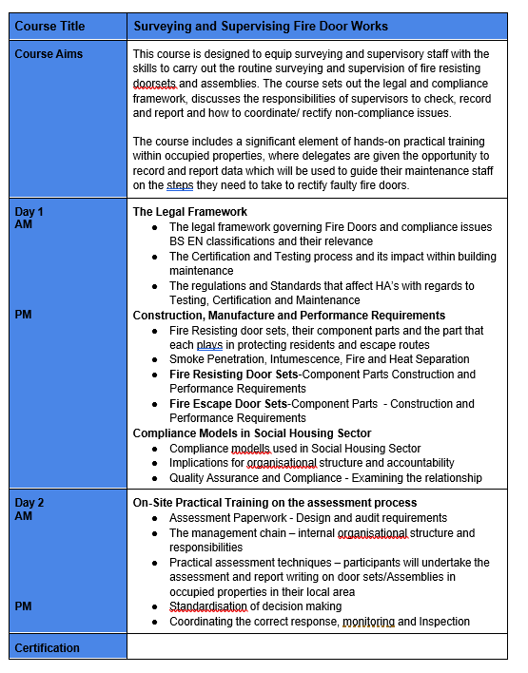

Course 2: Level 3 for Inspection and testing of fire resisting door installations

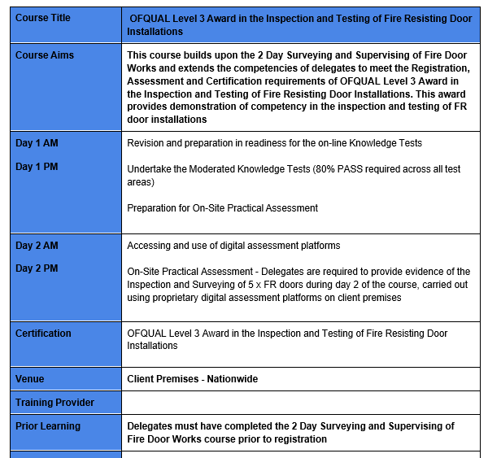

Course 3: Installation of Fire Resisting Doors
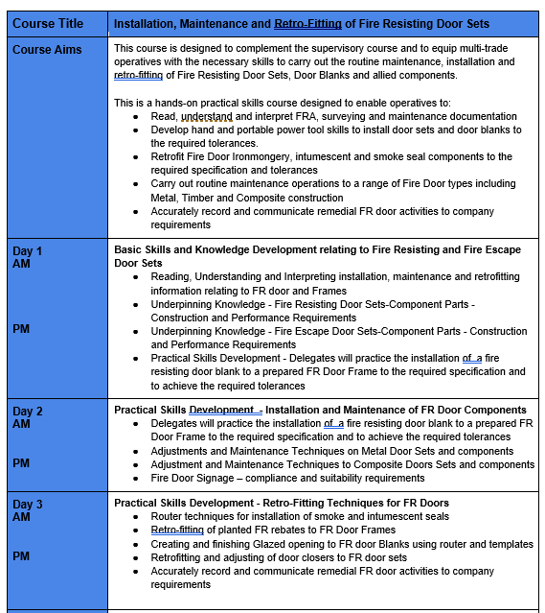

Course 4: Fire Door Repair and Maintenance
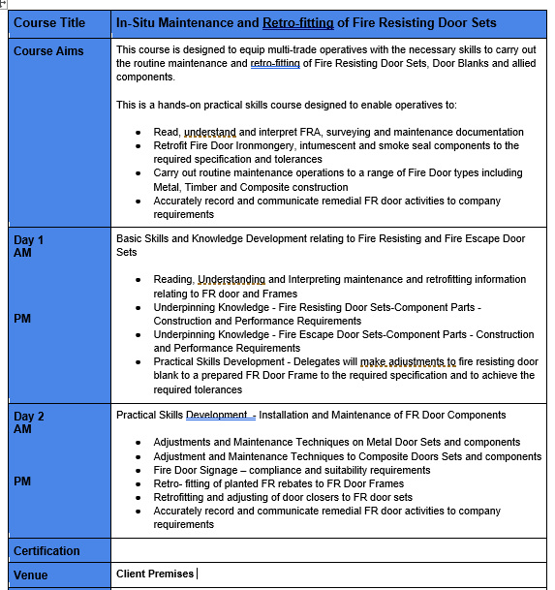

Pricing Schedule
Please Note: We are looking at the training be provided in April 2022 dates TBC
Anticipated Volume of resource requiring training.
Please Note: LiveWest to provide relevant Venues for practical and classroom requirements:
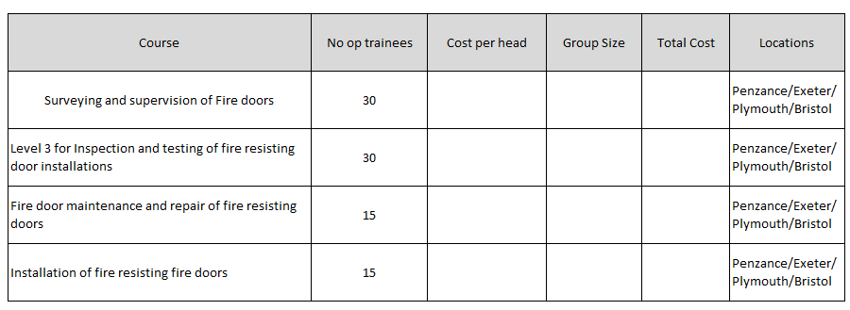
It is anticipated that additional training may be required during the year as LiveWest develops it’s in hose capabilities.

