Appendix I: Blackpool Context: Universal Primary Resilience Programme

Summary Information and Blackpool Key Statistics

RFQ Process for: - ‘The Provision of a Universal Primary Resilience Programme

Universal Primary Resilience

Background
HeadStart Blackpool is an innovative new 5 year strategic programme, with £10,000,000 in total invested by the Big Lottery to build the resilience of young people aged 10-16 and therefore reduce the number that go on to develop mental health conditions in the future.
Blackpool Council, the lead organisation for the investment, has an existing 5 year Council Plan with just 2 objectives, achieving economic re generation and building resilient communities. Therefore, the HeadStart investment will form part of the whole town strategy and take a collaborative approach to transforming systems for young people, in both our schools and the community, to ensure they grow up in environments that actively promote their resilience and allow them to flourish and succeed in life (whatever that may mean for them)
HeadStart Blackpool in now in phase 3 of the investment, this phased approach, which began in 2014, has enabled all 12 of the HeadStart partnerships to pilot new and innovative activities to evaluate their impact and to develop the bid for phase 3 ( see attached) . The bid document will have all the information you require in order to develop your application, however we would ask you to give particular attention to the phase 3 strategy chapter that outlines the delivery framework for the programme.
Young people in the town have clearly articulated to the HeadStart partnership the adversity that they face on a daily basis and in response to this we have adopted a social justice approach to the investment by actively working towards reducing the adversity that exists in the town and to level out the playing field for our more disadvantaged young people. Young people are at the heart of this investment and will continue to drive forward the development of the programme to ensure that meeting the needs of young people is always our ultimate priority.
The investment will fund a number of traineeships and apprentice roles across the programme that will be prioritised to Blackpool young people who have experienced disadvantage and there is a clear expectation that any successful providers will provide a minimum of one apprenticeship within their commission. Applicants will also need to clearly demonstrate how young people have influenced their applications.

Blackpool - Key Statistics

Location
Blackpool is a large seaside town located in Lancashire County in North West England. Blackpool is a Unitary Authority and covers an area of 13.46 square miles. Blackpool boundary sits within the urban area stretching along the Fylde Coast, and is one of the most densely populated authorities in the UK outside London.

Demographics
The population of Blackpool is estimated at 141,400, with a larger proportion of residents aged 60+ compared to national age structure. Residents are mostly of White British ethnicity. Black and Minority Ethnic groups, including Irish and European residents, are estimated to make up 6% of the population approximately 8500 people, compared with the estimated proportion for England of 20%.

Table 1: Population Demographics
Age | Blackpool | England
Aged 0-17 years | 21% | 21%
Aged 18-24 years | 9% | 9%
Aged 25-59 years | 45% | 47%
Aged 60+ | 26% | 23%
Ethnicity
White British | 94% | 80%
White Other e.g. European, Irish | 3% | 6%
Mixed/multiple ethnic groups | 1% | 2%
Asian/Asian British | 2% | 8%
Black/African/Caribbean/Black British | 0.2% | 3%
Other ethnic group | 0.2% | 1%
Tenure
Owned or Shared Ownership | 62% | 64%
Social Rented | 11% | 18%
Private Rented | 26% | 17%
Sources: See endnotes

Housing
Blackpool has a similar proportion of Owner-Occupiers compared to national (England) levels, but almost double the proportion of Private Rented accommodation (26.1% vs 16.8%). This is driven largely by changes in the seaside economies with many former guest houses converting to flats, and fluctuations in seasonal work creating demand for temporary accommodation in resort areas. Blackpool has a significant proportion of Houses in Multiple Occupancy (HMOs) in central wards close to the promenade and a monitoring project by Blackpool Council identified up to 37% of private sector rented properties in resort areas could be classified as a HMO.

Poverty and Deprivation
Blackpool has a large proportion of residents living in deprived areas and is currently ranked the 6th most deprived authority in England under the Indices of Deprivation 2010 – a higher rank than in 2007 (12th) and 2004 (24th) Additionally, in the 2010 Indices, Blackpool ranked 1st for the concentration of deprivation.
Map 1 below shows the relative positions of local areas in Blackpool. Around half of Blackpool’s 94 Lower Super Output Areas (LSOA’s), are in the most deprived 20% of all LSOAs in England. Specific areas in the central wards of Talbot, Bloomfield, Brunswick, Claremont and the outer wards of Clifton and Park have the highest ranked levels of deprivation in Blackpool.
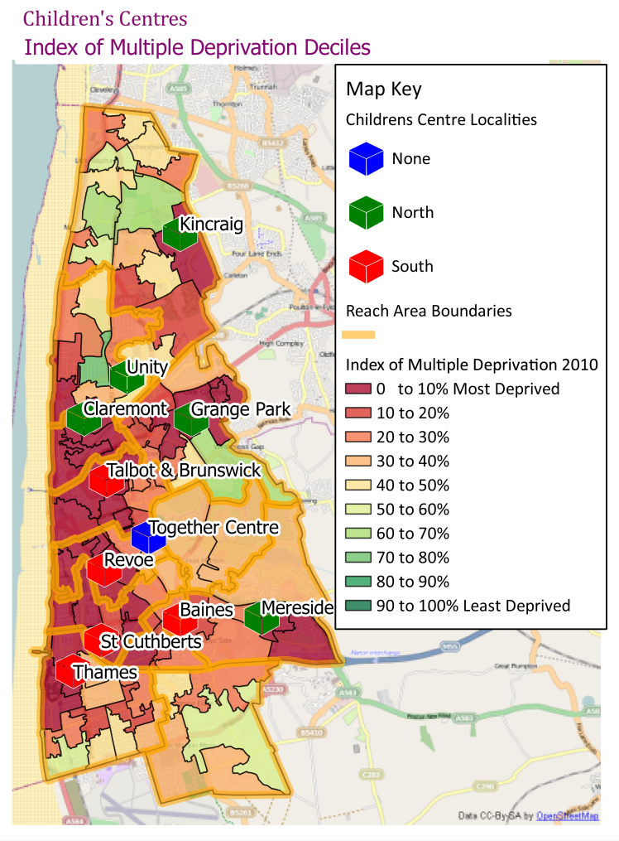
Poverty is also a significant factor in Blackpool. In 2012, 29.3% of children in Blackpool were estimated to be in poverty, compared to 18.6% of all children in England. Further analysis highlights that 67% of children in poverty live in lone parent families.
There are strong relationships between deprivation and a range of social issues and as a continued effort to address inequalities, Blackpool has launched a Fairness Commission. The Commission is made up of a range of local people representing different organisations which will explore social and other inequalities in depth and make recommendations for further improvements. 2012 also saw the introduction of a Child Poverty Framework aimed at reducing the levels of children in low income families and providing support for families currently in financial difficulty.
Source Data: CLG, Indices of Deprivation, 2010

Employment and Benefits
In terms of workforce, Blackpool has a low employment rate at 64.9% compared to a national (GB) rate of 72.4%. There are a high proportion of benefit claimants with out-of-work benefits, including Employment Support Allowance (ESA) and Job Seekers Allowance (JSA) at almost twice the national (GB) level - currently 18.7%, compared to 10.0% (GB). This approximates to about 16,390 individuals claiming an out-of-work benefit, the majority (10,880) of which claim ESA. Table 2 below shows the distribution of claims by group.
Table 2: Distribution of benefits claims in Blackpool by Statistical Group
 | Number | Blackpool | Great Britain
Total claimants | 20,310 | 23.2 | 12.7
Key out-of-work benefits† | 16,390 | 18.7 | 10.0
By statistical group
Job seekers | 4,800 | 5.5 | 2.9
ESA and incapacity benefits | 10,670 | 12.2 | 6.2
Lone parents | 1,720 | 1.9 | 1.2
Carers | 2,070 | 2.4 | 1.4
Others on income related benefits | 630 | 0.7 | 0.3
Disabled | 1,600 | 1.8 | 1.2
Bereaved | 190 | 0.2 | 0.2
Source: DWP Aug 2014

For residents in employment, the median wage for full time employees in Blackpool is around £386.60, which is £137 per week less than the national median. An estimated 13.0% of the working age population in Blackpool have no formal qualifications.

Education and Children's Outcomes
For young people in Blackpool, there are a range of challenges across both educational attainment and life chance indicators. The range of issues is partly driven by the existing high levels of poverty and social disadvantage in Blackpool, both of which have generational impacts whereby parents’ difficulties create problems in the family and influence children's outcomes. The rate of Looked after Children in Blackpool is the highest in England at a rate of 152.4 per 10,000 children; this is over twice the rate for England as a whole at 60 per 10,000.
In terms of academic achievement, the proportion of children attaining the expected level at Key Stage 2 is similar to national levels at 80-85% attainment dependent on subject. There are strong differences between the highest and lowest performing areas however with evidence for the North West region suggesting the proportion attaining level 4 in the 10% most deprived areas is 18 percentage points lower than those in the least deprived 10%..
Blackpool pupils perform below national levels at GCSE level with a lower proportions achieving 5 or more A* to C grade GCSEs (53.2% compared to 63.8%). When Maths and English are included this gap remains – 44.0% of Blackpool pupils achieve 5+ A*-C (incl. Maths & English) compared to 53.4% nationally.
In addition, approximately 7% of Blackpool’s young people are not in education, employment or training compared to 5% for the sub-region.

Health and Lifestyles
Blackpool has poor life expectancy, with life expectancy for males the poorest in England at 74.3 years compared to 79.4 years. Life expectancy for females is similarly poor, at 80.1 years, compared to 83.1 years for England -the 3rd poorest after Manchester and Liverpool. The biggest contributors for both men and women are circulatory diseases, digestive diseases including cirrhosis, and respiratory disease. These three areas contribute over half of the overall life expectancy gap in Blackpool. Lung Cancer is also a significant contributor to Female Life Expectancy.
Substance and Alcohol misuse is considered high, with alcohol-related death the 2nd highest in England for males (cirrhosis being one of the major drivers of the life expectancy gap). Further estimates suggest that the prevalence of problematic heroin and/or crack cocaine use in Blackpool was 21.89 per 1,000 populations. Blackpool has the highest drug prevalence rate across the region, and is within the top ten nationally.
While not directly a health damaging issue, teenage Pregnancy rates in under-18s are the 4th highest in England & Wales. In addition, Blackpool has a lower proportion of teenage pregnancies leading to abortion (42%) compared to England & Wales (51%). This implies a greater relative proportion of teenagers go on to become parents and may require further local authority support. Teenage conceptions have associated risks for both parent and child’s health and social wellbeing.

An LSOA is a small area of approximately 1500 residents
ONS Mid Year Population estimates 2013
ONS Mid-Year Population Estimates 2013
ONS Census 2011 Ethnicity, 2011
ONS Census 2011 Tenure, 2011
Blackpool Council - MIPS Summary Report - 2011
HMRC Children in Low Income Families, 2012
DWP WPLS, August 2014
ONS Annual Survey of Hours and Earnings 2014
ONS Labour Force Survey, 2013 – Estimates for Jan-Dec 2014.
DfE: Children Looked After by Local Authorities in England,2014
DfE: Local Area Data Tables, 2014
CCIS Database, March 2015, (12 month averages of 2014 data)
ONS Life Expectancy, 2011-13
Public Health England –2009-11
NWPHO Local Alcohol Profiles 2011
Blackpool Drug Health Needs Assessment 2014
ONS, Conception Statistics, England and Wales, 2013

