LUTON COUNCIL SOFT MARKET TESTING

Luton Drug and Alcohol Treatment and Recovery Service

SUBMISSION DEADLINE: 4pm (16:00) on 19th July 2024

PROJECT REFERENCE DN727009

Introduction

Luton Council is looking to engage suitably qualified organisations to participate in some soft market testing in order for us to review our specification and requirements for drug and alcohol treatment and recovery services.

Outline brief of requirements:

The National Drug Strategy From Harm to Hope, published in December 2021 outlines the phased expansion nationally of treatment capacity to create 54,000 new high quality treatment spaces and prevent 1,000 deaths.

https://assets.publishing.service.gov.uk/media/629078bad3bf7f036fc492d1/From_harm_to_hope_PDF.pdf

Luton Borough Council aims to assess the market capacity to deliver Drug and Alcohol Treatment and Recovery Services to the adults, children and young people of Luton. Luton is a super diverse community with many of the existing service users and potential service users experiencing a high level of interconnected needs.

Luton has operated different models of delivery for treatment and recovery services, from a multi service provider model prior to 2017, to a single service delivery model since 2017.

The proposed model will be delivered through an Alliance, with targeted services working together to address the drug and alcohol treatment and intervention needs within the community of Luton. The Alliance will include Alliance Clinical, Alliance Care and Alliance Recovery services working together. The Alliance will implement a robust shared case management system and information sharing agreement to support positive transitions for service users from pre-contemplation to treatment and long-term recovery.

The Alliance will work together with wider services and teams across Luton to provide our service users with comprehensive interventions and care plans.

The image below provides and outline of the proposed model of delivery of the Alliance. This model is split in to three ‘lots’:

Lot 1 Alliance Clinical: Specialised treatment services for adults, children and young people (CYP), including building on hospital and criminal justice in-reach and a dedicated CYP provision. Service to include quality case management, NICE guideline-led treatment, pharmacological treatments, opiate substitution therapy, psychosocial intervention, detox/rehab programmes, counselling, trauma-informed care, needle exchange, harm reduction, assessments, screening and testing and administration of prolonged release injectables.

Lot 2 Alliance Care: The service will help to identify and address the wider health and wellbeing issues of those individuals who are not able or ready to engage with treatment services. They will offer practical support, interventions and services for service users including single point of contact (SPOC) for target groups, aftercare, women's groups, support for rough sleepers, families, harm reduction, dual diagnosis, opioid antagonist medication, and promoting positive behaviours.

Lot 3 Alliance Recovery: Providing high quality recovery support for our residents in recovery, building a robust, safe and visual recovery community. Offering quality recovery support for residents in Luton, prioritising community-led progress and long-term support through lived experience and peer intervention. The flexible service will aim to rebuild lives, promote access to essential services, and prevent relapse.
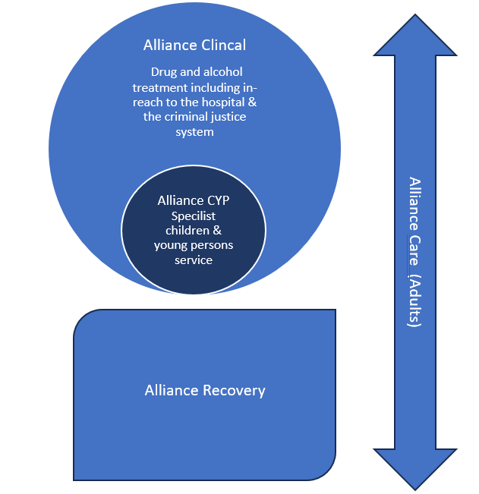

This will allow the council to understand, identify and explore constraints, opportunities, and risks in the marketplace.

Please note this is an informal/fact finding process to help us understand the current market and to enable/guide us to draft a specification.
This is not a call for competition or indeed any form of tender.

Luton Council are hoping to gain the following out of this soft market testing:
- An understanding of what Luton Council could or should be looking to deliver as part of upcoming and future tender activities;
- Identify innovative and cost-effective delivery solutions, which may inform our specification development
- Whether the market has experience of being involved in and delivering similar projects;
- What the market currently looks like and how we can work with current providers to develop and grow our requirement

Any information provided will remain confidential.

Please have your submission returned by 4pm (16:00) on 19th July 2024

SECTION 1 - Details of your organisation

Name of Organisation:
(Legal entity name)
Organisation Address:
Post Code:
Primary Contact Name:
Position:
Telephone Number:
E-mail Address:

Please confirm if you would like to attend the Supplier Engagement event on 24 July 2024 in Luton (venue tbc) 1-4pm. YES / NO

SECTION 1 – Project Details

Service Area | Drug and Alcohol Treatment and Recovery
Requirement Summary:  Goods, Service, Works, Software , Consultancy | Services – delivery drug and alcohol prevention, early intervention, treatment and recovery
Potential Procurement Start date | 2024
Councils Historic Information | See Introduction
Information Required by Date | 19th July 2024 @ 12 noon

Each response to the questions below should be no more than 500 words, attachments with diagrams and process charts will be accepted, however marketing and promotional materials will not.

Questions

Q1. Which lot(s) interest your service after the Supplier Engagement Event, and shared presentation, on July 2nd 2024?
Please provide detail and evidence as to why
Q2. We are looking to let a contract for a full term of 10 years (8+1+1). How would you be able to ensure commitment, quality, and resource availability over that period? Please provide detail and evidence.
Q3. Based on the model provide and our intention to deliver as an Alliance, can you share how have you previously worked with partners to ensure clear delivery of service?
Please provide detail and evidence

Q4. What innovative and robust ideas do you have to future-proof and enhance the service you are passionate about?
Please provide detail and evidence

Q5. What do you feel are the key objectives and outcomes for the lot you are interested in Luton?
Please provide detail and evidence

Q6. How have you previously worked to ensure the successful implementation of shared case management systems and information sharing, to the benefit of service users?
Please provide detail and evidence

Declaration

Declaration
I declare that:
- The information provided is accurate. I accept that if it becomes evident that the information given is inaccurate any award may be withdrawn
- I am authorised to sign on behalf of the organisation for this submission

Name
Position
Date

