QUOTATION REQUEST
Gosport Borough Council run two splash parks and invite quotes for the supply and delivery of chemicals as detailed below for delivery by the 21st May 2021.
General considerations
The supplier must agree to Gosport Borough Council terms and conditions.
Requirements
To supply chemicals as stated:-

1 x Quick floc Liquid (PAC) (40% + basisity) – 20L (BS:EN 885:2004)
1 x PH Minus liquid 45% - 20L (BS:EN 15078)
1 x liquid Sodium Hydrochloride 14/15% with anti-scale – 20L (BS:EN 15077)

1 x granular Calcium Hypochlorite – 10kg (BS EN 15796)

Delivery
Deliver to Grange Farm, Little Woodham Lane, Gosport, PO13 8AB indicated by the red spot on the plan below.
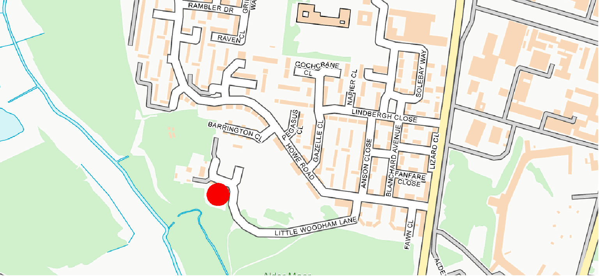

QUOTATION PROCESS
Please return quotes through the South East Business Portal, also known as Proactis, this must be your full and final price and must include delivery.
Quotes are to be returned by 13th May 2021.

Evaluation
The submitted quotes will be awarded on best value price, provided the quotation covers all of the required considerations detailed above.

