Tender Information Pack
Causeley Road Shops
April 2019

Unitas (Stoke on Trent) Ltd
Planned, Mechanical & Electrical
Alton House, Cromer Road, Stoke on Trent, ST1 6AY

Property Surveying Team

Tender Information Pack
Estate & Bungalow Refurbishment Programme

Client | City of Stoke on Trent
Project Description
Number of dwellings/ units: | 4 x flats, 6 x shops
Build Year: | 1950 onwards
Construction Type: | Traditional cavity brickwork, pitched pan tiled roofs, single storey flat roofs, timber windows and doors.
Property Type: | 2 bedroom flats, 6 shops
Number of Archetypes: | 2 Archetypes
Nr of storeys: | 2

Key Points
- This document outlines the work contained within the attached tender pack.
It provides a narrative and instructions to support contractors in the pricing process.
- This tender contains shop and flat refurbishment works detailed in the proposed programme.
- Contractors are reminded that they must familiarise themselves with the site in order to fully appreciate the means of access, facilities for the storage of plant & materials etc. and, be satisfied with all site conditions, property types and layouts prior to commencement.
- Any Requests for Information must be submitted to Unitas prior to tender submission.
Quantified Schedule of Works
The pricing schedule is broken down as follows:
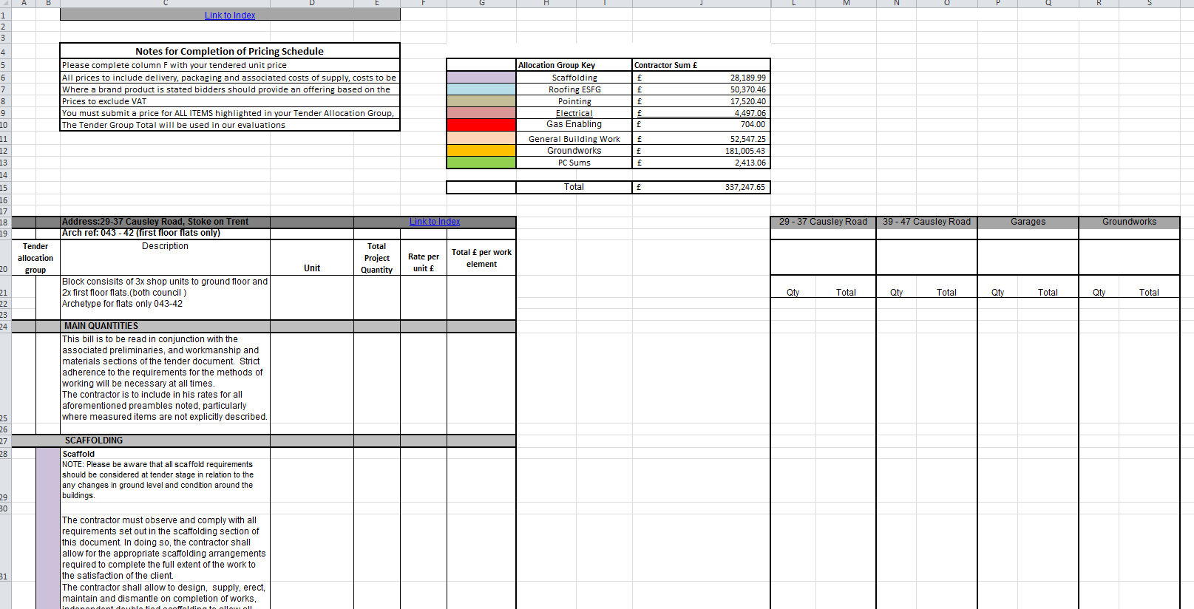
The schedule (tab 7.) consists the main programmed works to be priced.
Each item is measured, and details cumulative quantities across Causeley Road Shops refurbishment.
Each works package is identified by colour code detailed as “Tender allocation group” in columns A & B, and corresponds with the key above. (See Figure 1.)
Figure 1.
Any contractor pricing a package of work must price all items within the work package to validate their submission.
Provisional Items (tab 6.), is also broken down into work packages and must be priced accordingly.
** Note - the only Tabs that need to be priced are - 6, 7 **

The contractor will complete their tender submission by completing the “rate per unit” column (A).
On entering that rate in tab 7. the schedule will automatically populate the document at address level. The project breakdown (B) shows how the overall quantity is built up at a glance.

(A)
(B)

Project Overview
Causeley Road Shop refurbishments.

This scheme comprises 10 properties which consist of 2 shop blocks, each containing 2 first floor flats and & 3 ground floor shops. These properties are two storey cavity wall construction with traditional pitched roofs, a mixture of UPVC double glazed windows and single glazed metal and timber windows; timber and composite external doors.
The refurbishment to the properties will consist of scaffolding, asbestos removal, re-pointing, re-roofing, loft insulation, renewal of rainwater goods and building plastics, replacement external doors, flat roof renewal, parapet -wall repairs, renewal of external lighting, installation of hardwired smoke alarms, installation of kitchen and bathroom extraction fans (where necessary) and redecoration.

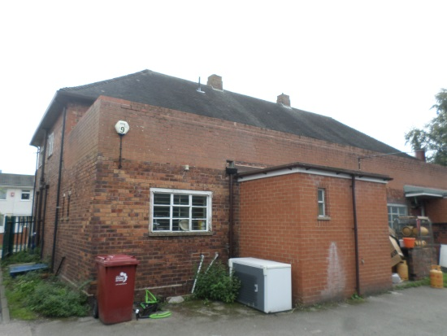
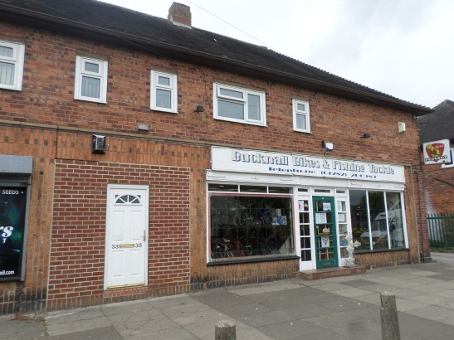

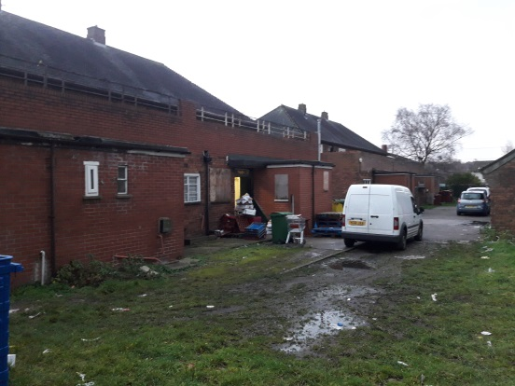
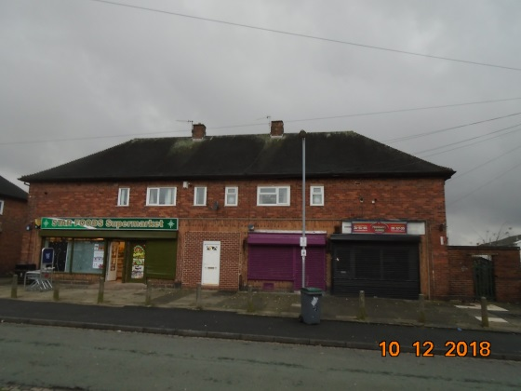

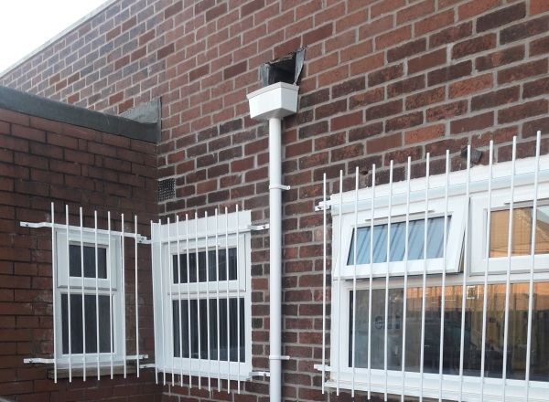
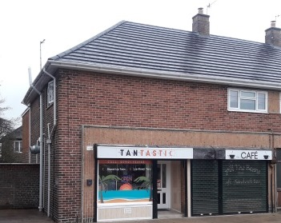

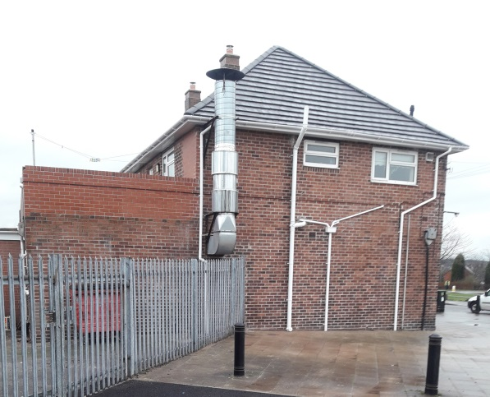
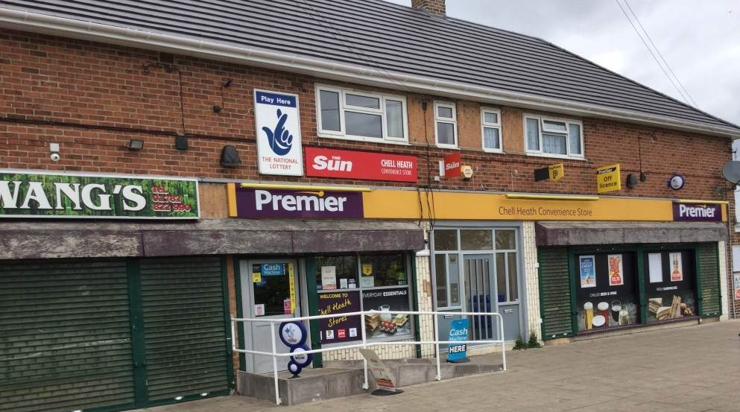

Example of typical completed shop refurbishment works.

Causeley Road Shops – Plan view

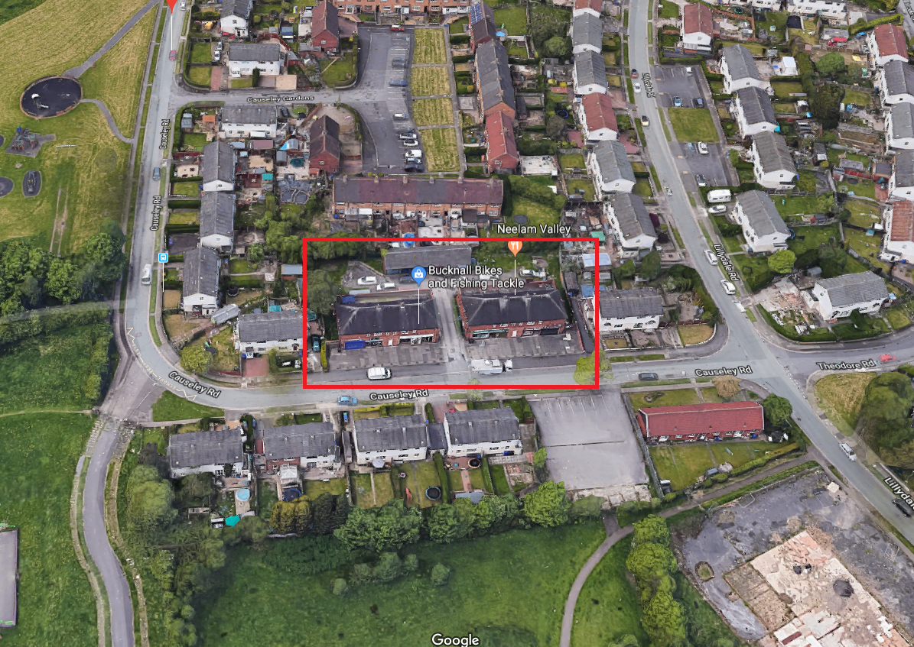

- End of Document -

