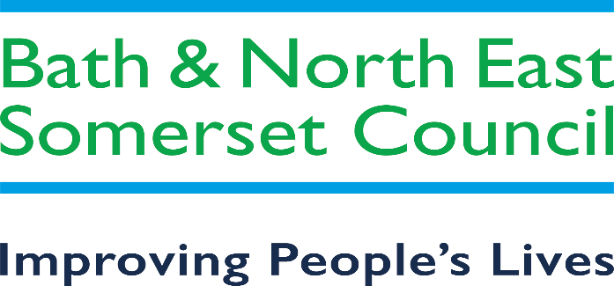

Bath & North East Somerset Advice and Information Service

Background
The current Advice and Information service is run by Citizens Advice Bath and North East Somerset.
This comprises a front facing service delivery model, with a telephone helpline and access to information through a dedicated website and a casework function for more in-depth problems.
The current contract requires the provider to undertake the following;
1) Deliver financial wellbeing outcomes for residents of Bath & North East Somerset Council, through the provision of advice and information on debt; budgeting and financial management; including the maximisation of income.
2) Deliver support and actively signpost and encourage customers to self-serve using digital access channels related to any of the above activities (e.g. use of Benefit Calculators and accessing online information / support).
3) Provide signposting where Citizen’s Advice is unable or not contracted to provide the appropriate service itself and/or there is alternative provision available from Bath & North East Somerset Council, its partner organisations or other sources i.e. housing services & support, Housing Benefit, blue badge applications etc.
It is proposed that these requirements are changed to provide support under the following headings;
Financial Support – to mediate for clients to access financial support from the council and other Local and National funding streams.
Welfare Advice – to provide accurate, comprehensible advice to residents who cannot access advice and information by themselves, and to signpost other residents as appropriate.
Specialist Support – to provide in-depth case management for complex client problems including Benefit appeals and liaison and mediation with council disputes.
Wellbeing Support – to provide access to affordable, healthy food, community inclusion and access to education and employment opportunities.
The aim of the newly commissioned service is to focus more on clients who require support to access services, rather than to provide a generalist advice and information service.
There will also be a requirement for the provider to maintain a significant presence in the council’s One stop shops, to act as mediator for residents to access council services.

Key information
Bath and North East Somerset has a population of around 192,000 residents. The current provider of the Advice and Information service would normally expect to have around 7,500 client contacts each year by telephone and through face-to-face appointments, although clients may present more than once, and an actual caseload figure is not known.

TUPE
It is likely that TUPE will apply to this contract.

Market Engagement Event 18th July 10am – 11am
Interested bidders are invited to join council officers in discussing the forthcoming opportunity for the Advice and Information service contract, which will be advertised within the next 3-4 months.
This market engagement event will not form a formal part of the council’s procurement decision but will be a chance for potential bidders to ask questions, and to comment on the procurement process and the current availability of advice and information services within the area. This is not a call for competition.
The event will be held virtual via Microsoft Teams. If you are interested in participating, please fill in the form via the link below and submit no later than 5pm on Thursday 14th July.
Provider Event Attendance Form
The council is looking to engage with potential bidders who already have some experience in the provision of Advice and Information services, therefore please do not attend this session if your organisation does not fulfil these criteria.

