Soft Market Testing Questionnaire – Zone Based Procurement

Title | Zone Based Procurement
Purchasing Authority (OCC/CDC) | Oxfordshire County Council (OCC) and 5 District Councils jointly procuring, OR any of these Councils procuring individually.
Category/ Department | Transport
Response Deadline | 16:00 05/08/2022
Contact Person (name, title, email, telephone number) | All correspondence to be sent through ProActis (South East Business Portal)
In person/hybrid/virtual open day event date: | Tbc – likely late August/early September
Description | Oxfordshire County Council and Oxford City Council are working in collaboration with the four Oxfordshire Districts to seek views from potential providers on a proposed new innovative “zone-based” procurement approach to EVCP roll-out.  If you are interested in sharing your views, please complete the questionnaire and return by 16:00 05/08/2022.  Please note that this is neither a call for competition nor a procurement exercise.
A Zone based procurement approach

We are keen to look into alternative models of procurement in order to meet the future needs of our communities.

Conventional procurement practices and resulting contract management are both highly time and staff intensive to deliver, and staff cost are not usually covered by project or infrastructure grants. Under conventional procurement, in order to achieve the required infrastructure targets without creating local monopolies, local authorities have to repeat these cost intensive exercises frequently and accumulate multiple contracts, leading to unsustainable ongoing costs.

Zone based procurement seeks to overcome this challenge, by creating a system that permits large scale and longer-term procurement while retaining end user choice and equitable infrastructure delivery.

In the example of Oxford City, the number of EVs will need to increase from 2% to 30% in under five years if Oxford is to achieve its Zero Carbon Objectives. Traditional procurement approaches are not sufficiently scalable to achieve the infrastructure required to support these targets.

We have analysed and projected the infrastructure requirements of the city across city wards and have bundled these wards into two zones with equivalent deprivation averages and on-street household percentages to enable equitable delivery of infrastructure across the different demographics of the city (see Appendix 1).

In a Zone Based Procurement model, we would look to contract a small number of Charge Point Operators (CPOs) to design, install, operate and maintain public EV charging services within each zone, to scale up the delivery of EV charging solutions
- at council owned car parks (as set out in Part 1 of this questionnaire)
- On-street
- On private land.

Contractors would be guaranteed a minimum number of EVPCs over the contract period, provided KPIs are met, and are given choice over charge point locations within an agreed set of criteria.

The zone based approach pursues four core aims:
- All end users have local choice in regard to charge point provision, and local monopolies and undersupply are avoided.
- Restriction of publicly procured CPOs in each zone to a small number makes project investments more secure.
- CPO contracts are sufficient in scale and length enable delivery of infrastructure across a healthy mix of higher and lower risk sites.
- Agile partnership approach enables rapid and responsive scaling of infrastructure

Cost for operation and maintenance of EVPCs would be covered by CPOs under concession with a small income share to the Council. The Councils may contribute to grid connection and supporting energy infrastructure cost, in particular at higher risk sites, or to encourage inclusion of additional energy benefits such as energy storage or renewable integration.

CPOs would be empowered to suggest and pursue locations both off-street and on-street, and the Councils will commit to support regular feasibility rounds to support the identification and delivery of the best sites, to bringing in grant funding (if required), and to coordinate delivery of sites across CPOs within each zone. Site approval will be in line with the locations hierarchy agreed within the Oxfordshire and Oxford EV Strategies, with on-street charging units only pursued where suitable off-street solutions cannot be delivered within an agreed timeframe and walking radius.

CPOs would be expected to join an evaluation board, which would evaluate charging provision in each zone at regular intervals, to ensure charge point delivery speed remains appropriate in regards to the actual EV trajectory in the city and beyond.

Questionnaire:

Company Name
Contact Person
Your experience in providing public EV charging services
Your current customers
- What are your general thoughts in regard to the zone based approach described above? Would this work for you?

Would you prefer this approach to delivering chargers only for pre-determined sites?
- Would this model be attractive to your project investors?

What could we do to make it more attractive?

- What is the minimum contact length you would accept under this approach?

- What is the minimum number of EVPCs you would wish to contract?

- Should we combine off-street and on-street EVPC contracts, or keep these separate? What are the implications?

- What would the best mechanism be to ensure we have competition within zones that enables end users to have true choice within walking distance of their home, but avoid putting investment at risk by crowding units from different CPOs too closely together:
- Allocating streets/post codes to CPOs?
- Collating suggested sites, collaboratively scoring for benefit/risk and allocate a fair selection to each CPO?
- Other?

- What interval is appropriate for the feasibility rounds? Should these be annual, or less frequent?

We are keen to make this schedule predictable, so that we can make the right officers in highways, planning and other relevant teams available to support.

- How would you ensure that EVCPs are delivered across both higher and lower risk sites consistently?

One way to do this, would be to agree a percentage of CPO chosen and Council chosen sites. For example, the CPO may choose sites for 80% of EVPCs, and the Council may choose 20%.
Would this be acceptable?

- The business case for AC on-street solutions is far more challenging than for AC off-street.

Should we bundle up the delivery of on-street and off-street solutions, so CPOs can do both to hedge commercial risk?

- What is the preferred approach to deliver the location feasibility?

We would like to play an enabling rather than a controlling role, but we will need to set clear criteria to ensure contractors deliver the charging infrastructure the city needs.

Would a regular, annual feasibility round work, with site suggestions from CPOs, residents and the Council?

- To maximise the scale of public charging we will seek to develop a set of land use agreement templates, that can be offered to private landlords that wish to deliver public charging.

Would you be willing to deliver public charging on private land, provided the terms of the contract apply? How could income share work in this context?

For example, we could request a standard connection fee share for the Councils to cover contract management cost, but allow CPOs to negotiate any other income share arrangements with land owners, or develop an acceptable ground rent proposition with CPOs.
Any other comments

Thank you for taking the time to complete this questionnaire, all responses will be considered in the drafting of any future project and/or procurement.

Appendix 1

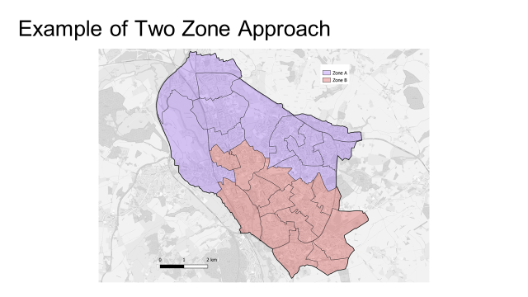

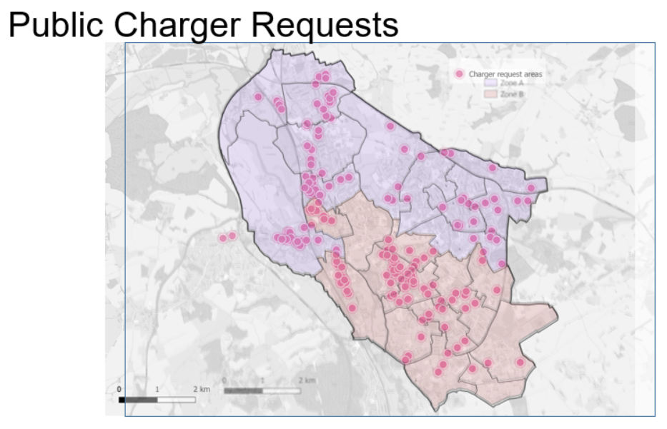
Evaluation maps display onstreet properties, deprivation score, capacity constraints, car club locations, deprivation, working driver populations, taxi ranks, five min walking radius of existing location, population density etc.

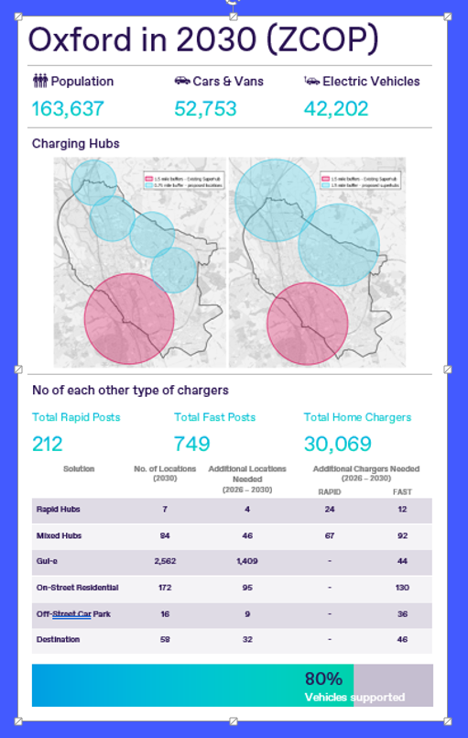

Questionnaire needs to be specific to the good/services you are looking to procure. Please add/change as required.

