ProContract - Supplier Guide
  - Troubleshooting

Troubleshooting
I have forgotten my username or password! 4
Where do I find the project documents? 6
I have looked in the right place but there are no project documents. 7
How can I raise a query to the project team? 8

  - I have forgotten my username or password!

Both a username reminder and a password reset can be requested from the ProContract login page.

- From the Supplying the South West portal home page, click on ‘Suppliers’ Login’.

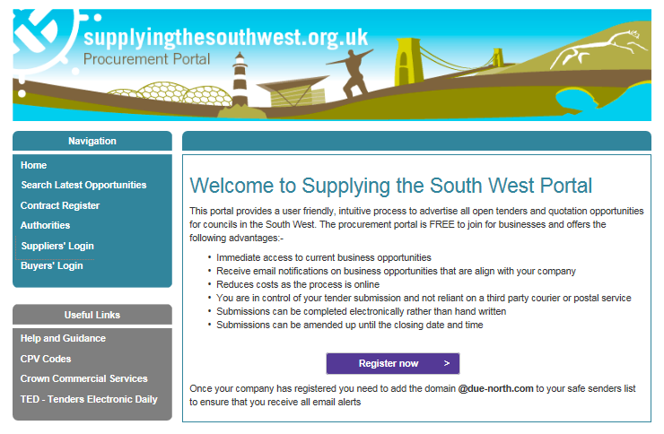

- Click on ‘Forgotten your username or password?’

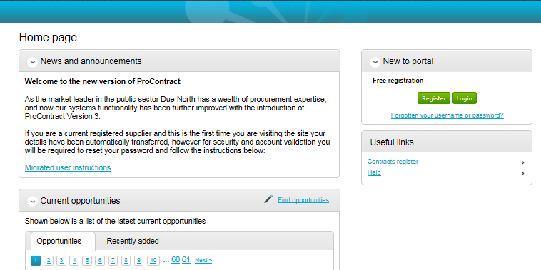

Forgotten usernames

- Click on ‘Forgotten your username?’

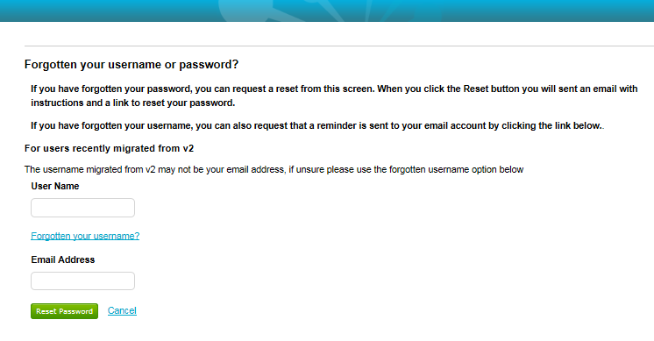
- Enter your email address and click on ‘Request username reminder’.

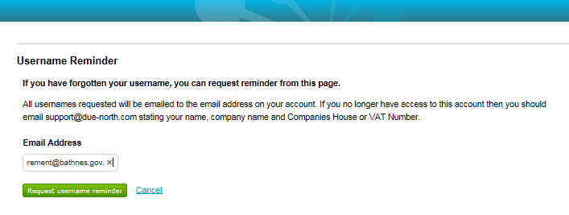
You will be sent an email with your registered username.

Forgotten passwords

- Enter your email address and click on ‘Reset password’.

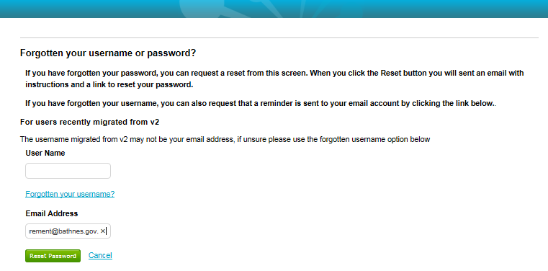
You will be sent an email with a link to reset your password.
  - Where do I find the project documents?

If you have been invited to take part in a quote or expressed an interest in an opportunity, project documents can be found in the quote or tender event.

- Log into ProContract.
- Click on the ‘Recently added’ tab and open the project by clicking on the blue title of the project.

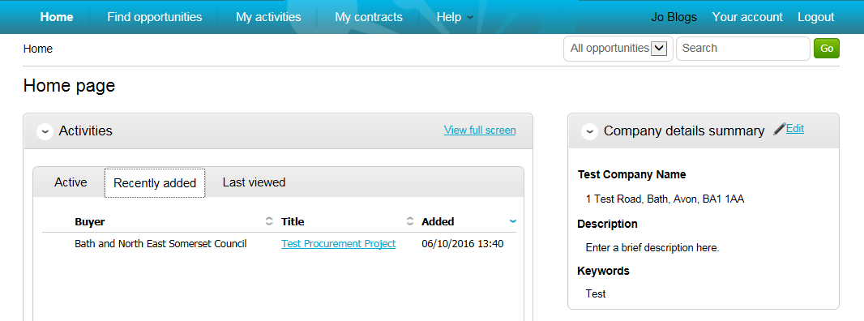

- Click on ‘Start’ to open the quote / tender event.

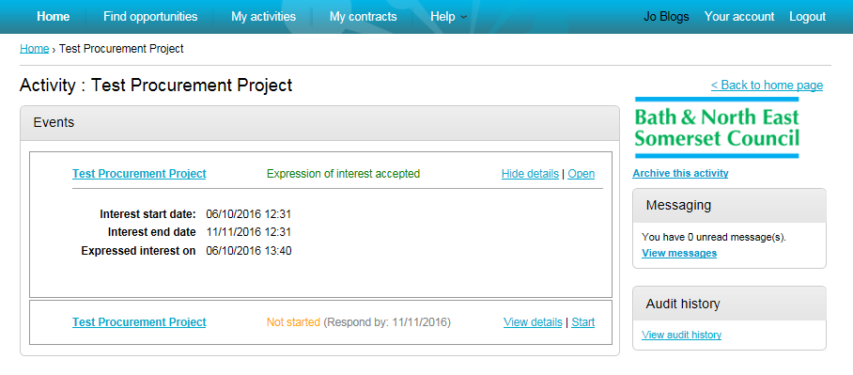

You will find all project documents under attachments.

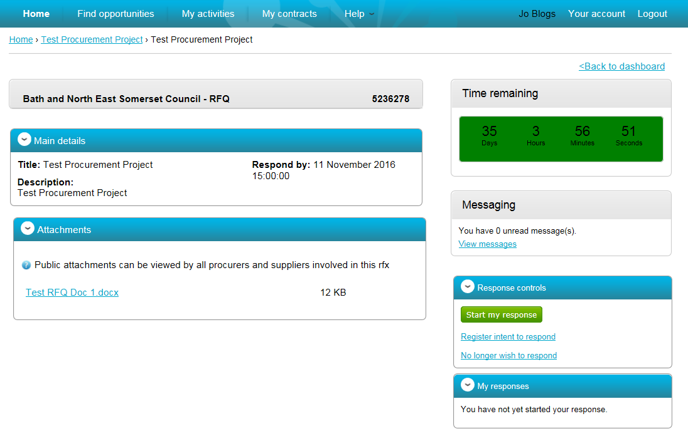

  - I have looked in the right place but there are no project documents.

If you are responding to an opportunity advertised on the portal

Please check the description in the advert in case additional information was provided. Sometimes an opportunity is advertised that does not require an expression of interest and is a signpost for a collaborative opportunity with another local authority or for a pre-procurement buyer event.

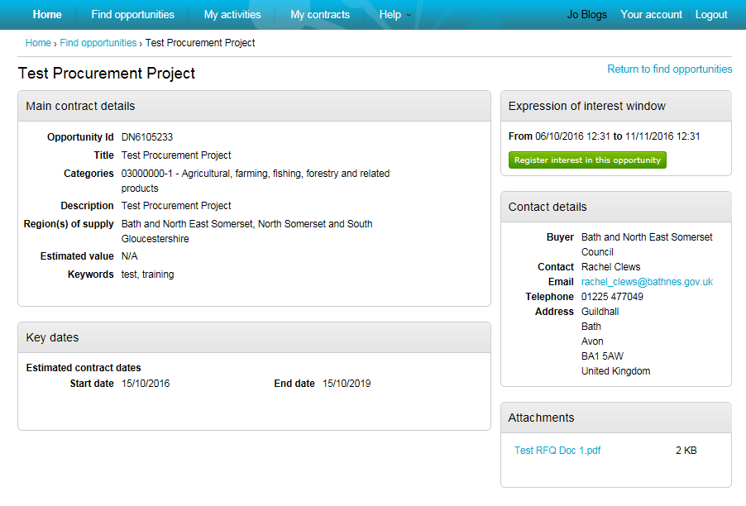

  - How can I raise a query to the project team?

Messages can be sent directly to the procurement project team through ProContract. The message section can be found on the project dashboard.

- From the ProContract Home page, click on the blue project name link in the ‘Activities’ section.

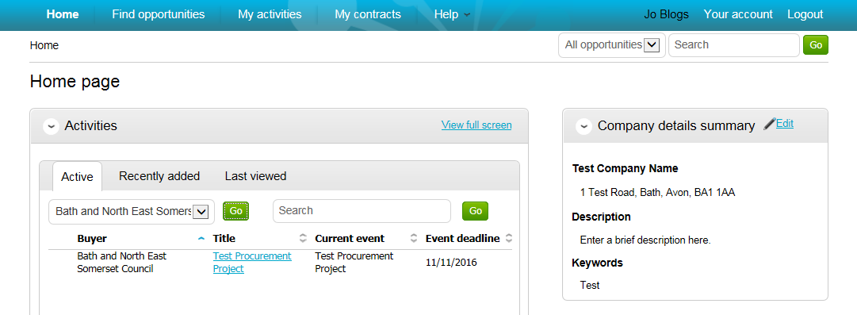

- Click on View messages to open the message section.

- Click on ‘Create new message’.

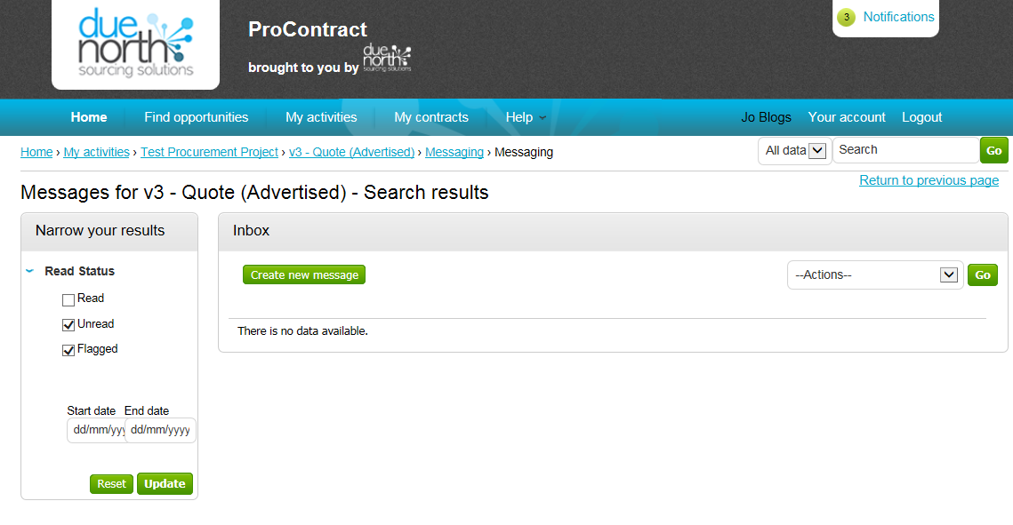

- Compose your message and click on ‘Send’.

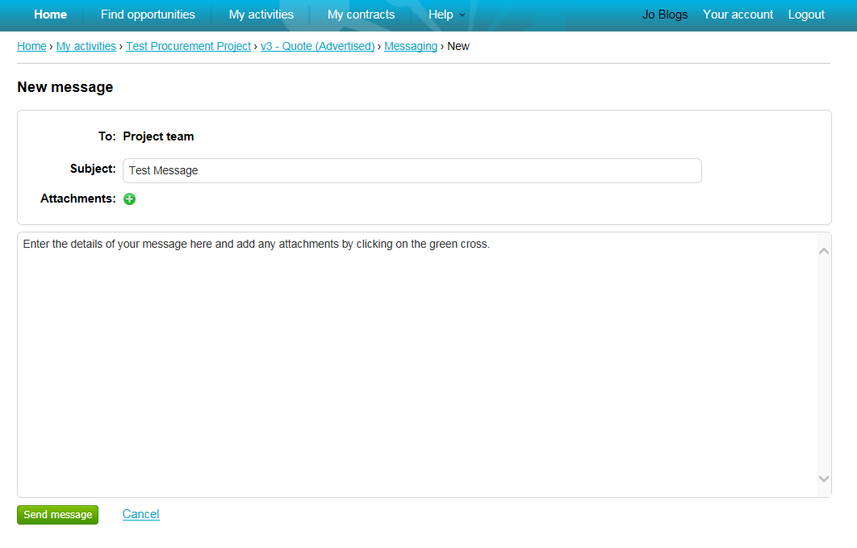Your message will be sent to the procurement project team

