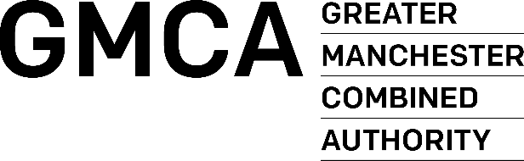

INVITATION TO TENDER

PART 3 – PRICING DOCUMENT

Greater Manchester Victim Services

Contract Ref: GMCA 706 (DN 661552)

Closing Time & Date: 12 Noon on 28/04/2023

Contract Duration: 36 months

with a provision to extend for 2 x 12-month periods

Name of Tenderer:

PRICING SCHEDULE
Please carefully read the instructions in this section regarding the completion of the Pricing Schedule.
Tenderers should ensure that all required relevant costs are included within the Pricing Schedule for years 1 - 3. They should be fully inclusive of all disbursements, expenses, and costs.
Tenders priced on a different basis will not be considered.
All costs should be completed in pounds STERLING (£), EXCLUSIVE of VAT.
The terms and conditions of the GMCA will apply to all orders placed as a consequence of this process.
Payment terms are 30 days.
Year 1
Description | Cost
Total

Year 2/3
Description | Cost
Total

I/We hereby offer to supply the above-mentioned services on the GMCA Conditions of Contract Services and confirm that we have read, understood and agree to be bound by the GMCA Conditions of Contract Services for all orders placed as a result of this process.

Signed
Name (Block Capitals)
Designation
For and on behalf of

