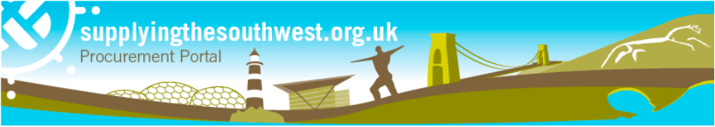

Dear supplier,

Later this year, significant new regulations will come into effect that will transform public procurement - the Procurement Act 2023. Following the laying of secondary legislation last month, we can confirm that we are working towards a ‘go-live’ date for the new regime of Monday 28 October 2024.

This is an important piece of legislation that will change the way the public sector buys goods and services. As one of our key suppliers this will impact the way we do business - so you need to know about these changes and our plans to prepare for go-live.

The existing rules will continue to apply for contracts that are already in progress, and for procurements started under the current regime, however for all new procurements post October, it is important that you understand the change. During the next few months of preparation, we will start providing you with updates and let you know nearer the go-live date when you may need to act.

The Cabinet Office, who are leading the Transforming Public Procurement programme, will also be providing regular updates, therefore if you have not done so we encourage you to subscribe to our update bulletin and check in to the dedicated gov.uk page. There are also plenty of conferences and events where the team are explaining how things will be different under the new regime.

A key objective for the Procurement Act 2023 was to make it easier for suppliers to do business with the public sector- as such there are some core benefits for suppliers once the new regime goes live in October, including:
- A main place to register and to store your core business details so that they can be used for multiple bids
- Improved transparency and access to information, with all public procurement opportunities in one place - making it easier to search for and set up alerts for procurements of interest to you
- Better visibility of procurement plans, engagement events and tender opportunities - including those below threshold - increasing the number of opportunities available to bid on
- Greater visibility about who is bidding for, and winning, larger public sector contracts above £5 million, and the details of those public contracts.
- Simplified bidding processes to make it easier to bid, negotiate and work in partnership with the public sector - including a new ‘competitive flexible’ procedure.
- Frameworks will be more flexible, so prospective suppliers are not shut out for lengthy periods of time.
- A new duty on contracting authorities to have regard to the barriers facing Small Medium Enterprises (SME) and Voluntary Community and Social Enterprise (VCSE) suppliers, and to consider what can be done to overcome them throughout the procurement lifecycle, helping level the playing field for smaller businesses so they can compete for more contracts.
- Strengthened provisions for prompt payment throughout the supply chain - enabling SMEs to benefit from 30-day payment terms on a broader range of public sector contracts.
- A stronger exclusions framework will take tougher action on underperforming suppliers.

This is a long-term change, so although these benefits may not be visible on day one - we are confident that the new regime will help break down barriers to entry into procurement.

Our procurement team is now working through the necessary training and guidance materials, so we are ready to operate under the new regulations and realise the benefits of the new regime when it goes live.

The Cabinet Office will continue working with leading business groups and trade associations to make sure information is available for suppliers.

There is already a range of information and resources about the new regime on the Transforming Public Procurement landing page.

If you have not already- we strongly recommend you watch the ‘Knowledge Drop’ videos with dedicated versions designed specifically for suppliers, including Small Medium Enterprises (SME) and Voluntary Community and Social Enterprise (VCSE) suppliers - these will give you a broader understanding of the changes which will be coming.

There are other actions you can start to take to prepare:

- Sign up for regular updates here.
- Familiarise yourself with the Act - check out the summary documents and videos on the Transforming Public Procurement landing page.
- Discuss the changes with us - we are now thinking about our forward pipelines and which procurements might benefit from the new flexible approaches and would be happy to discuss our preparations and timelines with you.
In the meantime, if you would like to discuss any aspect of the new Act, please contact the dedicated Transforming Public Procurement helpdesk at procurement.reform@cabinetoffice.gov.uk.

Kind regards,

To see the local authorities that are members of the Suppling the South Procurement Portal use this link.

