Blackpool Council Engineering (Trams)

Rail replacement on Blackpool and Fleetwood Tramway

Revision History

Version | Date | Description of Change
Draft | October 2014 | First Draft for comment
1.0 | June 2020 | Initial Issue

BC Document Number: | BPL-TWY-GD-002
Issue Number: | 1.0
Issue Date: | June 20
Author: | Blackpool Council, Track Services
Approver:  Signature: | Tramway Safety Officer  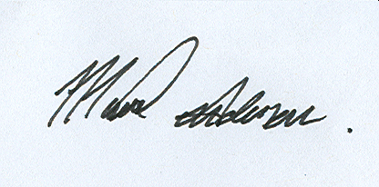
Review Date: | June 21

Record of Review
Date of Review | Occasion  A- Annual  X- Exceptional | Name of Reviewer | Signature

Issue Record:
Copy No. 1 Track Safety Officer
Copy No. 2 Blackpool Council Occupational Health & Safety Department
Copy No. 3 Blackpool Transport Services

Contents
1 Introduction 6
1.1 Background 6
1.2 Roles 6
2 Permanent Way 7
2.1 Network Layout 7
2.2 Plain Line Track Construction 8
2.2.1 Track Gauge 8
2.2.2 Minimum curve radii 8
2.2.3 Ballasted Track Construction 8
2.3 Switch and Crossing Track Construction 9
3 Wheel Rail Interface 11
3.1 Compatible Wheel Profile 11
4 Platforms & Structural Clearances 12
4.1 Tram Stops 12
4.2 Structures 12
5 Track Access 14
5.1 Guidance 14
5.2 Stabling & Security 14
6 Requirements Specification 16
6.1 Scope 16
6.1.1 Scope of work/special precautions 17
6.2 Possession Strategy 17
6.2.1 Protection Arrangements 17
6.2.2 Permit Applications 17
6.3 Working Safely on the Tramway 17
6.3.1 Restricted working hours 18
6.4 Suggested Methodology 18
6.5 Tram Stops and crossings 18
6.6 Ballasted track 18
6.7 Technical & Functional Requirements 19
6.7.1 Pre-bent rails 19
6.7.2 Outer worn rail 19
6.7.3 Sleepers 19
6.7.4 Tamping 19
6.8 Road closures 19
6.8.1 Track crossing installations 19
6.9 Contact 20

List of Figures
Figure 1 Blackpool & Fleetwood Tramway Network Layout 7
Figure 2 Ri60R1 Groove Rail Profile 9
Figure 3 Crossing Nose & Check Rail Flange Running Profiles 10
Figure 4 Compatible Wheel Profile 11
Figure 5 Critical Wheel Profile Dimensions 11
Figure 6 Platform Edge Clearances 12
Figure 7 OLE Centre Pole Minimum Clearance 13
Figure 8 Tamper On Tracking 14
Figure 9 Melton Place 15
Figure 10 Orion Curve 15
List of Tables

Abbreviations
BC Blackpool Council
BTS Blackpool Transport Services
IM Infrastructure Manager
OLE Overhead Line Equipment
ORR Office of Rail Regulation
ROGS Railways and Other Guided Transport Systems (Safety) Regulations 2006
RSP2 Guidance on Tramways
RRV Road Rail Vehicle
TSO Tramway Safety Officer
TO Transport Operator
TU Transport Undertaking

References
RSP2, Guidance on Tramways
URL: http://orr.gov.uk/__data/assets/pdf_file/0018/2637/rspg-2g-trmwys.pdf
Tramway Technical Guidance Note 1 Design Requirements for Street Track
URL: http://orr.gov.uk/__data/assets/pdf_file/0019/5068/ttgn1-StreetTrack.pdf

Introduction

Background
The Blackpool & Fleetwood Tramway is the only remaining first generation tramway in the United Kingdom, having remained in constant operation since it first opened in 1885. The current network extends for 18.2Km along the Fylde coastline from Starr Gate terminus at the southern end of the alignment to Fleetwood Ferry in the north.
Blackpool & Fleetwood Tramway is owned by Blackpool Council (BC) and operated under licence by Blackpool Transport Services (BTS).

Roles
The Railway and Other Guided Transport Systems (Safety) Regulations 2006 places legal obligations on persons carrying out specific duties under the regulations. These bodies are called Duty Holders. The Duty Holder’s for Blackpool & Fleetwood Tramway are:
- Infrastructure Manager - Blackpool Council Track Safety Officer
- Transport Operator – Blackpool Transport Services Head of Tramway
The Infrastructure Manager is responsible for the condition of the asset and is the principal point of contact for all matters relating to the tramway.

Permanent Way

Network Layout
The track layout is as shown in Figure 1.
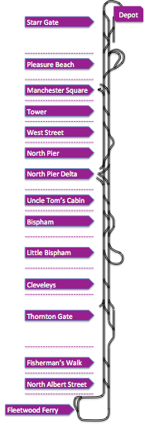
Figure 1 Blackpool & Fleetwood Tramway Network Layout
Ballasted track construction is used on Blackpool & Fleetwood tramway between Uncle Tom’s Cabin and Fisherman’s Walk only. However, the ballast track is punctuated at regular intervals by short sections of paved track construction types between these tram stops. Therefore there is a requirement for plant that cannot easily disengage steel wheel contact with the rails to exhibit rail wheel interface characteristics that are compatible with the requirements set out in this section of this Guidance Document, especially through the embedded Switch & Crossing (S&C) Permanent Way configuration.

Plain Line Track Construction
Track on United Kingdom tramways is classified as integrated and segregated depending upon the environment in which it operates. Track on the Blackpool & Fleetwood tramway is fundamentally of two construction types:
- Ballasted track form to Network Rail Track Construction Standard to satisfy the requirements for Category 4; and
- Paved track with encapsulated groove rail (Ri60R1).
All Switch & Crossing units are constructed in paved track sections of the alignment and Tamper & Road Rail Vehicle (RRVs) wheel profiles proposed to be used on the network will need to be compatible with both the plain line Ri60R10 and S&C in respect of rail groove and gauge corner compliance.

Track Gauge
Track gauge is 1435mm throughout.

Minimum curve radii
The minimum curve radii on the network are as follows for the different types of track construction:
- Ballasted track 147m; and
- Paved Track 22.5m.

Ballasted Track Construction
The ballast track on the network is constructed from the following materials:
- Rail profile predominantly CEN56E1 with some 95lb bullhead rail on tight curves (see Note);
- Rail inclination 1:20 nominal;
- Sleeper spacing nominally 700mm (26 per 18.288m);
- Sleeper type G44 except for tight radius curves where timber sleepers are used with check rail; and
- Depth of ballast 250mm nominal.
Note: At Thornton Gate and Cumberland Avenue there are extended lengths of vertically mounted Ri60R1 on 001 Bearers. Note that the gauge corner for the asymmetric groove rail used on the network is 10mm. The groove is 36mm wide at its maximum width and 47mm deep. The detailed drawing is shown in Figure 2.
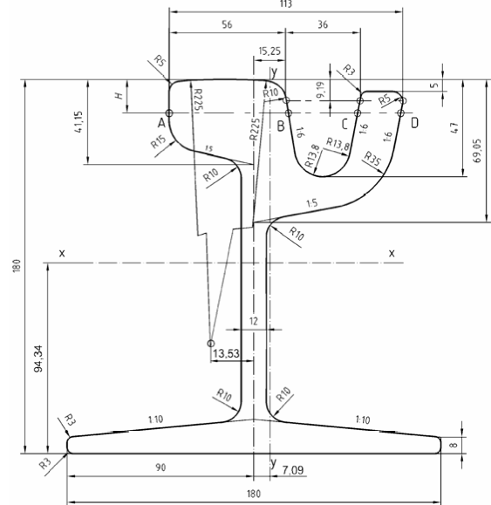
Figure 2 Ri60R1 Groove Rail Profile

Switch and Crossing Track Construction
S&C construction is important because tampers and rail mounted plant that ideally need to stay on the rail head to move from site to site must be compatible with the changes in the rail configuration as the wheel flange passes through the crossing nose and parallel check rail section. At this point the groove width and depth alter significantly to present a rail profile to the wheel that forces the wheel out of the groove and generates ‘flange running’ during which the flange makes contact and runs on the shallow (circa 14mm) rail channel. Figure 3 illustrates the changes in the rail groove profile through all S&C crossing noses and check rail sections and the transitional arrangements between full Ri60R1 groove rail.

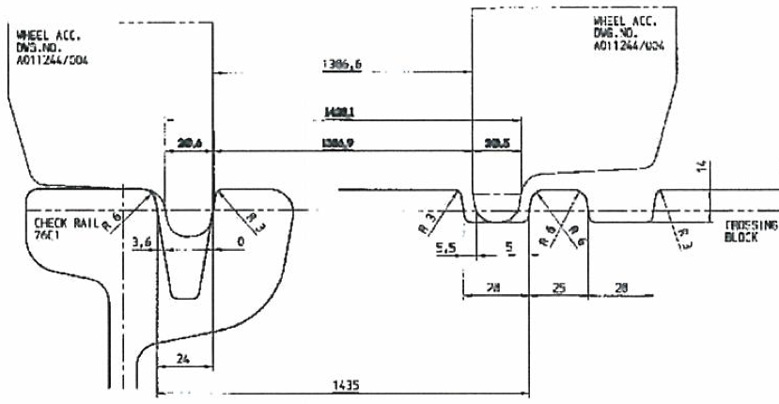

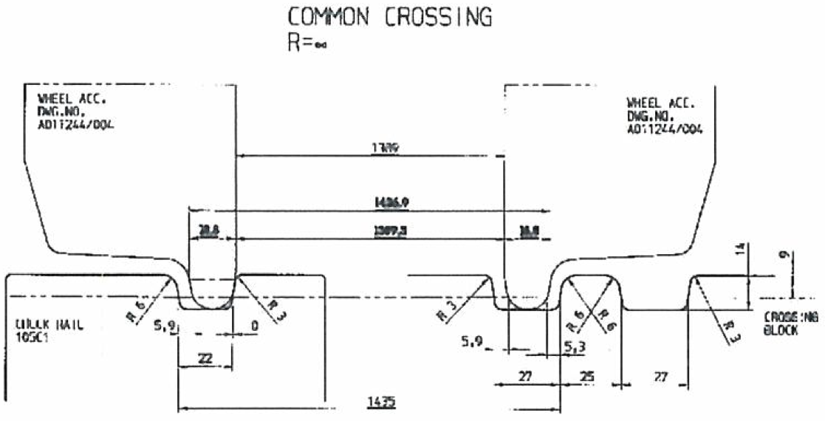

Figure 3 Crossing Nose & Check Rail Flange Running Profiles

Wheel Rail Interface

Compatible Wheel Profile
Figure 4 illustrates a proven compatible wheel profile for plant utilised on the Blackpool & Fleetwood tramway during the 2009-2011 track renewal works.
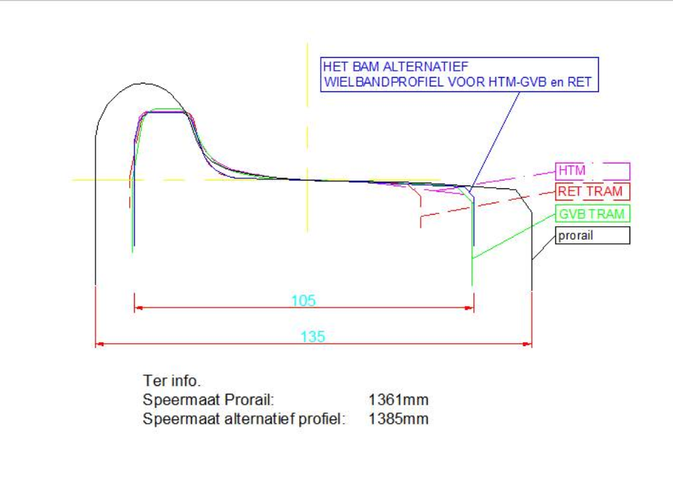
Figure 4 Compatible Wheel Profile
Figure 5 tabulates the critical dimensions of the proven wheel profile illustrated at Figure 4.
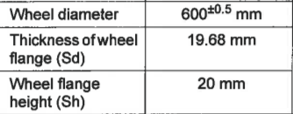
Figure 5 Critical Wheel Profile Dimensions

Platforms & Structural Clearances

Tram Stops
Blackpool & Fleetwood Tramway complies with the Mobility Inclusive Regulations and Rail Vehicle Accessibility Regulation through the provision of low level platforms across the network with stepping distances nominally 50mm between tram and stop edge in both the vertical and horizontal planes. Figure 6 identifies the setting out clearances that are applied at all tramstops across the network.
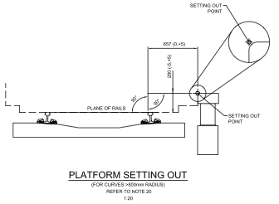
Figure 6 Platform Edge Clearances

Structures
The minimum clearance to any structure is to centre mounted Overhead Line Equipment (OLE) poles. The clearance to these structures is set at Developed Kinematic Envelope (DKE)+100mm (minimum) based on the DKE of the Flexity 2 tram. This means that for straight and level track the closest point of a centre mounted OLE pole can be 857.5mm from the running edge of the 6ft rail (1575mm from the track centre line). As dynamic effects of track curvature and can’t influence different vehicles in different ways it is the responsibility of the prospective supplier to ensure that gauging clearances are satisfied for operation on the Blackpool & Fleetwood tramway. It should however be noted that the structural clearances applied on the network are both consistent with the requirements of RSP2 and those installed on all other UK light rail networks. Figure 7 is an extract from RSP2 that illustrates the minimum clearances.
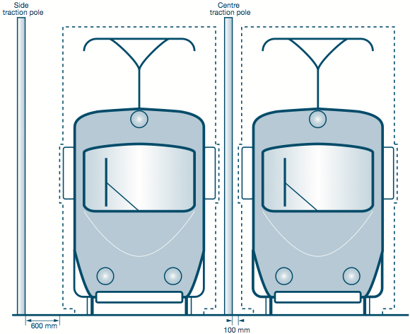
Figure 7 OLE Centre Pole Minimum Clearance

Track Access

Guidance
Standard precautions and procedures for gaining access to the network are contained in the document ‘Safety on the Line’, which is available upon request from the TSO. Amongst other things it sets out the minimum OLE wire height for the network and the standard safe working heights to be adopted.
Figure 8 shows a tamper on tracking at Fisherman’s Walk close to the northern limit of the ballast track construction.

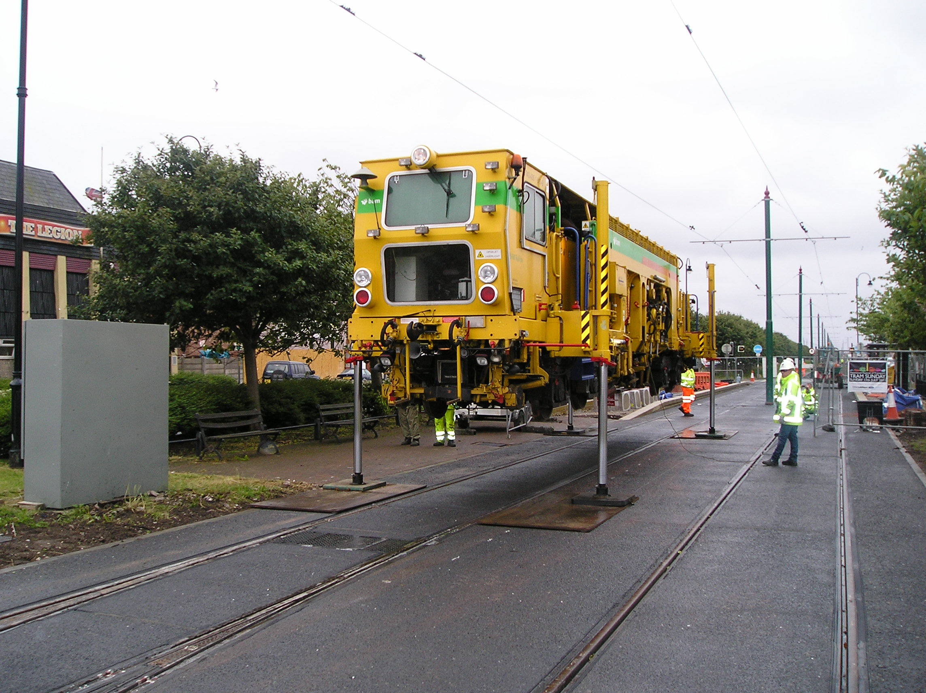
Figure 8 Tamper On Tracking
The selection of the most appropriate on and off tracking point requires careful consideration due to the close proximity of residential properties and constricted turning opportunities for Long Wheelbase vehicles. Fisherman’s Walk is a good choice of location because it represents the boundary between integrated on street and segregated off street track construction types.

Stabling & Security
All areas of the tramway between Uncle Tom’s Cabin and Fisherman’s Walk are entirely accessible with no secure area available for stabling Tampers or other large items of plant. The most appropriate stabling areas are at Thornton Gate or Bispham. Access to the secure tram depot at Starr Gate is impractical because of the nature of the network south of Uncle Tom’s Cabin and the tight radius curves within the depot. The requirements for stabling and security should be discussed with the TSO during the consultation process which will happen post-award and prior to commencement on site.

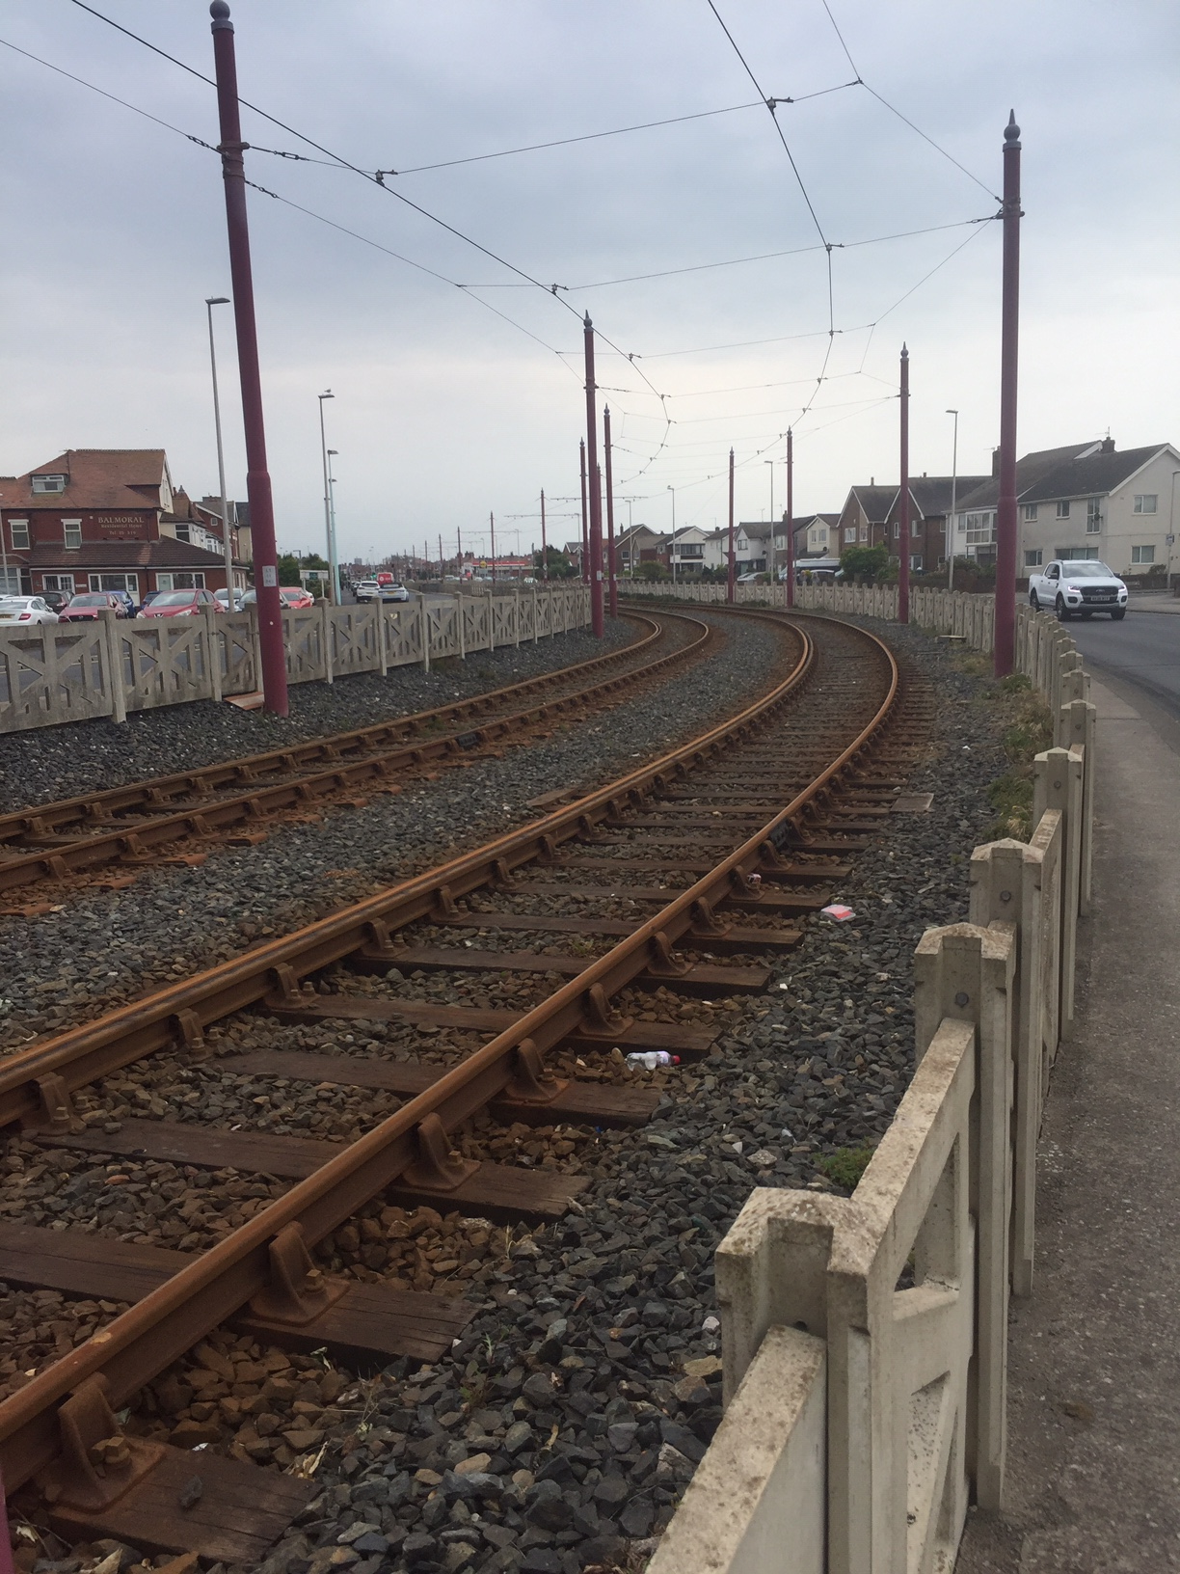
Figure 9 – Orion Curve
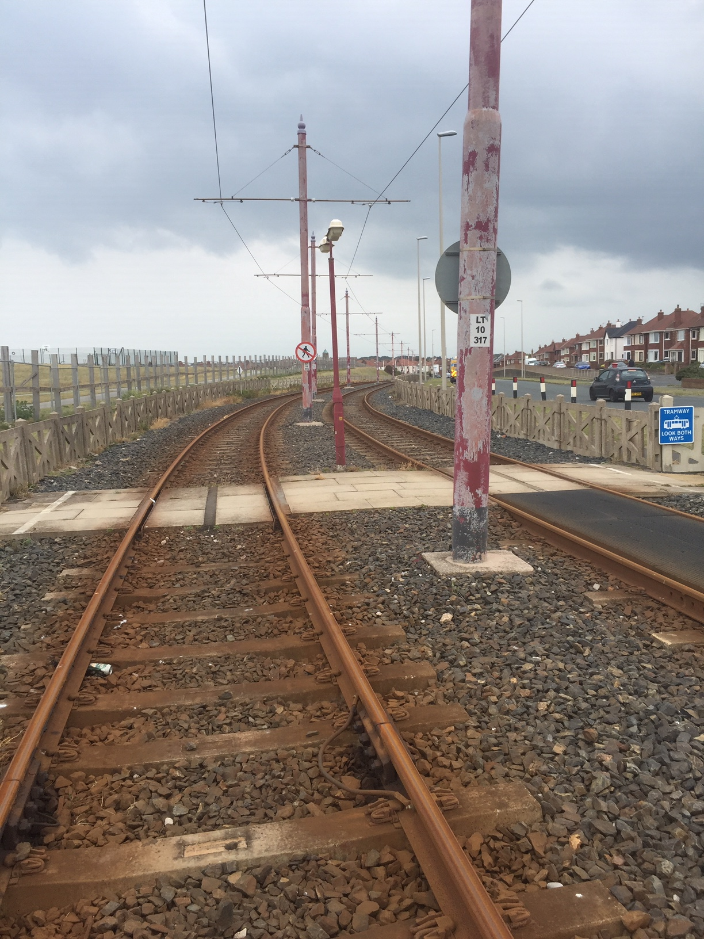
Figure 10 – Melton Place

Requirements Specification

Scope
This section outlines the key information necessary to enable interested suppliers to develop a technical proposal to undertake rail replacement on the Blackpool & Fleetwood tramway system. Applications to Blackpool Council should include an indicative programme of works, a schedule of rates and an offer price.

Scope of work/special precautions
The work areas shall be surveyed prior to ordering new rail. Any crossings where underrun needs to be removed shall be identified prior to commencement. Additionally, the pedestrian crossings formed in hard materials will also need to be identified and removed by the Council to necessitate the work.

All platforms shall remain untouched. Please note restricted access when passing through the platforms.

Other works are programmed during the system closure, this includes sub arc welding and tamping. Refer to the other appropriate lots to clarify where the proposed works are and what if any impact it will have on the work.

Possession Strategy
Works on the tramway are to be undertaken outside the resorts tourist and illumination season. The preferred date for undertaking the works is during the February half term holiday (week commencing 15th Feb 2021). A detailed works programme is required to enable the Tramway Safety Officer to establish whether the required access can be negotiated with the Transport Operator.
Contractors must be aware of other potential works during this period including tamping (Uncle Tom – Fishermans Walk) and sub-arc welding which may be undertaken by other Contractors. The successful Contractor should liaise with BC to avoid scheduling conflicts.

Protection Arrangements
Rail replacement will be under full possession (system closed). Unless specifically arranged in advance the OHLE is LIVE AT ALL TIMES. Full details of the definitions and requirements for establishing safe systems of work are contained in Blackpool Council’s track safety publication, ‘Safety on the Line’. This document is the equivalent of the Rule Book GE/RT8000.

Permit Applications
Permits should be submitted to the Tramway Safety Officer. A copy of the Permit Application Form, including information on how to submit can be found via the following URL:
https://www.blackpool.gov.uk/Business/Licensing-and-permits/Documents/Tramway-Activity-Permit-Application.pdf

Working Safely on the Tramway
Full details of how to implement safe systems of work on the tramway including working adjacent and under overhead line electrification equipment is contained within the document ‘Safety on the Line’. A condensed version of the document outlining the salient points is available on Blackpool Council’s website via the following URL:
https://www.blackpool.gov.uk/Business/Licensing-and-permits/Documents/tramway-overhead-powerlines.pdf

Restricted working hours
Some work may be conducted at night to allow a tram service during the normal working day. Trams cease to operate between 01:00 to 05:30, however the OHLE remains LIVE. Advanced notice must be given for any out of hours work proposed.

Suggested Methodology
Where possible, a Highways lane possession will be acquired to assist in loading/storage and rail installation operations. During the work, if safe to do so and access allows, the other line may be used to operate the service where the trams will run bang line. Where access to the site is restricted, the operational line will be closed for work plant access (road/rail machines)
The network layout map indicates where the turnback locations are but for clarity these are scheduled out here:
- Bispham;
- Little Bispham;
- Cleveleys; and
- Thornton Gate.
Once work is complete beyond the recognised turnback point the line block will be shortened to enable revenue service to be extended.

Tram Stops and crossings
Melton Place site will require the removal of a pedestrian crossing. Upon completion, the crossing and underrun protection (supplied by the Council) will be reinstated.
Any road rail plant required to undertake the work must ensure adequate clearance to the platform edge

Ballasted track
The areas of relay are;
Flat bottom 113lb (56E1)
Location pole nr length track sleeper
Melton Place LT10.231 – 354 123m East G44
Melton Place LT10.259 – 354 95m West G44
Cleveleys Crescent LT11.362 – 435 73m East G44
Maplewood Drive LT10.555 – 782 227m East G44

Bullhead 95lb rail
Orion Curve LT11.207 – 307 100m west timber
(note check rail present in this location)

The majority of the existing infrastructure (sleepers/ballast etc) does not require replacing. Although a small number of G44 sleepers with damaged fastclip housings will require replacing (10 maximum). The sleepers will be provided by the Council. The scope of the work is to replace the outer rail of each bend. At the start and end of the rail replacement there is an existing plated joint.

Technical & Functional Requirements

Pre-bent rails
The contractor, in adequate time, must survey the area and determine the radius of each bend and order the pre-bent rail accordingly.
The system is continuously welded rail (CWR) – There will be 1 fish plated joint followed by 2 welded joints.

Outer worn rail
Only the outer rail (in relation to direction of travel) will be replaced.

Sleepers
It is envisaged that there are a maximum of 10 G44 concrete sleepers that require replacing. This shall be undertaken by the contractor following the installation of the new rail. Sleepers will be provided by the Council. All the timber sleepers and chairs in the bullhead section are in good condition.

Tamping
Following installation of the new rail, the area of replaced rail +50m in each direction will require tamping.

Road closures
Road closures will not be required, however lane possessions may be required and if the contractor requires them to facilitate the work. Any lane possessions must be requested 8 weeks in advance so the Council can arrange the appropriate permits/traffic management.

Track crossing installations
It is not envisaged that any works will be required in the vicinity of underrun protection or vehicle crossings. For information, proprietary rubber mat crossings are installed at the following locations:
- Road (vehicular):
  - Bispham
  - Norbreck
  - Anchorsholme Lane
  - Westmoreland Avenue
  - College Farm
  - Rossall Lane
  - South Strand
  - Larkholme Avenue
- Pedestrian:
  - Vicarage Ave
  - Clarence Ave
  - Stockdove Way
- Platforms – in ballasted areas only.

Contact
All enquiries to undertake works on the tramway should be directed to the Tramway Safety Officer at Blackpool Council’s Layton Depot site at the following address:
Plymouth Road
Blackpool
FY3 7HW

Full contact details for Blackpool Council can be found via the following URL:

https://www.blackpool.gov.uk/Contact-us.aspx.

