LCRCA BUS SERVICE DELIVERY – OPERATOR MARKET ENGAGEMENT

1. Introduction and Purpose
1.1. The Liverpool City Region Combined Authority (LCRCA) is undertaking an assessment of new bus reform options in the Liverpool City Region (LCR) pursuant to the Transport Act 2000 (as amended by the Bus Services Act 2017) (the Act).
1.2. This information memorandum (IM) has been issued by the LCRCA as part of a market engagement exercise to provide current and prospective operators with information about the LCRCA's commercial proposition for bus franchising and to seek input from interested parties to inform the LCRCA's understanding of the capabilities of the market.
1.3. This IM is being sent to bus operators within the LCR and respondents to the Periodic Indicative Notice (PIN) for Liverpool City Region Bus Franchising: Market Sounding. This IM includes a questionnaire to assist the LCRCA in carrying out the market engagement exercise.
1.4. At this stage, the LCRCA is establishing the level of market interest to inform the franchising assessment. Any information gathered pursuant to this IM will not be considered in any future tender evaluation exercise.
1.5. Participation or non-participation in this market engagement shall not prevent any party participating in a potential consultation or procurement process nor is it intended that any information supplied shall place any party at an advantage in any forthcoming consultation or procurement process.
1.6. Responses given pursuant to this IM shall not be taken as support or otherwise for the franchising proposition itself.
1.7. This IM is without prejudice to the LCRCA's assessment of other bus service delivery options and does not formally signify the beginning of a consultation, nor constitute a commitment by the LCRCA or the Metro Mayor of the LCR to implement a bus franchising scheme. In the event that a formal consultation on the assessment is to be undertaken pursuant to the Act, a separate contract notice will be issued.
1.8. Parties shall be responsible for their own costs incurred in connection with this market engagement exercise.
2. Market Engagement Objectives
2.1. The objectives of this market engagement exercise are to:
2.1.1. seek evidence to inform the assessment for franchising and to allow the LCRCA to critically assess the viability and suitability of the commercial proposition;
2.1.2. gain insight to the market's capabilities and preferences and to identify the level of market interest;
2.1.3. understand the associated risks and issues;
2.1.4. identify opportunities to refine the commercial proposition, considering the best outcomes for passengers, operators and the LCRCA; and
2.1.5. raise operator awareness of the commercial proposition and the potential effect on their businesses,
(the Objectives).
3. Progress to Date
3.1. The LCRCA published a notice on 26 September 2018 confirming its intention to prepare an assessment of bus franchising within the LCR pursuant to section 123(C)(4) of the Act. Following publication of this notice, it commenced its work on the development of an Outline Business Case for franchising in accordance with the Act and associated statutory guidance.
3.2. The LCRCA has gathered data from operators within the region to help develop its assessment to its current point and, on 20 February 2020, it announced that, subject to completion of the assessment and the statutory process, franchising had emerged as the "leading option", amongst others, for the future of the region's bus network.
3.3. The LCRCA is in the process of refining its franchise assessment to take into account the impact of a range of potential Covid-19 recovery scenarios both in relation to the bus market and the city region a whole. When the LCRCA's proposition has been finalised for audit and consultation, it will complete the assessment for submission for audit followed by a statutory consultation in Q2 2022 with a Mayoral decision on whether to implement the franchising scheme anticipated in Q3 2022.
4. Timeline
4.1. The LCRCA intends to undertake a number of activities to engage the market. This includes:
4.1.1. issuing a Periodic Indicative Notice (PIN) – the PIN was issued on 3 August 2021 (ref: 2021/S 000-018578);
4.1.2. issuing a market sounding questionnaire to gather operator feedback on the proposition and invite their input into the process – contained within this IM;
4.1.3. reviewing responses to the questionnaire, refining the proposition as appropriate and identifying areas on which respondents should be further consulted; and
4.1.4. inviting respondents to bilateral or group meetings (as appropriate) with representatives from the LCRCA to discuss responses and answer any further questions.
5. Questionnaire
5.1. The questions set out in this IM are designed to help the LCRCA achieve the Objectives.
5.2. Respondents should provide evidence to support their assertions where appropriate. The LCRCA wishes to avoid any bias being introduced into the process and, as such, any sales related material or statements will not be accepted and may result in the entire questionnaire response being disregarded for that organisation.
5.3. Responses to the questions should be in the format provided in the Annex to this IM. Respondents may wish only to respond to questions that are relevant to their organisation, however they are welcome to respond to as many or as few questions in as much detail as desired.
5.4. Responses to the questionnaire may be subject to disclosure in accordance with the Freedom of Information Act. If respondents wish information that has been provided to be treated as confidential, they should state this clearly in writing when sending responses to the questionnaire. However, the LCRCA cannot give an assurance that confidentiality can be maintained in all circumstances.
5.5. Questionnaire responses should be submitted at the respondent's earliest available opportunity and by 10 September 2021 at the latest. Respondents should submit questionnaire responses to tender@liverpoolcityregion-ca.gov.uk

ANNEX: QUESTIONNAIRE
Areas for Engagement / Questionnaire
This section sets out the LCRCA’s positions across a number of Areas for Engagement, and questions which LCRCA requests operators to answer.
The LCRCA’s overall proposition is to replace the current arrangements with a set of gross cost franchises, with revenue risk being taken by the Authority. Further detail is provided within the Areas for Engagement below.
- Franchise package size
Due to the size of the LCR and the number of suburbs and key corridors feeding into the city, the LCRCA’s current proposal is to split the bus network into 6 geographical areas, referred to as “Rounds”. For the purposes of the franchising scheme, each Round is deemed to be a “sub-area”. Once franchising is introduced in a sub-area, only services under a franchise contract or a valid service permit would be allowed to run in that sub-area.
The Rounds are as follows:
- Halton;
- Knowsley North & Liverpool North;
- Knowsley South & Liverpool South;
- Sefton;
- St Helens; and
- Wirral.
Rounds range in size, measured in Peak Vehicle Requirement (PVR), from 59 (Halton) to 299 (Knowsley North & Liverpool North).
Within each Round bus service routes would be grouped together as “Lots”, which would form the basis of franchise contracts. The LCRCA has developed the Lots within each Round considering the geography of the routes (on a key corridor basis) and specific vehicle requirements for particular groups of routes (e.g. routes suitable for single deck-only vehicles, longer distance radial routes).
There is an inevitable degree of geographical overlap between Lots and Rounds. This is not extensive and should not be an issue once the whole of LCR is franchised. In addition, LCRCA would have a permit regime for cross boundary, non-franchised services.
A breakdown of the proposed Rounds and Lots and package sizes is provided below:
Round | Lots and required PVR | Geographical area
Halton | PVR of Lots: 15; 30; 6; and 8.  (59 PVR Total) | 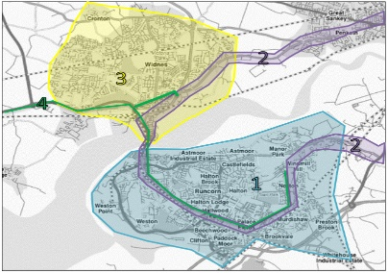
Knowsley North & Liverpool North | PVR of Lots: 16; 24; 46; 51; 41; 14; 68; 8; 4; 12; 8; and 7.  (299 PVR Total) | 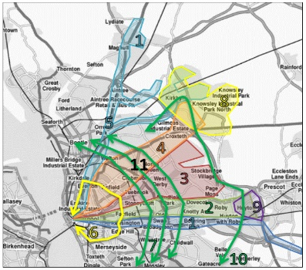
Knowsley South & Liverpool South | PVR of Lots: 53; 89; 9; 16 and 12.  (179 PVR Total) | 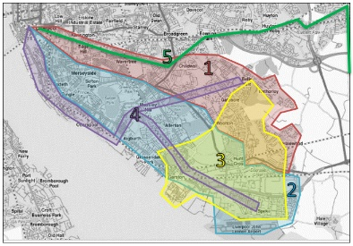
Sefton | PVR of Lots: 27; 31; 3; 51; 9; and 10.  (131 PVR Total) | 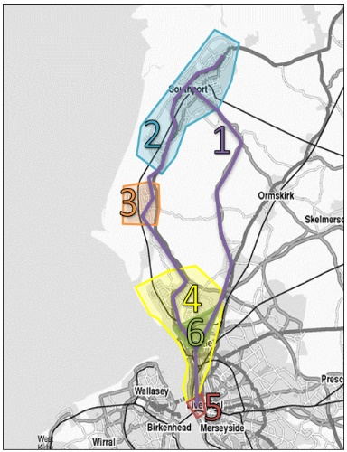
St Helens | PVR of Lots: 45; 17; 8; 56; 16; 11; 9; and 6.  (168 PVR Total) | 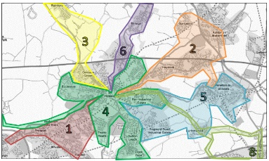
Wirral | PVR of Lots: 51; 33; 9; 5; 27 and 10.  (135 PVR Total) | 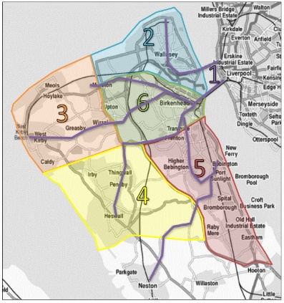

Franchise contracts would consist of either an individual Lot, procured on a stand-alone basis, or groups of Lots procured together as a single contract where it is beneficial to do so, e.g. to provide economies of scale.
Question to operators:
(i) Please set out the benefits and limitations of the franchise package sizes and related geographies proposed from the perspective of your organisation.
(ii) Do you have any views on the frequency in which Lots are tendered (for example, if all Lots within a Round were tendered concurrently)?

- Franchise package phasing
There would need to be a transition period(s) during which franchised services and deregulated services run concurrently. However, the LCRCA would minimise such periods to enable earlier achievement of the full impact of franchising and to limit the period when customers are offered a potentially inconsistent service across different parts of the LCR. Balanced against this are the challenges of implementation, both in terms of ensuring that the proposed approach works effectively and managing the number of procurements required.
The LCRCA’s proposed approach to phasing is therefore to franchise all routes over a 3 year period, with each of the 6 proposed Rounds let at 6-month intervals.
The Authority is open to receiving suggestions as to the optimal order in which Rounds should be tendered.
The earliest franchise contracts could have franchise periods shorter than the target five year period, in order to provide for a regular and consistent level of procurement activity for the LCRCA and the bus market.
In the steady state, following the introduction of franchising in the LCR, there would be a regular pattern of franchise procurement which would mean there are one or two Rounds being re-tendered each year.
Franchising would require the unwinding of the Alliance, and the LCRCA would engage with Alliance members to ensure that the transition is efficient and mutually beneficial.
Questions to operators:
(i) To what extent do you consider the proposed phasing strategy to be appropriate?
(ii) Do you have any views on the order in which Rounds should be tendered / the potential sequencing of franchise packages? If so please provide these together with your underlying rationale.
(iii) To what extent do you consider the proposed re-tendering strategy to be appropriate? Does your organisation consider that this approach will maintain an active bus market within the LCR?
(iv) Do you agree that the availability of fleet and depots are the main barriers to entry and do you consider there to be any others?
(v) Do you have any views on the minimum length of time required to mobilise post-contract award?
- Franchise package length (including extension periods)
The LCRCA's current proposal is for fixed 5 year contracts for all Lots, other than:
- some initial Lots where shorter contracts will be offered to regulate the flow of contracts coming to the market after the initial period of franchising is completed; and

- certain contracts which contain school services, which may require contracts shorter than a 5 year fixed term and which will be agreed on a contract by contract basis.

The LCRCA is considering options for extension, which may include rights to extend for LCRCA discretion, force majeure and/or for operator performance.

Questions to operators:
(i) To what extent do you consider the Authority’s proposal on franchise package length to be appropriate and/or attractive to your organisation?
(ii) To what extent does the Authority’s proposal provide you with the ability to manage cost risk and make a suitable return on investment?
(iii) Do you have any views on contract extension?

- Franchise design: Procurement
The LCRCA would design the procurement process to meet the following broad requirements:
- competition is maximised;
- prospective operators are treated fairly and given an equal opportunity to participate;
- high quality services are economically delivered across the region; and
- legal obligations are complied with.
The procurement of franchise contracts would be governed by the Utilities Contracts Regulations 2016 (UCR). The UCR impose a number of structural constraints on the procurement design but also offer a degree of flexibility that will enable the LCRCA to adopt a design that best fits its requirements. LCRCA would also be required to comply with certain provisions in EU Regulation (EC) No 1370/2007 (as amended by the Regulation (EC) No 1370/2007 (Public Service Obligations in Transport) (Amendment) (EU Exit) Regulations 2020).
The LCRCA proposes to establish a qualification system under the UCR to pre-qualify prospective operators. This would enable a prospective operator to submit a single pre-qualification response and, if successful, to remain pre-qualified for the remainder of the franchising programme, entitling it to bid in all of the Rounds.
To be admitted to the qualification system a prospective operator would need to satisfy the LCRCA's stated selection criteria. These criteria would cover good standing; capability; capacity; and track record. It is also anticipated that the criteria would include a minimum financial standing requirement relevant to the scale of contract.
All prospective operators that satisfy the criteria would be admitted to the relevant qualification system. There would be no limit on the number of pre-qualified operators, and applications for admission to the qualification system can be made at any time, allowing for applications from new entrants or re-application from those whose position has improved since a previous (unsuccessful) application. Each pre-qualified operator would be required to keep its information refreshed and up to date. Any operator admitted to the qualification system would be removed if it no longer meets the selection criteria.
For each Round, the LCRCA would issue an invitation to negotiate (or "ITN") to all of the prospective operators that have been admitted to the qualification system (and, as applicable, that have passed any further, targeted pre-qualification exercise). The issue of the ITN would commence the bidding phase for that Round.
The LCRCA intends to adopt the negotiated procedure for the whole franchising programme. However, safeguards would be built in to ensure that each procedure is as effective and efficient as possible. This would include the right for the LCRCA to accept an initial bid for any given Lot, without triggering negotiations, where that bid delivers sufficiently strongly against the evaluation criteria (borrowing from a similar concept in the competitive procedure with negotiation that is available to contracting authorities under the Public Contracts Regulations 2015).
Having established a qualification system, the LCRCA proposes to have a continuous (and continually refreshed and updated) list of pre-qualified prospective operators, offering a ready-made group of market participants with whom an ongoing engagement dialogue can be maintained, to ensure that the procurement strategy continues to represent best practice while delivering the LCRCA's broad requirements (maximising competition; fairness and equal treatment; consistent high quality of services; and compliance).
The LCRCA proposes to retain the option to limit the number or size of Lots within a Round that a single operator can bid for or win. Any limit would apply on a Round-by-Round basis. The LCRCA would confirm any limit applicable to any Round(s) prior to inviting bids for the first Round, so that prospective operators have as clear a view as possible across the whole franchising programme.
Any limit might apply to the number of Lots within a Round that:
- a prospective operator can bid for; or
- (more likely) a prospective operator can win, meaning that rules would be required to determine the allocation of Lots where a particular operator was the highest scoring for a number of Lots in excess of the limit.
The reason for imposing a limit would be to deliver outcomes such as enhancing the diversity and resilience of the service operator market, facilitating strong competition for the Lots (by enhancing the opportunities for prospective operators to win) and facilitating the involvement of small and medium sized operators. The LCRCA considers that a procurement design that would permit one operator (or a small number of operators) to win all of the Lots would risk not delivering those outcomes.
Questions to operators:
(i) What does your organisation consider to be the optimal number of bidders that you would expect to see shortlisted at the main bid stage?
(ii) Do you have any other comments in respect of the proposed procurement process?
(iii) What information does your organisation consider necessary for it to be able to put together a bid?

- Franchise design: Commercial aspects
The LCRCA proposes the following:
(a) Fares and ticketing strategy (i.e. responsibility for establishing products and setting fares, and retailing tickets):
The Authority’s vision for ticketing is a simple, easy to understand, customer focused and smart offer.
The LCRCA would implement a common, simple fares and ticketing policy across all franchised services. This may include:
- reducing and standardising the number of products available;
- fare validity at all times on an individual service
- simplified product availability for both singles and multi-trips;
- fare-capping (daily and weekly).

(b) Revenue risk allocation:

The Authority would assume revenue risk across all franchised services. This means that the LCRCA will be at risk for any decreases in revenue (for example due to falls in patronage) and will be required to fund any resulting shortfalls.

However, operators will be incentivised to encourage passenger usage through the performance regime set out under Area of Engagement 6 below by meeting performance standards related, for example, to bus standards, passenger satisfaction and driver compliance.

(c) Marketing and brand management: The LCRCA would control the specification and branding of buses and related infrastructure/ticketing systems and will standardise vehicle quality requirements, external branding and identity for bus services, to support a consistent user experience across all local transport services.
(d) Customer relations and service quality: The LCRCA would operate all central customer service and support functions. Passengers’ day-to-day interaction with the bus network will be with operators’ bus staff (e.g. drivers), who will be responsible for maintaining the quality of service and customer interaction. The operator’s performance will be incentivised and measured through the performance incentive regime set out in the franchise contract and referred to below.
Questions to operators:
(i) To what extent do you consider the proposed fares and ticketing strategy to be appropriate? Are there any areas where you would consider the franchise operator to be better placed to manage risk and, if so, why?
(ii) To what extent do you consider the proposed allocation of revenue risk to be appropriate? Are there any areas where you would consider the franchise operator to be better placed to manage risk and, if so, why?
(iii) To what extent do you consider the proposed marketing and brand management strategy to be appropriate? Are there any areas where you would consider the franchise operator to be better placed to manage risk and, if so, why?
(iv) To what extent do you consider the proposed allocation of customer relations and service quality responsibility to be appropriate? Are there any areas where you would consider the franchise operator to be better placed to manage risk and, if so, why?
- Franchise design: Operational aspects
The price bid by operators should cover their underlying costs together with their profit requirement. During the franchise term operators would be at risk for increases in operating costs, including fuel costs. This will be mitigated to some extent by indexation of franchise payments.
The Authority is open to discussion with operators about the form of contract, for example:
      - the Authority contracts operators to deliver a set mileage and pays operators per mile; and/or
      - the Authority contracts operators to deliver a timetable.
Alternatively, the Authority is open to considering a form of contract whereby the operator specifies mileage/timetable/passenger journeys/other measure, with incentives on the operator to optimise.
Within each franchise contract, the LCRCA proposes to incorporate a reward-based (rather than a deductions-based) performance-based incentive regime. The LCRCA envisages that the regime will cover areas including:
- Core KPIs - e.g. running services on time;
- Specification measures - e.g. CCTV on vehicles, destinations clearly displayed;
- Bus standards - e.g. average age of vehicles, cleanliness, Euro emissions standard;
- Passenger satisfaction - e.g. number and nature of complaints received;
- Driver performance - e.g. uniform compliance, behaviour;
- Fares, revenue and monitoring - e.g. accuracy of returns/data, ETM issues;
- Improvement notices, warnings and benchmarking;
- Brand Standards;
- Passenger journeys (e.g. increase in journeys over the duration of the contract); and
- Accident investigations.

Questions to operators:
(i) To what extent do you consider the proposed allocation of operational cost risk, including fuel cost risk, to be appropriate?
(ii) What is your preferred form of contract?
(iii) What are your views on an appropriate indexation mechanism? How would you wish this to work under a proposed franchising model? What would you propose as a fair and representative indexation mechanism?
(iv) To what extent do you consider the proposed performance mechanism measurement areas to be appropriate and why? What alternative approaches do you think the Authority should consider?

- Franchise design: Assets
Fleet:
The LCRCA is considering a model where all Zero Emission Buses (ZEBs) will be owned or otherwise made available by the Authority. In addition, there would be a trajectory to diesel bus replacement with an anticipation that the fleet will comprise solely ZEBs by 2028. On that basis, the LCRCA is interested in the market's views in relation to (a) the ownership/availability structure for diesel buses during the ZEB roll out/transition period and (b) the ownership/availability structure for ZEBs generally.
The franchising requirements would specify the fleet requirements for each Lot, including the maximum average age and specification of vehicles and how they are to be provided. Requirements for the fleet will differ between Lots and will be determined on a contract-by-contract basis. It is not anticipated that all Lots will require new vehicles.

The LCRCA is considering three core options for fleet provision (described below) and may adopt a combination of them as appropriate in different parts of the scheme.
Option 1: Operator-provided fleet
Operators provide their own fleet and recover the cost of providing vehicles as part of their bid price. Operators’ vehicles will need to meet the specific requirements for the Lot as specified by the LCRCA within the franchise contract.
Option 2: Operator-provided fleet with Residual Value Mechanism
Bidders provide their own fleet, with an option for the LCRCA (or a new franchisee) to take ownership of the fleet for a fixed price at the end of the franchise. This fixed price would be guaranteed as part of a residual value mechanism.
Option 3: LCRCA-provided fleet
The LCRCA provides vehicles to the operators. During the franchise term operators will be responsible for maintaining the vehicles to the required standard and required to hand these back to LCRCA at the end of the franchise term at a specified standard.
Question to operators - Fleet:
- What are your comments on the options described above? Which option(s) would be suitable for your organisation and under what circumstances? Which option(s), if any, would not be suitable for your organisation and why not?
- To what extent do you believe it is beneficial for the CA to provide the fleet for franchises? What would be your preferred fleet ownership model and why?
- What other models for fleet provision do you believe the CA should consider? Please elaborate regarding whether any specific model is more appropriate to transform the network to zero emissions.
- To what extent do you think the options described above will support the Authority’s objective of transitioning to a net zero fleet? What alternative approaches do you think the Authority should consider to better achieve this objective?

Depots:
Across the LCR there are 7 major depots which are owned and operated by existing bus operators: Arriva owns five depots and Stagecoach owns two.
The location of depots within the LCR is shown below:
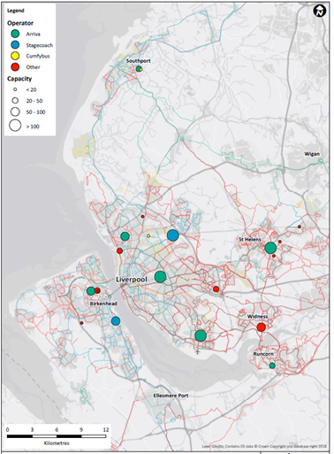
The Authority’s strategic objective of achieving a ZEB-only fleet by 2028 stated under “Fleet” above means that depots will need to be equipped to service ZEBs.
It may not be economic or desirable to convert the existing depots for ZEBs.
Therefore, the Authority is considering investing in strategically located depots which would be made available for use to any operators who secure a contract to run franchised services in the LCR and will be primarily for ZEBs. Access to depots would be incorporated into the terms of franchise contracts and will support multi-operator use.
Division of Rounds into Lots may lead to a requirement for depot sharing.
Questions to operators - Depots:
(i) What are your views on depot ownership? Do you agree that the Authority should invest directly in and own depots? What alternative approaches to depot investment and ownership would you propose and why?
(ii) Would your organisation consider bidding for a franchise if the LCRCA was not providing a depot(s)?
(iii) If the LCRCA were not to provide depots, what would be the lead time required to mobilise for a franchise? Would it be beneficial to have a buy-back arrangement for the LCRCA to take over the depot at the end of the franchise?
(iv) What are your views on the options for depot management and sharing? What would you see as being the benefits and disadvantages of an ‘anchor’ tenant being responsible for depot management versus direct management by the Authority?
(v) To what extent, if any, does the Authority’s proposed depot ownership structure influence your views on the lotting strategy set out in Area for Engagement 1?

8. TUPE-transfer of staff from existing operators
The implementation of a franchising scheme may mean that some staff transfer between operators or from operators to the LCRCA by virtue of the Transfer of Undertakings (Protection of Employment) Regulations 2006 (TUPE).
(i) Please set out your current views on what TUPE-transfers of staff will be required in the event that your organisation wins one or more franchises, including any concerns you may have and/or risks you may perceive.

