Invitation to Tender (ITT) for School Meals and Shire Hall Catering Services Framework Agreement

Document 7d - ICT Questionnaires
- Baseline security standards
- ISO 27001 standards
- PCDISS standards

As part of this contract you will be required to process personal data from customers and take payment details from them.

GCC have strict security standards for all their suppliers, to ensure that personal data is held securely, safely and is managed correctly, minimising risks to both customers, suppliers and GCC.

You must demonstrate compliance with these (over and above the requirements of the CCS DPS).

It is likely that you already comply with these requirements for your current business activity, so this should be straightforward to complete. For any clarifications please contact us via the portal.

The following flow chart will help you identify next steps .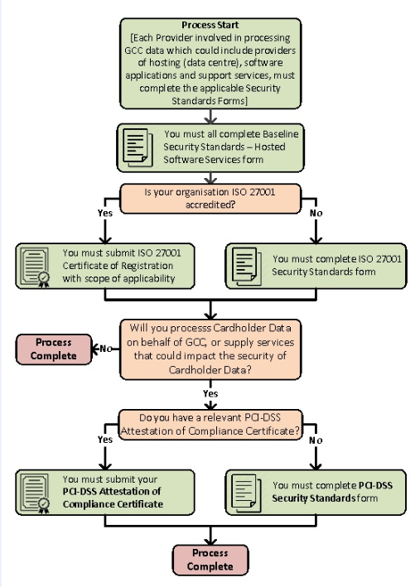

 | item | Attachment
Baseline security
- Standards – please read
- Complete hosted services form
 | Provide your ISO27001 certification which covers both the hosting (datacentre services) and software (development and support)  or  complete the ISO27001 Security Standards Form in reference to one or both of these areas depending on the certification provided. | ISO certificate attached  OR
 | Provide your relevant PCI-DSS Attestation of Compliance  or  complete the PCI-DSS standards form | PCI-DSS Attestation of Compliance certificate attached  OR

