C10/1001/2:
Site Inspection Photographs
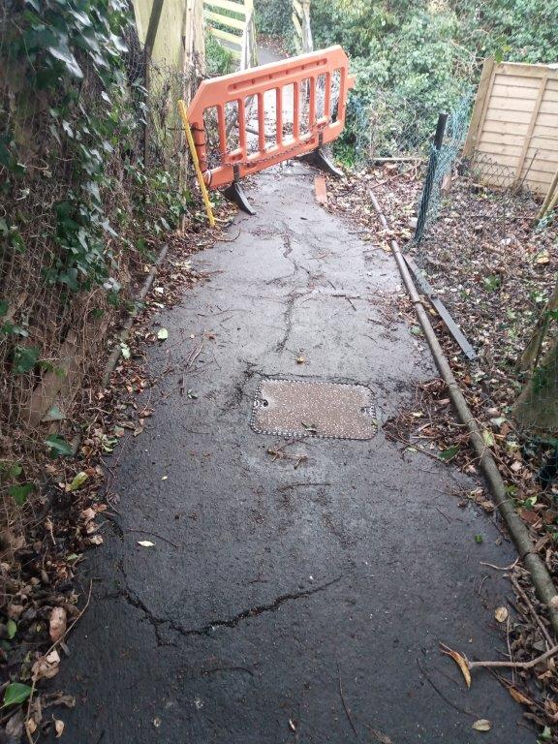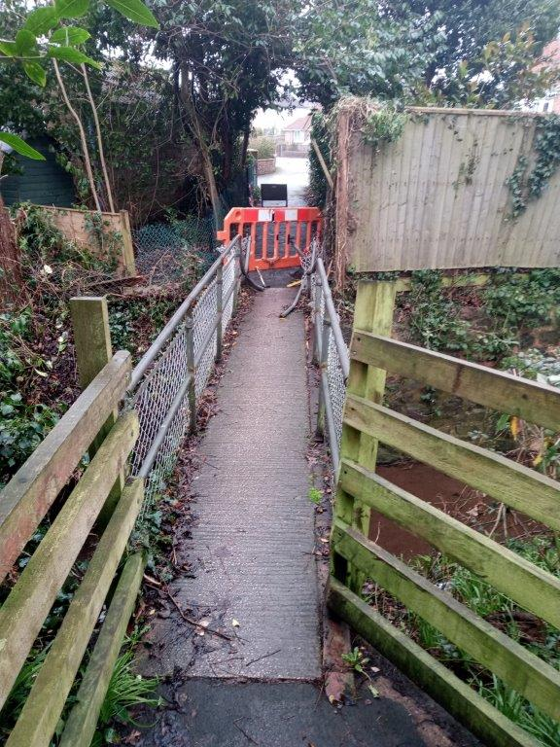
Image 1 and 2: The existing bridge viewed first from Springfield Road, and then Burnside.

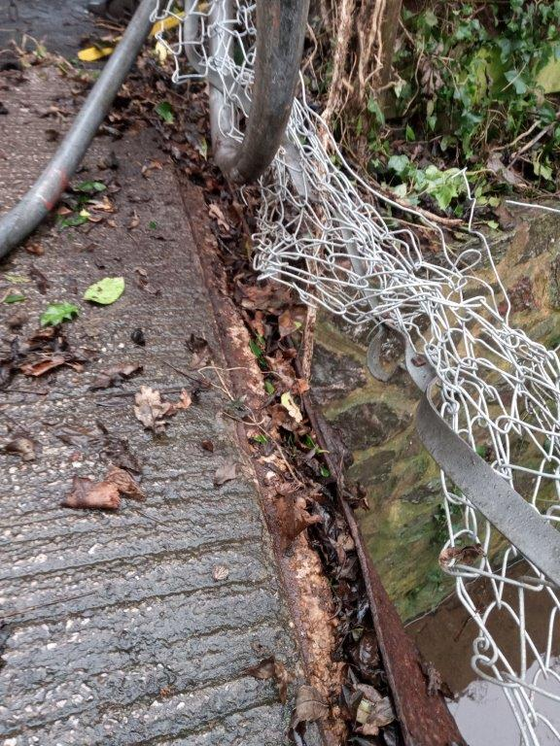
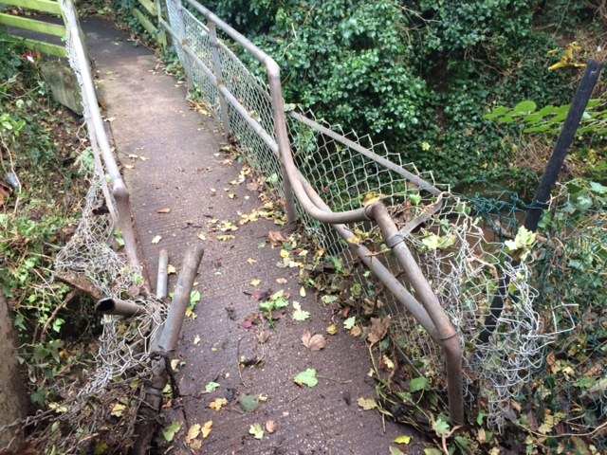
Image 3 and 4: Damage to the existing RSJ and handrails on the existing bridge
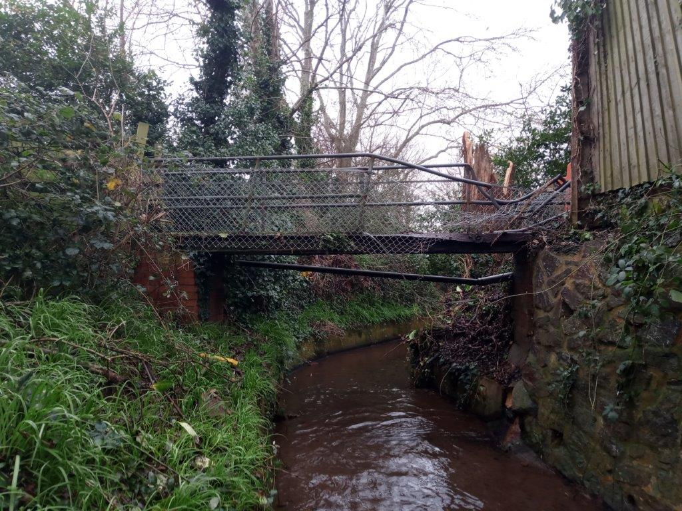

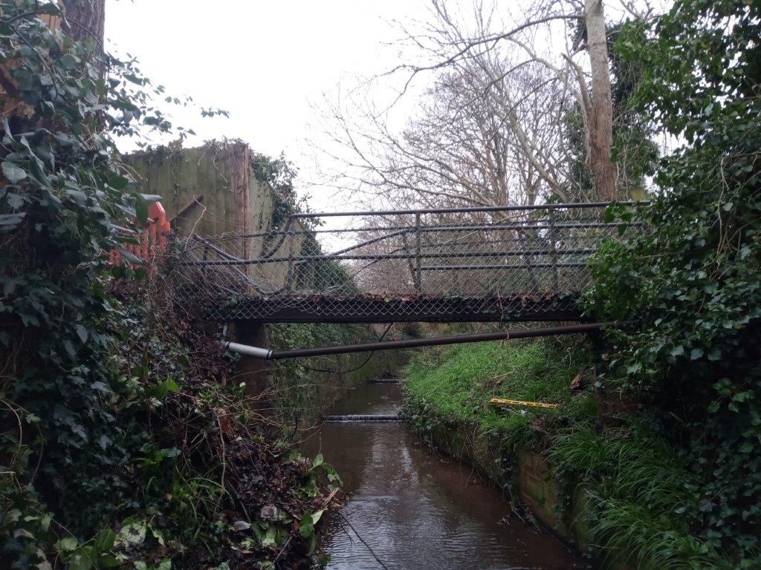
Image 5 and 6: Existing bridge viewed first from upstream direction, then downstream. Note the service duct running underneath the bridge.
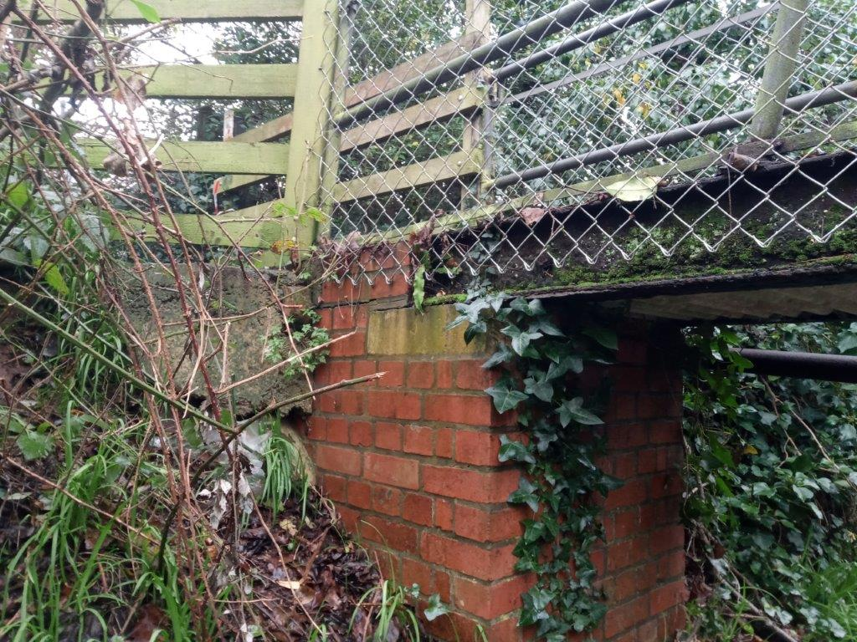
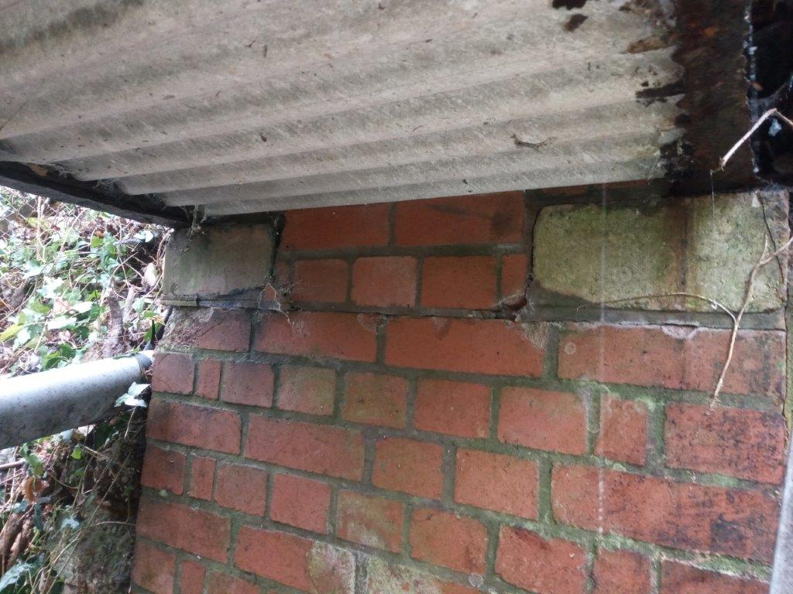
Image 7 and 8: Existing brick abutments.
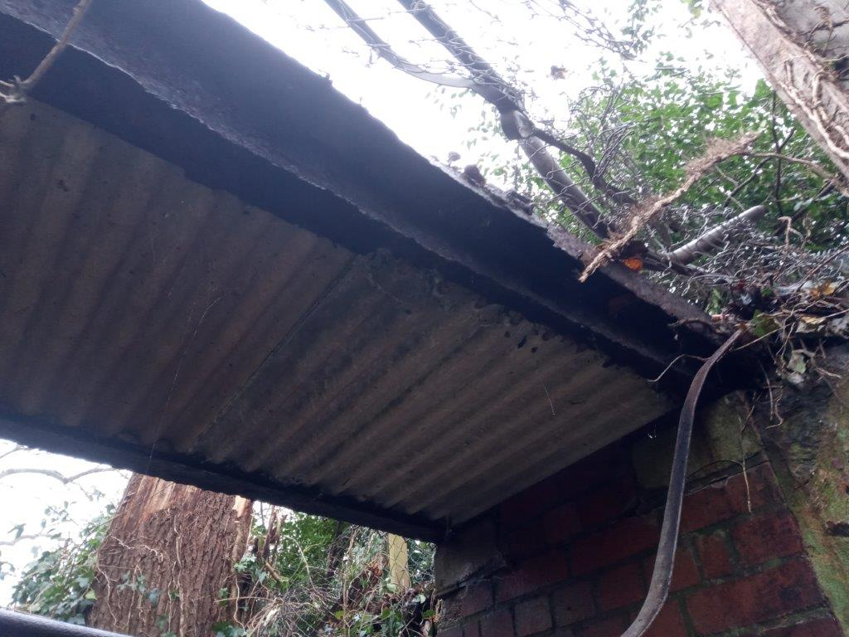
Image 9: Possible corrugated asbestos board formwork
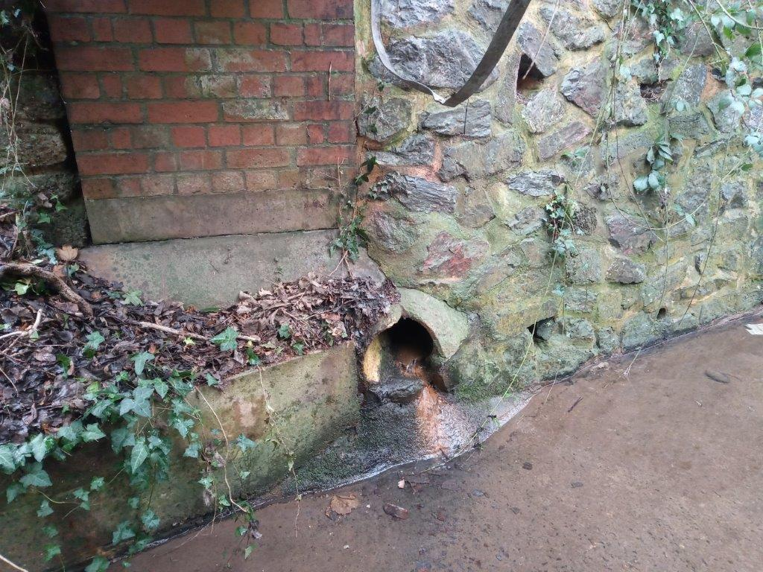
Image 10: Surface water outfall below bridge.
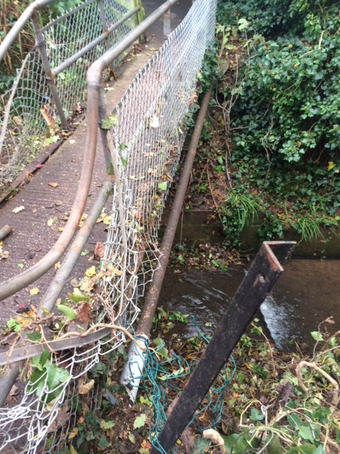
Image 11: Service duct on the downstream side of the existing bridge.

