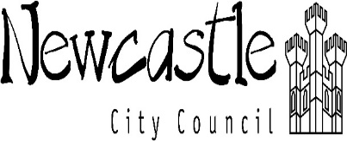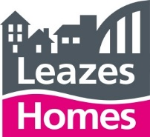

Contract for:

THE PROVISION OF A REPAIRS AND MAINTENANCE SERVICE FOR COMMUNAL LAUNDRY EQUIPMENT, DISHWASHER EQUIPMENT AND COMMERCIAL KITCHEN EQUIPMENT CITYWIDE, THROUGHOUT NEWCASTLE UPON TYNE (C-012000)

Appendix 1 - Contact Details - Site Visits and Property Viewings ONLY

Clients: Newcastle City Council, Your Homes Newcastle and Leazes Homes Limited

Nominated Representative: Your Homes Newcastle Limited

-------------------------------------------------------------------

Various dates have been set aside for any ‘pre-booked’ site visits to each / any of the identified property locations.

Site visits must be booked in advance of attendance. No one will be allowed onto any of the sites without prior permission for attendance. To confirm attendance and, to clarify all site visiting times, all interested Tenderers should contact:-

Mark Riley - (YHN Compliance Officer)
e-mail: mark.riley@yhn.org.uk
telephone: 07967 890496 (mobile) or 0191 278 7747

Please note that due to current Government ‘Covid-19’ guidelines, social distancing measures and appropriate PPE will be be required on all site visits. You will be instructed on any special requirements when your visit(s) have been confirmed.

