Free Standing Advertisements and Operations Contract
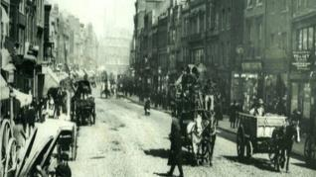
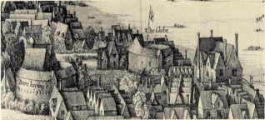
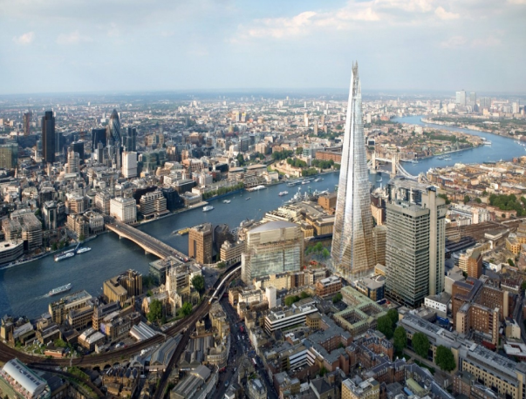
- Southwark is London’s most historic borough. Two roman roads: Stane Street and Watling Street meet in Southwark at what is now Borough High Street. Southwark is recorded in the Domesday Book as Sudweca. The name means "southern defensive work" and is formed from the Old English sūth and weorc. During the early Middle Ages, Southwark developed an important market that occupied the High Street and it was confirmed under a separate Act of Parliament in 1756. The area was renowned for its inns, especially The Tabard from which Chaucer's pilgrims set off on their journey in The Canterbury Tales. In 1599 the Globe Theatre, in which Shakespeare was a shareholder, was erected on the Bankside. It burned down in 1613, and was rebuilt in 1614, only to be closed by the Puritans in 1642 and subsequently pulled down not long thereafter. A modern replica called Shakespeare's Globe has been built near the original site. The Mayflower set sail for America from Southwark in July 1620

- Southwark borders the City of London and Tower Hamlets to the north along the River Thames, Lambeth to the west and Lewisham to the east. To the south are the London Boroughs of Bromley and Croydon. The main centres within Southwark include Borough, Elephant & Castle, Bermondsey, Rotherhithe, Walworth, Camberwell, Peckham and Dulwich.

- With an approximate population of 314,200 Southwark represents a thriving community, which has shown itself more than capable of adapting to its changing fortunes, the most recent of which is a bold vision of urban regeneration and innovative approaches to land use and partnership which have brought about a re-birth within the area. Vast sections of Southwark are currently under regeneration programmes with an estimated value stretching into £billions.

- Modern Southwark is an area of contrasts. In the north around London Bridge is a thriving business district, home to financial institutions, services companies and an emerging arts and media sector. Highly desirable riverside residential districts embody high quality design and lifestyle. Further south in Peckham is one of the biggest regeneration initiatives in the country. Heralded as best practice by visitors from all over the world, it has replaced high rise flats with houses and gardens for local families. Other large-scale regeneration is currently well underway in the Elephant & Castle and Walworth areas, with other areas such as the Old Kent Road corridor and Canada Water in the planning stages.

- Southwark is a diverse borough with people from a wide range of ethnicities and backgrounds. Over 120 languages are spoken here, and 11% of households have no members who speak English as their first language. Approximately 54% of Southwark’s population is of white ethnicity, 25% black, 11% Asian and 10% other ethnicities.

- The median age of Southwark residents in 2017 was 33.1 years. While the population is comparatively young, this is not driven by a large number of children and young people. It is primarily a result of the large number of young adults in their 20s and 30s. The latest population projections indicate the population of Southwark is expected to increase by almost 20% (around 60,000) by 2030.

10. Southwark high street footfalls naturally tend to vary between the busiest and the quietest times. The highest densities were found in Peckham Rye, Borough High Street (approximately 1600 people per hour) and Camberwell, with the quietest at Nunhead Lane and Southwark Park Road. Typical patterns show lunchtime peaks, followed by lows after around 2.30 during the week, while on Saturdays the footfall builds to reach a lunchtime peak, declines a little later but remains stable over the afternoon. There are some local variations. The busiest locations match the densities seen in some busy West end locations.
11. This tender presents the opportunity to utilise Council controlled highway across the Borough to establish a valuable digital 6-sheet concession; one that has the potential to reach the variety of audiences unique to the heart of one of the world’s most diverse and important Cities. In return, the Council expects a concession of the highest quality; a concession befitting of Southwark’s status, that optimises the benefit this opportunity represents and adds another facet to the animation and vibrancy of its thriving commercial and financial districts.

