SUPPLIER GUIDE
FOR FINDING AND RESPONDING To
A DYNAMIC PURCHSASING SYSTEM (DPS) OPPORTUNITY
WITHIN PROCONTRACT

This document will guide the user in locating and responding to a DPS opportunity which are available to all suppliers.

Please see alterative guidance for standard Tenders, Tenders with a Confidentiality Agreement, Further Competitions and pre-selected supplier Quotes.

This guidance relates to Gloucestershire County Council opportunities ONLY

Contents
1. Finding an Opportunity 2
2. Viewing the Opportunity 4
3. Submitting a Response 6
4. The Response Wizard 7
5. Additional Information (optional) 7
6. Uploading Attachments (mandatory in most cases) 8
7. Terms & Conditions (T&C’s) (mandatory) 9
8. Submitting the Tender Response 9
9. Editing Response and Re-Submission 11

Advertisements for opportunities issued by Gloucestershire County Council may be found in a variety of places, however, all documents, tender submissions, notification of awards and clarifications are all managed within the ProContract system.

When an opportunity is created, Gloucestershire County Council selects the Common Procurement Vocabulary (CPV) code/s which describes the procurement. If a supplier is registered with one or more of those codes they will receive an emailed notification of a new opportunity, the email will contain a link direct to the opportunity advertisement.

If you have accessed an opportunity from a link within a ProContract notification email skip to Section 1, step 5 in this guidance.

Finding an Opportunity

  - New opportunities can be found by going to https://www.supplyingthesouthwest.org.uk/ and clicking on “Search latest opportunities”.

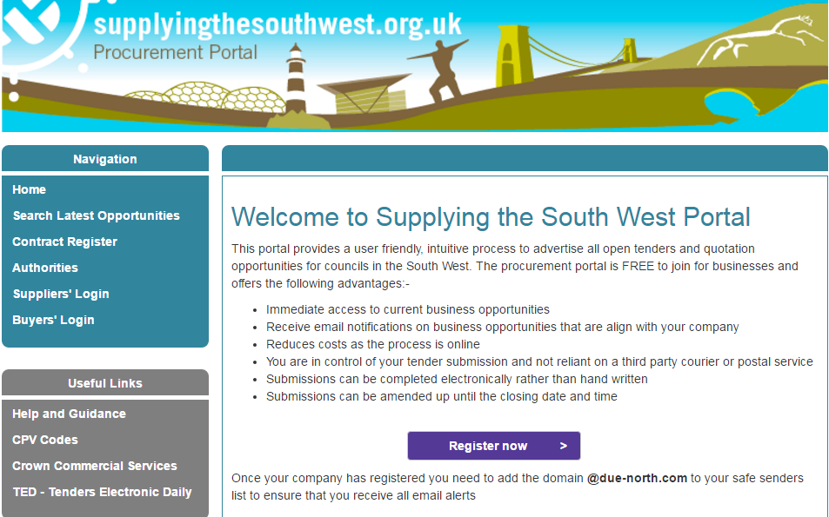

  - A list of opportunities published by Local Authorities in the South West using ProContract will be displayed.
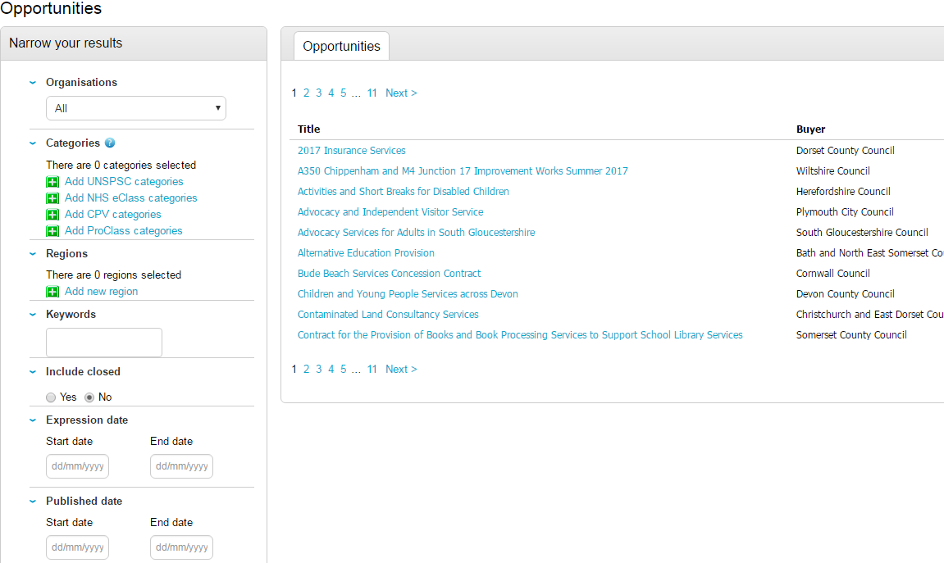
  - Using the “Organisation” drop down menu (highlighted above), filter the results by “Gloucestershire County Council”.

  - Click the “title” of the opportunity you would like to view.
The following screen will be displayed:

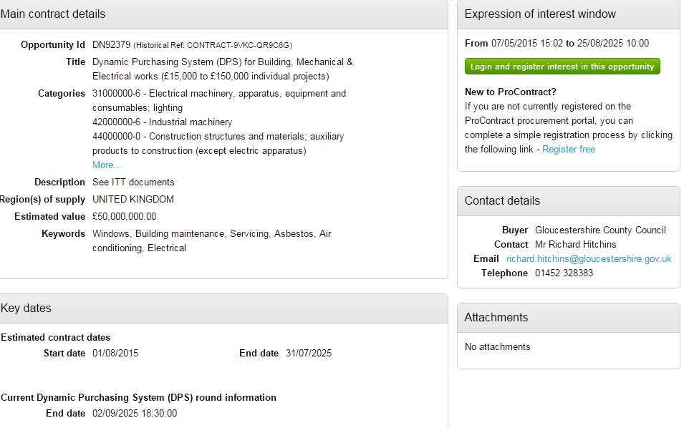

  - The above screen will provide a brief overview of the opportunity.
To view the documents and further information all suppliers must login to ProContract and register an interest in the opportunity.
  - If not logged in Click the “Login and Register interest in the Opportunity” as highlighted above. Login with your username and password.
If you do not currently have a username or password, click the “register free” link and follow guidance document: Initial Registration on the Portal and First Time System Login

  - Once logged in to ProContract the green button on the advertisement will change to “Register an Interest in this opportunity”

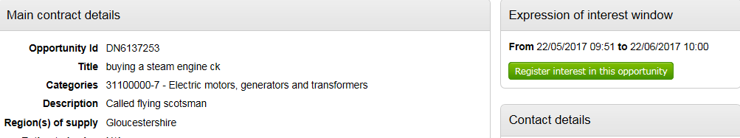

  - Click the “Register an interest in this opportunity” button

  - The advertisement will remain displayed with the button now greyed out indicating this opportunity has been added to your “activity list”.

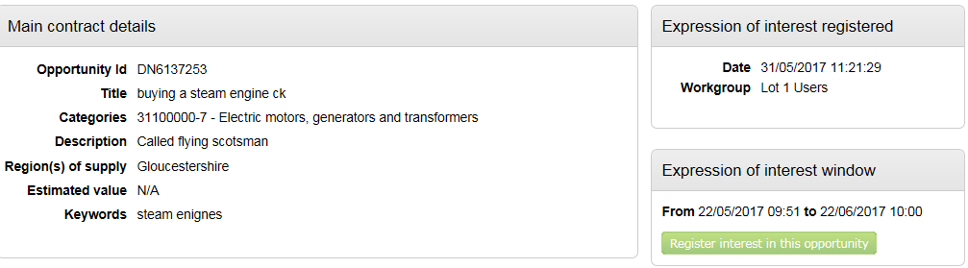
Go to Section 2 “Viewing the Opportunity”

Viewing the Opportunity

Once the “register interest” button has been selected the opportunity is added into the “My Activity” area of ProContract. Note: This area can only been seen when logged in.

- When logged in to ProContract, the below home page will be displayed

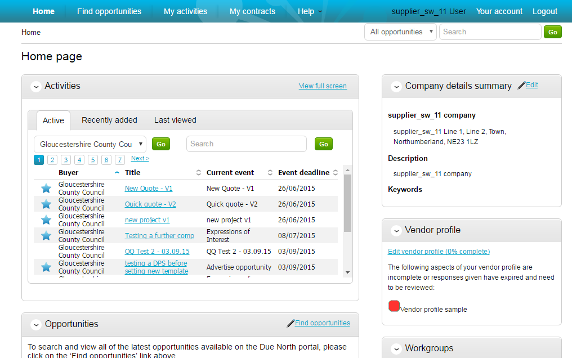
If no activities are displayed, amend the drop down to show Gloucestershire County Council and click

The Activities section will display all opportunities that either an expression of interest has been registered for, or you have been pre-selected for.

On the above screen, the Buyer, Title of the project, current event and event deadline is shown.

The symbol illustrates a new opportunity which has not been viewed or worked on.

- To view an opportunity click on the title of the Activity to be worked on

- The screen below provides the events for the opportunity.
When a DPS is first opened there will only be 2 events displayed (see image below)
- The Expression of interest event, which is the original advertisement.
- The first round of the opportunity which is where all the relevant documentation is held.

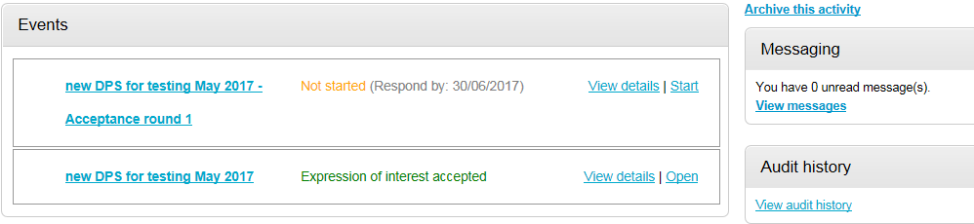

INFORMATION:
After the first round has been completed and the DPS restarts the opportunity will re-open to Round 2.

When new applications to join the DPS are submitted the GCC project team close the round to access the response/s, this action will send a notification stating that the DPS is closing; however this notification can be ignored, as a new round will start straight away which means the DPS continues to be open and available for new submissions.

When you open the DPS project you may see multiple rounds listed (below is an image of what this may look like), you will need to open the round with the highest number to submit your application.

If you open a round which has already closed the system will not give you the option to submit a response, you will need to go back to the previous screen and click start on the round with the highest number.

- Click Start within the event that has the highest round number

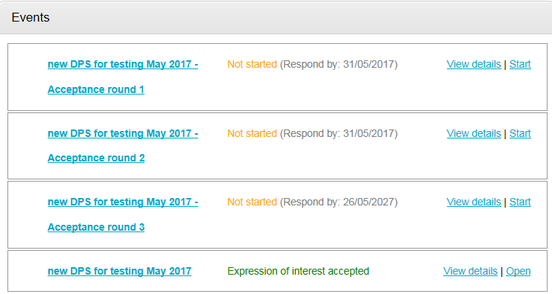

- A summary screen will be displayed like below which is split up into different sections;
Main details, Public attachments, and Messaging.
See below for section explanations.
There is also a countdown timer in the top right indicating the time left until the submission deadline for this opportunity.

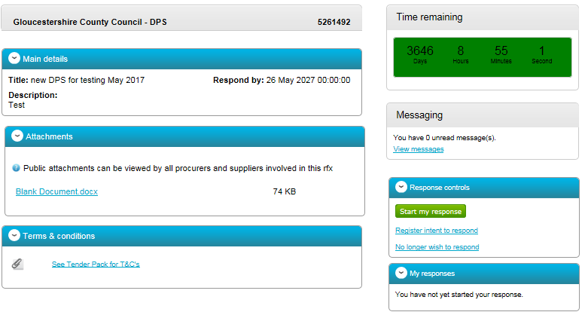

Main details
This section shows the title, description and date and time the completed Quote or Tender submissions must be returned by.

Attachments
This section shows the attachments that have been published by Gloucestershire County Council. To download click on the title of the attachment, save the document to your own network or desktop before working on them. Please note that you must abide by the data protection rules.

Note: If no attachments have been added, an item breakdown may have been used. If this is not visible send a message via ProContract to verify with the team.

Terms and Conditions
These are the terms and conditions associated to the opportunity. If a “See Tender Pack” or “See Quotation Pack” documents is displayed, the terms and conditions will be within the main attachments.

Messages
During the process all questions should be raised using the portal and any messages sent to you can be viewed in the same place.

Any messages sent through this area will go to the Gloucestershire County Council contacts that are working on this opportunity. Open this area by clicking on View messages.

For further information see guidance document – Messaging in ProContract

Submitting a Response

Note: Responses can be completed in stages, and can be re-submitted up until the closing time. Gloucestershire County Council will only see the final response submitted once the opportunity has closed.

- To begin the response, from the summary screen, click

The Response Wizard

The response wizard will open, which will go through each stage of the response submission to make sure it is completed successfully. Note, you can skip stages at this point and come back at a later stage to complete. However, all mandatory areas will need to be completed before a submission can be made.

- Stage 1 will always contain a welcome message which should be read carefully.

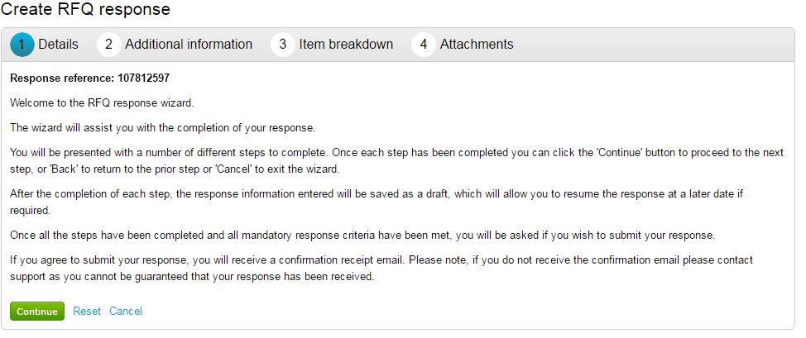

- At the bottom of the page click to move onto the next page or click to leave the wizard.

Additional Information (optional)

Additional information can be entered, however it is not mandatory.

Additional information includes a reference or additional comments relevant to the submission for the individual opportunity.
  - Click to move onto the next page.

Uploading Attachments (mandatory in most cases)

The next stage allows you to upload your relevant attachments.

Note: If an attachment has been set to be mandatory by the Project team, the system will not let you complete a response submission until an attachment has been added. However, you can come back to this stage at a later time to add an attachment before submitting the response.
- To add an attachment click

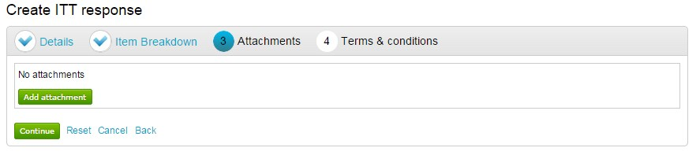
- Click

- Select the required file via the browser option and click Open

You can now browse your computer for the attachments using the file uploader. You can add as many attachments as required.

- Once all the attachments have been added click

When uploaded, you can view an attachment by clicking its name.

- To remove the attachment click

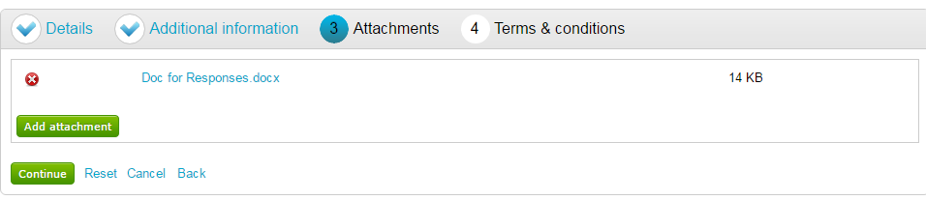

- When complete click to move onto the next page.

Terms & Conditions (T&C’s) (mandatory)

All tenders and quotations will have terms and conditions. If the terms and conditions have been included within the Tender or Quotation documents, then the Terms and Conditions document will either be “See Tender pack for T&C’s” or “See Quotation pack for T&C’s”.
However, if the terms and conditions are separate they will appear in this area as a document.
  - Click on the link to view the T&C’s document

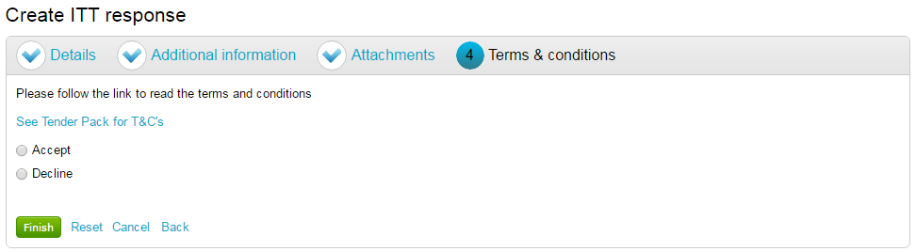

  - Irrespective of where the Terms and Conditions are documented, you must still either “Accept” or “Decline” the terms and conditions by clicking the relevant radio button.
IF DECLINE is selected then a reason must also be included.
  - When completed click the button to proceed to the next screen.
- Reset will begin the wizard again and remove all info,
- Cancel will leave the wizard completely (without saving)
- Back will return to the previous stage.

Submitting the Tender Response

The response will remain in Draft until all mandatory sections are complete and the submission has been confirmed.
If the response is not fully submitted Gloucestershire County Council will not be able to view it.
- To submit the response click

Note: If the Submit response button is greyed out, this means mandatory information is missing. Click Edit against each section to add the required information. See section 6 or 7 (above) of this guidance for information on how to complete

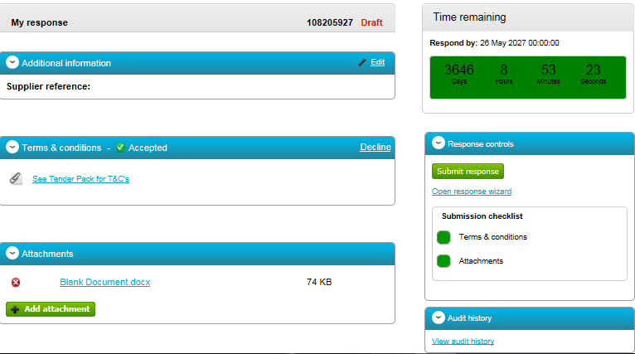

- Confirm the submission by clicking Submit response for a second time on the pop up screen

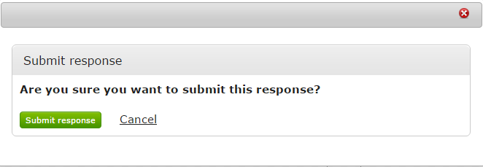

- When a response has been fully submitted the opportunity screen will update and the highlighted areas below will indicate that the response has been sent to GCC
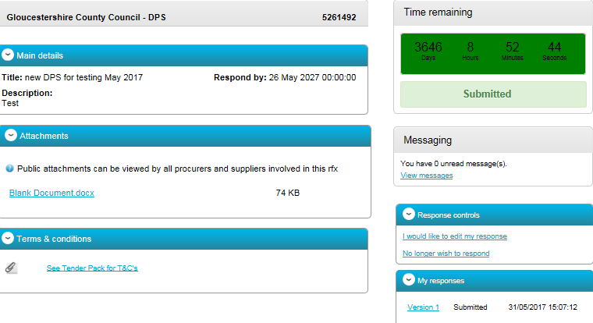
NOTE: Responses can be edited and resubmitted up until the round has been closed, see section 9 on how to edit your response. If you submission was incorrect and the Round has been closed, use the messaging area to inform the Project Team. You can submit your response again in a later round on the opportunity.

Once the Project team have closed the round and collected your response, it will be evaluated. The team will then inform you if you have been successful in joining the DPS, or if you were not successful they will provide feedback as to why.

If you were successful in joining the DPS, the further competition opportunities will be issued through ProContract, and will automatically appear in the “my activities” area of ProContract. See guidance “Responding to a Further Competition” for further information.

Editing Response and Re-Submission

After the Tender or Quotation response has been submitted it can be edited and updated as many times as required before the submission time and date has passed.

Gloucestershire County Council is only able to view the latest version of information and documentation submitted before the tender/quotation has closed.

- To edit a response from the tender summary screen, click under the response controls area.

- When this is clicked it will create a draft version 2.

- Each area can then be amended, either by editing the relevant section or clicking Open response wizard, and then submitted using the process outlined above.
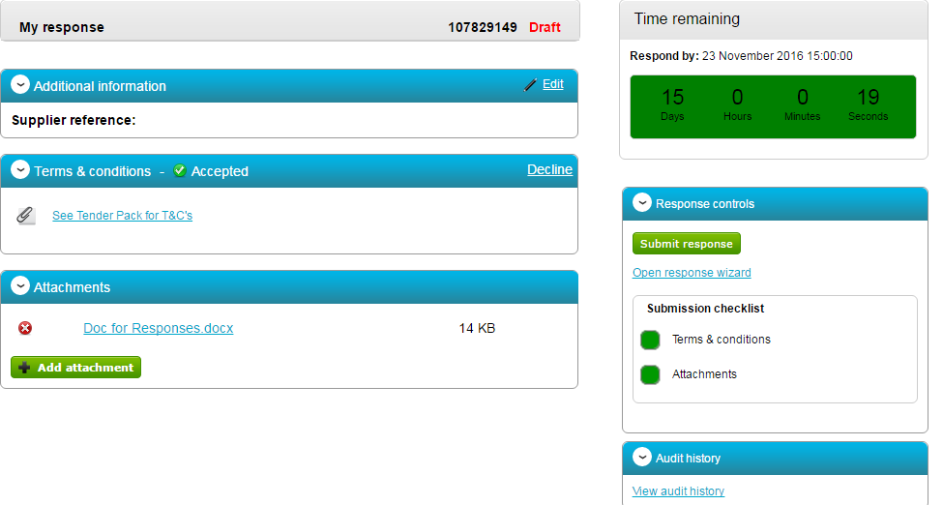

- For GCC to receive the updated response, you must click the again.

Note: If your edited version is submitted after the deadline has passed, GCC will only be able to accept the previous version which was submitted on time.

