Employer’s Agent Services

Council Housing Residential Development on Heath Town Estate, Heath Town, Wolverhampton

April 2018
Contents
- Purpose of the Brief
- General Information
- Site Details
- Programme/Timing
- Scope of Services
Appendices
Appendix A -Summary site details following sites:
Site 1 – Hobgate Road (3 sites)
Site 2 – Chervil Rise (2 sites)
Site 3 – Tithe Croft
Site 4 – Inkerman Street
Site 5 – Long Ley
Site 6 – Tremont Street
Site 7 – Clover Ley
Appendix B – Location Plan
Appendix C – Wolverhampton Homes’ Investment Programme

- Purpose of the Brief:

  - The Client is City of Wolverhampton Council (CWC), delivering new council housing development on a number of sites across the Heath Town Estate, Heath Town Ward, Wolverhampton, for management by the Council’s Arm’s Length Management Organisation (ALMO), Wolverhampton Homes.

  - The Heath Town masterplan sets out to deliver a large-scale regeneration of this 1960s built estate. The proposed changes consist of targeted demolition, new build infill housing of mixed tenure, upgrading the security, performance and appearance of the remaining estate blocks, an upgrade of existing sports pitches, development of new play areas and a small football pitch, and environmental works. The intention is to transform the appearance and perception of the estate, and improve the setting for both new and existing homes there.

  - The overall aspiration is to develop up to 350 new housing units on the estate.

  - The Employer’s agent will provide services for the affordable housing element which delivers the 25% affordable housing requirement. Employer’s Agent services will progress the schemes from feasibility stage through to completion of the defects period.

  - In supporting the delivery of the affordable housing element, The Employers Agent will to take account of the co-ordination of the build programme for the overall masterplan, which includes:

- Development of affordable Council housing for rent (approximately 114 units)
- Building of new houses for sale, shared ownership, and market rent by the City of Wolverhampton’s Housing Company trading as WV Living (a trading company wholly owned by the council) (approximately 138 units)
- Disposal of 3 sites on the south side of the estate to a private developer for market housing delivery (approximately 101 units)

  - Effective project management is critical to this project to ensure minimal disruption to existing residents. The new housing will be delivered on a “live” occupied residential estate. The estate consists of over 1000 units comprising a mix of maisonettes, medium and high-rise tower blocks.

  - In addition to this constraint, Wolverhampton Homes is delivering a major Investment Programme to upgrade the existing blocks. Contractors will be working across the whole estate in a phased programme. All newbuild delivery must be carefully co-ordinated with the other works on site, to ensure that the life of the estate is not unduly disrupted, works are not delayed, and health and safety is not compromised. Details of this work can be found in Appendix C.

  - In addition to the sites identified, the Employer’s Agent will manage the development of a new football pitch and refurbishment of existing sports pitches located in the centre of the estate.

  - The Client will work with the project team throughout the design stage to optimise the balance between cost and quality.

- General Information:

2.01 The Client is to develop 100% affordable housing for rent on these 10 sites. The sites will provide a range of accommodation types which should include houses, bungalows and low-level apartments. The detail of the numbers and types of property will be determined during the design process, however a breakdown of the current proposals in the Heath Town masterplan for these sites are as follows:

2.02 The following minimum unit sizes are required for all housing properties (sizes are based on Gross Internal Floor areas):

1 bed apartments (26 units) 50m²
2 Bed House (60 units) 70m²
4 Bed House - 2 storey (10 units) 117.50m²
4 Bed House – 3 storey (4 units) 117.50m²
2 Bed Bungalow (CAT 2) (12 units) 80m²
2 Bed Bungalow (CAT 3) (2 units) 86m²

2.03 The Client intends to procure the building works by competitive tender.

2.04 The form of construction contract shall be the JCT Design and Build 2016.

- Site Details:
3.01 Summary details of the sites proposed for development are set out within Appendix A. These sites are within the attached masterplan proposals and indicate approximately 114 units of apartments, 2,3 and 4-bed houses and bungalows.

3.02 Detailed information will be provided to the appointed Employer’s Agent as necessary.

- Programme/Timing:

4.01 The Client’s indicative development timetable provides for the following milestone dates:

- Submission of planning application by July 2018 (for sites A, B, C, D, E, F and G)

- Achieving planning approval by the end of September 2018

- Phase 1 - Start on site by January 2019
Phase 2 – Start on site by December 2019
Phase 3 – Start on site by June 2020

4.02 The Consultant must ensure they have sufficient capacity to manage the development appropriately throughout the scheme.

- Scope of Services:

  - The following services shall form the Employer’s Agent Services under this appointment:
Core Services
  - Generally
The Employers Agent shall:
    - Chair Client, design, project, site and other meetings and publish minutes of the meetings in a timely fashion to all relevant parties;
    - Issue instructions, on behalf of the Client, to the Contractor in accordance with the terms of the construction contract;
    - Agree project reporting and recording procedures with the Client, the professional team and the Contractor. Implement agreed procedures. The professional team will be all professionals involved in the delivery of the Projects including: architects, site surveyors, structural engineers, environmental health officers; H&S officer, Clerk of Works, and Wolverhampton Homes representative.
    - Monitor the performance of the Contractor and report to the Client; and
    - Liaise with the professional team and prepare regular/monthly quality, cost and programme reports. Advise the Client of any risks identified, mitigation recommended, and decisions required and obtain authorisation.
    - Liaise with the relevant project managers and teams for the WV Living development and Wolverhampton Homes investment works taking place in parallel on the Heath Town estate, to ensure that co-ordination is effective, monitoring and optimising the programming of works across the Heath Town estate.

  - Preparation

The Employers Agent shall:

    - Liaise with the Client and the professional team to determine the Client’s initial requirements and develop the Client’s brief. Establish review, approval, variation and reporting procedures. Prepare recommendations for Client’s approval;
    - Advise the Client on specialist services, including consultants (Party Wall, etc.), sub-contractors and suppliers required in connection with the project;
    - Liaise with the professional team and advise the Client of its obligations under the CDM Regulations;
    - Comply with the CDM Regulations insofar as they relate to this Appointment;
    - Advise the Client on design services required under the construction contract;
    - Liaise with the professional team and advise the Client on statutory approvals required and fees due in respect of the Project;
    - Visit the site and carry out initial inspection. Advise the Client on areas of concern including any factors likely to affect cost, time or method of implementation;
    - Advise on the cost of the Project. Advise on the cost of alternative design and construction options;
    - Prepare an initial budget estimate to test feasibility proposals; and
    - Prepare a preliminary cost plan and cash flow forecast.
    - Prepare a joint programme consisting of the Heath Town Regeneration Project, including Council and WV Living newbuild activity, and Wolverhampton Homes Investment Works, compiling a Risk Register for the programme as a whole.
    - Advise on the phasing of all works to create efficiency, and minimise disruption to residents, and manage and mitigate any delays.

  - Design

The Employer’s Agent shall:

    - Prepare, maintain and develop a cost plan and cash flow forecast.
    - Advise on the cost of the professional team’s proposals, including effects of site usage, shape of buildings, alternative forms of design, procurement and construction etc. Advise on any cost variances to the allowances contained in the cost plan;
    - Measure gross floor areas;
    - Confirm the scope of the construction contract to the Client and advise on additional works required by third parties;
    - Liaise with the Client and the professional team and prepare the Employer’s Requirements;
    - Liaise with the professional team and establish a structure and procedure for quality management. Establish review, approval, variation and reporting procedures. Prepare recommendations for Client’s approval;
    - Liaise with the professional team and identify any long delivery building components and systems. Prepare recommendations for the Client’s approval; and
    - Liaise with the Professional Team and identify any specialist/proprietary building components and systems. Prepare recommendations for the Client’s approval.

  - Pre-Construction

The Employers Agent shall:

    - Liaise with the Client and the professional team and prepare tender documentation;
    - Attend pre- and post-tender clarification meetings as required;
    - Liaise with the Professional Team and advice on errors, omissions, exclusions, qualifications and inconsistencies between the Employer’s Requirements and the Contractor’s Proposals. Form part of the evaluation team;
    - Advise on the tenderer’s design and construction programmes and method statements;
    - Liaise with the professional team and obtain cost and design studies or specialist enquiries to assess alternative Contractor’s Proposals. Prepare recommendations for the Client’s approval;
    - Obtain documentation from the professional team to confirm the agreed design and/or performance specifications. Prepare documentation to confirm adjustments to the Tender Sums;
    - Liaise with the Client and the professional team and advise on methods of progressing design and/or construction works prior to the execution of the construction Contract;
    - Co-ordination of the contract drawings and specifications from the Client and the professional team. Liaise with the Client’s legal advisers and participate in preparing the contract documents; and
    - Convene and chair a pre-start meeting with the Client, the professional team, the contractor and, where appropriate, the sub-contractor(s) or supplier(s). Take minutes of the matters discussed and issue copies of the minutes to the Client, the professional team, the Contractor and such other persons attending the meeting.

  - Construction

The Employers Agent shall:

    - Agree approvals required from the Professional Team under the Building Contract. Administer the construction Contract;
    - Convene and chair regular/monthly site meetings with the Client, the professional team, the Contractor and, where appropriate, the sub-contractor(s) or supplier(s). Take Minutes of the matters discussed and issue copies of the Minutes to the Client, the Professional Team, the Contractor and such other persons attending the meeting;
    - Receive monthly progress reports from the Contractor, highlighting any risks or recommended mitigation measures to the Client.
    - Liaise with the Client and the professional team and conduct negotiations with the Contractor. Prepare documentation to confirm the agreements reached;
    - Advise on the cost and programme effect of variations prior to the issue of instructions under the Construction Contract. Liaise with the Council’s procurement team over any variations. Prepare recommendations for the Client’s approval;
    - Agree the cost of instructions proposed by the Contractor under the Construction Contract;
    - Obtain authorisation from the Client for all additional costs;
    - Undertake regular site inspections. Obtain progress and quality reports from the site staff representing the Client, the professional team and the Contractor;
    - Visit the site periodically and assess the progress of the Project for interim payment purposes;
    - Prepare recommendations for interim payments to the Contractor;
    - Undertake a monthly cost and valuation monitoring exercise and report this to the CWC co-ordinating officer for review.;
    - Agree all test certificates and statutory and non-statutory approvals required from the professional team and Contractor. Prepare recommendations for the Client’s approval;
    - Liaise with the Client, the professional team and the Contractor and prepare and maintain a handover plan identifying the roles and responsibilities of the Client, the professional team and the Contractor;
    - Advise on the rights and obligations of the parties to the Construction Contract.
    - Monitor the Contractor’s delivery of the social value activities included in the Construction Contract;
    - Prepare recommendations for interim payments and release of retention funds;
    - Prepare the Final Account. Facilitate agreement to the final account from the parties to the Construction Contract; and
    - Administer the application of liquidated and ascertained damages within the Construction Contract.

APPENDIX A

SUMMARY SITE DETAILS

10 Sites on Heath Town Estate, Heath Town, Wolverhampton

10 Sites on Heath Town Estate, Heath Town, Wolverhampton

1.01. Location

Site 1 (sites a, b and c) – Hobgate Road is located on the north side of the Heath Town estate. The site is adjacent to an industrial estate and surrounded by residential properties with a Network Rail boundary towards the edge of the north side. The site can be accessed via Woden Road.

Site 2 (sites a and b) - Chervil Rise is located in the centre of the estate. The site runs adjacent to Chervil Rise on one side and is surrounded by residential properties. The site can be accessed via Grove Street and then onto Chervil Rise or Inkerman Street and onto Chervil Rise

Site 3 – Tithe Croft is located towards the east side of the Heath Town estate. There is a high-rise tower block located immediately to the south of the site. The site can be accessed via Grove Street and then onto Chervil Rise or Inkerman Street and onto Chervil Rise.

Site 4 – Inkerman Street – the site is located just off Inkerman Street adjacent to the railway line towards the south of the estate. The site can be accessed via Inkerman Street. This site is being considered for a community self-build scheme, but will be subject to traditional development for Council housing should the self-build scheme not progress.

Site 5 – Long Ley is located centrally in the estate. It is surrounded by residential properties on 2 sides and an existing sports facility on the other. The site can be accessed via Inkerman Street and onto Long Ley.

Site 6 – Tremont Street is located towards the west of the estate and is surrounded by residential properties and a commercial warehouse site. The site can be accessed via Tremont Street and Inkerman Street.

Site 7 – Clover Ley is located in the middle of the estate at the rear of Inkerman Street. It is surrounded by residential properties. The site can be accessed from Inkerman Street and onto Clover Ley.

1.02 Former Use

Site 1 - Hobgate Road
- Site A was previously used as an Adventure Playground which was demolished in 2017
- Site B – this site was cleared of a disused car park and high-level walkways in 2017
- Site C - As site B above

Site 2 – Chervil Rise
- Site A was previously a residential and commercial shopping centre including a GP surgery and old housing office.
- Site B is an existing unused green space

Site 3 – Tithe Croft
- The site is currently open space that is not used for any purpose

Site 4 – Inkerman Street
- The site is currently a vacant space

Site 5 – Long Ley
- The site was previously a school which was demolished in October 2007. It is currently being used as a site compound by contractors working on the estate

Site 6 – Tremont Street
- The site currently forms part of the car parking area for Wednesfield Road maisonettes but this area is being re-configured to accommodate housing units

Site 7 – Clover Ley
- This site was a former children’s play area which has been closed as it did not meet current health and safety regulations

In addition to these sites, there are 2 new play areas being developed by Wolverhampton Homes, a refurbishment of the existing Sports Pitches led by the Council along with a new 7v7 football pitch on the green field at Grosvenor Street. These are identified on the masterplan in Appendix B, and form part of the wider works for co-ordination and programming.

1.03 Site Area

The Heath Town estate area is 22.6 hectares
This is broken down as follows:

Site 1 a – 3898m2
b – 1635m2
c – 351m2

Site 2 a – 746m2
b - ??

Site 3 – 1704m2

Site 4 – 1670m2

Site 5 – 2948m2

Site 6 – 947m2

Site 7 – 540.79sqm

  - Site Information

Site investigation works have been completed and detailed surveys are available to the successful Employer’s Agents.

1.05 Site constraints

A Constraints Plan has been produced which has supported the development of the masterplan proposals.

Appendix B

Site Location Plan for the HRA units

The sites proposed for the new council housing development are shaded in brown on the plan below. The sites shaded in blue are for WV Living development. The Employer’s Agent will ensure successful coordination between the HRA and WV Living development programmes, so that maximum efficiency and minimum disruption is achieved.

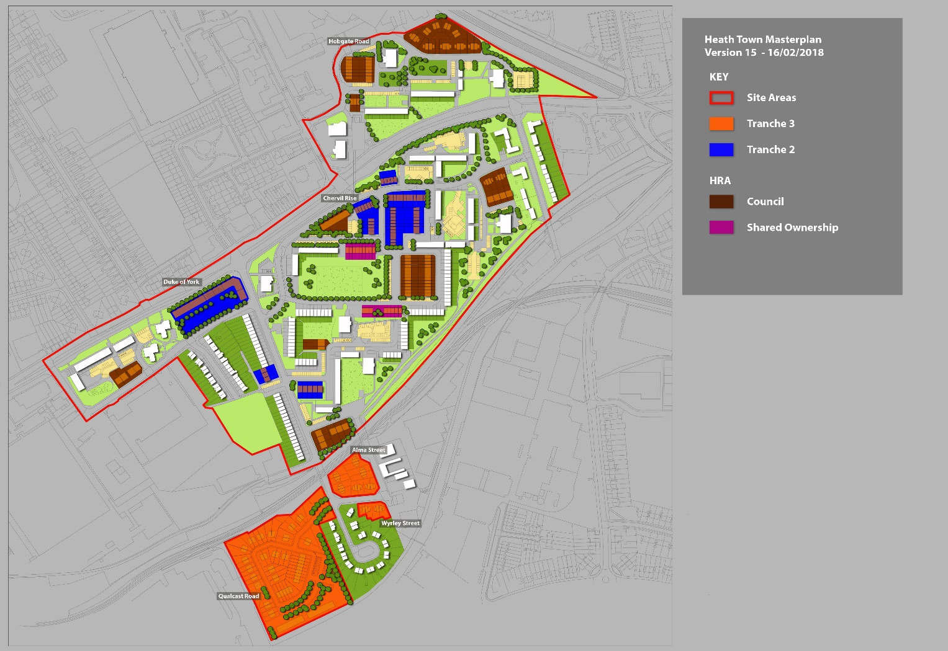
Appendix B

Red line Plan showing all sites labelled on a single plan

Appendix C
Wolverhampton Homes’ Investment Programme
Wolverhampton Homes will be carrying out significant improvements to the existing blocks on the estate. This work will be delivered by the construction partner United Living, below is a summary of the work proposed over the next four to five years.
Deck-access blocks
The deck-access blocks will be the first to be refurbished. Work has already begun to replace the screens and front doors to each home. This improvement work will include:
- New UPVC windows
- New coverings to the walkways
- New coverings to the balustrades and the ceilings along the walkways
- New external cladding to the blocks and the stair-towers
- Improved security with CCTV to walkways, stairs and the entrances of the blocks
- New secure entrances into each block with a door-entry intercom system
- New mono-pitch roofs to each block

The high-level walkways that link the two blocks either side of Chervil Rise and the two Hobgate Road blocks will be removed as they are in a very poor condition. The removal of these ‘link-bridges’ will also provide a more secure environment for these blocks, as visitors will only be able to enter through the new secure main entrance doors.
Work will begin in November at the blocks in Wednesfield Road and Lincoln Street, with scaffolding being erected and the main work will start in January 2018. Shortly after this, contractors will move onto the blocks in Hobgate Road, then move to the first blocks in Chervil Rise (1-225), before then moving around the remaining deck-access blocks on the estate.
High-rise tower blocks
The tower blocks across the estate are almost 50 years old and designs are currently being drawn up for these blocks. It is hoped that this work will be ready to commence within the next two years. These improvements will include:
- Installing new external cladding
- A new entrance to each block
- New fire doors and screens to each landing
- New flooring to each landing

Brockfield House, Campion House and Longfield House already has some external cladding, which was installed in the early 1990s, but this is coming to the end of its life, so needs replacing. These blocks will also be having new windows fitted on the north and south sides only (replacing the windows to the kitchen & living room), as the windows on the east and west sides were renewed in 2009.
Tremont House, Lincoln House, Ling House, Red Oak House, and Hawthorne House will be having new windows fitted throughout.
Play Areas
The children’s play equipment in Heath Town has been removed, as it was no longer safe for children. These will be replaced across the estate along with refurbishment of the existing sports pitch and a new small football pitch at the end of Grosvenor Street.

