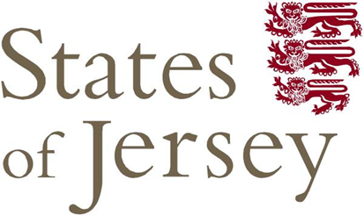
Expression of Interest for
Monitoring, Collection and Transportation
Leachate & Dirty Waters
-States of Jersey-
-Department for Infrastructure-
-Solid Waste-

Introduction
The Department for Infrastructure (DfI) is seeking companies interested in monitoring, collecting and transporting Leachate & Dirty Waters produced at La Collette Reclamation Site.
DfI is to reconsidering how it works with the market in dealing with Leachate, collected via side wall risers (dip tube) from various containment cells, and Dirty Waters.
Dirty Waters comprise of:
- surface water (rainfall runoff from roadway and unused containment cells),
- organic water (surplus water from the composting process),
- wheel wash water and,
- treated water (water generated at Bellozanne for use at La Collette).

DfI invites expressions of interest from companies that are able to provide this service for an initial period of 3 year with the possibility to extend by an additional period of 2 year.
DfI is legally obliged to prevent pollution to ground and marine waters under penalty of prosecution under the Water Pollution (Jersey) Law 2000 and under the conditions of Waste Management Licence WML001.
This Expression of interest is designed to identify companies interested in providing the above services. Individual meetings will be held between DfI and interested parties as part of pre-tender research before commencing the tender phase, with a contract commencement date: March 2018.
DfI hopes to learn what solutions are available in the market so that any tender process allows bidders to demonstrate efficiency and/or innovation when proposing the best possible solution for the Island.
Figures for Leachate and Surface Water under current contract:
YEAR | DIRTY WATERS | Sum of Net Weight (tonnage)
2015 | LEACHATE | 7,683
 | SURFACE WATER | 448
Total 2015 |  | 8,131
2016 | LEACHATE | 10,504
 | SURFACE WATER | 232
Total 2016 |  | 10,736
2017 (until end June) | LEACHATE | 4,439
 | SURFACE WATER | 84
Total 2017 (Jan-June) |  | 4,523

Instructions
Companies are requested to complete the questionnaire “Expression of Interest: Questionnaire Monitoring, Collection and Transportation of Leachate & Dirty Waters” of this document.
Companies are required to upload their response to this EOI via the E-Portal, which can be found at www.tenders.gov.je

The closing date for EOI returns is: 12pm, Wednesday 01st November 2017.

Expression of Interest Questionnaire: Monitoring, Collection and Transportation of Leachate & Dirty Waters
No. | Question | Answer
1 | Organisation trading name
2 | Correspondence address  (including postcode)
3 | Registered office address  (if different to Q1)
4 | Please list the full names of Directors, Company Secretaries, Partners and / or Associates
5 | Please list full names of persons occupying a position of authority or responsibility as part of this bid
6 | Main contact(s) and company position(s)
7 | Contact telephone number(s)
8 | Contact email address(es)
9 | Date established
10 | Company website address
11 | Type of organisation (i.e. Private, PLC, Partnership, voluntary, charity, consortium)
12 | Meeting to be scheduled. Date: after EOI closing date within a period of 10 working days. Meeting in Jersey or conference call | Yes or No  Jersey or Conference call

