Quotation request
Gosport Borough Council invites quotations to reinstate the boundary line at Wych Lane Allotment site to supply and install 25m of Weldmesh fencing as detailed in section 2.
- GENERAL CONSIDERATIONS

The contractor must take the physical constraints of the works locations into account when submitting their quotation.
1.1 Services
The contractor shall be responsible for checking that underground services will not be disturbed during the works, if it is considered this may be a factor the contractor is to make this clear in their submission to allow GBC sufficient time to obtain service plans (approximately 2 weeks).
1.2 It is advised to visit the site prior to submitting a quotation; you will require permission to access the garden of 363 Fareham Road. To arrange this please call Di Dobinson on 023 92 545597
1.3 Materials
All materials are to be supplied by the contractor. The contractor shall also be responsible for calculating required quantities and ensuring that materials conform to all relevant industry standards.
The contractor will specify the materials to be used within their returned quotation.
The contractor must also provide information on products that are subject to COSHH regulations will be used and or stored on site.

1.4 Brief Method Statement
The contractor shall provide a bullet point method statement that includes how the contractor intends to protect the environment during the works.
Ensure all Health and Safety requirements are in place including submission of a risk assessment and method statement, including Covid 19 risks and mitigation.
Risk assessments will be checked and approved by Gosport Borough Council’s Covid 19 Team prior to the start of the works.
The contractor must also provide proof of insurance with their quotation:
- Public Liability Insurance (minimum 5m)
- Employer Liability Insurance (minimum 5m)
All operatives must be provided with and use/wear appropriate Personal Protective Equipment (PPE) All PPE shall be to relevant British Standard or equivalent. All operatives shall wear safety footwear and Hi-Visibility waistcoat or jacket of the appropriate class at all times for the duration of working on site.
1.5 Detail of Required Works
To reinstate the boundary to its original line between Wych Lane Allotments site and the garden of 363 Fareham Road; alongside allotment plot 1a up to the end of plot 3a as detailed in map reference 2.4
2.1 Brief Specification for Weldmesh Fencing with Gravel Board.
- Remove existing fencing, keep sections of Herris fencing and return to GBC
- Cut back vegetation along original boundary line marked on map reference 2.4
- Excavate footings for post holes, supply materials and construct footings, and erect as per detail drawing in Appendix 1 below
- Insert 2 concrete gravel boards 1.82m x 300mm x 50mm
- Erect 25m length x 1.8m high of weldmesh fencing and include bracing posts to support end posts.
- Ensure all materials meet relevant British Standards or similar applicable standards.
- Remove arising from site
- Ensure site is left safe for the public and residents to use.

2.2 Site information
LOCATION | FAULT | ACTION
Wych Lane Allotment site & 363 Fareham Road | Fencing broken in places and boundary line encroachment across the boundary of 363 Fareham Road | Reinstate original boundary line erect 25m new weldmesh fencing with concrete gravel board where the level of the allotment garden is higher than that of 363 Fareham Road between the end of plot 1a and plot 3a

2.4 Map
Wych Lane Allotment Site
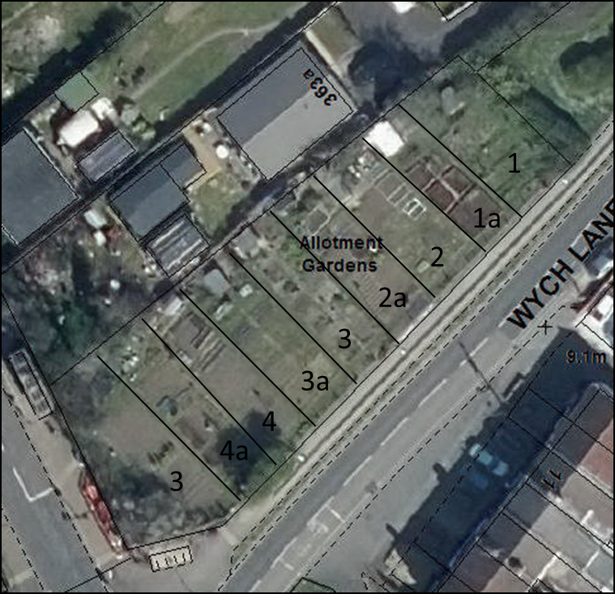
25m of gravel board and fencing to be erected

- Quotation Process
Please provide a breakdown of costs in your quotation; this should include parts, materials and labour and must be submitted through the South East Business Portal, also known as Proactis, by 1200 hrs on 20 April 2021
Please send any enquiries through the messaging function on the South East Business Portal/Proactis
4.0 Evaluation
These works will be awarded on best value price, provided the quotation covers all of the required information detailed in this document, including;
- Full and final price for the required works
- Method Statement covering all aspects referred to in Section 1.4
- Copy of Public and Employers Liability Insurance

Appendix 1.
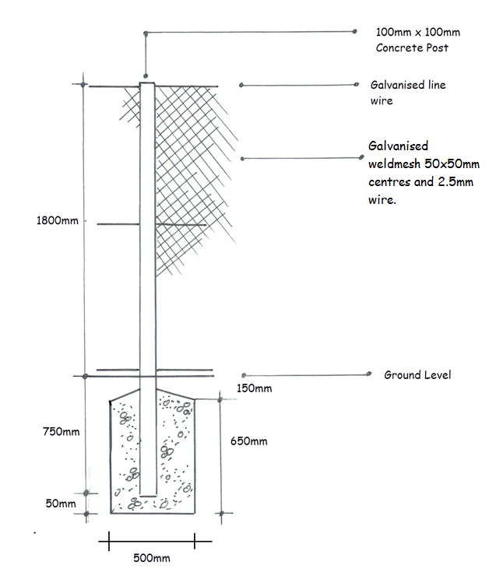

Drawing detail of post and foundation, drawing approx.1:20 (when printed on A4
Include bracing posts at either end of the fencing run.

