Completing Your submission
On the right hand side of the screen you will see the” start my response” button, click on this and continue through the next fields.
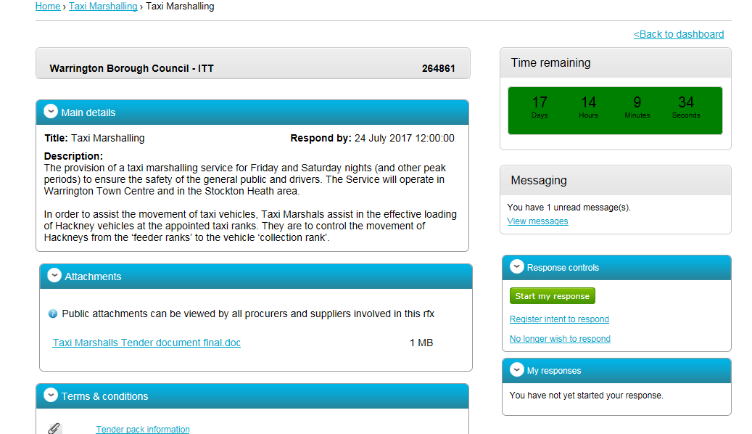

You will then see a screen with edit response highlighted, click on this, there is also a progress bar, to monitor your progress
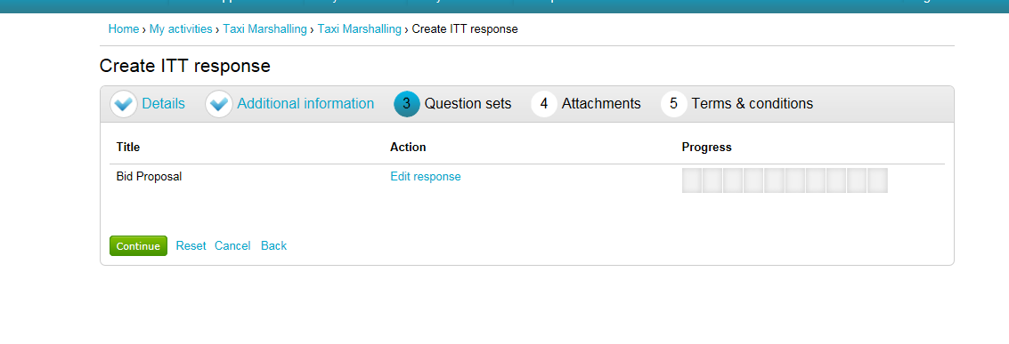
At the next screen you can start to complete the questionnaire by going into the Answer question function. Make sure you answer all questions

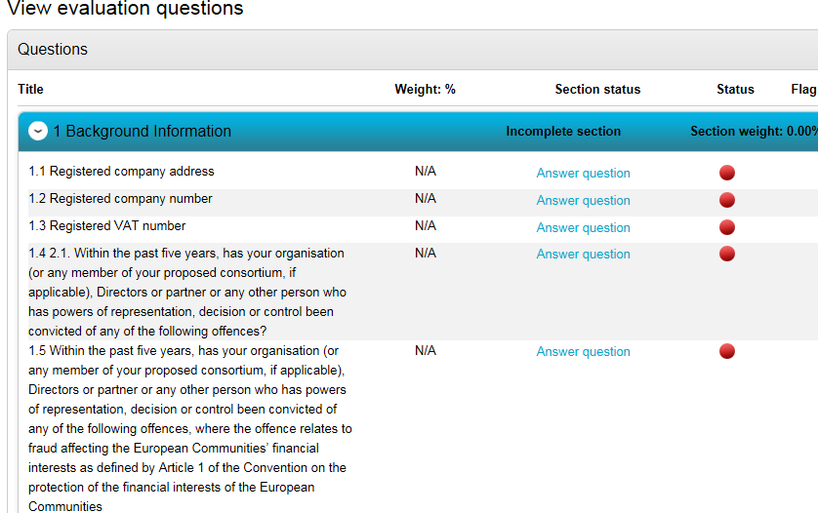

Different questions will require different forms of answer, from a simple confirmation or yes/no option through to answering in the text box or submitting an attachment
Ensure that you complete the assessment and that you submit correctly and on time. When you submit you will receive a confirmation.

You will be able to make amendments up to the closing time. Please ensure you make your submission in good time to avoid any technical difficulties.

