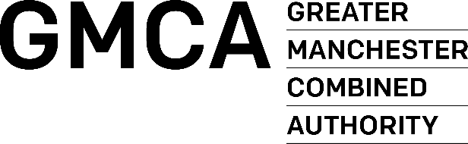

INVITATION TO TENDER

PART 3 – PRICING DOCUMENT

For the provision of a contract to provide:

Evaluation and Research, Greater Manchester Violence Reduction Unit

Contract Ref: DN618048 (GMCA526)

Closing Time & Date: 12:00 on 20th July 2022

Contract Duration: 30 months

Name of Tenderer:

FINANCE / PRICING SCHEDULE

  - Please read carefully the instructions in this section regarding the completion of the Financial Template or Pricing Schedule
  - Tenderers should ensure that all required cost elements are included within the Pricing Schedule. They should be fully inclusive of al disbursements, expenses, and costs
  - All costs should be completed in pounds STERLING (£), EXCLUSIVE of VAT.
  - The terms and conditions of GMCA will apply to all orders placed as a consequence of this process.
  - Settlement terms are 30 days.
  - Prices to be held for a minimum of 2.5 years.

Financial Template example
Provide a detailed rationale to support the expenditure (revenue) costs in the financial template submission. In particular, describe the rationale for the costs which make up and give as a proportion of the total contract value the expenditure budgeted for:
- Direct (front line delivery) costs
- Corporate Overheads (including other corporate costs) and Operating Profit
- Risk Premium

Pricing Schedule

 | Description of Goods/Services | UNIT COST  (excl. V.A.T)  £ : p
1. |  | £
2. |  | £
3. |  | £
4. |  | £
TOTAL |  | £
Maximum Points Available 5
Weighting = 5%

The above costs must include all travelling/subsistence, expenses and disbursements.

I/We hereby offer to supply the above-mentioned services on the GMCA Conditions of Contract Services and confirm that we have read, understood and agree to be bound by the GMCA Conditions of Contract Services for all orders placed as a result of this process.

Signed
Name (Block Capitals)
Designation
For and on behalf of

