Clarification Questions:

ONe-to-one Guidance service for prospective Trainee teachers in fenland and east cambridgeshire

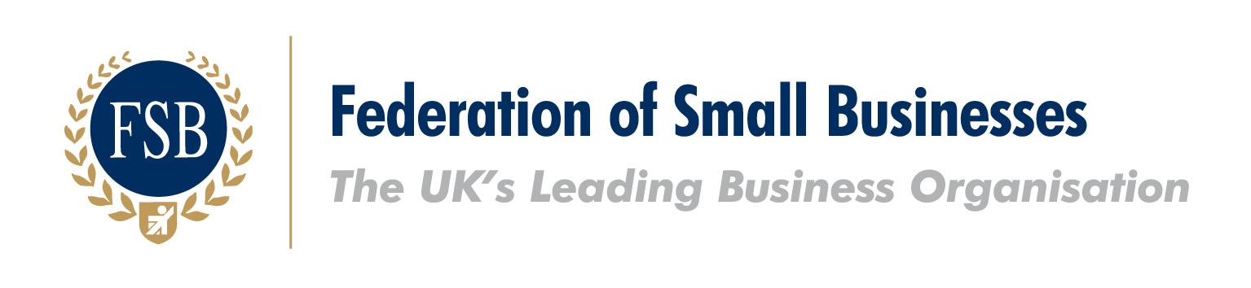
The Federation of Small Businesses (FSB) is pleased to endorse this RFQ document. Through changes to their procurement process to support small businesses, Cambridgeshire County Council are showing their commitment to improving the local economy. This positive action is a step forward in the simplification of the procurement process and the FSB look forward to working with Cambridgeshire County Council to encourage effective trade between the Council and local small businesses.

Clarification Questions
A summary of queries submitted in response to the Request for Quotation for One-to-one Guidance Service for Prospective Trainee Teachers in Fenland and East Cambridgeshire is provided below, along with further clarification:

  - We just want to double check that the £22,000 is on top of the incentive grant of £22,500 to £34,000?
Yes, the successful provider would be entitled to an additional budget of £22,000 on top of the £22,500–£34,000 budget for delivering the service outlined in the Request for Quotation. This additional £22,000 budget should be used to reimburse schools for any expenses incurred through participation in the Teaching Experience Programme and to cover any costs associated with delivering information evenings such as room hire or refreshments.

