MEDWAY COUNCIL

Adult Substance Misuse Services
Memorandum of Information
Document 3: Health Needs Assessment

Medway Public Health Programmes Team
March 2022
From Harm to hope:
A Medway Health Needs Assessment through the lens of the 2021 Drug strategy

Contents
Introduction 4
Policy Framework 4
About Medway 5
Data to indicate current treatment services impact 8
Deaths from Drug Misuse 8
Alcohol Specific Deaths 9
Current interventions and impact 10
Substances and Crime 12
Medway’s starting point to meet the objectives of “From Harm to hope”. 14
Objective 1: Breaking Supply Chains 14
Objective 2: Delivering world-class treatment and recovery services 15
1. delivering world-class treatment and recovery services – rebuild local authority commissioned substance misuse services, improving quality, capacity and outcomes 15
2. rebuilding the professional workforce – develop and deliver a comprehensive substance misuse workforce strategy 18
3. ensuring better integration of services – making sure that people’s physical and mental health needs are addressed to reduce harm and support recovery 19
4. improving access to accommodation alongside treatment – access to quality treatment for everyone sleeping rough, and better support for accessing and maintaining secure and safe housing 22
5. improving employment opportunities – employment support rolled-out across England and more peer support linked to Jobcentre Plus services 23
6. increasing referrals into treatment in the criminal justice system – specialist drug workers to support treatment requirements as part of community sentences so offenders engage in drug treatment 23
7. keeping prisoners engaged in treatment after release – improved engagement of people before they leave prison and better continuity of care into the community 24
Objective 3: Achieving a shift in the demand for recreational drugs 26
1. building a world-leading evidence base – ambitious new research backed by a cross-government innovation fund to test and learn and drive real-world change 26
2. applying tougher and more meaningful consequences – decisive action to do more than ever to target more people in possession of illegal drugs, and a White Paper next year with proposals to go further 26
3. delivering school-based prevention and early intervention – delivering and evaluating mandatory relationships, sex and health education to improve quality and consistency, including a clear expectation that all pupils will learn about the dangers of drugs and alcohol during their time at school 26
4. supporting young people and families most at risk of substance misuse – investing in a range of programmes that provide early, targeted support, including the Supporting Families Programme 26
Objective 4: Partnerships and accountability 28
1. providing focused investment, targeted at the places with the greatest need – this will mean that areas with high levels of drug use, drug-related deaths and crime will be prioritised for aligned additional funding across treatment, justice, employment and accommodation support 28
2. improving partnership working – we will set out what good partnership working looks like and who should be involved, using lessons from Project ADDER and other locally-based partnership initiatives such as Changing Futures to develop best practice and a learning network 28
3. developing a system of national and local outcomes, frameworks and accountability that will drive a consistent and clear set of expectations across the next decade, and ensure measurement of government against its promises 29
Summary of identified gaps and commissioning recommendations 31
Conclusions 33

From Harm to hope: A Medway Health Needs Assessment through the lens of the 2021 Drug strategy.

Introduction
The latest Drug strategy was released in December 2021 and has a ten-year life span. This report looks at the elements of the strategy that the Public Health (PH) Directorate within the Local Authority has a significant role to play and assesses the readiness of Medway to meet the objectives.
This report does not intend to summarise the strategy and should be read in conjunction with original document. The strategy can be found here.
The intended audience for this document are commissioners, service providers and partners across the wider workforce. It is intended to highlight areas where collaborative working will achieve improved outcomes and will be used by the Medway Drugs and Alcohol Action Team to develop areas of work.
This Health Needs Assessment will be refreshed annually and re-written in 2027.

Policy Framework
People use substances to alter their state of mind; this ranges from a morning coffee or an evening ‘nightcap’, to psychedelic drugs used in religious and spiritual ceremonies, or use of substances to ‘self-medicate’ for emotional, mental, or physical health need.

All substances present some level of risk, but some carry more risk than others. Treatment for problematic substance use is often framed in one of two paradigms, firstly the abstinence agenda and secondly the harm reduction agenda. The former seeks to support or prevent people from using substances through things such as peer support (12 steps programmes), legislation (Misuse of Drugs Act 1971) and current drug strategies. The latter acknowledges that, while in some cases unlawful, people use substances and the main aim is to prevent additional harms, this may be through interventions such as Opiate Substitution Therapy, Needle and Syringe Programmes, and education (Talk to FRANK). The emphasis between these approaches is not static, is generally politically driven and has changed several times.

Two key pieces of legislation which establish drug offences in the UK are the 1971 Misuse of Drugs Act (MDA) and the 2016 Psychoactive Substances Act. In 2017, the UK Government launched its 2017 Drug Strategy, the strategy aimed to promote effective partnership working between health and social care, the criminal justice system, housing and employment support. The strategy was framed around the following themes: reducing demand, restricting supply, building recovery, and global action. It reiterated the pivotal role of local authority public health teams in building and sustaining substance misuse services. In July 2021, the government published its initial response to the Dame Carol Black review. Based on the recommendations made, the government plans to draft a Local Outcomes Framework and a commissioning quality standard to strengthen the accountability of local authorities. Furthermore, following the proposition to introduce a new central Drugs Unit to reinforce clear central government leadership and oversight, the government launched a new joint combating drugs unit in July 2021. The government released the long-term drug strategy in December.
Local authorities have the responsibility for commissioning services to support people who use drugs (PWUD); these services are funded through the Public Health Grant. This HNA relates to Medway and the activities delivered through the PH grant.
National Commissioning Quality Standards for drug and alcohol treatment and recovery are being developed. At the time of writing they are out for consultation and are due to be published in March 2022. These standards will underpin the commissioning of a system approach in Medway.

About Medway
Geography: Medway is in geographic Kent in the southeast of England. The unitary authority of Medway was established in 1998 and comprises the five main towns of Strood, Rochester, Chatham, Gillingham and Rainham as well as smaller conurbations.
Population: In 2020, the population of Medway was 279,142, representing a growth of 6.2% within the last decade. The population growth in Medway is primarily due to natural growth, as migration to Medway has decreased since 2011/12. Medway has a younger population than England and the South-east. The median age of the population was 38.4 years in 2020. this compares to a median age of 40.2 for England.
Between 2019 and 2039, Medway's population is predicted to grow by 4% to reach 290,050 people by 2039, an increase of 11,457 people. Medway’s population is ageing; projections between 2019 to 2029 indicate that the proportion of adults aged 65+ will increase by 16% (or to 51,879 individuals) and that the proportion of adults aged 85+ will increase by 25% (or to 6,413 individuals), while the number and proportion of those in younger age groups are expected to decrease.
Figure 2. Population structure of Medway in 2020

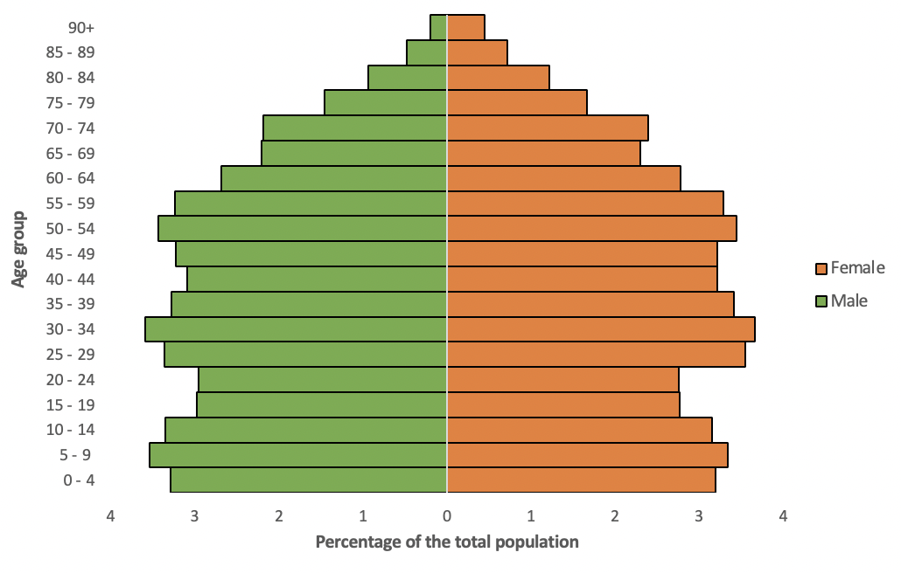
Note. Data are from ONS (2021)

In 2011, the majority of the population in Medway was white (89.6%), followed by Asian and Asian British (5.2%), Black, African, Caribbean and Black British (2.5%), Mixed (2%), and other ethnic groups (0.7%) (Figure 3). In 2016, the proportion of Medway’s population from ethnic minorities was 9.2%, slightly higher than the South-east value of 8.3% and lower than the England average of 13.6%.

Figure 3. Ethnic groups in Medway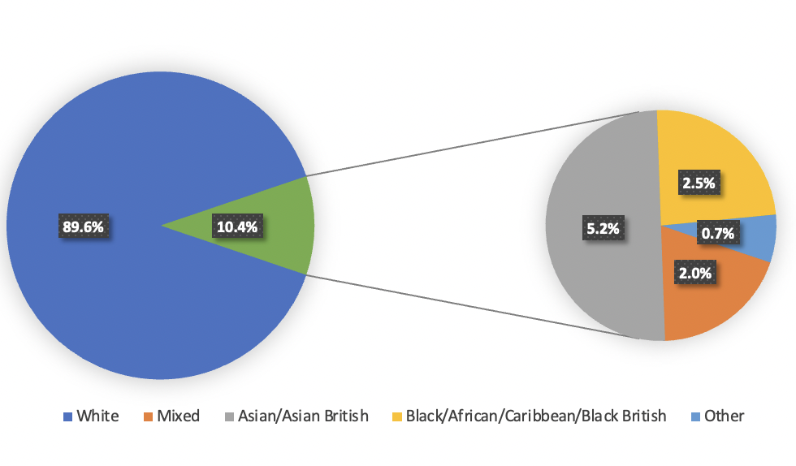
Note. Data are from the 2011 census by ONS

Health: Life expectancy at birth in Medway was 79.1 years for men and 82.6 years for women in 2017/19, which is below the England and South-east averages. Similarly, the under-75 mortality rate from all causes is higher in Medway than in the South-east region and England. The inequality in life expectancy at birth in Medway was 9.1 years for men and 6.7 for women in 2017-19. In 2019/20, 14.1% of adults aged above 18 were current smokers, which is similar to the England average. 71.6% of Medway’s population over 18 were classified as overweight or obese, significantly worse than the England and South-east averages.
Socio-economic factors: In 2015, Medway had a deprivation score of 22.3, slightly higher than the value of 21.8 for England but still placing Medway in the middle quintile nationally. In 2019, Medway was ranked the 98th most deprived local authority out of 317 local authorities in England. Deprivation within Medway varies geographically (Figure 4). In Medway, 75.3% of people were in employment in 2020/21, similar to the England average. The proportion of people in employment is increasing. In August 2021, 5.8% of Medway’s working-age population were claiming Jobseekers Allowance or Universal Credit due to unemployment, the claimant rate is highest among those aged 18 to 24, suggesting a relatively high rate of unemployment among young people. 18.6% of children under 16 in Medway lived in low income families in 2016, which is higher than the England and South East average.
Figure 4. Deprivation in Medway (darker colours indicate higher levels of deprivation)
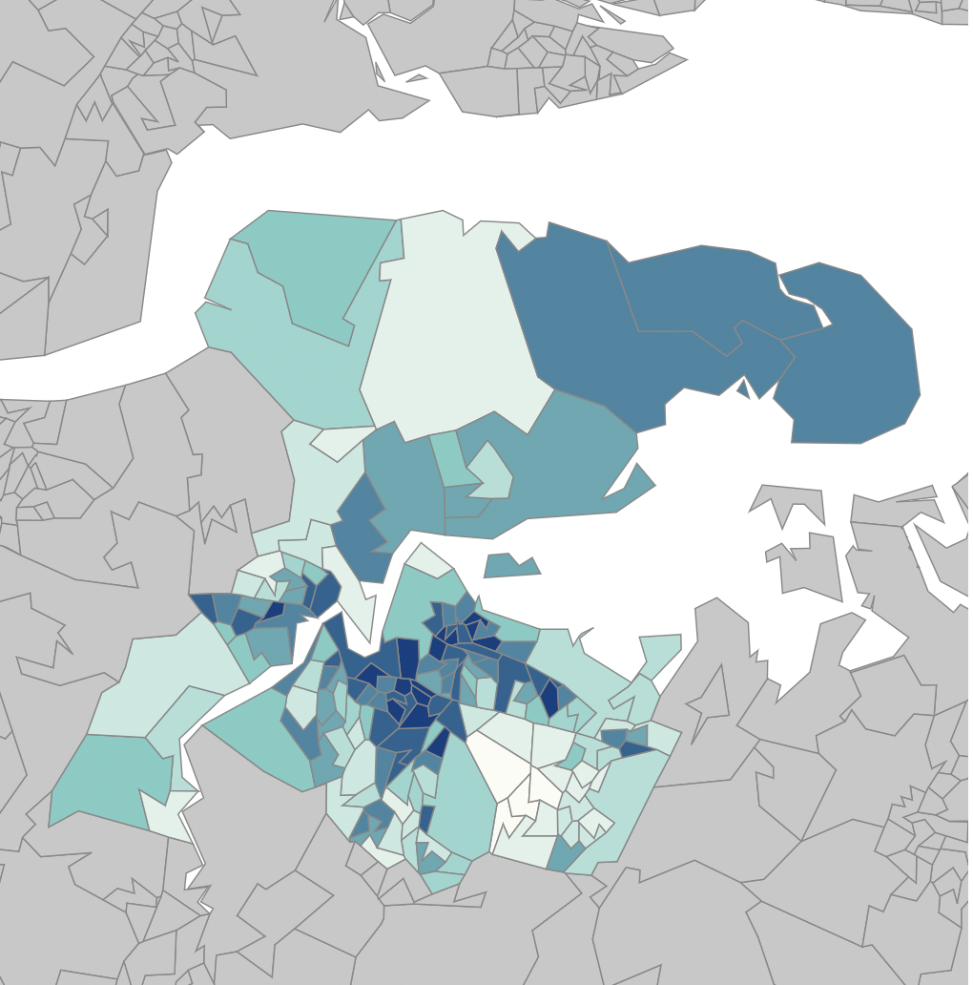
Note. Figure taken from IoD 2019 Interactive Dashboard. Darker colours indicate higher levels of deprivation.

Data to indicate current treatment services impact
Using substances can lead to death, this is particularly true for alcohol, opiates, cocaine and some Novel Psychoactive Substances (NPS). These deaths can take the form of poisoning or through long term health implications.

Drug poisonings in England and Wales have increased 3.8% at a 2019 and 2020. A rise from 76.7 deaths per million to 79.5 deaths per million. This represents 4561 people dying of drug poisoning in 2020; the large majority of these were males. Opiates and cocaine were the drugs most commonly recorded as the reason for the poisoning, (deaths due to alcohol are not included in these figures) and cocaine related deaths showed greatest increase.
There is a clear “north / south” divide in deaths through drug poisoning with the highest drug poisonings happening in the North East (104.6 deaths / million) and the lowest in London (33.1 deaths / million).

Drug poisonings are not spread evenly across all ages; the highest rates are among people in their 40’s

Among homeless people who died in England and Wales in 2020, 38% were related to drug poisoning.

Drug poisoning deaths in Medway show variation but no consistent discernible trend (Table 1 below).

 | 2020 | 2019 | 2018 | 2017 | 2016 | 2015 | 2014 | 2013 | 2012 | 2011 | 2010
ENGLAND | 4,312 | 4,115 | 3,983 | 3,482 | 3,450 | 3,416 | 3,156 | 2,734 | 2,367 | 2,425 | 2,509
Medway | 25 | 16 | 27 | 14 | 22 | 24 | 27 | 21 | 16 | 8 | 11
Table 1: Number of deaths related to drug poisoning, persons by local authority and England, registered in each year between 2010 and 2020 (ONS 2021)

Deaths from Drug Misuse
A broader definition of deaths resulting from substance use that lead to death are reported as Deaths from Drug Misuse (Chart 1), Alcohol is reported separately and is not includes in deaths from drug misuse. Deaths from drug misuse are more complex to accurately capture, and data relies on how individual cases are coded by the coroner and elsewhere in the system. Data is reported on a three-year average. There has been an upward trend nationally in deaths from drug misuse and the reported spike that started in 2011-13 in Medway has settled back to just above the England average.

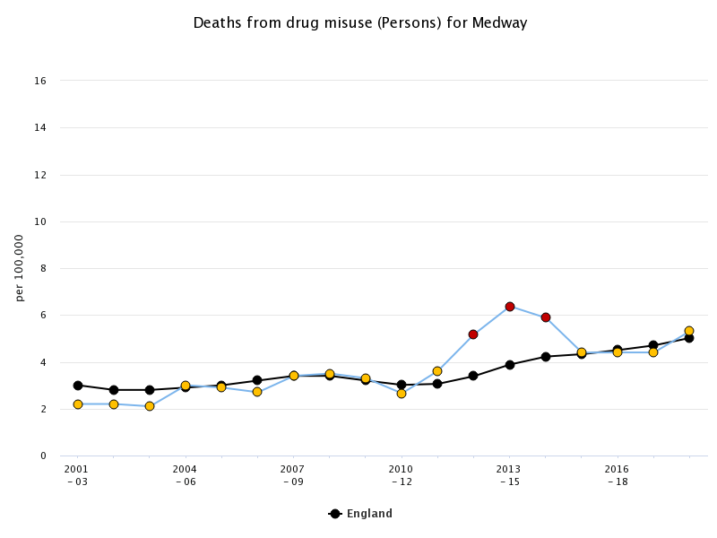
Chart 1: Deaths from drug misuse (Medway)

Alcohol Specific Deaths
Deaths specifically from alcohol use in Medway are below the England average however there is an increasing trend. The data is reported as a three-year basis and it is therefore anticipated that the next data to be released will continue that upward trend.

There is also emerging evidence of an increase in alcohol consumption during the pandemic and lockdowns which is likely to have an adverse impact on health. Alcohol specific mortality indicates deaths that are clearly linked to alcohol use; these are reported on a 3-year basis. Medway is currently below the England average but shows a rising trend. Evidence indicates that during the pandemic unplanned hospital admissions for alcoholic liver disease increased between 2019 and 2020. Should this trend continue, it can be presumed that alcohol attributable deaths will also increase.

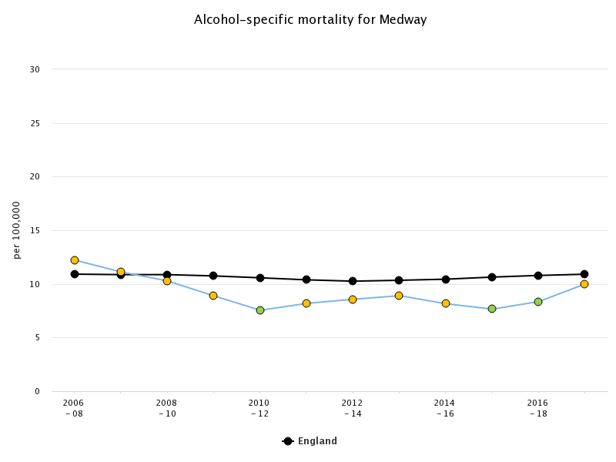
Chart 2: Alcohol Specific Mortality (Medway)

Current interventions and impact
Treatment services are commissioned by Medway Council and managed by the Public Health Team. The services are made up of two parts the Engagement Assessment Stabilisation and Treatment service delivered by Turning Point and a smaller Wellbeing and Recovery contract delivered by Open Road. Engagement with treatment services is regarded as a protective factor. Pre-pandemic data indicates that treatment is equal to or better than the England average (Charts 3-5 below). Locally reported data indicates that this has continued throughout the pandemic

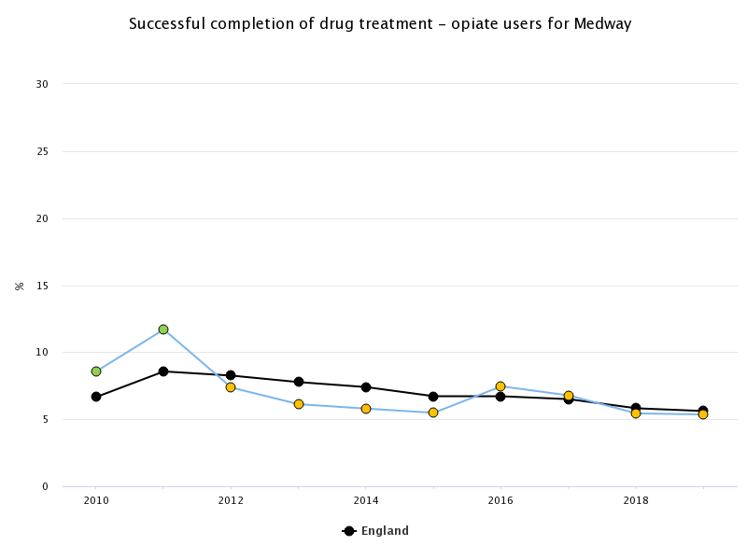
Chart3: Successful completion of Drug treatment for Opiate Users up to 2019 (Latest available data)

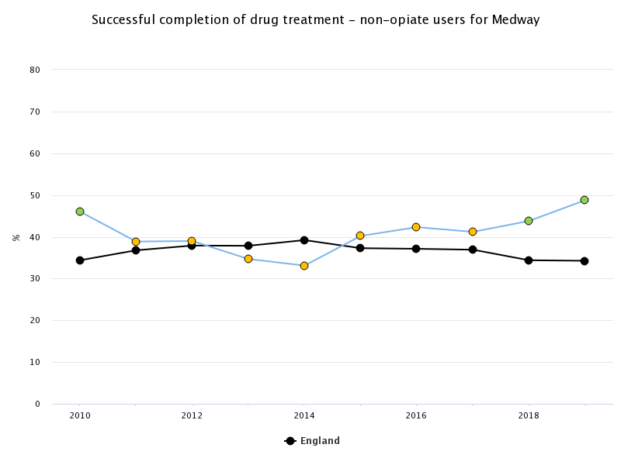
Chart4: Successful completion of Drug treatment for Non-Opiate Users up to 2019 (Latest available data)

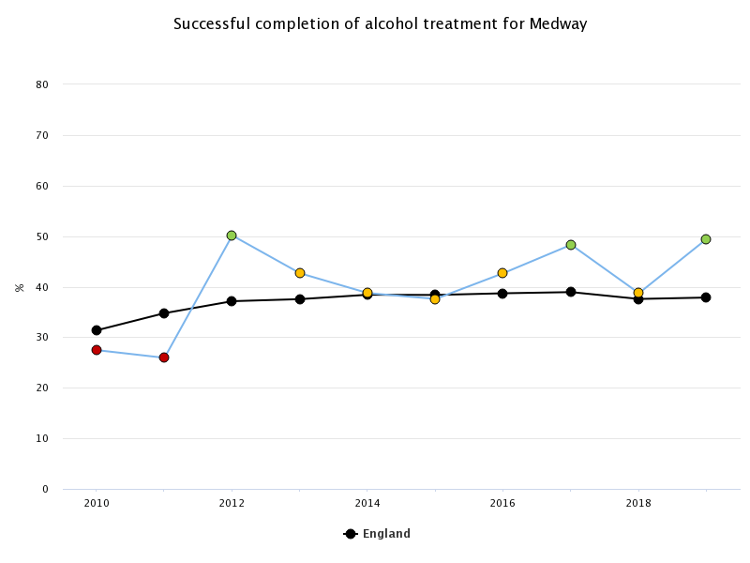
Chart5: Successful completion of Alcohol treatment up to 2019 (Latest available data)

Substances and Crime
The relationship between drug use and crime has been well established, with approximately half of all homicides and acquisitive crimes relating to drugs. In January 2021, the government announced a £148 million funding would be made available to tackle crime and aim to protect those harmed by illicit drugs, with £80 million among the treatment and recovery services. Addressing crime is a central theme of the 2021 drug strategy.
The Dame Carol Black review criticised the reduction in use of community sentences with drug rehabilitation (DRR) and alcohol treatment requirements (ATR) and recommends expanding these as an alternative to custody. The treatment services report low use of DRR and ATR, and poor levels of successful completions.
NHS England commission a Liaison and Diversion service that is based in the custody suites of Police stations across Kent. Medway custody suite is the busiest however the numbers of referrals from L&D to treatment services were low.
Continuity of care as people transition between prison and community is important to ensure that people do not become lost to the treatment system. A stretch target of 75% pick up rate for those leaving prison has been set. Latest data indicates Medway successfully engages with 58%, which is well above the England Average (Chart 6) yet indicates that significant improvement is required to meet the new target. To achieve this close collaboration will be needed between NHSE/I Health and Justice commissioners, Prison treatment providers, and their community partners.
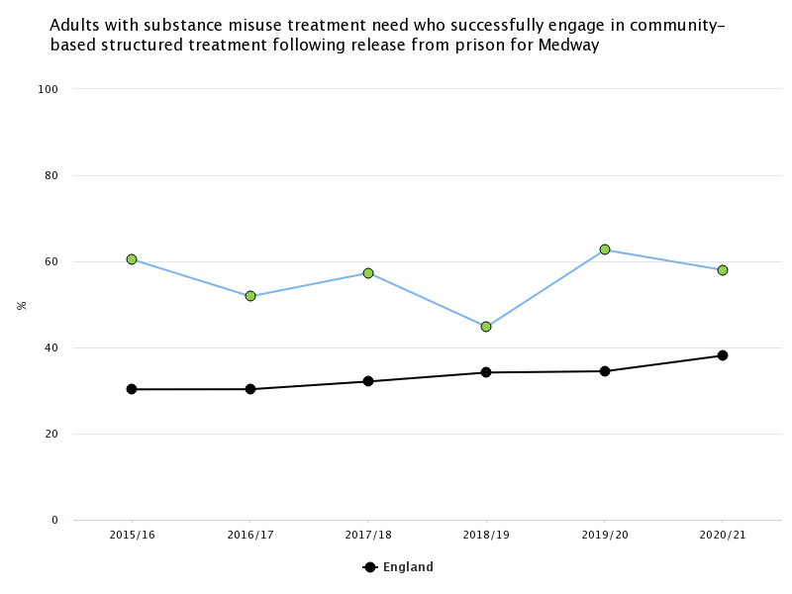
Chart 6: Adults with substance misuse treatment need who successfully engage in community-based structured treatment following release from prison

Medway’s starting point to meet the objectives of “From Harm to hope”.

Objective 1: Breaking Supply Chains
The activities under objective one are primarily for the Home Office and the Ministry of Justice. While PH can support interventions such as ‘rolling up county lines’ this will be led by criminal justice systems.

Objective 2: Delivering world-class treatment and recovery services
Additional funding has been made available to Local Authorities that is ringfenced for substance misuse treatment services. The Office for Health Improvement and Disparities (OHID) will oversee the use and impact of the additional budget.

1. delivering world-class treatment and recovery services – rebuild local authority commissioned substance misuse services, improving quality, capacity and outcomes

1.1 LA commissioned services
Treatment services are commissioned by Medway Council and managed by the Public Health Team. Evidence based interventions are recognised for their effectiveness in preventing drug and alcohol deaths. Current treatment service delivery is based on a recovery model, with harm reduction delivered as secondary and tertiary prevention. Primary prevention for alcohol is delivered by Medway Public Health. The main commissioned services are made up of two parts: the Engagement Assessment Stabilisation and Treatment service delivered by Turning Point and a smaller Wellbeing and Recovery contract delivered by Open Road.

1.2 Quality
The treatment services delivered by Turning Point have been rated Good at a 2019 CQC inspection and key performance indicators have been met across the life of the contract.
In Late 2021 a series of stakeholder interviews and public surveys were conducted to gain insights. The key findings were as follows:

Accessibility
Some people spoke of barriers accessing services and spoke of feeling judged and stigmatised by professionals, some said that there was little consideration of the circumstances to led to the person being dependant on substances. There appears to be a need for greater awareness of Trauma Informed Practice.
Communication between case worker and client was seen as important as failure in that area may result in the clients being discharged for ‘non-engagement’.

Whole person support
Some service users indicated that housing had been an issue for them. Generally, they spoke highly of third sector and supported housing providers who often acted as advocates and were willing to offer support to those who had been turned down by mainstream housing providers. Supported housing and charities working with street-based communities have trust-based relationships with people who face additional barriers to services.
Some of those surveyed indicated that there was a lack of joined up working in their care and pointed out that one service cannot solve the issues around substance misuse as they are driven by societal issues such as fragmentation of communities and individualism. Those surveyed included the following as factors that should be considered as part of their treatment:
- giving people a purpose,
- having a visible recovery community,
- general practice appointments,
- mental health,
- housing,
- being involved and listened to,
- poverty,
- social inclusion,
- additional support after engagement with criminal justice and prison,
- appropriate and accessible scripting,
- volunteering and education opportunities
- an understanding of the reasons for non-engagement

Codesign and delivery with those with lived and living experience
Peer mentors are recruited, trained and mobilised within the current services, some of those interviewed felt these opportunities were valuable and helped support other service users. However there was some sense that they were underutilised and sometimes peers were excluded from the main work of the service due to what were felt to be procedural issues. Service users interviewed indicated that peer mentors lacked diversity and therefore it was difficult on occasions to identify with them. The peers were well thought of but some of those surveyed felt they could me more instrumental in-service design and the work they did could be developed into a peer support system. Some of those surveyed felt that there was not enough collaboration between commissioned services and the mutual aid groups such as Alcoholics Anonymous and Narcotics Anonymous. It was highlighted that mutual aid groups are available when commissioned services are shut.
Since the survey, the Naloxone peer to peer programme has developed some excellent ways of working to train and mobilise those with lived experience.

Co-occurring conditions
Difficulties accessing mental health services was a constant theme among those interviewed. Despite there being a co-occurring conditions policy between providers of mental health and substance misuse services, people who needed both services often felt they were inadequately supported, some stated they had dropped out of services due to the requirement to address substance misuse or mental health before they were able to receive support for the other. Interviews with professionals appeared to confirm the lack of joined up working and examples of interviewees attributing blame on the other agency were noted. The mental health transformations programme being undertaken as part of the Integrated Care System should be encouraged to address the pathways for those with co-occurring conditions.

Venues
Interviewees generally disliked the Turning Point building; some felt it increased their exposure to stigmatization from the local community. This increased during COVID restrictions as the building's small size meant only 1 person was allowed in the waiting room at a time, leaving the rest to wait outside. Some service users stated they felt that the building should not be on the high-street or near a school, as they were embarrassed to be seen by parents and children. The current opening time of 2pm was said to exacerbate this, as this was only 1hr before the end of school, meaning they were highly exposed.
Interviewees recommended that treatment services move to a bigger building located away from the town centre. They also suggested more flexible opening times, including weekends and out of office hours.
GAP: Building or buildings that are suitable for a range of clients and that deliver a discrete, non-stigmatising service.

Psychosocial services
Many of those surveyed preferred one to one support sessions over group work. The main reasons given for this were having anxiety, feeling uncomfortable and having difficulty opening up. Telephone support was used widely during the COVID restrictions but among people surveyed who used the services these were unpopular. However, many professionals and other stakeholders considered them a good way of maintaining contact that should continue as a new way of working.
GAP: There is an apparent mismatch between those who provide the services and those who use them; this should be addressed as soon as possible to improve outcomes.

1.3 Capacity
There is an expectation that treatment capacity will increase by 20% in Medway. This equates to an additional 87 alcohol and 162 drug treatment journeys per annum compared to 2020-21 activity levels (Reference commissioning packs)
Local Authority Capacity: Medway Public Health deliver their commissioning responsibilities with 1FTE Project Officer, 0.2 FTE Commissioning Support Manager, 0.5 FTE Commissioning / Programme Manager, 0.25 FTE Senior Public Health Manager. The Public Health team also draw on expertise from the Council Procurement, Finance and Legal teams as required. Should the reporting and commissioning requirements from OHID increase it is likely that additional commissioning support will be required.
Provider capacity: The pandemic has reduced the providers capacity due to limitations on the numbers of people who can access the building at any one time. Numbers in treatment have fallen slightly for Opiate users but increased for non-opiate and Alcohol (DOMES Q2 2021-22). 1054 people were in treatment between 01/04/20 to 31/03/21, which rose to 1174 between 01/01/21 to 31/12/21. This represents an 11% increase. Providers indicate that the current case load has at times been 60 per worker; this is considered too high and additional resources are needed to reduce this. A high caseload reduces the time workers can spend in meaningful engagement, care planning and progress monitoring.
The wellbeing and recovery service employs 1x FTE service manager 4x FTE coordinators, 0.4 FTE Administrator. The treatment services employ 0.2 senior manager, 1x FTE Operations Manager, 0.4x FTE Psychologist, 0.8x FTE Clinical Lead, 0.8x FTE NMP, 1x FTE Nurse, 1x FTE Hub Manager, 1x FTE Admin and Performance, 1x FTE Team Leader Outreach, 3x FTE Admin, 1x FTE Receptionist, 1x FTE Family Worker, 3x FTE Senior Recovery Worker, 11x FTE Key Worker.
Providers should be asked to demonstrate how they will meet the additional treatment journeys and how many case workers within treatment services would be needed.

1.4 Outcomes
The services both contribute to successful completions that are above or in line with national levels. The Medway treatment system has worked collaboratively with other partners and agencies to provide holistic care.
Care should be taken with KPI setting and national indicators as they can create adverse incentives. For example, some of those surveyed felt that clients were closed as non-engaging when the reality was that the person’s life was chaotic, or there were other complexities such as co-occurring mental health and they were unlikely to achieve abstinence expected by the national indicators. Although people benefit by the regular harm reduction support it is difficult to demonstrate the impact in national data that focusses on those “in treatment”, “completed treatment” and “Represented into treatment”. It is recognised that the 10-year strategy is abstinence focussed and therefore national indicators are likely to follow suit.
GAP: Outcome measures should capture harm reduction as well as abstinence.

2. rebuilding the professional workforce – develop and deliver a comprehensive substance misuse workforce strategy
As recent recruitment attempts have shown there is a lack of qualified and experienced people looking to work as part of the substance misuse workforce. The reasons for this are varied and this paper makes no attempt to explain the shortages. The strategy pledges 800 more medical, mental health and other professionals; 900 substance misuse criminal justice workers; and additional commissioning capacity in LAs. The DHSC will work with HEE to develop a workforce strategy – Medway should take every opportunity to influence the strategy through any available consultations.
Any new contract to deliver services in Medway should include training with a recognised qualification for existing and new staff. It should be recognised that upskilling of staff makes them attractive to other organisations and therefore this should be supplemented with a good package of staff benefits to retain them in Medway.
The calls for Covid Vaccination as Condition Of Deployment (VCOD) in 2021 threatened to limit the deployment of volunteer and peer supporters within the CQC registered service. The wellbeing and recovery element of the contract would not have been subject to VCOD. This requirement is (at the time of writing) being reviewed and is likely to be withdrawn, and concerns had already been raised about its negative impact of substance misuse services. However, to mitigate against similar risks in the future consideration should be given to remodelling the service with a clear distinction between regulated and unregulated activity.

3. ensuring better integration of services – making sure that people’s physical and mental health needs are addressed to reduce harm and support recovery

Physical health
Alcoholic Liver Disease (ALD) has been a key factor in alcohol deaths and it appears that early identification opportunities have been missed. To rectify this, Medway Public Health purchased a Fibroscan machine that measures the elasticity of a person’s liver and can identify damage sooner than a liver function test. The Fibroscan is loaned to the treatment provider who use it as a screening tool to then give health improvement advice. Where ALD is identified, a referral is made into the Hepatology department at Medway hospital. Pathways are also being investigated between the Health Checks delivery team and fibroscanning opportunities.
Due to historic serious incidents Medway does not operate a General Practice / Treatment Provider shared care model. There are currently no intentions to change this for people accessing Opiate Substitution Therapy (OST). However, general practice is often the first point of contact or opportunity for early identification for problematic illicit, prescribed and alcohol use. Direct referral pathways exist from GPs into the service and collaborative projects have been trialled, but these trials often rely on an interested individual to drive them forward.
Physical health checks are given to those accessing prescribing through the treatment service but there is additional scope for regular health checks including weight, blood pressure monitoring etc. This could be achieved through self-service machines or through suitably trained staff and basic equipment.
GAP: Opportunities for self-managed care.
Diversionary activities such as gardening, mindfulness, service and social events are intended to improve the physical health and well-being of people accessing recovery support. Greater consideration should be given to the use of sport and a broader range of physical activities to improve physical health.

Mental Health
It is widely acknowledged that thresholds within Mental Health provision can adversely affect the patient journey. Those with co-occurring conditions of mental ill-health and substance misuse fare particularly badly. NICE guidelines NG58addresses care for those with severe mental illness. Severe mental illness includes a clinical diagnosis of: schizophrenia, schizotypal and delusional disorders, or bipolar affective disorder, or severe depressive episodes with or without psychotic episodes. The guidance does not cover people with PTSD, Dementia such as Korsakov’s or common mental health disorders. Attempts have been made on several occasions to improve the support for people facing co-occurring conditions through Joint Protocols, however experiences of people are often reported as being poor.
Across Medway, 22.5% of people entering treatment were in contact with mental health and substance misuse services in 2016/17, which is slightly lower than figures for Kent and the national average. Among people who use alcohol in Medway, 20.4% were in concurrent contact with mental health services in 2016/17, compared to a national average of 22.7% and the Kent average of 24.5%. In aiming to target the complexities of co-occurring conditions, NICE clinical guidelines suggest that to treat alcohol misuse successfully and CMHD, alcohol misuse should be targeted first as this may lead to significant improvements among depression and anxiety. Additionally, evidence-based psychological treatments are recommended to treat comorbid depression and anxiety with cannabis or stimulant misuse specifically.
Chart 7 highlights the proportion of individuals entering drug treatment, who also require co-occurring mental health treatment. The figure depicts whether the treatment is adequately provided to individuals within Medway, along with the benchmark value for Medway and England. Findings demonstrate that more than half of those accessing drug treatment currently also require mental health treatment; however, a significant proportion of individuals are failing to receive this required treatment type. Although Medway remains comparable to the England average benchmark areas, access to mental health treatment remains problematic for some service users.

Proportion of individuals entering drug treatment who have a mental health treatment need, and for whom this need is not met, according to parental status

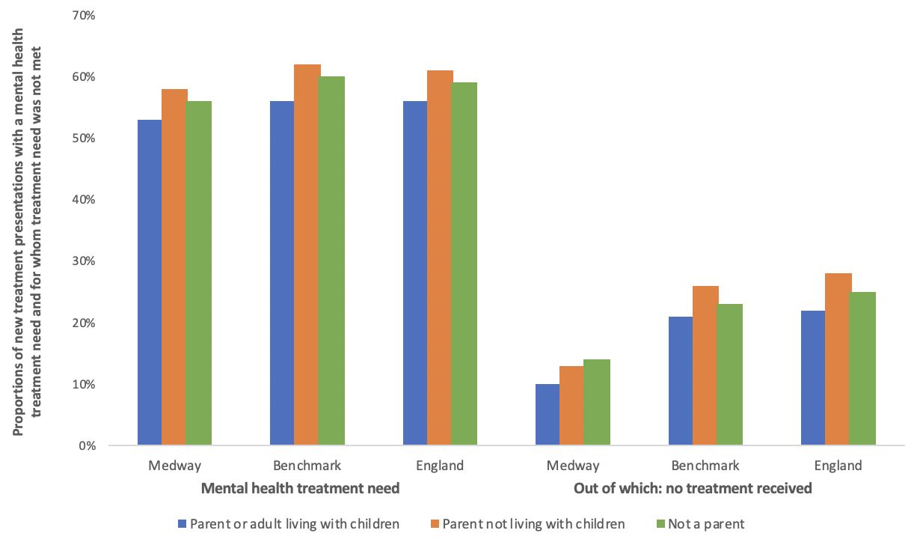
Chart 7: Proportion of new treatment presentations with a mental health treatment need
GAP: A working approach to supporting people with co-occurring conditions

Reducing harm
Whilst Naloxone (an opiate overdose antidote) has been provided in Medway for many years, this year access has been increased by using non-recurrent grant funding from Public Health England. Medway Public Health have set up a peer-to-peer Naloxone distribution outreach scheme. Peers have been trained and mobilized by an expert in the field, they can then train people who use drugs, friends and professionals how to use Naloxone. This includes supported accommodation, street-based communities, and late-night fast-food outlets. The peers have reported several accounts of how the naloxone they have distributed has been used to reverse an overdose. This project not only saves lives but will also reduce ambulance call out and Emergency Department attendances. The project also includes other health improvement activities, for example Hep C testing, Needle and Syringe programme, clearing up drug litter from public areas, and basic sexual health advice and condoms.

Enforcement
Medway have good working relationships with Police at both operational and strategic levels. The Medway Taskforce is a multi-disciplinary team led by the Police and overseen by the Community Safety Partners. The Taskforce regularly act as a first point of contact when non-urgent operational support and advice are needed. The (Name of HQ based drugs team) contribute to the Medway Drugs and Alcohol Action Team (MDAAT) with regular communication.
Medway Police and the Probation Service are key members of the Blue Light Project, who are actively contribute to support the most vulnerable and use enforcement measures proportionately.
All enforcement activities are undertaken by the police and the wider criminal justice system.

4. improving access to accommodation alongside treatment – access to quality treatment for everyone sleeping rough, and better support for accessing and maintaining secure and safe housing
Long-term consequences of substance misuse can include the loss of housing. Additionally, rough sleepers are disproportionately affected by substance misuse: the Rough Sleeping Questionnaire from the Ministry of Housing, Communities and Local Government estimates that 60% of rough sleepers currently need support relating to drug or alcohol misuse¹⁸⁶. Homelessness also often intersects with other complex issues. Many homeless who have substance misuse problems have had adverse childhood experiences (ACEs).

Partnership working is strong in Medway between housing and substance misuse systems. Medway has a well-established Rough Sleepers Programme that is managed by the Strategic Housing team. The programme has provided 221 placements since 2018 and works closely with the treatment service provider to deliver holistic care. The treatment service has an outreach function as part of the core contract and additional funding has been given to increase the amount of outreach including to those from street-based communities. The treatment provider also delivers in-reach to hospital and other health settings where possible to engage with those who are treatment naive or face additional barriers to community services.
The peer run Naloxone distribution programme (Medway HOPE) actively engages with street-based communities. Pathways to Independence deliver peer led support for people with lived and living experience of problematic substance use who are transitioning into supported accommodation.
The council have very strong partnership links with third sector organisations who are supporting rough sleepers, street-based communities and other vulnerable groups. This includes One Big Family, Gillingham Street Angels and Caring Hands.

5. improving employment opportunities – employment support rolled-out across England and more peer support linked to Jobcentre Plus services
Before the restrictions needed to reduce the transmission of Covid-19, Peers regularly attended JCP to support clients and accept referrals from JCP staff.
A primary function of the Wellbeing and recovery part of the substance misuse treatment system in Medway is to increase volunteering and employment opportunities. Since the contract started 86 people have been helped to gain work placement and volunteering experience out of a total 586 contacts. It should be remembered that opportunities were impacted by Covid lockdowns and restrictions. Opportunities included retail, service sector and volunteering in the substance misuse sector.

6. increasing referrals into treatment in the criminal justice system – specialist drug workers to support treatment requirements as part of community sentences so offenders engage in drug treatment
While acknowledging the links being built between the criminal justice system and treatment services it is recognised that there are significant areas for improvement. Existing contracts and areas for improvement are listed below:
Liaison and Diversion (L&D) service (delivered by KMPT and Commissioned by NHSE/I Health and Justice). The service aims to identify health needs of people passing through Police custody suites and make appropriate referrals to support services. L&D presents an opportunity for early engagement and intervention. Turning point are subcontracted by KMPT to accept and complete the administration of referrals from L&D. Activity levels have been relatively low and referrals into treatment services per year are listed below.
Number referred into TP from the Liaison and Diversion service
Year | Referrals | Clients
2018-19 | 77 | 74
2019-20 | 143 | 140
2020-21 | 142 | 132
Total | 454 | 412

There are currently no direct links from courts into the treatment services via a dedicated specialist drugs worker. Turning Point liaise with courts and probation on sentencing arrangements, as necessary. They then support the Alcohol Treatment Requirement (ATR) and Drug Rehabilitation Requirement (DRR). Numbers of referrals are low and successful completion of ATR / DRR is significantly lower than for people accessing treatment via other routes.
Number of ATR / DTR referrals and successful completion rates
ATR | Referrals | Clients | Successful Completion | % of All ATR Discharges in Period
Apr 2019 - Jan 2022 | 49 | 43 | 5 | 14%
DRR | Referrals | Clients | Successful Completion | % of All DRR Discharges in Period
Apr 2019 - Jan 2022 | 22 | 20 | 2 | 11%

Only a small number of people referred into treatment are supported jointly by probation and Turning Point. This may mean that opportunities for holistic care are missed.
Number of service users jointly supported by Probation and TP (over the past 3 years)
Year | Referrals | Clients | Supported | % Supported
Apr 2019 - Jan 2022 | 145 | 127 | 79 | 62%

GAP: Specialist substance misuse treatment worker based in courts, probation and Police custody suites to build links and present treatment opportunities with people who use substances. Supportive rather than punitive.
GAP: Robust supportive and trauma informed pathways between services

7. keeping prisoners engaged in treatment after release – improved engagement of people before they leave prison and better continuity of care into the community
A review of sudden and unexpected drug deaths in Medway concluded that “…there can be barriers accessing the full range of services needed to support an individual with multiple and complex needs. These barriers become more apparent on transition between services, e.g. leaving hospital, custody, disengaging from substance misuse treatment or accessing mental health services. The individual’s behaviour and the responses of staff may contribute to those barriers. Treatment is a protective factor for people who have multiple and complex needs.”

Medway has good engagement with those being released from prison establishments and has worked hard to maintain links with the providers of treatment services in Kent and in particular at the Sheppey cluster (Elmley, Stanford Hill and Swaleside). Forward Trust who deliver the treatment services are an active partner in the Blue Light Project that enables a degree of continuity of care for those most likely to fall between the gaps in services. There is a risk that these links may be lost with changes in prison health providers in Kent’s prisons, this risk highlights the need for formally agreed pathways rather than relying on informal and relational links.
Strategic housing have started to make links with the NHSE Health and Justice commissioners for prison health in an attempt to develop pathways to prevent homelessness on release from prison. Treatment providers and other support agencies could work in partnership with this project to deliver holistic care.
Medway Probation Service officers are an active partner in the Blue Light Project and links between probation and wider services has improved in recent years. This partnership is based on buy in from individual members of staff rather than through formal pathways. This makes them vulnerable to any changes in staffing.
The Re-connect project delivered by KMPT should provide additional resources to support people transitioning between prison and community. This is a service commissioned by NHSE/I Health and Justice.
GAP: Strategic collaboration between LA, National Probation Service and NHSE Health and Justice to ensure continuity of care.

Objective 3: Achieving a shift in the demand for recreational drugs

1. building a world-leading evidence base – ambitious new research backed by a cross-government innovation fund to test and learn and drive real-world change
There are no direct actions required by the local authority. Public Health is an evidence-based practice and the latest most robust evidence should be used to inform service delivery; treatment providers and systems should be willing to contribute to and learn from the emerging evidence base.

2. applying tougher and more meaningful consequences – decisive action to do more than ever to target more people in possession of illegal drugs, and a White Paper next year with proposals to go further
While this element of the objective sits with central government and criminal justice systems it could impact on the willingness of people with living experience of substance use to become visible and support their peers.
Many of those put before the courts for possession offences are unlikely to benefit from treatment episodes where their use is recreational. Any requirements for them to attend treatment could take up capacity that would be better used who are experiencing problematic drug use.

3. delivering school-based prevention and early intervention – delivering and evaluating mandatory relationships, sex and health education to improve quality and consistency, including a clear expectation that all pupils will learn about the dangers of drugs and alcohol during their time at school
Medway public health support schools to deliver RSE and health education. They provide schools with a variety of high-quality support including subject review visits, teacher training, providing resources and co-facilitation of lessons. They have a role as a critical friend and assess schools’ policies and plans, speak to staff, senior leadership teams and pupils, and observe the delivery of lessons.
They have supported schools with the implementation of statutory Health Education, which includes learning about drugs and alcohol, the risks and harms as well as strategies for resisting peer pressure and seeking support. Schools are provided with lesson plans and resources produced by the PSHE Association and have the opportunity to attend training through the Medway PSHE Network.

4. supporting young people and families most at risk of substance misuse – investing in a range of programmes that provide early, targeted support, including the Supporting Families Programme

Medway Public Health are working with colleagues in Children’s Social Care to support vulnerable women who repeatedly have new-born babies taken into care. Analysis has shown that over 60% of these women use substances and a 2 year pilot has been established with Substance Misuse services one of the key stakeholders.
Medway Council has also received investment from Department of Education to trial a multi-disciplinary approach to supporting families. A substance misuse worker will be funded to co-locate with social work teams to upskill and provide case management support for social work staff.
Public Health and Social Care are working with Essex Foundation Trust on a pilot project to support children in care over the age of 16 with mental health and resilience support with the aim of diverting young people away from risky behaviours and the criminal justice system.
This is an area for development for the system. Partners such as Social Care and Probation offer some support as part of their core services, and some additional support is planned it is an area where additional resources could be invested. Work the work of AdFam and courses such as CRAFT present opportunities to partner with people who have living experience of supporting people address substance misuse outside of statutory or commissioned services. This approach would build on other peer led approaches currently being adopted in Medway.
Young people’s (YP) services are separate from adult services and commissioned by a different team. The YP substance misuse contract is a small part of the Young People’s Mental health support contract. This has not delivered the anticipated outcomes and has increased fragmentation.
GAP: Improving support for young people and families
GAP: All age service delivered in age-appropriate ways and locations

Objective 4: Partnerships and accountability

1. providing focused investment, targeted at the places with the greatest need – this will mean that areas with high levels of drug use, drug-related deaths and crime will be prioritised for aligned additional funding across treatment, justice, employment and accommodation support
Medway has received notification of the additional funding available and has been added to the 2023/24 tranche of enhanced funding. This additional money is ring fenced and must be spent in addition to the existing funding and not as a replacement for it.
The Office for Health Improvement and Disparities (OHID) monitor the outputs and outcomes achieved with this additional funding and are prescriptive on what the funding can be spent on. The menu of interventions includes: Outreach, commissioning support, collaboration with criminal justice agencies, Naloxone, Needle / syringe programmes and Buvidal long acting opioid substitution therapy.
Key outcomes from the first-year funding included:
Providing additional outreach capacity. Funding has been allocated to provide outreach workers specifically involved in street and supported accommodation communities with the additional remit of increasing engagement with alcohol dependent users. Additionally, hospital liaison and criminal justice workers will be added to the main treatment provider to improve continuity of care and provide in-reach services to engage at-risk cohorts that may previously have been discharged without contact with treatment services. Funding has also been confirmed to continue with the Medway Hope peers who deliver outreach services, needle syringe pack and naloxone distribution/training and plans are in place to expand this outreach to all areas of Medway.

2. improving partnership working – we will set out what good partnership working looks like and who should be involved, using lessons from Project ADDER and other locally-based partnership initiatives such as Changing Futures to develop best practice and a learning network
Turning Point have been key partners in the Blue Light Project (BLP) which is a multi-disciplinary team to support people who face severe and multiple disadvantages (SMD) of problematic substance use, insecure housing or homelessness, and a frequent user of blue light services (for most clients this is criminal activity). The over-arching aim is to prevent people from falling between the gaps in services. Representatives include people from Public Health, Social Care, Police, Probation, Housing Providers, Rough Sleepers initiative, Third sector organisations and mental health. The team discuss the needs of clients and write an action plan intended to minimize risks and maximise opportunity for engagement with services. BLP supports approximately 15 people each year and is currently chaired by a Public Health Manager
Strategic partnership working is achieved through the Medway Drugs and Alcohol Action Team (MDAAT) that has representation from Police, Local Authority Public Health, NHS England Health and Justice, treatment service providers, Housing providers, Strategic Housing and Third Sector organisations who work to support the most disadvantaged. The MDAAT acts as an oversight panel for the treatment and support system, and reports into the Health and Social care (HaSC) Overview and Scrutiny panel.
A report presented to HaSC in January made the following recommendations in response to increased deaths due to substances nationally:

  - The work at reducing deaths from Drug Misuse in Medway should be acknowledged. Successful completion of treatment for drugs and alcohol are above the England average
  - Alcohol mortality should be monitored closely and a review of alcohol related deaths should be completed by Public Health and the results disseminated for system learning
  - To effectively meet the needs of people who use drugs a whole system approach is needed. It is recommended that early identification of people whose health is affected by substance misuse becomes “everyone’s responsibility” and robust pathways developed into treatment services.
  - A local response to the 2021 drug strategy should be developed and agreed by all relevant partners across health, social care, criminal justice and community led organisations.

This Health Needs Assessment is the first step in achieving that local response. Next steps include developing closer working with NHSE/I Health and Justice, and CCG commissioned services.

GAP: Specialist substance misuse treatment worker based in courts, probation and Police custody suites to build links and present treatment opportunities with people who use substances.
Recommendation:
- Move away from a ‘come to us’ model of service delivery for those in the criminal justice system. Data from ATR/DRR indicates that successful completions are low therefore a different approach is needed to compliment them. Taking treatment opportunities to where people are facing crisis of arrest, trial or sentencing is in keeping with the COM-B model of behaviour. Presenting an opportunity and capability at the time of upheaval may result in a behaviour change.

3. developing a system of national and local outcomes, frameworks and accountability that will drive a consistent and clear set of expectations across the next decade, and ensure measurement of government against its promises
This objective will be driven at a national level. However it is of vital importance that Medway actively contribute to any consultations. This should be submitted through regional and national commissioners’ forums, through Local Government Associations and Association of Directors of Public Health. The aim should be to ensure a balance of harm reduction and abstinence measures that place those with lived and living experience front and centre.

Summary of identified gaps and commissioning recommendations

GAP: Outcome measures should capture harm reduction as well as abstinence
Recommendation:
- While acknowledging that national datasets are reflective of government priorities it is important to see substance treatment as being a balance of harm reduction and abstinence. KPIs should demonstrate and capture effectiveness of harm reduction initiatives and opportunities should be taken to add this to the evidence base.
- Commissioners and providers should work with OHID to review existing and develop better measures of success.

GAP: A working approach to supporting people with co-occurring conditions
Recommendation:
- Consideration should be given to employing mental health specialist in treatment services who is able to diagnose mental health disorders and directly refer into the appropriate mental health service.
- Work with ICB Mental Health Transformation project to ensure the needs of those with co-occurring conditions are considered and addressed.

GAP: Building or buildings that are suitable for a range of clients and that deliver a discrete, non-stigmatising service.
Recommendation:
- Buildings used for the service should enable visible recovery. A range of venues and community settings should be considered to prevent stigmatisation between service user groups.
- Service users should co-design spaces used for service delivery. This should include location, style and furnishing of any permeant buildings, as well as location and modifiable factors for other community spaces whether hired or loaned.
- Venues design, layout and decor should be psychologically informed. The intention being to reduce trauma and triggering.

GAP: There is an apparent mismatch on methods of service delivery between those who provide the services and those who use them.
Recommendation:
- Services should be codesigned and be a true collaboration between people with lived and living experience, and commissioned services. It should be a genuine partnership with delegated power in the hands of the experts by experience.

GAP: Strategic collaboration between LA, National Probation Service and NHSE Health and Justice to ensure continuity of care. Resulting in robust supportive and trauma informed pathways between services
Recommendation:
- Many of the pathways between services rely on working relationships between individual members of staff. This leaves the pathways at risk when staff changes occur. With the Integrated Care Boards being established and the additional funding to better support those in the criminal justice system who use drugs to problematic levels, there is an opportunity to develop care pathways at a strategic level that will be applied in a trauma informed way at operational level. This will require additional resources as it is a significant piece of work in scope and complexity.

GAP: Opportunities for self-managed care.
Recommendation:
- Not everyone needs to attend a specialist treatment service, but without early intervention opportunities there is a risk that problems associated with substance use will increase. Commissioners should identify good and innovative practice nationally and pilot in Medway. If suitable self-managed care resources cannot be identified they should be codesigned with people who have lived and living experience.

GAP: All age service delivered in age-appropriate ways and locations
Recommendation:
- Opportunity should be sought to bring the young people’s substance services into the main contract. The two elements must be distinct and separate in delivery but transitions between young persons and adult services should work closely together. Pathways for people who use drugs and their families should be clear and without barriers.

Other general recommendations
- To meet the additional treatment journeys and performance manage the additional elements of the service there is an expectation from OHID that Medway will increase commissioning and delivery capacity. Providers should be able to demonstrate an adequate size workforce to achieve safe and effective case management. Medway Public Health should employ enough staff to provide subject expertise and capacity to design, mobilise and performance manage health improvement interventions.
- Medway Public Health should collaborate with Health Education England (HEE) as they consult on the workforce development strategy. Learning from that consultation process should be added to the terms and conditions of provider staff wherever possible. The procurement process should be used to ensure staff receive good terms and conditions of employment as this is likely to improve staff recruitment and retention.
- The physical health of service users should be supported by including holistic health checks, opportunities for sport and active leisure, and close partnership working with other health and wellbeing services.
- It was felt by the writers of this report that current services were rightly proud or their regulated activity, however this also led to suppression of creative and new ways of working. It is recommended that new ways of working be established that enable increased flexibility and creativity but retain high standards in prescribing and any other regulated activity.

Conclusions
The systems are in a good position to meet the relevant expectations of the strategy.
As the detail of the strategy is developed over the coming months Medway should be proactive in influencing the framework, the outcomes and the measurables that will be used to measure success.
Medway has very strong relational links with other services in the system; these should be formalised at a strategic level to ensure learning is not lost with staffing or organisational structure changes.
Retendering the service against a new service specification that focusses on co-production, flexible ways of service delivery, and builds on strengths and community assets, presents an opportunity to meet the aims of the strategy.

https://www.ons.gov.uk/peoplepopulationandcommunity/populationandmigration/populationestimates/datasets/populationestimatesforukenglandandwalesscotlandandnorthernireland
https://www.ons.gov.uk/peoplepopulationandcommunity/populationandmigration/populationestimates/bulletins/2011censuskeystatisticsforenglandandwales/2012-12-11#ethnic-group
https://fingertips.phe.org.uk/profile/health-profiles/data#page/1/gid/3007000/pat/6/par/E12000008/ati/202/are/E06000035/cid/4/tbm/1/page-options/car-do-0
https://app.powerbi.com/view?r=eyJrIjoiOTdjYzIyNTMtMTcxNi00YmQ2LWI1YzgtMTUyYzMxOWQ3NzQ2IiwidCI6ImJmMzQ2ODEwLTljN2QtNDNkZS1hODcyLTI0YTJlZjM5OTVhOCJ9
https://www.ons.gov.uk/peoplepopulationandcommunity/birthsdeathsandmarriages/deaths/bulletins/deathsofhomelesspeopleinenglandandwales/2020registrations
https://assets.publishing.service.gov.uk/government/uploads/system/uploads/attachment_data/file/1002627/Alcohol_and_COVID_report.pdf
https://www.gov.uk/government/publications/independent-review-of-drugs-by-dame-carol-black-government-response/government-response-to-the-independent-review-of-drugs-by-dame-carol-black#initial-response-to-the-recommendations-in-part-2-of-dame-carol-blacks-review
https://www.gov.uk/government/publications/review-of-drugs-phase-two-report/review-of-drugs-part-two-prevention-treatment-and-recovery
https://www.nice.org.uk/guidance/ng58/chapter/recommendations#severe-mental-illness
https://www.kent.gov.uk/__data/assets/pdf_file/0003/75063/DUAL-DIAGNOSIS-BOOKLET.pdf#:~:text=The%20locally%20agreed%20term%20for%20%E2%80%98dual%20diagnosis%E2%80%99%20inrespect,over.%20Is%20normally%20resident%20in%20Kent%20or%20Medway.
https://www.ndtms.net/resources/public/Parental%20substance%20misuse/South%20East/SE_Medway_2019-20_Parental_substance_misuse_data_pack.html
Hahn, R.A., Kuzara, J.L., Elder, R. et al. Effectiveness of policies restricting hours of alcohol sales in preventing excessive alcohol consumption and related harms. American Journal of Preventive Medicine. 2010;39(6):590–604 [Accessed 15 November 2021]. Available from: 10.1016/j.amepre.2010.09.016
Community Preventive Services Task Force. Recommendations on privatization of alcohol retail sales and prevention of excessive alcohol consumption and related harms. American Journal of Preventive Medicine. 2012;42(4):428–429 [Accessed 15 November 2021]. Available from: 10.1016/j.amepre.2011.12.006
https://adfam.org.uk/
https://georgecharlton.com/craft/
https://democracy.medway.gov.uk/mgconvert2pdf.aspx?id=61301
https://social-change.co.uk/files/02.09.19_COM-B_and_changing_behaviour_.pdf
https://www.historyofsocialwork.org/1969_ENG_Ladderofparticipation/1969,%20Arnstein,%20ladder%20of%20participation,%20original%20text%20OCR%20C.pdf

