REQUEST FOR QUOTATION

FOR

NCC Irchester Country Park, Wild Play
NORTHAMPTONSHIRE COUNTY COUNCIL
REF: ICPWP1

Issue Date: 17th September 2019

Return Date: Noon 28th October 2019

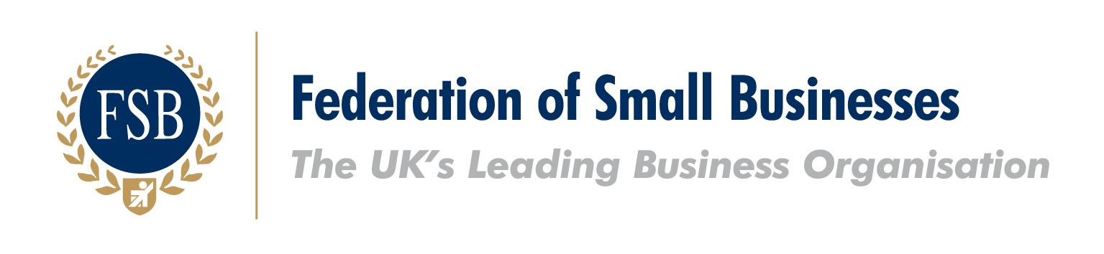
The Federation of Small Businesses (FSB) is pleased to endorse this RFQ document. Through changes to their procurement process to support small businesses, Northamptonshire County Council are showing their commitment to improving the local economy. This positive action is a step forward in the simplification of the procurement process and the FSB look forward to working with Northamptonshire County Council to encourage effective trade between the Council and local small businesses.

SECTION 1 - INTRODUCTION

- GENERAL REQUIREMENTS
Quotations are invited for the provision of nature themed children’s play features at Irchester Country Park, Gipsy Lane, Little Irchester Wellingborough, Northamptonshire, NN29 7DL

The Council’s detailed requirements are defined in Part 2 - Specification.

Please take care in reading this document in particular the Specification; In the event of any questions or queries in relation to this Request for Quotation (RFQ) should be addressed to the web site below.

The Council reserves the right to carry out due diligence checks on the awarded provider.

- BACKGROUND
Irchester Country Park is a former quarry and now comprises 200 acres of woodland, scrub, quarry and meadows. Situated close to Wellingborough, the park is owned by Northamptonshire County Council and receives in the region of 450,000 visits a year.

This is a Public Health grant funded project and therefore we are procuring to a budget and evaluating primarily on quality grounds. The parks have to generate sufficient income to cover the cost of their provision: Providing exciting and unique play areas that attract large numbers of people is a key element generating this income. This means that it is vital that maximum play value and value for money is achieved from this project. Further information on the park can be found at www.northamptonshireparks.co.uk

- PROCUREMENT TIMETABLE

- Request for Quotation Issued | 17/09/19
- Deadline for Clarification Questions | Noon 22/09/19
- Deadline for Quotation Responses | Noon 28/10/19
- Quotation Evaluation | Estimate 29/10/19
- Contract Awarded | Estimate 30/10/19
- Deadline for Delivery | 27th March 2020

- CLARIFICATION QUESTIONS
Any queries about this document, the procurement process, or the proposed contract itself, should be submitted on line via: www.lgssprocurementportal.co.uk

Please note we are planning to hold a contractor’s question session at the park at 10am pm on October 2nd 2019. We strongly urge you to attend as it will provide all bidders with a chance to view the site and talk to us about what we are looking to achieve from this more unusual project.

- QUOTATION RESPONSES
Should you wish to take part in the selection process you must complete this RFQ and submit via the Due North portal.

- EVALUATION OF QUOTATIONS
Any bids not compliant or completed fully will be discarded. Based on the information provided by organisations, each compliant submission will be evaluated based on the following criteria:

Weighted combination of Quality and Price
Quality Questions at 90% + Pricing at 10%

- Quality Questions (Part 3 Section B)
Quality Score % will be calculated as follows:

Total sum of (question score × weighting of question)
= Potential Provider Quality Score

(Potential Provider Quality Score ÷ Max Quality Score Available) × 90
= Potential Provider Quality %
E.g.:
Bid | Potential Provider Quality Score | Max Quality Score Available | Score %  (If “X” = 9)
Bid 1 | 22 | 22 | 90
Bid 2 | 20 | 22 | 81.8
Bid 3 | 18 | 22 | 73.6

The Quality Questions will be scored using the following scale:
Score | Criteria to Award Score
4 | The Potential Provider's response enables the evaluator to have a comprehensive understanding of how the requirement will be met. The evaluator can clearly identify comprehensive evidence that the response given will deliver all stated requirements. The response also demonstrates how relevant added value will be provided.
3 | The Potential Provider's response enables the evaluator to have a comprehensive understanding of how the requirement will be met. The evaluator can clearly identify comprehensive evidence that the response given will deliver all stated requirements.
2 | The Potential Provider's response enables the evaluator to have an understanding of how the requirement will be met. The evaluator can identify sufficient evidence that the response given will deliver most of the stated requirements. The response may have either raised a concern, several small issues, or is inconsistent in some aspects.
1 | The Potential Provider's response does not enable the evaluator to have an understanding of how the requirement will be met. The evaluator cannot clearly identify that the response given will deliver most of the stated requirements due to insufficient evidence and/ or the Potential Provider only demonstrating a limited understanding.
0 | The evaluator believes that the Potential Provider has failed to either answer the question or provide a relevant response.

- Pricing (Part 4)
Pricing % will be calculated as follows:
(Lowest compliant bid price ÷ Potential Provider's price) × 10

E.g.:
Bid | Lowest Compliant Bid Price (£) | Potential Providers Price (£) | Score %  (If “Y “= 10)
Bid 1 | £50,000 | £70,000 | 7.1
Bid 2 | £50,000 | £50,000 | 10
Bid 3 | £50,000 | £65,000 | 7.69

Total score:
Bid | Quality Score (%) | Price Score (%) | Total (%)
Bid 1 | 90 | 9.5 | 97.1
Bid 2 | 81.8 | 10 | 91.8
Bid 3 | 70 | 8.9 | 81.29

SECTION 2 - SPECIFICATION

This Request for Quotation (RFQ) is for the supply and installation of play structures at Irchester Country Park. The project is grant funded by Public Health, with the aim that it increases physical activity in children and families by encouraging them to walk, move and interact together: The maximum budget available for this RFQ is £70,000.00p excluding VAT.

Background
We are inviting quotations is for the supply and installation of play features at two locations (see map) as part of a wider project to create a ‘wild play trail’ in the woodland at Irchester Country Park.

We are looking for a contractor to provide the main eye catching play structures on this play trail as outlined in this specification. Other less specialist elements of the project will be delivered by park staff. We have already created a Jurassic wild play themed area that will become part of this play trail (See map).

Aims – We want the play features to be eye catching, visually attractive and to reflect the nature of the park and to enhance the surrounding woodland landscape. Your offer should provide good imaginative and active play value to help us create a play trail through the park that is exciting enough to encourage families with children (indicative ages 3 to 12 years) to walk and be active away from the main hub - and to explore nature and the landscape through play.

Materials – To be in keeping with the woodland location and ‘wild play’ theme, natural looking materials such as non-machined wood like Oak and Robinia are preferred, but we are not precluding other materials. We anticipate this equipment (like the others in the park) will get very high levels of use and so we are looking for very robust designs that can withstand a lot of wear and tear.

The park is open all day, every day and the area will be heavily used, so the provision of robust and low maintenance equipment is required.

Standards - The equipment and safety surfacing provided must ensure compliance with BSEN 1176 and BSEN 1177.

Timber must be from sustainable sources and you are asked to provide evidence of this.

Safety surfacing – Wood chip is preferred, unless there is a sound basis otherwise.

Trees- Some tree removal may be necessary to accommodate your design: You must identify any trees affected which should not exceed 4m³ of timber in total which is the threshold for a felling licence – The parks team will remove trees prior to your works so you need not cost for tree removal.

Ground works – Some ground shaping is anticipated. Surplus spoil can be disposed of on site at agreed locations at/next/near to the works.

Safety fencing – You will be responsible for ensuring safety for all aspects of your work

Welfare – You are able to use the park toilets and cafe. Alternatively you may situate welfare units at agreed locations.

Storage - You may store equipment at your own risk in the park compound or on site at another suitable place agreed with the Senior Ranger.

Timing of works - Construction can start anytime form November 2019 – February 2020 is our preferred construction window with works being completed by end of March 2020. It is preferred that you do not work at weekends or school holidays. It will be important for you to provide us with a definite start date so we can coordinate our works.

Public access - The main public paths in the park need to be kept operational during your works.

Post installation - You must provide a satisfactory post installation assessment by an independent RPII inspector deeming the area safe for use.

Equality – Although the equipment is located in woodland a fair distance from car parks etc. we would like you to consider carefully the layout to enable safe use of the zone by as wide a range of abilities as practical.

PLAY ZONES
We are looking for a contractor to provide the main eye catching, stand out play feature (or features) for both areas that will be sufficiently attractive to tempt visitors out from the main hub. – See map for indicative locations.

We have the following themes and ideas in mind, as they are directly relevant to the park’s wildlife; however, we don’t wish to be overly prescriptive so as to completely exclude new ideas. As a result we are prepare to evaluate up to two options from each provider. You do not have to provide two but if you do, please clearly identify them as option A and option B. We do not wish to have more than two options provided as it will make evaluation too problematic.

The themes and ideas we have identified are:
- Buzzard/sparrow hawk/bird of prey - aerial nest/lookout that can be climbed up to, rope swings etc.
- Insect/spider - predator and prey, climbable play spider, climbing webs, rope swings etc.

Other significant features of the site are:
- Ironstone – the park was developed on a former ironstone quarry site and has an ironstone heritage interpretation trail telling this story around the park.
- Jurassic geology (as per interpretation trail)
- Woodland – the park has been planted with a range of trees – notably conifers but also native deciduous trees.

The Parks team may further develop the areas (along with adding other elements on the wider play trail) with simple features such as stepping logs, log balances. We may provide tube style bank slide/s so please do not quote for these kinds of items, although we are not precluding slides and crawl tubes etc. from your main feature designs.

We are also planning to commission sculptures to build on the themes of the play zones, once the design of the zones is identified.

Zone A – Main area - Indicative budget split 75%

Zone B – Secondary area - Indicative budget split 25%

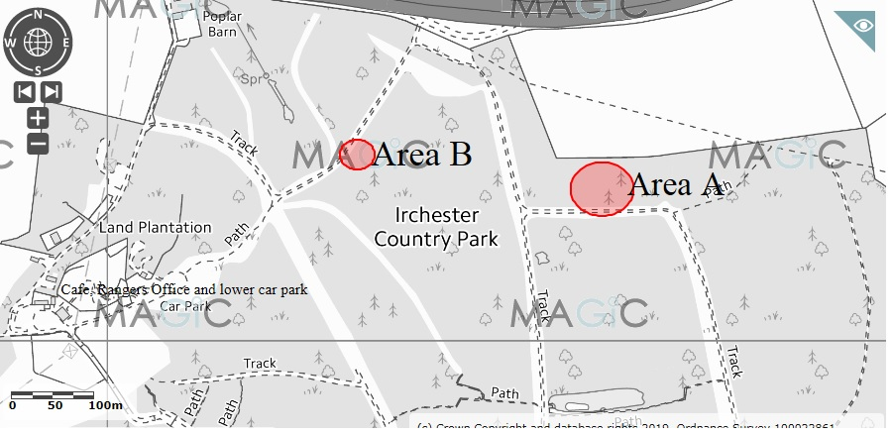

Note- Because of the location you will need to contact the rangers to arrange viewing the area on 0300 125 5934 (note the Rangers will show you the area but not answer questions on this RFQ).
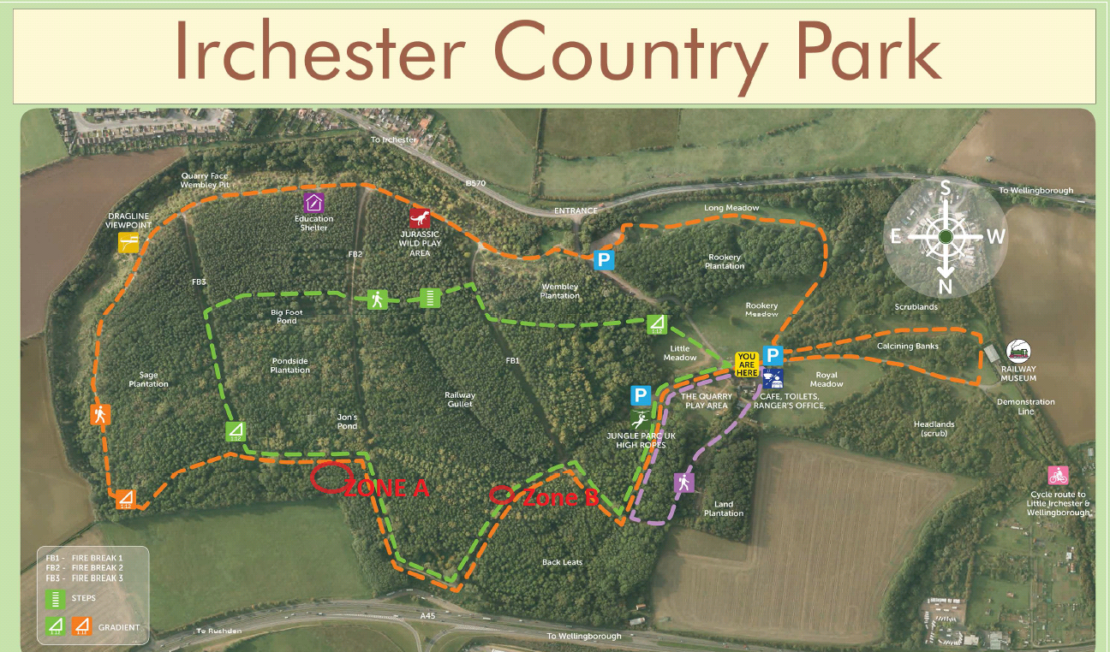

SECTION 3 - SUPPORTING INFORMATION

Note to Potential Providers– You may adjust the size of the following text boxes to suit your response.

SECTION A Organisation and Contact Details

A-1 Name of your
organisation

A-2 Registered office
(if applicable)

A-3 Trading address
(if different from registered
office)

A-4 Organisation
Registration Number
(if applicable)

A-5 Is your organisation a:
Sole Trader
Partnership
Public Limited Company
Private Ltd Company
Voluntary & Community Sector
Charity
SME (Small and Medium Enterprise)
Other

If you selected other, please
specify

A-6 What, if any, local
connections do you have with the
County

A-7 If the Company is a

member of a group of companies,
please give the name and
address of the ultimate holding
company

A-8 Name of person to whom

any queries relating to this quote
should be addressed

A-9 Telephone

A-10 Email

A-11 Address

(if different to the Address above)

SECTION B Questions
Please see section 6 for details on the weighting and scoring criteria.
Question  Number | Question | Weighting (1 = Low, 2 =Med or 3= High)
1 | Please provide drawings of your scheme sufficient for us to evaluate the play value and quality of your design and its match with our specification. | Weight 3
Potential Provider’s Response
2 | Please provide warranty information | Weight 1
Potential Provider’s Response
3 | Please provide specification and information data sheets for the equipment and recommended maintenance and inspection information. | Weight 1
Potential Provider’s Response
4 | Please provide contact details of at least two references for similar work you have done in the past 5 years | Pass/fail
Potential Provider’s Response
5 | The level of insurance required is £5million -Can you confirm that your organisation has the required level of cover or is prepared to obtain the level of cover prior to award? | PASS/FAIL question. Potential Providers who answer ‘No - have not got cover and won't provide Authority’s level of cover’ will fail the RFQ process.
Potential Provider’s Response | Yes - have levels of cover already and will continue to for this contract  No - but will provide the Authority‘s level of cover requested if awarded contract  No - have not got cover and won't provide Authority’s level of cover

SECTION 4 – PRICING SHEET

Pricing and Costs

Please insert your costs in the table below. The costs should be broken down into components with a full description of each component and its associated time and costs.

[Component] | [Component description] | [Delivery by] | [Costs (£)]
 | Total Costs (£):

SECTION 5 – FREEDOM OF INFORMATION

Information in relation to this RFQ may be made available on demand in accordance with the requirements of the Freedom of Information Act 2000 (“The Act”) and your organisation details will be disclosed where the expenditure is over <£500 as per the Government Transparency agenda. Details of all contracts worth £30,000 or more in total value will also be published on the Council’s website.

Organisations should state if any of the information supplied by them is confidential and commercially sensitive or should not be disclosed in response for the Information under the Act. Organisations should state why they consider the information to be confidential or commercially sensitive.

Please state here any specific information in this RFQ that you do not wish to be disclosed under Freedom of information Act. This will not guarantee that the information will not be disclosed but will be examined in the light of the exemptions provided in the Act.

Insert specific Information here if applicable

SECTION 6 – SIGNATURE AND DATE

Request for Quotation for: Barnwell Country Park Sand and Water Play

I the undersigned hereby declare by marking an X in the box:

that the information provided is complete and accurate;

that the price in Part 4 is our best offer;

that no collusion with other organisations has taken place in order to fix the price;

to be subjected to the terms and conditions set out in Conditions of Contract identified in Appendix 1;

that no works/goods/supplies/services will be delivered or undertaken until both parties have executed the formal contract documentation as identified in Appendix 1 and an instruction to proceed has been given by the Council in writing.

Name ...............................................................

Position Held ...........................................................

Dated ...............................................................

APPENDIX 1: CONDITIONS OF CONTRACT

Northamptonshire County Council Standard terms and conditions will apply

