London Borough of Hackney
INSURANCE TENDER

Property, Liability, Liability Claims Handling, Fidelity Guarantee, Motor Fleet, Motor ULR & Motor Legal Expenses, Engineering Insurance & Inspection, Group Personal Accident & Travel, Terrorism, excluding Broker Services

CONTRACT INCEPTION DATE: 1 April 2023
CONTRACT NOTICE: <<Contract Number>>

The information contained within this document is confidential to Marsh Ltd and London Borough of Hackney and has been produced solely for the purpose of consideration of the latter's risk financing programme. The contents may not be reproduced or disclosed to any third party without the prior written approval of Marsh Ltd.

Date of Preparation: September 2022

Public Sector - UK Retail
Marsh Ltd
Tel No: 020 7528 4000
Fax No: 020 7558 3289

CONTENTS
INTRODUCTION 2
INSTRUCTIONS FOR TENDERING 5
Award Criteria 11
General Information 18
Services and Structure - London Borough of Hackney 22
Financial Information 36
Strategic Risk Management Information 38
Current Insurance Programme 41
LOT 1 – PROPERTY / MATERIAL DAMAGE 44
General Properties 46
Housing Properties 47
Tiger Way & Nile Street Developments 50
Education Properties 53
Commercial and Industrial Properties 55
Business Interruption - Increase in Cost of Working 57
Business Interruption - Gross Revenue 58
Contract Works 59
Money 60
Computers 61
Specified All Risks Cover 62
LOT 2 – COMBINED LIABILITY & FIDELITY GUARANTEE/CRIME 63
Combined Liability Risk Information 63
Combined Liability – Current Programme 68
Employers Liability 69
Public/Products Liability 72
Officials Indemnity 77
Professional Indemnity 79
Hirers Liability 81
Fidelity Guarantee / Crime Risk Information 82
LOT 3 – MOTOR FLEET INSURANCE 85
LOT 4 – ENGINEERING INSPECTION & INSURANCE 89
LOT 5 – GROUP PERSONAL ACCIDENT & TRAVEL INSURANCE 90
LOT 6 - TERRORISM - First Loss Basis 92
CLAIMS HANDLING REQUIREMENTS - ALL LOTS 93
APPENDICES 93
APPENDIX 1 – Compulsory Return Documents 94
APPENDIX 2 – General / Risk Management Information 95
APPENDIX 3 – Risk Schedules 96
APPENDIX 4 – Claims Experiences 97

INTRODUCTION
We are seeking tender responses for annual policies, which commence on 1 April 2023 in the name of:-

London Borough of Hackney
Hackney Service Centre
1 Hillman Street
E8 1DY

The London Borough of Hackney is seeking tender submissions from suitably experienced organisations to comprehensive insurance arrangements to be in place with effect from 1 April 2023 for a period of three (3) years with an option to extend the term for a further two (2) years.

Additional Insured Interests
The Hackney Learning Trust, Hackney Homes, London Borough of Hackney Pension Board, Governors and the Governing Body of Schools registered as Members of the Hackney Borough of Hackney Insurance scheme.

Cover is also required for voluntary aided, foundation and special agreement schools as indicated within Appendix 3.01 - School Insurance Membership Sheet 2022-23 and the relevant asset schedules.

The London Borough of Hackney also requires cover to incorporate the following wholly owned Local Authority Trading Companies;

Hackney Commercial Services (London) Ltd - Company No: 13700731
Incorporated 25 October 2022 this is wholly owned by London Borough of Hackney and relates to the provision of commercial waste (non-hazardous) collection services across London and potentially further afield. The Company has no employees and utilises existing Council owned assets to undertake this service i.e. existing refuse collections vehicles and crew.

Directors & Officers Cover is procured separately and not required under this tender.

Hackney Housing Company Ltd - Company number 11738936 (including Hackney HLR Housing Company Ltd - 11750958 & Hackney PRS Housing Company Ltd - 11750933)
Incorporated 4 January 2019 this is wholly owned by London Borough of Hackney and relates to the provision of other letting and operating of own or leased real estate. The Company has no employees.

Directors & Officers Cover is procured separately and not required under this tender.

Otto Management Co Ltd - Company Number 11043383
Incorporated 2 November 2017 this is wholly owned by London Borough of Hackney and relates to the provision of property services at the Tiger Way development. The Company has no employees.

Directors & Officers Cover is procured separately and not required under this tender.

Makers Management Co Ltd - Company Number 11043263
Incorporated 1 November 2017 this is wholly owned by London Borough of Hackney and relates to the provision of property services at the Makers development. The Company has no employees.

Directors & Officers Cover is procured separately and not required under this tender.

Hackney Light & Power
The Council is considering creating a wholly owned Energy Company called Hackney Light
& Power. It is not yet trading with the business case under review. The details will
be shared with the insurers and Marsh when appropriate.

Please advise if you require any further information in respect of the additional Insured interests

INSTRUCTIONS FOR TENDERING
Tender Procedure – Find a Tender Service
Please note this exercise is being conducted under the Open procedure.

Tender response quotations must be submitted on a ‘net of normal commission’ basis and all amounts shown in Pounds Sterling. Marsh brokerage of 3.5% will apply to all classes.

Tender Timetable
(with the exception of the final date, these are target dates and may be subject to change)

Activity | Deadline / Date and Time
Invitation to Tender (ITT) documents available from | 09 November 2022
Last date for mid tender clarification questions | 25 November 2022 (12:00 noon)
Deadline for return of tender responses | 19 December 2022 (12:00 noon)
Post tender clarification period | 19 December 2022 onwards
Intention to Award / start of standstill period | 17 February 2023
Award of contract | 28 February 2023
Contract inception | 01 April 2023

General Tendering Information
Please read all the sections of this invitation to Tender to understand fully the Council’s requirements.

This procurement exercise will be operated using the Council’s e-tendering portal Pro-Contract. All documentation are located under reference DN638397 and responses should be submitted in line with the requirements in this ITT and the instructions set out on ProContract.

These instructions are designed to ensure that all Tenderers are given equal and fair consideration. It is important therefore that you provide all information asked for in the format and order specified on ProContract. If you have any doubt as to what is required or will have difficulty in providing the information requested, please submit a question via the messaging function of ProContract.

Please note that reference to the Council in this Invitation to Tender document and others issued along with it, means the Mayor and Burgesses of the London Borough of Hackney acting through his representative.

Tenders shall be submitted in accordance with these instructions.

Tenders that do not comply with any mandatory requirement (i.e. where the words “shall” or “must” are used) will be rejected.

This Invitation to Tender does not constitute an offer and the Council does not undertake to accept any tender. The Council reserves the right to accept a Tender in part, rather than in full.

Whilst the information contained in this ITT is believed to be correct at the time of issue neither the Council, nor its advisors, will accept any liability for its accuracy, adequacy or completeness nor will any express or implied warranty be given. This exclusion extends to liability in relation to any statement, opinion or conclusion contained in or any omission from this ITT (including its appendices) and in respect of any other written or oral communication transmitted (or otherwise available) to any Tenderer. This exclusion does not extend to any fraudulent misrepresentation made by or on behalf of the Council.

The Council will not be liable for any bid costs, expenditure, work or effort incurred by the Tenderer in proceeding with or participating in this procurement, including if the procurement process is terminated or amended by the Council. The Tenderer is responsible for independently checking and satisfying itself/himself/herself of the accuracy of the information provided in this tender.

Communications and Further Questions
All formal communications (including, but not limited to, clarifications and the submission of Tenders) to the Council are to be made in writing using the Council’s e-tendering system Pro-Contract.

It is the Tenderer’s responsibility to ensure any verbal queries or clarifications they generate are confirmed in writing through Pro-Contract. In the event of any misunderstandings reliance on verbal communications will not be permissible.

If a Tenderer is in doubt as to the interpretation of any part of the Invitation to Tender or if they consider that any of its requirements are ambiguous or conflict with any other requirements, they should contact the Council via the ProContract system.

No representation, explanation or statement made to the Tenderer or anyone else by or on behalf, or purportedly on behalf of the Council as to the meaning of the Tender documents, or otherwise in explanation as aforesaid, shall be binding on the Council in the exercise of its obligations under a subsequently awarded contract.

Tenderers will have the opportunity to ask further questions until 12 noon, 25 November 2022. The Council will use their best endeavours to respond as a matter of assistance to the Tenderer but it shall not be construed to add to, modify or take away from the meaning and intent of the proposed contract and/or the obligations and liabilities of the Tenderer.

Where an enquiry is beneficial to all Tenderers, both an anonymised copy of the clarification question and the response will be communicated to all Tenderers. If a Tenderer wishes the Council to treat a clarification as confidential and not issue a response to all Tenderers it must state this when submitting the clarification question. If, in the opinion of the Council, the clarification is not confidential, the Council will inform the Tenderer and the Tenderer will have an opportunity to withdraw it. If the clarification is not withdrawn, both the question and response will be sent to other Tenderers anonymously.

The Council reserves the right (but shall not be obliged) to seek clarification of any aspect of a Tender during the evaluation phase where necessary for the purposes of carrying out a fair evaluation. Tenderers are asked to respond to such requests promptly.

If you have any questions on or technical problems regarding the web site please contact the Pro-Contract Support team at support@due-north.com or call 0330 005 0352.

Long Term Agreements
The Contracting Authority is looking for tender responses based upon a Long Term Agreement of 3 years plus the option to extend for a further 2 years.

The Long Term Agreement shall contain a break clause in the event of any significant changes to the Contracting Authority introduced by Central Government or other bodies that would make the continuance of the Long Term Agreement unsuitable for the Contracting Authority.

In the event of an intended break in the Long Term Agreement the insurer must provide the Contracting Authority with 6 months’ notice to enable the Contracting Authority to procure a suitable alternative. Please advise within your Tender response if this cannot be complied with.

The Contracting Authority allows a successful bidder / Insurer to transfer the insurance policies placed as a result of this Tender to another insurer during the term of the LTA provided that the new insurer is in the same ultimate ownership as the original one, the insurer credit rating is not adversely affected and the terms and conditions of the insurance remain the same.

Enquiries
All requests for clarification and questions regarding this ITT should be submitted by the date and time shown in the Tender Timetable above and must be sent via the Contracting Authority’s chosen portal. Bidders / Insurers will be alerted via the portal of document revisions, responses to questions and clarifications, and any amendment to the tender timetable.

Please note that any queries received after the deadline, date and time shown in the tender timetable may not be answered.

It is the intention that All bidders / Insurers will receive the answers to all mid tender clarification questions submitted.

Submission of Tender Responses
Tender responses must be submitted and received via the Contracting Authority’s chosen portal no later than the deadline, date and time shown in the tender timetable.

Tender responses submitted after the deadline, time and date shown may be rejected by the Contracting Authority.

Tender responses must not be submitted by post, fax or email.

Tender responses must be written in English and unless specifically withdrawn in writing, Tender responses shall remain open until the inception date. A tender response valid for a shorter period of time may be rejected.

Contents of your tender response
Your tender response must contain the following information:

- Contract certain insurance quotations including all policy wordings.
- Full satisfactory completion and return of the Selection Questionnaire via the Procurement Portal. Please see Appendix 1.07 – SQ Explanatory Document for further information.
- Confirmation that you are able to provide the cover as specified within these Tender Documents. Where there are variations in the cover being offered this should be specifically highlighted within your tender response.
- Where you are quoting for more than one Lot, you must ensure that quotations provided are on a standalone basis. Please note that no points are available for package discounts. Any Long Term Agreement discounts must also be made clear in your pricing schedule. Failure to provide your quotation on the basis outlined above may render your submission void.
- All individual Lots will be evaluated and awarded separately and the Contracting Authority categorically reserves the right to place individual Lots with separate Insurers irrespective of any package conditions put forward by any Insurers.
- Any Long Term Agreement discounts must also be made clear within your tender response.
- If your bid for a specific Lot is utilising other insurers/suppliers then please detail specifically how Long Term agreements would operate within the Lot that is being considered and specifically whether those Long Term Agreements are independent to each other.
- Failure to provide your tender response at the deadline, time and date shown in the tender timetable and on the basis outlined above may render your tender response void. Please note that it is the responsibility of all bidders / Insurers to ensure that all information is included within their tender response. The Evaluation will be based upon documentation received from each bidder / Insurer. If information is omitted from your tender response this will not be taken into account.

Further Steps
The Contracting Authority reserves the right to ask bidders / Insurers to clarify or explain any aspects of their tender response. This may include presentations to the Contracting Authority.

Alterations
You may not alter any of the ITT documents

Acceptance of Tender Response
By issuing this ITT the Contracting Authority is not bound in any way and does not have to accept the lowest or any tender response.

Amendment to the ITT Documents
The Contracting Authority reserves the right to amend the enclosed ITT documents at any time prior to the deadline, date and time shown in the tender timetable for tender responses. Any such amendment will be issued via the Contracting Authority’s chosen portal. Where amendments are significant, the Contracting Authority may at its discretion extend the deadline for tender responses.

Inducements
Offering an inducement of any kind in relation to obtaining this or any other contract with the Contracting Authority will disqualify your tender response from being considered and may constitute a criminal offence.

Conflict of Interest
It is the responsibility of the Tenderer to ensure that there are no actual or potential conflicts of interest involved in their commission. The Council must be notified as soon as any actual or potential conflicts of interest arise during the procurement.

Collusion
Please note that if you collude with any other supplier so that one of you does not submit a tender response or restricts your premiums, you will be disqualified from the tender process. Please see Appendix 1.07 – SQ Explanatory Document further details and complete Appendix 1.09 - Certificate of Non-Collusion and Appendix 1.08 - Certificate of Non-Canvassing.

Cost and Expenses
You will not be entitled to claim from the Contracting Authority any costs or expenses that you may incur in preparing your tender response whether or not your tender response is successful.

Confidentiality
All information supplied by the Contracting Authority to you must be treated in confidence and not disclosed to third parties except insofar as this is necessary to obtain sureties or quotations for the purposes of submitting your tender response. All information supplied by you to the Contracting Authority will similarly be treated in confidence except as required by law, e.g. Freedom of Information Act 2000.

Award Criteria
Each Tender submission will be evaluated as detailed below.

Activity | Title | Activity
1 | Selection Stage – Find a Tender Service | Validity – This is to ensure that all Tender Responses received are valid and in accordance with the Instructions for Tendering  Completeness: A complete Tender Response shall include all documents required in accordance with the Instructions to Bidders / Insurers. Incomplete Tender Responses may result in your Tender Response being excluded  Capability – this is to ensure that the Bidders / Insurers can meet the minimum requirements required of this procurement process. Failure to pass this stage will mean the tender response will not be evaluated.  This stage includes:  - Insurer Rating / Financial Checks  - Full satisfactory completion and return of the Selection Questionnaire via the Procurement Portal. Please see Appendix 1.07 – SQ Explanatory Document for further information.
2 | Detailed Consideration of Tender Response | Consideration of Tender Responses to determine the Most Economically Advantageous Tender Response (MEAT) to the Contracting Authority in terms of price and quality. In accordance with Section 5 of the Public Contracts Regulations 2015, the criteria and weightings for the award criteria are set out within the Evaluation Sheet for each Lot.
3 | Notification of Award Process | All bidders / Insurers will receive Intention to Award Letters following the completion of the Detailed consideration of the Tender Response.

Activity 1 – Selection Questionnaire (SQ)

- Insurer Rating / Financial Checks
All Insurers must meet the Marsh minimum financial guidelines, being an interactive Standard and Poor’s rating of BBB or higher and the local currency equivalent of US $100 million in unencumbered policyholders’ surplus and / or approved by the Marsh Market Information Group. In the absence of an interactive Standard and Poors rating, companies with an interactive A.M. Best rating of A- or higher and the local currency equivalent of US $100 million in unencumbered policyholders’ surplus and / or approved by the Marsh Market Information Group. Otherwise their submission will be automatically rejected. Please note if the rating of the Insurer drops below the acceptable minimum standard during the life of the contract, the Contracting Authority can make alternative arrangements at their own discretion.

The Contracting Authority may obtain financial information through credit checks concerning the Bidders / Insurers. The Contracting Authority reserves the right to request further financial information from the Tenderer after the submission deadline.

- Satisfactory completion and return of the Selection Questionnaire via the Procurement Portal. Please see Appendix 1.07 – SQ Explanatory Document for further information.
Bidders are required to complete the Selection Questionnaire only once

Activity 2 - Detailed Consideration of Tender Response
- The award criteria are set out within the Evaluation Sheet for each Lot. They comprise both Financial (price) and Non-Financial (policy cover, claims service, added value and innovation) criteria.
- Please ensure you respond to each element of the evaluation criteria for each Lot you submit. To ensure you receive marks for the items requested you must complete and submit the Evaluation Sheet for the Lot for which you are tendering. Failure to do so will result in no evaluation of your tender.
- Each Bidder / Insurer will be awarded a score out of 100% for each Lot.
- The Contracting Authority will award each Lot individually.
- The Contracting Authority may require the successful Bidders / Insurers to be available for a detailed clarification meeting to discuss their tender response.
- The Contracting Authority reserves the right not to award the Contract to the lowest bidder / Insurer, reserving also the right to accept the same in whole or in part.
- The Contracting Authority reserves the right to ‘disqualify’ any bidder / Insurer that the Contracting Authority judges upon investigation to be incapable of fulfilling the contract requirements of a particular Lot.
- The Contracting Authority reserves the right to ‘disqualify’ any bid that is ‘qualified’ or tries to change the terms on which the tender response is submitted.
- The Contracting Authority reserves the right not to award the Contract to any bidder / Insurer if an unacceptable change in circumstances occurs during the procurement process.
- The Contracting Authority will award the Contract in accordance with the Public Contracts Regulations 2015

Evaluation Sheets
- Price - With regards to the price evaluation, the lowest price Insurer will be awarded the maximum price score and Insurers will thereafter be ranked and scored by weighting the higher priced bid(s) as a direct proportion of the winning bid. As per the following calculation – (Lowest price received ÷ bidders price) x price weighting
- Quality (Policy Cover / Claims Handling / Added Value and Innovation Part 1) - Insurers will be awarded a score which directly reflects the points achieved from the answers given in the completed Evaluation Spreadsheets returned with Insurer’s submission. The Insurers score will be calculated as follows (Points scored ÷ Maximum points available) x quality weighting
- Insurers are requested to indicate in the yellow boxes provided within each Evaluation Sheet - using the drop down menus, where applicable, whether their tender includes or does not include the item(s) requested.
- There is a menu option "Please State Variation" against each requirement; this option should be selected where the Insurer cannot comply with any of the requirements of any given Lot, but, can offer similar cover, or, where the Insurer is providing the cover, but under another Lot. The Insurer must clearly indicate the nature of the variant cover being offered and, where appropriate, the Lot where the core cover is provided within the column marked "Additional Comments, Subjectivities, Variations and/or Exceptions".
- Please note that each scoring item within each tab of an evaluation spreadsheet will be moderated by Marsh and/or the Contracting Authority, and adjusted where necessary. By completing and returning the Evaluation spreadsheets the Insurer is accepting that the final points awarded are at the sole discretion of the Contracting Authority.
- Please note that the Insurer must evidence any Policy Cover, Claims Handling Requirements, Service Delivery and / or Added Value and Innovation being provided via their tender response, method statement, quotation, endorsement and/or policy wording. Where this is not provided Marsh and/or the Contracting Authority reserve the right to reduce points accordingly.
- Please note that the Evaluation Sheets/Tabs should be read in conjunction with this Invitation to Tender document, attaching appendices and the accompanying risk information.
- All the Evaluation sheets/tabs relating to the Lot(s) the Insurer is tendering for should be completed and returned with the Insurer’s tender response / submission. Failure to do so will result in the Insurer’s tender response / submission not being considered for evaluation.
- Please note that reductions in points / percentage scores will be made under the Policy Cover and Claims Handling Sections for areas where the Bidder / Insurer quotation(s) and / or tender response include; restrictions in service delivery and/or additional administrative requirements on the Contracting Authority, additional restrictive terms, conditions, exclusions or endorsements are imposed (above and beyond what has been requested / stated within all the Evaluation sheets/tabs relating to each Lot). Please note that where the Insurer is providing something significantly different to what has been requested, further reductions in points / percentage scores can be applied.
- The above can apply even to items that have already had points reduced. An example of this could be that the Contracting Authority requested £1,000 excess with 10 points available to this item. An Insurer could respond with a £10,000 excess being applicable to their quotation. So, the Insurer could score 0 points against the 10 points available for that item after Evaluation / Moderation but Marsh and/or the Contracting Authority could apply further reductions in points / percentage scores using the table below as it is significantly different to what has been requested.
- The value of the points deducted will be based upon the potential financial impact on the Contracting Authority and will be deducted upon the discretion of the Contracting Authority using the table below.

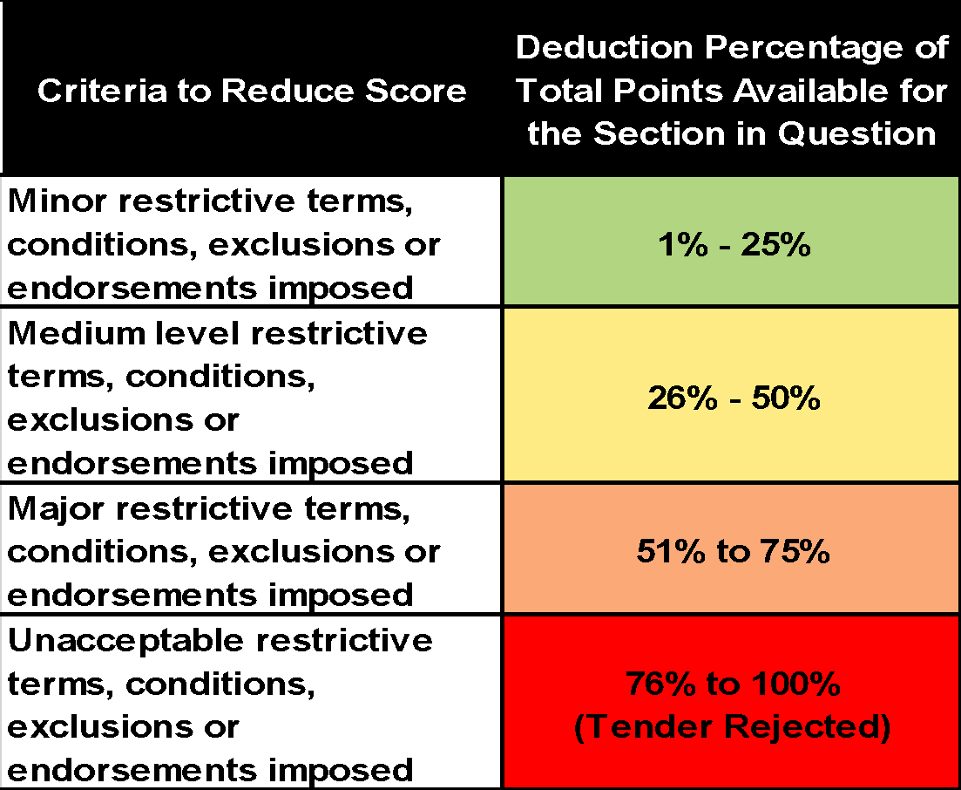

- Please remember if any additional restrictive terms, conditions, exclusions or endorsements imposed are considered serious / significant the tender response may be rejected.

- Added Value and Innovation Part 2 - The Maximum Points available will be awarded at the discretion of the Contracting Authority using the Quality Evaluation table below.

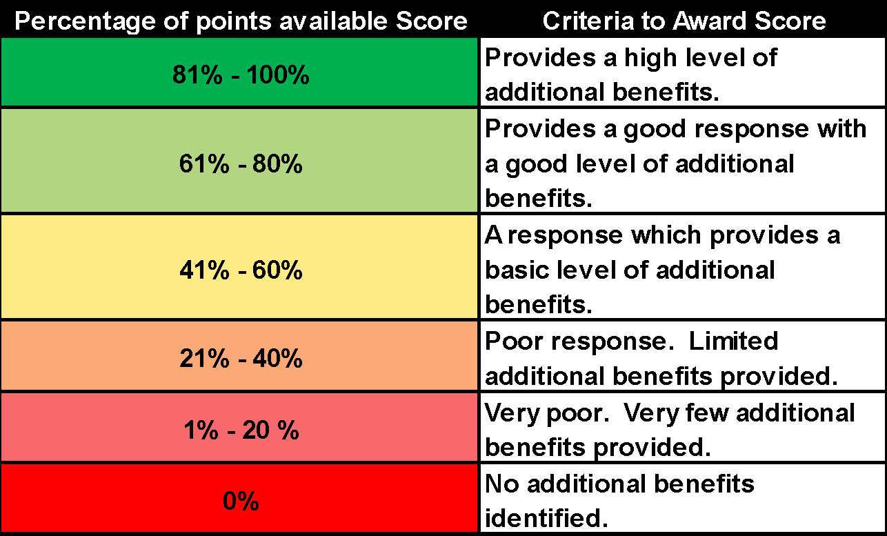

- Social Value - The Maximum Points available will be awarded at the discretion of the Contracting Authority using the Quality Evaluation table below.

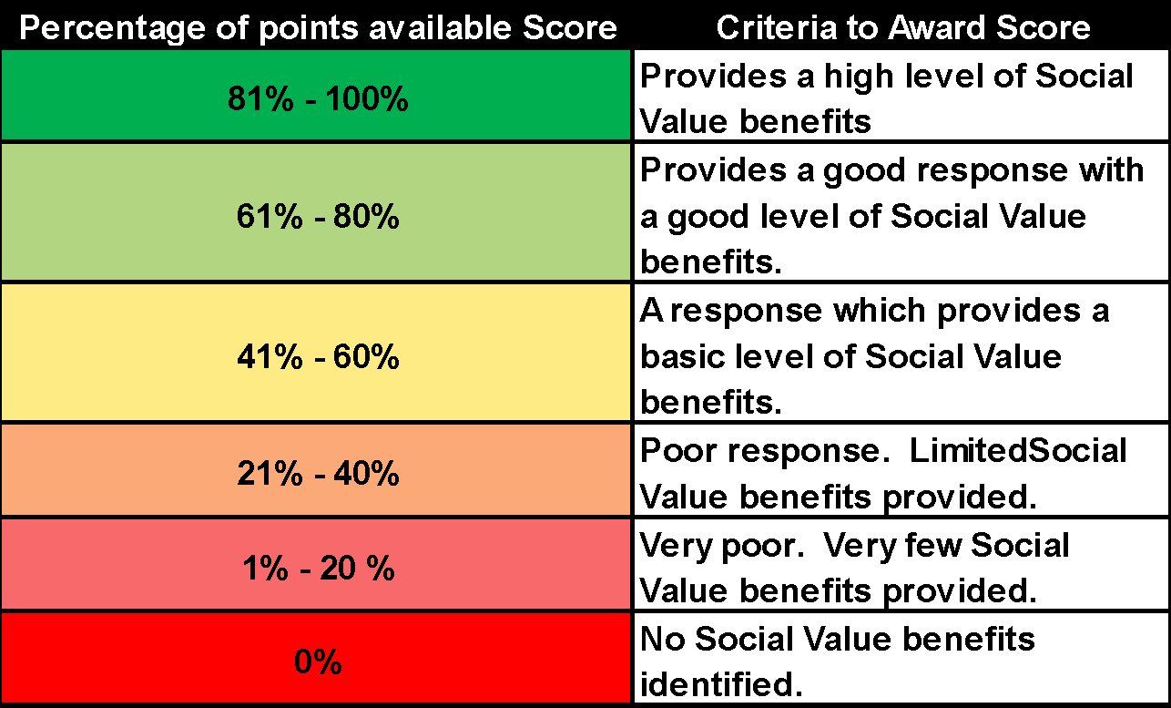

Activity 3 - Notification of Contract Award Process
When the Contracting Authority has evaluated the tender responses, it will issue Intention to award letters to all bidders / Insurers in respect of the Lots for which they have submitted a tender response.
Acceptance of the Tender by the Contracting Authority shall be in writing and shall be communicated to the bidder / Insurer. Upon such acceptance the Contracting Authority shall thereby be constituted and become binding on both parties and, notwithstanding that, the bidder / Insurer shall upon request of the Contracting Authority enter into an agreed formal contract.
Bidders / Insurers should not undertake work without first having received a letter of intent or written notification that they have been awarded the contract and are required to start work. Contract documents will be prepared and issued for execution as soon as possible thereafter and must be issued within 14 days of cover commencing.

Freedom of Information Act 2000 and the Environmental Information Regulations 2004
As a public body, the Council is subject to the provisions of the Freedom of Information Act 2000 and the Environmental Information Regulations 2004 (the Information Legislation) in respect of information it holds (including third party information). Any member of the public or other interested party may make a request for information. The Council may receive requests for information relating to a contract and the services which, save for any right to claim an exemption under the Information Legislation, the Council may be under a statutory obligation to disclose. Tenderers will render all necessary assistance to the Council to meet its statutory obligations under the Information Legislation.

The Council will consider the disclosure of any information, including pricing information (for both successful and unsuccessful Tenderers), subject to the exemptions / exceptions under the Information Legislation. Tenderers should be aware that attaching a blanket label of "private and confidential" or "commercial in confidence" to their proposal may not exempt / except the proposal from disclosure under the Information Legislation. Tenderers should carefully consider the impact of the Information Legislation and take their own legal advice with regard to any information/data that is intended to be submitted in support of a Tender which may be commercially sensitive and/or confidential.

If a Tenderer considers that all or any part of its proposal and/or any specific information contained therein constitute a “trade secret”, or that information contained therein is commercially sensitive information disclosure of which would be likely to prejudice the commercial interests of any party, or believes that a duty of confidentiality applies or otherwise considers that such documents and/or information falls within any other exemption or exception set out in the Information Legislation, the Tenderer should:-

(a) attach information it considers to be commercially sensitive e.g. costing or a trade secret in a separate schedule marked ‘commercially sensitive information’ or ‘trade secret’ and include a time limit for the sensitivity of the information; and

(b) in respect of such schedule and/or specific information, identify the particular exemption/exception that the Tenderer claims applies in the particular circumstances. Tenderers should do so in full knowledge of the relevant terms of the Secretary of State’s Code of Practice (the Code) under Section 45 of the Freedom of Information Act 2000, on the handling of requests under the Freedom of Information Act 2000. This will enable Tenderers to make such claims based on reasons that address the requirements of the Code.

Tenderers should be aware that, even when they have scheduled or identified relevant documents and/or information and seek to claim an exemption, the Council shall have complete discretion in deciding whether such documents and/or information should be disclosed under the Information Legislation.

General Information
History of the Contracting Authority
Formed in 1965 from the area of the earlier metropolitan boroughs of Hackney, Shoreditch and Stoke Newington, the London Borough of Hackney is a North East London Borough within Inner London. Southern and eastern parts of the borough are popularly, but unofficially, regarded as being part of east London, with northern and western areas considered to belong to north London. Although The London Plan issued by the Greater London Authority assigns whole boroughs to sub-regions for statutory monitoring, engagement and resource allocation purposes.

Hackney is bounded by Islington to the west, Haringey to the north, Waltham Forest to the north-east, Newham to the east, Tower Hamlets to the south-east and the City of London to the south-west. Much of Hackney maintains its inner-city character and, in places like Dalston, large housing estates now sit side-by-side with gated communities. In South Hackney, near Victoria Park, there is terraced Victorian and Edwardian housing.

The historical and administrative heart of Hackney is the area roughly extending north from Mare Street and surrounding the Church of St John-at-Hackney; known as Hackney Central. To the north of the borough are Upper Clapton and Lower Clapton, Stamford Hill and Stoke Newington. To the east are the large open space of Hackney Marshes and the districts of Hackney Wick and Homerton.

Elected Representatives
Hackney has 21 wards, 15 wards represented by three councillors and 6 wards represented by two councillors. Council elections take place every four years. Hackney has a directly elected Mayor. The Mayor selects some of the councillors to be part of his cabinet. Together, they decide what policies should be put before full council for a vote.

Political Composition - Labour Controlled

Party | Seats
Lab | 50 + 1 directly elected mayor
Con | 5
Green | 2

Population characteristics
Hackney’s population is estimated at 259,200 people based on the 2021 Census.

Hackney is a relatively young borough with a quarter of its population under 20. The proportion of residents between 20-29 years has grown in the last ten years and now stands at just under 25%. People aged over 55 make-up only 15% of the population.

Hackney is a culturally diverse area, with significant ‘Other White’, Black and Turkish/Kurdish communities. A large Charedi Jewish community is concentrated in the North East of the borough and is growing.

People from Australia, the US and Western European countries like Spain, France and Italy make up the largest groups who have recently come to live in Hackney from abroad.

Just over a third of Hackney’s residents are Christian. This is a lower percentage than the London and England averages. Hackney has significantly more people of the Jewish and Muslim faiths and a higher proportion of people with no religion and those who did not state a religion than London and England.

In 2011, 14.5% of Hackney residents said they were disabled or had a long-term limiting illness.

Nine out of ten Hackney residents say that Hackney is a place where people from different backgrounds get on well together. Hackney’s diversity and multiculturalism are the main factors contributing to residents feeling proud of the borough. Over a third of Hackney residents were born outside the UK.

Hackney’s population is likely to grow to 294,300 people by 2028 and to 325,600 people by 2050.

Health and wellbeing
Life expectancy is increasing for men and women, and is now 79.6 years for men and 83.7 years for women. Life expectancy in Hackney is below the London average, especially for men.

Deprivation
Hackney was the 22nd most deprived local authority overall in England in the 2019 Index of Multiple Deprivation, in 2015, it was ranked eleventh, and in 2010 it as ranked second. Hackney is relatively more deprived in relation to barriers to housing and services. income and living environment than its overall rank suggests, but generally less deprived than its overall ranking for crime, employment and health and significantly less deprived for education.

Education
At GCSE the average Attainment 8 point score per pupil in Hackney was 49.2 points, slightly lower than the London average of 49.7.

Economy
Hackney has experienced rapid economic growth over the last decade. In 2019, Hackney hosted 22,560 businesses, a 13% increase from 19,905 businesses in 2018.

The March 2020 data shows a 8.5% increase in the unemployment rates in Hackney which is slightly higher than London which saw a 7.4% increase. The increase in unemployment can be attributed to the financial impact of the Coronavirus on businesses.

Housing
The proportion of households who rent from a private landlord in Hackney has more than doubled in the past 10 years. Nearly a third of all households are now private renters. Nearly 45% of all households in Hackney rent from a social landlord. They tend to have higher unemployment and lower average incomes than people living in other tenures.

Over 13,000 additional new homes are expected to be built in the borough in the next 10 years. Development will be most heavily concentrated around Manor House and Dalston in the West, Hoxton and Shoreditch in the South and Hackney Central and Hackney Wick in the East.

Environment and transport
Hackney is the third most densely populated borough in London, but it is also one of the greenest in inner London with 58 parks and green spaces, 27 of which have been awarded the green flag quality mark.

Crime and community safety
Crime fell by over a third between 2003 and 2015 (over 13,000 fewer victims of crime). Crime levels have increased by a third since 2015. Crime in Hackney is now higher than in other inner-London boroughs with similar social and economic characteristics.

Growth and change
Significant growth is expected in the North West of the borough, centred round the regeneration of the Woodberry Down estate, in Shoreditch in the south of the borough.

Recognition
In 2016 The London Borough of Hackney was awarded the Local Government Chronicle Award: “Council of the past 20 years”.

“A compelling story of innovation and exceptional transformation across the whole range of services with a clear focus on delivering leading services for residents. Hackney has led the sector in showing that areas of high deprivation can also be areas of high achievement. It is a real game changer.” Judges’ comment

Map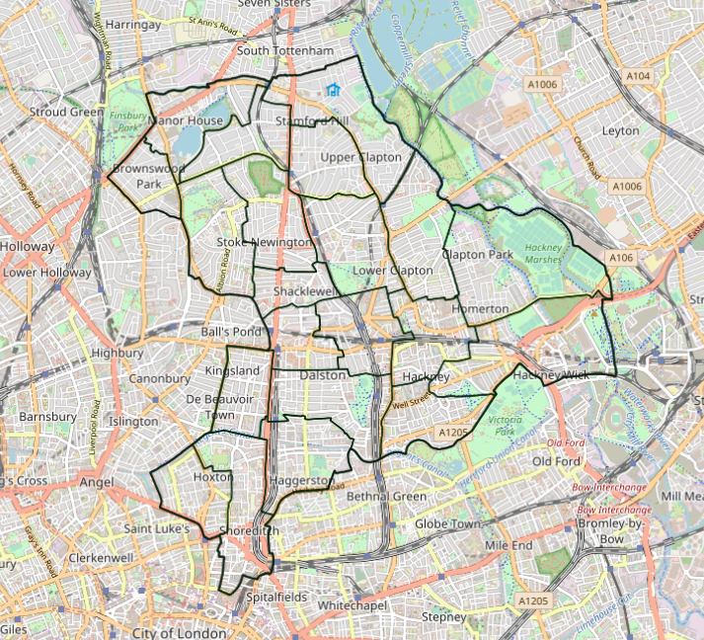

Services and Structure - London Borough of Hackney
Business Description
The usual activities of the insured as a London Borough.

Key Services within the Contracting Authority
The functions of the Contracting Authority are those normally associated with this type of authority and include: -

Service / Function | Currently Undertaken (Y/N) | Outsourced or undertaken in house | Date Transferred in / out | Delivery Partner | Changes planned for the next 12 months
Airside Activities | No
Building Control | Yes | In House | n/a
Cemeteries and Crematories | Yes*  (non-active only) | In House  (Primarily) | 2015 | Abney Park Trust (Abney Park Cemetery)
Coastal Management including Harbours/ Moorings and Coastal Bye Laws | No
Commercial Properties / Industrial premises | Yes | In House | n/a | A very small number of managing agents assist with specific assets
Education | Yes | In House | 1 August 2012 | Hackney Learning Trust  2002 to 2012
Elections | Yes | In House | n/a
Environmental Health | Yes | In House | n/a
Finance / Administration | Yes | In House | n/a
Highways | Yes | Mixed | n/a | Marlborough Highways  (S.41 Inspections, gritting & gully cleansing undertaken in-house)
Housing | Yes | In House | 1 April 2016* | Hackney Homes (Housing ALMO)
Land Changes Searches | Yes | In House | n/a
Leisure Centres | Yes | Outsourced | Out to GLL from  1 Sept 2005 | Greenwich Leisure Ltd (GLL -operating as “Better”)
Licensing | Yes | In House | n/a
Parks and open spaces | Yes | In House | n/a
Pensions Administration/Pension Board | Yes | Outsourced | prior to 2009 | Equiniti  (2009 onwards)  (LPFA Prior to 2009)
Planning & Planning Enforcement | Yes | In House | n/a
Public Health | Yes | In House  (Primarily) | n/a | NHS Homerton Hospital  ELFT - East London Foundation Trust
Refuse Collection | Yes | In House | n/a
Social Services - Children | Yes | In House | n/a
Social Services - Adults | Yes | In House  (Primarily) | n/a
Waste Processing | Yes  (sorting only) | In House | n/a
Retrofit Assessor & Retrofit Coordinator roles - PAS2035 Roles  Qualified and Trust Marked assessors and Coordinators to be undertaken for Housing and Leasehold Council residencies only - no external private customers. | Yes | In House | Commenced in 2022
Commercial Dog Boarding Services  Boarding services only for Hackney staff only and NHS patients etc that have been sectioned etc | Yes | In House | Commenced in 2018

∗ Please Note: Housing Risks: Please note that from 2011, the ALMO (Hackney Homes) insurance arrangements were brought under the Councils main portfolio of cover.

Key In-sourcing & Out-sourcing information

Out-sourced functions
- ICT Management - Capita provided this service up to 1st April 2012, however was brought back in-house – (see below).
- Housing - via Hackney Homes an ALMO established in 2006. From 2011, the ALMO insurance arrangements were brought under the Councils main portfolio of cover. The ALMO is now being dissolved and ceased operating from 1 April 2016 (see below).

In-sourced functions
- Education Provision – The Learning Trust (Outsourced 1st August 2002) now back in house with effect from 1st August 2012
- Housing Management function was in-sourced on 1st April 2011 for the Stamford Hill, Shoreditch, Stoke Newington, Homerton and De Beauvoir areas.
- ICT in-sourcing from 1st April 2012 (approximately 40 staff)
- Waste Recycling Services - sorting only
- PCT Services as part of the Public Health Act 2012 (services and duties primarily commissioned)
- Vehicle Repairs & Maintenance (no third party custom) - Andrews Road Depot - April 2021
- Cleaning Services - Council owned/leased buildings, libraries etc - January 2021
- Enforcement/Parking Control (1 April 2022) - The Council is insourcing a number of Parking Service (statutory) duties on expiry of the external contract 31 March 2022. This excludes provisions of CCTV software & vehicle removal services.
- Wick Village TMC - Housing services undertaken by Wick Village TMC returned in-house effective 1 March 2022

Please advise if further information is required on any of the above.

General Strategy & Business Case Review
The Council’s general strategy is to undertake its powers & duties in-house. However, where this is not the preferred business model any contract involving a third party provider where a certain threshold is exceeded or where the risk demands it regardless of value (such as non-delegable statutory duties are being outsourced) is referred to the Head of Insurance Services and Legal for input into the risk analysis, financial implications and insurance & indemnity wording
requirements. Subrogation waivers, and liability caps are generally avoided (especially where these relate to insurable risks) and risk specific insurance indemnity levels are applied. A recent improvement in the identification of risks & key service changes is the inclusion of a referral to Head of Insurance Services in all future Business Case reports - this should ensure that no Business Case is approved without an Insurance triage and where necessary further engagement.

Insourcing Committee
The Head of Insurance is also a core member of the recently created In-Sourcing Committee designed to review and consider key factors when considering insourcing of services and any risks associated.

Partnerships, Joint Ventures and Shared Services
The Council is moving towards a structure which facilitates delivery of some key services through partnerships and affinity arrangements and this will be a developing area during the course of this insurance contract.

Some of the Partnership entities will arrange insurance in their own right, though this will vary according to constitutional arrangements. The Council require Insurers to cover the activities of the partnerships up to the extent of the Councils legal liability

In terms of some of these partnerships, please see below some of the committees where the Council is represented at Member level with some Officer input on occasion

Partnership | Activity
City and Hackney Adult Safeguarding Board | The board is a multi-agency partnership which has statutory functions under the Care Act 2014. The main objective of the board is to assure itself that local safeguarding arrangements and partners act to safeguard adults at risk of abuse in the local area.  Statutory from 2015
City and Hackney Safeguarding Children Partnership  Independent Chair | Both Local Authorities are responsible for establishing an LSCB in their area and ensuring that it is run effectively. The City of London Corporation and Hackney Council have agreed to the operation of a dual-borough Board given the range of organisations covering both areas  The City and Hackney Partnership is a multi- disciplinary forum, bringing together senior representatives of each of the main agencies and professionals responsible for helping to safeguard children from harm. The primary role is to reach agreement around how local services and professionals work together to safeguard and promote the welfare of children, and to ensure that these agreements are adhered to and implemented.  To coordinate what is done by each person or body represented on the Partnership Board for the purposes of safeguarding and promoting the welfare of children in the area; and to ensure the effectiveness of what is done by each such person or body for those purposes.
Community Safety Partnership  Co-Chairs: LBH Chief Executive / Borough Commander, Hackney Police  Lead organisation: London Borough of Hackney  No Financial Responsibilities (but is a decision making body so could have financial implications). | The Community Safety Partnership comprises the Statutory Officer Group (SOG), the Community Resilience Partnership (CRP) and 4 strategic boards responsible for delivering the priorities of the Community Safety Plan. The SOG is the decision making body of the Community Safety Partnership comprising of statutory partners and officer support.  The 2006 review of the Crime and Disorder Act and subsequent amendments to legislation requires that there is:  - a strategy group to be made up of senior representatives from the responsible authorities  - prepare, implement and performance manage an evidence-led annual strategic assessment and three-yearly partnership plan for the reduction of crime and disorder in the area  - consult the community on the levels and patterns of crime, disorder and substance misuse and on matters that need to be prioritised by the partnership  - reduce re-offending  - coordinate domestic violence homicide reviews  - share information among the responsible authorities within the CSP  - have a crime and disorder scrutiny committee with the power to review and scrutinise decisions made and action taken by the community safety partnership  - assess value for money of partnership activities  The 4 sub groups of the Community Safety Partnership are:  Night Time Economy Group (Drugs and Alcohol) - A Strategic sub board that focuses on the strategic priority of alcohol, drugs and the night time economy as set out in the Community Safety Plan.  Gangs and Serious Violence Group - A Strategic sub board that focuses on the strategic priority of serious violence and gangs as set out in the Community Safety Plan.  Safer Young Hackney Group - A Strategic sub board that doubles up as the Youth Justice Board (which is a statutory group) and covers all crime priorities related to young people.  VAWG - A Strategic sub board that focuses on the strategic priority of violence against women and girls as set out in the Community Safety Plan.
Community Strategy Partnership  Chair: Mayor of Hackney  Lead partner: Hackney | The Hackney Community Strategy Partnership is our local strategic partnership board. It ensures that we, and the organisations that work with us, are working towards our collective vision for Hackney.  We consider the whole borough and work across organisations, to looking at the big challenges are that no single organisation or partnership can solve on its own, and work towards solving them together.  The board aims to:  - set clear priorities for how our partners work towards the vision set out in the community strategy and review them every year  - work out what our partners need to do to achieve our joint aims, and influence and shape the agendas for formal partnerships when needed  - enable businesses, voluntary and community organisations and residents to play their part in delivering our priorities for Hackney
East London Housing Partnership | This partnership is responsible for acting as a voice for the East London boroughs in the sub-region and co-ordinate relevant sub-regional activity to improve the standard of housing services across the sub region.
East London and City Mental Health Trust s75 Agreement | The Council has statutory responsibilities relating to the provision of care to those with mental health needs. The objective of this partnership is to achieve integration of mental health services for 18 to 65 year olds.  Integration of services will cost the Council approximately £11m while the Mental Health Trust’s contribution is significantly more.
East London Lettings Company | The Council has statutory responsibilities relating to the provision and allocation of social housing .in discharging this duty the Council has adopted a choice based lettings system which is in part administered by the East London Lettings Company (ELLC) who produce the weekly magazine that is distributed to residents in Hackney. The council pays ELLC an annual fee and sits on the shadow board
Health and Wellbeing Board  Chair: Hackney Councillor | The Hackney Health and Wellbeing board is a statutory committee of the Council. Established in 2012  This means senior leaders from the NHS, Hackney Council, Healthwatch and the voluntary and community sector can work together to improve the health and wellbeing of people in Hackney and reduce health inequalities.  The health and wellbeing board aims to improve the health and wellbeing of local people and tackle health inequalities by:  - Identifying local health needs and priorities, and making sure commissioning plans reflect the findings of our analysis of local health needs, the joint strategic needs assessment (JSNA).  - preparing and publishing a joint health and wellbeing strategy based upon the needs identified within the City and Hackney health and wellbeing profile  - plan the delivery of integrated local services by addressing the underlying factors of health and wellbeing  - encouraging agencies to collaborate  - communicating and engaging with the public and other stakeholders about how to achieve the best possible quality of life  - assessing needs for pharmaceutical services in Hackney and publishing a pharmaceutical needs assessment
Integrated Commissioning Board | In February 2017 the City & Hackney Clinical Commissioning Group Governing Body, the London Borough of Hackney and the City of London Corporation each agreed to establish a collaborative model for the closer integration of commissioning between the three statutory bodies in partnership, commencing in April 2017.  Central to this collaboration, is the establishment of the Integrated Commissioning Boards (ICBs), which are to function as committees of the statutory bodies with delegated authority to make decisions and direct commissioning work in certain areas as defined by the terms of reference.
Learning Disability Service s31/s75 Agreement | This is a partnership between the Council and the Primary Care Trust. The objective of the partnership is to jointly manage and deliver services for people (mostly aged between 18 and 64) with learning disabilities. The service it provides costs approximately £20m in total, of which £13.4m is contributed by the Council.
MAPPA  Multi Agency Public Protection Arrangement | Police and probation have statutory responsibilities under ss.67 & 68 Criminal Justice Act 2000 to establish in consultation with partner agencies, ‘multi-agency public protection arrangements’. The objectives of the partnership are:  - Establish arrangements for the assessment and management of risks posed by relevant sexual and violent offenders and other persons who, by reason of offences committed by them are considered to be persons who may cause serious harm to the public  - Monitor and review the arrangements made and make any necessary or expedient changes
MARAC  Multi Agency Against Child Sexual Exploitation (MAACSE). | MARAC (multi-agency risk assessment conference)  A MARAC is a meeting where representatives of the local police, probation, health, children's social care, adult social care, housing and other specialists share information about high risk cases of domestic abuse. Professionals working with victims of domestic abuse are present to ensure victim's views are heard and to share their professional assessment of risk. The MARAC discusses options for making the victim safer and takes action to reduce risk. The main focus of MARACs is safeguarding the victim.
North London Waste Partnership | The North London Waste Authority (NLWA) is made up of seven north London boroughs (Barnet, Camden, Enfield, Hackney, Haringey, Islington and Waltham Forest). Nearly 1.9 million residents live in the NLWA area.  NLWA is responsible for helping the seven north London boroughs dispose of the 850,000 tonnes of waste they collect every year.

Some of the Partnership entities will arrange insurance in their own right, though this will vary according to constitutional arrangements. The Contracting Authority require Insurers to cover the activities of the partnerships up to the extent of the Contracting Authority’s legal liability.
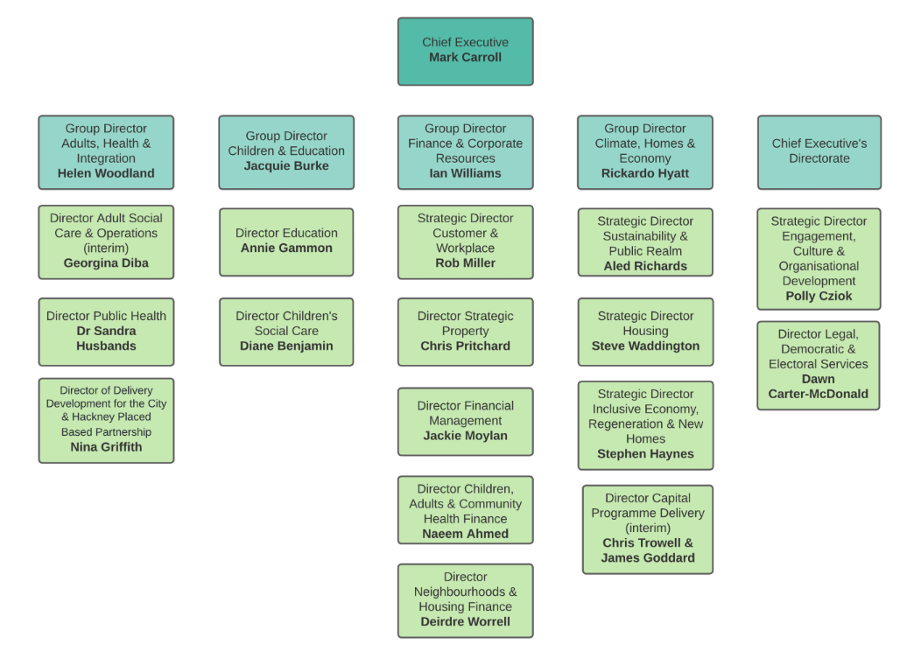
Structure of the Contracting Authority

Directorate Descriptions

Chief Executive's Directorate
Within this Directorate sits:

Legal & Governance
Governance supports the Council’s decision-making process for Cabinet, Council and committees ensure these areas of work are covered lawfully with good governance, corporate compliance and best practice.
Legal Services provides a full legal service to the Mayor, Council Directorates and Officers.

Strategy, Policy & Economic Development
The Mayor’s Office provides administrative, executive and casework support to the Mayor of Hackney as well as members of the Cabinet and Cabinet advisers.
Business Intelligence and Member Services lead on performance, service improvement and business planning across the Council and its partnerships to achieve our objectives
The Executive Support Service provides policy and administrative support to the Chief Executive, the Hackney Management Team and tier 2 Directors across the organisation.
Employment & Skills deliver a wide range of employment and opportunity led services and initiatives including Hackney Works, the Apprenticeship Programme, Hackney 100 and the Supported Employment Service.
Policy & Partnerships ensure that the Council and our partners can make strategic decisions based on a sound understanding of the needs, priorities and inequalities of Hackney communities.
Corporate Programmes design and deliver Hackney’s most ambitious, transformational and cross-cutting programmes of work.

Business Analysis and Complaints
Leads on performance, service improvement and business planning across the Council and its partnerships to achieve our objectives.

Communications, Culture and Engagement
Provides the Council with a range of services including press enquiries, publications, marketing, online communications and consultation.

Electoral Services
Ensures that the democratic process in Hackney is managed in accordance with the law.

Member Services
Helps the elected members of the Council in their role as ward councillors and support the Speaker of Hackney.

Overview & Scrutiny

Finance & Resources Directorate
Within this Directorate sits:
Audit and Anti-Fraud
Leads, advises and supports the whole Council on corporate risk management and governance.

Corporate Facilities Management
Property and building support services.

Corporate ICT Service
Customer-facing ICT service and trusted partner to the business.

Corporate Energy Management Unit
The interface between energy suppliers and client departments, Hackney schools and Hackney Homes for the Council's housing stock landlord supplies.

Fleet Management Unit
Supports the acquisition, maintenance, management and disposal of Council and its partners' vehicle fleets.

Financial Management
Corporate guardians of the Council's overall finances.

Hackney Procurement Services
Responsible for all activities that relate to the purchase of goods, services and work at the Council.

Revenues and Benefits
Responsible for customer services, council tax collection, benefit claims and housing needs services.

Strategic Property Services
Valuation, property management and property-related services for the Council and business tenants, and strategic property advice to the Mayor, Chief Executive and Cabinet.

Building Schools for the Future (BSF)
Responsible for delivering the Building Schools for the Future (BSF) programme in Hackney, which aims to improve education attainment by making all secondary schools in Hackney fit for the 21st century.

Climate, Homes & Economy Directorate
Within this Directorate sits:

Housing
Responsible for around 31,000 tenanted and leasehold homes in Hackney, providing support to families and individuals; ensuring properties are safe, warm and dry; and making sure communal areas are safe and clean.

Public Realm
Environmental Operations is responsible for Commercial, household refuse and bulky waste collections, street cleansing including markets, removal of fly-tips, fly-posting and graffiti, street washing, pest control, animal warden and clinical waste.
Environment and Waste Strategy looks after the Council’s waste strategy including recycling and local environmental quality and statutory functions and statutory environmental enforcement to protect the local environment.
Parking and Markets manage parking on the street and in Council car parks, and enforcing in selected Hackney Homes estates; managing and regulating markets and shop front trading, including administration of licences.
Streetscene designs and maintains the highways, footways, bridges and street lighting on public roads, including road safety and traffic management, school crossing patrols and promotion of sustainable transport including walking, cycling and public transport.
Libraries, Heritage and Culture
Leisure and Green Spaces
Planning and Regulatory Services promote a culture of ‘positive planning’ that works with regeneration partners and other Council services

Leisure & Green Spaces
The Sport, Leisure and Physical Activity Development Team promotes, facilitates and provides sport and physical activity opportunities for all Hackney residents.
The Parks Team maintains 58 parks and open spaces. Our services range from conservation and biodiversity to activities, events, play areas for children and families and sports pitches and facilities

Regeneration
Regeneration and Capital Programme Delivery is responsible for the delivery of more than 9,000 new homes in Hackney (including more than 1,500 being built directly by the Council between 2018 and 2022), as well as the Council’s housing strategy and policy including lobbying government, and the enforcement of standards in private sector housing.
Area Regeneration is leading and working in partnership to deliver and shape strategic regeneration in the borough’s town centres and key growth areas, supporting a fair recovery from the coronavirus pandemic in Hackney’s high streets and town centres, and managing projects and programmes that deliver physical, social and economic benefits for Hackney residents and businesses and create a more inclusive economy.

Children & Education Directorate
Within this Directorate sits:

Hackney Education
Hackney Education is responsible for children’s centres, schools, and early years and adult education. It provides a range of statutory and traded services to support the education of children, young people and their families in the borough.

Hackney Children and Families Service (HCFS)
The Children and Families Service works in partnership with families, carers and other organisations to ensure that every child and young person in Hackney has the best opportunities for their future.
Clinical Services provides accessible and integrated clinical support alongside other services provided by the Local Authority. Our clinical team works jointly with other CAMHS providers in the Hackney CAMHS Alliance Partnership to support the emotional health and wellbeing of any family or individual in Hackney open to HCFS.
The Corporate Parenting Service is responsible for all areas related to the safeguarding and welfare of children who are in the care of the local authority. This includes planning for their future placements via fostering and adoption, supporting rehabilitation to home whenever possible, and supporting young people who have previously been in care up to the age of 25.
Hackney’s Early Help and Prevention Services is comprised of:
- Young Hackney is the Council’s early help, prevention and diversion service for children and young people aged 6-19 years old and up to 25 years if the young person has a special education need or disability
- The Family Support Service units are social work led delivering targeted support to families in need of additional and/or intensive support to achieve their potential, including those identified as Troubled Families.
- The Youth Justice Service works with all young people in Hackney who are arrested or convicted of crimes.
- The Domestic Abuse Intervention Service (DAIS) works with anyone experiencing domestic abuse who is living in Hackney, aged 16 or over, of any sex and gender, and of any sexual orientation.
The Family Intervention and Support Service is comprised of:
- The Multi Agency Safeguarding Hub (MASH) is a single point of contact or ‘front door’ for Children and Families Services.
- Access & Assessment (A&A) undertakes statutory assessments of children in need and child protection investigations for all new referrals to Children’s Social Care.
- Children in Need Service is responsible for the safeguarding of children and young people assessed as being ‘at risk’ including child protection work, court proceedings and statutory family support to help children remain at home safely.
The Safeguarding and Quality Assurance Service is comprised of two teams - the Safeguarding and Reviewing Team and the Quality Assurance and Improvement Team

Adults, Health & Integration
Within this Directorate sits:

Adult Social Care
Care Management and Review Services for Adults with Disabilities and Older People provides adult social care services for those with long-term care needs through our North, Central and South Hackney area teams.
The Client Financial Affairs Team (CFAT) manages the financial and property affairs on behalf of service users who are unable to manage their own finances/property due to mental incapacity, serious physical disability or serious safeguarding issues and there is no-one else willing, able or appropriate to do this.
Direct Payments promote direct payments as an option for self-directed support, monitor individual accounts and reconcile financial and management information to support the Adult Social Care teams.
Mental Health Services support adults with mental health needs of all ages. They also support service users and their carers, in partnership with care providers to ensure the highest levels of service user independence as possible is maintained.
Occupational Therapy coordinates the provision of occupational therapy services, advising on equipment and adaptations for short-term interventions as well as complex specialist and long-term support.
Preventive Services encompass the access, assessment, re-ablement and intermediate care functions.
Provided Services provide in-house, community and home-based services for adults with a disability and for older people, following an assessment of need by a care manager.

Public Health
Responsibility for protecting and promoting the health of the general population moved back to local government in April 2013, after being part of the NHS for almost 40 years. The Council delivers a range of public health services to tackle the big health challenges that residents face. This change has created an unparalleled opportunity for health objectives to be included in the work of other local services - such as libraries, leisure, planning, transport, housing and welfare.

As well as working closely with other council services, Hackney's Public Health team is partnering with other health providers in the borough, including the City and Hackney Clinical Commissioning Group, the Homerton University Hospital Foundation Trust, the North East London NHS Foundation Trust and voluntary organisations.

Financial Information
Budget Figures | £
Total for Last Financial Period (01/04/2021 - 31/03/2022) | 1,201,502,538
Total for Current Financial Period (01/04/2022 - 31/03/2023) | 1,264,860,385
Total for Forthcoming Financial Period (01/04/2023 - 31/03/2024) | 1,278,553,385

Directorate Budget Split / Allocation
Department / Directorate | Last Financial Period  £ | Current Financial Period  £ | Forthcoming Financial Period  £
Adults, Health & Integration | 154,104,213 | 147,259,175 | 156,842,119
Children & Education | 334,044,146 | 346,524,313 | 349,991,195
Finance & corporate Resources | 452,464,874 | 469,883,208 | 470,123,790
Climate, Homes & Economy | 231,562,703 | 275,595,766 | 275,727,877
Chief Executive’s Directorate | 29,326,602 | 25,597,923 | 25,868,404

Staffing / Wageroll for the Forthcoming Period
Category* | Estimated Annual Wages and salaries for forthcoming annual period | Number of people in this category
All Council Non-Teaching Employees | £309,864,909 | 4499
Teachers & Staff at schools that are part of the Local Authority e.g. Community Schools | £135,836,457 | 3190
Teachers & Staff at Voluntary Aided and Foundation Schools | £19,527,172 | 676
Agency / Casual staff  (not including non-employee agency staff) | £1,765,962 | 320
Council Members & Mayor | Not applicable | 58

*Not Including Election Staff (other than where they hold a substantive role at the Council)

Historic Information
Year | Wages and Salaries | Number of Employees (FTE)
2011/12 | £286,722,389 | 7,700 circa
2012/13 | £295,950,388 | 7,600 circa
2013/14 | £316,526,088 | 7,500 circa
2014/15 | £325,715,532 | 7,414
2015/16 | £314,779,588 | 7,200
2016/17 | £376,141,000 | 7,106
2017/18 | £382,876,000 | 7,400
2018/19 | £405,663,607 | 7,400
2019/20 | £435,770,377 | 7,500
2020/21 | £436,823,761 | 7,500
2021/22 | £446,000,000 | 7,929
2022/23 | £472,000,000 | 8,032

Strategic Risk Management Information
Structure of Risk Management Delivery
The Corporate Risk Management team at Hackney is part of the Audit and Anti-Fraud Division, which is headed by the Corporate Head of Audit, Anti-Fraud and Risk Management. There is one full time officer in position as the Corporate Risk Advisor, but (in terms of the whole picture of Risk Management delivery within the organisation) this is not reflective of the overall position, as Risk is embedded throughout the Council, with various officers carrying out important supporting roles (as Risk Champions for example). Each of the five Directorates within the Council has a designated Risk Champion, and they usually have other officers within their directorate supporting them in facilitating effective risk reporting around their areas.

The Corporate Health, Safety and Wellbeing team continues to review the health and safety risk profile for the organisation with the aim of developing a targeted approach for those areas with significant risks. This will allow the Corporate Health and Safety Team to develop an HSE guidance aligned health and safety management system, promoting improved support for service areas in the management of risk including risk assessments, technical advice and guidance, standards and training.

Risk Management Policy
The Council has a Risk Management Policy and also a detailed Risk Strategy. Both of these are reviewed biennially and are being presented to (and ratified by) Audit Committee in October 2022. Both documents go into intricate detail about the Council’s approach to risk and each one is attached under Appendix 2.03 – Risk Management Policy and Appendix 2.02 – Risk Management Strategy.

Achievements & Successes
A clear indicator as to how effectively Risk Management is embedded into the workings of the Council, lies in the form of the quarterly Audit Committee meetings. Each meeting reviews different registers (along with an Annual reports and Policy / Strategy biennially) and features a constructive exchange of views and updates on risk management. This robust and rigorous scrutiny should provide strong assurance of an effective, and well embedded risk management process in place.

Strategic Risk Registers
The Council has very clear reporting structures for registers at service, divisional, directorate and overall corporate level. Each directorate has to present their main risks on an annual basis to Committee. The overarching corporate, strategic risks of the Council are updated and reviewed on a quarterly basis and presented to Committee accordingly. All these registers are available publicly on the democracy pages of Hackney’s website, but the latest version of the corporate risk register is available on request. All registers are created from the Council’s risk software, Pentana Risk (formerly Covalent), where all risks are logged.

Working with Insurers/Directorates
The Council’s Insurance Services section has undertaken or participated in various risk awareness and Insurance related exercises, training and awareness sessions, often in partnership with Insurers, Legal Representatives and/or specialist advisers: These include:

- Public Health; Responsibilities & Risks Arising
- Contract Management (Procurement) Healthcheck
- Housing Liability Risks
- Educational/School Risks
- Motor Risk Awareness
- Emergency Planning (Multi-Agency) Incident Exercises covering:
  - Major Flood Incident
  - Toxic Waste Fire
  - Major RTC with Chemical spill
  - Major Power Outage
  - Terrorism (planned for December 2022)
Future commitments include:

- Highway Network Management Policy Review & Risk Review
- Managing Risks: Cemeteries (Abney Park)
- Tree Maintenance Review

The Insurance Services
With over 75 years combined insurance experience, over 65 of which has been in the local government sector, our Chartered Insurance Institute qualified team consists of;

Michael Pegram (ACII) Head of Insurance Services
James Whitehouse (Dip CII) Senior Insurance Officer
Louise Georgiades (Cert CII) Insurance Officer
Remona Porter (Cert CII) Insurance Officer

Officers within the team are core members of key working groups or committees such as;
- Corporate Resilience Committee
- H&S Committee
- Insourcing Committee
- Covid Response Group
- Cyber Gold Response
- Future Workforce Planning
- Cyber/Silver or Bronze Incident Response Groups (Incident dependant)

Risk Management Accreditation
Members of both the Insurance and Risk Management teams are signed up with ALARM and regularly attend their conferences, workshops and seminars

The Council’s Environmental Operations just achieved their 8th ROSPA Gold award for Occupational Risk Management. RoSPA Gold Award winners have achieved a very high level of performance, demonstrating well developed occupational health and safety management systems and culture, outstanding control of risk and very low levels of error, harm and loss. Gold Medal Awards are then presented to those organisations which have achieved five to nine consecutive Gold Awards

Fraud policy
Please refer to Appendix 2.04 – Anti-Fraud Policy for details of the authority’s fraud policy

Current Insurance Programme
Risks Insured
LOT No. | Class of Business | Current Insurer | Renewal Date
1 | Property comprising Material Damage including Industrial and Commercial properties, Business Interruption, Contract Works, Money, Computers, Schools Balance of Risks and Specified All Risks  Fidelity Guarantee / Crime | Zurich | 1 April 2023
2 | Casualty comprising Employers Liability, Public & Products Liability, Libel and Slander, Officials Indemnity, Land Charges, Public Health Act cover, Professional Indemnity | QBE/RMP | 1 April 2023
3 | Motor Fleet | Zurich | 1 April 2023
4 | Engineering Insurance & Inspection | Bureau Veritas & Aviva | 1 April 2023
5 | Group Personal Accident and Travel including Schools Off-Site and On-Site Activities | Zurich | 1 April 2023
6 | Terrorism | Charles Taylor | 1 April 2023

Historical Deductibles
We have included details of the current deductible and Aggregate under each policy section. These have not changed other than via standard indexation during the contract period, and to assist claims analysis calculations, summary details are provided below: -
 | Lot 1 |  |  |  |  | Lot 2 |  |  |  | Lot 3
Year | Property Housing Damage Deductible* | Property General Damage Deductible* | Property Education Deductible* | Property Damage Aggregate | Property Commercial/Industrial Damage Deductible | Employers Liability Deductibles | Public Liability Deductibles | Officials Indemnity Deductible | Combined Liability Aggregate | Council Motor Deductible (A, D, F, T & G)
2012/2013 | £250,000 | £250,000 | £250,000 | £4,000,000 | £250 | £100,000 | £100,000 | £100,000 | £2,900,000 | £5,000
2013/2014 | £250,000 | £250,000 | £250,000 | £4,000,000 | £250 | £100,000 | £100,000 | £100,000 | £3,000,000 | £5,000
2014/2015 | £250,000 | £250,000 | £250,000 | £4,000,000 | £250 | £250,000 | £250,000 | £100,000 | £3,950,000 | £5,000
2015/2016 | £250,000 | £250,000 | £250,000 | £4,000,000 | £250 | £250,000 | £250,000 | £100,000 | £3,950,000 | £5,000
2016/2017 | £250,000 | £250,000 | £250,000 | £4,000,000 | £250 | £250,000 | £250,000 | £100,000 | £3,950,000 | £5,000
2017/2018 | £250,000 | £250,000 | £250,000 | £4,000,000 | £250 | £250,000 | £250,000 | £100,000 | £3,000,000 | £5,000
2018/2019 | £250,000 | £250,000 | £250,000 | £4,000,000 | £250 | £250,000 | £250,000 | £100,000 | £3,000,000 | £5,000
2019/2020 | £250,000 | £250,000 | £250,000 | £4,000,000 | £250 | £250,000 | £250,000 | £100,000 | £3,000,000 | £5,000
2020/2021 | £250,000 | £250,000 | £250,000 | £4,000,000 | £250 | £250,000 | £250,000 | £100,000 | £3,000,000 | £5,000
2021/2022 | £250,000 | £250,000 | £250,000 | £4,000,000 | £250 | £250,000 | £250,000 | £100,000 | £3,300,000 | £5,000
2022/2023 | £250,000 | £250,000 | £250,000 | £4,000,000 | £250 | £250,000 | £250,000 | £100,000 | £3,600,000 | £5,000
*Please note that the Property Damage deductible for Housing, General & Education assets ranged from £250k to £2m throughout this period depending on the peril concerned. Refer to Confirmed Claims Excess in Appendix 4.03 - Zurich Property Commercial CCE - Summary and Appendix 4.04 - Zurich Property - Housing, Gen & Edu CCE - Summary for excess split.

The following pages outline the Contracting Authority’s Risk / Underwriting Information.

LOT 1 – PROPERTY / MATERIAL DAMAGE
Please refer to Appendix 1.01 - Lot 1 - Property - Material Damage Specification - Evaluation Spreadsheet, which outlines the cover requirements for this Lot.

This Lot incorporates the following classes of business:
- Material Damage
  - General
  - Housing
  - Education
  - Commercial & Industrial Properties
- Business Interruption
  - Gross Revenue
  - Additional Expenditure
  - Loss of Rent
- Contract Works
- Money
- Computers
- Specified All risks

Please note
A quotation to include Terrorism Insurance via Pool Re is required. The Council request bidders submit Pool Re Terrorism Quotations. Please note that Loss Limit quotations will also be sought under Lot 6.

The decision to purchase under Lot 1 or 6 will be determined by the respective advantages and disadvantages of bids under each Lot

Territorial Limits
Great Britain Northern Ireland the Isle of Man and the Channel Islands but restricted to Great Britain for any applicable Terrorism Extension

Jurisdiction
Law of England and Wales

Valuation & Inflationary Increases (All Property Assets)
The Council has applied an inflationary uplift to all assets insured under the Property Schedules in accordance with recommended % levels - This is summarised as follows;

- 2021 & Prior - 3 to 4%
- 2022 (February) - 7.4%
- 2023 (February) - 20% *Applied in October 2022 in advance for tender purposes

The Council has sought quotations for a programme of valuations on key property risks with a view to commence these in 2023.

General Properties
General Description
Property & assets including Council operated, owned and/or occupied sites such as municipal offices, depots, events spaces and leisure centres

Declared Value
Item | Property to be insured | Declared Value | Sum Insured
1 | General Properties – Buildings & Contents  *Excluding Haggerston Baths (See Below) | £1,084,844,420 | £1,247,571,083
2 | Contents (10% of Buildings Declared Value) | Included Under Item 1 (£98,622,200) | N/A
3 | Haggerston Baths (Vacant – Grade II Listed) | £29,554,840 | £33,988,066

Property Schedule
Please refer to Appendix 3.02 - General Property Schedule and the underwriting information below.

Haggerston Baths - Whiston Road, Haggerston E2 8BN
Haggerston Baths is a Grade II Listed property. Originally opened in 1904 as a public bath, it has been closed since 2000. The Council in 2015 asked developers to come forward with expressions of interest in restoring the public building and bringing it back into public use - these expressions of interest and the future of the building remain a key consideration for the Council.

Due to the condition of the property, cover is currently provided on FLEA perils only.

Claims Experience
Please see the following appendices for full Claims information:
- Appendix 4.02 - Property - In House Handled (inc Fire)
- Appendix 4.04 - Zurich Property - Housing, Gen & Edu CCE - Summary
- Appendix 4.07 - Zurich Manual Claims Report - (Redacted)
  - Please note 4.07 include claims across various Zurich policies including motor and property

Notable Claims
Stoke Newington Town Hall (Incidents; August 2022)
Ingress of water due to adverse weather conditions. McLarens instructed directly by the Council as the loss is within the £2m deductible. Preliminary report issued.

Total Incurred Reserved at £52k

Housing Properties
Declared Value
Item | Property to be Insured | Declared Value | Sum Insured
1 | Housing Properties | £7,620,871,451 | £8,764,002,169
2 | loss of rent if any building or any portion of it is unfit for occupation but only in respect of the period necessary for reinstatement for an amount not exceeding 20% of the full value of the building.

Property Schedule
Please refer to Appendix 3.03 - Housing Stock Count 2022-23 and the Underwriting information below.

Underwriting Information
Background
The LBH housing stock consists of approximately 21,628 tenanted properties and 9,900 leasehold/Service Chargeable properties.

Risk Management information relating to Housing can be found in Appendix 2.05 - Housing Key Risk Management.

Housing Block Information (18m+):
Appendix 3.04 - Blocks 18m+ with Sum Insured and Construction Data contains details of all housing blocks which are 18m+. Our Property & Asset Management Teams receive regular updates with survey data, whether that is commissioned by the team, or data received from other sources, (i.e. in respect of new builds). Regular meetings are conducted with the Resident Safety Team to identify, monitor and mitigate risk.

Housing Stock Valuation
In 2011, the Council employed an independent company to undertake valuations of all Housing Properties. Prior to this exercise the Council had index linked all properties in accordance with Insurers recommended indexation rate. "Beacon" Rate methodology was used to value the substantial Housing portfolio and the Beacon rates have now been adjusted to allow for % indexation over each year of the following years.

This Indexation is summarised as follows;

- 2021 & Prior - 3 to 4%
- 2022 (February) - 7.4%
- 2023 (February) - 20% *Applied in October 2022 in advance for tender purposes

The adjusted property type rate is now recorded as follows:

Bedrooms | 0 | 1 | 2 | 3
Bungalow | 88,233.14 | 117,643.72 | 263,858.60 | 238,649.34
House | N/A | 185,709.73 | 215,120.30 | 253,774.31
1-2 Storey Flats | 119,323.94 | 151,257.04 | 194,953.18 | 215,961.14
3-5 Storey Flats | 123,526.69 | 164,701.78 | 207,557.09 | 214,279.46
6-9 Storey Flats | 148,735.96 | 219,321.61 | 284,025.72 | 296,631.07
10+ Storey Flats | 141,172.75 | 168,903.07 | 212,599.24 | 221,003.28
1-2 Storey Maisonettes | 142,852.97 | 171,424.14 | 205,036.02 | 259,657.30
3-5 Storey Maisonettes | 174,786.06 | 209,238.77 | 251,253.24 | 263,017.75
6-9 Storey Maisonettes | N/A | 223,522.91 | 245,371.72 | 420,997.16
10+ Storey Maisonettes | N/A | 202,516.39 | 242,850.64 | 243,691.48
Duplex | 420,997.16

Bedrooms | 4 | 5 | 6 | 7
Bungalow | 235,287.43 | N/A | N/A | N/A
House | 324,361.40 | 415,115.63 | 529,397.42 | 610,067.36
1-2 Storey Flats | 226,884.82 | 237,808.50 | N/A | N/A
3-5 Storey Flats | 222,683.52 | 234,448.03 | 245,371.72 | N/A
6-9 Storey Flats | 357,133.88 | 356,506.13 | 374,779.93 | N/A
10+ Storey Flats | 249,573.01 | N/A | N/A | N/A
1-2 Storey Maisonettes | 272,261.20 | 285,707.40 | N/A | N/A
3-5 Storey Maisonettes | 275,623.10 | 289,908.70 | 304,194.29 | N/A
6-9 Storey Maisonettes | 420,997.16 | N/A | N/A | N/A
10+ Storey Maisonettes | 256,295.38 | N/A | N/A | N/A
Duplex | 420,997.16

Housing Stock Management:
The Housing property portfolio is now managed in-house under the Hackney Housing section of the Climate, Homes & Economy Directorate. There are ten Tenant Management Organisations (TMO’s) within Hackney and they carry their own risk. Hackney Housing works closely with each TMO providing advice, support and guidance. The Council also monitors TMO performance and requires an independent competency assessment.

Claims Experience
Please see the following appendices for full Claims information:
- Appendix 4.02 - Property - In House Handled (inc Fire)
- Appendix 4.04 - Zurich Property - Housing, Gen & Edu CCE - Summary
- Appendix 4.07 - Zurich Manual Claims Report - (Redacted)
  - Please note 4.07 include claims across various Zurich policies including motor and property

Notable Claims
Hathaway House - Explosion (Incident: 11 February 2021)
Large explosion in top (5th) floor premises in block of flats. Major damage to the source leasehold property and flooding to a number of mixed tenure properties below. Forensic investigations have not identified any negligence on the part of the Council.

Estimated Costs - £200k (under review and split between Leasehold Insurers, not included in the scope of this procurement, and Council S.I.R)

Tiger Way & Nile Street Developments
Property Insured & Cover Required

As a minimum requirement London Borough of Hackney requires:

Loss or damage resulting from causes specified within the appropriate section of

Appendix 1.01 - Lot 1 - Property - Material Damage Specification - Evaluation Spreadsheet

to the leaseholders/owners demised area including fixtures and fittings permanently installed in such dwellings and the leaseholders/owners proportion for common parts/areas, foundations, roofs etc. in accordance with the lease and regardless of any lease variation to the contrary.

All units within a property block are insured to include a proportional element to reflect the common parts and foundations etc.

Declared Value - Tiger Way
Item | Property to be insured | Declared Value | Sum Insured
1 | Residential Properties – Buildings & Contents of Communal Areas | £63,787,889 | £73,356,072
2 | Contents of Communal Areas  (10% of Buildings Declared Value) | Included Under Item 1 (£98,622,200) | N/A

Declared Value - Nile Street
Item | Property to be insured | Declared Value | Sum Insured
1 | Residential Properties – Buildings & Contents of Communal Areas | £147,857,125 | £170,035,694
2 | Contents of Communal Areas  (10% of Buildings Declared Value) | Included Under Item 1 (£98,622,200) | N/A

Tiger Way (The Otto Building)
Downs Road, Lower Clapton, Hackney, E5 8DE

Tiger Way is an innovative mixed-use development. The property consists of a primary school and nursery, providing much needed school spaces for the Borough of Hackney. The site includes 89 high quality private sale residential apartments co-located on the same site.

- Development completed : 2019
- 89 Residential Units - Private Sale (via Long Lease)
- 14 Storeys
- Concrete Floor Construction
- Standard Construction - Concrete, Steel, Cladding, Flat Roof

(The School & Communal Areas are included in Appendices 3.02 - General Property Schedule & 3.05 - Education Property Schedule and not required for cover under this section)

Nile Street (The Makers Building)
NIle Street, London, Hackney, N1 7RD

Nile Street is a development of 175 private sale (long lease) homes, with a co-located college.

An interconnected podium and tower, reaching 28 storeys, houses five studio flats, 155 two and three bedroom apartments and a small number of family duplexes with private roof gardens.

- Development completed : 2019
- 89 Residential Units - Private Sale (via Long Lease)
- 28 Storeys

Nile Street Building
- Reinforced concrete frame with post-tensioned concrete floor slabs and
reinforced concrete columns on piled foundations
- Bespoke precast masonry panels with metallic PPC nish curtain wall system & high performance, solar control triple glazed units
- Floors 5, 6 & 7 have anthracite fibre-cement or metallic PPC finish aluminium rain screen cladding (depending on location) with precast masonry spandrel panels

Tower Building
- Bespoke curtain wall system with metallic PPC finish aluminium cladding and
aluminium extrusions and high performance, solar control triple glazed units.
- All units have winter gardens, balconies or terraces

Safety & Security
- 24/7 manned concierge desk in the main entrance lobby
- Audio and video entry systems with colour monitor
- Secure key fob access control to communal access doors throughout the development
- CCTV camera monitoring to main entry points, basement car park entrance and open communal spaces within the development, linked to concierge area
- Sprinkler system fitted to apartments
- Fire alarms installed throughout and interfaced with the sprinkler system. Additionally in the common areas, the fire alarms are linked to smoke extract systems.

(The School & Communal Areas are included in Appendices 3.02 - General Property Schedule & 3.05 - Education Property Schedule and not required for cover under this section)

Additional Insured Interests
Cover is required to note the interest of:

- Otto Management Co Ltd - Company Number 11043383 - Tiger Way (The Otto)
- Makers Management Co Ltd - Company Number 11043263 - NIle Street (The Makers)

Claims Experience
Please see the following appendices for full Claims information:
- Appendix 4.02 - Property - In House Handled (inc Fire)
- Appendix 4.04 - Zurich Property - Housing, Gen & Edu CCE - Summary
- Appendix 4.07 - Zurich Manual Claims Report - (Redacted)
  - Please note 4.07 include claims across various Zurich policies including motor and property

Notable Claims
None Declared

Education Properties
Declared Value
Item | Item | Declared Value | Sum Insured  (after 15% Day One Uplift)
1 | Educational Premises -  Buildings & Contents | £770,619,487 | £886,212,410
2 | LEA Education Premises - Contents | 10% Included Above | 10% Included Above
3 | Voluntary Aided School  Buildings & Contents | £6,651,390 | £7,649,099
4 | Voluntary Aided School Contents | 10% Included Above | 10% Included Above
5 | Sprinklered Schools  Buildings & Contents | £164,594,315 | £189,283,462
6 | Sprinklered Schools Contents | 10% included Above | 10% Included Above
Total |  | £941,535,192 | £1,083,144,970

Sprinklered Schools
The following Schools in the portfolio have sprinklers

Secondary (Special) Schools
New Ickburgh School
The Garden School
Stormont House*
* Currently inactive due to a fault.

Primary Schools
Thomas Fairchild Community School
New Regents College (Nile Street)
Nightingale School (Tiger Way)

Property Schedule
Please refer to Appendix 3.05 - Education Property Schedule and the Underwriting information below.

Underwriting Information
Hackney Education Property Team manage the Education Estate for all the Authority’s schools within the borough. This includes 57 Primary Schools, Children’s Centres & Nurseries alongside the 10 BSF schools built during the last round of construction.

- Delivery of Asset Management Programme (AMP) works in excess of £3.3m annually
- Currently developing a wide ranging scheme to enhance the London School Board schools dating from Victorian and Edwardian times
- Member Schools within the Insurance Scheme have 24/7 emergency contact access to the Head of Insurance Service
- The Council’s Corporate Health & Safety Officers undertake routine surveys of member Schools and provide risk and Health & Safety advice
- Condition Surveys are commissioned by the Hackney Education Property Team

Consortia Schools
The Council does not have any of the following premises on its Education Schedule:

i) CLASP | (Consortium of Local Authorities Special Programme)
ii) SCOLA | (Second Consortium of Local Authorities : 1961)
iii) CLAW | (Consortium – Local Authorities in Wales : 1962)
iv) SEAC | (South Eastern Architects Collaboration : 1963)
v) METHOD | (Consortium for Method Building : 1963)
vi) ASC | (Anglian Standing Conference : 1964)
vii) ONWARD | (Organisation of North West Authorities for Rationalised Design, 1966)
viii) MACE | (Metropolitan Architectural Consortium for Education, 1966)

Claims Experience
Please see the following appendices for full Claims information:
- Appendix 4.02 - Property - In House Handled (inc Fire)
- Appendix 4.04 - Zurich Property - Housing, Gen & Edu CCE - Summary
- Appendix 4.07 - Zurich Manual Claims Report - (Redacted)
  - Please note 4.07 include claims across various Zurich policies including motor and property

Notable Claims
Millfields School (Incident: 5th October 2021)
Ingress of water during adverse weather conditions - McLarens instructed directly by the Council as the loss is within the £2m deductible and need to investigate cause and relationship with recent works at the premises.

Total Incurred Reserved at £200k - Potential Recovery To Be Considered

Parkwood Primary School (Incident: March 2022)
Drainage issue leading to internal property damage to two classrooms. McLarens instructed directly by the Council as the loss is within the £2m deductible.

Total Incurred Reserved at £72k

Commercial and Industrial Properties
Declared Value
Item | Declared Value | Sum Insured
Buildings | £257,835,567 | £296,510,902

Item | Total Sum Insured | Indemnity Period
Total Rental Income of the above Properties | £14,762,588  (24 Months Total) | 24 Months

Property Schedule
Please refer to Appendix 3.06 - Commercial Property Schedule and the Underwriting information below.

Underwriting Information
There is a wide range of business activities within the occupancy of the Properties. Of course the occupancy is subject to change as new tenants take occupancy.

Our Commercial and Voluntary & Commercial Sector (VCS) team manages our portfolio of commercial premises. They check all void properties on a weekly basis in order to comply with our current insurance policies. When a property is vacant they assess if extra security measures are needed and will carry out an assessment. The extra security measures could include: mobile security patrols, 12 hour security cover, 24 hour security cover or guardians.

A copy of the Health & Safety guidance for business tenants is provided in Appendix 2.11 Health and Safety Guidance for Business Tenants.

All of the commercial properties have a CIPFA building survey carried out every five years. The team writes out to all commercial tenants asking them to provide evidence of their most up to date Fire Risk Assessment (FRA.) Within the VCS portfolio all properties are on our Preventative Property Maintenance schedule (PPM), this includes legionnaires testing, lift maintenance, fire alarm, like the commercial portfolio VCS tenants are expected to complete their own FRA.

“Global Guardians” are the current guardian service provider across the corporate portfolio. They are utilised to secure and protect various vacant properties across the Borough against squatters and potential vandalism and are more cost effective than utilising 24/7 security.

Where required Global Guardians will assist the Council to comply with the appropriate statutory, regulatory and corporate standards, although the statutory element is primarily under the responsibility of the Council's term contractor, BAM FM as is the arrangement regarding PPM. In exceptional cases such as an emergency, any essential repairs and maintenance will be undertaken by Global and agreed with the Council, with the cost being recharged back to the Authority.

Monthly inspections also form part of the guardian arrangement and we also undertake our own in house inspections to ensure the provider is performing consistently to the standard and level expected.

Claims Experience
Please see the following appendices for full Claims information:
- Appendix 4.03 - Zurich Property Commercial CCE - Summary
- Appendix 4.07 - Zurich Manual Claims Report - (Redacted)
  - Please note 4.07 include claims across various Zurich policies including motor and property
Notable Claims
None declared

Business Interruption - Increase in Cost of Working
Property Description
Premises as detailed in Property Schedule within Appendix 3.02 - General Property Schedule, Appendix 3.03 - Housing Stock Count 2022-23 and Appendix 3.05 - Education Property Schedule, cover to also include locations when the Council is a tenant however, is not necessarily required to insure the building.

Cover Provided
Any additional cover necessarily and reasonably incurred for the sole purpose of avoiding or diminishing the interruption of or interference with the business.

As per the Cover provided under the relevant Property Section

Claims Experience
Please see the following appendices for full Claims information:
- Appendix 4.04 - Zurich Property - Housing, Gen & Edu CCE - Summary
- Appendix 4.07 - Zurich Manual Claims Report - (Redacted)
  - Please note 4.07 include claims across various Zurich policies including motor and property

Notable Claims
No significant large loss under Business Interruption for 10 years

Business Interruption - Gross Revenue
Property Description
Specific premises owned or operated by the Insured and included with the insurance of Material Damage and where Revenue is derived from the operation of the facility/premises

Claims Experience
Please see the following appendices for full Claims information:
- Appendix 4.04 - Zurich Property - Housing, Gen & Edu CCE - Summary
- Appendix 4.07 - Zurich Manual Claims Report - (Redacted)
  - Please note 4.07 include claims across various Zurich policies including motor and property

Notable Claims
No significant large loss under Business Interruption for 10 years

Contract Works
Basis of Sums Insured
Day One (15%) basis - Non Adjustable

Cover to include
- £170m estimated Capital Works programme
Estimated Gross Budget for Capital Works in 2022/23 and after 15% Day One Value

Underwriting Information
For work on existing structures the balance of perils not insured under the Property item are included under this item. Where possible the Council will seek to transfer the responsibility for insuring the works to the Contractor.

Please use the Current Sum Insured for rating purposes.

Estimated Gross Budget for Capital Works in 2022/23 and after 15% Day One Value is £170m
Where appropriate the Council will seek to transfer the responsibility for insuring the works to the Contractor. Please use the Current Sum Insured for rating purposes

Claims Experience

Please see the following appendices for full Claims information:
- Appendix 4.04 - Zurich Property - Housing, Gen & Edu CCE - Summary
- Appendix 4.07 - Zurich Manual Claims Report - (Redacted)
  - Please note 4.07 include claims across various Zurich policies including motor and property

Notable Claims
No notable declared losses

Money
Underwriting Information
Main payment facilities consist of three Self Service Terminals and a back office for cheques. Aside from any safes kept by schools and service areas the council has one large safe with a resistance grade: VI.

The safe is also used to temporarily securely store valuable items held by Social Care, following a resident passing away.

Estimated Annual Carryings by security company:
The Council’s contractor BDI collects cash from its pay and display machines across the borough. In 2021/22 total coin revenue amounted to £282,314.92. We expect a downward trend in the amounts collected throughout the current year as usage of our pay by mobile system is growing. To date (April to September) £93,346.73 has been collected – a reduction of £54,702.27 at the same time last year.

An estimated £6.5 million (Cash & Cheques) will be collected from the Self Service Payment Centre.

Claims Experience
Please see the following appendices for full Claims information:
- Appendix 4.04 - Zurich Property - Housing, Gen & Edu CCE - Summary
- Appendix 4.07 - Zurich Manual Claims Report - (Redacted)
  - Please note 4.07 include claims across various Zurich policies including motor and property

Notable Claims
No notable claims

Computers
Underwriting Information
All necessary information is included within Appendix 1.01 - Lot 1 - Property - Material Damage Specification - Evaluation Spreadsheet

Claims Experience
Please see the following appendices for full Claims information:
- Appendix 4.06 - Zurich FG, Comp & BT CCE - Summary
- Appendix 4.07 - Zurich Manual Claims Report - (Redacted)
  - Please note 4.07 include claims across various Zurich policies including motor and property

Notable Claims
Data Erasure/Distortion (Incident: October 2020)
Losses arising from the cyber incident. McLarens instructed.

Total Incurred Reserved at £103k (Open - Payments <£4k to-date)

Specified All Risks Cover
Underwriting Information
All necessary information is included within Appendix 1.01 - Lot 1 - Property - Material Damage Specification - Evaluation Spreadsheet

Claims Experience
Please see the following appendices for full Claims information:
- Appendix 4.04 - Zurich Property - Housing, Gen & Edu CCE - Summary
- Appendix 4.07 - Zurich Manual Claims Report - (Redacted)
  - Please note 4.07 include claims across various Zurich policies including motor and property

Notable Claims
No notable claims

LOT 2 – COMBINED LIABILITY & FIDELITY GUARANTEE/CRIME
Please refer to Appendix 1.02 - Lot 2 - Combined Liability and FG-Crime Specification, which outlines the cover requirements for this Lot.

This Lot incorporates the following classes of business:

- Employers Liability
- Public/Products Liability (including Libel and Slander)
- Officials Indemnity (including Land charges and Public Health Act)
- Professional Indemnity
- Claims Handling
- Fidelity Guarantee / Crime

Combined Liability Risk Information
Employers Liability
Employer Reference Number (ERN) 120/LB4

Additional Insured Interests
Cover is required to incorporate the liability risks arising from the activities of the additional insured interest noted above (Introduction Section - Additional Insured Interests) - including:

- Hackney Commercial Services (London) Ltd - Company No: 13700731
- Hackney Housing Company Ltd - Company number 11738936 (including Hackney HLR Housing Company Ltd - 11750958 & Hackney PRS Housing Company Ltd - 11750933)
- Otto Management Co Ltd - Company Number 11043383
- Makers Management Co Ltd - Company Number 11043263
- Hackney Light & Power

5 Highest Concentrations of Employees
Details of Address including Postcode | Number of Employees (Headcount)*
Hackney Service Centre, 1 Hillman Street, Hackney E8 1DY | c.2000
Hackney Town Hall, Mare Street, E8 1EA | c.500
TLC Building, 1 Reading Lane, E8 1GQ | c.500
Millfields Depot, Millfields Road, E5 0AR | c.250
Robert House, 6-15 Florfield Road, London, E8 1DT | c.100
* The Council continues to review the use and occupation of its assets and supports a hybrid working policy which reduces the daily concentration of employees in the offices at any time.

Pollution:
An incident occurred at Pedro Street, E5 following demolition of a former boiler house in advance of regeneration of the site. The Environment Agency has been informed and it is unclear from two site reports as to the extent and cause of the pollution. Investigations are underway into whether this occurred during or prior to demolition and full details have been requested from the Regeneration Project Owner for full disclosure. In mitigation I am informed that all adjoining land is owned by the Council.

The clean up operation is approved and underway and that there has been no sanction from the EA who is sighted on the situation.

Health and Safety:
The Council’s Corporate Health & Safety team effectively manages a range of risks including Health & Safety at Work, HSE & Trade Union liaison, Legionella, Asbestos and have been a lead member in the response to the pandemic.

The corporate team is supported by departmental H&S Officers and teams such as the Council’s dedicated Resident Safety Team.

The most recent report from our Corporate Health & Safety Team can be viewed as an example under Appendix 2.01 - Corporate Health & Safety Committee Health and Safety (October update).

Covid-19:
The Council adopts robust and fully compliant working practices, undertaking individual vulnerability assessments for every employee and risk assessments for specific operational needs. This included training Managers in how to manage hybrid working environments, a review of fire marshalling within partially occupied buildings and an assessment of ventilation in all key buildings following removal of social distancing guidance.

Tree Roots:
A new Tree Risk Management Policy has been prepared and is presently awaiting cabinet approval. However in summary the procedure we are presently following is as follows:

Conditional Inspection frequencies are undertaken on a:

3 year cycle - Highways detailed inspection
Annual Inspection - Highways boroughwide inspection on the public highway for dead trees

3 year cycle - Parks and Open Spaces detailed inspection
Annual Inspection - Parks and Open Spaces for high access areas detailed inspection such as
playgrounds

Maintenance is undertaken in work programmes - i.e planned, unplanned, urgent works, emergency works and ad-hoc works as outlined in our Arboricultural Maintenance Framework Programme Specification available upon request.

All records of both inspection and maintenance are recorded on our IT package EzytreeV.

Reservoirs:
West Reservoir is situated between Stoke Newington and Finsbury Park in the north west of the borough. West Reservoir is owned by the Council and operated on its behalf by Greenwich Leisure Limited as part of the Council’s wider Leisure Management Contract.

West Reservoir was constructed in about 1833, but is now a non-operational reservoir and used as a recreational water sports centre.

West Reservoir is a registered reservoir under the Reservoirs Act 1975, as it contains more than 25,000m3 of water above the surrounding natural ground level and as such is subject to annual inspections by a reservoir inspector. The Reservoir is currently categorised as a Category A reservoir meaning that it is in the highest consequence class and a breach of the dam could endanger lives in a community. The Reservoir is also classified as ‘High Risk’ by the Environment Agency based on the resulting consequences if it failed.

The design standards for a Category A reservoir are consummate with the high consequences of failure. For example, a Category A reservoir has to safely pass the 1 in 10,000 year flood, and the larger Probable Maximum Flood , without failure.

The 2.59m diameter Thames-Lee Tunnel runs underneath the Reservoir from the north east to the south west. There is a shaft at the north east corner of the reservoir constructed to access the Thames-Lee Tunnel. A 2.44m diameter TWRM tunnel from Coppermills Water Treatment Works enters a shaft at the south end of the site, after passing near to the toe of the south east embankment, at approximately 50m below ground level. A 36" (900mm) diameter buried water main passes along most of the crest of the south east embankment from near the old pumping station (the castle) in the south, to Lordship Road in the north. The depth of the main below ground level at the south end of the Reservoir is around 6.5m and around 7.0m at the north end - the main was recommissioned by Thames Water in 2021

2020 - Cyber Attack (STRICTLY CONFIDENTIAL)
During the weekend of 10/11 October 2020 the Council became aware of a cyberattack. The network was immediately shut down and isolated and ICO notified within the required 72 hours.

A Response Team was immediately stood up reporting to the Gold Hackney Management Team and support from Central Government, Enforcement (National Cyber), forensic investigators and cyber security experts engaged. Mitigation and prevention strategies considered and implemented.

Whilst there was no evidence of data being taken in the attack; on the 6 January 2021 The Council were informed that Council controlled data appeared on the dark web. The ICO is aware and continues to work with us whilst investigating the incident.

Plans were activated immediately and the type and extent of data has been thoroughly analysed. Mitigation plans have been invoked and legal advice continues to be provided.

An independent auditors report has stated that;

“Work performed by our IT audit and Cyber specialists has confirmed that the Council had appropriate arrangements in place to either prevent or reduce the likelihood of a cyber security breach”

The ICO Investigation findings remain outstanding.

Local Government Pension Scheme:
The administration of member records is outsourced to Equiniti & the fund is also subject to external management. The Insurance Services team at London Borough of Hackney was actively involved in the setting of the necessary insurances & indemnities and the suppliers concerned have met these requirements.

Claims Experiences
Please see the following appendices for full Claims information:
- Appendix 4.01 - LBH - In House Handled Claim Report
- Appendix 4.10 - JLT Casualty (below deductible) 1 April 13 to 31 Mar 14.
- Appendix 4.11 - QBE - EL&PL Authenticated Claims Experience Summary
- Appendix 4.12 - QBE - OI/PI Claims Experience Summary
- Appendix 4.13 - QBE Med Mal CCE 2022 Summary
- Appendix 4.16 - Travelers Casualty - Run-off Claim Experience Summary
- Appendix 4.17 - RMP Claims Listing

Notable Claims
Narrative on notable claims is included under each relevant section below.

Combined Liability – Current Programme
Current Limits of Indemnity and Deductibles
Cover | Current Indemnity Limit | Current Deductible
Employers Liability | £50,000,000 | £250,000
Public Liability | £50,000,000 | £250,000
Officials Indemnity (including Land Charges and Public Health Act) / Professional Indemnity | £5,000,000 | £100,000
Professional Indemnity | £2,000,000 | £100,000
Hirers Liability | £5,000,000 | £250

Annual Aggregate Required
The current Aggregate Stop Limit is £3,600,000.

An Aggregate Applies to all sections above. The Insured would prefer that these are not index linked over the Contract Period

Claims Handling
Please include within the bid Claims Handling below the Deductible quotations. The Claims Handling Service and Pricing Specification is contained in Appendix 1.02 - Lot 2 - Combined Liability and FG-Crime Specification.

Employers Liability
ERN (Employer Reference Number)
London Borough of Hackney: ERN Reference Number: 120/LB4

Staffing / Wageroll for the Forthcoming Period
Category* | Estimated Annual Wages and salaries for forthcoming annual period | Number of people in this category
All Council Non-Teaching Employees | £309,864,909 | 4499
Teachers & Staff at schools that are part of the Local Authority e.g. Community Schools | £135,836,457 | 3190
Teachers & Staff at Voluntary Aided and Foundation Schools | £19,527,172 | 676
Agency / Casual staff  (not including non-employee agency staff) | £1,765,962 | 320
Council Members & Mayor | Not applicable | 58
*Not Including Election Staff (other than where they hold a substantive role at the Council)

Historic Information
Year | Wages and Salaries | Number of Employees (FTE)
2011/12 | £286,722,389 | 7,700 circa
2012/13 | £295,950,388 | 7,600 circa
2013/14 | £316,526,088 | 7,500 circa
2014/15 | £325,715,532 | 7,414
2015/16 | £314,779,588 | 7,200
2016/17 | £376,141,000 | 7,106
2017/18 | £382,876,000 | 7,400
2018/19 | £405,663,607 | 7,400
2019/20 | £435,770,377 | 7,500
2020/21 | £436,823,761 | 7,500
2021/22 | £446,000,000 | 7,929
2022/23 | £472,000,000 | 8,032

5 Highest Concentrations of Employees
Details of Address including Postcode | Number of Employees
Hackney Service Centre, 1 Hillman Street, Hackney, E8 1DY | 1800 to 2000
Hackney Town Hall, Mare Street, Hackney E8 1EA | 300
Hackney Learning Trust, 1 Reading Lane, Hackney, E8 1GQ | 300
The Annexe, 2 Hillman Street Hackney, E8 1DY | 300
Christopher Addison House, 72 Wilton Way, Hackney, E8 1BJ | 300

NB: The above figures are estimates whilst the Council continues to consolidate its municipal property portfolio and move offices to hybrid working environments.

Claims Handling
Claims handling will be required below the deductible.

However, the Council wishes to seek delegated authority to handle casualty claims within the deductible and would welcome the opportunity to discuss this proposal with the successful underwriter.

Below deductible liability claims are currently handled by the casualty Insurers appointed third party administrator and The Council nominates its own preferred Solicitor on a case by case basis. The Council does not utilise its own in-house legal term for liability claims.

In addition to the dedicated departmental Officers within Highways & Housing the Insurance Services Team consists of four experienced Officers all CII qualified ranging from CII to ACII with substantial public sector insurance experience. Further information is available on request.

All Insurance Services Officers actively engage in claim investigation, witness identification and support, Court Hearings and liability considerations.

Claims Experiences
Please see the following appendices for full Claims information:
- Appendix 4.10 - JLT Casualty (below deductible) 1 April 13 to 31 Mar 14.
- Appendix 4.11 - QBE - EL&PL Authenticated Claims Experience Summary
- Appendix 4.16 - Travelers Casualty - Run-off Claim Experience Summary
- Appendix 4.17 - RMP Claims Listing

Notable Claims (over the deductible and/or complex in nature)
Employee Impact/Crush (February 2015)
An employee undertaking vehicle checks, prior to driving it, became compressed between the vehicle and a car park pillar. The vehicle had been inadvertently left in gear by the previous user.

Policy and practice relating to the undertaking of vehicle checks was reviewed immediately after and drivers instructed not to leave the vehicle in gear.

Total Paid: £339k (Claim Closed)

Public/Products Liability
Underwriting Information

Children's and Young People's Services
The council does not operate any Children's Homes at present.

There are approximately 300 Looked after Children registered at The Council and c.150 approved and registered Foster Parent families. As at January 2022 the split between children cared for by “in-house” foster carers and those appointed by an Independent Fostering Agency was approximately equally split.

Ofsted - Children’s Services
The latest Ofsted Inspection of Children’s Social Care Services was published on 20 December 2019 - The Judgement and Grade table is copied immediately below.
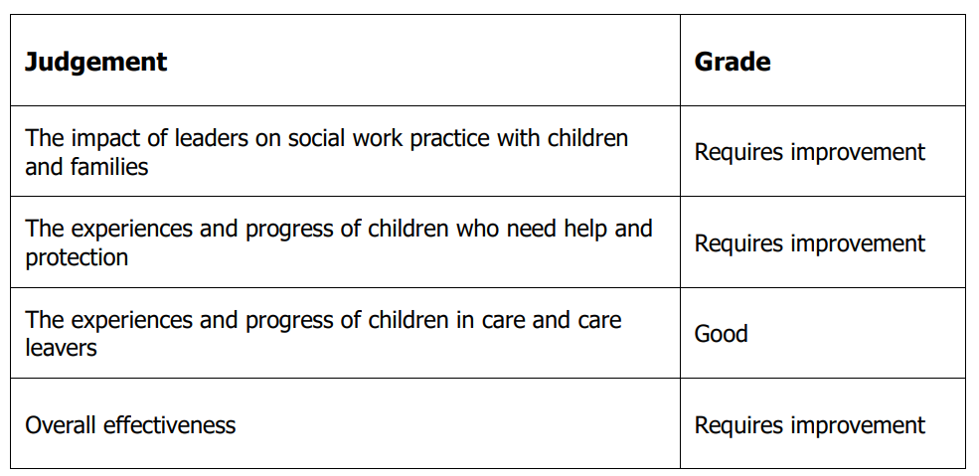

Since 2020 the Council has had two focused visits which identify the improvements made since the 2019 report. These can be located at;

Appendix 2.13 - Ofsted Focused Visit Report September 21
Appendix 2.12 - Ofsted Focused Visit Report October 22

The Headline findings in October 2022’s report highlight the improvements made.

“Headline findings [October 2022 Report]

Children in need of help and protection in Hackney benefit from strong front door services that help to ensure they receive the right support at the right time. The recent integration of early help (EH) workers into the multi-agency safeguarding hub (MASH) is improving screening of contact and referrals, to ensure children and families are directed promptly to the appropriate service. Most children receive proportionate responses that meet their needs. Action for children at immediate risk is timely and effective. Senior leaders are driving necessary changes to improve practice at a pace that suits the workforce and allows for the ongoing delivery of safe services. Committed and skilled staff feel supported through the implementation of a new practice framework, with a focus on an anti-racist, trauma-informed and systemic approach to practice. They feel listened to, valued and supported.

Senior leaders know their services well and are making improvements in a challenging context. As leaders recognise, caseloads in the access and assessment (A&A) teams, and for some newly qualified workers, are too high and recording of supervision is inconsistent. Leaders have Ofsted Piccadilly Gate Store Street Manchester M1 2WD T 0300 123 1231 Textphone 0161 618 8524 enquiries@ofsted.gov.uk www.gov.uk/ofsted 2 sustained significant financial investment in youth services to address the risk of serious youth violence. “

Leisure Risks
The Council does not currently manage any of its 6 Leisure facilities. The facilities within the Borough are managed by Greenwich Leisure (Trading under contract until 2029. Within the contract agreed with Greenwich Leisure Limited there is provision for the management of the following:
- Risk Assessment of the facilities themselves
- Programme for inspection of paths, fencing and walls pertaining to the Leisure facilities
- Risk assessment for parks, playgrounds, cemeteries and open spaces
All of the above is undertaken by the Councils Leisure Partner - Greenwich Leisure Limited.

Highways
Risk Management here has been a huge success story involving collaboration between:

- Council Highways Team
- Insurance Services
- Solicitors
- Insurers

In the late Nineties and early part of the millennium, the Boroughs roads were in a poor state of condition and this was severely impacting on Council finance and efficiency

The starting point was an audit of the Hackney’s Highways Department. The Project Group examined all aspects of the administrative process for claims within the department, including adequacy of investigations and compliance with Civil Procedures Regulations.

This allowed the Group to draw up a series of recommendations for changes to the handling procedures, which the council’s Head of Insurance was instrumental in implementing.

Interrogation of the claims data was critical in identifying claims ‘hotspots’. Highway footpath injuries alone amounted to £772,000 and as a result of these investigations Hackney were able to release £4m from their self-insurance fund, which they then used to repair over 16,000 potholes. This emphasis on repair helped bring about a significant improvement to the overall loss ratio, thereby allowing the council to make a substantial reduction in the annual contributions to their self-insurance fund.

The Council has maintained this investment both in processes and procedures and indeed in the assets themselves. This is demonstrated in the Graph immediately below.

Graph 1: The reduction in Highway related claims following investment in 2003/04

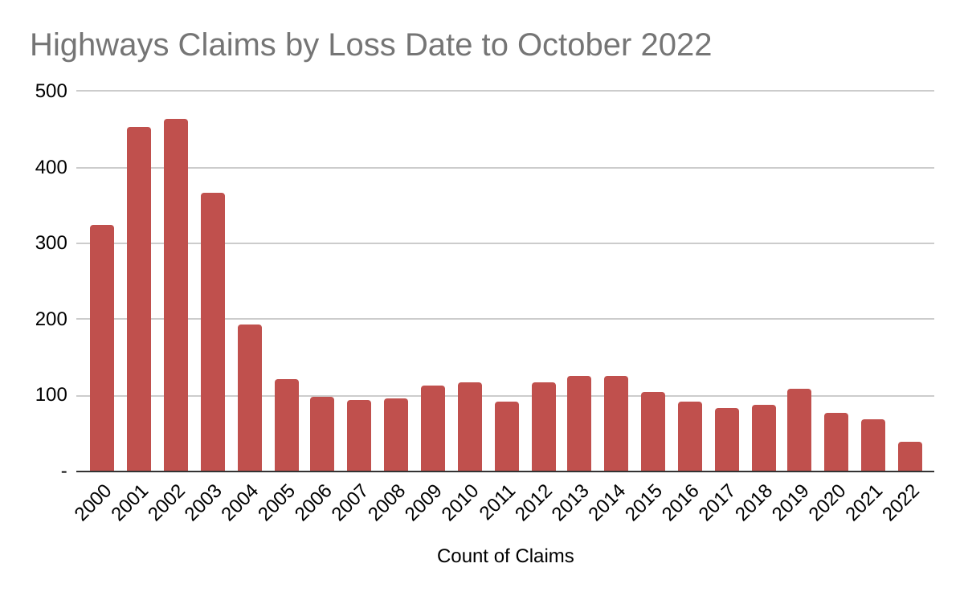
Dedicated Highways Officer
The Insurance Services team within the Council works very closely with the Highways team and a dedicated Highways Inspector is allocated to investigating claims and undertaking site visits on the vast majority of injury related losses.

Approximate Kilometres of highway
The Council is responsible for maintaining c.240km of public highway. There is also a further 40km (34km Housing Roads and 6km Private Road) for which Hackney are not responsible for and 22km of Red Routes whose maintenance is the responsibility of Transport for London (TfL). Bringing the total length of highway to 302km

Housing
Hackney Housing are replicating the success in Highways in terms of slips and trips on Housing land. They have created a dedicated new post within the Property Services Division to be responsible for investigating Insurance Claims.

External Housing Estate paths & roads are now inspected by the Council’s qualified Highways Inspection Team. This has increased the level of experience and assessment of defects and reduced significantly the risk of “no man's land” esq. issues where Housing or Highways may have believed an area to be maintained by the other - in essence the inspections should now dovetail.

Hackney Housing attend regular meetings with the Council’s Insurance Team to review claims and associated risks and to identify areas of improvement.

Repudiation Rates
Graph 2: Repudiation Rates – Closed Claims Occurring
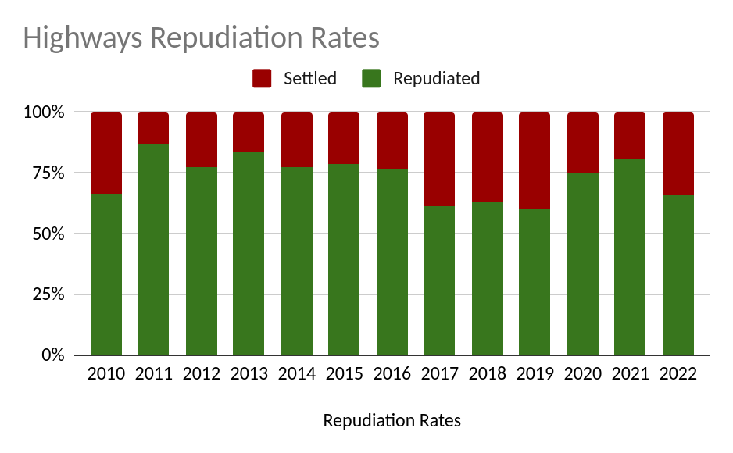

Housing Fire Risks:
Please refer to Appendix 2.05 - Housing Key Risk Management for information.

Notable Activities:
Retrofit Assessor & Retrofit Coordinator roles - PAS2035 Roles
Qualified and Trust Marked assessors and Coordinators to be undertaken for Housing and Leasehold Council residencies only - no external private customers.

Commercial Dog Boarding Services
Boarding services only for Hackney staff only and NHS patients etc that have been sectioned etc

Claims Handling
Claims handling will be required below the deductible.

However, the Council wishes to seek delegated authority to handle casualty claims within the deductible and would welcome the opportunity to discuss this proposal with the successful underwriter.

Below deductible liability claims are currently handled by the casualty Insurers appointed third party administrator and The Council nominates its own preferred Solicitor on a case by case basis. The Council does not utilise its own in-house legal term for liability claims.

In addition to the dedicated departmental Officers within Highways & Housing the Insurance Services Team consists of four experienced Officers all CII qualified ranging from CII to ACII with substantial public sector insurance experience. Further information is available on request.

All Insurance Services Officers actively engage in claim investigation, witness identification and support, Court Hearings and liability considerations.

Claims Experiences
Please see the following appendices for full Claims information:
- Appendix 4.01 - LBH - In House Handled Claim Report
- Appendix 4.10 - JLT Casualty (below deductible) 1 April 13 to 31 Mar 14.
- Appendix 4.11 - QBE - EL&PL Authenticated Claims Experience Summary
- Appendix 4.16 - Travelers Casualty - Run-off Claim Experience Summary
- Appendix 4.17 - RMP Claims Listing

Notable Claims (over the deductible and/or complex in nature)
Wall Collapse (May 2014)
In respect of the incident on 18 May 2014, this claim involved the collapse of a wall on a housing estate injuring two children who had been playing, with a rope, on or about the wall. The Council immediately undertook a review of all walls constructed in a similar nature, regardless of condition, and arranged removal of the same as a priority risk control. The wall itself had been subject to monthly inspection, was not obviously hazardous and had been in situ since, approximately, the 1950’s.

Total Incurred: £2.327m (Open)

Officials Indemnity
Retroactive Date
1st April 1992

Underwriting Information
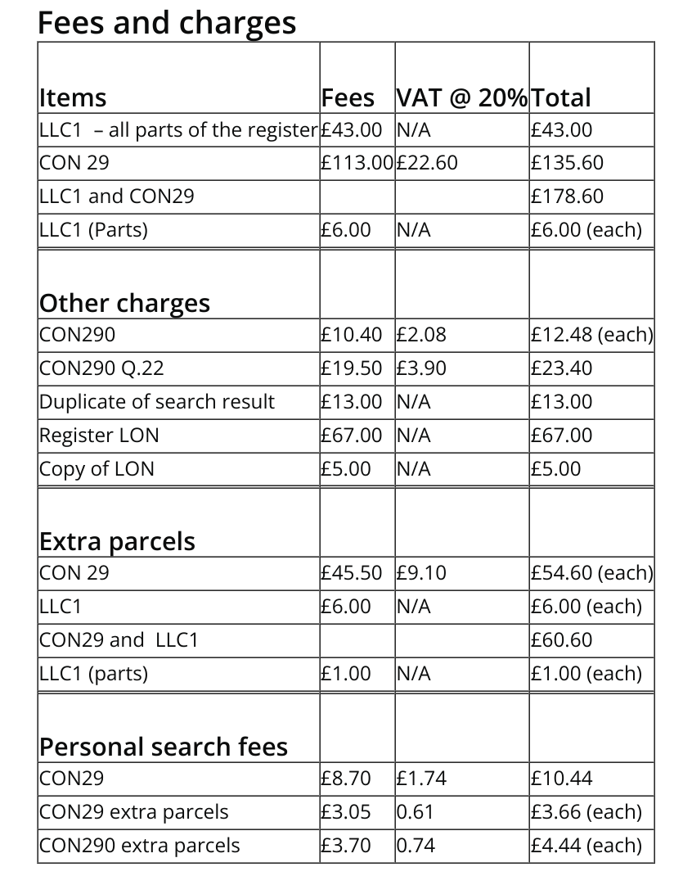
Land Charges
Number of Official Land Searches undertaken over the past 12 months:
2021/22 - 1730 Searches Sent (Partial)
2022/23 - 1180 Searches Sent (Partial) - * Up to 24 October 2022

Full land searches
Unfortunately, we are not currently able to process full land searches. This is because of a cyberattack that affected the land charges processing system.
We are working hard to recover data and expect to have new systems in place by Spring 2023.
We strongly recommend that buyers and sellers explore indemnity insurance alongside partial searches to enable transactions to proceed.
The scope of the partial search is made expressly clear to any enquirer and we have worked with the Central Government, leading market & mortgage lenders to mitigate the impact. This has been widely reported as very successful.

Procurement Procedures
The Council adopts a robust policy and practice in compliance with the appropriate European & UK procurement Regulation – This is strictly followed. The Council manages this spend through a dedicated, qualified Procurement team which supports Contract Sponsors and Contract Managers.

To compliment this the process maps, regulations, risk assessments and associated documents are available to all employees via dedicated procurement pages on our intranet.

Inclusion of insurance limits and advice is now a mandatory component of the formal Business Case, helping to ensure we manage risks appropriately and identify any significant changes in service.

Claims Experiences
Please see the following appendices for full Claims information:
- Appendix 4.10 - JLT Casualty (below deductible) 1 April 13 to 31 Mar 14.
- Appendix 4.12 - QBE - OI/PI Claims Experience Summary
- Appendix 4.16 - Travelers Casualty - Run-off Claim Experience Summary
- Appendix 4.17 - RMP Claims Listing

Notable Claims (over the deductible and/or complex in nature)
Breach of DPA (June 2016)
This related to the inadvertent disclosure of the name and address of adoptive parents which was considered to put them at risk so prudent risk controls were agreed with the data subjects,

The Council reacted promptly and proactively to this incident. The Information Commissioner took no formal action and found that the Council promptly put in place suitable safeguards to prevent a re-occurrence of the relatively unique circumstances. These included a secondary check of the content of all outgoing post from the Social Care legal team.

Total Incurred: £144k (Closed)

Professional Indemnity
Underwriting Information
The cover is presently arranged on a "blanket" basis with all activities covered other than*
(a) architectural design
(b) work or advice associated with any design and build contracts
(c) quantity surveying building surveying or any surveying or valuation work
(d) civil engineering mechanical engineering or electrical engineering
(e) treasury management
(f) procurement
(g) medical pharmaceutical or scientific work consultancy or testing
(h) legal and financial services

*Unless expressly agreed

Professional Indemnity Services
Department | Description of service | Estimated fee income for 2022-23
Hackney Education | See Product List at Appendix 2.14 - 2022 Traded Services Order information | £3.8m  estimated
Planning Services | - Pre-Application Planning Advice  - Planning Performance Agreement | £300k  £600k
Youth Services | e.g Violence Reduction Unit  training/awareness/workshops | £300k
Printing & Design Services | Design & Print Services | £40k
Legal Services to London Borough | The Council is providing legal advice around potential decisions that will impact SEN transport projects. The request is for our education lawyer to research and advise. This would be charged at a maximum rate of £170 per hour.  A Service Level Agreement is in place with the work due to conclude in late 2022. | £10k
Legal Services to County Council | The Council is providing legal advice around potential decisions that concern Low Traffic Neighbourhoods.  The request is for a senior lawyer to provide legal advice. This would be charged at a maximum rate of £155 per hour.  A Service Level Agreement is in being signed with work due to commence in November 2022 for approximately 6 months. | c.£60k - £100k
Retrofit Assessor & Retrofit Coordinator roles - PAS2035 Roles | Qualified and Trust Marked assessors and Coordinators to be undertaken for Housing and Leasehold Council residencies only - no external private customers. | n/a
Commercial Dog Boarding Services | Boarding services only for Hackney staff only and NHS patients etc that have been sectioned etc | c.£2k p.a.

Where any of the following services are provided, the Contracting Authority can comply with the statements below:

Legal Services
- All legal services work is undertaken or supervised by a legally qualified employee
- No conveyancing work is undertaken
- All work is undertaken under a formal written contract (Client Letter or Service Level Agreement) with the third party.
- No prior Professional Indemnity losses in this area

Construction Services
Including engineering, design and construction activities, surveying activities and architecture
- All construction work is undertaken or supervised by a qualified employee
- No work is undertaken on bridges, tunnels, airports, railways, sewage or harbours
- All work is undertaken under a formal written contract with the third party.
- No prior Professional Indemnity losses in this area

Valuation Services
- No valuations are undertaken for lending purposes.
- No single valuation is undertaken which is larger than GBP1,000,000
- All work is undertaken under a formal written contract with the third party.
- No prior Professional Indemnity losses in this area

Procurement
No prior Professional Indemnity losses in this area

Claims Experience
Please see the following appendices for full Claims information:
- Appendix 4.10 - JLT Casualty (below deductible) 1 April 13 to 31 Mar 14.
- Appendix 4.12 - QBE - OI/PI Claims Experience Summary
- Appendix 4.16 - Travelers Casualty - Run-off Claim Experience Summary
- Appendix 4.17 - RMP Claims Listing

Notable Claims
None declared

Hirers Liability
Insured
Hirers of premises / grounds owned by the Insured

Underwriting Information
Hirers are required to agree to a formal Hire Agreement and are asked to demonstrate evidence of appropriate levels of Public Liability Insurance for their event/activity. Indemnity is primarily limited to small groups and voluntary organisations considered to be low risk however, we have provided an estimate of the fee income generated over five key venues for rating purposes.

Estimated External Hiring Net Income 2022/23
Property Type | Hiring Income
Schools & Community Halls | £150,000
Other Public Halls:  Hackney Town Hall  Stoke Newington Town Hall  The Glass House  Clissold House  The Tomlinson Centre  Abney Chapel - Opening Summer 2023  Total Estimate | £450,000  £ 30,000  £100,000  £160,000  £120,000  TBC  £1,010,000
Claims Experience
Incorporated within casualty claims experience. No claims within the last 5 years.

Notable Claims
None declared

Fidelity Guarantee / Crime Risk Information
Underwriting Information

Confirmation of maximum value of cash at any one location:
This is not expected to be in excess of £100,000 and has reduced since the start of the pandemic to circa £20,000.

Detail of existing management controls / systems of check:
There is an annual internal audit plan, this is based on an assessment of risk, and systems are reviewed each year, recommendations are issued when appropriate and these are followed up to check that they are implemented. Internal Audit work is regularly reported to the Audit Committee, ensuring that there is top level oversight.

Monthly management reports are examined for variances against budget forecasts and any such variances investigated:

The Council complies with the principle of dual control and independent validation with regard to all payments, including the use of electronic funds transfers, opening new bank accounts and amending approved signatory details.

Two signatories are required to seek transfer of funds, one of whom needs to be a Budget Holder or Senior approved signatory (usually Head of Service or Director level) depending on the payment value & type. For instance electronic fund transfers would require a Director sign-off for payments over £20k in addition to that of the budget holder.

Payments are then only released following two approved and registered payment authorisers review of the payment and authorisations.

External Audit
The Council’s external auditors focus on material business issues which are set out at the Audit Committee and planned for the forthcoming period.

Detail of any Pension Fund Administration activities
The Council is an Administering Authority for a Local Government Pension Scheme (LGPS) namely London Borough of Hackney Pension Fund.
The administration of member records is outsourced to Equiniti & the fund is also subject to external management. The Insurance Services team at London Borough of Hackney was actively involved in the setting of the necessary insurances & indemnities and the suppliers concerned have met these requirements.

Fraud policy
Please refer to Appendix 2.04 – Anti-Fraud Policy for details of the authority’s fraud policy

The Council’s position on fraud is embedded in a series of policy documents which enhance and reinforce the attention given to this particular aspect of the Council’s processes and procedures, namely: -

The Constitution | The Council’s Fraud Policies
- Members’ Code of Conduct  - Officers’ Code of Conduct  - Financial Procedure Rules  - Standing Orders  - Contract Standing Orders | - Anti-Fraud & Corruption Policy  - Whistleblowing Policy; and  - Anti-Money Laundering Policy

Regular reviews of both Member and Officer compliance with the Council’s policy in respect of corporate governance arrangements are undertaken and this informs the Annual Governance Statement which is required to be included as part of the final accounts process.

The Council’s Anti-Fraud & Corruption Policy reinforces that managers, as ‘owners’ of the Council’s systems and processes, are responsible for ensuring that adequate systems of internal control are in place to prevent or detect fraudulent activity. The primary responsibility for the prevention and detection of fraud therefore rests with managers and staff. AAF’s role is to undertake independent assessments of the key risks and associated controls within systems across the organisation. AIT has systems in place to receive, assess and react to potential fraud referrals from all stakeholders.

Managers are required to ensure that all staff receive training in fraud awareness. In addition, all new employees are briefed on the Council’s approach and are provided with a copy of the policy as part of the induction process. AAF offers advice and where necessary undertake training in key areas of activity.

The Council has procured an external provider, Navex, to provide a confidential corporate whistleblowing hotline. This facility is available 24/7 to all Council workers. Nominated Officers within the Council have been identified to receive confidential reports. This facility is also available to Hackney Education and has been rolled out to all grant maintained schools. In addition, there are also a number of fraud hotlines (e.g. Tenancy and Blue Badge) which are maintained for members of the public. An annual whistleblowing report is provided to the Committee separately, most recently in April 2022.

Where investigations identify that control weaknesses have contributed to fraud or loss this is reported so that corrective action can be taken.

Claims Experience
Please see the following appendices for full Claims information:
- Appendix 4.06 - Zurich FG, Comp & BT CCE - Summary
- Appendix 4.07 - Zurich Manual Claims Report - (Redacted)
  - Please note 4.07 include claims across various Zurich policies including motor and property

Notable Claims
None declared

LOT 3 – MOTOR FLEET INSURANCE
This Lot incorporates the following classes of business:
- Motor Fleet

Underwriting Information
Vehicle Numbers
Council Vehicles: 533 (not inclusive of temporary hire/demo vehicles)

A schedule of vehicle types is shown in Appendix 3.07 - Fleet List.

Additional Interests
Please note that approximately 10 of the Council’s own refuse vehicles and employed crews are also utilised for the purposes of the Hackney Commercial Services (London) Ltd - Company No: 13700731 as described above (Introduction - Additional Insured Interests)

Security – the following describes the security surrounding our main depot. The Millfields Depot is home to approximately 170 vehicles, a combination of commercial & plant vehicles.

The depot is surrounded by a perimeter fence. There are 34 CCTV cameras linked to our Stoke Newington Control Room. In addition the site is subject to 24 hour security with two guards present between 7am and 7pm and one guard on site between 7pm to 7am. A night patrol officer also visits the site during this period.

During the day barriers both for ingress and egress are operated by the guard in the gate house and at night a metal palisade gate is slid across which has to be manually opened by the guard before lifting the barrier.

The vehicle movements in and out of the depot are recorded by the security guard along with any visitors to the site. This log is available for inspection upon request.

The Transport Team has a robust system in place to ensure they are able to identify who is in possession of any vehicle which gives added security.

The vehicle keys are handed out by the Management team, each drivers signs a log sheet to confirm receipt of the vehicle and its contents. Upon return to the depot the key are handed back to the Management team and log sheet signed to confirm the vehicle has been returned. The log sheet confirms the drivers name, time and date thus confirm who was in possession of the vehicle at all times.

Motor Trade Servicing & Repairs
London Borough of Hackney does not carry out repairs to third party vehicles for revenue generation. We carry out repairs to third party vehicles only when said vehicles are leased to us without maintenance and therefore the service/repair responsibility falls to us as if the vehicles are owned by us.

Age Profile of Drivers (Indicative)
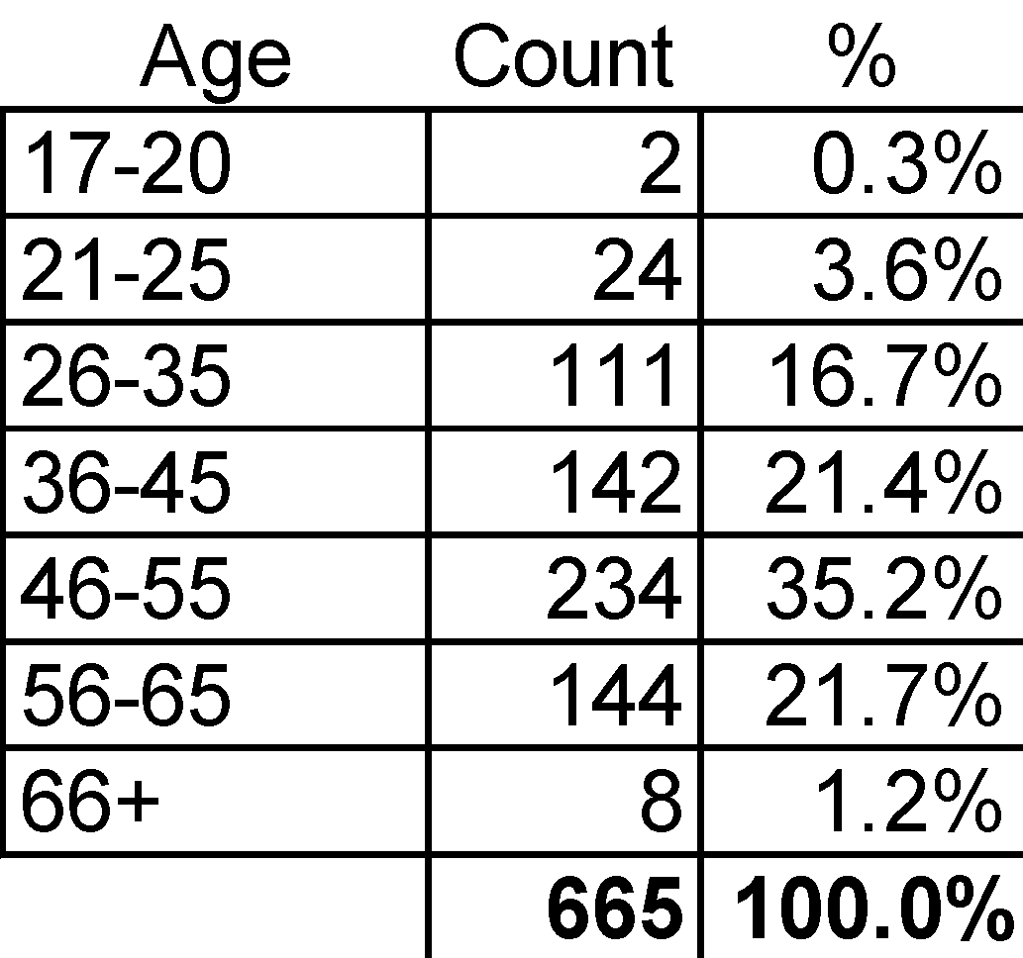

Driving Restrictions
Vehicles are not to be used for personal use. Only employees of the Council may drive fleet vehicles. Drivers can only drive vehicles relevant to their licence categories and/or if the vehicle is fitted with specialist equipment that they have been appropriately trained to use that equipment. Where vehicles are required to enter third party premises such as waste vehicles entering tipping stations then drivers are trained relative to that third parties health & safety procedures.

Non-Employees are not permitted to drive London Borough of Hackney vehicles save for where agreed by the relevant Insurer.

Significant Changes to the Fleet
We now have circa 80 electric vehicles on fleet but we also have 10 motorcycles and a much higher turnover of fuel consumed is renewable biofuel HVO rather than diesel.

Risk Management Initiatives
- Some vehicles are fitted with technology including:
  - External reversing audible warning devices for pedestrians
  - Recording camera systems
  - Telematic systems
  - Speed limiters: some ‘geo-fenced’ to specific areas
- Driver training
- Accident management monitoring
- Internal audits
- Quality accreditations i.e. Fleet Operator Recognition Scheme (FORS)
- Driver licence checks via ‘LicenceCheck’

Fleet and Driver Management Policies, including Licence check procedures
We have an Occupational Road Risk Policy supported by numerous guidance notes that drill down into greater details on particular subject areas (available on request.) All drivers licences are checked four times a year through a DVLA approved third party.

Driver Guidance Following an Incident
New drivers are given an induction by their employing department relative to the type of vehicle they will be driving and the operating environment. We hold an overarching policy covering a very wide range of driving activities which includes specific guidance note on dealing with roadside accidents.

First Notification of Loss
The Council has an excellent record over the last 10 years for prompt reporting timescales allowing Insurers to mitigate against unnecessary liabilities and costs such as credit hire and/or personal injury.

Vehicle Maintenance Procedures
Because we hold two 'Operators Licences' (HGV & PSV) we are obligated to have comprehensive vehicle maintenance procedures in place. Under 'best practice' procedures we cascade these fundamental principles to our light commercial fleet as well. All drivers are expected to do a walk round check of their vehicle every day, sometimes called a 'first use inspection' where more than one driver shares a vehicle. Defects identified are reported to our in-house vehicle maintenance facility for the repairs to be completed. All maintenance, programmed and reactive, is recorded in a software system.

Maximum Value of Any One Vehicle
Our most expensive vehicles are our refuse collection vehicles – replacement value would be circa £250k (purchase value 2020 was £198k)

Vehicle Accumulation
Item | Property to be insured | Declared Value
1 | Motor Vehicle Accumulation at  Millfields Depot, Millfields Road, E5 0AR | £14,500,000
2 | Motor Vehicle Accumulation at  Workshop - 14 Andrews Rd, E8 4QL | £5,000,000
3 | Motor Vehicle Accumulation at  Depot - 40-43 Andrews Rd, E8 4RL | £2,670,000

For security of the main site, please see Security above

Claims Experience
Please see the following appendices for full Claims information:
- Appendix 4.05 - Zurich Motor CCE - Summary
- Appendix 4.07 - Zurich Manual Claims Report - (Redacted)
- Appendix 4.08 - Aviva motor claim data Hackney 2011-2018
  - Please note 4.07 include claims across various Zurich policies including motor and property

Notable Claims
None Declared

LOT 4 – ENGINEERING INSPECTION & INSURANCE
LOT 4 incorporates the following classes of business:

- Engineering Insurance
- Engineering Inspection

Underwriting Information

Plant Schedule
Please see Appendix 3.08 - Plant & Engineering Schedule for a full and itemised list of equipment and plant requiring inspection as at October 2022.

Dedicated Service Contacts
The Council has identified key department contacts for the following service areas;
- Housing
- Education Property (inc Schools)
- General & Commercial Property

This is in addition to the dedicated contacts with the Insurance Services team as contract managers and ensures availability of an appropriate officer should an urgent need arise i.e. Category A defect.

The Council is considering co-opting the Corporate Health & Safety Compliance team during 2023/24 to help support service areas in the monitoring and response to defect reports.

Overdue Inspections
We are working with the existing provider who have assured the Council that they will undertake all of the overdue inspections listed within the schedule.

Claims Experiences
Please see the following appendices for full Claims information:
- Appendix 4.09 - Aviva Engineering Confirmed Claims Experience

Notable Claims
There are no claims recorded under this policy

LOT 5 – GROUP PERSONAL ACCIDENT & TRAVEL INSURANCE
This Lot incorporates the following classes of business:

- Personal Accident
- Business Travel

Underwriting Information
All necessary information is included within Appendix 1.05 - Lot 5 - Personal Accident & Travel Specification - Evaluation Spreadsheet

5 Highest Concentrations of Employees
Details of Address including Postcode | Number of Employees (Headcount)*
Hackney Service Centre, 1 Hillman Street, Hackney E8 1DY | c.2000
Hackney Town Hall, Mare Street, E8 1EA | c.500
TLC Building, 1 Reading Lane, E8 1GQ | c.500
Millfields Depot, Millfields Road, E5 0AR | c.250
Robert House, 6-15 Florfield Road, London, E8 1DT | c.100

* The Council continues to review the use and occupation of its assets and supports a hybrid working policy which reduces the daily concentration of employees in the offices at any time.
Travel Pattern
No scheduled trips declared for the 2023/24 period to-date
The following provides an indication of the proposed pattern
Destination | Number of Trips | Average Duration
Insured Journeys solely within the UK | not declared | not declared
Europe | 7 | 5 days
USA / Canada | 0 | 0
Elsewhere in the World | 2 | 7 days
*Travel pattern (note: 3 people on 1 trip = 3 trips)
Claims Experiences
Please see the following appendices for full Claims information:
- Appendix 4.06 - Zurich FG, Comp & BT CCE - Summary
- Appendix 4.07 - Zurich Manual Claims Report - (Redacted)

Notable Claims
No claims declared

LOT 6 - TERRORISM - First Loss Basis
Cover required
Property Damage and Business Interruption following loss caused by Terrorism or series of acts of Terrorism and/or sabotage.

Property Insured
(i) Property Damage
All real and personal property of the Insured including buildings, contents and works in progress

(ii) Business Interruption
Increase in Cost of Working

Please include day one uplift where relevant

Underwriting Information
Blast Radius Map
A “Blast Radius Map” is available for review as Appendix 2.15 – Top Blast Zones.
*Please note that this is indicative as values were provided as at 2018.
Claims Experiences
Please see the following appendices for full Claims information:
- Appendix 4.14 - Charles Taylor Confirmed Terrorism Claims Experience

Notable Claims
No declared claims

CLAIMS HANDLING REQUIREMENTS - ALL LOTS
Claims Handling requirements are listed within the individual Evaluation Spreadsheets for each Lot. See Appendix 1.01 to Appendix 1.06.

The Council will require the winning bidder/bidders to provide full claims handling for all claims including those falling below the deductibles

APPENDICES

APPENDIX 1 – Compulsory Return Documents

Item / Appendix Reference
Appendix 1.01 - Lot 1 - Property - Material Damage Specification - Evaluation Spreadsheet.xlsx
Appendix 1.02 - Lot 2 - Combined Liability and FG-Crime Specification.xlsx
Appendix 1.03 - Lot 3 - Motor Fleet Specification - Evaluation Spreadsheet.xlsx
Appendix 1.04 - Lot 4 - Engineering Insurance and Inspection Specification.xlsx
Appendix 1.05 - Lot 5 - Personal Accident & Travel Specification - Evaluation Spreadsheet.xlsx
Appendix 1.06 - Lot 6 - Terrorism Specification - Evaluation Spreadsheet.xlsx
Appendix 1.07 – SQ Explanatory Document
Appendix 1.08 - Certificate of Non-Canvassing Standalone
Appendix 1.09 - Certificate of Non-Collusion Standalone

APPENDIX 2 – General / Risk Management Information
Item / Appendix Reference
Appendix 2.01 - Corporate Health & Safety Committee Health and Safety (October update)
Appendix 2.02 - Risk Management Strategy
Appendix 2.03 - Risk Management Policy
Appendix 2.04 - Anti-Fraud & Corruption Policy
Appendix 2.05 - Housing Key Risk Management
Appendix 2.06 - Oct 22 Love Hackney Newsletter
Appendix 2.07 - Housing Asset Management Strategy
Appendix 2.08 - Leaseholders Rules
Appendix 2.09 - Housing Tenancy Guide
Appendix 2.10 - Your Tenancy Conditions
Appendix 2.11 - Health and Safety Guidance for Business Tenants
Appendix 2.12 - Ofsted Focused Visit Report
Appendix 2.13 - Ofsted Focused Visit Report
Appendix 2.14 - 2022 Traded Services Order information for Insurance purposes
Appendix 2.15 - Top Blast Zones
Appendix 2.16 - Sustainable Procurement Strategy

APPENDIX 3 – Risk Schedules
Item / Appendix Reference
Appendix 3.01 - School Insurance Membership Sheet 2022-23
Appendix 3.02 - General Property Schedule October 2022
Appendix 3.03 - Housing Stock Count 2022-23 (Oct) (v2)
Appendix 3.04 - Blocks 18m+ with Sum Insured and Construction Data (v2)
Appendix 3.05 - Education Property Schedule - October 2022
Appendix 3.06 - Commercial Property Schedule (Updated Oct 22 onward)
Appendix 3.07 - Fleet List
Appendix 3.08 - Plant & Engineering Schedule

APPENDIX 4 – Claims Experiences

Item / Appendix Reference
Appendix 4.01 - LBH - In House Handled Claim Report - 27/10/22
Appendix 4.02 - Property - In House Handled (inc Fire) - 27/10/2022
Appendix 4.03 - Zurich Property Commercial CCE - Summary.pdf
Appendix 4.04 - Zurich Property - Housing, Gen & Edu CCE - Summary.pdf
Appendix 4.05 - Zurich Motor CCE - Summary.pdf
Appendix 4.06 - Zurich FG, Comp & BT CCE - Summary.pdf
Appendix 4.07 - Zurich Manual Claims Report - (Redacted).xlsx
Appendix 4.08 - Aviva motor claim data Hackney 2011-2018.xlsx
Appendix 4.09 - Aviva Engineering Confirmed Claims Experience.pdf
Appendix 4.10 - JLT Casualty (below deductible) 1 April 13 to 31 Mar 14 bord.xlsx
Appendix 4.11 - QBE - EL&PL Authenticated Claims Experience Report (30.09.22).pdf
Appendix 4.12 - QBE - OI/PI Claims Experience Summary.pdf
Appendix 4.13 - QBE Med Mal CCE 2022 Summary.pdf
Appendix 4.14 - Charles Taylor Confirmed Terrorism Claims Experience - 03.09.2022.xlsx
Appendix 4.15 - Ecclesiastical - Fine Art - ABI claims experiences as at 06.10.22.pdf
Appendix 4.16 - Travelers Casualty - Run-off Claim Experience Summary 2022.xlsx
Appendix 4.17 - RMP Claims Listing as at 300922

