Barrow Borough Council

Scope for Levelling Up Fund Programme Delivery
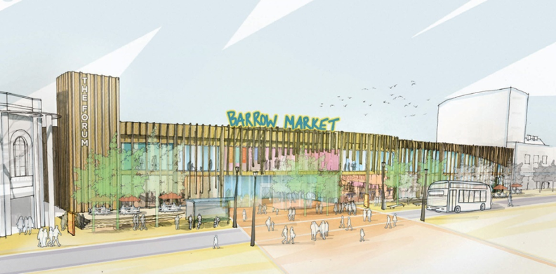
Brief for Consultants

December 2021

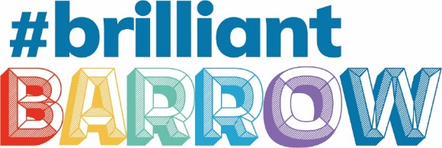
Levelling Up Fund, Barrow Town Centre
OVERVIEW
Barrow Borough Council has secured £16m in funding through the Government’s Levelling Up Fund to support the regeneration of Barrow Town Centre.
The bid for Barrow is focussed around a package of projects aimed at addressing the long term economic strategy for Barrow. These projects are:
- Improving the Market Hall and the frontage and access to the Forum Theatre
- Enhancing access to these cultural assets/attractions and connecting them to the rest of the town through better transport infrastructure and improvements to the public realm.
These projects represent a high impact scheme that will transform the character and attractiveness of the town centre and improve accessibility to this area from all modes of transport providing the catalyst to increase footfall and deliver lasting change.
The proposal responds to the government’s request to deliver impactful projects that regenerate the town centre, provide investment in cultural facilities; the theatre and market hall and upgrade local transport infrastructure in Barrow Town Centre.

Submission Date
Submissions must be returned by 5pm on Friday 21st January 2022. The Authority will then undertake an assessment to select the Consultant whose proposal most appropriately matches the requirements listed in this brief. The Council will look to award the contract 7th February 2022 commencing as soon as possible thereafter.
Key Tasks | Date to be completed by
Invitation to Quote documents published | Friday 16th December 2021
Quotation Submission Deadline | Thursday 27th January 2022 @ 5pm
Evaluation of Quotations including clarification meetings (if required) | 27th to 31st January 2022
Award | 7th February 2022
Commencement | w/c 7th February 2022

Liability and Collateral Warranty
The Council’s liability to the Contractor under the Contract whether in contract, tort (including negligence) or otherwise shall be limited to 125% of the proportion of the Price which is paid and payable at the time that the liability arises (where there is a single price) or to an amount equivalent to 125% of the total amounts paid by the Council in respect of Orders in the preceding twelve month period ending with the day on which the Council accepts liability or is deemed liable by a court competent jurisdiction.
Consultants are required to notify the Authority of sub-consultants at tender submission stage. The Authority may require the consultant to provide collateral warranties to the Authority for any sub- consultants within its Projects delivery team.
Tender Award
We aim to inform the successful consultant of our intent to award by 7th February 2022 and make the award as soon as possible thereafter.
REQUIREMENTS
Commission Outline
Barrow Borough Council are seeking a fixed fee tender submission from a suitably qualified consultancy/practice to deliver an ambitious capital works programme funded by the Levelling Up Fund. Due to the nature and scale of the work a multidisciplinary team by be appropriate and the successful tender will demonstrate previous experience of programme delivery of this scale.
The Levelling Up Fund Programme for Barrow Town Centre will deliver transformational change and will be high profile for the Borough Council and the wider town. The programme alongside the Brilliant Barrow Town Deal will be instrumental in delivering the Councils vision and objectives.
The consultant shall set out in their proposal a costed and timetabled Plan to deliver the programme of works for each of the elements within the Levelling Up Fund Delivery Plan in order to meet the ambitious milestones agreed with government to deliver on time and within budget.

The successful applicant will engage with the Councils Regeneration & Policy and Programme Management Teams to ensure the programme is embedded within the Councils wider regeneration programme.

The LUF Programme is comprised of two work packages; the Market Hall and Accessibility & Transport Improvements. The Borough Council is the accountable body for the overall programme however the Transport & Accessibility work package will be delivered in partnership with Cumbria County Council.

The funding programme will run from January 2022 to March 2025.

Reporting
Contract management will be provided by Barrow Borough Council.
The commission will start with an inception meeting the week commencing 7th February 2022.
The contract will be managed by the Director of People & Place in conjunction with the Development Services Manager (Policy Regeneration & Information) at Barrow Borough Council. Figure 1 below sets out the relationships within LUF Project Team.
Regular meetings will be held between the consultant and the Council at a frequency to support the agreed programme and deliverables.

Figure 1: LUF Project Team
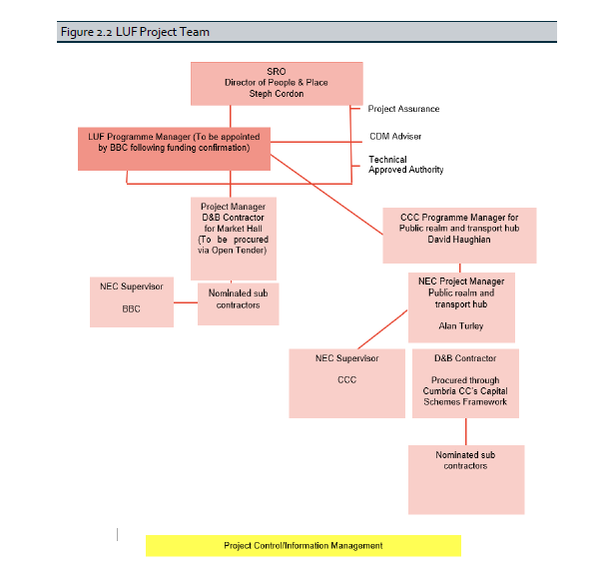

Objectives
The objectives of the commission can be summarised as follows:
1. To deliver a transformational programme, comprising two discreet but interdependent projects as outlined in the LUF Delivery Plan.
2. To provide programme management of the wider LUF Programme and specifically the Market Hall work package, and to work with Cumbria County Council to deliver the Accessibility work package;
3. To ensure the Programme meets all milestones as set out in the Delivery Plan.
4. To liaise with Council staff and report back to the Council at regular agreed intervals on progress, risks, dependencies and spend profile.
Projects
Appendix 1 shows the location within the town centre of the high-level projects associated with the LUF programme.
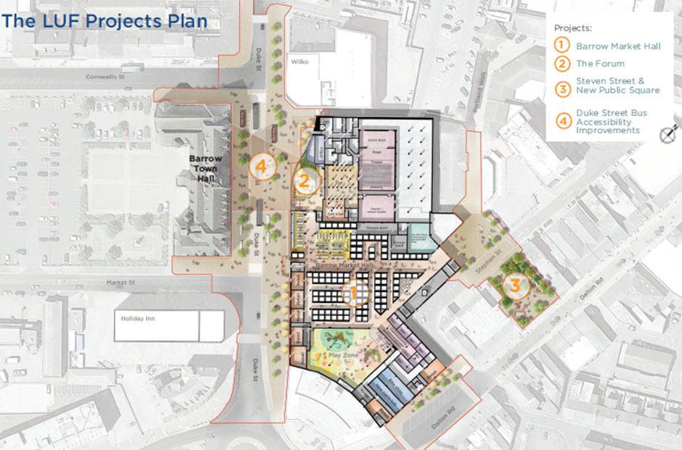
The programme includes two work packages:
- Revitalised Market Hall – modernising and diversifying the Market Hall to provide a major attraction and inject vitality into the heart of the town centre. This will attract and support stallholders to thrive, create a supportive environment to incubate business start-ups/entrepreneurship, establish a food hall to offer more food and drink experiences and local produce, provide family friendly leisure including a soft play area, and create a high-quality modern shop window to our high street. The project will facilitate sustainable travel through incorporating a cycle hub. The proximity of the project to the listed Town Hall and Heritage Action Zone will enhance Barrow’s heritage offer. The project will integrate the Market Hall with the adjacent Forum Theatre and planned Town Centre Community Hub, creating an exciting destination of culture, leisure and retail attracting shoppers and families, providing an alternative experience for visitors to the Lake District and creating an environment that will attract people to live and work in Barrow, supporting the high street and our nationally significant industries.

- Accessibility Improvements & Public Realm – connecting people to the civic, cultural and leisure quarter and our high street through a package of improvements to create a high-quality arrival point and the creation of quality links into the heart of the retail area. The project will demolish vacant buildings to create enhanced links between the Market Hall and the high street and create a new gateway to the town centre through investment in sustainable travel infrastructure including new bus stops, enhanced pedestrian connectivity, wayfinding and public realm improvements.

Project Plan
Appendix 2 outlines the proposed timeframe and milestones for each of the projects within the programme, based on the submitted LUF Delivery Plan and updated Project Management Spreadsheet November 2021. It is acknowledged that these may be amended on commencement of the programme.
Each work package will be required to develop its own PID and Project Plan at the outset to confirm the milestones set out in the LUF Delivery Plan and updated Project Management Update November 2021.
Due to the tight timescales involved from inception to beginning delivery it is imperative that the successful tender demonstrates that the team is ready to mobilise at speed in order to meet the ambitious targets agreed with Government.
Resource Requirements
Access to appropriate resources from the Council such a systems, asset details, finance, budget and other relevant information with be agreed at inception.
Risk Management & Dependencies
High Level Risk Assessments were produced as part of the funding submission these should be regularly updated throughout the delivery of the programme and reported to the Council to enable both internal and external reporting and monitoring and evaluation.
Governance
The successful tender must name a Programme Lead who will be expected to maintain regular contact with the lead officer at the Council and provide regular reports to the relevant agreed boards and committees as required.
Due to time constraints for beginning delivery of the LUF Programme this tender process is running in parallel with direct recruitment for a dedicated Programme Manager. Should this recruitment be successful the Council will withdraw this tender opportunity.

CONSULTANTS SUBMISSION
The following information is required from consultants:
A. Quality - Experience (40%)
Details of the skills and experience of the consultant including:
- Evidence of knowledge and experience delivering similar programme in terms of value and scale;
- A CV for each individual, containing a synopsis of their skills and experience relevant to this project, examples of similar projects worked on by each team member (maximum three sides A4);
- A maximum of two concise ‘project summary sheets’ describing projects of a similar nature which the consultant has delivered successfully within the last three years.
B. Quality – Methodology and Approach (10%)
- Please give details of your approach and the methodology you will undertake to deliver the commission. Please include key milestones and details of how you will keep the Council and other delivery partners informed and updated during the period of the contract.
C. Social Value – (10%)
What outcomes does your organisation produce to meet the Council’s objectives of Social Value?
Please provide details and evidence against any of the following objectives:
- Promote employment and economic sustainability – tackle unemployment and facilitate the development of skills
- Raise the living standards of local residents – working towards foundation living wage, maximise employee access to entitlements such as childcare and encourage suppliers to source labour from within Barrow-in-Furness
- Promote participation and citizen engagement - encourage resident participation and promote active citizenship
- Build the capacity and sustainability of the voluntary and community sector– practical support for local voluntary and community groups
- Promote equity and fairness – target effort towards those in the greatest need or facing the greatest disadvantage and tackle deprivation across the borough
- Promote environmental sustainability – reduce wastage, limit energy consumption and procure materials from sustainable sources

D. Price (40%)
The consultants are to provide a fixed lump sum cost. The consultant is to provide proposed hourly rates which may apply should any additional works be instructed.
All costs such as travel and expenses should be included in the rates as part of the fee proposal. No additional costs will be paid other than those agreed with the Council.
The fee for delivery of the project is to be inclusive of disbursements.

PAYMENT OF FEES
It is proposed that fees will be paid on a monthly basis in accordance with a fee schedule to be agreed and on receipt of detail of works completed and subsequent invoice.

EVALUATION OF SUBMISSION
The Authority will undertake to select the tenderer whose submission most appropriately matches the requirements listed in this brief, in terms of price, experience, and confirmation of delivery.
The Council reserves the right to cancel the tender process at any point. The Council is not liable for any costs resulting from any cancellation of this tender process nor for any other costs incurred by those tendering for this contract.
Following the award of the contract Barrow Borough Council reserves the right to terminate the contract at any point.
DEADLINE
Submissions should be returned to by 5pm on Friday 21st January 2022.

