Homes England Multidisciplinary Framework
Further Competition Invitation to Tender (Stage 3 Over FTS Threshold)

Environment Agency National Borehole Decommissioning Project
Issue Date: 21/10/2021
ProContract Identification Number: DN569146

Table of Contents

Introduction 4
Part 1 – Commission Requirements
- Commission Background 5
- Objectives 5
- The Services 5
- Key Deliverables 5
- Site Information 6
- Indicative Programme 6
- Management 6
- Key Staff 7
- Risks 7
- Payment 7
- Budget 8
- Collateral Warranty 8
- Limitation of Liability 8
- Termination 9
- Conflict of Interest 9
- Confidentiality 9
- Health and Safety 10
Part 2 – Instructions for Submitting a Response
- General 11
- Quality 12
- Pricing 12
- Evaluation 13
- Documents to be Returned 14
- Evaluation Criteria 15
- Worked Example 18
Part 3 – Response Form
3.1 Response Form 21
3.2 Resource and Pricing Schedule 23

Introduction
The purpose of this Further Competition Invitation to Tender (ITT) is to award the call-off contract for the above commission.
We ask you to respond to the questions detailed in Part 2, Section 6 (Evaluation Criteria) using the Response Form and to return the Response Form and Resource and Pricing Schedule in Part 3 with your tender.
This Further Competition ITT is divided into 3 parts:
Part 1 – Commission Requirement
- Details the commission requirements.
- Details additional terms and conditions for the Further Competition. The successful Supplier will be subject to both the terms and conditions of this Further Competition and the Framework Contract. Unless otherwise defined in these instructions, terms used shall have the meaning given to them in the Framework Contract.
Part 2 – Instructions for Submitting a Response
- Contains important information and instructions on preparing and submitting a tender response. Please read these instructions carefully prior to submitting your tender response.
- Outlines the evaluation criteria which will be used for assessment. It is important that Suppliers familiarise themselves with the criteria and ensure they are considered when compiling their tender response.
Part 3 – Standard Forms
- Contains the standard forms required to be completed and returned by the Supplier when submitting a tender response.

Part 1 - Commission Requirements
- Commission Background

Executive Summary
The Environment Agency (EA) Groundwater Area Implementation Group (GWAIG) have adopted a strategic approach to borehole decommissioning by initiating the National Borehole Decommissioning Project (NBDP). The NBDP currently requires external technical support over the next five-years to survey redundant boreholes and urgently remediate or decommission any high-risk boreholes that are located across the country.

Background
The EA GW Level Monitoring Network (GWLMN) comprises of approximately 5,000 active boreholes of our own and other private boreholes. The GWLMN has evolved over a long period of time from regional groundwater level monitoring networks that were first established by the water authorities. This network of GWLMN boreholes and wells is now used by the Environment Agency (EA) to assess the condition of water resources, support drought management decisions, assist in flood forecasting, evaluate WFD compliance, etc.

The EA GW Teams constantly review the validity of the GWLMN and if a borehole is judged as being redundant it is now transferred across to the NBDP. To date, 2,496 redundant boreholes have been identified on a Master Information Request Spreadsheet (MIRS) as assets for further investigation.

The aim of this commission is to provide technical support to identify and survey a catalogue of redundant boreholes that has been compiled during a comprehensive desk-based survey. Currently, 421 redundant boreholes have been surveyed, leaving an outstanding number of 2,075 redundant boreholes to be surveyed. This commission builds on previous work performed since 2017.

The ambition is to survey all of the outstanding boreholes within the next five-year contract period. The winning bidder is required to confirm that they will be able to deliver this ambitious programme of work. The actual volume and value of work which will be commissioned over the next five years, will be dependent on budget allocation to the project from the Environment Agency on a yearly basis and bidders should be aware of this funding restriction when submitting their proposal. The full list of outstanding sites including their geographical location will be made available to the winning bidder. We are unable to publish the full list at this point, as it contains personal information, which requires redaction. If you need further information to support your proposal, please contact the Environment Agency via ProContract with your request.

- Objectives
The project objectives are to:
- Continue performing field-based surveys following the current risk-based approach to locate redundant boreholes listed on the MIRS and to gather the required on-site information to populate the field-based survey reports, PSRA documentation and the MIRS,

- Carry out remediation work on redundant boreholes when required to ensure they are safe to members of the public and do not create any environmental problems,

- Temporarily make safe and then urgently decommission (within two months of the survey) any high-risk boreholes that are located as part of the field surveys to ensure they are safe to members of the public and do not create any environmental problems.

Project drivers
The NBDP has many project drivers:
- Performing checks on existing redundant boreholes,
- Identifying redundant boreholes located within Source Protection Zones as these present a greater risk to public water supplies,
- Reducing the risk of open or unsealed boreholes to act as pollution pathways to aquifers,
- Eliminating the risk of mixing groundwaters of variable quality from different aquifers,
- Ensuring that the unnecessary loss of groundwater from our aquifers is prevented, by stopping the flow from uncapped boreholes,
- Adhering to Public Safety Risk Assessment (PSRA) duties which mitigates H&S risks to members of the general public and wildlife,
- Implementing a resource and cost-effective method of delivering this project whilst taking into account the ongoing work pressures of the 14 Area Groundwater teams,
- Reconciliation of the EA Fixed Asset Register.

- The Services

3.1 The Project Scope of work

The scope of work is to continue populating the MIRS using field data collected via field surveys and to urgently remediate and/or decommission any high-risk boreholes that are located. A redacted version of the MIRS has been supplied to you (minus asset names, landowner names and contact details) for tendering purposes and has been partially populated by a desk-based survey. The outputs of the desk-based survey have helped provide information to support the field-based surveys like NGR checks, level of risk presented by the redundant boreholes, landowner contact details, etc. The aim of the field-based work is to continue populating the MIRS once the redundant borehole has been surveyed on the ground. Careful and accurate record keeping to the MIRS is very important for this project as it is the basis of future work, funding and an amount of effort.

The successful bidder is expected to continue this survey work across the country and to urgently make safe, remediate and/or decommission any high-risk boreholes that are located to a prompt timescale. An internal project group is already set-up and a list of EA GW Representatives and direct contact details will be provided to the successful bidder. Examples of project outputs including field survey reports, PSRA reports and the redacted MIRS have been supplied with the tender documents to help you understand what work has been performed previously (Section 5).

Please find below additional information relating to the three main categories of project work under this commission:

- Field-based surveys (assume 100% of the work):
For every borehole to be surveyed, the tasks below will need to be performed and documentation sent across to the EA PM two weeks beforehand. The field-surveyors will also need to carry a copy of the documentation during the field-surveys:
- EA and supplier access letter;
- Confirmation that land access has been granted by the landowner and a Privacy Notice being posted or e-mailed,
- Confirmation that the sites are not within the vicinity of a Hostile Site as recorded on the EA Hostile Sites Database,
- Site Specific RAMS;
- Dynamic Risk Assessment form;
- Weils disease information card;
- A copy of suppliers Employers & Public Liability insurance,
- Staff identification cards,
- Any other Operational Instructions that your company has for this type of survey work.

To date, we have been using GIS Survey (123) and we shall continue using this survey app for consistency. The Agency will provide the winning bidder access to the App at contract award stage.

The field-surveys should be performed by two people for H&S reasons. One of the two surveyors should have a background in hydrogeology and must be able to properly assess the risks presented by redundant boreholes. The maximum amount of search time allowed for each field-survey is 45-minutes. The field-surveys have adopted a risk-based approach with wide-diameter boreholes (>200mm) being the main focus of the field-based surveys to date.

- Borehole remediation work (assume approximately 25% of the 2075 sites may require remediation work):
Some boreholes identified through the Public Safety Risk Assessment (PSRA) scheme will need to be made safe and we require the supplier to consider how best to achieve this as part of the field-survey work. We envisage this type of remediation work to be the spraying and sealing of standpipes, removing cabinets and the securing of loose borehole covers. You will need to gain all of the permissions and organise all of the paperwork, H&S and CDM Procedures that will be required for this type of work. Where a borehole is located on privately owned land, the Environment Agency will provide guidance on how to proceed.

- For borehole decommissioning work (assume approximately 5% of 2075 sites may require decommissioning):
High risk boreholes identified through the Public Safety Risk Assessment (PSRA) scheme will need to be urgently made temporarily safe and then decommissioned (within two months of the survey) to ensure they are safe to the public and don’t create any environmental problems. You will need to gain all of the permissions and organise all of the paperwork, H&S and CDM Procedures that will be required to perform this type of work. Where a borehole is located on privately owned land, the Environment Agency will provide guidance on how to proceed.

3.2 Requested information to include in your tender response
We require a project proposal including a methodology, programme of works linked across to the Resource and Pricing Schedule, which should include costs for each stage, tasks and day rates for work performed on this project.

Please confirm the number of surveys that you will be able to complete on a yearly basis.

Please Include a Gantt chart showing payment milestones at the end of each stage, dates of each deliverable, project partner review periods (minimum of 10-working days), etc. We would also like to see an organogram, 1-page CVs of all the proposed project staff and office locations/depots of where they are based.

You should include within your tender response the environmental efficiencies you can demonstrate while performing this work, including efficient travel routes to maximise survey points with minimum travel. Please describe any new and novel ideas that you, as a supplier, can offer this project.

3.3 Requested costings to include in your tender response (Tab 4 of the Resource and Pricing Schedule)

As we don’t yet know what the surveys will produce over the next five-years, we are requesting tender costs on a number of survey, remediation and decommissioning scenarios. These scenarios will produce an average price to complete remediation and decommissioning work and this average price will be multiplied by the estimated % of work outlined previously. This will allow the Agency to evaluate costs consistently between bidders.

The following section has been sub-dived into the three main categories of work and a price for each should be inserted into Tab 4 of the Resource and Pricing Schedule:

- Costings of the field-based surveys (100% of the work):
Include a breakdown of all the stages and related project costs for field-based surveys and include an average price per borehole survey and a total price for all 233 boreholes listed in Appendix 3. Assume the full search time of 45-minutes is used at each redundant borehole and that the redundant borehole is located towards the end of the survey. Please use corrected NGRs that are listed within the MIRS.

Costs should take into account all aspects of the field-based surveys including project management, the background preparation work and documentation (please see Section 5) including H&S regulations and documentation, landowner permissions, equipment, travel and all the required output that needs to be produced once the survey has been performed including reporting, MIRS updates, PSRA documents, field-survey reports, etc.

Cost A is calculated as: The total cost to survey the 233 boreholes listed in Appendix 3.

- Costings of the borehole remediation work (assume approximately 25% of the 2075 sites may require remediation work, which equates to 518 sites):
For the costings of the borehole remediation work, please include an average price for borehole remediation at 518 sites.

This will be calculated using the average cost across each borehole remediation technique across the 14 borehole locations highlighted in yellow in Appendix 3 (CLA 39, DCS 50, EAN 37, EMD 67, GMC 21, HNL 2, KSL 27, CAN 48, NEA 20, SSD 36, THM 46, WMD 11, WSX 20 & YOR 42)

Cost B is calculated as: The total average borehole remediation cost across each technique for 14 sites x 518 sites.

Your costs will need to include all background planning, materials, travel time, remediation work, H&S regulations and documentation, CDM Procedures that will be required to perform this type of work. Asbestos may be located within the cabinet structures and this would need to be evaluated prior to any work starting. If asbestos is identified, this will need to be notified to the Agency in your report. Please exclude this cost from the main survey and include an e/o cost for an asbestos survey and sampling, which can be used, should it be required. Please use the corrected NGRs listed in the MIRS and assume that these sites are accessible to within 25m by off-road vehicles.

- Spraying and sealing of concealed standpipes for better visibility -
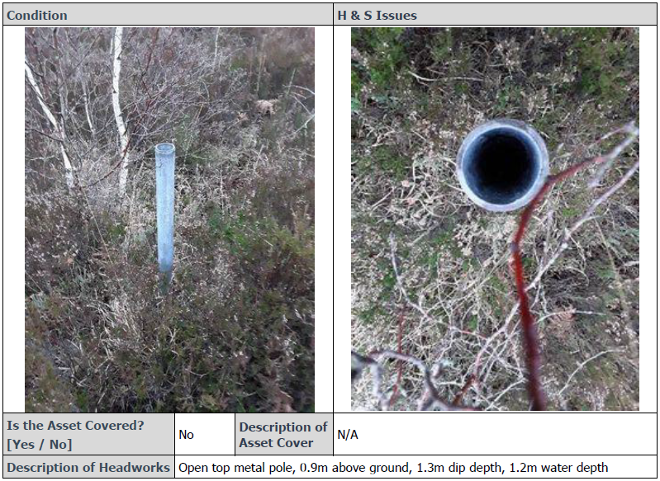

- Removing cabinets –

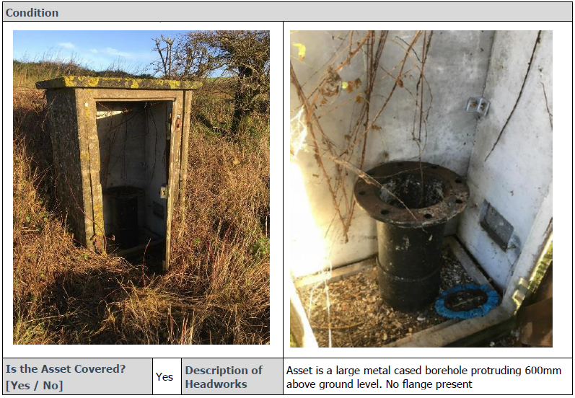

- Replacing borehole covers -
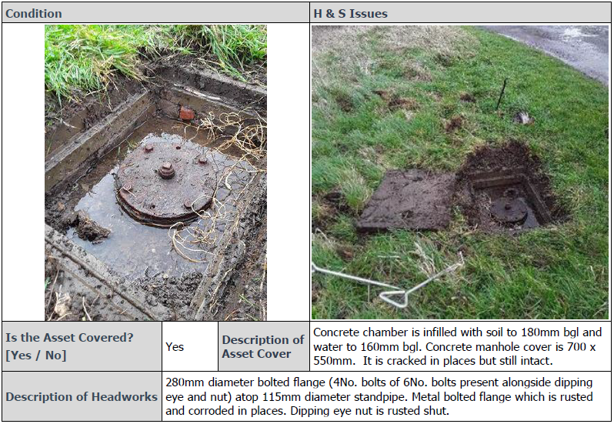

Once the go-ahead has been provided by the EA for remediation works to proceed, we would expect the supplier to manage the remediation works and report back to the EA once work has been completed with a 10-page completion report. Contents/template of the completion report to be confirmed during the early stages of the project.

- Costings of the borehole decommissioning work (assume approximately 5% of 2075 sites may require decommissioning, which equates to 103 decommissioning sites):
For the costings of the borehole decommissioning work, please include an average price for decommissioning one borehole. This will be calculated as an average price across all 14 boreholes highlighted in yellow in Appendix 3. Appendix 4 includes headwork schematics and a drilling log of the borehole to be decommissioned. Please assume the same borehole construction for all 14 borehole locations highlighted in yellow in Appendix 3.

Cost C is calculated as: the average cost for decommissioning one borehole x 103 sites.

Your costs should include all background planning, materials, travel time, remediation work, H&S regulations and documentation, CDM Procedures that will be required to perform this type of work. Please use the corrected NGRs listed in the MIRS and assume that these sites are accessible by vehicles.

Once the go-ahead has been provided by the EA for borehole decommissioning works to proceed, we would expect the supplier to manage the remediation works and report back to the EA once work has been completed with a 10-page completion report. Contents/template of the completion report to be confirmed during the early stages of the project.

The commercial evaluation will use the following formula to calculate your total bid price:

Cost A + Cost B + Cost C = Bid price

Cost A, B and C should include all requirements listed in the Specification and required to deliver the contract.

The lowest bid price will be awarded the maximum points available for the commercial section (40).

The contract will be formed based on the number of surveys which the bidder confirms they are able to complete in the maximum contract period (5 years), using the average price per survey + the costed assumptions for remediation and decommissioning work (cost B & C). This is to allow the Agency the potential to complete the maximum amount of survey work within the five-year period, should the internal EA funding be available.

- Key Deliverables
The suggested main tasks listed in the table below is not an exhaustive list. Please include within your methodology and costings any other tasks that you feel would be beneficial to the successful delivery of this project. A potential breakdown of suggested main tasks and deliverables are as follows:
Suggested Main Tasks | Introductory meeting / teleconference with the EA Project Group and then regular monthly teleconferences (assumed to be 2-hours and organised by the supplier) with the supplier project group to feedback progress and any issues encountered. What constitutes a high-risk site should be discussed at the introductory meeting. Monthly meetings should also include discussion on any sites requiring remediation work.  For high-risk sites - urgent teleconferences will need to be organised (by the supplier) to discuss the temporary remediation and urgent decommissioning work required.
Deliverables | - A start-up meeting / teleconference, organised by the supplier, to discuss the methodology,  - All the required documentation listed in Section 3.1 to be sent to the EA PM prior to the surveys commencing,  - Regular monthly 2-hour progress teleconferences organised by the supplier,  - Urgent meetings organised by the supplier to discuss any high-risk boreholes located,  - Annual draft reports (approximately 100 pages) circulated for review including the methodology used, comments and future recommendations, progress of populating the Information Request Spreadsheets, all field-based survey reports, etc.,  - Quarterly batches of PSRA documents to be sent across in draft format and then finalised after internal EA review for upload onto EA systems,  - Final draft report of all findings and work delivered at the end of the five-year period,  - Circulation of draft meeting minutes for comment and then finalised to be included as an appendix in the final reporting,  - A close out meeting held at the end of the contract, organised by the supplier, to discuss through the task to date and any recommendations for future work,  - Delivery of all information including field-survey reports and photographs, updated master Information Request Spreadsheets (and a master sheet sub-divided into the 14 EA GW Areas) and associated GIS mapping output outlining the current locations of EA redundant boreholes that have been identified to date,  - Circulation of the final report including any meeting minutes as an appendix before the end of the contract.

- Supporting Information

Documents Supplied
The following documents have been supplied to you to support your tender response:
- An example of a PSRA forms from a previous round of work (Appendix 1),
- An example of a field-survey report (Appendix 2).
- The most up-to-date version of the field-survey report (Appendix 3) redacted from 2,496 to 235 redundant boreholes with EA, asset names, landowner and neighbour contact details removed,
- Borehole construction details to support pricing (Appendix 4).
- NBDP – MIRS – Final 27.07.20 – redacted for tender (Appendix 5).
- The redacted Defra Borehole Decommissioning Desktop Study is available on request.

These documents are only to be used to support your tender submission and must not be forwarded on beyond your tender group.

- Indicative Programme
Suppliers should note the indicative programme dates when preparing their Programme information in the Response Form.
Key Delivery Milestones | Anticipated Date
Commencement Date | 06/12/2021
The sequencing of the survey work will be determined by the Contractor, to ensure they can offer the Agency maximum value and minimise negative environmental impacts associated with the work. | To be established through the tender period and agreed with the winning bidder.
Completion Date (Initial Contract Period) | 06/12/2024
Maximum Contract End Date (including two 12-month extensions) | 06/12/2026

- Management
The Environment Agency Project Officer will manage the Supplier day to day and is responsible for providing any further instructions to the supplier.
The Environment Agency (EA) Groundwater Area Implementation Group (GWAIG) is a group of Borehole Network Managers and the Contractor will be required to communicate with them directly for boreholes within their area.
Meeting Requirements:
An introductory meeting / teleconference with the EA Project Group is required.
Beyond this, regular monthly teleconferences (assumed to be 2-hours and organised by the supplier) will be required with the supplier project group, to feedback progress and any issues encountered. Monthly meetings should also include discussion on any sites requiring remediation work.
What constitutes a high-risk site will be discussed and agreed at the introductory meeting. For high-risk sites - urgent teleconferences will need to be organised (by the supplier) to discuss the temporary remediation and urgent decommissioning work required.
The Supplier’s reporting requirements are outlined in the deliverables section above.

Poor Performance
Regular communication will be maintained between the Supplier and the Agency so any drop in performance can be quickly highlighted, managed, and rectified as early as possible, to ensure the project is not negatively impacted.

- Key staff
All staff required to complete this commission, must be outlined in the Resource and Pricing Schedule, including their role and responsibilities under each task. This should include any potential subcontractors involved in delivering the contract.

- Payment
Monthly invoicing will be accepted for this project, based on the number of surveys completed and the remediation/ decommissioning work completed at each site. Management and reporting costs should be built into these monthly invoices to allow for an even distribution of cost, relative to the work completed.
A Gantt chart showing proposed payment milestones should be included in your proposal. This will be confirmed and agreed with the winning bidder, prior to contract award.

Other Requirements
- Limitation of Liability
Consultant liability levels in relation to this instruction shall be as set out in the Framework Contract unless different requirements are specified below:
The Consultant’s total liability to the Public Sector Body for all matters arising under or in connection with this instruction, other than the unlimited matters referred to in clause 36 of the Framework Contract, is limited to £1 million in the aggregate, save in respect of claims relating to contamination, pollution, date recognition and asbestos, which with respect to Professional Indemnity shall be limited to £5 million in aggregate

- Termination
Please refer to the termination provisions in the Framework Contract.

- Conflict of Interest
Environment Agency will exclude the Supplier if there is a conflict of interest which cannot be effectively remedied. The concept of a conflict of interest includes any situation where relevant staff members have, directly or indirectly, a financial, economic or other personal interest which might be perceived to compromise their impartiality and independence in the context of the procurement procedure.
Where there is any indication that a conflict of interest exists or may arise then it is the responsibility of the Supplier to inform Environment Agency, detailing the conflict in a separate Appendix.

- Confidentiality
This Further Competition ITT and associated information is confidential and shall not be disclosed to any third party without the prior written consent of Environment Agency. Copyright in this Further Competition ITT is vested in Environment Agency and may not be reproduced, copied or stored on any medium without Environment Agency prior written consent.
Suppliers shall not undertake, cause or permit to be undertaken at any time any publicity in respect of this Further Competition process in any media without the prior written consent of Environment Agency.

- Contract Break Clause
The Homes England Multidisciplinary Framework Terms and Conditions will apply to this commission.

The contract is expected to commence in December 2021 and end in March 2026. The Agency will award the contract for the initial 36 month period with the option to extend for an additional two twelve month periods. Each extension period will be awarded based on the supplier’s performance in the previous contract period and the Environment Agency’s ongoing requirements.

A break clause will be included in the contract to allow the Agency to terminate after each financial period (at the end of March) should further EA project funding not become available.

- Health and Safety
The successful supplier must be able to demonstrate they have appropriate Health & Safety, Risk Assessment & Public Safety Risk Assessment qualifications and accreditations to meet all the project requirements outlined in the scope of works.

Part 2 - Instructions for Submitting a Response
- General
1.1 The Further Competition deadline is 10:00 on 11/11/2021 and tender responses must be submitted on ProContract. Please regularly check ProContract for any amendments to the Further Competition deadline. For all ProContract portal issues please contact ProContractSuppliers@proactis.com.
  - Suppliers must ensure that suitable provision is made to ensure that the submission is made on time. Any tender responses received after the Further Competition deadline shall not be opened or considered unless Environment Agency, exercising its absolute discretion, considers it reasonable to do so. Environment Agency may, however, at its own absolute discretion extend the Further Competition deadline and shall notify all Suppliers of any change via ProContract.

  - Please note all communications during the tender period will be via the ProContract website. All Suppliers that have registered their interest for the Procurement will receive a direct email notification from ProContract on any updates via the Suppliers registered email address. No approach of any kind should be made to any other person within, or associated with, Environment Agency. It is the Suppliers responsibility to check the ProContract website for any updates to the Procurement process. No claim on the grounds of lack of knowledge of the above-mentioned item will be entertained.

  - The Supplier should check the Further Competition ITT for obvious errors and missing information. Should any such errors or omissions be discovered the Supplier must send a message via the messaging function on ProContract. No alteration may be made to any of the documents attached thereto without the written authorisation of Environment Agency. If any alterations are made, or if these instructions are not fully complied with, the tender response may be rejected.

  - All clarification requests must be sent using ProContract no later than 5 working days before the Further Competition deadline shown on ProContract. Any queries submitted after this may not be answered. Environment Agency will respond to clarifications as soon as practicable.

  - Suppliers should specify in their clarification questions if they wish the clarification to be considered as confidential between themselves and Environment Agency. Environment Agency will consider any such request and will either respond on a confidential basis or give the Supplier the right to withdraw the clarification question. If the Supplier does not elect to withdraw the question and Environment Agency considers any clarification question to be of material significance, both the question and the answer will be communicated, in a suitably anonymous form, to all prospective Suppliers who have responded. If Suppliers consider that page limits set out in Section 6 (Evaluation Criteria) are insufficient to provide the information required by the question then a clarification request should be raised. No guarantee can be given that the page limit will be increased.

  - Tender responses must not be accompanied by statements that could be construed as rendering the tender response equivocal and/or placing it on a different footing from other Suppliers. Only tender responses submitted without qualification strictly in accordance with the Further Competition ITT (or subsequently amended by Environment Agency will be accepted for consideration. Environment Agency decision on whether or not a tender response is acceptable will be final.

  - Tender responses must be written in English.

  - Under no circumstances shall Environment Agency incur any liability in respect of this Further Competition or any supporting documentation. Environment Agency will not reimburse the costs incurred by Suppliers in connection with the preparation and submission of their tender response to this Further Competition.

  - Environment Agency reserves the right to cancel this Further Competition process at any time.

Quality
  - A Response Form template has been provided in Part 2 to respond to the Quality questions detailed in Section 6 (Evaluation Criteria). The Response Form must be completed and returned as part of the tender response.

  - Suppliers must provide information on proposed staff in the Response Form and Resource and Pricing Schedule provided in Part 3. If the Supplier is a consortium or intends to sub-contract the Services, in whole or in part, then it should specify precisely in the Resource and Pricing Schedule which economic operator shall perform the Services (or parts thereof).

Pricing
  - A Resource and Pricing schedule has been provided with this Further Competition ITT which must be completed and returned as part of the tender response.
  - The pricing approach for this Further Competition is:
Lump sum, fixed rates (based on the information provided in/ with this document)
  - The extent of the remediation and decommissioning work will be subject to the findings of each survey

3.4 The list of activities in the Resource and Pricing Schedule is not exhaustive and there may be additional duties/services required that will emerge as work is undertaken. This commission may be extended on client instruction to cover such matters as arise, based on a time charged fee schedule completed in the tender response. The commission will only be extended if the services relate to the original objective of the overall call off contract.

  - Suppliers are reminded that day rates for all individuals must be the agreed Framework Contract rates unless discounted rates are offered and will be used for all of the services.

  - Suppliers should outline any assumptions made, in their Resource and Pricing Schedule.

- Evaluation
  - Tender responses will be evaluated on the basis of the overall most economically advantageous Tender (MEAT) submitted to Environment Agency. The evaluation criteria (and relative weightings) that Environment Agency will use to determine the most economically advantageous Tender are set out in Section 6 (Evaluation Criteria) below and the scoring approach is detailed in Section 6 (Worked Example). Scores will be rounded to two decimal places.

  - Evaluators will initially work independently. Once they have completed their independent evaluation they will meet to discuss, understand and moderate any differences they have via a consensus meeting, where a single consensus score for each question will be agreed.

  - Award decisions will be subject to the standstill period if over the EU Services threshold. Unsuccessful Framework Suppliers will be provided with their scores and feedback to explain the award decision

- Documents to be Returned
Suppliers are expected to provide the following information in response to this Further Competition ITT:
- Completed Response Form
- Completed Resource and Pricing Schedule
- Supporting CV’s for staff proposed to undertake this commission (no more than 1 page each)

EVALUATION CRITERIA

Quality will account for 60% of the Overall Score. The following scoring methodology will apply:
5 – Excellent Satisfies the requirement and demonstrates exceptional understanding and evidence in their ability/proposed methodology to deliver a solution for the required supplies/services. Response identifies factors that will offer potential added value, with evidence to support the response.
4 – Good Satisfies the requirement with minor additional benefits. Above average demonstration by the Supplier of the understanding and evidence in their ability/proposed methodology to deliver a solution for the required supplies/services. Response identifies factors that will offer potential added value, with evidence to support the response.
3 – Acceptable Satisfies the requirement. Demonstration by the Supplier of the understanding and evidence in their ability/proposed methodology to deliver a solution for the required supplies/services.
2 - Minor Reservations Some minor reservations of the Supplier’s understanding and proposed methodology, with limited evidence to support the response.
1 – Major Reservations/Non-compliant Major reservations of the Supplier’s understanding and proposed methodology, with little or no evidence to support the response.
0 - Unacceptable/Non-compliant Does not meet the requirement. Does not comply and/or insufficient information provided to demonstrate that the Supplier has the understanding or suitable methodology, with little or no evidence to support the response.
PLEASE NOTE:
If your response scores 0 or 1 for any one question your overall submission will be deemed as a fail.
Any text beyond the specified page limits below will be ignored and will not be evaluated.
Environment Agency will not cross-reference to other answers when assessing quality responses.
Evaluators will initially work independently. Once they have completed their independent evaluation they will meet to discuss, understand and moderate any differences they have via a consensus meeting, where a single consensus score for each question will be agreed.

Number | Criteria | Demonstrated by | Weighting
1 | Technical Merit of Proposal  PAGE LIMIT: Maximum 6 A4 pages, 11-point Corbel font | - Describe your methodology for each outcome so the project will be successfully delivered before the 23rd March 2026. Please also include a brief description of your proposed tasks.  - Confirm the annual number of surveys you will be able to deliver under this contract.  - Detail what EA and third party data will be required to support your methodology. What is the associated cost of any third party data? How will you manage this risk if the data is not available? Can you please identify any associated licensing issues?  - Please identify how your methodology and project outputs support the project objectives listed in the Project Specification.  - Can you please demonstrate how you will ensure value for money is delivered for each task and the deliverables that you are offering? (the technical response should exclude commercial information)  - Describe how you will manage any personal data which is processed through the project, to ensure your practices are in line with GDPR and the Data Protection Act. | 35 %
2 | Staff and other Resources  PAGE LIMIT: Maximum 4 A4 pages, 11-point Corbel font + CV’s + equality and diversity policy | - Please provide 1-page CVs (additional to the page limit) of all staff and sub-consultants who will be working on this project.  - Please identify any specific benefits, skillset and expertise that your company holds, which will be particularly beneficial to the delivery of this project.  - What staff resource can you commit to this project before the 23rd March 2022? Please confirm the number of surveys you will be able to complete in this first contract period and include a clear cost for this in the Resource and Pricing Schedule (excluding any remediation or decommissioning work).  - Please provide a time estimate for each staff member for each stage and task and an overall breakdown of resources against tasks.  - Please provide a summary of your equality and diversity policy. Please also provide a hyper link (preferred) or upload the full policy as a separate document, which will not contribute to the overall page limit for this section.  - Describe how your equality and diversity policy has positively impacted the staff engaged on this project and describe how this will influence your project management approach and the project as a whole? | 20% (Q1 – 4)  5% (Q5-6)
3 | Management and Communication  PAGE LIMIT: Maximum 3 pages, 11-point Corbel font | - Please include details of the project organisation (organogram), management, quality review/assurance, staff and location for those working on the project.  - Please describe how the project will be effectively managed and who will be the main point of contact for the EA Project Manager?  - Describe the number and format of project meetings, who will attend those meetings and why?  - Please describe your Health, Safety and wellbeing procedures and confirm how these will be implemented on this project and how they are in line with the EA requirements outlined in the Specification.  (Supported by relevant examples, where applicable, demonstrating how they are relevant to the approach proposed) | 10%
4 | Programme  PAGE LIMIT: Maximum 3 A4 pages, 11-point Corbel font | - Please provide a detailed Gantt chart outlining when the commission will be completed and showing clear payment milestones.  - Highlight when key milestones will be completed.  - Confirm any programme dates we have given are achievable and if not describe what could be achieved.  - Describe your mobilisation and exit procedures for the project | 15%
5 | Environmental  PAGE LIMIT: Maximum 3 A4 pages, 11-point Corbel font | - The Environment Agency has a commitment to achieve Net Zero by 2030. Please outline how you will deliver this contract in support of this ambition? Environment Agency: reaching net zero by 2030 - GOV.UK (www.gov.uk)  - Describe the programme for the required services and outline how this will deliver best Value to the Agency whilst minimising any negative environmental impacts associated with the work, including a description of how this would be measured throughout the lifetime of the contract. | 10%
6 | Risks  PAGE LIMIT: Maximum 2 A4 pages, 11-point Corbel font | - Can you please describe the key risks for the project and outline how you plan to manage and mitigate these risks?  - The table below provides some risks related to this project. Please complete the risk register and add in your perceived risks for the project. | 5%

Risk description | Owner | Likelihood  (L/M/H) | Impact  (L/M/H) | Action/Mitigation | Post Likelihood  (L/M/H) | Post Impact (L/M/H)
- Internal/external staff changes cause loss of experience and project momentum
- Budget cuts affect Environment Agency’s ability to support the project
- Project costs escalate beyond risk cost (contingency) agreed
- One or more objectives cannot be delivered by Consultant(s) within agreed timescales
- Failure to gain internal records in a timely fashion
- Failure to gain external records in a timely fashion
- EA delays
- EA Staff not engaging or meeting deadlines
- Delays whilst replacing staff and familiarisation time.
- Funding is cut or reduced by WLB portfolio
- Covid-19 Restrictions
- Software Compatibility
- Data security, transfer and licensing
- Please add in your perceived risks…..

Price will account for 40% of the Overall Score. The lowest price will gain the maximum marks with other prices expressed as a proportion of the best score using the maths explained in the worked example below.
The commercial evaluation will use the following formula to calculate your total bid price;
Cost A + Cost B + Cost C = Bid price

Lowest bid price/ Your bid price x maximum points available (40) = your score

Criteria | Demonstrated by | Weighting
Price | Completed Resource and Pricing Schedule | 40%

- Worked Example
How your quality scoring will be used to give a weighted score

Bidder | Question | Score out of 5 | Weighting | Weighted Score | Total Weighted Score | Total Quality score (60)
Supplier A | 1 | 3 | 35% | 21 | 61 | 46.92
 | 2 | 4 | 25% | 20
 | 3 | 3 | 10% | 6
 | 4 | 2 | 15% | 6
 | 5 | 4 | 10% | 8
Supplier B | 1 | 5 | 35% | 35 | 78 | 60
 | 2 | 4 | 25% | 20
 | 3 | 4 | 10% | 8
 | 4 | 3 | 15% | 9
 | 5 | 3 | 10% | 6
Supplier C | 1 | 2 | 35% | 14 | n/a (fail)* | n/a (fail)*
 | 2 | 1 | 25% | n/a
 | 3 | 2 | 10% | 4
 | 4 | 2 | 15% | 6
 | 5 | 2 | 10% | 4
* in the example above Supplier C’s pricing will not be scored

Worked example of how your price will be used to calculate a score
Bidder | Cost A | Cost B | Cost C | Form of Tender price | Lowest price/Supplier’s price (as %) | Price Score (out of 40)
Supplier A | £1000 | £500 | £200 | £1,700 | 1700/1700 = 100% | 100%*40 = 40
Supplier B | £2000 | £500 | £300 | £2,800 | 1700/2800 = 60% | 60%*40 = 24.29
Supplier C | £1,500 | £700 | £300 | £2,500 | n/a | n/a

Worked example of Overall Score and Ranking
Bidder | Total Quality Score | Price Score | Total Score | Ranked Position
Supplier A | 46.92 | 40 | 86.92 | 1
Supplier B | 60 | 24.29 | 64.29 | 2
Supplier C | n/a | n/a | n/a | n/a

Part 3

3.1 RESPONSE FORM

Framework: | [insert]
Project Title: | [insert]
ProContract Identification Number: | DN [insert]
Supplier: | [insert]
Date: | [insert]

To enable Environment Agency to evaluate your tender, we require Suppliers to respond to the questions below whilst making reference to the evaluation section above.
Please refer to the evaluation section for page limits for each question. Any text beyond this will be ignored and will not be evaluated.

1. Technical Merit of Proposal

2. Staff and other Resources

3. Management and Communication

4. Programme

- Environmental
- Risks

3.2 RESOURCE AND PRICING SCHEDULE
Excel spreadsheet to be embedded by Supplier in response

enquiries@homesengland.gov.uk
0300 1234 500
gov.uk/homes-england

