Development and Regeneration Technical Services (DARTS) Framework
Further Competition Invitation to Tender (Stage 3 Over FTS Threshold / Stage 1 Under FTS Threshold)

Primary School 1 Direct Delivery, Brookleigh
Issue Date: 27/09/2023
ProContract Identification Number: DN681870

Introduction

The purpose of this Further Competition Invitation to Tender (ITT) is to award the call-off contract for the above commission.

We ask you to respond to the questions detailed in Part 2, Section 6 (Evaluation Criteria) using the Response Form and to return the Response Form and Resource and Pricing Schedule in Part 3 with your tender.

This Further Competition ITT is divided into 3 parts:

Part 1 – Commission Requirement
- Details the commission requirements.
- Details additional terms and conditions for the Further Competition. The successful Supplier will be subject to both the terms and conditions of this Further Competition and the Framework Contract. Unless otherwise defined in these instructions, terms used shall have the meaning given to them in the Framework Contract.

Part 2 – Instructions for Submitting a Response
- Contains important information and instructions on preparing and submitting a tender response. Please read these instructions carefully prior to submitting your tender response.
- Outlines the evaluation criteria which will be used for assessment. It is important that Suppliers familiarise themselves with the criteria and ensure they are considered when compiling their tender response.

Part 3 – Standard Forms
- Contains the standard forms required to be completed and returned by the Supplier when submitting a tender response.

Part 1 - Commission Requirements

A PROJECT BRIEF

Homes England are seeking to appoint a Lead Consultant to provide the services to enable the delivery of the Eastern Primary School / Primary School 1 (PS1) at Brookleigh. Brookleigh is a 3,500 home strategic site of subregional importance, supported by key stakeholders locally. Homes England secured an Outline Planning Permission and completed a Section 106 in 2019. The Section 106 agreement secured the provision of two primary schools and one secondary school, with a primary school allocated in each of the eastern and central neighbourhood centres and a separate secondary school allocated to the north of the eastern neighbourhood centre.
PS1 is the first of these schools to be delivered so there is an onus on the school to be an exemplar for the quality of design and sustainability to meet the aims and objectives of Brookleigh and Homes England Strategic Plan 2023 - 2028.
  - Commission background

- Brookleigh is a development to the North of Burgess Hill that is intended to deliver 3,500 homes, as well as associated community, commercial, and other non-residential uses. The first parcel known as Freeks farm, containing 460 homes has commenced on the site, with the other phases due to come forward over the coming years. AECOM is providing consultant services to guide the disposal of sites along the agreed Phasing Plan.

- The outline planning consent (ref DM/18/5114) specifies for three local neighbourhood centres within the development, known as the Eastern, Western, and Central neighbourhood centres respectively. A primary school is allocated in each of the eastern and central neighbourhood centres, a separate secondary school is allocated to the north of the eastern neighbourhood centre.

- The delivery of the Brookleigh is expected to take place in a series of four phases, each comprising several sub-phases as identified in the Sub-Phase Location Plan appended to the Outline Planning Permission and Section 106 Agreement. A full phasing plan can be found in Appendix 1.

- The site is to be served by a central spine road, known as the Northern Arc Avenue, that runs predominantly East-West in an arc through the development, off which serviced land parcels are to be let to housing delivery partners. Construction contracts have been let by Homes England to construct the eastern and western ends of this spine road, with the eastern most section of the Northern Arc Avenue being delivered in part by Countryside Properties within the Freeks Farm development, and in part by Homes England’s own contractor (John Sisk and Son). The central section of the Northern Arc Avenue Reserved Matters Application (RMA) is to be submitted in September 2023 with construction starting in 2025 and completion in 2026.

- Following Freeks Farm /Oakhurst the first serviced parcels to be brought forward are those surrounding the Eastern Bridge and Link Road, which includes the Eastern Neighbourhood Centre (ENC). This area is known as the Eastern Wedge, which is bordered by Isaacs Lane to the west, and the Freeks Farm development to the east. The ENC is intended to be delivered by a delivery partner who will take responsibility for obtaining Reserved Matters consent through to construction.
- In line with the Section106 agreement, PS1, to the south of the ECN, is to be delivered separately from the rest of the ECN with Homes England maintaining responsibility for design and delivery on behalf of West Sussex County Council (WSCC) and the University of Brighton Academies Trust (https://www.brightonacademiestrust.org.uk/). PS1 is to be a two-form entry (420 pupils) primary school with early years (50 places) and Special Educational Needs (16 places) provision. The school required to open for the new school term in September 2026.

- Homes England have a Section 106 obligation to transfer the land and completed school to WSCC. The transfer requirements are still being drafted and will be made available to the consultant in due course. The Section 106 Agreement requires PS1 to be provide prior to occupation of the 646th dwelling at Brookleigh. No calendar date or trigger is specified. Based on the current housing trajectory, which the project team regularly monitor, this trigger is anticipated to be met in 2026.
  - Delivery strategy

- The intention is for the awarded design team to progress the design to a level of design suitable for planning submission, so a well-considered RIBA stage 3+ design. The design team will be responsible for submission and obtaining planning permission.

- The route to appoint a contractor is envisaged as being a design and build contractor. The timing for the appointment of which is to be advised by the awarded consultant. Potential procurement routes are both a 2-stage tender with a PCSA, or a single stage procurement. The choice of framework to be utilised is also yet to be confirmed and it is envisaged that the awarded consultant will assist with reviewing appropriate options.

- This strategy is provisional and may change as the project progresses.

  - High level objectives

- Homes England have highlighted the below as a key list of deliverables for this project. For this commission to be considered successful all the below must be achieved.
  - A RIBA standard design evolution for PS1 and its surrounding being taken through.
    - Feasibility (RIBA Stage 0/1) including assessment of procurement routes available.
    - Conceptual design (RIBA Stage 2); and
    - Developed design (RIBA Stage 3+).
  - To prepare a successful Reserved Matters Application for PS1.
  - To procure and supervise a design and build contractor in the design and build of PS1.
  - To Handover to WSCC, including all snagging.
  - To achieve all the above by the handover deadline of Summer 2026 for opening in September 2026.

  - Quality standards

- In our recent strategic plan, Homes England committed to the creation of vibrant and successful places. To achieve this aim, we as an agency must ask the consultants and contractors we work with to conform to a list of local and national quality standards. Below is a list of documents and a summary of the implications to the site.

- Homes England Strategic Plan: Homes England set out of there new strategic plan in June 2023 that set the mission for Homes England. The mission and strategic objectives are included in Appendix 2. The Strategic Plan includes Homes England’s Key Performance Indicators. KPIs that are particularly relevant to the delivery of this project are KPI 5: Social value per pound of investment, KPI 12: Share of supported schemes that meet or exceed the agreed standards for design quality (in line with Building for a Healthy Life), KPI14: Average percentage biodiversity net gain planned on supported schemes and KPI 16: Share of partners reporting overall satisfaction with Homes England. More details of these KPIs are found with Appendix 3.

- Building for a Healthy Life (BfHL): BfHL is Homes England’s adopted design coding that all Homes England sites are assessed against. It was created as a collaboration between Homes England and NHS England. It assesses sites on 12 criteria, which can be found in Appendix 4. These are marked on a traffic light system. Whenever Homes England dispose of sites they ask the delivery partner to complete a BfHL self-assessment that is reviewed by our internal Design team. This will be the same for the school site and would be required to progress the site through Homes England’s internal approvals process.

- The Brookleigh Design Guide and Street Design and Adoptions Guide: Brookleigh has a comprehensive design code and street design guide to ensure the development is governed by comprehensive principles of development and design. The purpose of the Design Guide is to set out the key urban design, public realm and place-making principles that will be applied across the site to create a distinctive and attractive place where people will want to live, work and visit for generations to come. For this project, the pertinent sections are pages 48 to 52 (extract in Appendix 5) that govern the Eastern Neighbourhood centre.

- Building With Nature: As Highlighted within our Strategic Plan, Homes England are committed to supporting biodiversity net gain and the natural world more widely. Homes England’s chosen standards for monitoring impact on the natural world is the Building with Nature Standards. There are 12 standards, broken down into 4 categories. 6 Core Standards and 2 Wellbeing, Water and Wildlife Standards. This will factor into discussions with our internal design review and technical teams.

- DfE Building Bulletin 103: The DfE have produced this bulletin to set out simple, non-statutory area guidelines for mainstream school buildings (part A) and sites (part B) for all age ranges from 3 to 19. It will be critical for the designer of this school to take the bulletins instruction into considerations as DfE approval will be required for this school to be taken into use.

- MSDC Planning Policy: It is expected that the appointed consultants will familiarise themselves with all relevant planning policy including the Mid Sussex District Plan 2014-2031. There is a forthcoming Local Plan Review and policies will be a material consideration in determining any planning application. We strongly recommend any planning application meetings the policy aims and objectives in the Local Plan Review relating to design and sustainability.

- BREEAM: We require the school building to be constructed to a BREEAM ‘Excellent’ standard.

- WSCC School Design Guide: West Sussex County Council have schools design guidance that the awarded consultant will have to understand to gain project approval.

  - Site Information

Planning Summary

- There are several relevant planning permissions for the site. Please see below for link to the planning application documents.
- Outline Planning Permission for Brookleigh development was granted by Mid Sussex District Council on 4th October 2019 (reference DM/18/5114). The full set of planning application documents and associated correspondence is available at:

  - https://pa.midsussex.gov.uk/online-applications/applicationDetails.do?keyVal=PK8M4RKT04L00&activeTab=summary

- A Section 106 Agreement was signed between Homes England, Mid Sussex District Council and West Sussex Country Council on 4th October 2019. A copy of the Section 106 is available at:

  - https://padocs.midsussex.gov.uk/PublicDocuments/00671231.pdf (Part 1)
  - https://padocs.midsussex.gov.uk/PublicDocuments/00671236.pdf (Part 2)
  - https://padocs.midsussex.gov.uk/PublicDocuments/00671240.pdf (Part 3)
  - https://padocs.midsussex.gov.uk/PublicDocuments/00671241.pdf (Part 4)
  - https://padocs.midsussex.gov.uk/PublicDocuments/00671243.pdf (Part 5)
  - https://padocs.midsussex.gov.uk/PublicDocuments/00671244.pdf (Part 6)

- A series of Deeds of Variation were agreed between Homes England and MSDC, these are found here:
  - Variations to Section 106 Agreement relating to DM/18/5114
  - Modification of the Section 106 Agreement by deed, pursuant to section 106A of the Town and Country Planning Act 1990 (as amended). The proposed variations are sought to reflect refinements in the proposed delivery of Brookleigh.
  - Planning application under Section 73 of the Town and Country Planning Act 1990 (as amended) seeking alterations to conditions 4 (approved plans) and 5 (approved parameter plans) of planning permission DM/21/3279 (itself a section 73 approval that permitted a variation of the conditions attached to planning permission DM/18/5114), to allow amendments to the planning application site boundary and the Access and Movement Parameter Plan (004) to clarify the approach to the Green Superhighway link over and in the vicinity of the western bridge on the Northern Arc Avenue.

- EBLR and WBLR: The permission for both the Eastern Bridge and Link Road and Western Bridge and Link Road application was granted on the 17th of Jan 2020. A full set of planning applications documents and correspondence can be found here:

  - https://pa.midsussex.gov.uk/online-applications/simpleSearchResults.do?action=firstPage
  - DM/20/0254 | Reserved Matters application for DM/18/5114 - the first phase of the Western Link Road, comprising the construction of a new all-movements roundabout on the A273 Jane Murray Way, a single-carriageway 7.3-metre wide highway link with two 3-metre shared footways/cycleways and two 2.75-metre verges, connecting to the A2300 via a new all-movements roundabout, junction to the UKPN electricity substation, junction to future employment uses, zones for two minor junctions, signalised crossing points, earthworks, surface water and foul drainage infrastructure, utilities corridors, lighting, and landscaping. Amended plans and updated supported documents received 17th March 2020 detailing amendments including the extension of the southern boundary of the site to accommodate increased drainage basins and inclusion of bridleway on north side of A2300. (Transport note received 30th April, Amended plans received 12th May showing minor increase in width of application site area either side of the proposed link road corridor and amended biodiversity report, planning statement and additional sections received 29th May) | Land West Of Burgess Hill Between The A273 And A2300 Burgess Hill West Sussex (midsussex.gov.uk)

- Phase 1B: Bellway are delivering Phase 1B for Homes England. They were granted planning permission on the 24th of May 2022. Phase 1 B is located close to the Phase 1C plot that PS1 will be located within. Details of the application, associated documents and correspondence can be found here.

  - https://pa.midsussex.gov.uk/online-applications/applicationDetails.do?keyVal=R28X23KT04L00&activeTab=summary

- Secondary School: Homes England received planning approval for a secondary school for the Brookleigh site. This was accepted on 16 August 2022. Further details are found associated with the application are found here.

  - DM/22/2553 | Application for reserved matters, pursuant to outline application DM/21/3279 for the erection of a Secondary School, including specialist support centre, car parking (including Electric Vehicle charging), cycle parking, drop off area, access, multi-use games area, all weather pitch, substation, bin storage, means of enclosure and lighting, with associated landscaping and infrastructure | Burgess Hill Northern Arc, Land North And North West Of Burgess Hill, Between Bedelands Nature Reserve In The East And, Goddard's Green Waste Water Treatment Works In The West (midsussex.gov.uk)

Technical Summary

- The site is bordered by the Eastern Bridge and Link Road (EBLR) which is due for completion in early 2024. The site is also bordered by a future housing partner developer area known as phase 1C which is yet to commence construction and is currently in its planning phase. Services provided within these bordering sites are surface water, foul water, water supply, power, telecoms. It is not envisaged that the primary school will make use of a gas connection however will be also present in the EBLR. The awarded consultant is to allow to review all technical aspects of the utilities and to allow to design appropriate connections, and to ensure compatibility of the school’s connections adhere to the overall development allowances.

- The site benefits from a ground investigation and interpretative report that was carried out around 2020. A topographic survey is also available however this is several years out of date and updated surveys may be required in certain areas due to the construction operations over recent years.
  - Stakeholders

External Stakeholders

- MSDC – Homes England has a close working relationship with the Mid Sussex District Council as the local authority for Brookleigh. They have taken an active interest in the delivery of PS1, being a cornerstone of the Eastern Neighbourhood Centre. MSDC were involved in the working group thought sought a MMC led solution to delivery of PS1. It is expected that this relationship will continue. Final designs for PS1 and its surroundings will have to be submitted to the Brookleigh Design Review Panel for approval. Primary liaisons with MSDC should concern design, sustainability and planning for the building.
- WSCC – West Sussex County Council are the Lead Education Authority.. Understanding WSCC view on safeguarding function and internal layout will be crucial to the success of this project.
- University of Brighton Academies Trust – UBAT are the Academy Trust proposed to run PS1.
- Phase 1C Developer Partner – There is a preferred developer partner selected for Phase 1C. Homes England and the developer partner are currently in contract negotiation and an announcement will be made shortly. Phase 1C will be responsible for delivering the Eastern Neighbourhood Centre. It is expected close engagement with the developer partner across a diverse range of elements during both design and construction. This partner is anticipated to be in place by Autumn 2023 and engagement will be expected from project initiation.
- Homes England Internal teams – including the project team, technical services and the Master Development and Design Team.
- The Local Community – Homes England place importance on community engagement and it is expected meaningful engagement should be carried out to support the planning application.
B CONSULTANT BRIEF

  - Programme

These dates are indicative only to illustrate the period of the commission envisaged. Suppliers as part of their response to Question 2 should prepare a programme which meets key milestones below.

Key Delivery Milestones | Anticipated Date
Design team to be instructed | November 2023
WSCC fit out (approx. 2 months) | June - July 2026
School opening | September 2026

  - The services and deliverables

1 | Project and Cost Management Services | - Project management, cost, risk management and governance (interfacing with project PMO (including approved Project Execution Plan) and external PMO teams where necessary) from inception through to projection construction and completion.  - Dedicated project manager and client representation role for anticipated 2 to 3 days a week, with ability to make decision on behalf of client to achieve the deliverables whilst protecting Homes England’s interest. Please note that due to limited Homes England internal resourcing capacity it is envisaged that much of the project management is to be relatively hands off by Homes England, with the consultant project manager role expected to drive the project forwards with a degree of autonomy where appropriate.  - Cost management as required to inform Homes England to manage budget at all stages of the project.  - We would also require the appointed consultant to provide a monthly fee forecast and hold briefing monthly meetings to agree fees prior to submission of invoices.
2 | Risk Management and Monitoring Services | - Prepare and manage a risk register that highlight risks and issues feed into wider project and programme risk reviews.
3 | Contract Advice and Procurement Services | - Procure a design and build contractor for delivery of PS1. This will involve liaising with the Homes England project, legal and commercial teams to ensure that the appointment is done in a in accordance with procurement regulations.  - To advise Homes England on appropriate procurement options, which may include single or two stage procurement routes.  - To prepare all necessary tender documentation for the chosen procurement route.  - To prepare all necessary contract documentation, including warranties and ancillary contractual services as may be required. Note Homes England will appoint a solicitor to provide legal services to support the project.  - To assist and advise in all matters that may arise during the project such as from defects, snagging, and points of contention where related to the contract.
4 | Construction, Design, and Management and Health & Safety Services | - Specification, procurement and management of surveys and site investigation works as required to support design and planning requirements.  - Support wider stakeholder engagement including the preparation of consultation materials where necessary activities (i.e., a strategic communications lead is available to support the project).  - Appointment ('Find a Tender') and management of contractors.  - Preparation of management and delivery strategies and plans – including the Construction Environmental Management Plan and other management plans and strategies.  - Technical and engineering support throughout the design, procurement, and construction phases of the project to assist with contactor management, parcel developer technical co-ordination and appointment, and other aspects of technical support than may be necessary to achieve the deliverables.  - Additional services as may be required to support delivery of the project for Homes England.  - Assume role of principal designer under Construction (Design and Management) regulations 2015 up to contractor appointment. Assisting Homes England with client duties under CDM regulations (see detailed requirements set out in Appendix 6).  - Homes England takes health and safety very seriously and expects all Suppliers to do the same. All Suppliers must adhere to the Health and Safety obligations in the Framework Contract and the following Homes England policies where applicable:  - Homes England Safety, Health and Environment Policy  - Homes England Asbestos Policy  - Homes England CDM Policy  - These polices / documents will be made available upon appointment.
5 | Town and Country Planning Services | - Preparation and submission of Reserved Matters Application for PS1, to include Environmental Impact Assessment coordination and mitigation.  - Manage post planning requirements and discharge of conditions.  - Prepare a Statement of Conformity with the Brookleigh EIA.
6 | Stakeholder and Community Engagement and Social Value Services | - As indicated above, Home England require engagement with a range of Stakeholders.  - Creation of a Social Value Strategy to ensure that Homes England In carrying out consultation on behalf of Homes England, the consultant will also need to comply with data protection requirements (General Data Protection Regulation (GDPR) 2016) and address matters relating to equality, diversity and inclusion in the approach to consultation and materials produced (legal requirements are set out in Government’s Public Sector Bodies (Websites and Mobile Applications) Accessibility Regulations 2018), as well as meeting Homes England’s branding guidelines.
7 | Masterplanning Services including Urban Design and Architecture | - Preparation of PS1 to detailed design (RIBA Stage 4+) and revised cost estimate (including a package of that provide detailed design safety audit (Stage 1 and 2), construction planning and other technical, environmental, geo-environmental assessment work.  - To lead on planning matters where the primary school may interact with the existing infrastructure and surrounding development, which may require planning amendments, new standalone applications etc, as may be required to support the primary school development.  - To lead on co-ordination between the primary school and the neighbouring development partners, which may be developing in parallel with the school’s design. To include attendance to any co-ordination and technical meetings in this respect.
8 | Landscape Design and Ecology Services | - The carrying out of relevant ecology surveys for the site in line with local and national requirements.  - Landscape design and ecology services as required to support the design of the school up to RIBA stage 4+, including planning, tendering, and assisting with contractor appointment and review of proposals.  - Where third party surveys are required these can be excluded from the tender bid. However, if an indication of an anticipated allowance for third party surveys can be included in the tender return please.  - To lead on co-ordination between the primary school and the neighbouring development partners, which may be developing in parallel with the school’s design. To include attendance to any co-ordination and technical meetings in this respect.
9 | Environment and Sustainability Services | - As outlined above, Homes England place weight on Building for Nature and thus would request that it is factored into the design and delivery stages of this commission.  - Environmental and Sustainability services as required to support the design of the school up to RIBA stage 4+, including planning, tendering, and assisting with contractor appointment and review of proposals.  - The delivery of the building to BREEAM excellent standards will be required. It is expected that the team bring onboard an experience practitioner.  - To lead on co-ordination between the primary school and the neighbouring development partners, which may be developing in parallel with the school’s design. To include attendance to any co-ordination and technical meetings in this respect.
10 | BREEAM Assessor | - Act as BREEAM assessor for the project to achieve a BREEAM excellent rating throughout the full duration of the project.
11 | Structural and Civil Engineering Services | - Civil and Structural Engineering design services as required to support the design of the school up to RIBA stage 4+, including planning, tendering, and assisting with contractor appointment and review of proposals.  - Consideration and review of the existing constructed infrastructure, amendments and co-ordination that may be required to suit the school’s connection and interaction with the existing infrastructure.  - To advise and lead on S278 and/or S38 agreements that may be required in interacting with the existing infrastructure, including any design work that may be required.  - To advise and lead on any interacting with or connection to the existing utilities infrastructure, including any design work that may be required.  - To lead on co-ordination between the primary school and the neighbouring development partners, which may be developing in parallel with the school’s design. To include attendance to any co-ordination and technical meetings in this respect.
12 | Transport and Traffic Services | - The creation of a School Travel Plan Framework including engagement with WSCC and UBAT to ensure it will meet the schools’ operational requirements and drop off / pick up to minimise impact on adjoining uses.  - Technical matters on highways (S38 Agreement and / or S278 Agreement), as indicated under the civil and structural engineering item.  - Transport and traffic services as required to support the design of the school up to RIBA stage 4+, including planning, tendering, and assisting with contractor appointment and review of proposals.  - To lead on co-ordination between the primary school and the neighbouring development partners, which may be developing in parallel with the school’s design. To include attendance to any co-ordination and technical meetings in this respect.  - Post appointment of the D&B contractor on going technical support services of all disciplines are required to assist Homes England with review and monitoring of contractor proposals, design, and performance.
13 | Mechanical and Electrical Services | - M&E services as required to support the design of the school up to RIBA stage 4+, including planning, tendering, and assisting with contractor appointment and review of proposals.  - To lead on co-ordination between the primary school and the neighbouring development partners, which may be developing in parallel with the school’s design. To include attendance to any co-ordination and technical meetings in this respect.  - Post appointment of the D&B contractor on going technical support services of all disciplines are required to assist Homes England with review and monitoring of contractor proposals, design, and performance.
14 | Fire Engineering Services | - Fire Engineering services as required to support the design of the school up to RIBA stage 4+, including planning, tendering, and assisting with contractor appointment and review of proposals.  - To lead on co-ordination between the primary school and the neighbouring development partners, which may be developing in parallel with the school’s design. To include attendance to any co-ordination and technical meetings in this respect.  - Post appointment of the D&B contractor on going technical support services of all disciplines are required to assist Homes England with review and monitoring of contractor proposals, design, and performance.

  - Project Consultants
Please see below for a list of the currently appointed consultant teams working with Homes England on this project.
- AECOM - AECOM are the lead consultants on this project, overseeing programme, cost, risk, transport, ecology, stakeholder engagement, design and infrastructure delivery on the project. It is expected that that the appointed consultant will engage with AECOM to ensure that there suggested design and build plan and schedule fits into the wider programme and cost management piece.
- DWF – DWF are providing Home England Legal advice on this project.
- RegenCo – RegenCo are managing the delivery of the Eastern and Western Sections of the Northern Arc Avenue. Currently Jacksons (WLR) and Sisk (EBLR) are the contractors on site currently.
- Montague Evans – Montague Evans are Providing Homes England with commercial and property advice on Brookleigh.
- Atkins – Will advise Homes England in discharging their duties as client under CDM legislation. Atkins will not cover the principal designer role, which will be filled by the winning bidder to this tender.

  - Meeting and reporting requirements

- Start-up meeting(s)
  - An initiation up meeting will be held after the 10-day standstill period. This would involve Homes England’s project team, the lead consultants’ team and the lead members of the associated consultant teams.

  - The purpose of this meeting would be to introduce the consultant team to Homes England’s team, cover over any initial points of interest raised through the procurement process. It would also cover off the Homes England project teams expectations of the services to be delivered and the most effective way for the consultancy team to report on the progress of the commission.

- Client meetings
  - This will be a minimum fortnightly progress review meeting chaired by the lead consultant that will function as a forum for raising actions, risk and issues for the project. It will also function as an update meeting for senior members of the Homes England team who may not be involved of the day to day running of the project.

- Working Group Meetings
  - It is envisaged that there will be working group meetings that will involve the consultant team, the Homes England Project Team, WSCC and MSDC. This meeting will be an opportunity to present the progress on the design, answer question and respond to reasonable critique from the LAs.

- Fee Meetings
  - Homes England Require a monthly fee meeting to cover off spend to date, clarify future spend and review any upcoming Work Request Forms.

- Pre-Application Meetings

  - Pre-Application meetings with the Local Planning Authority will be necessary in the run up to submitting the planning application.

- Poor Performance Meeting

  - These meetings will hopefully not be required. However, if poor performance is repeated following escalation to the Supplier’s Key Personnel to resolve the issue, as required in the Framework Management Schedule of the Framework Contract, the Framework Manager must be notified, and Homes England may call for a Poor Performance Meeting.

  - Beforehand, Homes England will present areas of concern so that the Supplier and Homes England can discuss what happened and why, what will be done to prevent it happening again and how matters will improve. The Supplier subject to such a meeting would be expected to outline in writing in a Rectification Plan afterwards what improvements/modifications they will be putting in place. There will be a maximum of two Poor Performance Meetings before termination of the commission.

- Design meetings, workshops
- The awarded consultant is expected to organise and chair where necessary all meetings as required to meet the projects objectives in terms of design, technical workshops, planning meetings, community engagement etc. These meetings will be numerous and variable and cannot be predicted in advance with any accuracy, but it is expected that the consultant will using knowledge of similar projects allow appropriately for all such meetings for the benefit of the project.

- Developer Partner co-ordination meetings
  - It is envisaged that potentially regular and ad hoc co-ordination and technical meetings will be required with Homes England’s the developer partners that border the site. The awarded consultant is expected to attend such meetings as required in the interest of the project.

- Procurement Timetable

Stage | Timing
ITT Issued to Selected Bidders | 27 September 2023
Clarifications Deadline | 11 October 2023
ITT Deadline | 26 October 2023
Evaluation of Tenders | 26 October – 9 November 2023
Notification of Successful Bidder | 9 November 2023
10 Day Standstill Period Ends | 19 November 2023
Inception Briefing | w/c 19 November 2023

C CONTRACT MATTERS

  - Payment

- Homes England have a set method for the review of invoices to ensure cost control and prompt payment.

  - Homes England expects forecasts every 6 months to be issued every 6 months and will be forward looking that are to be as accurate as feasibly possible.
  - Draft Invoice –Homes England Requires the issue of a draft invoice before the monthly fee review meeting.
  - Fee Review Meeting – At the monthly Fee Review meeting, the draft invoice will be discussed, and a final invoice sum will be agreed.
  - Issue of Final Invoice for payment.

  - Collateral Warranty

While this consultant will not form part of the contractors D&B team Collateral Warranties maybe required for various items of design and survey as governed under the terms of surveys as in Darts Framework.

  - Termination
Should performance during the period of this appointment prove unsatisfactory following the Poor Performance meeting provisions set out in the Management section above, Homes England will exercise its right under the Termination and Suspension of the Contract clause in the Framework Contract to give notice to terminate the arrangement with immediate effect.

If the services are no longer required, for whatever reason, then Homes England reserves the right to terminate the appointment and pay for services completed at that point.

Part 2 - Instructions for Submitting a Response
  - General
  - Please refer to the ProContract Portal Advert for the Further Competition deadline. Tender responses must be submitted on ProContract. Please regularly check ProContract for any amendments to the Further Competition deadline. For all ProContract portal issues please contact ProContractSuppliers@proactis.com.

  - Suppliers must ensure that suitable provision is made to ensure that the submission is made on time. Any tender responses received after the Further Competition deadline shall not be opened or considered unless Homes England, exercising its absolute discretion, considers it reasonable to do so. Homes England, may, however, at its own absolute discretion extend the Further Competition deadline and shall notify all Suppliers of any change via ProContract.

  - Please note all communications during the tender period will be via the ProContract website. All Suppliers that have registered their interest for the Procurement will receive a direct email notification from ProContract on any updates via the Suppliers registered email address. No approach of any kind should be made to any other person within, or associated with, Homes England. It is the Suppliers responsibility to check the ProContract website for any updates to the Procurement process. No claim on the grounds of lack of knowledge of the above-mentioned item will be entertained.

  - The Supplier must check the Further Competition ITT for obvious errors and missing information. Should any such errors or omissions be discovered the Supplier must send a message via the messaging function on ProContract. No alteration may be made to any of the documents attached thereto without the written authorisation of Homes England. If any alterations are made, or if these instructions are not fully complied with, the tender response may be rejected.

  - All clarification requests must be sent using ProContract no later than 6 working days before the Further Competition deadline shown on ProContract. Any queries submitted after this may not be answered. Homes England will respond to clarifications as soon as practicable.

  - Suppliers should specify in their clarification questions if they wish the clarification to be considered as confidential between themselves and Homes England. Homes England will consider any such request and will either respond on a confidential basis or give the Supplier the right to withdraw the clarification question. If the Supplier does not elect to withdraw the question and Homes England considers any clarification question to be of material significance, both the question and the answer will be communicated, in a suitably anonymous form, to all prospective Suppliers who have responded. If Suppliers consider that page limits set out in Section 20 (Evaluation Criteria) are insufficient to supply the information required by the question then a clarification request should be raised. No guarantee can be given that the page limit will be increased.

  - Tender responses must not be accompanied by statements that could be construed as making the tender response equivocal and/or placing it on a different footing from other Suppliers. Only tender responses gave without qualification strictly in accordance with the Further Competition ITT (or subsequently amended by Homes England) will be accepted for consideration. Homes England’s decision on whether a tender response is acceptable will be final.

  - Tender responses must be written in English and both Microsoft and PDF versions of tender documents must be given.

  - Under no circumstances shall Homes England incur any liability in respect of this Further Competition or any supporting documentation. Homes England will not reimburse the costs incurred by Suppliers in connection with the preparation and submission of their tender response to this Further Competition.

  - Homes England reserves the right to cancel this Further Competition process at any time.

- Conflict of Interest
  - Homes England will exclude the Supplier if there is a conflict of interest which cannot be effectively remedied. The concept of a conflict of interest includes any situation where relevant staff members have, directly or indirectly, a financial, economic or other personal interest which might be perceived to compromise their impartiality and independence in the context of the procurement procedure.

  - Where there is any sign that a conflict of interest exists or may arise then it is the responsibility of the Supplier to inform Homes England, detailing the conflict in a separate Appendix.

- Confidentiality
  - This Further Competition ITT and associated information is confidential and shall not be shown to any third party without the prior written consent of Homes England. Copyright in this Further Competition ITT is vested in Homes England and may not be reproduced, copied or stored on any medium without Homes England's prior written consent.

  - Suppliers shall not undertake, cause or permit to be undertaken at any time any publicity in respect of this Further Competition process in any media without the prior written consent of Homes England.

- Quality
  - A Response Form template has been provided in Part 3 to respond to the Quality questions detailed in Section 8. The Response Form must be completed and returned as part of the tender response.

  - Suppliers must supply information on proposed staff in the Response Form and Resource and Pricing Schedule provided in Part 3. If the Supplier is a consortium or intends to sub-contract the Services, in whole or in part, then it should specify precisely in the Resource and Pricing Schedule which economic operator shall perform the Services (or parts thereof).

- Pricing
  - A Resource and Pricing schedule has been provided with this Further Competition ITT which must be completed and returned as part of the tender response.

  - The pricing approach for this Further Competition is a fee proposal.

  - The list of activities in the Resource and Pricing Schedule is not exhaustive and there may be additional duties/services required that will emerge as work is undertaken. This commission may be extended on client instruction to cover such matters as arise, based on a time charged fee schedule completed in the tender response. The commission will only be extended if the services relate to the original objective of the overall call off contract.

  - Suppliers are reminded that day rates for all individuals must be the agreed Framework Contract rates unless discounted rates are offered and will be used for all the services.

- Evaluation

  - Tender responses will be evaluated based on the overall most economically advantageous Tender (MEAT) submitted to Homes England. The evaluation criteria (and relative weightings) that Homes England will use to determine the most economically advantageous Tender are set out in Section 20 (Evaluation Criteria) below and the scoring approach is detailed in Section 25 (Worked Example). Scores will be rounded to two decimal places.

  - Evaluators will initially work independently. Once they have completed their independent evaluation they will meet to discuss, understand and moderate any differences they have via a consensus meeting, where a single consensus score for each question will be agreed.

  - Award decisions will be subject to the standstill period if over the FTS Services threshold. Unsuccessful Framework Suppliers will be provided with their scores and feedback to explain the award decision.

- Documents to be returned.
  - Suppliers are expected to provide the following information in response to this Further Competition ITT:
- Completed Response Form (consultants are welcome to use their own response form as long as page limit are adhered to)
- Completed Resource and Pricing Schedule
- Supporting CVs for staff proposed to undertake this commission (no more than 2 pages each) as an annex.

- Appendixes
  - Consultants are not to use appendixes unless specifically instructed. All appendixes supplied will be considered as a part of the page limit.

- Evaluation criteria

8.1 Scoring method
Quality will account for 60% of the Overall Score. The following scoring methodology will apply:

5 – Excellent Satisfies the requirement and demonstrates exceptional understanding and evidence in their ability/proposed methodology to deliver a solution for the required supplies/services. Response identifies factors that will offer potential added value, with evidence to support the response.
4 – Good Satisfies the requirement with minor additional benefits. Above average demonstration by the Supplier of the understanding and evidence in their ability/proposed methodology to deliver a solution for the required supplies/services. Response identifies factors that will offer potential added value, with evidence to support the response.
3 – Acceptable Satisfies the requirement. Demonstration by the Supplier of the understanding and evidence in their ability/proposed methodology to deliver a solution for the required supplies/services.
2 - Minor Reservations Some minor reservations of the Supplier’s understanding and proposed methodology, with limited evidence to support the response.
1 – Major Reservations/Non-compliant Major reservations of the Supplier’s understanding and proposed methodology, with little or no evidence to support the response.
0 - Unacceptable/Non-compliant Does not meet the requirement. Does not comply and/or insufficient information provided to demonstrate that the Supplier has the understanding or suitable methodology, with little or no evidence to support the response.
PLEASE NOTE:
If your response scores 0 or 1 for any one question your overall submission will be deemed as a failure.
Any text beyond the specified page limits below will be ignored and will not be evaluated.
Homes England will not cross-reference to other answers when assessing quality responses.
Evaluators will initially work independently. Once they have completed their independent evaluation they will meet to discuss, understand and moderate any differences they have via a consensus meeting, where a single consensus score for each question will be agreed.

8.2 Quality Questions
Lots 1 and 2 – ITT questions
Number | Criteria | Tender requirement | Weighting | A4 limit
1 | Resourcing | Please confirm that the resourcing information provided at Sifting Brief stage still stands. If you wish to change any of the subconsultants or personnel on the following appointment, this can only be done with the express consent of the Homes England Project Manager. | N/A | 1 page
2 | Programme and risk | - Please explain how each required discipline will deliver their scope of services during this programme.  - Demonstrate how you will ensure that proposals are technically deliverable and do not have conflicts, e.g., ecology, landscape and drainage proposals all work together.  - Review the project brief and all due diligence information provided.  - Please prepare a high-level programme which meets the dates as set in Section B.1.  - Explain where you see the key risks to programming and cost, and how you will mitigate these. These might include technical, planning, stakeholder, or other risks.  - Please include a detailed delivery programme based on the indicative programme provided in Part 1B of this Further Competition ITT showing key activities and dependencies.  - Confirm there are no conflicts of interest. | 10% | 5 pages in total - 3 pages for approach plus 2 pages for programme (which can be A3)
3 | Methodology | Please supply your analysis of the site and brief, stating where the opportunities and risks lie for achieving strong placemaking, referring to the first four criteria of Building for a Healthy Life, sustainability and any relevant sections in the Design Guide and Street Design and Adoption Manual.  Please also provide details of your analysis and approach to highways, engineering, utilities, and other technical matters, how you see the project coordinating and interacting with the existing infrastructure and surrounding development parcels, and identifying what work will need to be undertaken up front to inform the development of the technical aspects of the design. | 10% | 5 pages total – 3 pages for approach plus 2 pages for site diagram (which can be A3)
4 | Methodology – Planning and Design | Please explain the design strategy you propose to adopt and supply a high-level commentary on the planning policies (national and local) (please do not list out the relevant policies) and how it may present opportunities or risks to the project as described in the project brief. | 10% | 3 pages
5 | Methodology – Contract Management | Please explain the procurement strategy and contract management you propose to adopt and supply case studies of where your team have acted in a role like this for a similar project. Please include examples and details as to how different procurement methods, frameworks, and forms of contract have been selected for previous projects and how these considerations may be relevant to this project | 20% | 3 pages
6 | Social value | Please demonstrate how you will support the government’s Social Value commitment throughout delivery of this project.  Your response should demonstrate how you will support two Model Assessment Criteria (MAC) below:  MAC2.3: Support educational attainment relevant to the contract, including training schemes that address skills gaps and result in recognised qualifications.  MAC 4.1: Deliver additional environmental benefits in the performance of the contract including working towards net zero greenhouse gas emissions.  For each Model Assessment Criterion chosen, please include in your response:  - Your ‘Method Statement’ stating how you will achieve the Model Assessment Criteria  - A timed project plan and process, including how you will implement your commitment and by when. Also, how you will monitor, measure and report on your commitments/the impact of your proposals. You should include but not be limited to:  - timed action plan  - use of metrics  - tools/processes used to gather data.  - reporting  - feedback and improvement  - transparency  - How you will influence staff, suppliers, customers and communities through the delivery of the project to support the Policy Outcome,  Please see Social-Value-Model-Edn-1.1-3-Dec-20.pdf (publishing.service.gov.uk) for more information on the Model Assessment Criteria | 10% | 4 pages in total - 3 pages for approach plus 1 page for Action Plan

Price will account for 40% of the Overall Score. The lowest price will gain the maximum marks with other prices expressed as a proportion of the best score using the maths explained in the worked example below.
Criteria | Demonstrated by | Weighting
Price | Completed Resource and Pricing Schedule | 40

8.3 Worked example of weighting and scoring.

How your quality scoring will be used to give a weighted score
Bidder | Question | Score out of 5 | Weighting | Weighting Multiplier | Weighted Score | Total Weighted Score
Supplier A | 1 | 3 | N/A | N/A | N/A | 46
 | 2 | 3 | 10% | 2 | 6
 | 3 | 5 | 10% | 2 | 10
 | 4 | 3 | 10% | 2 | 6
 | 5 | 4 | 20% | 4 | 16
 | 6 | 4 | 10% | 2 | 8
Supplier B | 1 | 3 | N/A | N/A | N/A | 36
 | 2 | 2 | 10% | 2 | 4
 | 3 | 3 | 10% | 2 | 6
 | 4 | 2 | 10% | 2 | 4
 | 5 | 4 | 20% | 4 | 16
 | 6 | 3 | 10% | 2 | 6
Supplier C | 1 | 2 | N/A | N/A | N/A | N/A (fail)*
 | 2 | 1 | 10% | 2 | N/A
 | 3 | 3 | 10% | 2 | 6
 | 4 | 3 | 10% | 2 | 6
 | 5 | 2 | 20% | 4 | 8
 | 6 | 3 | 10% | 2 | 6
* in the example above Supplier C’s pricing will not be scored

Worked example of how your price will be used to calculate a score.
Bidder | Form of Tender price | Lowest price/Supplier’s price (as %) | Price Score (out of 40)
Supplier A | 350 | 350/350 = 100% | 100%*40 = 40
Supplier B | 700 | 350/700 = 50% | 50%*40 = 20
Supplier C | 250 | N/A | N/A

Worked example of Overall Score and Ranking
Bidder | Total Quality Score | Price Score | Total Score | Ranked Position
Supplier A | 46 | 40 | 86 | 1
Supplier B | 36 | 20 | 56 | 2
Supplier C | N/A | N/A | N/A | N/A

Part 3 – Response Form

Framework: | [insert]
Project Title: | [insert]
ProContract Identification Number: | DN [insert]
Supplier: | [insert]
Date: | [insert]

To enable Homes England to evaluate your tender, we require Suppliers to respond to the questions below whilst referring to the evaluation section above.

Please refer to the evaluation section for page limits for each question. Any text beyond this will be ignored and will not be evaluated.

- Resourcing

2. Programme and Risk

3. Methodology

4. Social Value

Resource and Pricing Schedule

Excel spreadsheet to be embedded by Supplier in response.

Appendix 1: Brookleigh Phasing Plan

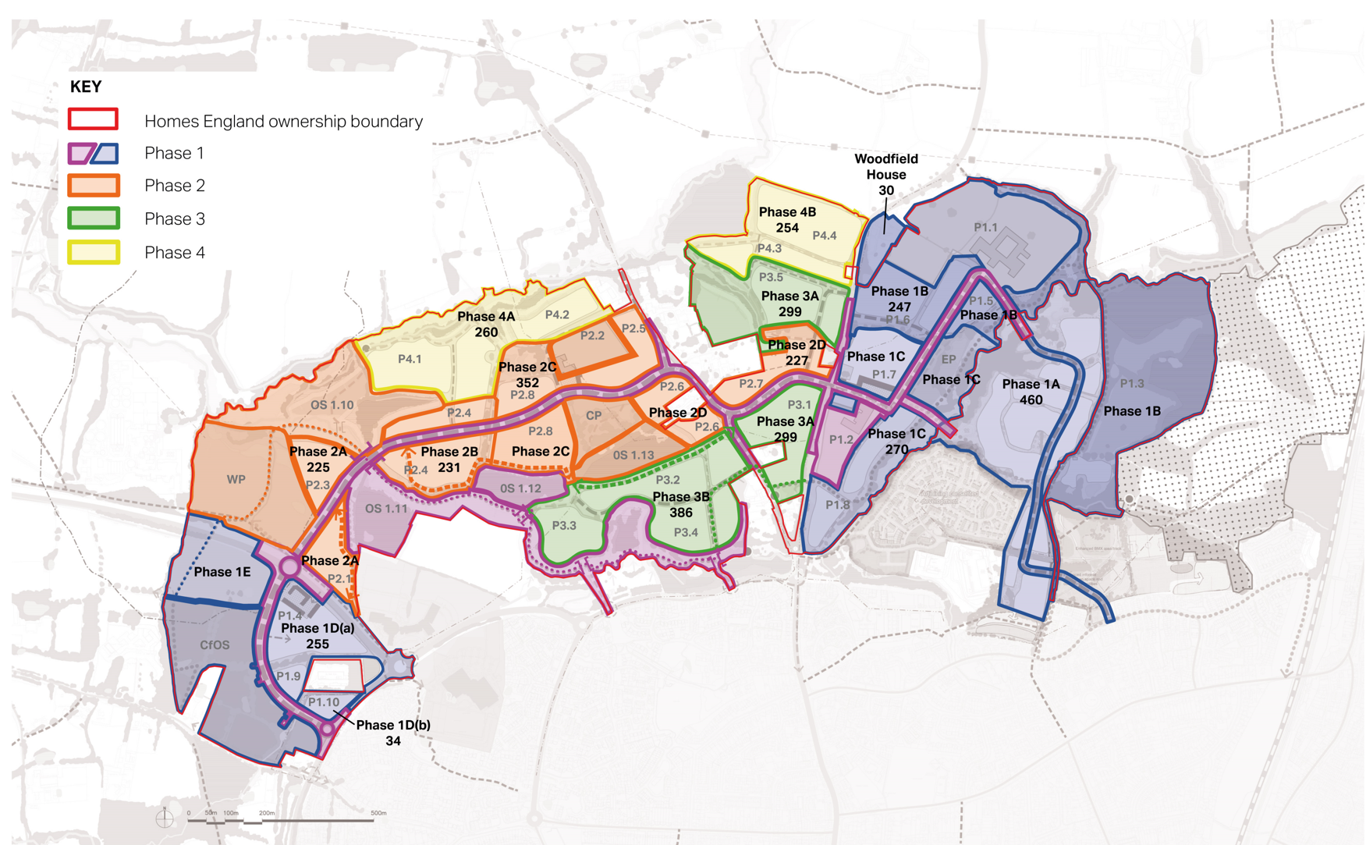

Appendix 2: Homes England Strategic Objectives.

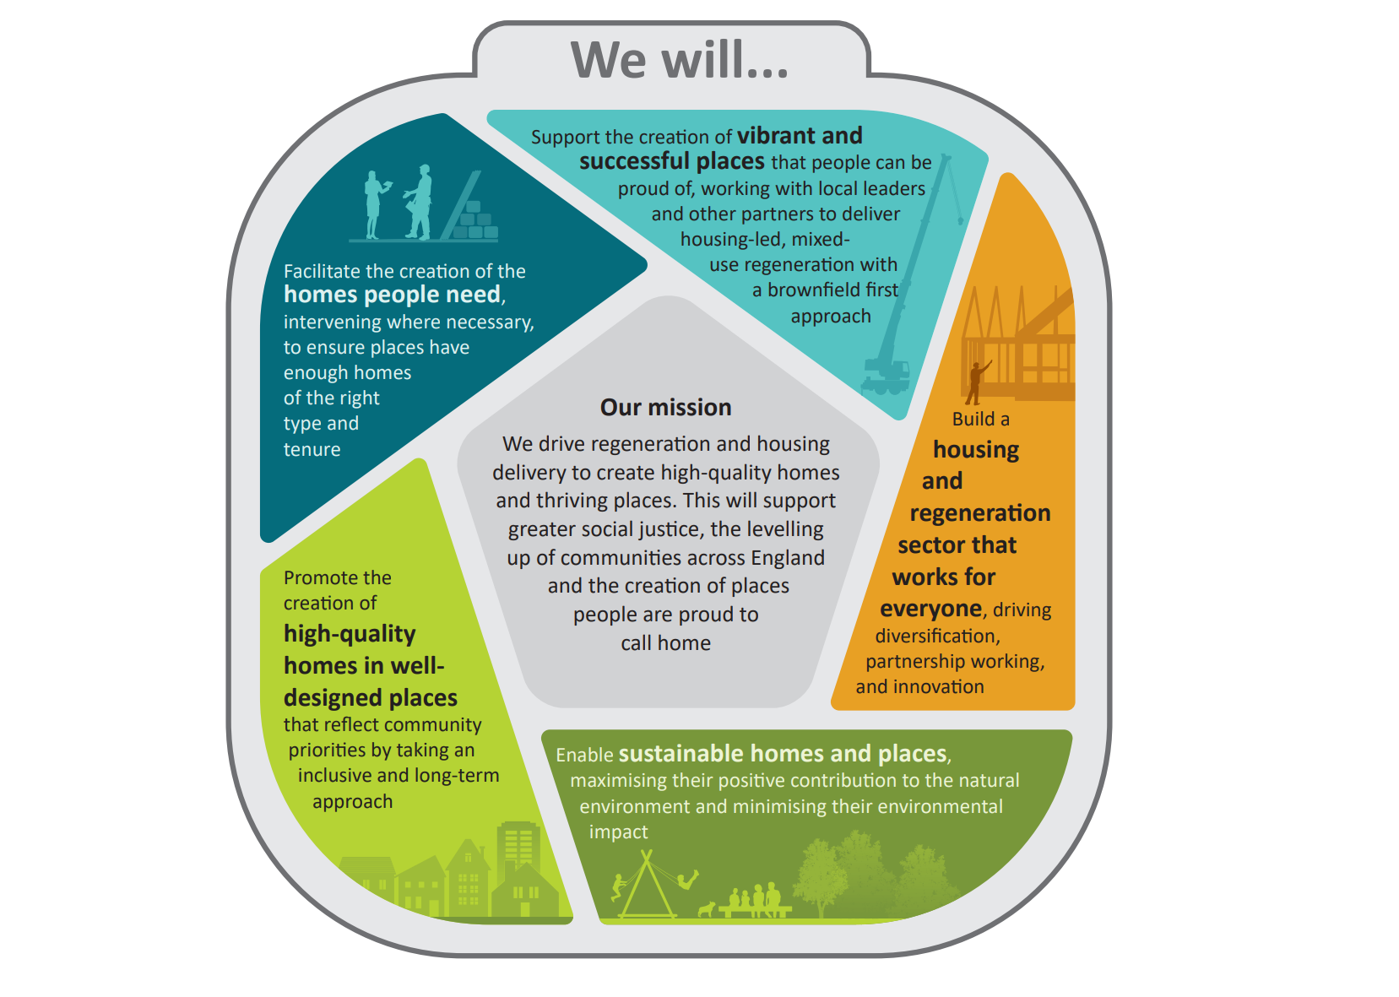

Appendix 3: Homes England KPI

Strategic Objective: Vibrant and successful places
KPI 1 | Brownfield land reclaimed.  Will support decisions on how and where to maximise delivery on brownfield land as Homes England moves towards a brownfield-first approach to delivery.
KPI 2 | Employment floorspace created | Will demonstrate the agency’s wider positive impact beyond the delivery of homes and help establish the long-term productivity of sites we are supporting.
KPI 3 | Number of jobs created
KPI 4 | a. Total number of Local Authorities receiving in-depth capacity support from Homes England  b. … of which share who report improved capacity to deliver their place-based ambitions as a result | Will demonstrate the Agency’s contribution and perceived effectiveness of its support to local authorities to deliver their place ambitions and local housing priorities.
KPI 5 | Social value per pound of investment  Will quantify and value changes in people’s welfare because of Homes England funding.

Strategic Objective: Homes people need
KPI 6 | Total number of housing completions directly supported.  Demonstrates the scale of homes delivered through Homes England direct interventions.
KPI 7 | Total housing capacity of land unlocked by Homes England interventions.  Demonstrates the impact of Homes England indirect support, for example through infrastructure funding, on unlocking land that homes could be built on.
KPI 8 | Total number of households supported into home ownership.  Demonstrates the impact of Homes England support on home ownership numbers.

Strategic Objective: A housing and regeneration sector that works for everyone
KPI 9 | Share of supported completions by low and medium volume builders  Reflects Homes England’s ambition to diversify the market and shift delivery of homes away from large volume builders who deliver a disproportionate share of the market.
KPI 10 | Share of supported completions using Modern Methods of Construction (MMC)  Demonstrates how much support Homes England has stimulated for the areas of the MMC market that need the greatest support and bring the construction benefits that support the government’s housing ambitions.
KPI 11 | Total value of private sector funds leveraged through Homes England support.  Indicates Homes England’s effectiveness of its ambition towards regeneration and how it adds value beyond its funded interventions through ‘soft powers’ such as the Local Government Capacity Centre (LGCC).

Strategic Objective: High-quality homes in well-designed places
KPI 12 | Share of supported schemes that meet or exceed the agreed standards for design quality (in line with Building for a Healthy Life)  Will ensure that design quality is maintained through the disposals process to deliver positive design outcomes for buildings and places, in line with Homes England’s key measure of design quality, Building for a Healthy Life (BHL).

Strategic Objective: Sustainable homes and places
KPI 13 | Building Performance – share of supported completions that are EPC rating B or above.  An interim measure of the operational carbon and energy efficiency of homes supported by the agency (using Energy Performance Certificate (EPC) ratings until a more ambitious measure is identified).
KPI 14 | Average percentage biodiversity net gain planned on supported schemes.  Demonstrates Homes England’s ability to enhance the natural environment of agency-supported homes and places through supporting biodiversity.
KPI 15 | Under development – embodied carbon of Homes England supported development

Achieving our plan
KPI 16 | Share of partners reporting overall satisfaction with Homes England  Measures how satisfied our partners are with Homes England based on their understanding of our role and remit.
KPI 17 | Average colleague rating for Homes England being a diverse and inclusive employer.  Demonstrates whether colleagues feel we are an inclusive employer and whether we foster a positive working environment and experience.
KPI 18 | Number of principle risks outside risk appetite  Identifies and monitors all principal risks outside the appetite agreed upon and set by our Board which could materially impact the successful delivery of our strategic objectives.

Appendix 4 Building for Healthy Life Criteria.

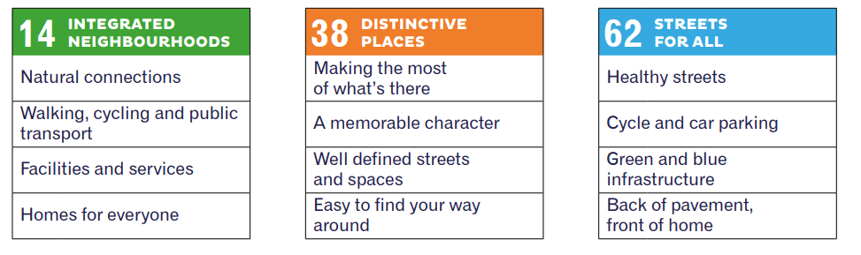

Appendix 5: Brookleigh Design Guide pages 48 to 52
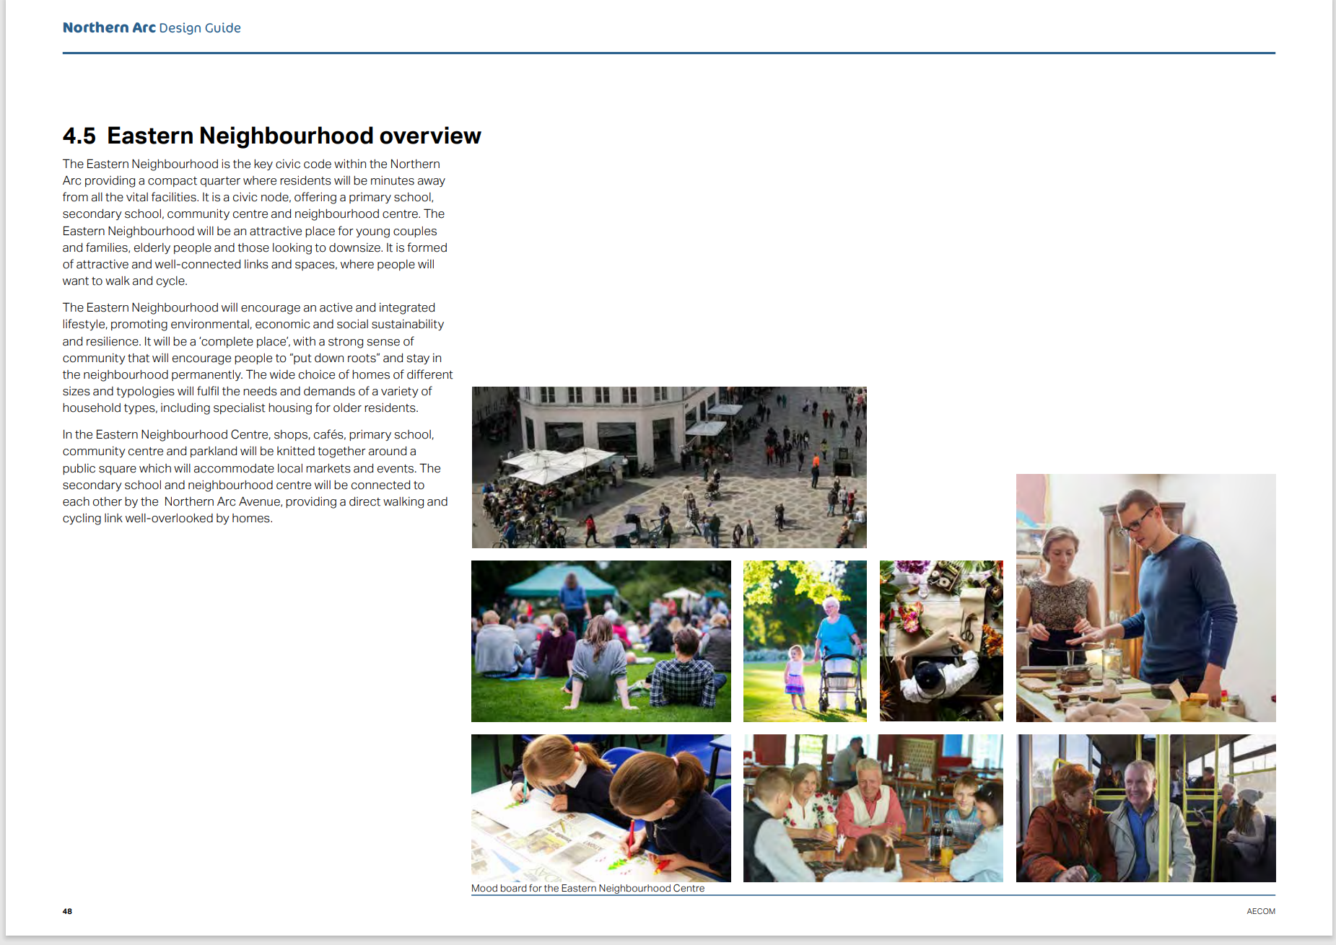

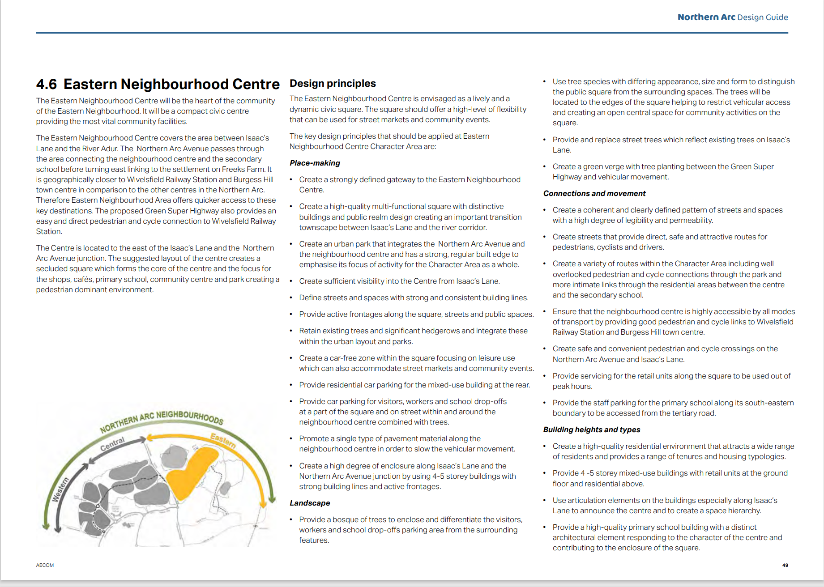

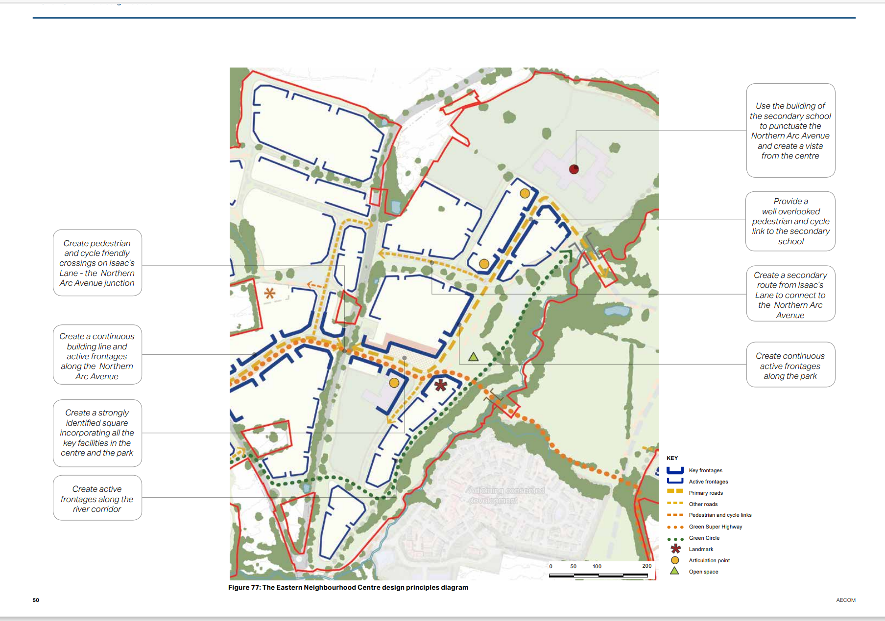
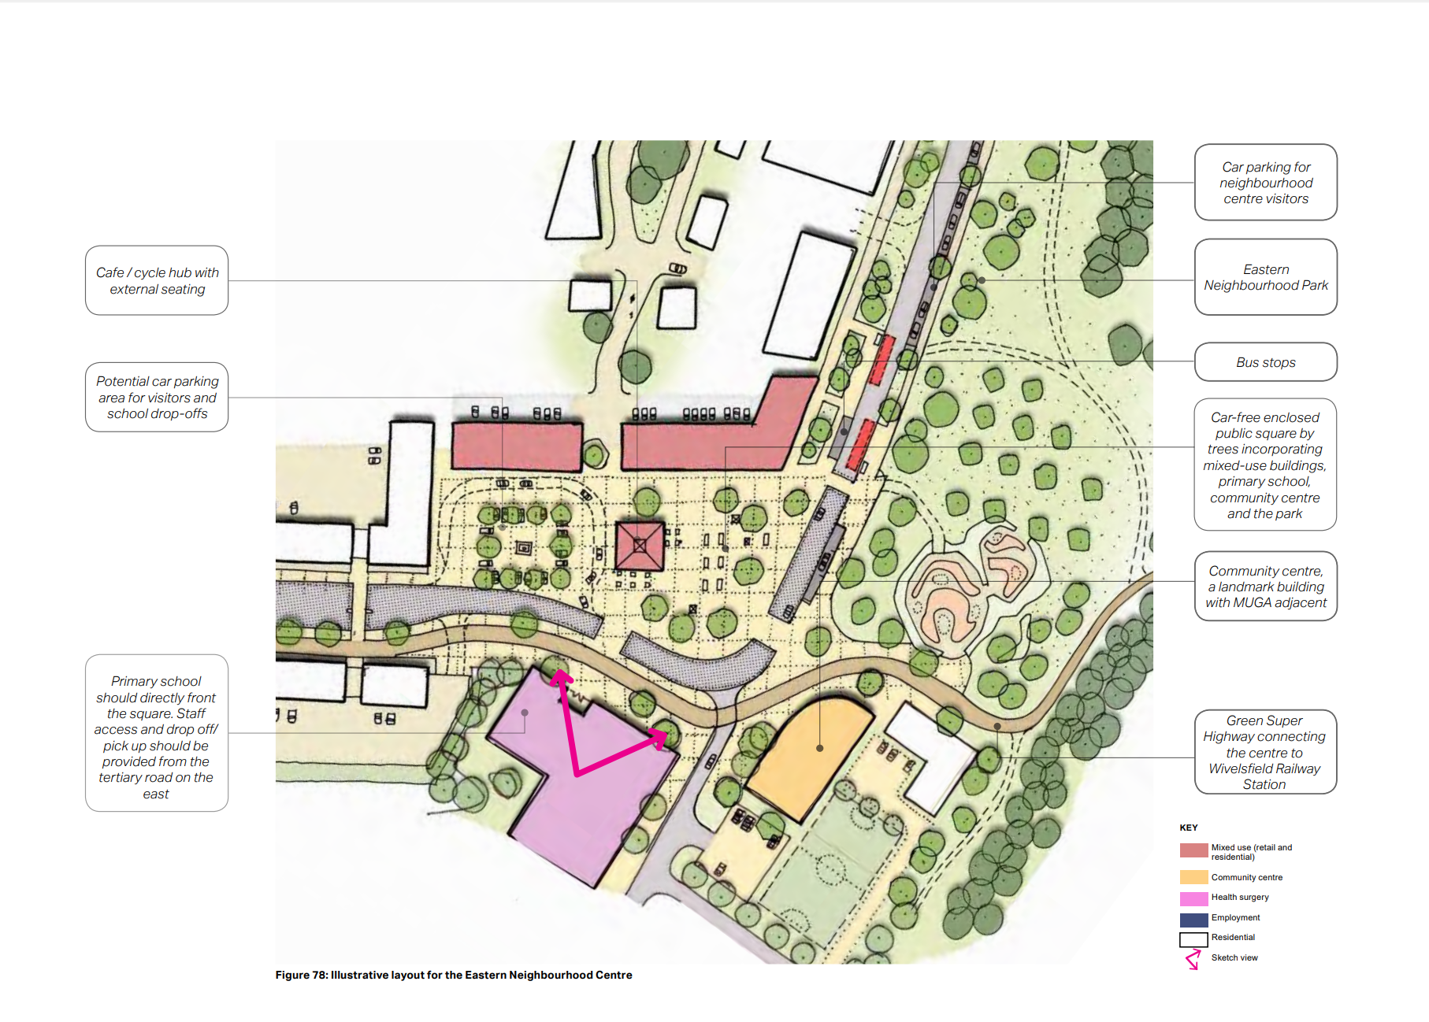

https://assets.publishing.service.gov.uk/government/uploads/system/uploads/attachment_data/file/1159274/Homes-England-strategic-plan-2023-to-2028.pdf

