Last Mile Logistics Hub in Hackney - Bentley Road Car Park
Pre-market Engagement Questionnaire

Introduction
Hackney Council is currently seeking authorisation to start procurement of a courier(s) to run a sustainable last mile logistics hub in a section of the outdoor Bentley Road Car Park, which is itself part of a wider conversion of a portion of the site into a car pound. In the meantime, we are carrying out market engagement to gauge the level of interest, courier needs and better share our requirements if authorised to proceed.

The changing street layout in Hackney, mainly through the introduction of low traffic neighbourhoods (LTN) has meant that van and cars aren’t necessarily the most efficient mode of travel for the last mile of most freight’s journey. This opportunity seeks to respond to demand from freight companies for new space to enable couriers to adapt to Hackney’s low traffic neighbourhoods and mitigate unintended consequences of not adapting such as increased vehicle miles.

This questionnaire will be live for four weeks for couriers to answer. The site is a public space and we encourage suppliers to visit the site prior to submitting their responses to this questionnaire.

About the site
The proposed last mile logistics hub would be located within the Bentley Road Car Park, lot 32 Tottenham Road, London N1 4DW. The car park has many attributes that make it ideal for a sustainable logistics hub:

- It is 100m from the A10; is located in central Hackney where LTNs have been implemented and continue to be implemented and is adjacent to the Borough of Islington where LTNs have also been implemented.
- The site has no height restrictions.
- High level of security on site due to the proposal for the site to be within a new Council car pound which is also being proposed for the site.
- Toilet/welfare facilities could potentially also be available for couriers via an adjacent council owned building, subject to ability to verify identification of personnel.
- Appendix A shows an indication of the proposed layout of the last mile logistics hub and other proposed uses within the Bentley Road Car Park.

To help in best shaping our specifications of a courier(s) for the proposed site, Hackney’s Streetscene team would like to collect information from interested courier companies. Please respond to the following questions.
Available space

The proposed site for the last mile logistics hub in Appendix A comprises 16 bays (2,000sqft), which can be physically separated between couriers if needed (dependent of planning permissions). In addition, space is provided for HGV access directly adjacent to the parking bays. We would discourage storage of freight on site. We want our proposition to appeal to a wide range of organisations whether seeking exclusive use of the site or seeking shared use of the space.

- How would you plan to use the proposed space?
- Do you have any feedback on the following proposal? Or any other suggestions of models that could potentially work best.
Ability for bidders to bid for one of the following Lots in the tender:
    - LOT A: 16 bays + HGV vehicle access to the space from 7 am-10pm Monday to Sunday
    - LOT B: 8 bays + HGV access 7am-2.30pm Monday to Sunday
    - LOT C: 8 bays + HGV access 2.30pm-10pm Monday to Sunday

- In addition to exclusive access to parking spaces (whether some or all of the 16 available), do you believe your company would require any additional infrastructure within the space, e.g. battery storage, lockers, number of electric sockets, HGV charging facilities, portacabin, kitchen area, drinking water access, personal toilet facilities etc.

- We could potentially have a hub manager to act as a point of reference for any issues between couriers and with the landlord. What challenges do you envisage with sharing the site shown at Appendix A with the Council’s Car Pound and public parking?

Costs

At present, a minimum of £40 per bay per day is sought from couriers to lease the individual parking spaces if a total of 16 spaces are allocated to the logistics hub. We are interested to hear from operators whether they are interested in a partnership on the retrofit of the space, for instance, contributing to the cost and design of the retrofit and with lower per bay rental fees. We are therefore exploring two options:
- Partnership: select and sign a lease with an operator prior to the retrofit (circa Autumn 2024) and 6 months prior to the opening of the hub .
- Leasehold: select and sign a lease with an operator following the retrofit and immediately before the opening of the hub (circa Spring 2025).

- Which option would suit your model best and why?

Vehicle access to site

At this stage we anticipate limiting vehicle access to the car pound to between 7am and 10pm.
- Can you provide an indication of your vehicle access needs to the site? E.g. time of day you would want to access the site, frequency and type/size of vehicles, any HGV/LGV accessible electric charging requirements etc.
- The site will be secured and the hub manager/Identification software will need to be able to identify the couriers. How do you propose that they will be identified as authorised personnel on the site?

Business impact

- Can you provide an indication of the number of vehicle km that would be averted if you were to use the site for a freight logistics hub?
- What type of delivery does your business conduct?
- Can you describe how this opportunity would change the way your business travels around the borough and/or other neighbouring boroughs? Describe which locations you would expect to transport goods from and to.
- How does this opportunity align with your businesses environmental commitments (if any)?
- Are you able to provide an estimate on the annual turnover you would expect to generate from the site?

Monitoring

Hackney Council’s Streetscene Team’s main objective for this project is to improve air quality and reduce congestion, as well as inform future projects from the findings of the Bentley Road Logistics Hub. The data collection and analysis would be limited to the Streetscene Team, no personal data is required. Please identify which from the list you would be able to provide by noting their reference ‘letter’, feel free to add any additional data you are able to provide.
  - Vehicle miles by zero emission vehicle, e.g. cargo bike
  - Frequency of deliveries by ICE vehicles
  - Pick-up and delivery postcodes with an indication, e.g. heat map to show the level of frequency of delivery to different postcode areas.
  - Indication of volume of freight transported
  - Number of staff/operatives based at the site
  - Number of cargo bikes being charged / stored at the hub
  - Number of cargo bike deliveries from the hub (and if these replaced any polluting vehicles)
  - Number of electric van deliveries to the site
  - Detailed delivery log
  - Delivery Dates
  - Delivery Times
  - Quantities (number of parcels)
  - Origin (Pick up postcode)
  - Finish (delivery postcode)
  - Distances travelled (broken down: origin > hub > finish)
  - Consolidation stats e.g., how many parcels are combined to one delivery
  - Are you doing return deliveries?
  - Frequency of recurring deliveries
  - Names and number of suppliers sending parcels via the hub
  - Names and number of businesses receiving parcels via the hub
  - Number of local businesses involved in the trial
  - Near miss & incident reporting
  - Emissions calculations / Air quality improvements (incl. a brief explanation of the methodology to understand how this was calculated)
  - Any additional Key Performance Indicator (KPI) data (e.g., economic operations comparisons with existing hub sites, efficiencies from being located here)
  - Network map of deliveries

Appendix A - Indicative Site Plan

Orange polygon: Indicative space to be used for distribution hub within the car pound.
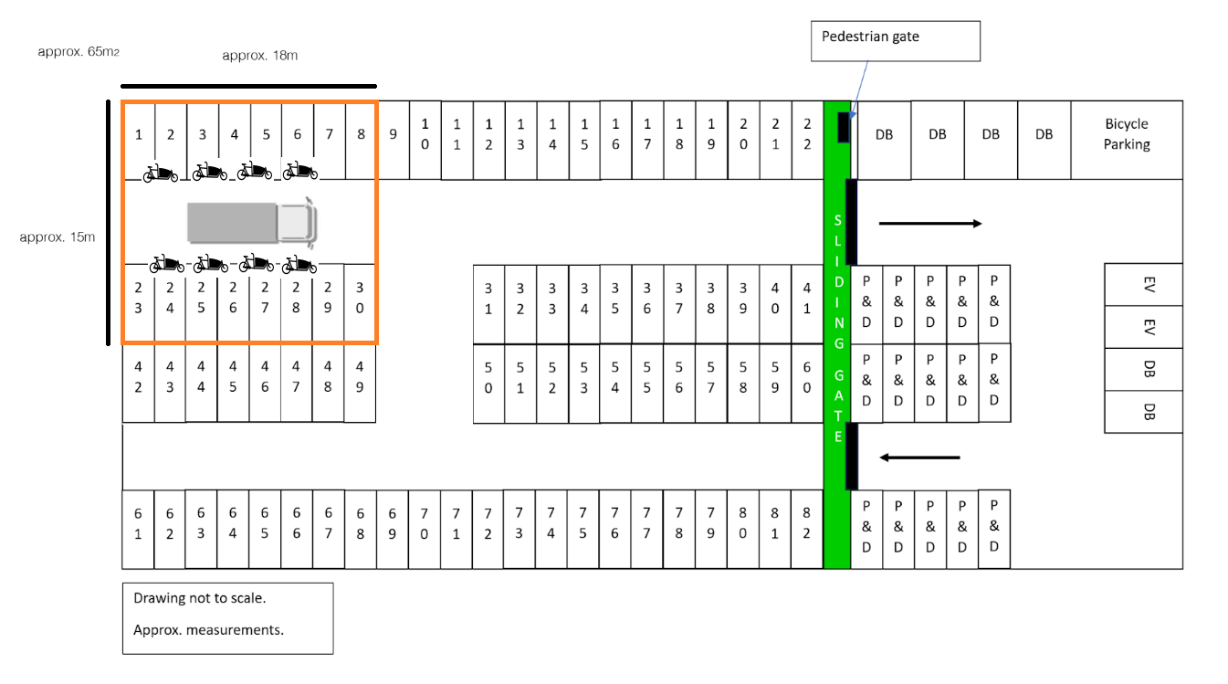
Appendix B: Photos of the site
