Specification for an
Alternative Provision Free School
with an Integrated Youth Offer
at the Roundwood Centre Brent

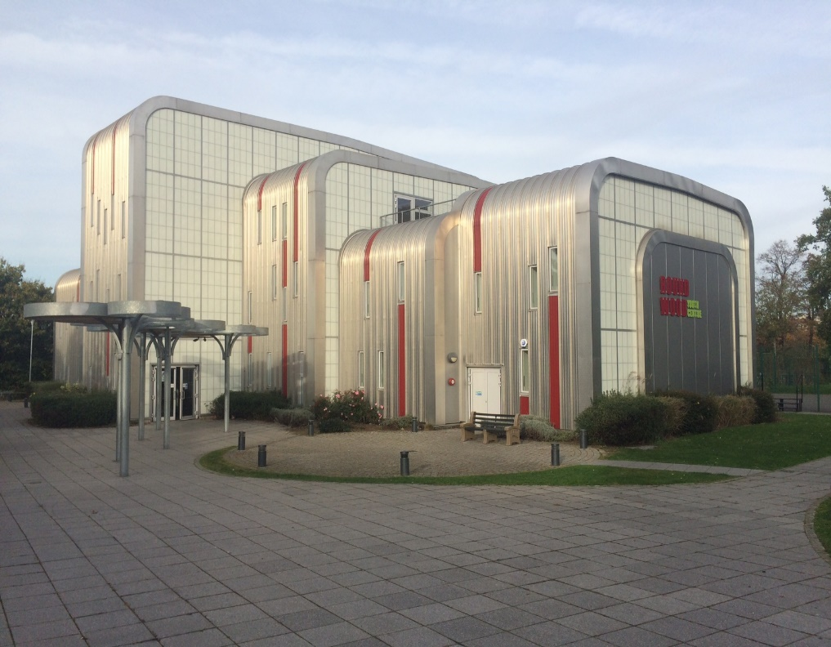

This document references, and should be read in conjunction with the “Free School presumption, Departmental advice for local authorities and new school proposers”, published by the DfE in May 2018.

Section A - Introduction
Under section 6A of the Education and Inspections Act 2006 (the ‘free school presumption’) where a local authority identifies the need to establish a new school it must, in the first instance, seek proposals to establish an academy. Brent has identified the need to establish a new Alternative Provision Free School with integrated youth offer, at the Roundwood Centre, Harlesden, to open by September 2020, for secondary pupils.
- The reasons the provision is required are outlined below under NEED

- A profile of the area is outlined below under Brent CONTEXT

The authority is seeking proposals from appropriate sponsors to open this new school.
Proposers should read this specification in conjunction with:
- the Invitation to Submit an application to establish an Alternative Provision with an Integrated Youth Offer
- the Equalities Impact Assessment
- the Assessment Criteria for the new Alternative Provision with an Integrated Youth Offer, which align with sections B, C, D, E, F & G of this Specification.

The indicative timeline and process for this project, including the opening and closing dates for submission of proposals and details of when and how Brent intends to assess the bids are all covered within the Invitation to submit an application.

NB: This local authority led Free School presumption is a different route from the current window for the DfE’s Free School central programme, for which some councils have already submitted a proposal. Brent is not one of these councils and hence, any new Alternative Provision Free School in Brent needs to follow the local authority presumption route. DfE guidance on the Free school presumption route is here:
https://www.gov.uk/government/publications/establishing-a-new-school-free-school-presumption

Introduction – the NEED for the school and integrated youth offer

The council has a statutory duty for arranging suitable full-time education for excluded pupils:

“Local authorities are responsible for arranging suitable full-time education for permanently excluded pupils, and for other pupils who – because of illness or other reasons – would not receive suitable education without such provision. This applies to all children of compulsory school age resident in the local authority area, whether or not they are on the roll of a school, and whatever type of school they attend. Full-time education for excluded pupils must begin no later than the sixth day of the exclusion.”
Alternative Provision Statutory guidance for Local Authorities, January 2013.

Within Brent, there are on average 30 pupils of secondary school age placed in Alternative Provision settings each academic year. Many of these are placed in provision out of borough because there is insufficient local, high quality provision to meet their needs. Some of these pupils will have received fixed term exclusions and/or are at risk of permanent exclusion.

Consultation with Secondary Headteachers within Brent has identified a need to develop local Alternative Provision which schools can commission for young people who are subject to fixed term exclusions, or for those whose needs cannot be met in mainstream, either for short term provision (respite) or longer term at KS4. There may also be young people who are permanently excluded from Brent Secondary schools, and therefore in need of an alternative setting and who cannot be placed at Brent River College (Pupil Referral Unit) for reasons of risk relating to gang affiliation/peer issues.

Alongside the need for an Alternative Provision Free School is the opportunity to maximise use of the Roundwood site, and expand the youth offer from the Roundwood Centre. Within this context, Brent Council has been reshaping its Youth Service over the past two years. The intention is to transition the current Roundwood Centre (currently run by Brent Council) to a new provider, whilst ensuring the needs of Brent’s young people continue to be met – both in terms of the opportunity of a new Alternative Provision and the continuity and development of an exciting, supportive and expanded youth offer in the mornings, afternoons, evenings, weekends and school holidays from the same site.

Increasing the participation of young people in learning and employment not only makes a lasting difference to individual lives, but is particularly important for the most vulnerable groups of young people, allowing for transformation of personal circumstances and social mobility. The Alternative Provision Free School on the Roundwood site is central to the council’s vision to support vulnerable young people by offering education provision throughout the school day, alongside the delivery of integrated youth services provided by the voluntary and community sector outside of these hours. This would bring together statutory and non-statutory services. The aim is for the Roundwood Centre to operate as a safe-space hub for youth and community activity where vulnerable young people will be able to access a range of youth enrichment activities (including sport and music), and support services, including access to information, advice and guidance related to careers and employment, as well as other relevant topics, such as sexual health. This integrated approach will primarily be preventative, supporting the personal development of individual young people, but it will also provide children and young people with access to crisis support and advice.

The impact of gang-related activity is a Brent council priority. The council’s Offender Management Programme has identified that young people who pose a high risk of re-offending are likely to be victims or perpetrators of serious youth violence. This is because young people who re-offend are often those affected by gang-related activity. The positive diversionary activities on offer at the new provision – including evenings and weekend schedules are likely to have a positive impact on young people’s activities outside of school hours. Mentors and youth leaders will play a critical role in terms of safeguarding, and ensuring positive outcomes for the young people, and particularly the vulnerable cohorts, who attend. Education, training and employment have been identified as the most prominent needs/pathway for the re-offender cohort and is a current concern for approximately 60% of the offenders on the Offender Management Programme.

Introduction – Brent CONTEXT

  - Brent is a dynamic borough located in the North West of London; it is one of the most culturally diverse boroughs in the UK. For the school age population, the ethnicity breakdown for pupils is as follows: Asian (34%), White (25%), Black (21%), Mixed (8%), Other (8%) and Unknown (4%).

  - 12% of Brent pupils receive free school meals compared with 14% nationally.

  - Education is crucial to helping people fulfil their potential and achieve their ambitions. The quality of education available within Brent has been recognised by Ofsted as at least Good in nearly all settings.

  - There are 15 mainstream secondary schools (including 2 with primary provision), 60 mainstream primary schools, 4 special schools, 4 maintained nursery schools and 2 pupil referral units in Brent. 94% of Brent’s schools have been rated as Good or Outstanding by Ofsted, including all the special schools, pupil referral units and maintained nursery schools.

  - Brent’s educational outcomes for secondary school pupils are strong: progress 8 average score for Brent schools in 2018 was +0.54, substantially above the national rate of -0.02. Half of all students (50.90%) who sat their English and Maths GCSEs in 2018 across Brent scored a Level 5 or higher for both subjects, compared with the national average of 40.20%. For the last 2 academic years, Brent has been within the top 3 boroughs nationally for progress at key stage 4. However, while most young people perform well, some are at risk of lower attainment and school exclusion, due to a variety of personal and social factors. Attainment and progress at secondary school for pupils on the SEN support register is not as strong as for non-SEND peers.

  - Brent’s exclusion data for the overall school-age population is positive. There has been a declining trend within the last 3 years in the number of permanent and fixed term exclusions at secondary school. Brent’s exclusion rates for fixed and permanent exclusions are both below national average, with fixed term exclusions (FTE) at 8.03% compared with a national rate of 9.4. The permanent exclusion (PEX) rate is 0.17 compared with the national rate of 0.2. Whilst the overall trend is positive, some cohorts are over-represented in the Fixed Term Exclusion data, including boys of Black Caribbean heritage and pupils with Special Educational Needs in mainstream schools. The Harlesden area has a higher number of school exclusions than other parts of Brent, and a higher proportion of Black Caribbean pupils in local schools. The achievement of Black Caribbean boys is a Brent borough priority within the recently published Borough Plan.

  - The area within which the Roundwood Centre is located has high levels of deprivation; the Index of Multiple Deprivation (IMD) highlights the ward that the centre serves as being in the bottom 10% decile of deprivation nationally, with many social challenges and risks, including; youth violence, poor health, substance misuse, gang activity, risk of radicalisation and increasing mental health needs.

  - The aspiration for the new Roundwood Centre – Alternative Provision and integrated youth offer, is that the combined provision will have a positive impact on the achievement of all young people attending, for attainment, reduction of Fixed Term Exclusions and longer term positive EET outcomes.

The Alternative Provision school will work in partnership with the voluntary sector such as to deliver positive diversionary activities and a wraparound youth offer, for pre and post school-day enrichment, as well as weekend and holiday programmes. Within Brent, Young Brent Foundation (YBF) works collaboratively as an umbrella organisation with its members and is committed to developing a diverse network and youth voluntary sector across Brent.

As an alternative to mainstream education, the Roundwood Centre will offer a different approach for young people who may be disengaged with a formal school setting, allowing them to fulfil their potential in a different environment.

The Roundwood Centre is currently a key access point for the council’s recently re-commissioned Targeted Service to Promote Education, Employment and Training for young people, which delivers the authority’s statutory duties in relation to Information Advice and Guidance (IAG) for 16-19 year olds, and young people up to the age of 25 for those with Special Educational Needs and Disability. For young people aged 16 – 18, the number Not in Education Employment or Training (NEET) is below national average, i.e. 1.6% (in 2017/18) compared with 2.7% nationally. However, some vulnerable cohorts are over-represented in this data, including looked after children (LAC) and those with special educational needs.

  - In 2018, Brent Council won London Borough of Culture (LBOC) for 2020, beating 21 other boroughs with a proposal recognised by the Mayor of London as “visionary”, and receiving £1.35 million to stage a year-long programme of activities which will place culture and the arts at the heart of Brent. Local schools and young people have the opportunity to be involved in a significant cultural education programme, a young ambassadors’ leadership initiative, and in shaping the future of the arts for young people within Brent. LBOC will leave a positive legacy for young people within Brent and can act in part as a counterpoint to national funding reductions to the arts in education.

  - The Roundwood building was funded by a £5 million Big Lottery Fund grant (BLF), awarded in 2009, on behalf of the Department of Children, Schools and Families. The grant was conditional on delivering MyPlace outcomes over a period of 20 years up to 2029. See Brent Assessment Criteria.

Section B - The school and integrated youth offer
The provision

The new school will deliver alternative education provision on site during the school day, with youth provision delivered in the mornings, evenings, weekends and school holidays, in line with the MyPlace outcomes under the management of the new provider at the Roundwood Centre.

SEN provision

Some pupils with Special Educational Needs, including those with an EHC plan may be enrolled. SEN register and non-SEN pupils will also be considered if their profile is suitable for the provision on offer.

Character and ethos of the new provision

The local authority aspiration is that the Brent Alternative Provision Free School will transform lives by empowering young people to develop resilience and ambition, with positive outcomes to match (see section C). It is expected the provider will create an ethos that meets the aspiration of Brent’s vision.

Location

The Alternative Provision Free School with an Integrated Youth Offer will be based at: The Roundwood Centre, Longstone Avenue, NW10 3UN.

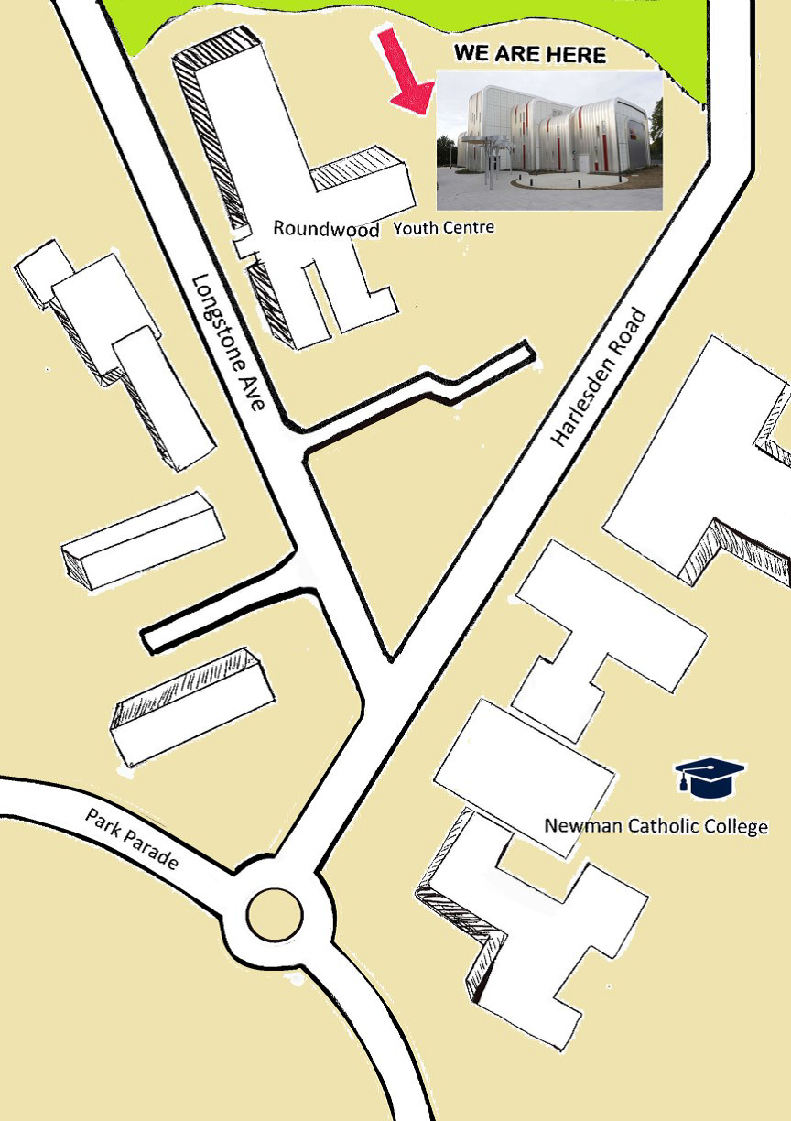

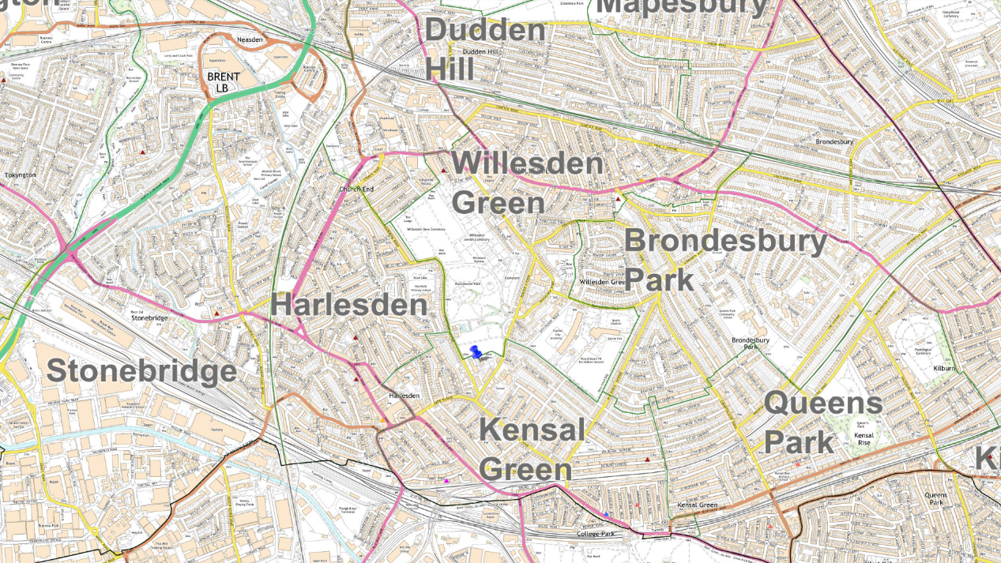

PAN/age-range

Initially, the school will have pupil capacity for up to 30 young people aged 11-16, across KS3 and KS4. The capacity is proposed to grow to 40 and further expand to 50 in the following year, depending on local demand. There will be no nursery or sixth form provision.

Gender
Mixed

Proposed admission arrangements

Places will be commissioned by Brent Targeted Inclusion, within the local authority, and local Secondary Schools. There should be short-term arrangements for dual registered placements at KS3 and KS4, with pupils remaining on roll at their mainstream setting, as well as the opportunity for longer term placements at KS4.

Community use and shared facilities

The intention is to have one single overall provider delivering the Alternative Provision Free School and integrated youth and community services, through a partnership arrangement. The provider will be responsible for supporting use of the building by community groups.

Transport arrangements

There is no expectation that the council will provide a home to school travel service. The Alternative Provision Free School will promote safe travel to school, including walking and cycling.

Equalities Impact Analysis
The council is looking for a provider which can promote inclusion, and support vulnerable learners, including both children on the edge of care and looked after children. The school should be able to make inclusive arrangements for children with a range of Special Education Needs and Disabilities. Please see the separate Equalities Impact Analysis document, which relates to the new Alternative Provision. This covers both impact on other schools and the local community, as well as an equalities analysis in terms of the effect of the new provision on different groups protected from discrimination by the Equality Act, to consider if there are any unintended consequences for some groups, or if the project will be fully effective for all target groups.
Site, and building ownership

This new provision will be based at the Roundwood Centre. The proposal is to have one single overall provider delivering the Alternative Provision Free School and integrated youth and community services. The council would retain the freehold of the Roundwood Centre, and lease the building to the Free School. The deed of designation would transfer to the new provider, who would then take on responsibility for maintenance of the building.

Opening date for new provision

April or September 2020.

Section C - Vision
Applicants should take account of the published criteria: Brent Alternative Provision with an Integrated Youth Offer Assessment Criteria.
As a minimum, please ensure you include the following:
- A strong educational vision and a curriculum delivery based on high standards of attainment for each key stage
- Plans for appropriate engagement with the local community and parents during the pre-opening period and any on-going engagement
- Excellent support facilities to meet the needs of all children, including looked after children, those with Special Educational Needs, etc.
- A commitment to an integrated and wrap-around youth offer, both before and after school, at weekends and in school holidays
- Supportive transition arrangement at all stages, both for short term AP placements, and for transition into EET opportunities at post-16
- A significant offer for pastoral support, therapeutic input, counselling and mentoring

Section D - Education Plan
Applicants should take account of the published criteria: Brent Alternative Provision with an Integrated Youth Offer Assessment Criteria.
As a minimum please ensure you include the following:
- An ambitious, broad and balanced, deliverable curriculum plan which is consistent with the vision and pupil intake. This could include a curriculum table and pupil build up chart
- Strategies for measuring pupil performance effectively and setting challenging targets
- A staffing structure that will deliver the planned curriculum within the expected income levels; with a focus on outstanding teaching (including strategies for effective performance management). This could also include an organogram and staff build up chart
- An inclusive curriculum offer such that the needs of all children are fully provided for
- Details of enrichment and extended services, for example, breakfast clubs, sports clubs, homework clubs and music/art clubs
- The school’s approach to: PHSE; the Prevent Duty; safeguarding and welfare; and, promoting fundamental British values (democracy, the rule of law, individual liberty, mutual respect and tolerance of those with different faiths and beliefs)

Section E - Capacity and Capability
Applicants should take account of the published criteria: Brent Alternative Provision with an Integrated Youth Offer Assessment Criteria.
As a minimum please ensure you include the following:
- The resources you would draw on and/or deploy to support the development of the new free school by the opening date
- Clear evidence that you have the range of skills and abilities necessary to set up and then run a school effectively, including: managing school finances; leadership; project management; marketing; human resources; safeguarding; youth provision; and health and safety
- How the school would be organised and what the governance arrangements would look like, including a diagram of the proposed structures

Section F - Funding and Costs
The Alternative Provision Free School will receive core funding from the High Needs block of the Dedicated Schools Grant (DSG). Core funding will be provided at £10,000 per full time equivalent place. The council anticipates that approximately 30 places will be offered by the Alternative Provision Free School for commissioning by either the local authority or local secondary schools.

Top up funding will be paid by the Local Authority or school that commissions the placement of each pre-16 pupil. The council will agree set top-up rates with the provider annually.
The Alternative Provision Free School will receive grants such as the pupil premium as applicable to its pupils.
The council will consider reasonable requests for capital funding for adaptations to the site which are necessary for the opening of the Free School. Revenue funding for start-up costs will also be negotiated with the chosen provider.
Full details of the funding arrangements for Alternative Provision providers are available in the High Needs Funding Operational Guide 2019/20 published by the ESFA. This can be accessed via the link below.
https://www.gov.uk/government/publications/high-needs-funding-arrangements-2019-to-2020

Section G - Impact and Equalities Assessment
As prescribed by section 9 of the Academies Act 2010 and section 149 of the Equality Act 2010, the local authority must assess the potential impact of any new school on existing educational provision in the area. The local authority must also consider whether the new school would impact on any groups with protected characteristics.
In summary, Brent’s Alternative Provision Free School will support vulnerable young people that have been, or are at risk of being permanently excluded, whilst creating an integrated youth and IAG offer. It is anticipated therefore, that there will be a positive impact on secondary school-age pupils within Brent, due to the availability of this new provision.

Please see the published Equalities Impact Assessment for the Alternative Provision Free School for further information.

