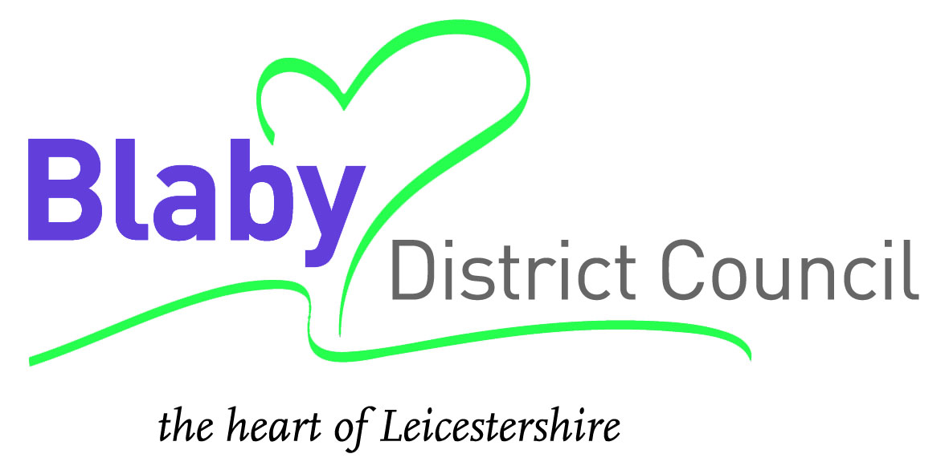

Tender for

Graphic Design Services Contract

Tender DOCUMENT TWO

Specification

June 2018

INSTRUCTIONS AND INFORMATION

These instructions are designed to ensure that all tenders are given equal and fair consideration. It is important that you provide all the information asked for in the format and order specified. Please contact Teena Tailor, Marketing Officer on email Teena.Tailor@blaby.gov.uk if you have any questions.

1. Instructions

1.1 Submission

Proposals and quotations must be received by 12:00pm on 25 July 2018. The expectation would be that you include three *samples of work with the submission and you complete the:-

- Design schedule
- Design brief
- Provide information relating to the ‘Contract Award Criteria’ section of this document
- Signature of acceptance of contract

You will be notified in writing if you are a successful contractor. You will be asked to sign this document as acceptance of contract documentation.

1.2 Evaluation

All bids will be evaluated against the following criteria in assessing which quotes are the most economically advantageous to the Council are as follows:

- Quality

- Ability to deliver full range of services and availability of appropriate software and equipment as detailed in the specification.
- Full details of how you will deliver the full range of services as detailed in the Specification
- Describe your Contingency and Risk Planning.
- Number, experience, capability and qualifications of the key personnel, including management and supervisory support, who will be involved in providing the service required by the specification.
- Quality documentation showing proposals for achieving and monitoring required performance standards.
- Design Brief.

- Price

  - Contractors are required to complete and return the price schedule.
  - When completing price schedules all costs must be provided in the relevant boxes.
  - Costs not supplied may result in the submission being disqualified from the contract process.
  - Please note: We would expect prices to remain unchanged for the duration of the contract. If you are aware of any forthcoming price changes, this must be stipulated in the price schedule.

2. Duration

The duration of the contract will be for a three year period commencing 1 October 2018, with an option to extend for a period of up to two years.

2.1 Background and Scope

2.1 The Communications Section provides a graphic design and artwork production service to the Council. This service covers a broad range of design and artwork and the demand can be at times quite high.

2.2 The Council wishes to source a contractor who can deliver a high standard of quality and professionalism whilst inspiring with flair and creativity. The supplier must consistently be able to produce materials that meet the Council’s corporate style and branding across the portfolio of products and services. Whilst also achieving excellent value for money.

2.3 As an indication the Council has spent approximately £32,000 in the last two years on graphic design services. The Contractor should note that there is no guarantee to the number of orders that may be placed during the contract period.

2.4 The contract is for the provision of graphic design services to support Blaby District Council and its partner organisations.

2.5 This contract does not restrict Blaby District Council to an exclusive contract with the supplier - other marketing materials are produced by suppliers outside the remit of this contract (e.g. Contact magazine).

3. Schedule of Requirements

3.1 The Contractor shall supply artwork to the Council in accordance with the specification and deliver such goods, carriage paid, to the address specified in the purchase order within the time agreed.

3.2 The Council requires the provision of the design of print ready artwork for a number of different print and display formats, including but not limited to:-

- Adverts (press and magazine)
- Booklets/brochures
- Document covers/style guides
- Diagrams/charts/graphs
- Direct marketing (leaflets and flyers)
- Event/exhibition work (posters/pop up displays/wing banners)
- Folders/conference packs/binders
- Newsletters
- Photography
- Bin hangers
- Signage
- Stationery (letterheads/invitations)
- Templates

3.3 The Contractor should note that there is no guarantee to the number of orders that may be placed during the contract period. Contractors must clearly understand that the Council does not bind itself to demand any quantities under this contract.

4 Contract Conditions

4.1 This contract will be let based on the Council’s Contract Regulations which form part of the Council’s Constitution.

4.2 You will be notified in writing if you are a successful contractor. You will be asked to sign this document as acceptance of contract documentation.

5 Contract Price

5.1 As well as signing this document you should also complete the Pricing Schedule and return it with your submission.

5.2 The Pricing Schedule should quote nett prices in sterling exclusive of VAT.

5.3 All prices should include delivery, packaging and unloading.

6 Management Information

6.1 The Contractor will be required to submit to the Marketing Officer a monthly statement of all transactions carried out against the contract.

7 Contract Monitoring

7.1 The Contract Manager for the Council will be the Marketing Officer. The Marketing Officer will be the point of contact for the Contract during the course of the contract. They may elect to meet a named representative of the Contractor as and when necessary, to discuss any issues which may have arisen during the provision of the service.

7.2 A six monthly contract monitoring review will be held at Blaby District Council offices to monitor performance. The Contractor will be obliged to co-operate fully in providing any information requested by the Council during each review period.

8 Quotations and Purchase Orders

8.1 Written information will be provided to the Contractor on the individual work requirements, this will include type and format of design required, estimated number of pages and text, and the requirements for pictures. A timescale/deadline for receiving finished work will also be provided.

8.2 The Contractor would be expected to confirm if they are able to meet the timescale and provide a written quotation before any work is to commence. A Purchase Order would be raised by the Council as an instruction to proceed with the work.

9 Consideration

9.1 When a requirement is identified the Council will supply any logos required to the successful contractor. Each publicity item must, unless otherwise stated, feature the Council logo, a publication date and adhere to the Council’s Corporate Identity and Accessibility Manual. The manual can be found at https://www.blaby.gov.uk/_resources/assets/attachment/full/0/14496.pdf

9.2 For each individual job the Marketing Officer will supply an individual purchase order number. The contractor should invoice each job separately and quote the PO number on the invoice.

9.3 Some illustrations may be required as part of this project. Any photographs used, as part of an individual job should not incur any additional costs for usage rights.

10 Proofs

10.1 Full colour proofs of all the designs must be supplied in either pdf or hard copy format and must be approved and signed off by the Council, before the final artwork is supplied. All artwork must include a full bleed.

10.2 Artwork may be supplied in the following formats, as requested by the Council:-

  - PDF or (JPEG/EPS/TIFF – depending on type of work) format
  - Adobe Photoshop (artwork created in Adobe Photoshop must be accompanied by the corresponding psd layer file)

10.3 Acceptable media:-

Email: send to Artwork@blaby.gov.uk, or public.relations@blaby.gov.uk

11 Supplied Material

11.1 All material supplied by the Council to the Contractor for the purposes of the design, for example copy, photographs, USB device, must be:-

a) Kept secure while in the possession of the Contractor
b) Returned to the Communications Section on request or at the end of the contract at Blaby District Council.

12 Finished Artwork

12.1 All artwork completed by the Contractor on behalf of the Council shall become the property of the Council upon completion.

12.2 Finished artwork must be supplied in a high resolution PDF file ready for print and when requested by the Council in a low resolution PDF for publishing on Blaby District Council’s website. Dependant on the type of work, artwork may be required in JPEG, EPS or TIFF.

13 Invoicing Requirements

13.1 Invoices are required for each job individually and should be submitted to the finance department. Payment will be made in arrears and within 30 days of receipt of correct invoice. Invoices must show a full breakdown of costs and quote the relevant Purchase Order number.

14 Financial Standing and Resources

14.1 The Council wishes to ensure that suppliers have the necessary financial standing and resources to meet their obligations throughout the duration of this contract. This may include (where appropriate) considering your level of existing work commitments and the potential impact on resources that awarding a contract would have.

15 Contract Evaluation and Award

15.1 The Council will evaluate the submissions it receives on the basis of a balance of quality and price in accordance with the following weightings.

- Quality 60%
- Price 40%

15.2 As part of the evaluation process you may be asked to a clarification meeting at the Council Offices or the Contract Manager may require a site visit to your premises.

15.3 Please note that when evaluating your submission, we will also take into account whether all of the requirements of the contract documentation have been met, such as whether all the additional documentation requested has been included.

15.4 The Contract will be awarded on the basis of the most economically advantageous quote to the Council. The criteria to be used in assessing which quotes are the most economically advantageous to the Council is set out at 1.2 of this document.

SIGNATURE OF ACCEPTANCE OF CONTRACT

I (or we) the undersigned do hereby offer and undertake on the acceptance of this submission by the Council, to provide the services described in the Contract in accordance with all documents that constitute the Contract.

Unless and until a separate formal agreement is prepared and executed this submission, together with the general Terms and Conditions, Specification and Pricing Schedule, together with your written acceptance thereof shall constitute a binding contract between us.

I (or we) understand that the Council is not bound to accept the lowest quote it receives.

Dated this _________________day of _______________________ 200

Signature________________________________________________________

Name (IN BLOCK CAPITALS)________________________________________

Status or Authority of Signatory________________________________________

Name of Establishment______________________________________________

If the firm is not a limited company please name the proprietors_______________

Postal Address or Registered Office_____________________________________

Telephone No:_____________________________________________________

Facsimile No:______________________________________________________

Email address______________________________________________________

The Pricing Schedule must also be signed.

Contractors will be notified in due course as to acceptance or otherwise of their submission.

