Cheshire East – Ansa area of operations
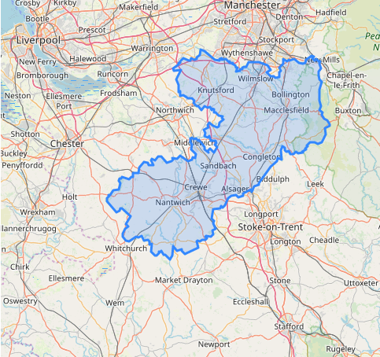

Lot 2 - High Peak – AES area of operations
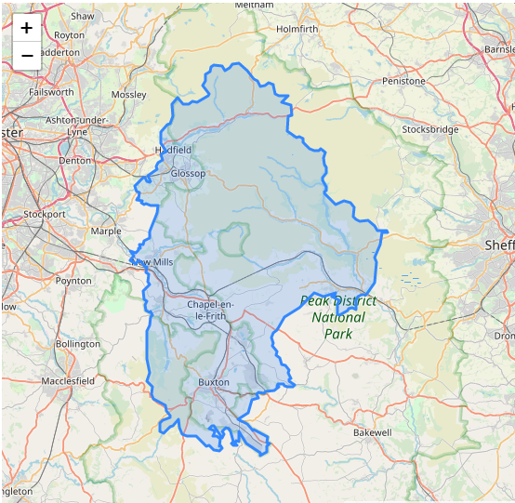

Lot 2 – Staffordshire Moorlands – AES area of operations
