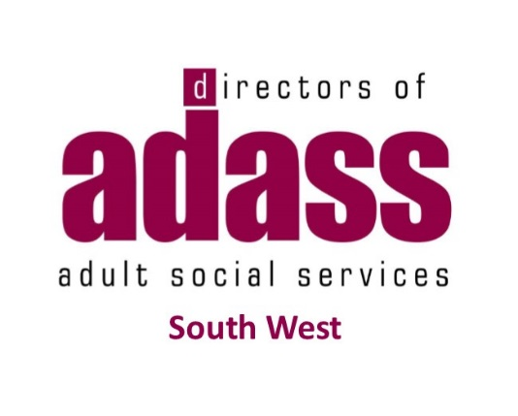
South West Region Learning Disability Residential Care Project
Provider Engagement Event
Wednesday 29th January and Friday 7th February 2020
10.00 – 16.00
Taunton Rugby Club, Commsplus Stadium, Hyde Lane, Bathpool, Taunton, Somerset, TA2 8BU
SW ADASS and Local Authorities across the South West have been working together to develop a regional contract and service specification that local authorities and clinical commissioning groups will be able to use to purchase residential care for adults with learning disabilities within the South West. Along with development of the contract, service specification and a standard Quality Assurance monitoring process, we have developed a costing model to be used for placements made under this contract.
Providers who provide residential care for adults with learning disabilities within the South West region will be invited to join the regional contract. The providers who decide to join will sign up to one contract and service specification and will only be required to complete one accreditation process to enable them to contract with all participating Local Authorities and Clinical Commissioning Groups. Providers will still work with individual authorities as they will still have the responsibility of making their own placements and payments.
Following our market engagement event we held on the 10th July 2019 we are now in a position to give you an update and share with you the documents that have been developed.
We would like to invite providers to a market engagement event where we can:
Gather feedback from providers on our proposals for a:
  - Service Specification and Contract
  - A Quality Assurance Process
  - The proposed Costing Model across the region
We are holding the same event on two separate dates to allow people an option to attend either. Please can you complete the attached attendance form confirming which date you would like to attend?
Forms to be returned to naomi.taviner@southglos.gov.uk by Wednesday 22nd January 2020. This is to allow enough time for catering.

