Viewing the Details/Documents

Login to the system and then it will take you to your homepage.

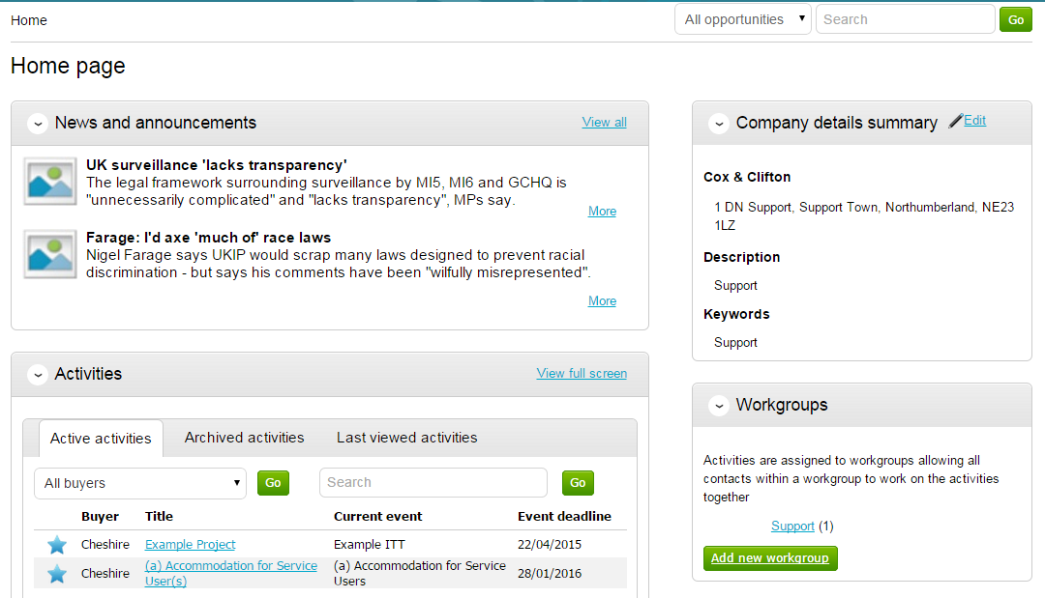

From here to view your current activities that you are working on, from the Activities section click on the title of the Activity you wish to work on.
The Activities area shows all the various tenders that you have registered with, this can be an ITT (Invitation to Tender), RFQ (Request for Quotation), a PQQ (Pre-Qualification Questionnaire) etc.

Note: The process is the same in the system for all types of tender opportunity, PQQ, ITT and RFQ’s, etc. however, in this case the ITT has been chosen to look through, and ITT will be referred to at various points. If you are completing a PQQ or Quotation (using attachments) then the screens will remain the same, it is only the terminology that will change. Online responses to online evaluations are covered in a separate guide/help section.
As you can see above, the Buyer, Title of the project, current event and event deadline is shown. In this case it shows a symbol to reflect it is new and it has not yet been viewed or worked upon yet.

By clicking on the title in blue, further information is now shown. From this screen all aspects of this project can be dealt with; the tender can be viewed, questions can be asked and answers received, additional information can be issued and your response can be put together and sent to the contracting organisation. Each stage of the procurement process will be seen as its own section.
To view the relevant stage of the project click Open Event within the relevant stage, in this instance ‘Example ITT’.

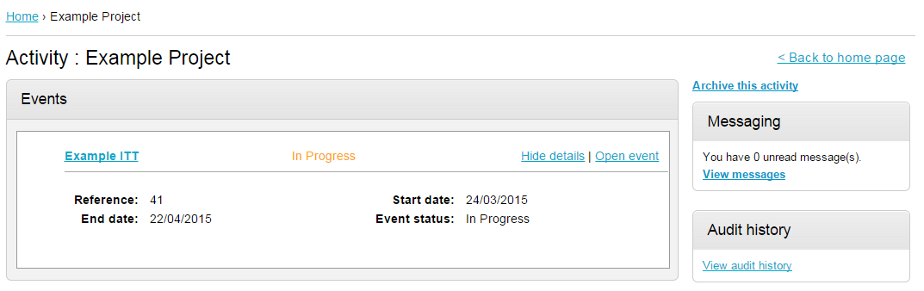

This will open the tender screen. This is broken up into different sections; Main details, Public attachments, Terms & Conditions, Item breakdown and Messaging. Note: There is also a countdown timer in the top right indicating the time left until the submission deadline.

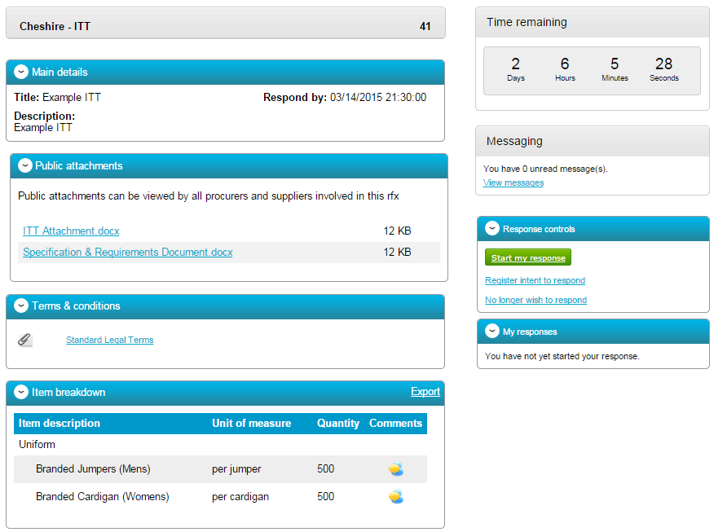

The different sections are explained below;

Main details

This section shows the title, description and date and time the completed tender must be returned by.

Public attachments

This section shows the attachments that have been published by the organisation. To download click on the title of the attachment.
Note: There may be no attachments here, however in the majority of cases there will be. Where there are documents, they should be downloaded and saved to your own network or desktop before working on them.

Item Breakdown

This section is the item breakdown for the tender used for pricing, if one has been created by the organisation.

Note: This is an optional section and there may not be one included with an exercise.

This shows the description of the group/line item, the unit the item is measured in, the quantity of these units required and any additional comments regarding the line item (shown by hovering over the icon.) An example of one is shown below.

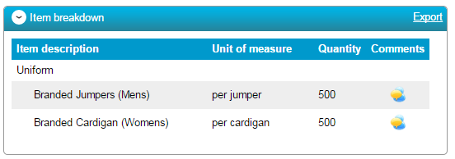
This can also be exported if required, by clicking Export.

Terms and Conditions

The Terms and conditions section shows the terms that have been used with this tender. To view them click on the Terms & Conditions title, shown in blue. There will be at least one set of terms here and there can be more depending what the procuring organisation have set up.

