PROPERTY
SERVICES
Place & Community Services

COMMUNAL AREA REFURBISHMENTS AT:

STANLEY COURT, BURSCOUGH

ASPEN WAY, SKELMERSDALE
&
BLYTHEWOOD, SKELMERSDALE (DN480271)

SCHEDULE NO. CR/21

CONTRACT DOCUMENTS

Heidi McDougall BSc(Hones) MBA

Corporate Director of Place and Community

Frank Lee
Property Services Manager

Property Services
Edden House
61 Westgate
Sandy Lane Centre
Skelmersdale
WN8 8LP

MAY 2020

I N D E X

- Preliminaries
- General Conditions
- General Preambles
- Health & Safety
- Insurance
- Works Section
- Collection page
- Location Maps
- Communal Area Colour Options
- Pre-contract Information
- Form of Tender
H&I, PST/IAM/CAPITAL WORKS PROGRAMMES 20-21/COMMUNAL AREAS 2020/21

SECTION 1

PRELIMINARIES

PRELIMINARY PARTICULARS

GENERAL

These conditions are supplementary to those stated in the invitation to tender and on the Form of Tender.

Alterations and qualifications to the Specification must not be made without the written consent of the Contract Administrator. Tenders containing such alterations or qualifications may be rejected.

Costs relating to un-priced items will be deemed to have been included elsewhere in the Specification.

NAME OF PARTIES

Employer shall mean West Lancashire Borough Council, 52 Derby Street, Ormskirk, Lancashire. L39 2DF.

Contract Administrator shall mean The Property Services Manager, West Lancashire Borough Council or in the event of him ceasing to be Contract Administrator for the purpose of the Contract, such other person who shall be nominated for the purpose by the Employer.

DESCRIPTION OF WORKS

The Contractor is referred to the “works section” of this specification and to the front cover, which gives the title of the project.

CONTRACTOR TO VISIT SITE

The Contractor is advised to visit the site and ascertain the conditions under which the work will be carried out. The Contractor must take full account of the position of any Local Authorities, statutory undertakings, private or public Company’s pipes, cables, manholes, inspection chambers, buildings and equipment on or adjacent to the site, or any condition which may influence his tender.

TENDER

The Contractor’s tender must include for the completion of all the Works and for total compliance with the Contract Documents. The tender should be completed, signed and uploaded on to The Chest portal at www.the-chest.org.uk no later than 12 noon on the date shown on the Invitation to Tender letter, otherwise it will not be considered.

TYPE OF CONTRACT

The Contractor should note that this will be a FIXED PRICE CONTRACT with no provision for fluctuations in rates, wages or prices of materials.

The successful Contractor will be required to sign the AGREEMENT FOR MINOR BUILDING WORKS 2016 Edition, issued by The Joint Contracts Tribunal.

The Contractor will be held to have studied the Conditions of the above carefully and made himself fully conversant with the implications thereof and the under mentioned amendments and additions and to have allowed a price in his tender for compliance therewith.

RECITALS

1st The Employer wishes to have the following work, (see the “Works Section” of this specification, the front cover of which gives the title of the project), (hereinafter called “The Works) carried out under the direction of The Property Services Manager, West Lancashire Borough Council, (hereinafter called “Contract Administrator”) and has caused a specification (hereinafter called “The Contract Specification”) and schedules (which documents are together with the conditions annexed hereto hereinafter called “The Contract Documents”) showing and describing the works to be prepared and which are attached to this Agreement.

2nd a Specification and Work Schedules

ARTICLES

Article 2 - sum of

Article 3 - The Property Services Manager

Article 4 - WYG Management Services Ltd

Article 6 - shall be RICS

Article 7 - shall be RICS

CONTRACT PARTICULARS

Fourth Recital and Schedule 2 – is NOT a ‘contractor’
(1.1, 1.2, 1.5, 1.6, 2.1 and 2.2)

Fifth Recital – the project is notifiable

Seventh Recital – Paragraphs 1, 3, 4, 5 and 6 do not apply

Article 7 – Article 7 and Schedule1 (Arbitration) apply

Commencement and Completion
(2.2, 2.3, 2.4, 2.5, 2.6, 2.7, 2.8, 2.9, 2.10, 2.11)

- Clause 2.2:- Monday 20th July 2020

b) Clause 2.2:- Friday 25th September 2020 (10 weeks)

c) Clause 2.8:- Not applicable

d) Clause 2.10:- 12 months.

Section 4
(4.1, 4.2, 4.3, 4.4, 4.6, 4.7, 4.8, 4.9, 4.10, 4.11)

a) Clause 4.11 will be deleted.

INJURY, DAMAGE AND INSURANCE
(5.1, 5.2, 5.3, 5.4, 5.5,)

- Clause 5.3.2 - The amount to be inserted is £5,000,000.

- See Section 5 (Insurance) for details of insurance requirements.

TERMINATION
(6.1.6.2, 6.3, 6.4, 6.5, 6.6, 6.7, 6.8, 6.9, 6.10, 6.11)

7.2- insert RICS
ADDITIONAL CLAUSES (9.1, 9.2, 10.0, 11.0, 12.0, 13.0, 14.0, 15.0, 16.0, 17.0)

9.1 Where any property included in the Schedule is in the process of being sold, the Employer, by one week’s written notice given to the Contractor, may remove the said property from the Schedules, and the tender price shall be reduced by an amount to be agreed upon between the Contract Administrator and the Contractor, and no claim for loss of profit will be entertained.

9.2 The Contractor must programme the delivery of materials to ensure that full ‘house sets’ are delivered in order to ensure that once work is started on a dwelling it can be completed in one ‘visit’.

AVOIDANCE OF FRAUD

10.0 Avoidance of Fraud – The Council may terminate this Contract and recover all its loss if the Contractor, its employees or anyone acting on the Contractor’s behalf do any of the following things:-

(a) offer, give or agree to give to anyone any inducement or reward in relation to the improper performance of any function or activity in respect of this or any other Council contract (even if the Contractor does not know what has been done), or

(b) commit an offence under the Bribery Act 2010 or Section 117(2) of the Local Government Act 1972, or

(c) commit any fraud in connection with this or any other Council contract whether alone or in conjunction with Council members, contractors or employees

Any clause limiting the Contractor’s liability shall not apply to this clause.

CONTRACTOR’S ARRANGEMENTS

11.0 Equality Act 2010

Where under the requirements of The Equality Act 2010 the contractor is required to make any arrangements in respect of a disabled contract worker and the Contractor requires the co-operation of the Council to ensure the effectiveness of those arrangements, and then the Contractor shall notify the Council accordingly.

- Human Rights Act

Where a public function is being carried out, the Contractor shall carry out his/its obligations hereunder at all times in accordance with the requirements of the Human Rights Act 1998 and hereby indemnifies the Council against any loss, claims, costs or proceedings arising out of a breach of his/its obligations (without prejudice to any indemnity provided under this Contract) PROVIDED ALWAYS that the Contractor shall not be responsible for any breach hereunder where such a breach results from any act or default of the Council.

- Third Parties

Notwithstanding any other provision of this contract, nothing in this contract confers or purports to confer any right to enforce ay of its terms of any person who is not a party to it.

- Data Protection

The Contractor hereby undertakes that any personal data provided under this Agreement shall be dealt with by him only in accordance with the instructions of the Council and at all times within the requirements of the Data Protection Act 2018, the General Data Protection Regulation and Law Enforcement Directive (as amended from time to time) without prejudice to the generality of the foregoing the Contractor shall:

  - The Parties acknowledge that for the purposes of the Data Protection Legislation, the Customer is the Controller and the Contractor is the Processor. The only processing that the Contractor is authorised to do is listed in the following Schedule by the Customer and may not be determined by the Contractor.
  - The Contractor shall notify the Customer immediately if it considers that any of the Customer's instructions infringe the Data Protection Legislation
  - The Contractor provide all reasonable assistance to the Customer in the preparation of any Data Protection Impact Assessment prior to commencing any processing. Such assistance may, at the discretion of the Customer, include:
      - a systematic description of the envisaged processing operations and the purpose of the processing;
    - an assessment of the necessity and proportionality of the processing operations in relation to the Services;
    - an assessment of the risks to the rights and freedoms of Data Subjects; and
    - the measures envisaged to address the risks, including safeguards, security measures and mechanisms to ensure the protection of Personal Data.

  - The Contractor shall, in relation to any Personal Data processed in connection with its obligations under this Agreement:
    - process that Personal Data only in accordance with the following Schedule, unless the Contractor is required to do otherwise by Law. If it is so required the Contractor shall promptly notify the Customer before processing the Personal Data unless prohibited by Law;
    - ensure that it has in place Protective Measures, which have been reviewed and approved by the Customer as appropriate to protect against a Data Loss Event having taken account of the:
      - nature of the data to be protected;
      - harm that might result from a Data Loss Event;
      - state of technological development; and
      - cost of implementing any measures;

    - ensure that:
      - the Contractor Personnel do not process Personal Data except in accordance with this Agreement (and in particular the following Schedule);
      - it takes all reasonable steps to ensure the reliability and integrity of any Contractor Personnel who have access to the Personal Data and ensure that they:
        - are aware of and comply with the Contractor's duties under this clause;
        - are subject to appropriate confidentiality undertakings with the Contractor or any Sub-processor;
        - are informed of the confidential nature of the Personal Data and do not publish, disclose or divulge any of the Personal Data to any third Party unless directed in writing to do so by the Customer or as otherwise permitted by this Agreement; and
        - have undergone adequate training in the use, care, protection and handling of Personal Data; and
    - not transfer Personal Data outside of the EU unless the prior written consent of the Customer has been obtained and the following conditions are fulfilled:
      - the Customer or the Contractor has provided appropriate safeguards in relation to the transfer (whether in accordance with GDPR Article 46 or LED Article 37) as determined by the Customer;
      - the Data Subject has enforceable rights and effective legal remedies;
      - the Contractor complies with its obligations under the Data Protection Legislation by providing an adequate level of protection to any Personal Data that is transferred (or, if it is not so bound, uses its best endeavours to assist the Customer in meeting its obligations); and
      - the Contractor complies with any reasonable instructions notified to it in advance by the Customer with respect to the processing of the Personal Data;·
    - at the written direction of the Customer, delete or return Personal Data (and any copies of it) to the Customer on termination of the Agreement unless the Contractor is required by Law to retain the Personal Data.

  - Subject to clause f, the Contractor shall notify the Customer immediately if it:
    - receives a Data Subject Access Request (or purported Data Subject Access Request);
    - receives a request to rectify, block or erase any Personal Data;
    - receives any other request, complaint or communication relating to either Party's obligations under the Data Protection Legislation;
    - receives any communication from the Information Commissioner or any other regulatory authority in connection with Personal Data processed under this Agreement;
    - receives a request from any third Party for disclosure of Personal Data where compliance with such request is required or purported to be required by Law; or
    - becomes aware of a Data Loss Event.

  - The Contractor's obligation to notify under clause e shall include the provision of further information to the Customer in phases, as details become available.

  - Taking into account the nature of the processing, the Contractor shall provide the Customer with full assistance in relation to either Party's obligations under Data Protection Legislation and any complaint, communication or request made under clause e (and insofar as possible within the timescales reasonably required by the Customer) including by promptly providing:
    - the Customer with full details and copies of the complaint, communication or request;
    - such assistance as is reasonably requested by the Customer to enable the Customer to comply with a Data Subject Access Request within the relevant timescales set out in the Data Protection Legislation;
    - the Customer, at its request, with any Personal Data it holds in relation to a Data Subject;
    - assistance as requested by the Customer following any Data Loss Event;
    - assistance as requested by the Customer with respect to any request from the Information Commissioner's Office, or any consultation by the Customer with the Information Commissioner's Office.

  - The Contractor shall maintain complete and accurate records and information to demonstrate its compliance with this clause. This requirement does not apply where the Contractor employs fewer than 250 staff, unless:
    - the Customer determines that the processing is not occasional;
    - the Customer determines the processing includes special categories of data as referred to in Article 9(1) of the GDPR or Personal Data relating to criminal convictions and offences referred to in Article 10 of the GDPR; and
    - the Customer determines that the processing is likely to result in a risk to the rights and freedoms of Data Subjects.

  - The Contractor shall allow for audits of its Data Processing activity by the Customer or the Customer's designated auditor.

  - The Contractor shall designate a data protection officer if required by the Data Protection Legislation.

  - Before allowing any Sub-processor to process any Personal Data related to this Agreement, the Contractor must:
    - notify the Customer in writing of the intended Sub-processor and processing;
    - obtain the written consent of the Customer;
    - enter into a written agreement with the Sub-processor which give effect to the terms set out in this clause such that they apply to the Sub-processor; and
    - provide the Customer with such information regarding the Sub-processor as the Customer may reasonably require.

  - The Contractor shall remain fully liable for all acts or omissions of any Sub-processor.

  - The Customer may, at any time on not less than 30 Working Days' notice, revise this clause by replacing it with any applicable controller to processor standard clauses or similar terms forming part of an applicable certification scheme (which shall apply when incorporated by attachment to this Agreement).

  - The Parties agree to take account of any guidance issued by the Information Commissioner's Office. The Customer may on not less than 30 Working Days' notice to the Contractor amend this agreement to ensure that it complies with any guidance issued by the Information Commissioner's Office.

Schedule Processing, Personal Data and Data Subjects

- The Contractor shall comply with any further written instructions with respect to processing by the Customer.

- Any such further instructions shall be incorporated into this Schedule.

Description | Details
Subject matter of the processing | [This should be a high level, short description of what the processing is about i.e. its subject matter]
Duration of the processing | [Clearly set out the duration of the processing including dates]
Nature and purposes of the processing | [Please be as specific as possible, but make sure that you cover all intended purposes.  The nature of the processing means any operation such as collection, recording, organisation , structuring, storage, adaptation or alteration, retrieval, consultation, use, disclosure by transmission, dissemination or otherwise making available, alignment or combination, restriction, erasure or destruction of data (whether or not by automated means) etc.  The purpose might include: employment processing, statutory obligation, recruitment assessment etc]
Type of Personal Data | [Examples here include: name, address , date of birth, NI number, telephone number, pay, images, biometric data etc]
Categories of Data Subject | [Examples include: Staff (including volunteers, agents, and temporary workers), customers/ clients, suppliers, patients, students I pupils, members of the public, users of a particular website etc]
Plan for return and destruction of the data once the processing is complete UNLESS requirement under union or member state law to preserve that type of data | [Describe how long the data will be retained for, how it be returned or destroyed]  app  .

- Electronic Transmission

Where this Agreement requires anything to be communicated in writing then the transmission of the relevant information by electronic means shall be deemed to satisfy this requirement.
- Duty of Care – Transportation and Tipping

Contractors are reminded of “The Duty of Care” requirements of the Environmental Protection Act 1990 and of the Pollution Prevention and Control Act 1999 which defines “Controlled Waste”. The Contractor must ensure that they comply with these pieces of legislation so far as they apply to the execution of the Contract Works and in connection with which:

- Prior to the commencement of the Contract the Contractor must provide to the Contract Administrator the names of all those who the Contractor intends to use to transport “ Controlled Waste” together with documented proof that such persons are properly registered to transport such waste.

- The Contract Administrator will require a copy of all “Controlled Waste Transfer Notes” both received and issued by the Contractor in connection with this Contract.

- The Contractor shall also comply with any requirement of the Contract Administrator to provide details of the final disposal of any “Controlled Waste” which has in any way been connected with this Contract.

- Notice of Repairs and Agents of the Council

Neither the Contractor nor any employee, servant or agent of the Contractor is authorised to act as an agent of the Council in respect of the issue of notice of repairs by tenants and the Contractor and any such employee, servant or agent shall not hold himself as being so authorised.

Should the Contractor or any employee, servant or agent of the Contractor receive notice of repair from any tenant at any time (whether within working hours or not), they must immediately notify such tenant that they do not act as an agent of the Council in respect to notification of repairs and advise them that they must contact the Council direct.

The Contractor shall indemnify the Council against any expense, liability, loss, claim or proceedings resulting from the acceptance of notice of repair by itself or its employee, servant or agent

GENERAL GUIDANCE TO CONTRACTORS AND TENDERERS ON ACCESS TO INFORMATION ABOUT OR ARISING UNDER CONTRACTS.

1 Background

With the introduction of the Freedom of Information Act 2000 (the Act) from January 2005 the Council will, potentially at least, have a legal obligation to disclose all information relating to any tender made to the Council or any contract to which the Council is party, including information arising under the contract or about its performance, unless an exemption applies. The legal obligation to respond to a request for information falls on the Council. The Council must determine whether an exemption applies to information and whether the request should be refused. The Council may also be subject to disclosure obligations under other legislation or codes of practice. This Guidance sets out the approach of the Council to the disclosure of information about contracts.

2 General rules on disclosure

2.1 The following rules will apply except where special circumstances dictate otherwise.

The invitation to Tender (ITT) will always be available under the Act to those who enquire upon payment of the prevailing fee at the time of the request.

Responses to tenders will be held in confidence until the award of the contract.

2.2 Any person tendering for or entering into a contract with the Council shall when required to do so, inform the Council of information which it regards as being eligible for a claim for exemption from disclosure by the Council under the Act. Such information is referred to below as potentially exempt information (PEI). Information about all tenders will be made available under the Act to those who enquire unless, the Council considers that it regards any of the information supplied with the tender as falling within the categories indicated below.

2.3 The Council will make information about the global pricing of the bid available under the act after award of the contract.

3 Potentially Exempt Information

3.1 If the contractor wishes to prohibit information from disclosure under the Act he must put forward any information or classes of information which it is wished to have reserved and the grounds of the exemption which relate to the information which may be one or more of the following:

- That the information constitutes a trade secret and is eligible for exemption under section 43(1)

- That the disclosure of the information would prejudice the commercial interest of any person (section 43(2)).

- That the information will be disclosed by the contractor to the Council and that the nature of the information, or the circumstances in which it is imparted or the circumstances are otherwise such as to justify the acceptance by the Council of an obligation of confidence in respect of it (section 41 (1))
- That the information is personal data or otherwise relates to the private life of any individual which is appropriate for protection (section 40)

- Any other specific exemption under the Act.

3.2 Information which is agreed between the parties to be exempt information from disclosure will only be disclosed where required by law. In each case the parties shall agree when it is likely that the information can be made available under the Act or if the information is unlikely ever to be made so available, if that is the case. Where such information is exempt under the rules governing commercial matters (section 43(2)) then unless special circumstances apply, it will not be with held under the act for more than five years after completion of the contract works.

3.3 Information relating to the overall value, performance or completion of the contract will not be accepted as exempt information. The Council may however withhold access to such information under the Act in appropriate cases. The decision as to whether to withhold information shall be for the Council alone to determine. It shall have no obligation to consult the contractor.

3.4 Information relating to contract records and administration will not be accepted as exempt information. The Council may however withhold access to such information under the act in appropriate cases. The decision as to whether to withhold information shall be for the Council alone to determine. It shall have no obligation to consult the contractor.

3.5 The Council will make information available under the Act from 5 years after award of the contract, in the absence of specific agreement to the contrary. In the event that the Council receives a request for such information before the expiry of the 5 year period which it considers it may be appropriate to provide it will, wherever possible, notify the tenderer and take account of any representations made by the tenderer within 7 days of receipt of the notice by the tenderer. Notices to the tenderer will be sent to the last notified e-mail, Fax or 1st class post contact point. In the case of e-mail or Fax will be deemed to have been received upon transmission and on the next working day by post.

- Handling requests for information and notice to those affected

4.1 Other than set out above the Council shall have no obligation to consult the contractor where any request for information, whether under the Act or otherwise, touches or concerns the contract.

- Information about the provision of the service, which is the subject matter of the contract, which arises in the course of performance of the contract.

5.1 The Council will have obligations to respond to the Act and other requests for information and the contract will include appropriate terms required the contractor to supply information as requested by the Council.

PRECEDENT

- The Contractor recognises that the Council is subject to legal duties, which may require the release of information under the Freedom of Information Act 2000 or the Environmental Information Regulations 1992 or any applicable legislation or codes governing access to information and that the Council may be under an obligation to provide information on request. Such information may include matters relating to, arising out of or under this Agreement in any way.

- The Contractor recognises that each request for information must be considered individually and that any decision to disclose information will be the decision of the Council.

- Notwithstanding anything in the Agreement to the contrary including, but without limitation, the general obligation of confidentiality imposed on the parties pursuant to the clause(s) dealing with confidentiality elsewhere in this agreement (if any), in the event that the Council receives a request for information under FOIA or nay other applicable legislation governing access to information, the Council shall be entitled to disclose all information and documentation (in whatever form) as necessary to respond to that request in accordance with the FOIA or other applicable legislation governing access to information.

- The Council shall not be liable for any loss, damage, harm or other detriment however caused arising from the disclosure of any information relating to this agreement under FOIA or other applicable legislation governing access to information.

- The Contractor will assist the Council to enable the Council to comply with its obligations under the Freedom of Information Act 2000 (FOIA) or other applicable legislation governing access to information. (In particular it acknowledges that the Council is entitled to any and all information relating to the performance of this agreement or arising in the course of performing this Agreement.) In the event that the Council receives a request for information under the FOIA or any other applicable legislation governing access to information, and requires the Contractor’s assistance in obtaining the information that is the subject of such request or otherwise, the Contractor will respond to any such request for assistance form the Council at its own cost and promptly and in any event within 10 days of receiving the Council’s request.

SCHEDULE 2 OF THE CDM 2015 REGULATIONS

Sanitary conveniences

1. Suitable and sufficient sanitary conveniences shall be provided or made available at readily accessible places. So far as is reasonably practicable, rooms containing sanitary conveniences shall be adequately ventilated and lit.

2. So far as is reasonably practicable, sanitary conveniences and the rooms containing them shall be kept in a clean and orderly condition.

3. Separate rooms containing sanitary conveniences shall be provided for men and women, except where and so far as each convenience is in a separate room, the door of which is capable of being secured from the inside.

Washing facilities

4. Suitable and sufficient washing facilities, including showers if required by the nature of the work or for health reasons, shall so far as is reasonably practicable be provided or made available at readily accessible places.

5. Washing facilities shall be provided:
(a) in the immediate vicinity of every sanitary convenience, whether or not provided
elsewhere; and
(b) in the vicinity of any changing rooms required by paragraph 14 whether or not provided
elsewhere.

6. Washing facilities shall include:
(a) a supply of clean hot and cold, or warm, water (which shall be running water so far as is reasonably practicable);
(b) soap or other suitable means of cleaning; and
(c) towels or other suitable means of drying.

7. Rooms containing washing facilities shall be sufficiently ventilated and lit.

8. Washing facilities and the rooms containing them shall be kept in a clean and orderly
condition.

9. Subject to paragraph 10 below, separate washing facilities shall be provided for men and
women, except where and so far as they are provided in a room the door of which is
capable of being secured from inside and the facilities in each such room are intended to
be used by only one person at a time.

10. Paragraph 9 above shall not apply to facilities which are provided for washing hands,
forearms and face only.

Drinking water

11. An adequate supply of wholesome drinking water shall be provided or made available at readily accessible and suitable places.

12. Every supply of drinking water shall be conspicuously marked by an appropriate sign where
necessary for reasons of health and safety.

13. Where a supply of drinking water is provided, there shall also be provided a sufficient number of suitable cups or other drinking vessels unless the supply of drinking water is in a jet from which persons can drink easily.

Changing rooms and lockers

14. (1) Suitable and sufficient changing rooms shall be provided or made available at readily
accessible places if:
(a) a worker has to wear special clothing for the purposes of his work; and
(b) he cannot, for reasons of health or propriety, be expected to change elsewhere,
being separate rooms for, or separate use of rooms by, men and women where necessary for reasons of propriety.

(2) Changing rooms shall—
(a) be provided with seating; and
(b) include, where necessary, facilities to enable a person to dry any such special
clothing and his own clothing and personal effects.

(3) Suitable and sufficient facilities shall, where necessary, be provided or made available
at readily accessible places to enable persons to lock away—

(a) any such special clothing which is not taken home;
(b) their own clothing which is not worn during working hours; and
(c) their personal effects.

Facilities for rest

15. (1) Suitable and sufficient rest rooms or rest areas shall be provided or made available at
readily accessible places.

(2) Rest rooms and rest areas shall:
(a) include suitable arrangements to protect non-smokers from discomfort caused by
tobacco smoke;
(b) be equipped with an adequate number of tables and adequate seating with backs for
the number of persons at work likely to use them at any one time;
(c) where necessary, include suitable facilities for any person at work who is a pregnant
woman or nursing mother to rest lying down;
(d) include suitable arrangements to ensure that meals can be prepared and eaten;
(e) include the means for boiling water; and
(f) be maintained at an appropriate temperature

West Lancashire Borough Council
Site Preliminary Costs
Version:
 |  |  | Date: May 2020
Preliminaries – Communal Area Refurbishments | Stanley Court, Aspenway & Blythewood
Ref | Description | Quantity | Unit | Rate |  | Total
1 | On and off site management
 | Description and breakdown of above:
 | 1 QS
 | 1 Site Manager
 | 1 Contract Manager
 | 1 Bonus Surveyor
2 | TLO
3 | Trade Supervision
4 | Tools
5 | Transport
6 | Welfare
7 | Office
8 | Mess Cabin
9 | COW Office
10 | Storage Cabins
11 | Transportation Of Cabins (To & From Site)
 | Intermediate moves
12 | Toilets Hire etc.
13 | Fuel etc. for Cabins
14 | Connections
15 | Meeting Room
16 | Telephone - Land Line
17 | Connection Of Telephone
18 | Mobile
19 | Signage (provisional)
20 | Sample Panels etc.
21 | Temporary Water
22 | Temporary Electrics
23 | Scaffolding
24 | Templates
25 | Hoist
26 | Crane
27 | Fork Lift
28 | Pan Man
29 | Cleaning
30 | Drying Out
31 | Testing
32 | Commission
33 | Defects - Plaster Patch
34 | Defects – Other
35 | General Attendances
36 | Special Attendances
37 | Phasing
38 | Security – Watchman
39 | - Fencing (provisional)
 |  | C/F

Preliminaries – Communal Area Refurbishments | Stanley Court, Aspenway & Blythewood
Ref | Description | Quantity | Unit | Rate | Total
 |  | B/F
40 | - Gates
41 | Access
42 | Temporary Roads
43 | Temporary Screens
44 | Temporary Protection
45 | Work Outside Boundary
46 | Obstructions
47 | Special Restrictions
48 | Ground Conditions
49 | Parking
50 | Photographs
51 | Overtime
52 | Landfill Tax
53 | CDM
54 | Fire Prevention
55 | Decent homes surveys
56 | Compound Fencing Inc Subcontract Compound Requirements
57 | Make Good after Removal of Compound
TOTAL OF PRELIMINARIES TO BE INCLUDED ON COLLECTION PAGE

SECTION 2

GENERAL CONDITIONS

GENERAL CONDITIONS

INTRODUCTION

The following conditions shall be read and construed as supplementary to the preliminary particulars and shall be priced accordingly.

TENDER EVALUATION PROCEDURE

Contractors must have an annual turnover of at least twice the contract value for the tenders to be considered.

Should the tender not comply with the specification it will not be considered.
Compliant tenders will be assessed on the basis of price (70%) and quality (30%).
Price will be assessed in the following manner:
The lowest price of the tenders received will be scored at 70 marks. All other tenders will be scored at 70 marks less the percentage by which that tender’s price is greater than the lowest priced tender (e.g. if the lowest priced tender is £1,000 then this will score 70 marks and a tender price that is £1,200 which is 20% more than the lowest priced tender will score 20% lower marks, i.e. 56 marks). Any tender price that is at least 100% more expensive than the lowest priced tender will score Nil marks.
Should obvious errors in pricing or errors in arithmetic be discovered, before acceptance of this offer, in the documents submitted, the tender price will in no way be adjusted.
Quality will be assessed in the following manner:
The tenderer shall, as part of its tender, submit descriptions of two projects undertaken by the tenderer during the past 3 years (no more than 200 words per project) which are similar in terms of specification and scale to the work being tendered for, together with the contact details of a referee for each project who may be approached to enquire about the tenderer’s performance on the projects described. Each project and reference (combined) will be scored out of 15 on the basis of its relevance to the work being tendered for and the tenderers' reported performance.
The Price and Quality scores will be then be added together to produce a final score.

PRICED SPECIFICATION

When requested, the Contractor must, within 7 days, submit a fully priced copy of the relevant Schedule including a full priced breakdown of the Preliminaries schedule, which must equal in total, the amount of the Contractor’s tender. Any item not priced will be deemed to be included.

SUPERVISION

The Contractor shall be responsible for co-ordination, supervision and administration of the works, including all sub-contractors.

PROGRAMME

Prior to commencement of the works the Contractor shall attend a Pre-Contract meeting with the Contract Administrator. A programme of work, indicating regular and diligent progress, including a hand-over rate of completed properties, shall be presented by the Contractor for agreement. Any claim arising from delays directly or indirectly caused by lack of consultation with the Contract Administrator will not be entertained.

ACCESS

During the period of the contract the Contractor will be expected to make his own arrangements for access in order to carry out the work and must give reasonable notice to suit each tenant’s individual requirements in order to carry out the work and to provide the minimum of inconvenience. Where possible the Contractor shall give 14 days written notice to each tenant as to when he intends to commence his operations.

In the event of the Contractor experiencing access difficulties at a property, the Contractor will be expected to attempt to gain access on three separate occasions. Visits to properties resulting in a no access should be documented with a notice to the tenant containing contact numbers for the tenant to arrange a further appointment with the Contractor. A copy of such notice is to be kept by the Contractor to be forwarded to the Contract Administrator in the event of three consecutive no access visits at a property.

Following attempts to access the property three times the Contractor must inform the Contract Administrator of the no access and all contemporaneous documentation, to prove access was attempted for the three occasions, is to be forwarded to Contract Administrator.

The Contract Administrator will then contact the tenant via a letter informing the tenant they have seven days to respond to arrange access.
If there is still no contact received from the tenant, a final letter will be issued informing the tenant they have a further seven days to respond to arrange access. Once this period has elapsed, and no contact has been forthcoming from the tenant, only then will the property be omitted from the Contract.

Properties will only be omitted from the Contract on the expressed written authority of the Contract Administrator

PROCEDURE OF WORK

The Contractor must notify the Contract Administrator when work is to be carried out, in order that an inspection can be made. Any work not properly carried out, whether it be due to faulty workmanship, faulty materials or whatsoever, will be rejected and the Contractor required to have it re-done in the specified manner at his own expense and to the satisfaction of the Contract Administrator.

Handover documentation to each property to be submitted to the Contract Administrator no later than 5 working days after the date of completion. Properties will be inspected within 5 working days of receipt of handover. Properties will be accepted as complete, once such handover documentation has been evaluated and signed off by the Contract Administrator.

ADVERTISING

Advertising rights on the site are to be strictly reserved by the Employer and advertisements affixed without the written consent of the Contract Administrator must be removed immediately. The employer reserves the right to advertise in any way upon the buildings or hoardings provided or any scaffolding etc., should he so desire.

OPERATIONS WITHIN THE LIMITS DEFINED

Operations must be kept within the limits of the boundaries of the site. The Contractor must not use the site for any other purposes and must confine his operations to the immediate precincts of the works and take all necessary measures to prevent trespass by his own or Sub-Contractors workman into any other building or portions of existing buildings or site not affected by this Contract and must prevent interference in any way with equipment or materials etc., belonging to the Employer or his tenants.

CLAIMS AGAINST THE CONTRACTOR BY TENANTS OR THIRD PARTIES

Should any claim be made against the Contractor by any tenant or any third party and should that claim be associated in any way with the Contractor’s execution of “The Works” then the Contractor shall forthwith so notify the Contract Administrator who shall similarly be notified when that claim is settled or failing settlement within nine months of the commencement of the claim, the Contract Administrator shall also be notified of such development.

ORDERING MATERIALS

Particulars of quantities or dimensions required for ordering materials shall be taken from site. Claims for over ordering or for incorrect sizes resulting from neglect in this direction will not be entertained.

INSPECTION OF WORK

Any defects in woodwork, gutters, ironwork, concrete or the fabric of the building generally not specified in the Schedule of Work section must be reported immediately to the Contract Administrator prior to commencement of work.

RESPONSIBILITY AND CARE OF WORKS

All damage to the works, together with all damage to unfixed materials, excluding only the perils detailed in Clause 6.3B of the Contract, shall be the responsibility of the Contractor who shall bear all costs of repair and replacement.

INTERFERENCE WITH TRAFFIC ETC.

The Contractor must ensure that during the execution of the Works (or any temporary works) all operations are carried out so as not to interfere unnecessarily or improperly with the public’s use of roads or footpaths.
The Contractor must indemnify the employer in respect of all claims, demands, proceedings, damages, costs, charges and expenses, whatsoever, in relation to such matters.

DAMAGE TO PUBLIC SERVICES

The Contractor shall carefully protect, maintain and uphold all gas and water pipes, electric, T.V. and telephone cables or other services which the Contractor may come into contact with during the works, and shall be responsible for and shall properly make good all or any damage to the satisfaction of the Organisation or Body concerned.

NOISE CONTROL

The Contractor shall include for providing insulation mufflers to drills, silencers to compressors etc., to reduce noise levels and noise nuisance arising from building operations affecting the site operatives, adjoining owners and the general public. The Contractor shall include for siting noisy machinery and means of access for vehicles in positions which will cause the least noise and disturbance, and shall indemnify the Employer against any claim or proceeding made at Common Law or any Act of Parliament, including the Noise Abatement Act 1960.

BRITISH STANDARDS AND THE EU

When in this Specification a material is required to comply with a British Standard then it is not the intention of this document to impose one national standard on the Contractor and preclude the Contractor providing material from other member nations of the EU.

Any material shall be deemed to satisfy this requirement providing the Contractor can prove to the reasonable satisfaction of the Contract Administrator that the material in question, at least, complies with the requirements of the respective British Standard.

“DUTY OF CARE” - TRANSPORTATION AND TIPPING

Contractors are reminded of their obligations under “the Duty of Care” requirements of the Environmental Protection Act 1990.

Particular attention should be paid to The Control of Pollution (Amendment) Act 1989 and the Controlled Waste Regulations 1992 under which “Controlled Waste” (whose definition is so broad as to embrace almost anything removed from any location where these contract works are to be executed) is to be transported only by those who are properly registered under that Act to carry such waste.

Prior to the commencement of the Contract the Contractor must provide to the Contract Administrator the names of all those who the Contractor intends to use to transport

“Controlled Waste” together with documented proof that such persons are properly registered to transport such waste.

Furthermore the Contract Administrator will require a copy of all ‘Controlled Waste Transfer Notes’ both received and issued by the Contractor in connection with this Contract.

The Contractor shall also comply with any requirement of the Contract Administrator to provide details of the final disposal of any “Controlled Waste” which has in any way been connected with this Contract.

WORKS IN INCLEMENT WEATHER

The Contractor will be required to maintain, whenever practicable, continuity of working productivity during inclement weather.

The Contractor will be expected to avail themselves of all reasonable means and aids to working in inclement weather which are currently available in using their best endeavours to prevent or minimise any delays (the extent to which the Contractor has done so will be taken into account when assessing any extension of time which may be given under Clause 2.7 of the Contract).

APPLICATIONS FOR PAYMENT

Further to Clause 4.3 of the Contract, the Contractor will be expected to submit a payment schedule, in line with the terms of the contract, calculated from the date of commencement.

For the purpose of interim payments the Contractor shall submit to the Contract Administrator a full valuation. The valuation date will be 7 days prior to the due date.
Under Clause 4.3.1 of the Contract the term “works properly executed” shall be deemed to mean only the value of work to properties where all the work to those properties is fully completed.

SITE MEETINGS

Site meetings shall be held at monthly intervals as and when the Contract Administrator requires, in order to ensure smooth running of the contract. The Contractor shall allow for attending such meetings and ensuring that sub-contractors, whether nominated or otherwise, attend such meetings if the Contract Administrator should so desire.

VARIATIONS AND EXTRA WORK

Variations issued in accordance with Clause 3.6 of the Contract shall be the subject of a written official Contract Administrator’s Instruction issued by the Contract Administrator. Claims for additional work will not be entertained unless an official Contract Administrator’s Instruction has been issued.

CONDUCT OF WORKS

The Contractor should note that the existing dwellings will be in full occupation during the course of the contract and should confine working hours from 9.00am to 4.30pm during the normal working week. No weekend or evening working will be allowed unless the contractor has the written permission of the Contract Administrator. If such permission is granted no overtime payments, etc., will be entertained by the Employer.

Extreme care is to be exercised in executing the works to ensure the complete safety of the tenants, the tenant’s property, the Employer or his representatives, and any other person on or about the site. All partially completed items of work should be sufficiently protected so as to remove any danger that would otherwise exist.
Rubbish and debris must be removed from the works as soon as possible and in all cases rubbish and debris must be removed at the end of each working day. Noisy and dusty work shall be confined to a minimum and all precautions should be taken by the use of water and draped polythene sheeting or tarpaulins to lay dust.

The Contractor shall appoint a member of his staff to act as Liaison Officer with the tenants and must avail himself at all times to ensure good working relationships with the tenants.

OWNER OCCUPIED PROPERTIES

The Contractor is hereby requested by the Council to offer to all owner occupiers of properties within the vicinity of the Works to supply works of a similar standard to those to be supplied to the Council as works under this Agreement at such rates and subject to such terms and conditions as shall be agreed between the Contractor and any owner occupier. (For the avoidance of doubt the Council will not be a party to the contract between the contractor and the owner-occupier).

PAYMENTS TO SUBCONTRACTORS

- Upon receipt of an invoice from a Sub-Contractor, the Contractor shall consider and verify that invoice in a timely fashion. The Contractor shall pay the Sub-Contractor any sums due under such an invoice no later than a period of 30 days from the date on which the Contractor has determined that the invoice is valid and undisputed.

- Where the Contractor fails to comply with clause (a) above and there is an undue delay in considering and verifying the invoice, the invoice shall be regarded as valid and undisputed for the purposes of this section after a reasonable time has passed.

- Where the Contractor enters into a Sub-Contract, the Contractor shall include in that Sub-Contract:

- Provisions having the same effect as clauses (a) and (b) above; and

(ii) A provision requiring the counterparty to that Sub-Contract to include in any Sub-Contract which it awards provisions having the same effect as clauses (a), (b) and (c) of this Agreement.
(iii) In this Clause 12.6 “Sub-Contract” means a contract between two or more suppliers, at any stage of remoteness from the Council in a subcontracting chain, made wholly or substantially for the purpose of performing (or contributing to the performance of) the whole or any part of this Agreement.

SECTION 3

GENERAL PREAMBLES

GENERAL PREAMBLES

PRICING
The Contractor should visit the site to satisfy himself regarding conditions, extent and type of property to be altered and must make all necessary enquiries on any points, which, in his opinion, are not sufficiently elucidated in the description of work, as no extra payment of any kind will be made for lack of knowledge in this respect. All costs in relation to surveying properties in Appendix 9 are deemed to be included in the Contractor’s tender price.

The scope of works as set out in Works Section (Section 6), and the address list in Section 9, is to be used as a cost model for tender assessment purposes. It is not to be relied on as an accurate forecast of the work to be done. No extra payment of any kind will be considered post tender for evaluating alterations to Section 6.

Allowance shall be made for all labour and material and incidental works of all kinds necessary to give effect to the Contract Administrator’s intentions as described in this specification, including scaffolding, lowering or getting out and removal of all rubbish to an authorised tip. Burning of rubbish etc., on the site will not be permitted.

MATERIALS

The materials to be used by the Contractor shall be of good quality and to the satisfaction of the Contract Administrator.

All materials delivered to site shall be in their original sealed containers or packaging, indicating contents and bearing Manufacturers trade names. Materials so delivered shall be clean and free from deleterious matters. Loose scale and rust shall be removed from ferrous metals. Damaged materials shall not be delivered to site.

Materials on site shall be stored under dry conditions and protected from damage.

Where British Standard Codes of Practice exist, the work is to be carried out in accordance with the latest code.

All materials shall be used or installed in accordance with the Manufacturer’s instructions.

WORKMANSHIP

The Council is intent on providing an expeditious and efficient maintenance and repair service to its housing tenants and consequently the Contractor shall do the utmost to promote and enhance the image and reputation of the Council in this respect.

The Contractor shall require his employees and employees of any sub-contractors engaged upon the Works, to be properly and presentably dressed in appropriate uniforms or work-wear and wear identification badges at all times.

The Contractor shall ensure that his employees and employees of any sub-contractor shall perform their duties in an orderly and quiet manner as may be reasonable and practicable having regard to the nature of the duties being performed by them.

The need to maintain the highest standard of hygiene and courtesy whilst the Contractor’s employees and any sub-contractors employees are engaged upon the Works is paramount and in particular, consideration must be given to the public generally and property occupiers in particular when working in or near occupied premises. The Contractor shall observe all of these provisions and also ensure that the said employees do not cause a nuisance and/or disturbance to the public generally and property occupiers in particular when they are working in or near occupied premises.

The Council will from time to time poll its tenants to obtain their views on the effectiveness of the works carried out by the Contractor and the conduct of the Contractors employees. The results of the polls will be taken into account when considering future tender lists.

PLANT TOOLS AND VEHICLES

The Contractor shall provide everything necessary for the safe, proper and expeditious execution of the work according to the true intent and meaning of the Specification, whether it be plant, tools, tackle, machinery, carriage, freightage, materials, work people, superintendence, scaffolding, etc. He shall also provide all necessary screens, guards, dust proof coverings, dust proof or other partitions, and other ample and adequate protection for the persons therein and the premises, fixtures, fittings, equipment etc.

TEMPORARY FENCING

The Contractor is to allow for providing, altering and adapting any temporary fencings, hoardings, etc., that may be considered necessary for the proper protection of the buildings, materials, plant or to safeguard trespass for the safety of the public.

TEMPORARY COMPOUND AREA

An area will be made available to the Contractor should he wish to set up a temporary compound area. The Contractor should allow for providing temporary access, making good and leaving clean and tidy upon completion, including re-seeding grassed area and renewing any damaged hard paved area and kerbing.

SCAFFOLDING

The Contractor must allow for providing and altering and adapting all general scaffolding, guard rails, planked walkways, ladders etc., necessary for the proper execution of the works. The external elevations are generally 6.0m high to eaves.

Access ladders must be removed outside working hours.

Care must be taken when siting scaffolding so as not to damage existing paved areas or obstruct the public footpath and shall in any case comply with the Highway Act 1980 - Section 172, 173, 174 and 175.

OVERLOADING STRUCTURES

Materials arising out of demolitions and alterations must not be stacked or allowed to accumulate on existing or temporary structures in such a way as to endanger their stability.

PULLING DOWN

Particular care must be taken when pulling down or stripping out to ensure that the remaining portions are adequately protected and supported with a full margin of safety. Damage caused to remaining structure including finishes shall be made good to the Contract Administrator’s satisfaction at the Contractor’s sole expense.
Debris from demolitions etc. shall not be allowed to fall on garden areas etc, and the Contractor shall include for all protection to the surrounding areas so that they are left in a similar state as to that prior to commencement on site.

SECTION 4

HEALTH AND SAFETY

COVID19 Pandemic:
- The company will include specific Government (i.e. HSE, PHE & other relevant) guidelines for preventing the spread, working safely and protecting all people who could be affected by our actions.
- The company will regularly review the current procedures and amend them as required.
- The company will liaise with all relevant interested parties
- The company will formally train operatives, sub-contractors and others as required on any new or changing procedures or policies
- The company will provide all required materials, PPE as required to ensure a safe working.
HEALTH AND SAFETY AT WORK (ETC.) ACT, 1974

NOTES FOR GUIDANCE OF CONTRACTORS AND THEIR SUB-CONTRACTORS

INTRODUCTION

These notes are intended to promote awareness of the health, safety and welfare of all persons engaged on contract works for the Council.

They are not intended to relieve Contractors and Sub-Contractors from any obligations, responsibility or duty imposed on them by law or the Conditions of Contract. Their intention is rather to ensure the effective implementation of all necessary safety measures by means of the co-operation of all those involved.

The Contractor and all persons (including Sub-Contractors) employed by him on Contract works shall comply fully with the Health and Safety at Work etc. Act 1974 and all the other relevant statutory provisions or otherwise, and with appropriate codes of practice.

This could include the:

Lifting Operations and Lifting Equipment Regulations 1998
Construction, Design and Management Regulations 2015
Noise at Work Regulations 2005
Electricity at Work Regulations 1989
Management of Health and Safety at Work Regulations 1999
Manual Handling Regulations 1992
Provision and Use of Work Equipment Regulations 1998
Personal Protective Equipment Regulations 1992
Workplace (Health, Safety and Welfare) Regulations 1992
Control of Substances Hazardous to Health Regulations 2002(COSHH)
Environmental Protection Act 1990 Part III.

The Contractor shall submit a copy of all relevant Health and Safety Documentation such as their Health and Safety Policy and example Construction Phase Plans, Method Statements and Risk Assessments as requested by the Client to demonstrate the provision and maintenance of a safe system of work. These should allow the Client/Contract Administrator to determine the adequacy of the Contractor’s arrangements and methods of work for all aspects of the project. The Contractor should carry out suitable and sufficient risk assessments (as required by the Management of Health and Safety Regulations) to identify significant hazards, evaluate the magnitude of risk and to select suitable and adequate control measures to carry the work out in a manner, which is safe and not prejudicial to health. The Contractor will be required to update method statements in the event of a change in design and/or circumstances at no additional cost.

The Health and Safety Executive Guidance Note HS(G)150 - “Health and Safety in Construction” will also provide useful information on this subject.

Furthermore, the Contractor shall make arrangements to provide the necessary information, instruction and training for his employees and others who may require it to ensure a safe work environment. This will include adequate co-operation between all the parties concerned (including Sub-Contractors) and adequate co-ordination of all activities directly or indirectly under his control.

Work must not commence and possession of the site will not be given until such time that the Contractor has submitted a sufficiently developed Construction Phase Plan as required by the Construction, Design and Management Regulations 2015 to the Client/Contract Administrator and Client’s H&S Advisor. Work will only commence on site once the Client’s H&S Advisor has approved this document.

The Contractor shall carry out suitable and sufficient risk assessments for all materials he intends to use and ensure there are suitable and adequate control measures in place for a system of work that is safe and not prejudicial to health (in accordance with the Control of Substances Hazardous to Health Regulations 2002). The Contractor shall submit these risk assessments if requested by the Contract Administrator for evaluation.

The Contract Administrator shall be empowered to suspend the provision of the “works” or part thereof in the event of non-compliance by the Contractor with this clause or with their legal duties in Health and Safety matters. The Contractor shall not resume provision of the “works” or such part until the Contract Administrator is satisfied that the non-compliance has been rectified. Payments made under the terms of this Contract shall be subject to adjustments if the “works” are suspended in accordance with this clause.

On receiving the Council’s instructions to carry out the Contract works, the Contractor shall establish contact with the Contract Administrator with the object of:

a) Advising him how full compliance with safety requirements specified or referred to in the Contract will be achieved.

b) Advising the method of meeting any additional requirements the Contract Administrator may specify.

c) Taking full account of the safety of the general public, Council staff and others on site.

Throughout the duration of the contract including the maintenance/defects liability period, whenever any Contractor’s staff are on site the Contractor shall take the following particular steps with the object of establishing high standards of safety:-

a) Appoint supervisors located on site with suitable qualifications and experience, who must be familiar with all relevant statutory regulations, with the requirements of the contract and with these notes.

- Appoint suitably qualified assistant supervisors as necessary to cover work locations and times not covered by the nominated supervisors. Ensure that an appropriate level of safety supervision continues in operation at all times notwithstanding holidays, sickness, terminations, etc.

c) Advise the ‘Contract Administrator’ of the site supervisors appointed initially; keep him/her posted with changes in supervision as they occur and keep him/her informed of arrangements for assistants.

d) Empower such supervisor to take immediate action on any matters of safety.

e) Carry out appropriate and regular inspections and check to ensure site supervisors are in fact carrying out their full responsibilities.

f) Keep in touch with new regulations and ensure that these are advised to the site supervisors for implementation.

g) Ensure that all appropriate and relevant information on health and safety aspects is effectively communicated in both directions between:

The Contractor’s Management
The Contractor’s Supervisors
The Contractor’s Labour Force
The Contractor’s Sub-contractors
The Contract Administrator
The Designer (where applicable)

h) Ensure that their supervisors and work people and those of any sub-contractors required to enter or work on the site are adequately trained and instructed to meet the required standards and to ensure their own safety and that of others who may be affected by their activities.

j) Discuss with or advise the Contract Administrator, of potentially hazardous substances prior to introducing them to site and must give particular attention to labelling, protection, storage and use of these materials.

The Contractor shall make adequate arrangements to ensure the safe use, handling, transport, storage and disposal of all articles and substances at work. This will include the prevention or at least the adequate control of exposure to any hazardous substance by any person in compliance with the COSHH Regulations 2002.

k) Provide suitable tools and equipment necessary for the works and arrange for their security when not in use and for their regular inspection and maintenance, ensuring particularly that all relevant regulations are complied with. Comply with the Council’s requirements for portable apparatus.

l) Provide, guards, barriers, warning notices, height gauges, warning lights, etc., as appropriate.

m) Ensure personnel are equipped with and trained in the use of such protective clothing and equipment as is necessary for their health and safety.

- Advise the Contract Administrator of proposals for scaffolding and ensure that proposals for scaffolding comply with Construction Design and Management
Regulations 2015 and the Working at Height Regulations 2005, and ensure that
any necessary statutory inspections are carried out.

Where a contract requires work to be carried out on a periodic basis (such as periodic maintenance contract), permission to commence work on each occasion shall be obtained in accordance with a procedure to be agreed with the Contract Administrator at the inception of the contract.

ACTION TO BE TAKEN BY CONTRACTOR’S SITE SUPERVISOR

On receiving The Client’s instructions to carry out the contract works, establish contact with the ‘Contract Administrator’ for the purpose of a preliminary site meeting.

The Contract Administrator reserves the right to inform the Health and Safety Executive if the Contractor continues to fail to comply with the requirements of the relevant statutory provisions.

Keep the Contract Administrator informed of all changes in site or working conditions which may affect the safety on site and which may arise as a result of the contract work or activities. Also keep the ‘Contract Administrator’ informed of any changes in circumstances, which might create a significant risk to any person, due to the activities of other persons in the vicinity of the contract works.

Control operations so that all appropriate safeguards are provided and ensure that all relevant information and instructions are received by all persons lawfully present on the site.

Maintain a daily roll of personnel engaged on the contract either on behalf of the Contractor or any Sub-Contractor on the site for security and emergency use.

POTENTIAL HAZARDS

In discharging its duties under Health and Safety legislation the Employer hereby brings to the attention of the Contractor, significant potential hazards of which it is aware, which may be encountered whilst carrying out “The Works” and which Contractors may not otherwise be readily aware of:-

(i) Much of the work will be carried out on or in occupied premises where the presence of the following could especially give rise to hazards:-

(a) children - are not always aware of the potential dangers their actions may cause to themselves or to others and this should be considered when carrying out the contract works.

(b) disabled people

(c) elderly people

(d) visitors to the premises who may be unaware that work is being carried out.

(ii) Presence of Underground and Above Ground Services.

(a) Contractors cannot rely on services being in the positions indicated on any drawings, which may be issued to them.

(b) particularly in the New Town area of Skelmersdale all services are invariably underground (this includes T.V. cables from communal aerials and telephone lines).

(c) above ground T.V. cables which may be high voltage.

NOTE: Any work which may involve or affect any electrical system should be carried out in compliance with the Electricity at Work Regulations 1989.

(iii) The Contractor shall ensure the provision and maintenance of a safe means of access to and egress from the premises by any person at all times. This will include the provision of alternative arrangements or measures to inform any person who may be affected in situations where a particular access or egress route cannot be used for the purpose intended. This is particularly relevant for fire escape routes.

(iv) The Contractor is likely to encounter asbestos containing materials such as vinyl floor tiles and decorative textured coatings in many of the Council’s properties. The Contractor will be expected to work on these non-licensable materials and should make provision for a safe method of working (such as those detailed in the HSE Task Manual). No additional payments will be made in respect of this work. All vinyl floor tiles and decorative textured coatings should be treated as containing asbestos.

Where asbestos materials are encountered, that may be licensable work must stop and this must immediately be brought to the attention of the Contract Administrator. Removal of asbestos material must be in strict accordance with the Current Regulations (i.e. Control of Asbestos Regulations 2012) and the Council’s “Policy and Guides on Asbestos”, a copy of which is available for viewing by the contractor at the Council’s Property Services offices, Edden House, 61 Westgate, Sandy Lane Centre, Skelmersdale. Lancashire. WN8 8LP.

(v) Empty premises (voids)

- are subject (often) to considerable vandalism

(b) can have been the scene of illegal drug use and may consequently contain used hypodermic syringes which could give rise to danger of infection including Hepatitis B and AIDS

- can contain human excrement and bodily fluids

(d) can be infested with fleas or similar (Note occupied properties can also be infested)

(e) can be boarded up excluding natural light and with services disconnected

(vi) A previous occupier may have carried out substantial amounts of work to the building and the services and this work may not have been carried out safely.

(vii) Dog faeces may be regularly encountered within the contract area. Furthermore, some properties are protected by guard dogs.

(viii) During the contract period other Contractors may be engaged by the Employer to carry out work in and around the areas where the Contractor is carrying out the Works.

(ix) In carrying out the Works the Contractor’s employees will often come into contact with members of the public, a limited number of whom can be violent under certain circumstances, especially when under the influence of alcohol or drugs and/or when receiving information which they do not consider favourable to their interests.

(x) Vandalism occurs in the contract area and the contractor should have due regard

(xi) Skelmersdale has a segregated road and footpath system which means pedestrians often walk along roads (even dual carriageways). The contractor employees should be aware of this when they travel by vehicle in Skelmersdale. Similarly, drivers of vehicles may abuse the footway system causing a potential hazard to pedestrians. Furthermore, some dwellings in Skelmersdale (because of the segregated road and footpath system) can be remote from the nearest road. The contractor must give due considerations to the implications of manual handling in this respect.

(xii) Skelmersdale’s footpath system contains many subways. These can be especially subject to vandalism, littering (the litter including discarded hypodermic needles and large household items which may have been thrown into the subway) and the blocking of rainwater gullies, which may result in pools of water which may conceal lifted flags and other debris.

The Contractor shall, whilst carrying out the contract works, give full regard to the above list of hazards and employ proper safe working practices to achieve a safe system of work and comply with the revelation legislation.

SAFEGUARDING

Contractors and Suppliers responsibility for Safeguarding
West Lancashire Borough Council is committed to safeguarding children and vulnerable adults and protecting them from abuse. Both members and officers believe the welfare of the child is paramount and should underpin all child protection work, as well as resolving conflicts.

Children and vulnerable adults have the right to participate and be safe in accessing services provided for them. In addition all children have the right to be protected from being hurt and mistreated in body or mind, regardless of age, race, disability, culture, sex or sexual orientation. This includes protection from all forms of abuse.

The Council expects any organisation wishing to provide Services where employees work directly or indirectly with children, young people or vulnerable adults, to be able to demonstrate standards of safeguarding, commensurate with those expected of statutory organisations.

What Responsibilities do Contractors Have?
It is not the Contractors responsibility to determine whether abuse is taking place, however, it is the Contractors responsibility to pass on concerns raised by employees. Contractors need to make sure that their employees are aware of what abuses might occur. Employees need to be alert and make sure they pass their concerns to the designated officer within the Contractors organisation. The designated officer must then report those concerns to the
Contract Administrator.

Safeguarding requirements
When entering a contract or providing services to the Council;

The Contractor shall at all times and for the purposes of any Contract have in place its own Safeguarding Policy. Should there be no policy in place the Contractor shall agree to abide by West Lancashire Borough Council’s Safeguarding Policy 2019-2022, which can be found in Appendix 2.

SAFETY, HEALTH AND WELFARE OF WORK PEOPLE

The Contractor must provide all safety, health and welfare facilities for his work people required under or by virtue of the provision of any enactment or regulations together with any amendments thereto and the working rules of any industry.

The Contractor shall, at his own expense, comply in all aspects with the requirements of:-

- The Health and Safety at Work etc., Act 1974 and all existing enactments which are “Relevant Statutory Provisions” under the Act and as outlined in the Introduction Section of these notes (which includes the Construction Design and Management Regulations 1994) together with regulations made there under and any other regulations from time to time amending or replacing same.

- The Construction Design and Management Regulations 2015 and the Workplace
(Health, Safety and Welfare) Regulations 1992

(c) The Code of Welfare Conditions for the Building Industry approved by the National Joint Council for Building Industry of any Regional Joint Committee thereof and for the time being in operation.

(d) Any enactment or anything done there under binding upon the Contractor or any agreements to which his is a party or by which he is otherwise bound.

(e) Health and Safety Executive Guidance Note CS6 - Storage and use of Liquefied Petroleum Gas (LPG) on construction sites.

“DUTY OF CARE” - TRANSPORTATION AND TIPPING

Contractors are reminded of their obligations under “the Duty of Care” requirements of the Environmental Protection Act 1990.

Particular attention should be paid to The Control of Pollution (Amendment) Act 1989 under which “Controlled Waste” (Whose definition is so broad as to embrace almost anything removed from any location where these contract works are to be executed) is to be transported only by those who are properly registered under that Act to carry such waste.

Prior to the commencement of the Contract the Contractor must provide to the Contract Administrator the names of all those who the Contractor intends to use to transport “Controlled Waste” together with documented proof that such persons are properly registered to transport such waste. Furthermore the Contract Administrator will require a copy of all ‘Controlled Waste Transfer Notes’ both received and issued by the Contractor in connection with this Contract.

The Contractor shall also comply with any requirement of the Contract Administrator to provide details of the final disposal of any “Controlled Waste” which has in any way been connected with this Contract.

ASBESTOS CEMENT PANELS, SOFFITS AND RAINWATER GOODS

The contractors must comply with the current Asbestos Regulations at all times. If any surfaces of asbestos items are found to be defective work must stop and the matter must be brought to the attention of the Contract Administrator. Any subsequent remedial work instructed by the Contract Administrator must comply with the current Asbestos Regulations.

CDM REGULATIONS 2015

The works will be subject to the Construction Design and Management Regulations 2015 (CDM Regulations). The successful contractor will be required to undertake the duties of “Principal Contractor” in respect of these regulations.

The Contractor must provide to the Contract Administrator/Client H&S Advisor the following information to allow an evaluation to be made of the adequacy of the tenderers provision for discharging his obligations under the CDM Regulations:

i) All relevant method statements
ii) A developed Construction Phase Plan

Only when the Contract Administrator and/or Client Advisor is satisfied with a tenderers approach to the CDM Regulations will that contractors tender be considered seriously for acceptance.

The provision by the tenderer of the information detailed above will in no way discharge a Contractor from full compliance with the CDM Regulations during the whole of the contract period.

In accordance with the CDM Regulations, the Contractor will not be allowed to commence the works unless he has an appropriate Construction Phase Plan for the contract, which must then be developed as necessary until the completion of the contract.

In addition, the Principal Contractor may be required to provide relevant information for the Principal Designer when compiling a Health and Safety file for the works.

SECTION 5

INSURANCE

INSURANCE

INSURANCE COVER REQUIRED

TYPE OF INSURANCE COVER AMOUNT OF COVER RELEVANT CLAUSE
CONDITIONS OF CONTRACT

“Employers Liability” Not less than
£10,000,000 Clause 5.3.1

“Public Liability” Not less than
£5,000,000 Clause 5.3.2

SECTION 6

WORKS SECTION

 | Works Section, Refurbishment of Internal Communal Areas and Decoration of communal areas at Aspen Way, Blythewood and Stanley Court.
1.0 | Scope of works
The project consists of the refurbishment works in the internal/ external communal areas at Stanley Court, Burscough. WN8 0HU, Aspen Way, Skelmersdale. WN8 8QJ and Blythewood, Digmoor WN8 9EN. There are three different types of layout from a total of nine blocks.

Asbestos Containing Materials (A.C.M)
The Contractor is likely to encounter asbestos containing materials such as vinyl floor tiles and decorative textured coatings in many of the Council’s properties. The Contractor will be expected to work on these non-licensable materials and should make provision for a safe method of working (such as those detailed in the HSE Task Manual). All vinyl floor tiles and decorative textured coatings should be treated as containing Asbestos.

Whilst it is not envisaged that the vinyl floor will contain A.C.M's the contractor shall provide a firm cost per square metre for the removal of a vinyl floor containing A.C.M's. THIS WILL NOT BE INCLUDED IN THE TENDER.

 |  | Qty | Unit | £ | p
 | Remove existing vinyl floor tiles and screed where floor coverings contain non licensable A.C.M's. | 1.00 | SQM

2.0 | Flooring Specification:- | Qty | Unit | £ |  | p
 | The contractor shall allow for the removal of the existing floor coverings and screed material from communal floor area, including treads, risers and aluminium nosings to existing staircases.
 | The Contractor shall identify all areas of damaged concrete to floors and stairs and repair with a rapid drying, epoxy based resin mortar.
 | Prepare all floor surfaces, treads and risers and lay new self-levelling floor screed ready to receive vinyl floor covering.
The contractor shall provide and lay new slip resistant vinyl floor covering "Polysafe Verona range" using an epoxy – based adhesive.
All in accordance with manufacturer's instructions and recommendations.
All joints shall be hot welded.

 | The contractor shall allow for the provision and fitting of any appropriately coloured aluminium thresholds that may need fitting to door entrances in order to provide a neat joint and interface between the different floor coverings.
 | Supply and fit new DDA compliant non slip aluminium nosings to all treads and landings. Colour contrasting nosings to be used on first and last tread of every flight of stairs.

 |  | Qty | Unit | £ | p
 | 1 – 6 Stanley Court, Burscough. | 40.00 | SQM
 | 7 – 12 Stanley Court, Burscough. | 40.00 | SQM
 | 25 – 30 Stanley Court, Burscough. | 40.00 | SQM
 | 175 – 185 Blythewood,  (Please note manhole covers to ground floor to be covered with vinyl floor covering to match) | 64.00 | SQM
 | 187 – 197 Blythewood  Please note manhole covers to ground floor to be covered with vinyl floor covering to match) | 64.00 | SQM
 | 199 – 209 Blythewood  Please note manhole covers to ground floor to be covered with vinyl floor covering to match) | 64.00 | SQM
 | 41 – 47 Aspen Way | 45.00 | SQM
 | 91 – 97 Aspen Way | 45.00 | SQM
 | 99 – 105 Aspen Way | 45.00 | SQM
TOTAL FOR FLOORING TO COLLECTION PAGE

3.0 | PAINTING SPECIFICATION FOR DECORATION:-
3.1 | Masonry (walls) - All Paint to be type O  The contractor shall prepare and decorate the walls as follows:-  Remove all useless hooks and nails and fill all holes and cracks and make good all surface imperfections.  Apply any stain blocker as required in accordance with Manufacturers recommendations.  Seal all joints with caulk and leave ready to receive paint finish.  NOTE FOR WALLS AT STANLEY COURT— To Rendered walls only and Under window panels | B/F
 | Apply overall three coats of Acrylic Eggshell to walls. (colour as directed in Section 9 - COMMUNAL AREA COLOUR OPTIONS)
 |  | Qty |  |  |  |  | Unit |  |  | £ | p
 | 1 – 6 Stanley Court - (Option A) | 76.00 |  |  |  |  | SQM
 | 7 – 12 Stanley Court - (Option B) | 76.00 |  |  |  |  | SQM
 | 25 – 30 Stanley Court - (Option E) | 76.00 |  |  |  |  | SQM
 | 175 – 185 Blythewood - (Option A) | 128.00 |  |  |  |  | SQM
 | 187 – 197 Blythewood - (Option B) | 128.00 |  |  |  |  | SQM
 | 199 – 209 Blythewood - (Option E) | 128.00 |  |  |  |  | SQM
 | 41 – 47 Aspen Way – (Option A) |  | 68.00 |  | SQM
 | 91 – 97 Aspen Way – (Option B) |  | 68.00 |  | SQM
 | 99 – 101 Aspen way - (Option E) |  | 68.00 |  | SQM
 |  |  |  | C/F

 |  | B/F
3.2 | Ceilings - (All Paint to be type O)  The contractor shall prepare and decorate the ceiling as follows:-  Remove all useless hooks and nails and fill all holes and cracks and make good all surface imperfections. Apply any stain blocker as required in accordance with Manufacturers recommendations. Seal all joints with caulk and leave ready to receive paint finish.
 | Apply overall 2 coats of Matt Emulsion to ceilings. (colour as directed in Section 9 - COMMUNAL AREA COLOUR OPTIONS)
 |  | Qty | Unit | £ | p
 | 1 – 6 Stanley Court - (Option A) | 27.00 | SQM
 | 7 – 12 Stanley Court - (Option B) | 27.00 | SQM
 | 25 – 30 Stanley Court - (Option E) | 27.00 | SQM
 | 175 – 185 Blythewood - (Option A) | 60.00 | SQM
 | 187 – 197 Blythewood - (Option B) | 60.00 | SQM
 | 199 – 209 Blythewood - (Option E) | 60.00 | SQM
 | 41 – 47 Aspen Way – (Option A) | 41.00 | SQM
 | 91 – 97 Aspen Way – (Option B) | 41.00 | SQM
 | 99 – 101 Aspen way - (Option E) | 41.00 | SQM
 |  | C/F

 |  | B/F
3.3 | Handrails /Balustrade to Staircase, whether timber or metal or a combination of both:-  The contractor shall prepare and decorate the timber handrails or parts of as follows:-  Remove all useless hooks and nails and fill all holes and cracks and make good all surface imperfections. Rub down surfaces to a smooth finish. Seal all joints with caulk and leave ready to receive paint finish.
 | Apply overall 2 coats of undercoat and one coat gloss all around, rubbing down between coats as necessary. (colour as directed on options) All Paint to be Type O)
Metal work to Staircase (All Paint to be Type O)
The contractor shall wash down to remove any dirt or grease, then rub down and prepare for painting. The contractor shall spot prime as necessary and apply overall one coat undercoat and two coats Gloss all around and all in accordance with manufacturer's instructions. (colour as directed in Section 9 - COMMUNAL AREA COLOUR OPTIONS))
 |  | Qty | Unit | £ | p
 | 1 – 6 Stanley Court - (Option A) | 14.00 | SQM
 | 7 – 12 Stanley Court - (Option B) | 14.00 | SQM
 | 25 – 30 Stanley Court - (Option E) | 14.00 | SQM
 | 175 – 185 Blythewood - (Option A) | 28.00 | SQM
 | 187 – 197 Blythewood - (Option B) | 28.00 | SQM
 | 199 – 209 Blythewood - (Option E) | 28.00 | SQM
 | 41 – 47 Aspen Way – (Option A) | 14.00 | SQM
 | 91 – 97 Aspen Way – (Option B) | 14.00 | SQM
 | 99 – 101 Aspen way - (Option E) | 14.00 | SQM
 |  | C/F

 |  | B/F
3.4 | Skirting Boards (All Paint to be Type O)  The contractor shall prepare and decorate the skirting boards or parts of as follows:-  Remove all useless hooks and nails and fill all holes and cracks and make good all surface imperfections. Rub down surfaces to a smooth finish. Seal all joints with caulk and leave ready to receive paint finish.
 | Apply overall 2 coats of undercoat and one coat gloss all around, rubbing down between coats as necessary. (colour as directed in Section 9 - COMMUNAL AREA COLOUR OPTIONS))
 |  | Qty | Unit | £ | p
 | 1 – 6 Stanley Court - (Option A) | 22.00 | LM
 | 7 – 12 Stanley Court - (Option B) | 22.00 | LM
 | 25 – 30 Stanley Court - (Option E) | 22.00 | LM
 | 175 – 185 Blythewood - (Option A) | 47.00 | LM
 | 187 – 197 Blythewood - (Option B) | 47.00 | LM
 | 199 – 209 Blythewood – (Option E) | 47.00 | LM
TOTAL FOR DECORATIONS TO COLLECTION PAGE

4.0 | REINSTATEMENT AND MAKING GOOD TO REAR COMMUNAL DOORS
 |  | Qty | Unit | £ | p
 | Rear doors at Stanley Court  Contractor to fill cavity opening to rear auto door with fire rated expanding foam and cut away excess once dry to finish flush with brickwork.  Contractor to remove existing 100mm UPVC trim to rear auto door. Piece and replace with 300mm white UPVC trim fixed and sealed with appropriate adhesive/ sealant. | 3.00  3.00 | No  No
TOTAL FOR REINSTATEMENT AND MAKING GOOD TO REAR COMMUNAL DOORS TO COLLECTION PAGE

5.0 | STAIR STRING AND LANDING EDGES
Supply and fit softwood seasoned timber stringers and trimmers to edge of stairs and to each landing edge. To comply with current fire regulations BS 476: Part 6: 1989, Class 0 for fire propagation, and, BS 476: Part 7: 1987, Class 1 for surface spread of flames. Painted to match Handrails and Balustrades.
Stringers 0.415 x 0.033mm
Trimmers to concrete landings 0.415 x 0.033mm
Capping – appropriately sized cover mould

 |  | Qty | Unit | £ | p
 | 1 – 6 Stanley Court – (Option A)  Stringers, approx  Trimmers, approx  Capping, approx | 4.3  4.6  4.6 | LM  LM  LM
 | 7 – 12 Stanley Court – (Option B)  Stringers, approx  Trimmers, approx  Capping, approx | 4.3  4.6  4.6 | LM  LM  LM
 | 25 – 30 Stanley Court – (Option E)  Stringers, approx  Trimmers, approx.  Capping, approx | 4.3  4.6  4.6 | LM  LM  LM
 | 41 – 47 Aspen Way – (Option A)  Stringer, approx. | 4.3 | LM
 | 91 – 97 Aspen Way – (Option B)  Stringer, approx. | 4.3 | LM
 | 99 – 105 Aspen Way – (Option E)  Stringer, approx. | 4.3 | LM
TOTAL FOR STAIR STRING AND LANDING EDGES TO COLLECTION PAGE

6.0 | ELECTRICAL UPGRADES OF COMMUNAL LIGHTING AND ALARM SYSTEM :-
 | The contractor shall carry out upgrades to the communal lighting and smoke alarm systems in each block. The contractor shall ensure that all electrical work is carried out in accordance with current NICIEC regulations and BS7671. The contractor will provide all necessary certification.
 |  | Qty | Unit | £ | p
6.1 | 41 – 47 ASPEN WAY
 | The communal smoke detectors shall be replaced with Aico Ei3016 optical smoke alarms with smart link in the same or similar positions. | 2.00 | No
 | The communal lights shall be changed for new fittings BG LBH154KMW3M | 4.00 | No
 | The contractor shall install a light over the front and rear door new fitting will be BG LBH154KMW3M. | 2.00 | No
 | The contractor shall allow for rewiring both lighting and smoke alarm circuits using galvanised conduit where needed and cables shall be run through the loft space where required. | 1.00 | ITEM
 | Smoke testing - The contractor shall fit an Aico Ei 450 radio link alarm controller in the L/L cupboard' | 1.00 | No
 | Emergency light testing – the contractor shall fit emergency key switch and back box in the L/L cupboard. | 1.00 | No
 | The contractor shall allow for any making good that may be required and for the removal of any old trunking, fixtures and fittings and bulkheads as required. | 1.00 | ITEM
 |  | C/F

 |  | Qty | Unit | £ | p
 |  | B/F
6.2 | 91 – 97 ASPEN WAY
 | The communal smoke detectors shall be replaced with Aico Ei3016 optical smoke alarms with smart link in the same or similar positions. | 2.00 | No
 | The communal lights shall be changed for new fittings BG LBH154KMW3M | 4.00 | No
 | The contractor shall install a light over the front and rear door new fitting will be BG LBH154KMW3M. | 2.00 | No
 | The contractor shall allow for rewiring both lighting and smoke alarm circuits using galvanised conduit where needed and cables shall be run through the loft space where required. | 1.00 | ITEM
 | Smoke testing - The contractor shall fit an Aico Ei 450 radio link alarm controller in the L/L cupboard' | 1.00 | No
 | Emergency light testing – the contractor shall fit emergency key switch and back box in the L/L cupboard. | 1.00 | No
 | The contractor shall allow for any making good that may be required and for the removal of any old trunking, fixtures and fittings and bulkheads as required. | 1.00 | Item
 |  | C/F

 |  | Qty | Unit | £ | p
 |  | B/F
 | 99 – 105 ASPEN WAY
 | The communal smoke detectors shall be replaced with Aico Ei3016 optical smoke alarms with smart link in the same or similar positions. | 2.00 | No
 | The communal lights shall be changed for new fittings BG LBH154KMW3M | 4.00 | No
 | The contractor shall install a light over the front and rear door new fitting will be BG LBH154KMW3M | 2.00 | No
 | The contractor shall allow for rewiring both lighting and smoke alarm circuits using galvanised conduit where needed and cables shall be run through the loft space where required. | 1.00 | Item
 | Smoke testing - The contractor shall fit an Aico Ei 450 radio link alarm controller in the L/L cupboard' | 1.00 | No
 | Emergency light testing – the contractor shall fit emergency key switch and back box in the L/L cupboard | 1.00 | No
 | The contractor shall allow for any making good that may be required and for the removal of any old trunking, fixtures and fittings and bulkheads as required. | 1.00 | Item
 |  | C/F

 |  | Qty | Unit | £ | p
6.3 | 175 – 185 BLYTHEWOOD
 | The communal smoke detectors shall be replaced with Aico Ei3016 optical smoke alarms with smart link in the same or similar positions. | 3.00 | No
 | The contractor shall install a light over the front door new fitting will be BG LBH154KMW3M | 1.00 | No
 | Smoke testing - The contractor shall fit an Aico Ei 450 radio link alarm controller in the L/L cupboard' | 1.00 | No
 | Emergency light testing – the contractor shall fit emergency key switch and back box in the L/L cupboard | 1.00 | No
 | The contractor shall allow for rewiring the smoke alarm circuit only using existing conduit and cables shall be run through the loft space where required. Allow for connecting up to AOV in loft | 1.00 | Item
 | The contractor shall allow for any making good that may be required and for the removal of any old trunking, fixtures and fittings and bulkheads as required. | 1.00 | Item
 |  | C/F

 |  | Qty | Unit | £ | p
 |  | B/F
6.4 | 187 – 197 BLYTHEWOOD
 | The communal smoke detectors shall be replaced with Aico Ei3016 optical smoke alarms with smart link in the same or similar positions. | 3.00 | No
 | The contractor shall install a light over the front door new fitting will be BG LBH154KMW3M | 1.00 | No
 | Smoke testing - The contractor shall fit an Aico Ei 450 radio link alarm controller in the L/L cupboard' | 1.00 | No
 | Emergency light testing – the contractor shall fit emergency key switch and back box in the L/L cupboard | 1.00 | No
 | The contractor shall allow for rewiring the smoke alarm circuit only using existing conduit and cables shall be run through the loft space where required. Allow for connecting up to AOV in loft | 1.00 | Item
 | The contractor shall allow for any making good that may be required and for the removal of any old trunking, fixtures and fittings and bulkheads as required | 1.00 | Item
 |  | C/F

 |  | Qty | Unit | £ | p
 |  | B/F
6.5 | 199 – 209 BLYTHEWOOD
 | The communal smoke detectors shall be replaced with Aico Ei3016 optical smoke alarms with smart link in the same or similar positions. | 3.00 | No
 | The contractor shall install a light over the front door new fitting will be BG LBH154KMW3M | 1.00 | No
 | Smoke testing - The contractor shall fit an Aico Ei 450 radio link alarm controller in the L/L cupboard' | 1.00 | No
 | Emergency light testing – the contractor shall fit emergency key switch and back box in the L/L cupboard | 1.00 | No
 | The contractor shall allow for rewiring the smoke alarm circuit only using existing conduit and cables shall be run through the loft space where required. Allow for connecting up to AOV in loft | 1.00 | Item
 | The contractor shall allow for any making good that may be required and for the removal of any old trunking, fixtures and fittings and bulkheads as required. | 1.00 | Item
 |  | C/F

 |  | Qty | Unit | £ | p
 |  | B/F
6.6 | 1 – 6 STANLEY COURT
 | The communal smoke detectors shall be replaced with Aico Ei3016 optical smoke alarms with smart link in the same or similar positions. | 2.00 | No
 | The communal lights shall be changed for new fittings BG LBH154KMW3M | 5.00 | No
 | The external lights shall be changed for new fittings BL LBH154KMW3M. | 4.00 | N0
 | Smoke testing - The contractor shall fit an Aico Ei 450 radio link alarm controller in the L/L cupboard. | 1.00 | No
 | Emergency light testing – the contractor shall fit emergency key switch and back box in the L/L cupboard. | 1.00 | No
 | The contractor shall allow for rewiring both lighting and smoke alarm circuits using galvanised conduit where needed and cables shall be run through the loft space where required. | 1.00 | Item
 | The contractor shall allow for any making good that may be required and for the removal of any old trunking, fixtures and fittings and bulkheads as required. | 1.00 | Item
 |  | C/F

 |  | Qty | Unit | £ | p
 |  | B/F
6.7 | 7 – 12 STANLEY COURT
 | The communal smoke detectors shall be replaced with Aico Ei3016 optical smoke alarms with smart link in the same or similar positions. | 2.00 | No
 | The communal lights shall be changed for new fittings BG LBH154KMW3M. | 5.00 | No
 | The external lights shall be changed for new fittings BL LBH154KMW3M. | 4.00 | No
 | Smoke testing - The contractor shall fit an Aico Ei 450 radio link alarm controller in the L/L cupboard. | 1.00 | No
 | Emergency light testing – the contractor shall fit emergency key switch and back box in the L/L cupboard. | 1.00 | No
 | The contractor shall allow for rewiring both lighting and smoke alarm circuits using galvanised conduit where needed and cables shall be run through the loft space where required. | 1.00 | Item
 | The contractor shall allow for any making good that may be required and for the removal of any old trunking, fixtures and fittings and bulkheads as required. | 1.00 | Item
 |  | C/F

 |  | Qty | Unit | £ | p
 |  | B/F
6.8 | 25 – 30 STANLEY COURT
 | The communal smoke detectors shall be replaced with Aico Ei3016 optical smoke alarms with smart link in the same or similar positions. | 2.00 | No
 | The communal lights shall be changed for new fittings BG LBH154KMW3M. | 5.00 | No
 | The external lights shall be changed for new fittings BL LBH154KMW3M. | 4.00 | No
 | Smoke testing - The contractor shall fit an Aico Ei 450 radio link alarm controller in the L/L cupboard. | 1.00 | No
 | Emergency light testing – the contractor shall fit emergency key switch and back box in the L/L cupboard. | 1.00 | No
 | The contractor shall allow for rewiring both lighting and smoke alarm circuits using galvanised conduit where needed and cables shall be run through the loft space where required. | 1.00 | Item
 | The contractor shall allow for any making good that may be required and for the removal of any old trunking, fixtures and fittings and bulkheads as required. | 1.00 | Item
TOTAL FOR ELECTRICAL UPGRADES OF COMMUNAL LIGHTING AND ALARM TO COLLECTION PAGE

SECTION 7

COLLECTION PAGE

 | COLLECTION PAGE | QTY | UNIT | £ | P
 | Preliminaries (page 20) |  | Sum
 | Cost of measured works:  Flooring (page 46)  Decorations (page 50)  Reinstatement & making good communal doors (page 51)  Stair string & landing edges  Electrical upgrades of communal lighting & Alarm (Page 61) |  | Sum  Sum  Sum  Sum  Sum
 | Contingency  Allow a contingency sum of £5,000.00 to be expended in part or whole as directed by the Contract Administrator. |  | Item | 5,000 | 00
 | TOTAL TO FORM OF TENDER

SECTION 8

LOCATION MAPS

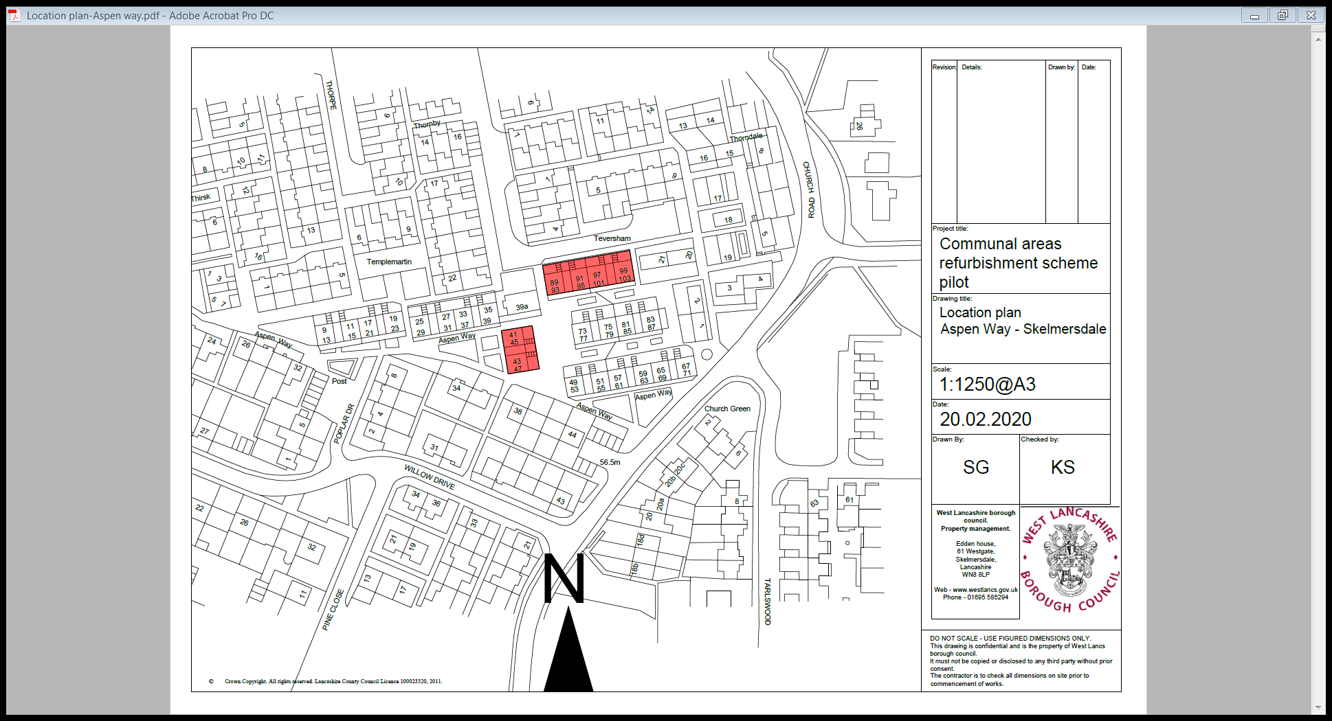
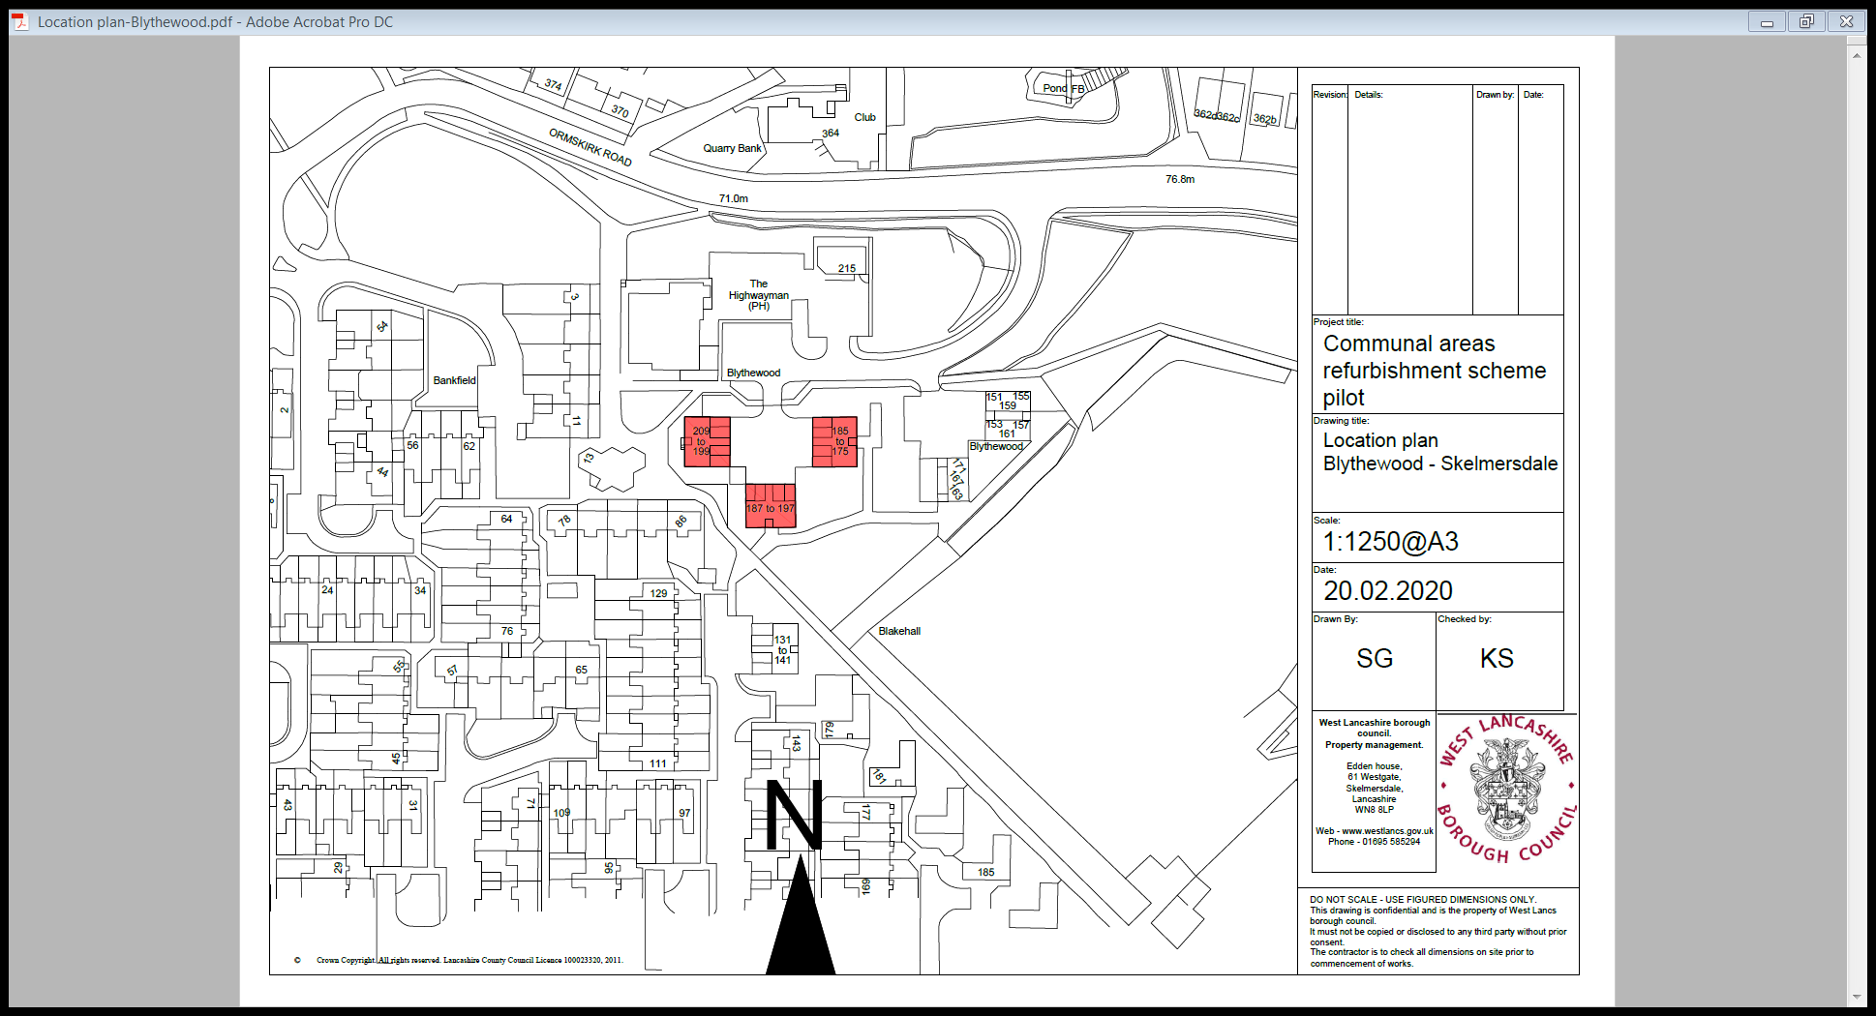

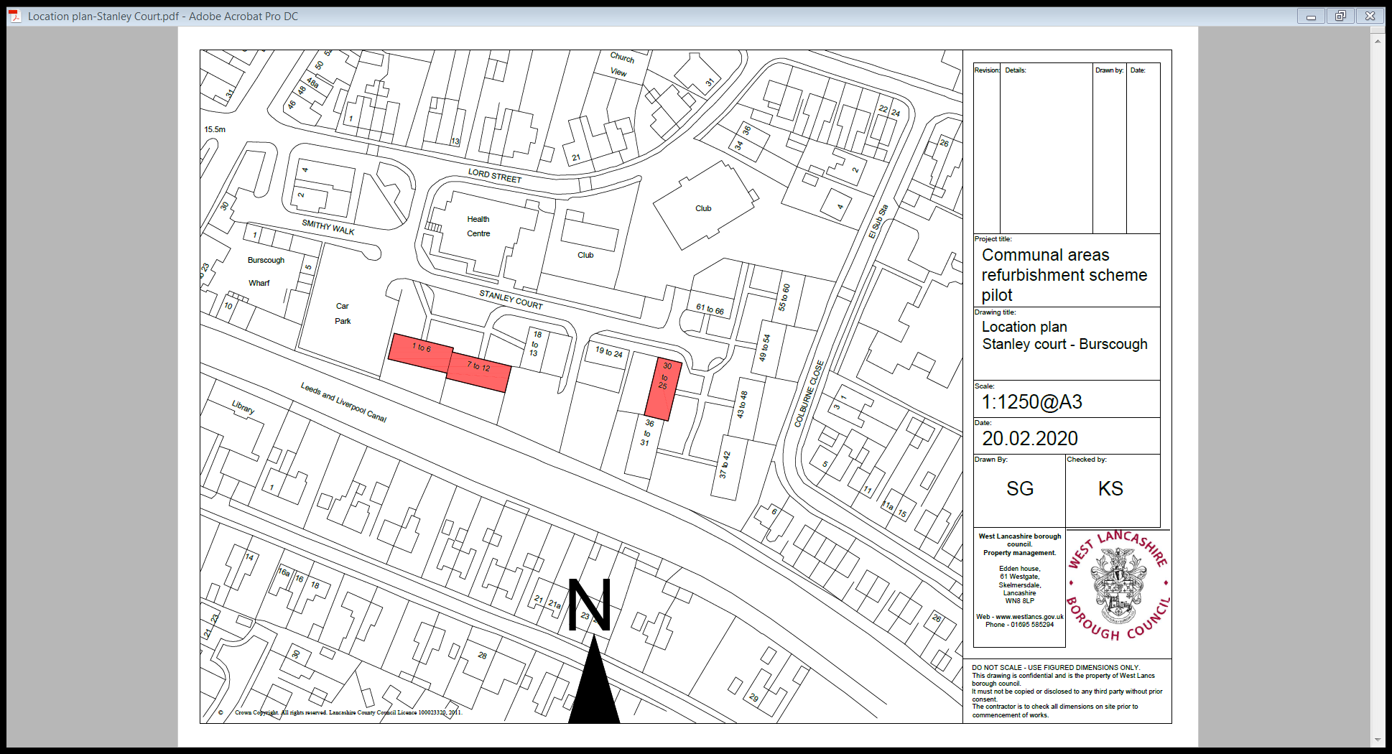

SECTION 9

COMMUNAL AREA
COLOUR OPTIONS

Double click on icon
to open

SECTION 10

PRE-CONTRACT INFORMATION

PRE-CONSTRUCTION INFORMATION
Project: Communal Areas Upgrade –  Stanley Court, Blythewood & Aspen Way | Date: 3rd March 2020
WYG Project A086265-49 | Revision: 0
Site Address:
Stanley Court Burscough L40 4LA Blocks 1-6, 7-12 & 25-30.
Blythewood Skelmersdale WN8 9EN Blocks 175-185, 187-197 & 199-209.
Aspen Way Skelmersdale WN8 8QJ Blocks 41-47, 91-97 & 97-103.
Brief Description of Works:
Prepare and repaint the communal areas to each block,
Remove existing vinyl floors and replace vinyl floor covering,
Electrical work upgrading the lighting and fire detection system.

Programme Details: Outstanding at Present
Start Date: Awaiting Confirmation of the actual date
Duration: Awaiting Confirmation of the actual date
Specific Requirements:
- Number of men likely to be on site at any one time
- Number of contractors on site at any one time

Project Contact Directory
Client: WLBC | Address | West Lancashire Borough Council  Eddon House  61, Westgate  Sandy Lane Centre  Skelmersdale  Lancashire  WN8 8LP
 | Phone | 01695 585 293
 | Mobile | 07825 425 686
 | Email | Kevin.spencer@westlancs.gov.uk
 | Contact | Kevin Spencer
Project Manager: WLBC | Address | West Lancashire Borough Council  Eddon House  61, Westgate  Sandy Lane Centre  Skelmersdale  Lancashire  WN8 8LP
 | Phone | 01695 585 293
 | Mobile | 07768 054799
 | Email | Alan.chadwick@westlancs.gov.uk
 | Contact | Alan Chadwick

Principal Designer: WYG | Address | 7th Floor Walker House  Exchange Flags  Liverpool  Merseyside  L2 3YL
 | Phone | 0151 236 4502
 | Mobile | 07730 658 107
 | Email | David.olive@wyg.com
 | Contact | David P Olive
Designer(s): WLBC | Address | All As above
 | Phone | 01695 585 293
 | Mobile | 07768 054799
 | Email | Alan.chadwick@westlancs.gov.uk
 | Contact | Alan Chadwick
Principal Contractor:? | Address | Details to be confirmed
 | Phone
 | Mobile
 | Email
 | Contact

Details of existing site: Residential properties and apartments to all three sites with -
Blythewood – Public House opposite (The Highwayman) and local retail outlets close by.
Stanley Court – Health Centre opposite.

Site Plans/drawings: Stanley Court
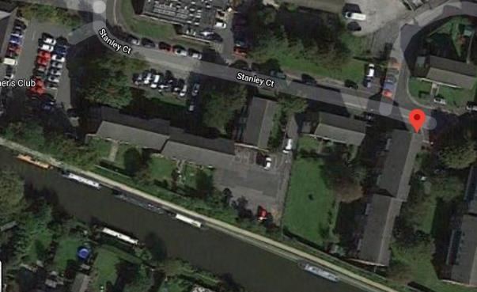

Blythewood:

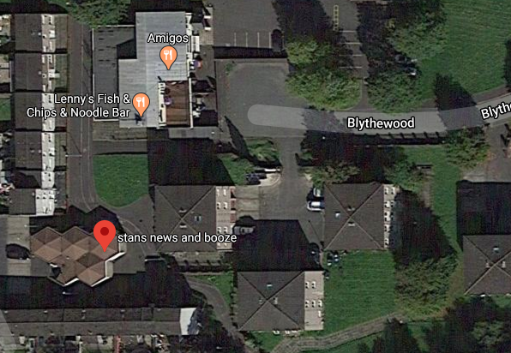
Aspen Way:

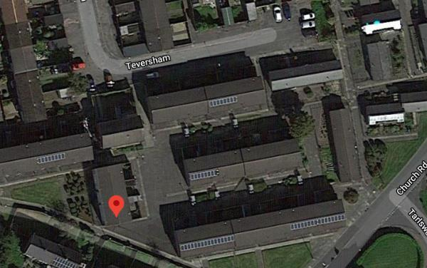
Existing Reports: Asbestos:

Blythewood Communal Areas
Lancashire County Scientific Services
Bulk Sampling Report
Blythewood Communal Areas
Ref: SV876/14WP
Date: 16.9.14

No asbestos materials noted to the flooring – Note: No reference to the artex ceiling finish.

Stanley Court Communal Areas
BDA Surveying Ltd
Bulk Sampling Report
BDA 069 Last Revised 3/7/17 Rev No 7.
Ref: WLB/AD/LA/00472

No asbestos materials noted to the flooring, Note: Ceiling finish appears to be paint.

Aspen Court Communal Areas
No Report received 4.3.20.

Existing Services/arrangements for isolating services:
Existing lighting and smoke detectors located within the communal areas and staircase. All appear to be surface mounted.

Summary of Significant Hazards/Risks:
(Consider existing hazards such as asbestos and live services and assess impact of proposed works. Consider any new hazards introduced, e.g. manual handling.)

Item | Hazard | Photo
1. | Slip hazard external paved areas, where the macadam has settled, silt layers have formed, during wet periods these are forming greasy slip hazards
2. | Residents access – staircase and landings. Do not store materials on the staircase, avoid loose cabling forming trip hazards.  Co-ordinate the removal and relaying of flooring with the residents prior to commencing work.  Avoid leaving loose materials on landings as these will form trip hazards. | 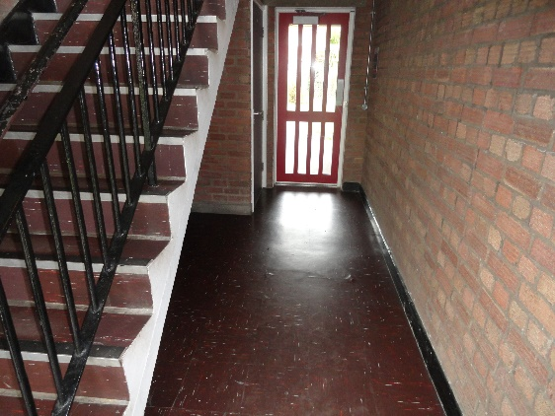
3. | Asbestos products – Artex ceiling finishes are not mentioned in the Bulk Analysis reports.  Aspen Court Report not as yet received. | 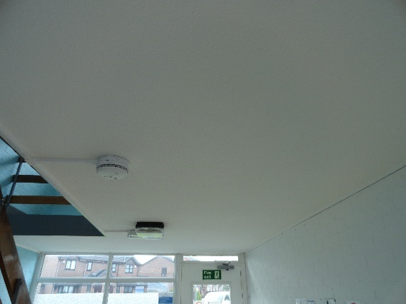

Access to Building/Work Area:
These are all residential apartments with mixed age group residents. Prior to commencing work the contractor(s) will have agreed with the client Project Manager and residents the proposed working hours with start and finish times.
Access to the sites will require key to allow entry to Aspen and Blythewood and a key fob for Stanley Court.

Welfare Facilities:
There are no facilities on site so welfare facilities will be required to be provided by the Principal Contractor. Facilities will be in line with the requirements of CDM 2015 Schedule 2 and the WYG Welfare Review Sheet (attached) to be completed and returned with the CPP.

Note: it is anticipated that the contractor, given the distances between sites, will use a mobile welfare unit.

Aspen Way to Blythewood 2.4 miles
Aspen Way to Stanley Court 5.8 miles
Blythewood to Stanley Court 7.8 miles

Note: HSE Document ‘Health and Safety In Construction HSG 150 Para’s 44 & 46

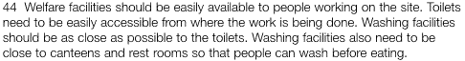
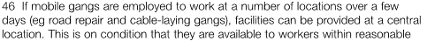
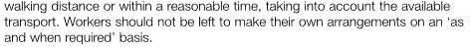
Traffic Plan: Identify parking areas for welfare units Note Aspen Way does not have easy access for vehicles as the area is largely pedestrianised.

See Photo Section

Site Rules:
Client Rules:
- No radios on site
- No personal music systems that may cause instructions to be mis heard
- No smoking on site
- All food to be consumed within the designated welfare area
- All PPE to be worn in line with the RAMS
- All contractors to wear identification while on site
- No foul or abusive language will be tolerated
- Observe any parking restrictions i.e. residents parking areas. Agree contractor parking with the client prior to commencing work.
Contractors Site Rules:
- Contractors rules to be included within the Contractors CPP (Construction Phase Plan)
File:
- Drawings where these are produced
- Description of the works carried out
- Contractor contact list giving address and contact details
- O&M File Information
- Flooring, electrical installation
- Electrical test certificates
- Warranties

Photos: Aspen Way
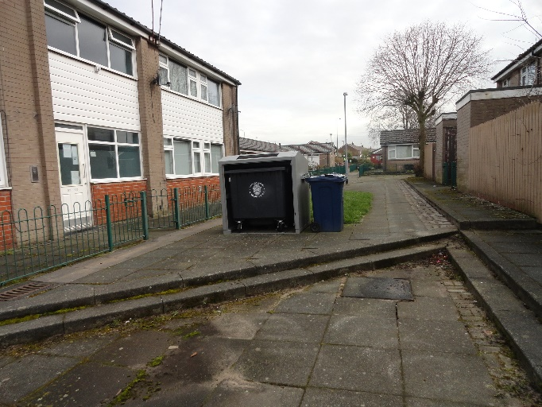 | 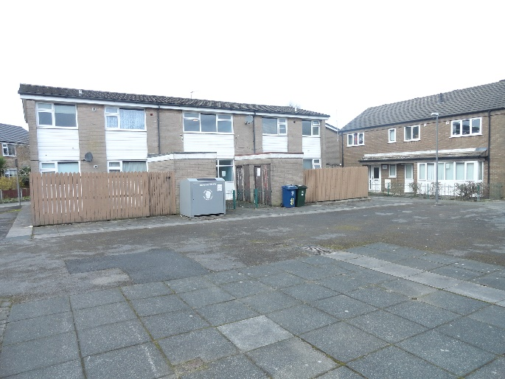
Typical front elevation | Rear and front elevations – Pedestrianised areas
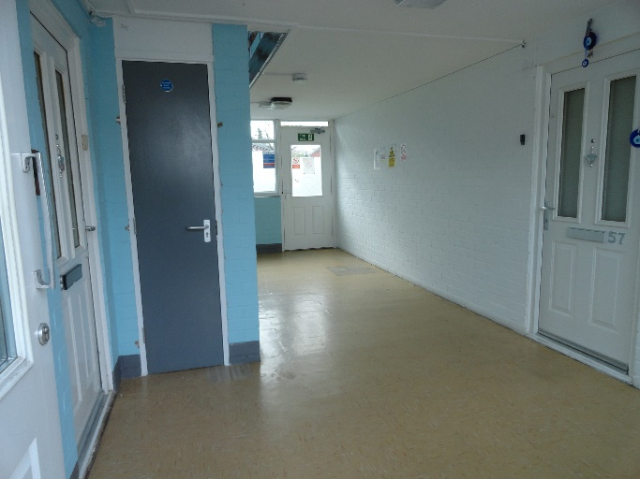 | 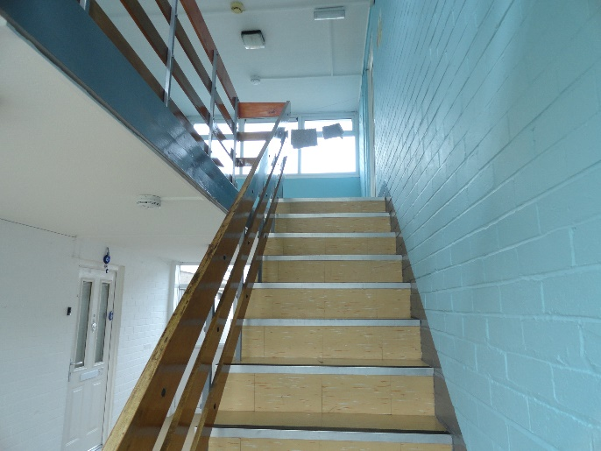
GF area and artex ceiling | Staircase and artex ceiling
Photos: Blythewood
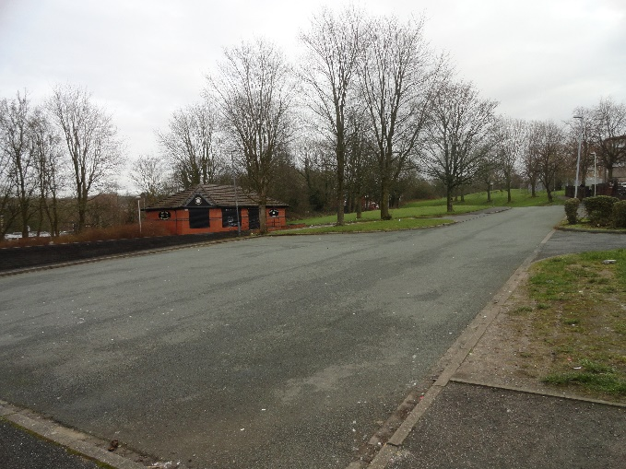 | 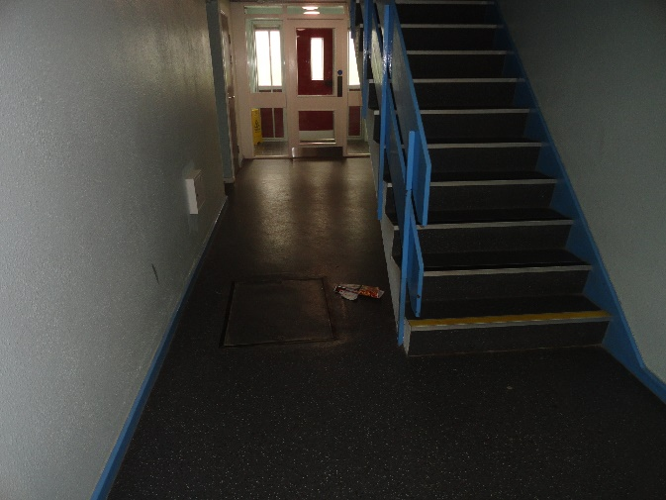
Adjacent parking area | Floor and staircase
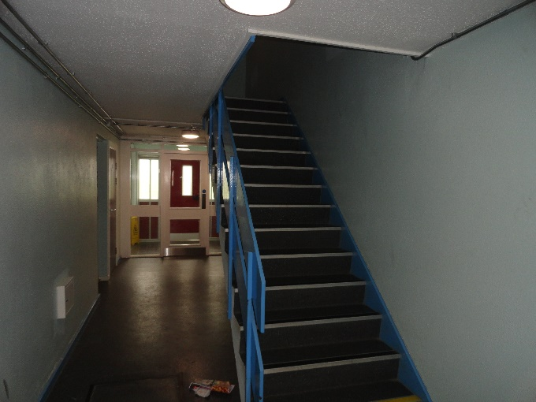 | 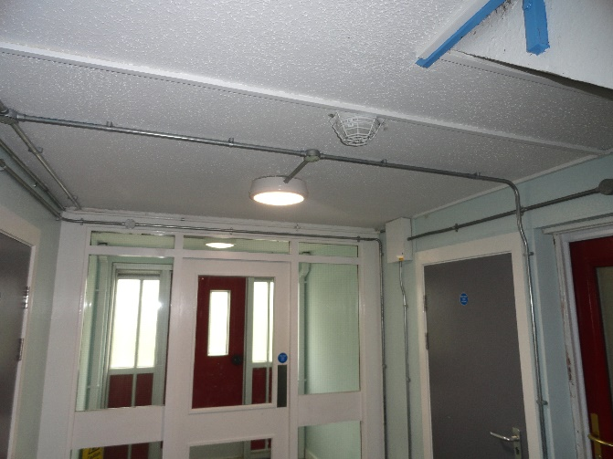
Stairs and ceiling | Existing electrical layout and artex ceiling
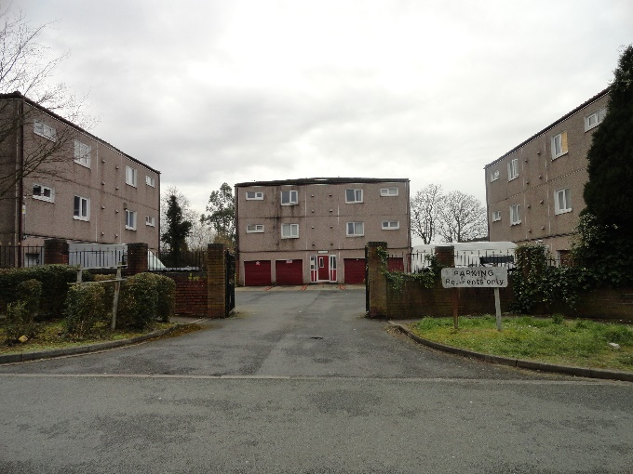
Gated area with residents parking bays.
Photos: Stanley Court
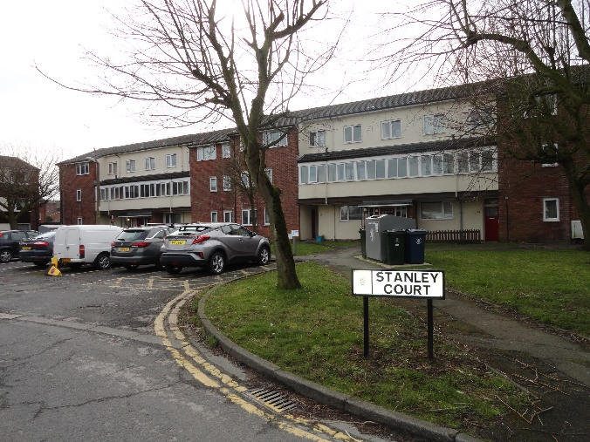 | 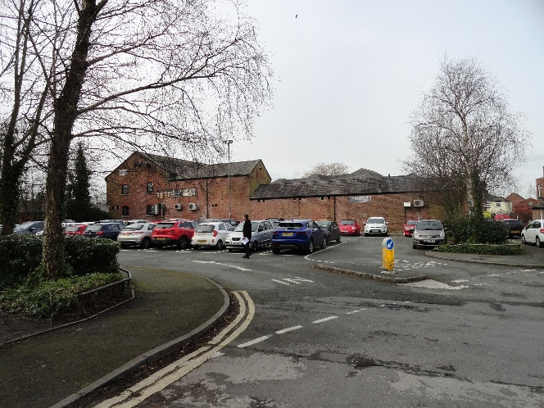
Units 1 – 6 single storey GF two storey upper levels access from fob operated front door | Adjacent parking area
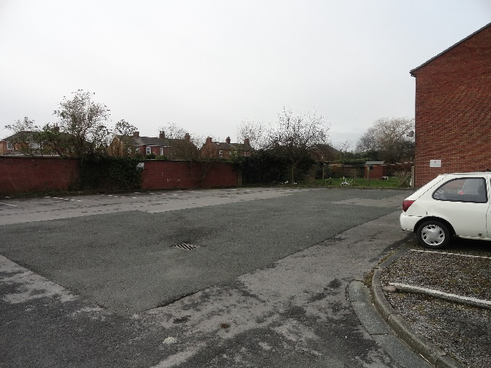 | 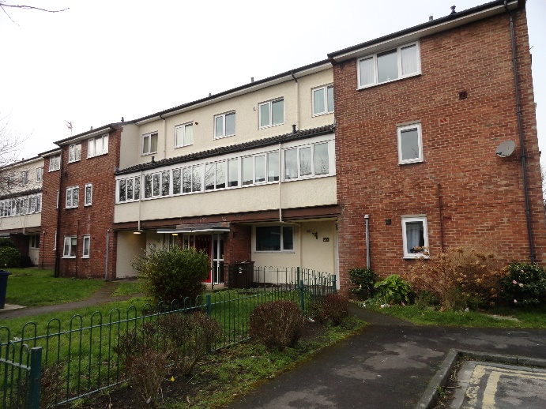
Residents large parking areas to the rear of 7 – 12 appeared largely unused at the time of my visit | Block 25 – 30
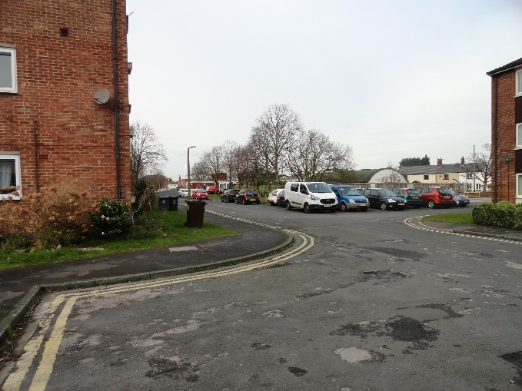 | 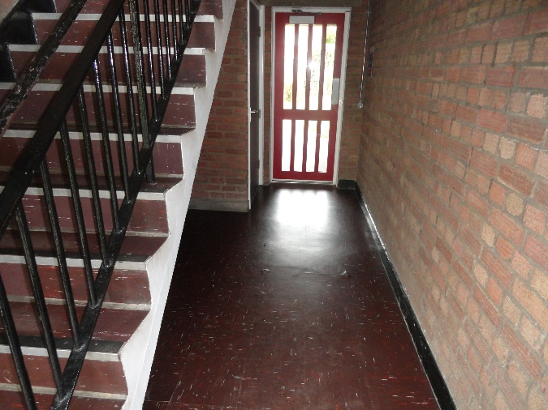
Congested access roads | GF and staircase
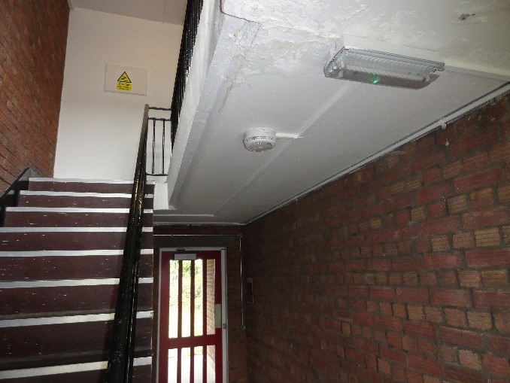 | 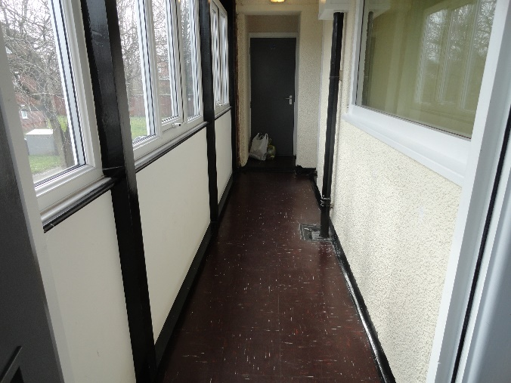
Stairs and painted ceilings | First floor landing

 | Produced by | Approved by
Name: | David P Olive | Mark Weeks
Signature: |  | 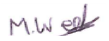
Date: | 4th March 2020 | 5th March 2020

Asbestos Reports

Double click on icon to open

SECTION 11

FORM OF TENDER

FORM OF TENDER FIXED PRICE

Tender for: COMMUNAL AREA REFURBISHMENT STANLEY COURT, ASPENWAY
& BLYTHEWOOD – SCHEDULE NO. CR/21

To : WEST LANCASHIRE BOROUGH COUNCIL Date :

I/We have read the Contract Documents for the above entitled contract, and having inspected the site do hereby offer to execute and complete the whole of the works described for the sum

of............................................................................... which is exclusive of V.A.T.

(£ ).

I/We state that I/We have not communicated to any person, other than the person calling for this tender, the amount of this tender and that I/We have not adjusted the amount of this tender in accordance with any arrangement between myself/ourselves and any person other than the person calling for this tender. Should the Employer suspect that any tender has indulged in any price fixing arrangements then the matter will be reported to the Office of Fair Trading.

The successful tenderer will be required to execute a formal contract and until such execution, the successful tender together with the Employer’s written acceptance shall form a binding agreement in the terms of the Contract Documents and where there is any discrepancy or difference between the tender and the Contract Documents the latter shall prevail.

I/We confirm that in compiling my/our tender, full regard has been paid to the specification clause headed “Potential Hazards” and I/We will only employ appropriate and safe methods of working in carrying out the Contract works.

The Fixed Price Tender shall remain open for acceptance by the employer for a period of 3 Calendar months from the date stated for the receipt of tenders.

Contractors signature(s)*
[print name(s) in full together ........................................................................................

with position in organisation] …….................................................................................

Date: ……………………………………..........................................................................

Name and Address of Firm …....................................................................................…

........................................................................................................................................

Tel. No: ………………...................................................................................................

* Where the Contractor is an incorporated association the company secretary and a duly authorised director should sign. In the case of a partnership at least two duly authorised partners should sign. In the case of an individual the proprietor should sign.

Insurance Declaration

I/We confirm that I/We have in effect insurance cover sufficient to satisfy the requirements as specified in the Contract Documents and I/We undertake to maintain such cover throughout the period of the Contract Works.

Signature and Position of person signed: ......................................................................

…………………………………………………..

Note : The Council does not bind itself to accept the lowest or any tender and will not be responsible for any costs incurred by the Contractor in preparing same.

The tender should be completed, signed and uploaded on to The Chest portal at www.the-chest.org.uk by 12 noon on the date shown on the Invitation to Tender letter, otherwise it will not be considered.

This page is intentionally blank.

